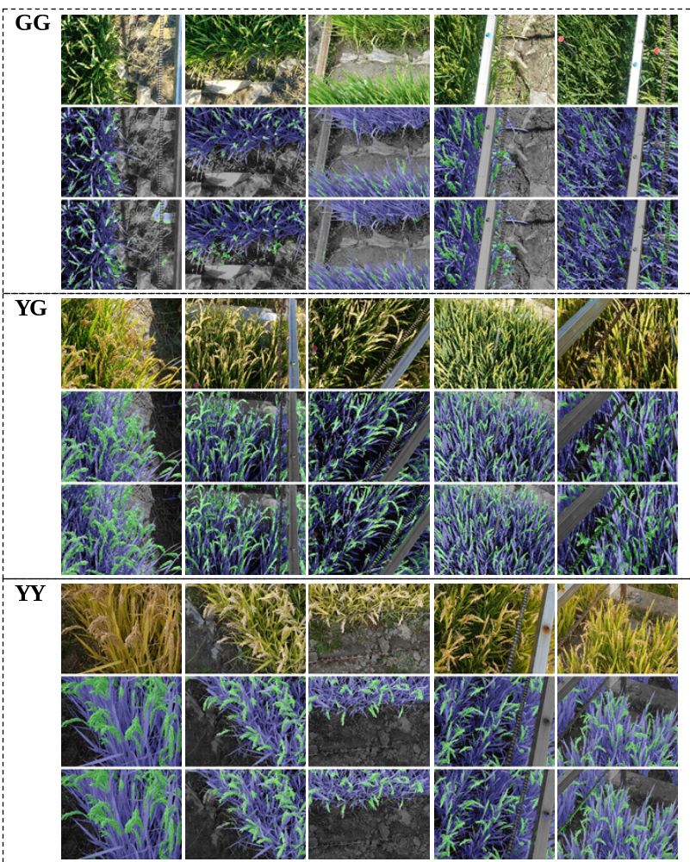
Fig. S1 FPN-Mask segmentation results for 15 selected samples at three growth stages of GG, YG, and YY. At each stage, there are three blocks with 5 images from the left to the right, within each block, rows from upper to bottom show the original image, the manually labeled ground truth, and the predicted results, respectively.

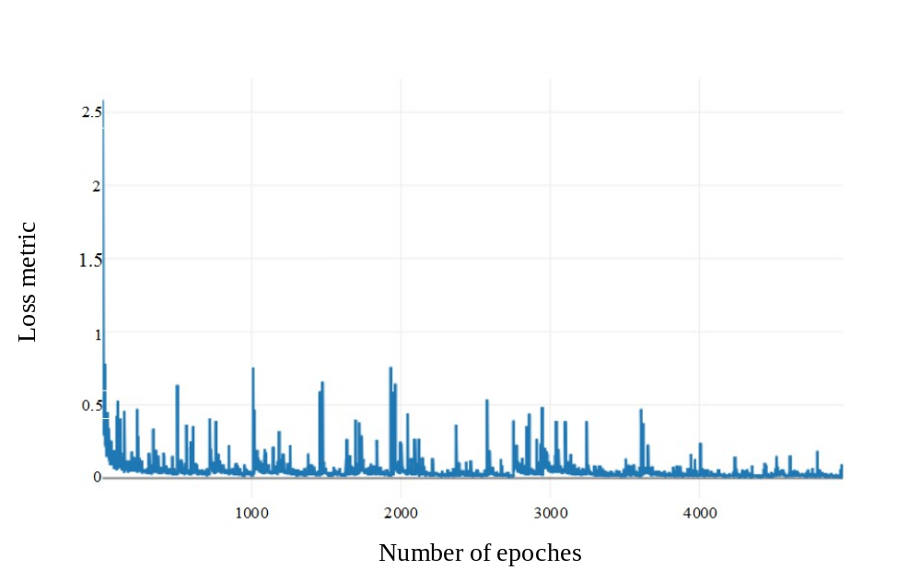
Fig. S2 Training loss curve. Each epoch has 8192 iterations.

Table S1 Statistical information of the training dataset
Field image | Min | Max | Average Interval
Growth Age (mm.dd) | 08.30 | 11.02 | 10.00
Azimuth (°) | -111.79 | 107.71 | 54.875
Altitude (°) | 0.62 | 78.39 | 19.44
Time (hh: mm) | 5:30 | 18:30 | 3.75
Variety | 9

Table S2 Statistical information of the testing dataset
Field image | Min | Max
Growth Age (mm.dd) | 08.30 | 11.02
Time (hh: mm) | 5:30 | 18:30
Variety | 9

Table S3 Pixel accuracy for each class
 | Panicle | Leaf | Background
GG | 0.99 | 0.976 | 0.814
YG | 0.99 | 0.983 | 0.849
YY | 0.99 | 0.977 | 0.894

Table S4 LPR of 192 mutants at 30 DAA
Material | LPR | Material | LPR | Material | LPR | Material | LPR | Material | LPR
DW073 | 1.37 | DW110 | 1.80 | DW165 | 1.95 | DW158 | 2.11 | DW103 | 2.50
DW150 | 1.42 | DW192 | 1.81 | DW041 | 1.95 | DW024 | 2.11 | DW087 | 2.51
DW060 | 1.46 | DW109 | 1.82 | DW010 | 1.95 | DW014 | 2.13 | DW061 | 2.52
DW118 | 1.47 | DW023 | 1.82 | DW179 | 1.96 | DW070 | 2.13 | DW141 | 2.52
DW124 | 1.49 | DW170 | 1.82 | DW102 | 1.96 | DW127 | 2.14 | DW080 | 2.54
DW037 | 1.52 | DW090 | 1.83 | DW089 | 1.96 | DW181 | 2.15 | DW106 | 2.59
DW143 | 1.56 | DW063 | 1.83 | DW105 | 1.96 | DW135 | 2.16 | DW187 | 2.62
DW162 | 1.56 | DW015 | 1.83 | DW007 | 1.96 | DW129 | 2.16 | DW176 | 2.71
DW171 | 1.58 | DW046 | 1.83 | DW017 | 1.97 | DW084 | 2.17 | DW125 | 2.73
DW018 | 1.58 | DW077 | 1.83 | DW008 | 1.99 | DW184 | 2.18 | DW167 | 2.76
DW050 | 1.60 | DW022 | 1.84 | DW190 | 2.00 | DW136 | 2.18 | DW032 | 2.79
DW028 | 1.60 | DW005 | 1.84 | DW096 | 2.00 | DW051 | 2.19 | DW146 | 2.80
DW163 | 1.62 | DW066 | 1.84 | DW166 | 2.00 | DW133 | 2.20 | DW012 | 2.81
DW104 | 1.64 | DW116 | 1.85 | DW016 | 2.00 | DW074 | 2.21 | DW128 | 2.84
DW130 | 1.64 | DW044 | 1.85 | DW140 | 2.01 | DW098 | 2.21 | DW182 | 2.87
DW002 | 1.65 | DW058 | 1.85 | DW078 | 2.01 | DW091 | 2.21 | DW001 | 2.90
DW065 | 1.65 | DW039 | 1.86 | DW123 | 2.02 | DW174 | 2.22 | DW142 | 2.90
DW027 | 1.66 | DW153 | 1.86 | DW030 | 2.02 | DW122 | 2.22 | DW145 | 2.91
DW093 | 1.67 | DW172 | 1.87 | DW115 | 2.02 | DW021 | 2.22 | DW025 | 2.95
DW049 | 1.68 | DW092 | 1.87 | DW079 | 2.02 | DW031 | 2.24 | DW155 | 2.96
DW045 | 1.69 | DW053 | 1.87 | DW114 | 2.02 | DW068 | 2.25 | DW186 | 3.01
DW026 | 1.69 | DW151 | 1.87 | DW175 | 2.03 | DW159 | 2.28 | DW131 | 3.03
DW052 | 1.69 | DW043 | 1.87 | DW100 | 2.03 | DW149 | 2.31 | DW139 | 3.10
DW117 | 1.70 | DW035 | 1.87 | DW147 | 2.03 | DW081 | 2.32 | DW152 | 3.12
DW059 | 1.70 | DW003 | 1.88 | DW071 | 2.03 | DW101 | 2.36 | DW134 | 3.20
DW042 | 1.71 | DW054 | 1.88 | DW188 | 2.04 | DW148 | 2.36 | DW086 | 3.44
DW064 | 1.72 | DW177 | 1.88 | DW072 | 2.04 | DW111 | 2.36 | DW085 | 3.47
DW038 | 1.72 | DW154 | 1.88 | DW013 | 2.05 | DW144 | 2.36 | DW156 | 3.83
DW029 | 1.72 | DW057 | 1.88 | DW132 | 2.06 | DW113 | 2.37 | DW055 | 3.92
DW004 | 1.73 | DW075 | 1.89 | DW056 | 2.06 | DW069 | 2.37 | DW169 | 4.58
DW019 | 1.73 | DW047 | 1.89 | DW180 | 2.07 | DW161 | 2.42 | DW099 | 4.68
DW137 | 1.74 | DW095 | 1.89 | DW009 | 2.07 | DW168 | 2.42 | DW112 | 5.60
DW138 | 1.74 | DW083 | 1.89 | DW107 | 2.07 | DW120 | 2.43
DW034 | 1.76 | DW160 | 1.90 | DW062 | 2.07 | DW126 | 2.43
DW097 | 1.76 | DW011 | 1.90 | DW033 | 2.08 | DW121 | 2.44
DW036 | 1.77 | DW094 | 1.90 | DW189 | 2.08 | DW185 | 2.45
DW082 | 1.78 | DW191 | 1.90 | DW076 | 2.08 | DW178 | 2.46
DW006 | 1.79 | DW067 | 1.93 | DW183 | 2.09 | DW020 | 2.47
DW048 | 1.79 | DW040 | 1.93 | DW164 | 2.10 | DW173 | 2.49
DW088 | 1.80 | DW119 | 1.94 | DW157 | 2.10 | DW108 | 2.49

