Supplementary Material
Title:
A nomogram for predicting prognosis in patients with acute respiratory distress syndrome (ARDS) and acute renal injury (AKI): A retrospective cohort study

Part I:
We used ICD code to identify ARDS. Modality specific details are given below.
ARDS：ICD ('51882', '5185','J80', 'J95821', 'J9600', 'J951', 'J952', 'J953', 'J95822', 'J9620' )
AKI: AKI followed the KDIGO definition: urine output less than 0.5 ml/kg/hour for 6 hours, or serum creatinine (SCr) increases >= 0.3 mg/dl within 48 hours or increases >= 1.5 times baseline value within 7 days. The stage of AKI was also in according with KDIGO criteria.

Part II:
Figure S1. Flow Chart Illustrating the Inclusion and Exclusion Criteria of Study Cohorts
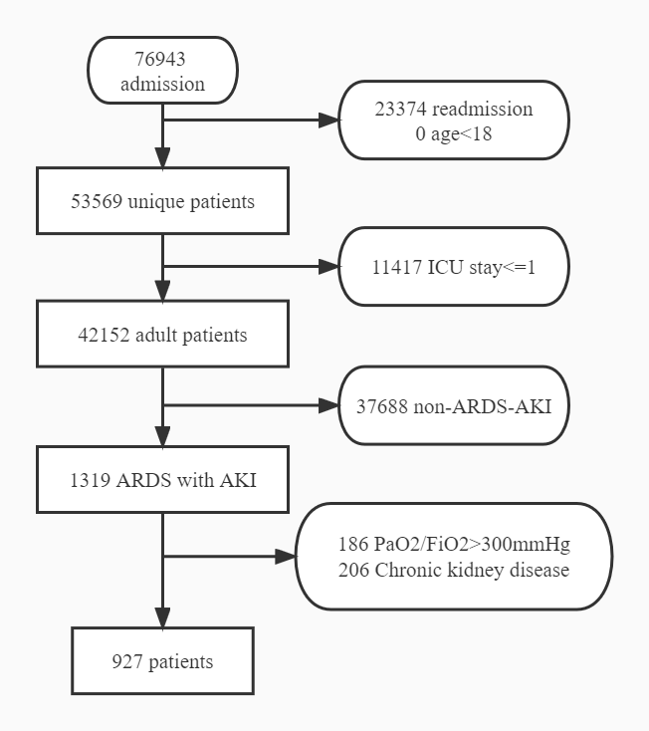

Figure S2. Pattern of missing data in variables of interest in MIMIC–IV database.
Figure S3. Demographic and clinical feature selection using the least absolute shrinkage and selection operator (LASSO) binary logistic regression model.

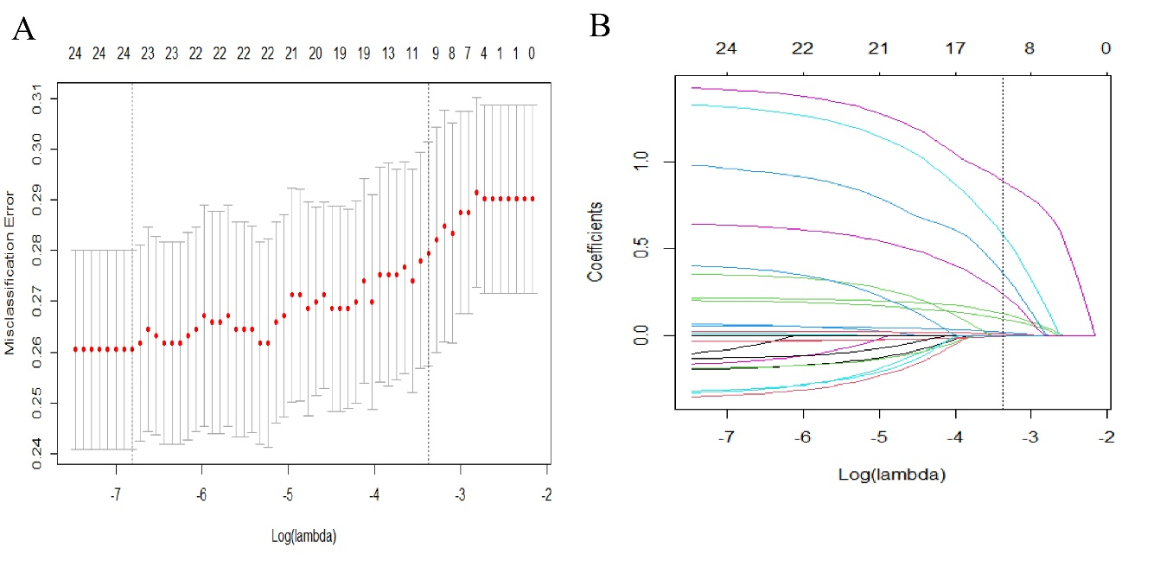
(A) Tuning parameter (λ) selection in the LASSO model used 10-fold cross-validation via minimum criteria. The partial likelihood deviance (binomial deviance) curve was plotted versus log(λ). Dotted vertical lines were drawn at the optimal values by using the minimum criteria and the one SE of the minimum criteria. λvalue of 0.03423 was chosen according to 10-fold cross-validation. (B) LASSO coefficient profiles of the 24 features. A coefficient profile plot was produced against the log (λ) sequence. The vertical line was drawn at the value selected using 10-fold cross-validation, where optimal resulted in 9 features with non-zero coefficients.

Figure S4. Calibration plots of nomogram to predict risk of pressure injury. A: train
cohort. B: test cohort.
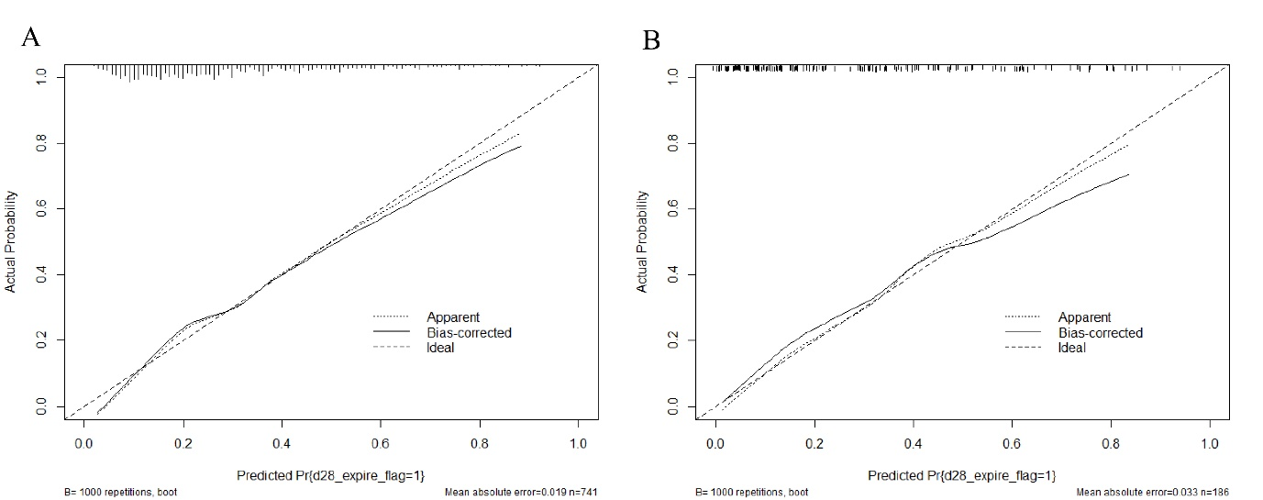

Table S1. Baseline Characteristics of the original cohort with missing data.
Variables | Survivor | Death | P value
Variables | 657 | 270 | P value
Potassium (mean (SD)) | 4.10 (0.56) | 4.09 (0.61) | 0.941
Chloride (mean (SD)) | 105.59 (5.46) | 104.31 (6.33) | 0.002
Lactate (mean (SD)) | 2.11 (1.12) | 2.54 (1.17) | <0.001
RR (mean (SD)) | 19.39 (5.73) | 21.03 (5.78) | <0.001
Gender = M (%) | 364 (55.4) | 136 ( 50.4) | 0.185
HR (mean (SD)) | 91.22 (19.11) | 93.54 (19.58) | 0.096
pO2 <=60 (%) | 115 (17.5) | 55 ( 20.4) | 0.352
pH (mean (SD)) | 7.35 (0.09) | 7.34 (0.11) | 0.043
BMI (mean (SD)) | 29.94 (5.82) | 28.57 (5.61) | 0.001
RDW (mean (SD)) | 14.35 (1.37) | 14.84 (1.60) | <0.001
Hb (mean (SD)) | 11.00 (2.36) | 10.95 (2.62) | 0.746
WBC (mean (SD)) | 12.89 (5.56) | 13.15 (5.71) | 0.514
Plt (mean (SD)) | 202.02 (85.43) | 187.23 (91.23) | 0.019
Alb (mean (SD)) | 3.10 (0.59) | 2.98 (0.62) | 0.008
Alt (mean (SD)) | 34.28 (23.01) | 37.36 (24.76) | 0.07
Age (mean (SD)) | 61.62 (17.16) | 66.95 (16.08) | <0.001
T (mean (SD)) | 36.74 (0.72) | 36.66 (0.72) | 0.136
INR (mean (SD)) | 1.29 (0.22) | 1.37 (0.24) | <0.001
MAP<=65 (%) | 86 (13.1) | 36 ( 13.3) | 1
Scr (mean (SD)) | 0.91 (0.30) | 1.09 (0.38) | <0.001
APTT (mean (SD)) | 31.18 (6.47) | 32.49 (7.26) | 0.007
Diabets (%) | 150 (22.8) | 58 ( 21.5) | 0.718
MI (%) | 84 (12.8) | 49 ( 18.1) | 0.044
Cancer (%) | 78 (11.9) | 43 ( 15.9) | 0.119
CBD (%) | 115 (17.5) | 88 ( 32.6) | <0.001
LD (%) | 76 (11.6) | 63 ( 23.3) | <0.001
SOFA (mean (SD)) | 5.96 (3.48) | 7.81 (4.68) | <0.001
SAPS II (mean (SD)) | 38.61 (13.76) | 47.58 (16.19) | <0.001

Table S2. Baseline Characteristics between the train cohort and test cohort.
Variables | Train cohort |  |  | Test cohort
Variables | Survivor | Death | P value | Survivor | Death | P value
Variables | 526 | 215 | P value | 131 | 55 | P value
Potassium (mean (SD)) | 4.12 (0.56) | 4.09 (0.61) | 0.601 | 4.01 (0.57) | 4.10 (0.60) | 0.379
Chloride (mean (SD)) | 105.66 (5.55) | 104.18 (6.39) | 0.002 | 105.30 (5.13) | 104.84 (6.09) | 0.598
Lactate (mean (SD)) | 2.09 (1.10) | 2.56 (1.15) | <0.001 | 2.17 (1.23) | 2.46 (1.27) | 0.141
RR (mean (SD)) | 19.41 (5.74) | 21.06 (5.78) | <0.001 | 19.30 (5.75) | 20.91 (5.82) | 0.085
Gender = M (%) | 286 (54.4) | 111 ( 51.6) | 0.549 | 78 (59.5) | 25 ( 45.5) | 0.109
HR (mean (SD)) | 91.39 (19.59) | 93.75 (19.21) | 0.134 | 90.52 (17.13) | 92.70 (21.12) | 0.463
pO2 <=60 (%) | 101 (19.2) | 49 ( 22.8) | 0.316 | 14 (10.7) | 6 ( 10.9) | 1
pH (mean (SD)) | 7.35 (0.09) | 7.34 (0.11) | 0.021 | 7.35 (0.08) | 7.36 (0.10) | 0.834
BMI (mean (SD)) | 29.89 (5.89) | 29.11 (5.58) | 0.097 | 30.14 (5.56) | 26.48 (5.27) | <0.001
RDW (mean (SD)) | 14.33 (1.40) | 14.86 (1.63) | <0.001 | 14.42 (1.24) | 14.74 (1.51) | 0.141
Hb (mean (SD)) | 11.01 (2.30) | 10.99 (2.58) | 0.919 | 10.98 (2.61) | 10.78 (2.79) | 0.636
WBC (mean (SD)) | 12.85 (5.51) | 12.97 (5.65) | 0.79 | 13.03 (5.79) | 13.86 (5.92) | 0.378
Plt (mean (SD)) | 200.76 (85.34) | 185.46 (88.75) | 0.029 | 207.08 (85.93) | 194.15 (100.93) | 0.376
Alb (mean (SD)) | 3.08 (0.59) | 2.98 (0.62) | 0.037 | 3.15 (0.60) | 2.99 (0.63) | 0.085
Alt (mean (SD)) | 34.75 (23.54) | 36.15 (24.22) | 0.467 | 32.39 (20.76) | 42.13 (26.49) | 0.008
Age (mean (SD)) | 61.70 (17.30) | 66.64 (15.81) | <0.001 | 61.27 (16.62) | 68.14 (17.21) | 0.012
T (mean (SD)) | 36.76 (0.70) | 36.65 (0.73) | 0.048 | 36.65 (0.78) | 36.71 (0.69) | 0.591
INR (mean (SD)) | 1.29 (0.22) | 1.37 (0.24) | <0.001 | 1.31 (0.22) | 1.39 (0.24) | 0.049
MAP<=65 (%) | 68 (12.9) | 24 ( 11.2) | 0.59 | 18 (13.7) | 12 ( 21.8) | 0.251
Scr (mean (SD)) | 0.91 (0.30) | 1.10 (0.38) | <0.001 | 0.92 (0.32) | 1.08 (0.38) | 0.004
APTT (mean (SD)) | 31.11 (6.47) | 32.54 (7.24) | 0.009 | 31.43 (6.47) | 32.30 (7.42) | 0.425
Diabetes (%) | 121 (23.0) | 44 ( 20.5) | 0.511 | 29 (22.1) | 14 ( 25.5) | 0.765
MI (%) | 63 (12.0) | 42 ( 19.5) | 0.01 | 21 (16.0) | 7 ( 12.7) | 0.726
Cancer (%) | 64 (12.2) | 32 ( 14.9) | 0.38 | 14 (10.7) | 11 ( 20.0) | 0.143
CBD (%) | 95 (18.1) | 71 ( 33.0) | <0.001 | 20 (15.3) | 17 ( 30.9) | 0.025
LD (%) | 61 (11.6) | 50 ( 23.3) | <0.001 | 15 (11.5) | 13 ( 23.6) | 0.058
SOFA (mean (SD)) | 5.94 (3.44) | 7.86 (4.74) | <0.001 | 6.05 (3.66) | 7.60 (4.45) | 0.015
SAPS II (mean (SD)) | 38.57 (13.71) | 47.63 (15.64) | <0.001 | 38.77 (13.99) | 47.40 (18.34) | 0.001

