Supplementary Files
Table S1: Imaging abnormalities in patients with COVID-19.

Parameters, n (%) | All patients | Myocardial Injury |  | P value
Parameters, n (%) | All patients | With | Without | P value
ECG abnormalities | 83(61.5), n=135 | 25 (59.5), n=42 | 58 (64.5), n=93 | 0.753
Sinus arrhythmia | 11 (8.1) | 2 (4.8) | 9 (9.7) | 0.502
ST-T abnormality | 17 (12.6) | 6 (14.3) | 11 (11.8) | 0.690
Atrial arrhythmia | 6 (4.4) | 1 (2.4) | 5 (5.4) | 0.665
LA enlargement | 1 (0.7) | - | 1 (1.1) | -
Ventricular arrhythmia | 7 (5.2) | 1 (2.4) | 6 (6.5) | 0.435
Conduction abnormality | 3 (2.2) | 1 (2.4) | 2 (2.2) | -
Low limb lead voltage | 1 (0.7) | - | 1 (1.1) | -
Complex ECG abnormality | 37 (28.1) | 14 (33.3) | 23 (25.8) | 0.300
Echo abnormalities | 27 (79.4), n=34 | 13 (92.9), n=14 | 14 (70.0), n=20 | 0.198
Pericardial effusion | 2 (5.9) | 1 (7.1) | 1 (5.0) | -
LV diastolic dysfunction | 9 (26.5) | 2 (14.3) | 7 (35.0) | 0.108
RV abnormality (PAH) | 1 (2.9) | - | 1 (5.0) | -
LA enlargement | 1 (2.9) | 1 (7.1) | - | 0.412
Complex Echo abnormality | 14 (41.2) | 9 (64.3) | 5 (25.0) | 0.022
CT/DR abnormalities (%) | 221 (72.7) | 69 (71.9) | 152 (73.1) | 0.827
ECG: electrocardiogram; LA: left atrial, LV/RV: left/right ventricle; PAH: pulmonary arterial hypertension; CT/DR, Computed Tomography/ Digital Radiography.
Table S2: Multivariate Cox Regression Analysis on the Risk Factors Associated with Mortality in Patients With COVID-19 from symptom onset
Factors | Univariate analysis |  | Cox regression model
Factors | Hazard ratio (95% CI) | P value | Hazard ratio (95% CI) | P value
Age, > 65 years | 3.79 (2.32-6.20) | < 0.001 | 2.22 (1.15-4.27) | 0.017
Sex | 0.53 (0.34-0.82) | 0.005
Hypertension | 2.05 (1.34-3.13) | 0.001
COPD | 2.95 (1.64-5.32) | < 0.001 | 2.43 (1.11-5.31) | 0.027
Chronic heart disease | 2.16 (1.34-3.47) | 0.002
Cerebrovascular disease | 3.10 (1.72-5.59) | < 0.001
HSTNI | 1.07 (1.05-1.10) | < 0.001 | 3.33 (1.96-5.66) | < 0.001
CRP | 1.01 (1.01-1.02) | < 0.001 | 1.01 (1.01-1.01) | <0.001
NT-proBNP on admission | 1.00 (1.00-1.00) | 0.082
PCT | 1.00 (1.00-1.02) | 0.768
D-dimer | 1.01 (1.00-1.01) | 0.003
NCP types |  | < 0.001 |  | 0.001
severe-common | 3.89 (1.95-7.76) | < 0.001 | 2.43 (1.05-5.67) | 0.039
critically severe-common | 18.42 (9.06-37.41) | < 0.001 | 5.40 (2.09-13.95) | 0.001
P-values by Cox regression analyses. PCT, CRP, and NT-proBNP on admission, D-dimer were performed as continuous variables. NT-proBNP, N-terminal pro-B-type natriuretic peptide; COPD: chronic obstructive pulmonary disease; PCT, Procalcitonin; NCP: novel coronary pneumonia.
Figure Legends:
Fig. S1 CT presentation of patients with COVID-19.

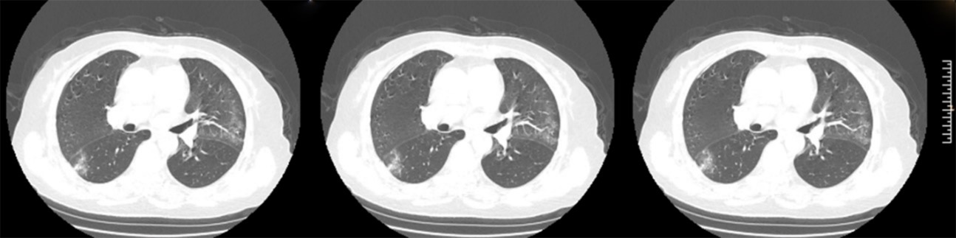

A older female patient was diagnosed with COVID-19, presenting with fever and shortness of breath at the onset. She had hypertension for 4 years. CT examination indicated multi-focal patch, and segmental ground glass opacities.

