Supplemental S1. Average measured concentration of testosterone (quantifier and qualifier) for the calibrators and NIST material. Standard deviation was used as a measure for error bars.
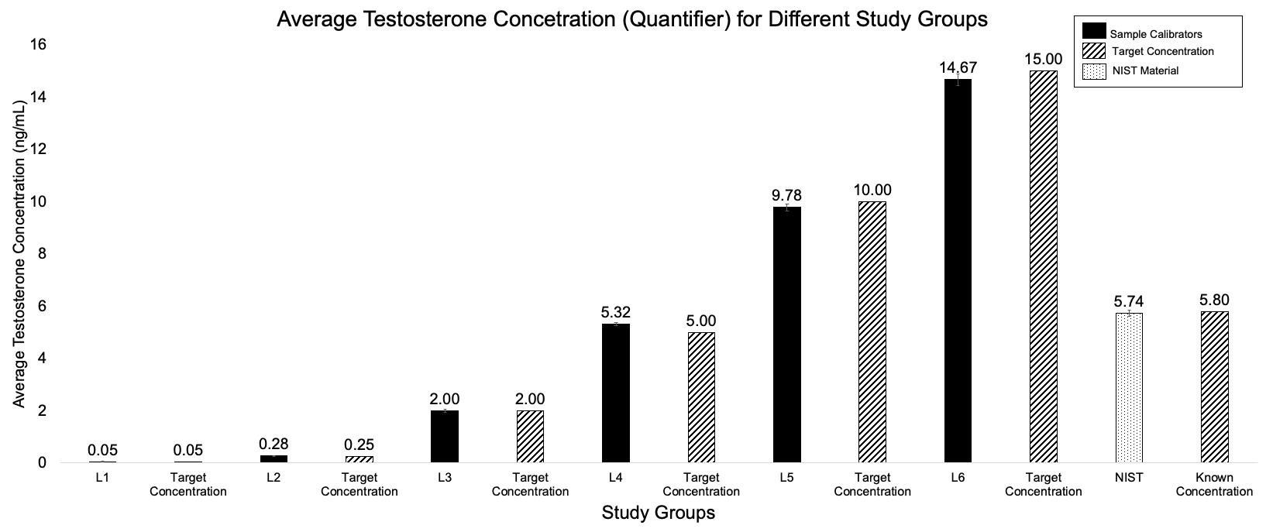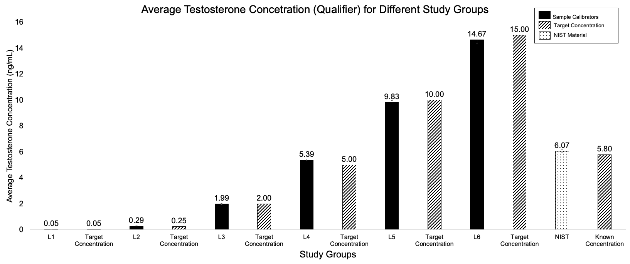

Supplemental S2. Normalized (to Day 0) average testosterone concentration for quantifier over 2-day intervals up to Day=14. Samples were mostly stable over the 14 days.

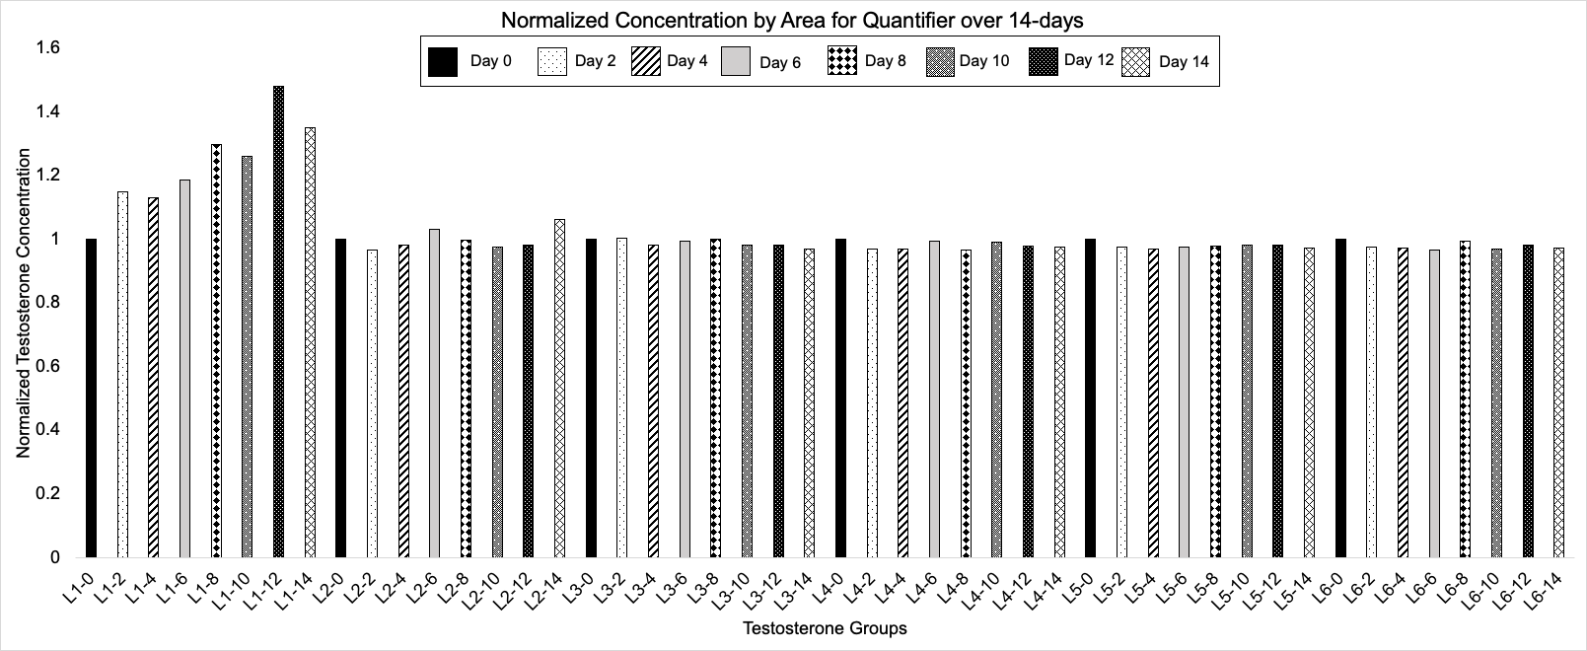

Supplemental S3. Average measured concentration of testosterone (quantifier and qualifier) for no formic acid, 0.1% formic acid and 1% formic acid during reconstitution step. Results obtained for 0.1% formic acid and 1% formic acid were not statistically significant.
