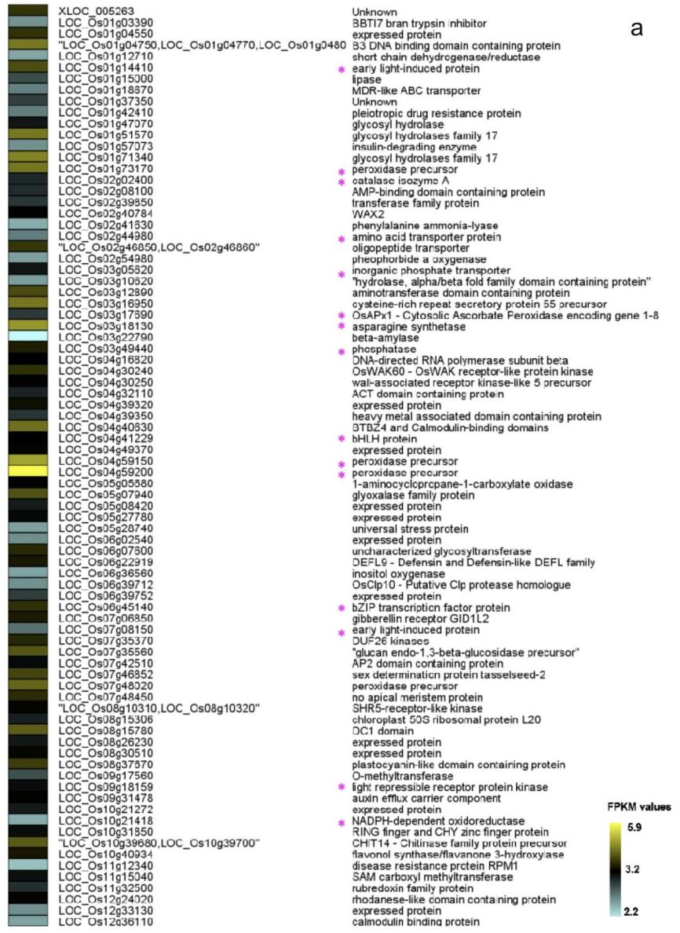

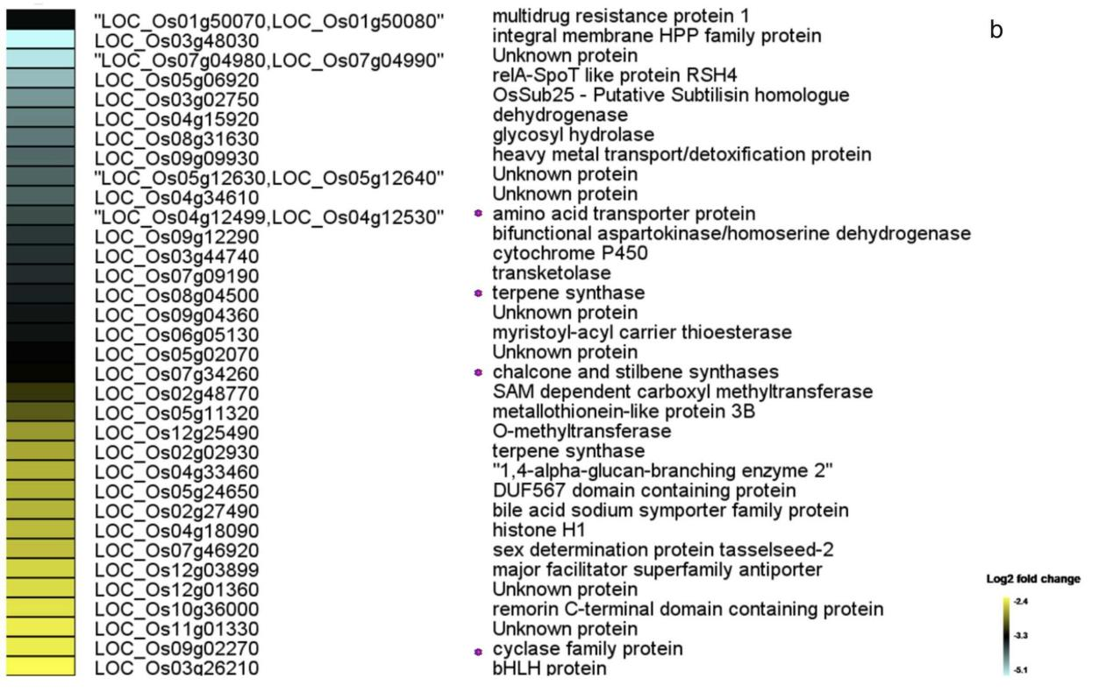
Figure s1. Heatmap showing the expression profiles of significantly (a) up- and (b) down-regulated DEGs in N22 vs. M-507. Color bars show the corresponding scale for log2 fold change in expression.

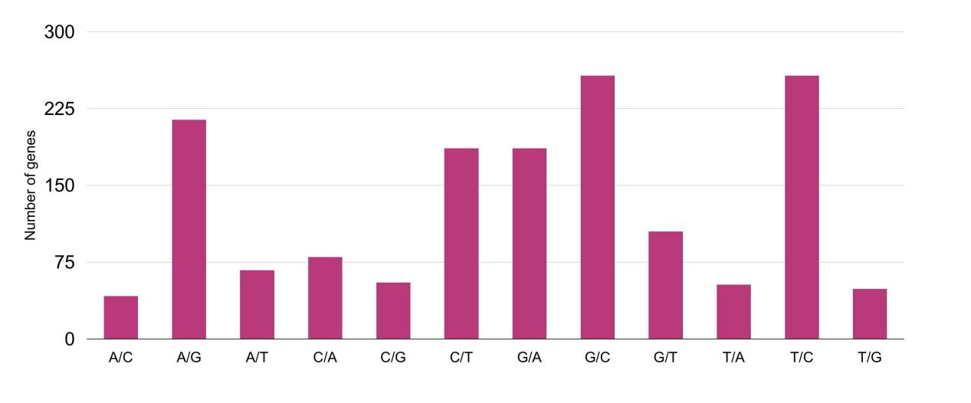
Figure s2. Total number of SNPs detected for N22 and M-507.

