Two- and Three-Directional Synthesis by 3-7MCRs of Novel (Imidazolidine/Thiazolidine)-2,4-Diones: Characterization, Antibacterial, Anticonvulsant and Molecular Docking Investigation

Hadiseh Yazdani Nyakiª, Nosrat O. Mahmoodi*^{, a}, Hossein Taherpour Nahzomi ^{b}, Esmaeel Panahi Kokhdan^{c}

ª Department of Organic Chemistry & Pharmaceutical Chemistry, Faculty of Science, University of Guilan, Rasht, Iran
* E-mail: mahmoodi@guilan.ac.ir
^{b} Department of Chemistry, Payame Noor University, Tehran, Iran
E-mail: h_taherpour@pnu.ac.ir
^{c}Medicinal Plants Research Center, Yasuj University of Medical Sciences, Yasuj, Iran
E-mail: esmaeel_panahi@yahoo.com

Contents:
Synthesis of compounds 1 -10
FT-IR, ¹H and ¹³C NMR data for products 1 and 2 S2
FT-IR, ¹H and ¹³C NMR data for products 4(a-b) S6
FT-IR, ¹H and ¹³C NMR data for products 5(a-c) S10
FT-IR, ¹H and ¹³C NMR data for products 6 and 7 S16
FT-IR, ¹H and ¹³C NMR data for products 9 and 10 S20
Molecular docking binding for E. coli (PDB ID: 1AB4) bactrial S26
Molecular docking binding for S. aureus (PDB ID: 3ACX) bactrial S29
Molecular docking binding for B. anthracis (PDB ID: 3TYE) bactrial S32
Molecular docking binding for P. aeruginosa (PDB ID: 5U39) bactrial S35
3.3. Synthesis of the compounds 1 and 2
(5Z,5'Z)-5,5'-(1,4-phenylenebis(methaneylylidene))bis(thiazolidine-2,4-dione)-- (1)
Following synthesis procedure method A, Terephthalaldehyde as a bis-aldehydes reactant and compound 1 was obtained as a Yellow powder as shown in Scheme 1.
Compound 1 (85% yield); m.p: 213-215 °C; FT-IR (KBr) ν cm⁻¹: 3133 (N-H stretch); 3038 (aromatic C-H stretching); 1748, 1699 (C=O); 1601 (C=CH stretch); 1158 (C-N stretch); 819, 683 (aromatic C-H out of plane bend). ¹H NMR (500 MHz, DMSO-d₆) δ (ppm): 12.73 (s, 2H), 8.02 (s, 2H), 7.81 (s, 4H). ¹³C NMR (125 MHz, DMSO-d₆) δ (ppm): 167.704, 167.70, 142.26, 138.47, 130.62, 130.41, 130.17, 130.03, and 126.74. HRMS-ESI (mlz) [M⁺] Calcd. For C₁₄H₈N₂O₄S₂ 331.9948, found 330.8978. Elemental Analysis Calcd. For C₁₄H₈N₂O₄S₂ (%): C, 50.60; H, 2.43; N, 8.43; O, 19.26; S, 19.29 Found: C, 50.54; H, 2.45; N, 8.47; O, 19.22; S, 19.32.
5,5′‐(1,4‐Phenylene)bis(imidazolidine‐2,4‐dione)--(2)
Following synthesis procedure method B, terephthalaldehyde as a bis-aldehydes reactant and the compound 2 was obtained as a Cream powder as shown in Scheme 1.
Compound 2 (82% yield); m.p: 295-297 °C; FT-IR (KBr) ν cm⁻¹: 3295, 3218 (N-H stretch); 1779, 1714 (C=O); 1192 (C-N stretch); 745, 639 (aromatic C-H out of plane bend). ¹H NMR (400 MHz, DMSO-d₆) δ (ppm): 10.92 (s, 2H), 9.03 (s, 2H), 7.45 (s, 4H), 5.28 (s, 2H). ¹³C NMR (100 MHz, DMSO-d₆) δ (ppm): 174.04, 157.45, 136.05, 126.98, and 60.88. HRMS-ESI (mlz) [M⁺] Calcd. For C₁₂H₁₀N₄O₄ 274.0735, found 274.0024. Elemental Analysis Calcd. For C₁₂H₁₀N₄O₄ (%): C, 52.56; H, 3.68; N, 20.43; O, 23.34 Found: C, 52.58; H, 3.62; N, 20.40; O, 23.40.

3.4. Synthesis of the 4(a-b) and 5(a-c) compounds
Bis-aldehydes 3(a-c) used as a precursor were synthesized according to the previously reported procedure ^{[39,52,53]}.
5,5'-((hexane-1,6-diylbis(oxy))bis(2,1-phenylene))bis(imidazolidine-2,4-dione)-- (4a)
Following synthesis procedure method B, Product 3a as a bis-aldehydes reactant, and compound 4a was obtained as a light yellow powder as shown in Scheme 2 and Table 1.
Compound 4a (75% yield); m.p: 126-128 °C; FT-IR (KBr) ν cm⁻¹: 3363, 3244 (N-H stretch); 3070 (aromatic C-H stretch); 2934, 2861 (aliphatic C-H stretch);1725 (C=O); 1598, 1554, 1496 (aromatic C=C stretch); 1259, 1011 (C-O stretch); 1121 (C-N stretch); 757(aromatic C-H out of plane bending). ¹H NMR (400 MHz, DMSO-d₆) δ (ppm): 12.77 (s, 2H), 11.72 (s, 2H), 8.15 (s, 2H), 8.07-8.10 (m, 2H), 7.79-7.83 (m, 2H), 7.57-7.68 (m, 2H), 7.30 (d, J = 2.1 Hz, 2H), 3.13 (t, J = 8.2, 2.3 Hz, 4H), 1.64-1.77 (m, 4H), 1.26-1.37 (m, 4H).¹³C NMR (100 MHz, DMSO-d₆) δ (ppm): 167.32, 160.78, 156.83, 130.66, 128.20, 122.30, 117.40, 67.96, 43.72, 28.96, and 22.18. HRMS-ESI (mlz) [M⁺] Calcd. For C₂₄H₂₆N₄O₆ 466.1935, found 466.2108. Elemental Analysis Calcd. For C₂₄H₂₆N₄O₆ (%): C, 61.79; H, 5.62; N, 12.01; O, 20.58 Found: C, 60.88; H, 5.60; N, 13.40; O, 20.12.
5,5'-((butane-1,4-diylbis(oxy))bis(4,1-phenylene))bis(imidazolidine-2,4-dione)-- (4b)
Following synthesis procedure method B, Product 3b as a bis-aldehydes reactant, and the compound 4b was obtained as a light yellow powder as shown in Scheme 2 and Table 1.
Compound 4b (72% yield); m.p: 180-182 °C; FT-IR (KBr) ν cm⁻¹: 3277, 3214 (N-H stretch); 3061 (aromatic C-H stretch); 2926, 2868 (aliphatic C-H stretch);1797, 1717 (C=O); 1598, 1508, 1469 (aromatic C=C stretch); 1246, 1051 (C-O stretch); 1176 (C-N stretch); 745, 638, 602 (aromatic C-H out of plane bending). ¹H NMR (400 MHz, DMSO-d₆) δ (ppm): 10.67 (s, 2H), 9.97 (s, 2H), 7.83 (d, J = 4.3 Hz, 4H), 7.07 (d, J = 4.1 Hz, 4H), 5.19 (s, 2H), 4.14 (t, J = 4.2, 2.2 Hz, 4H), 1.96 (t, J = 6.2, 2.0 Hz, 4H).¹³C NMR (100 MHz, DMSO-d₆) δ (ppm): 174.51, 158.53, 157.40, 131.79, 127.91, 114.55, 67.14, 60.65, and 25.31. HRMS-ESI (mlz) [M⁺] Calcd. For C₂₂H₂₂N₄O₆ 438.1545, found 436.8574. Elemental Analysis Calcd. For C₂₂H₂₂N₄O₆ (%): C, 60.27; H, 5.06; N, 12.78; O, 21.89 Found: C, 58.88; H, 4.62; N, 15.40; O, 21.10.
(5Z,5'Z)-5,5'-(((hexane-1,6-diylbis(oxy))bis(2,1-phenylene))bis(methaneylylidene))bis(thiazolidine-2,4-dione)-- (5a)
Following synthesis procedure method A, Product 3a as a bis-aldehydes reactant, and the compound 5a was obtained as a Yellow powder as shown in Scheme 2, Fig.2 and Table 1.
Compound 5a (63% yield); m.p: 258-260 °C; FT-IR (KBr) ν cm⁻¹: 3150 (N-H stretch); 3037 (aromatic C-H stretch); 2941, 2867 (aliphatic C-H stretch); 1740, 1694 (C=O); 1589 (C=CH stretch); 1458, 1453 (aromatic C=C stretch); 1249, 992 (C-O stretch); 1154 (C-N stretch); 751, 686 (aromatic C-H out of plane bending). ¹H NMR (500 MHz, DMSO-d₆) δ (ppm): 12.49 (s, 2H), 7.99 (s, 2H), 7.43 (t, J = 6.1, 1.8 Hz, 2H), 7.37 (d, J = 4.6 Hz, 2H), 7.12 (d, J = 4.4 Hz, 2H), 7.06 (t, J = 8.2, 2.4 Hz, 2H), 4.10 (t, J = 6.5, 2.8 Hz, 4H),1.82 (m, 4H), 1.55 (m, 4H).¹³C NMR (125 MHz, DMSO-d₆) δ (ppm): 167.93, 167.23, 157.52, 132.24, 128.22, 126.23, 121.63, 120.76, 112.77, 68.11, 28.36, and 25.11. HRMS-ESI (mlz) [M⁺] Calcd. For C₂₆H₂₄N₂O₆S₂ 524.1133, found 523.6512. Elemental Analysis Calcd. For C₂₆H₂₄N₂O₆S₂ (%): C, 59.53; H, 4.61; N, 5.34; O, 18.30; S, 12.22 Found: C, 57.35; H, 5.42; N, 6.40; O, 20.11; S, 10.72.
(5Z,5'E)-5,5'-(((butane-1,4-diylbis(oxy))bis(4,1-phenylene))bis(methaneylylidene))bis(thiazolidine-2,4-dione)-- (5b)
Following synthesis procedure method A, Product 3b as a bis-aldehydes reactant, and the compound 5b was obtained as a white powder as shown in Scheme 2 and Table 1.
Compound 5b (77% yield); m.p: 166-168 °C; FT-IR (KBr) ν cm⁻¹: 3235 (N-H stretch); 3132 (aromatic C-H stretch); 2950, 2878 (aliphatic C-H stretch);1738, 1695 (C=O); 1602(C=CH stretch); 1573, 1511 (aromatic C=C stretch); 1256 (C-O stretch); 1158 (C-N stretch); 831, 651 (aromatic C-H out of plane bending). ¹H NMR (500 MHz, DMSO-d₆) δ (ppm): 12.49 (s, 2H), 7.85 (d, J = 6.6 Hz, 4H), 7.74 (s, 2H), 7.11 (t, J = 8.4, 2.6 Hz, 4H), 4.14 (t, J = 8.2, 2.4 Hz, 4H), 1.91 (t, J =7.6, 2.8 Hz, 4H). ¹³C NMR (125 MHz, DMSO-d₆) δ (ppm): 167.87, 167.37, 160.34, 131.75, 129.57, 115.35, 114.90, 67.66, and 25.12. HRMS-ESI (mlz) [M⁺] Calcd. For C₂₄H₂₀N₂O₆S₂ 496.0844, found 494.6231. Elemental Analysis Calcd. For C₂₄H₂₀N₂O₆S₂ (%): C, 58.05; H, 4.06; N, 5.64; O, 19.33; S, 12.91 Found: C, 59.77; H, 3.68; N, 6.40; O, 18.21; S, 11.94.
(5Z,5'Z)-5,5'-((((1,4-phenylenebis(methylene))bis(oxy))bis(4,1-phenylene))bis(methaneylylidene))bis(thiazolidine-2,4-dione)-- (5c)
Following synthesis procedure method A, Product 3c as a bis-aldehydes reactant, and the compound 5c was obtained as a light yellow powder as shown in Scheme 2 and Table 1.
Compound 5c (78% yield); m.p: 216-218 °C; FT-IR (KBr) ν cm⁻¹: 3107 (N-H stretch); 2959 (aromatic C-H stretch); 2931, 2872 (aliphatic C-H stretch); 1731, 1689 (C=O); 1600 (C=CH stretch); 1510, 1463, 1424 (aromatic C=C stretch); 1251, 1001 (C-O stretch); 1158 (C-N stretch); 886,831, 797 (aromatic C-H out of plane bending). ¹H NMR (500 MHz, DMSO-d₆) δ (ppm): 11.61 (s, 2H), 9.03 (s, 2H), 7.04-7.05 (m, 2H), 6.72 (d, J = 6.3 Hz, 2H), 6.66 (d, J = 1.4 Hz, 4H), 6.37 (d, J = 7.2, 4H), 4.41 (s, 4H).¹³C NMR (125 MHz, DMSO-d₆) δ (ppm): 163.25, 162.26, 136.23, 132.03, 131.80, 129.85, 128.00, 127.96, 125.83,115.75,115.33, and 69.41. HRMS-ESI (mlz) [M⁺] Calcd. For C₂₈H₂₀N₂O₆S₂ 544.0824, found 545.1452. Elemental Analysis Calcd. For C₂₈H₂₀N₂O₆S₂ (%): C, 61.75; H, 3.70; N, 5.14; O, 17.63; S, 11.77 Found: C, 63.36; H, 4.82; N, 4.40; O, 15.85; S, 11.57.

3.5. Synthesis of the compound 6
5-(4-hydroxyphenyl)-5-phenylimidazolidine-2,4-dione --(6)
Following synthesis procedure method B, 4-hydroxy benzophenone as an aldehyde reactant and compound 6 was obtained as a light yellow powder as shown in Scheme 3.
Compound 6 (61% yield); m.p: 182-185 °C; FT-IR (KBr) ν cm⁻¹: 3265, 3147 (N-H stretch); >3000 broad peak (O-H stretch); 1725, 1630 (C=O); 1601, 1562, 1512 (aromatic C=C stretch); 1238, 1035 (C-O stretch); 1146 (C-N stretch); 841, 741, 695 (aromatic C-H out of plane bending). ¹H NMR (500 MHz, DMSO-d₆) δ (ppm): 11.00 (s, 1H), 10.45 (s, 1H), 9.17 (s, 1H), 7.31-7.40 (m, 5H), 7.11 (d, J = 8.3 Hz, 2H), 6.75 (d, J = 8.2 Hz, 2H). ¹³C NMR (125 MHz, DMSO-d₆) δ (ppm): 175.68, 162.42, 157.53, 138.54, 132.96, 129.57, 128.82, 127.03, 115.70, and 70.30. HRMS-ESI (mlz) [M⁺] Calcd. For C₁₅H₁₂N₂O₃ 268.0854, found 269.1684. Elemental Analysis Calcd. For C₁₅H₁₂N₂O₃ (%): C, 67.16; H, 4.51; N, 10.44; O, 17.89 Found: C, 70.10; H, 5.32; N, 12.41; O, 12.17.
5,5'-(((1,4-phenylenebis(methylene))bis(oxy))bis(4,1-phenylene))bis(5-phenylimidazolidine-2,4-dione)-- (7)
To a mixture of Product 6 (2.0 mmol), 1,4-bis(chloromethyl)benzene (1.0 mmol) in DMF (10 mL) was added K₂CO₃ (1.0 mmol, 0.11g), was refluxed for 24 hr. then the reaction mixture was placed in an ice-water bath and H₂O was added to it. After it was stirred for 30 min and the precipitates of the product were filtered, washed with H₂O, and recrystallized with EtOH, Compound 7 was obtained as a light pink powder as shown in Scheme 3 and Fig. 3.
Compound 7 (47% yield); m.p: 167-170 °C; FT-IR (KBr) ν cm⁻¹: 3281 (N-H stretch); 3058 (aromatic C-H stretch); 2930, 2889 (aliphatic C-H stretch); 1773, 1713 (C=O); 1643, 1598 (aromatic C=C stretch); 1248, 1003 (C-O stretch); 1174 (C-N stretch); 842, 698 (aromatic C-H out of plane bending). ¹H NMR (400 MHz, DMSO-d₆) δ (ppm): 11.01 (s, 2H), 10.66 (s, 2H), 7.81-7.89 (m, 2H), 7.81 (t, J = 8.4, 2.3 Hz, 3H), 7.66-7.70 (m, 3H), 7.55 (d, J = 7.9 Hz, 1H), 7.47 (dd, J = 8.3 Hz, 4H), 7.38 (d, J = 8.1 Hz, 1H), 7.21-7.32 (m, 4H), 6.88 (d, J = 8.4 Hz, 4H), 5.31 (s, 4H). ¹³C NMR (100 MHz, DMSO-d₆) δ (ppm): 173.38, 157.12, 155.06, 132.14, 129.23, 128.43, 128.11, 127.99, 127.85, 127.40, 126.54, 115.17, 75.89, and 69.22. HRMS-ESI (mlz) [M⁺] Calcd. For C₃₈H₃₀N₄O₆ 638.2236, found 636.5438. Elemental Analysis Calcd. For C₃₈H₃₀N₄O₆ (%): C, 71.46; H, 4.73; N, 8.77; O, 15.03 Found: C, 69.98; H, 5.74; N, 7.65; O, 16.63.

3.6. Synthesis of the compounds 9 and 10
4,4',4''-((1,3,5-Triazine-2,4,6-triyl)tris(oxy))tribenzaldehyde-- (8)
A mixture of p-hydroxybenzaldehyde (6 mmol, 0.733 g), NaOH (8 mmol, 0.32g), and H₂O (20 mL) was added to the suspension of cyanuric chloride (2 mmol, 0.36 g) in dry acetone (50 mL) at 0-5 °C and this was stirred for 5 hr. After that, the solid was collected by filtration and washed three times with H₂O. Then, the product was isolated by recrystallization from EtOAc. Product 8 was prepared as white powder as shown in Scheme 4.
Compound 8 (90% yield); m.p: 180-181 °C; FT-IR (KBr) ν cm⁻¹: 3068 (aromatic C-H stretch); 1702 (C=O); 1568 (C=N stretch); 1367, 1212 (C-O stretch); 1160 (C-N stretch); 838 (aromatic C-H out of plane bending). ¹H NMR (500 MHz, DMSO-d₆) δ (ppm): 9.98 (s, 1H), 7.97 (d, J = 8.2 Hz, 2H), 7.48 (d, J = 8.2 Hz, 2H). ¹³C NMR (125 MHz, DMSO-d₆) δ (ppm): 191.82, 172.68, 155.60, 134.06, 131.10, and 122.29. HRMS-ESI (mlz) [M⁺] calcd. For C₂₄H₁₅N₃O₆ 441.0961, found 441.0967. Elemental Analysis Calcd. For C₂₄H₁₅N₃O₆ (%): C, 65.31; H, 3.43; N, 9.52; O, 21.75 Found: C, 66.12; H, 3.45; N, 8.47; O, 21.96.
5,5',5''-(((1,3,5-triazine-2,4,6-triyl)tris(oxy))tris(benzene-4,1-diyl))tris(imidazolidine-2,4-dione)-- (9)
Following synthesis procedure method B, Product 8 as a tris-aldehyde reactant and compound 9 was obtained as a cream powder as shown in Scheme 4.
Compound 9 (65% yield); m.p: 268-270 °C; FT-IR (KBr) ν cm⁻¹: 3327, 3193 (N-H stretch); 1733, 1671 (C=O); 1617, 1510, 1455 (aromatic C=C stretch); 1252, 1090 (C-O stretch); 1190 (C-N stretch); 784, 640 (aromatic C-H out of plane bending). ¹H NMR (400 MHz, DMSO-d₆) δ (ppm): 11.19 (s, 1H), 10.71 (s, 1H), 7.51-7.54 (m, 2H), 7.16-7.21 (m, 2H), 6.12 (s, 1H). ¹³C NMR (100 MHz, DMSO-d₆) δ (ppm): 182.68, 173.60, 157.82, 150.40, 134.19, 131.33, 127.78, and 70.09. HRMS-ESI (mlz) [M⁺] Calcd. For C₃₀H₂₁N₉O₉ 651.1568, found 650.9984. Elemental Analysis Calcd. For C₃₀H₂₁N₉O₉ (%): C, 55.30; H, 3.25; N, 19.35; O, 22.10 Found: C, 53.54; H, 3.45; N, 18.97; O, 24.04.
(5,5',5''-((((1,3,5-Triazine-2,4,6triyl)tris(oxy))tris(benzene-4,1-diyl))tris(methaneylylidene))tris(thiazolidine-2,4-dione))-- (10)
Following synthesis procedure method A, Product 8 as a tris-aldehyde reactant and compound 10 was obtained as a yellow powder as shown in Scheme 4.
Compound 10 (87% yield); m.p: 244-246 °C; FT-IR (KBr) ν cm⁻¹: 3131 (N-H stretch); 3008 (aromatic C-H stretch); 1755, 1691 (C=O); 1589 (C=CH stretch); 1504, 1377, 1338 (aromatic C=C stretch); 1216, 1009 (C-O stretch); 1152 (C-N stretch); 824,690 (aromatic C-H out of plane bending). ¹H NMR (500 MHz, DMSO-d₆) δ (ppm): 12.44 (s, 1H), 7.69 (s, 1H), 7.44 (d, J = 8.5 Hz, 2H), 6.90 (d, J = 8.5, 2H).¹³C NMR (125 MHz, DMSO-d₆) δ (ppm): 171.27, 167.68, 167.44, 159.87, 152.93, 132.34, 131.17, 122.43, and 116.30. HRMS-ESI (mlz) [M⁺] calcd. For C₃₃H₁₈N₆O₉S₃ 738.0297, found 738.0308. Elemental Analysis Calcd. For C₃₃H₁₈N₆O₉S₃ (%): C, 53.66; H, 2.46; N, 11.38; O, 19.49; S, 13.02 Found: C, 52.58; H, 2.62; N, 11.40; O, 20.10; S, 13.30.
FT-IR, ¹H and ¹³C NMR data for products 1 and 2:
(5Z,5'Z)-5,5'-(1,4-phenylenebis(methaneylylidene))bis(thiazolidine-2,4-dione) --(1)
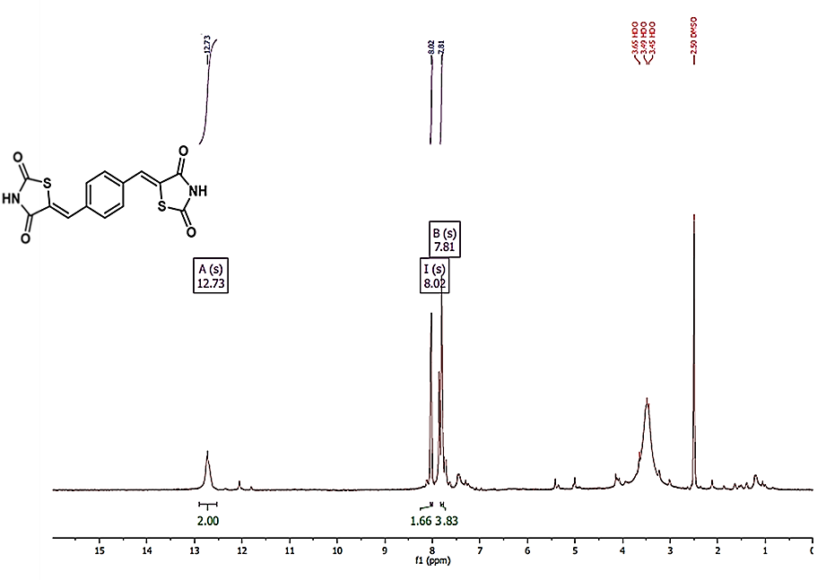
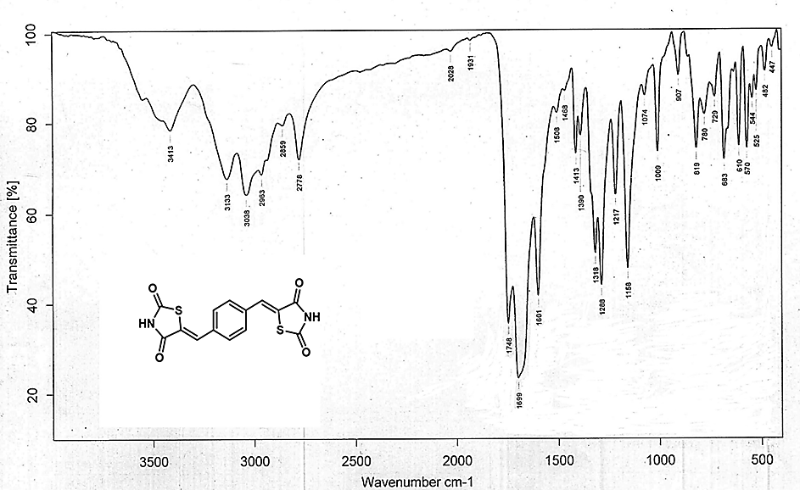

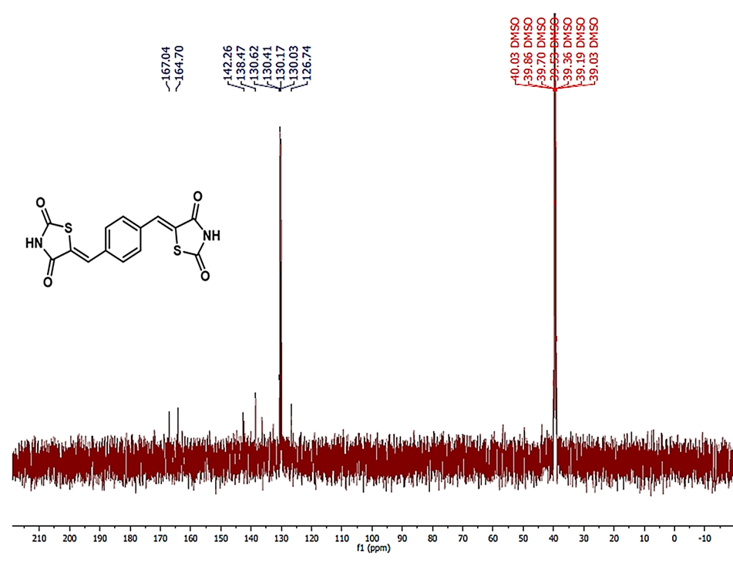
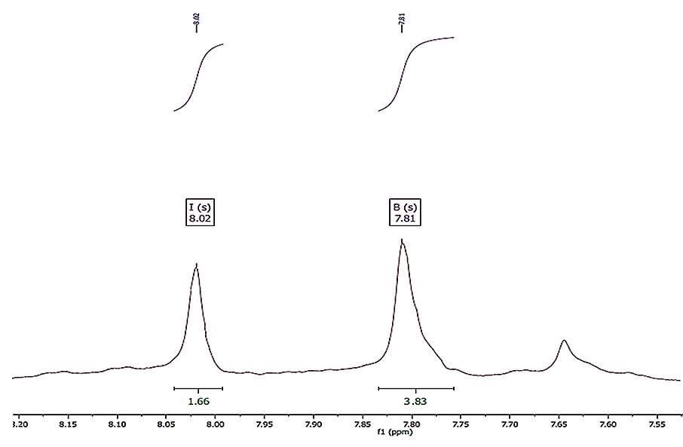
5,5′‐(1,4‐Phenylene)bis(imidazolidine‐2,4‐dione)--(2)
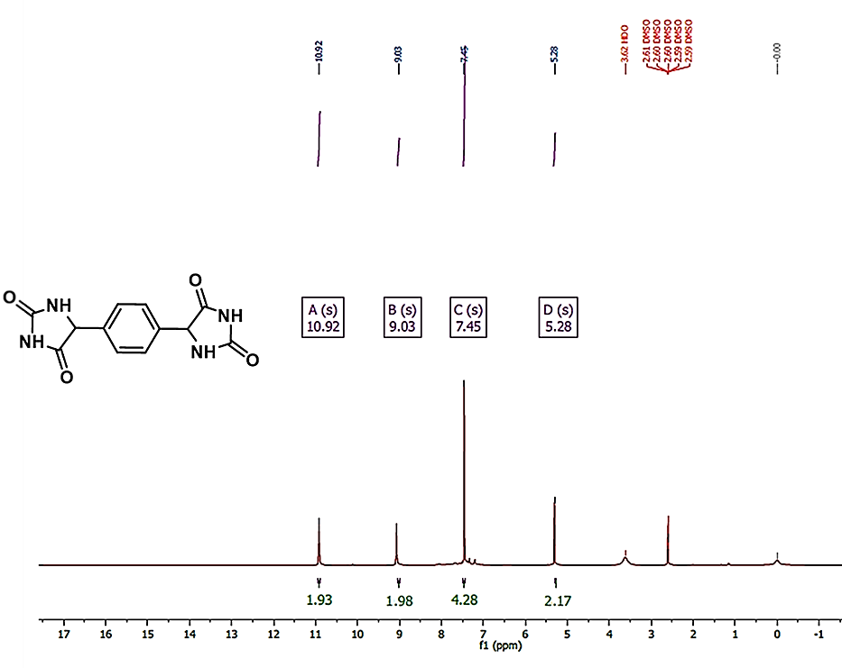
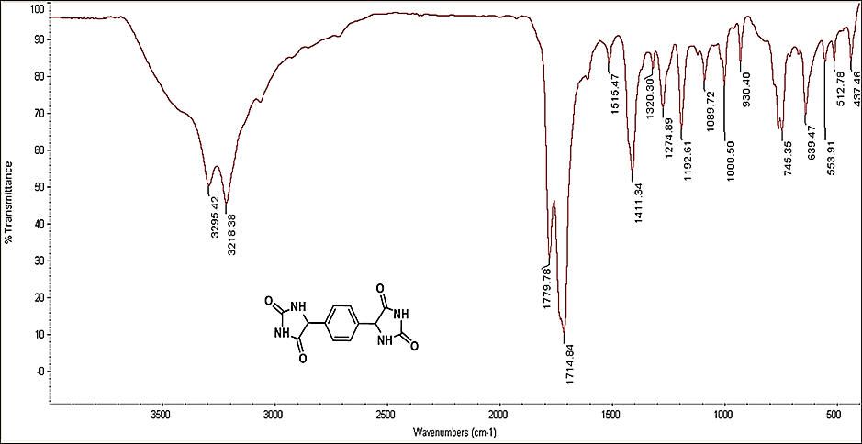

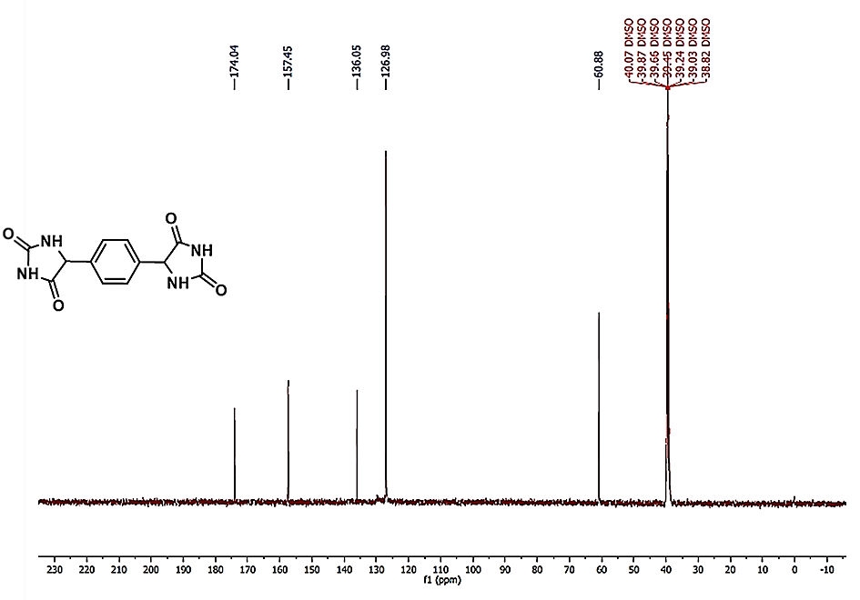
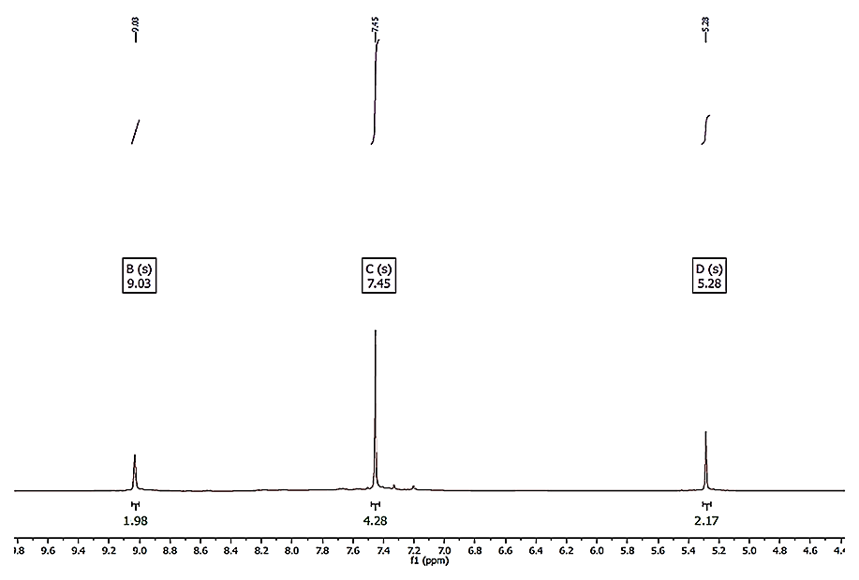

FT-IR, ¹H and ¹³C NMR data for products 4(a-b):
5,5'-((hexane-1,6-diylbis(oxy))bis(2,1-phenylene))bis(imidazolidine-2,4-dione)-- (4a)
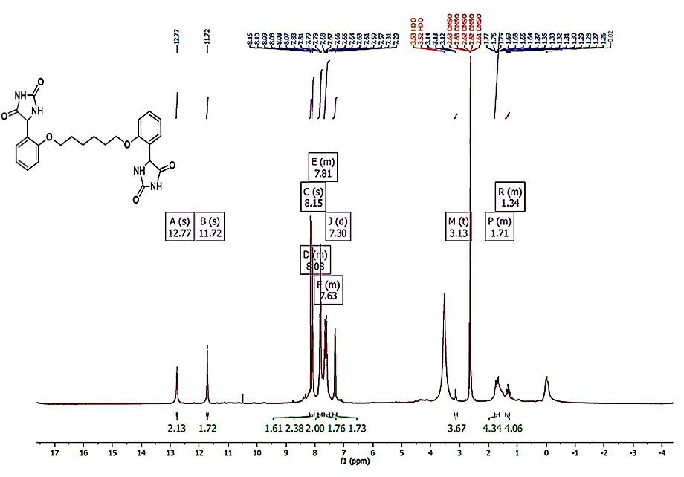
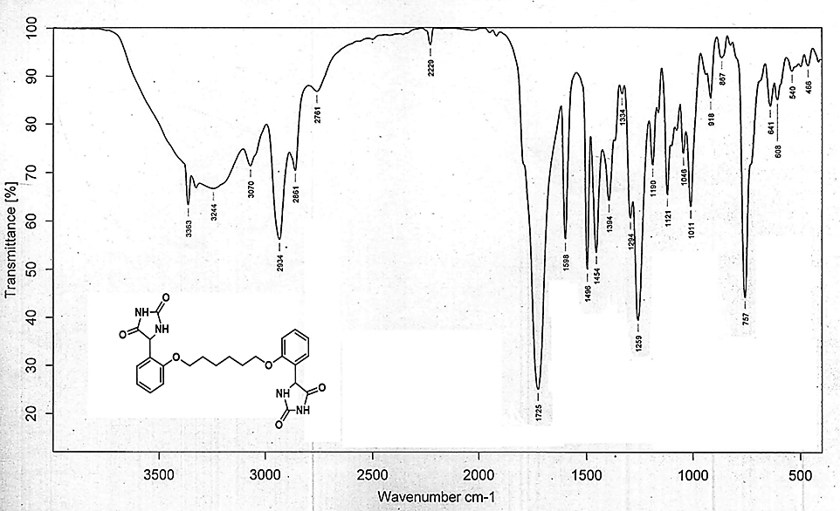
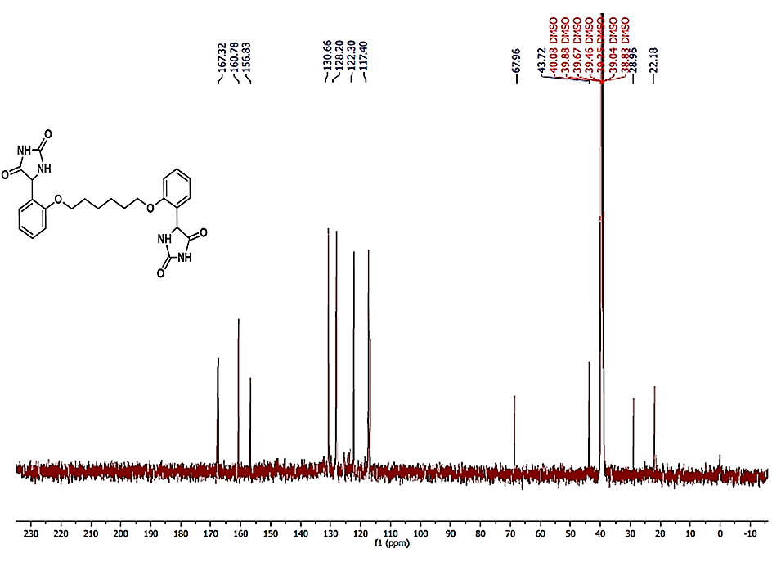
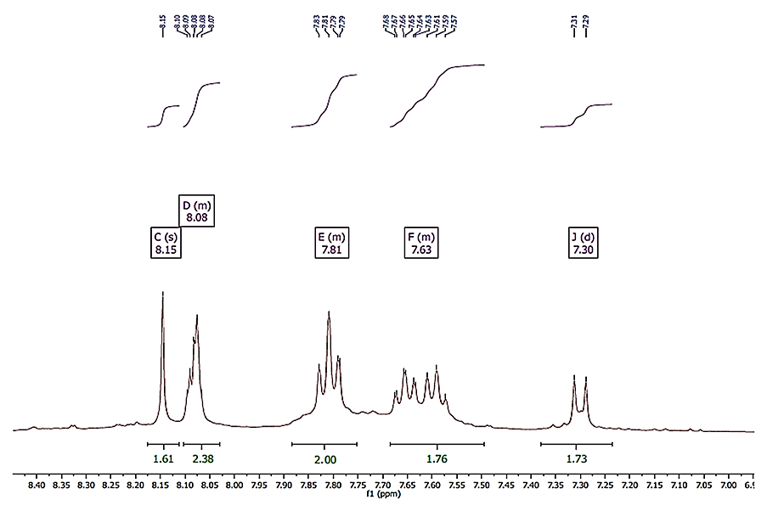
5,5'-((butane-1,4-diylbis(oxy))bis(4,1-phenylene))bis(imidazolidine-2,4-dione)-- (4b)
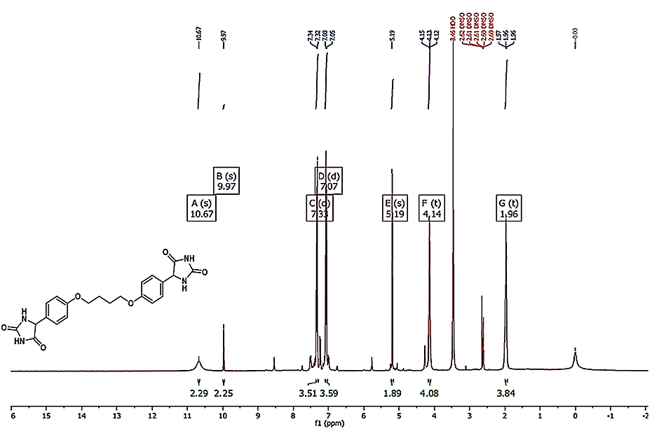
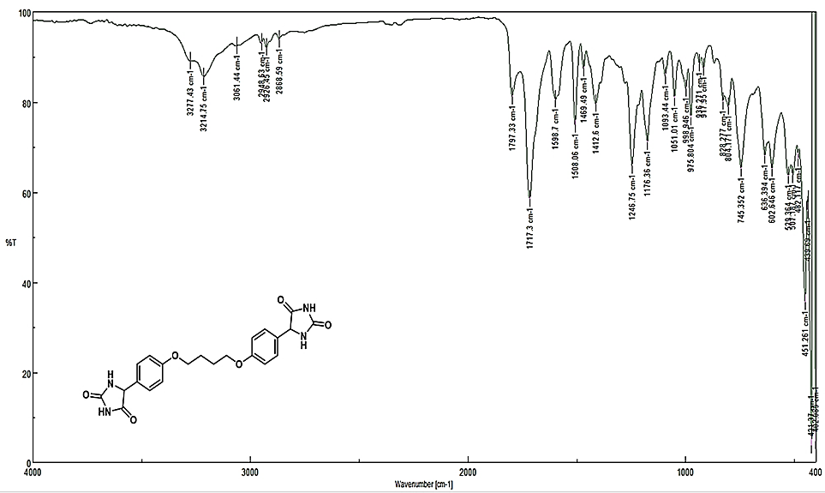

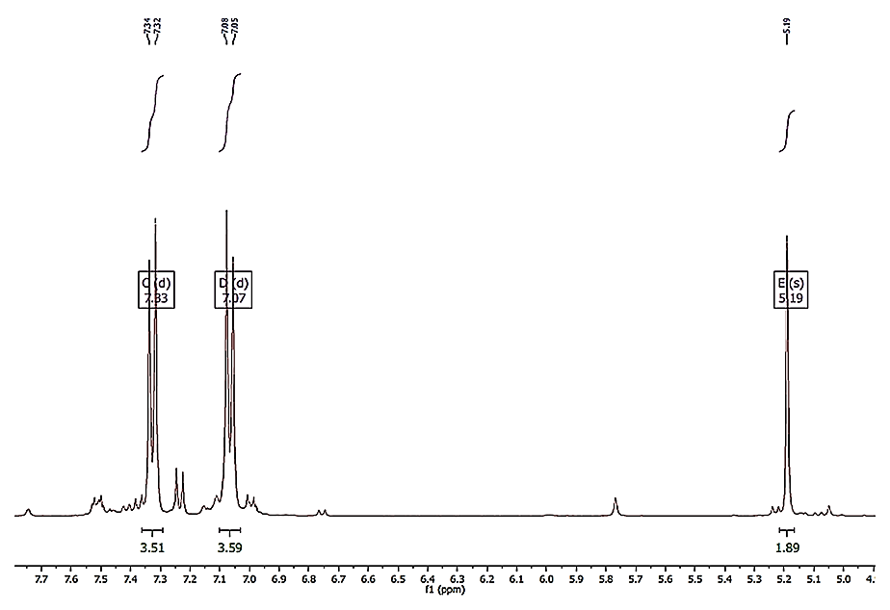
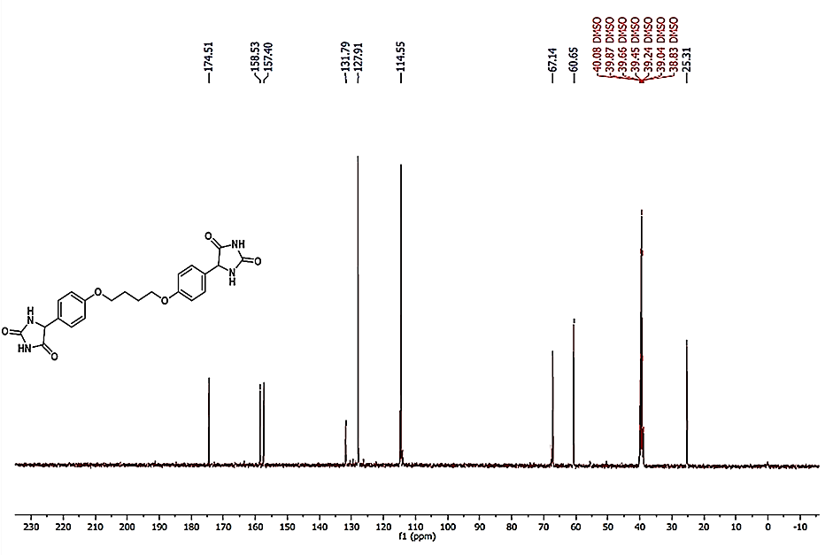

FT-IR, ¹H and ¹³C NMR data for products 5(a-c):
(5Z,5'Z)-5,5'-(((hexane-1,6-diylbis(oxy))bis(2,1-phenylene))bis(methaneylylidene))bis(thiazolidine-2,4-dione)-- (5a)
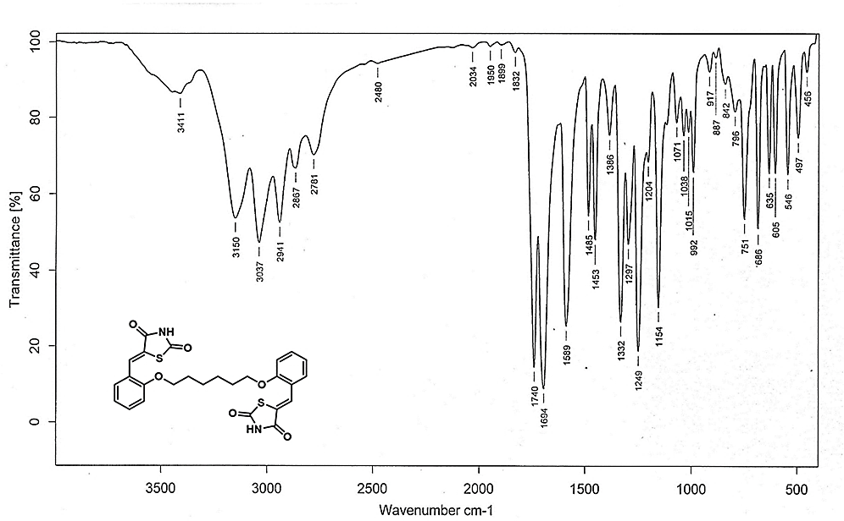
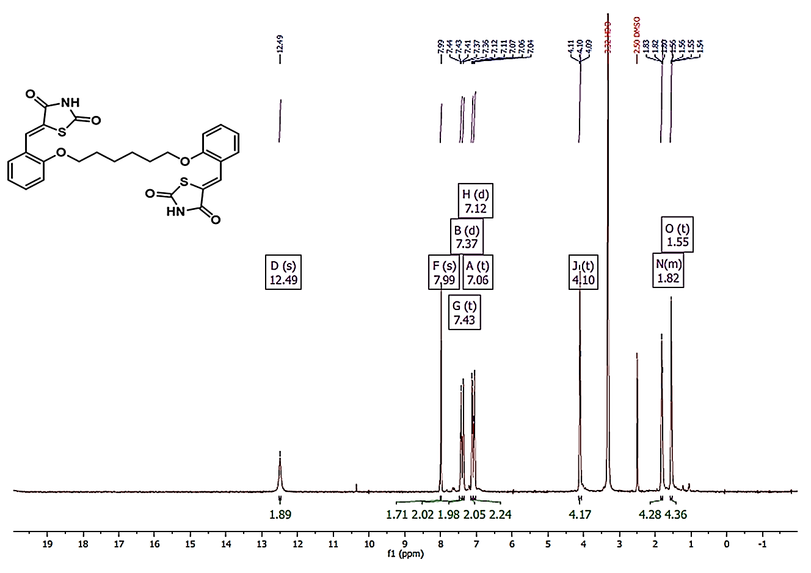
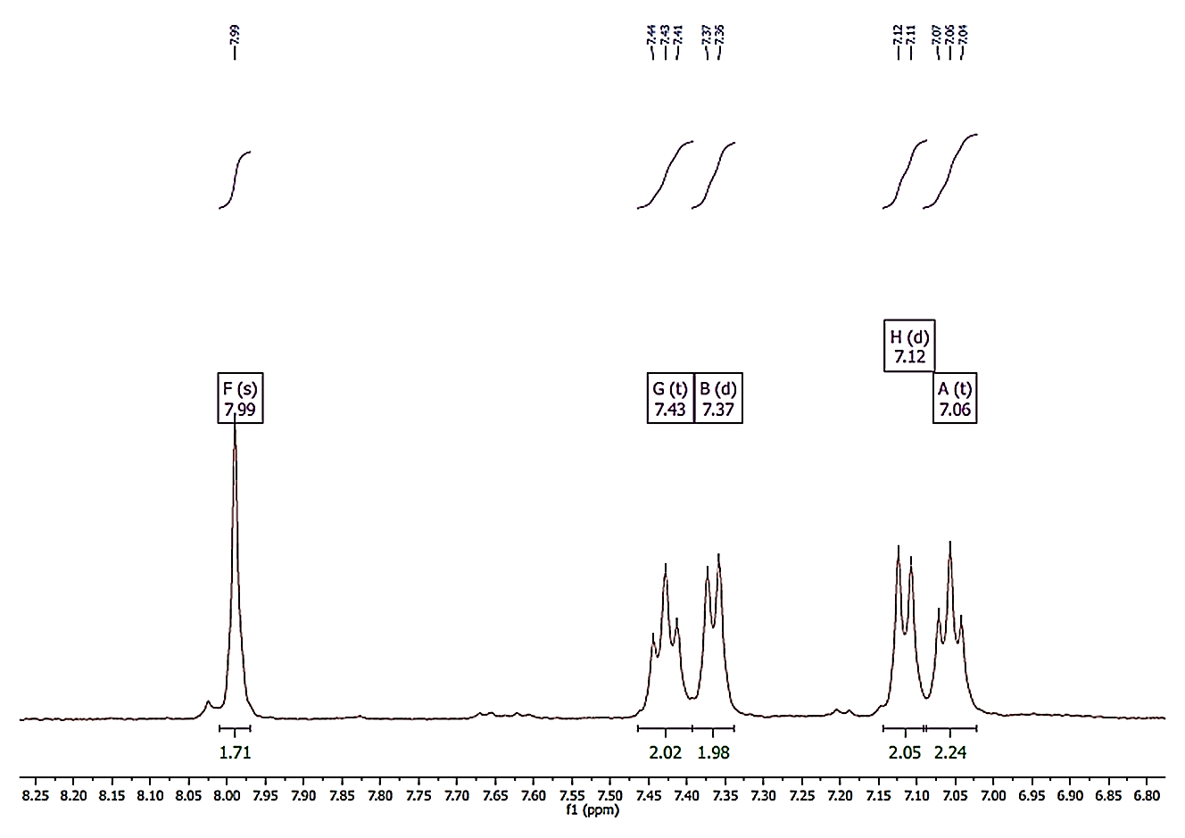
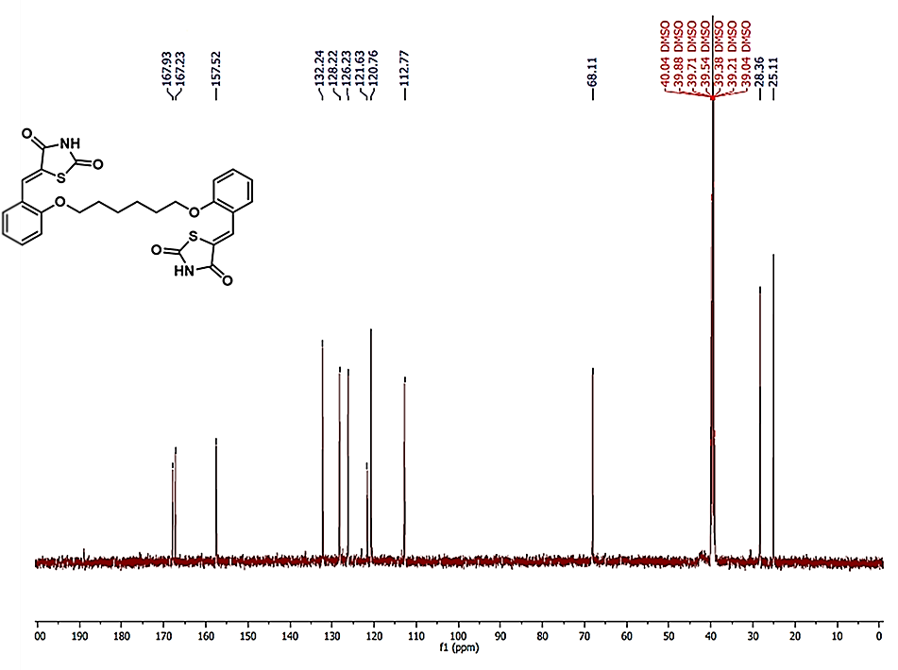
(5Z,5'E)-5,5'-(((butane-1,4-diylbis(oxy))bis(4,1-phenylene))bis(methaneylylidene))bis(thiazolidine-2,4-dione)-- (5b)
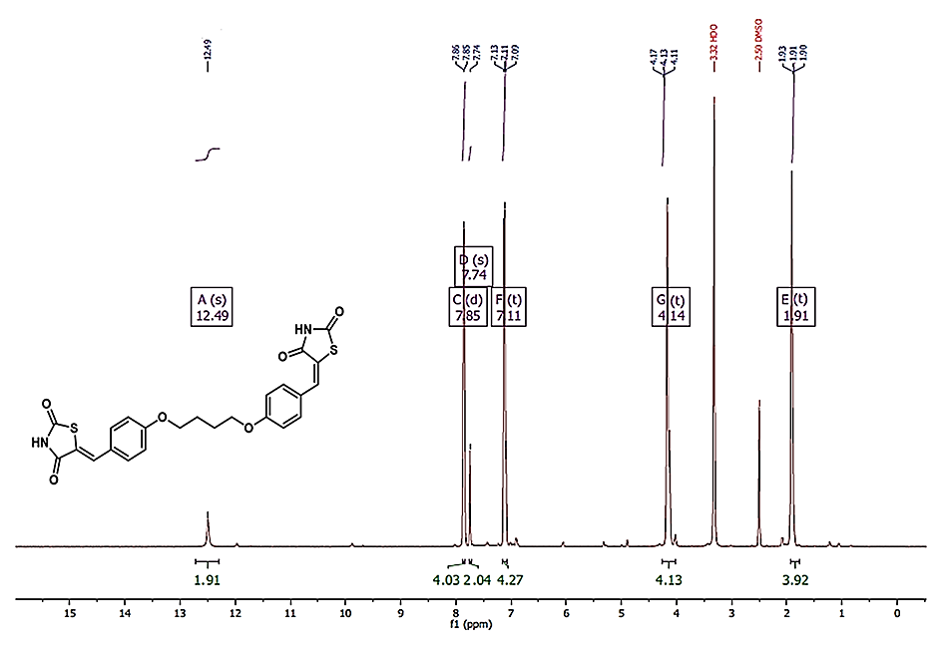
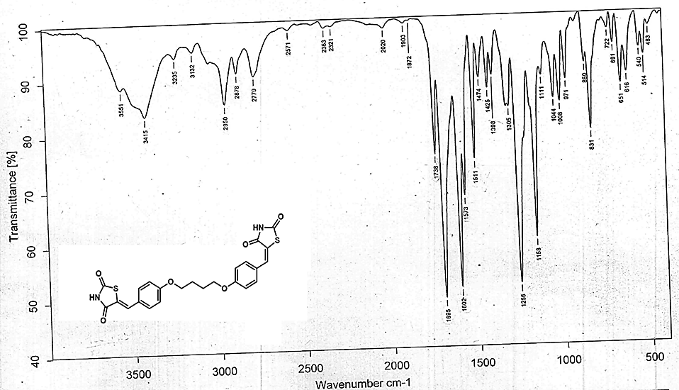
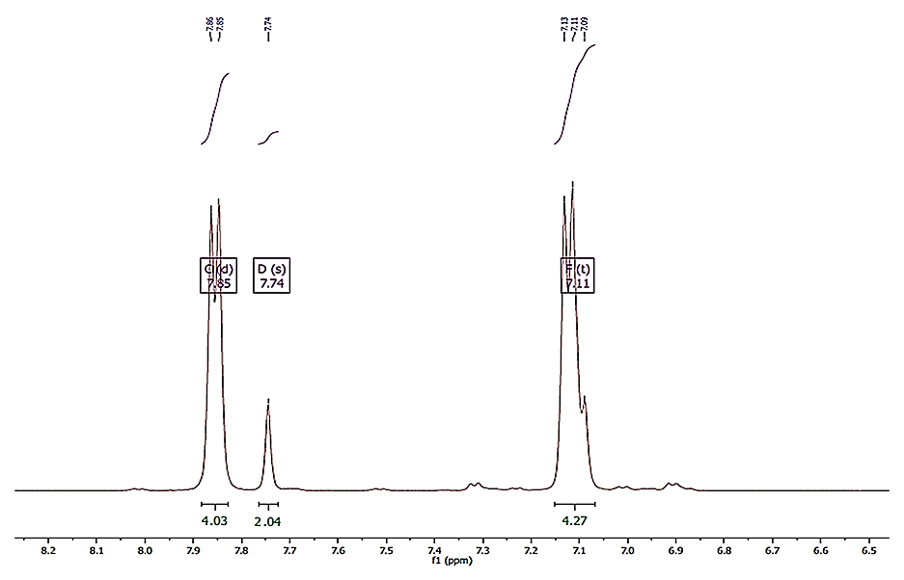
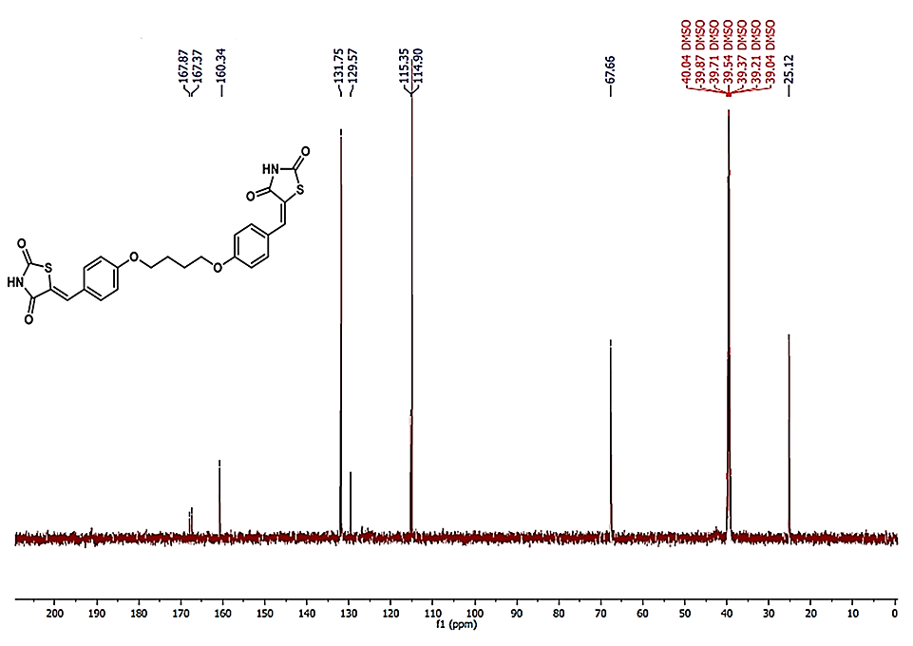
(5Z,5'Z)-5,5'-((((1,4-phenylenebis(methylene))bis(oxy))bis(4,1-phenylene))bis(methaneylylidene))bis(thiazolidine-2,4-dione)-- (5c)
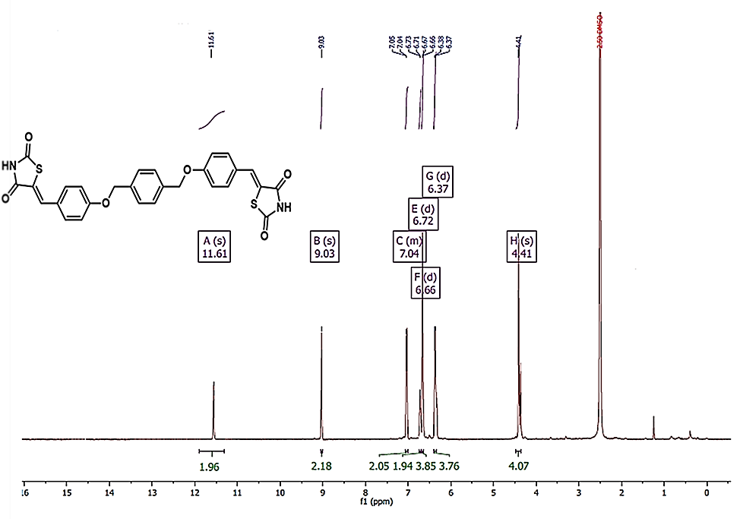
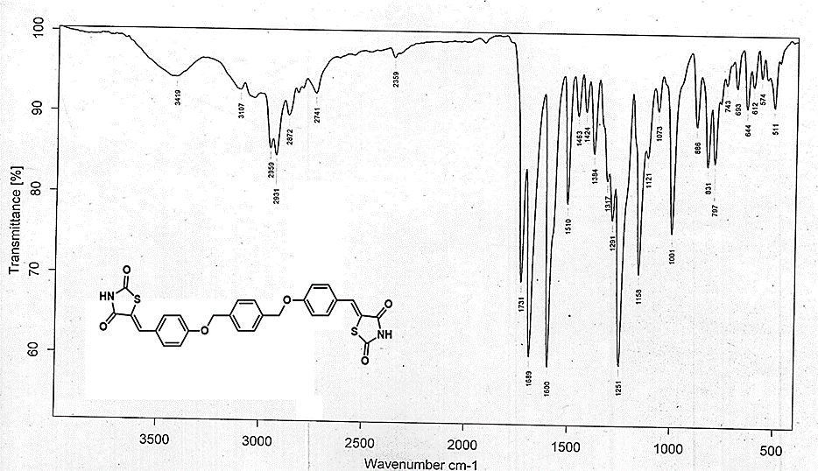

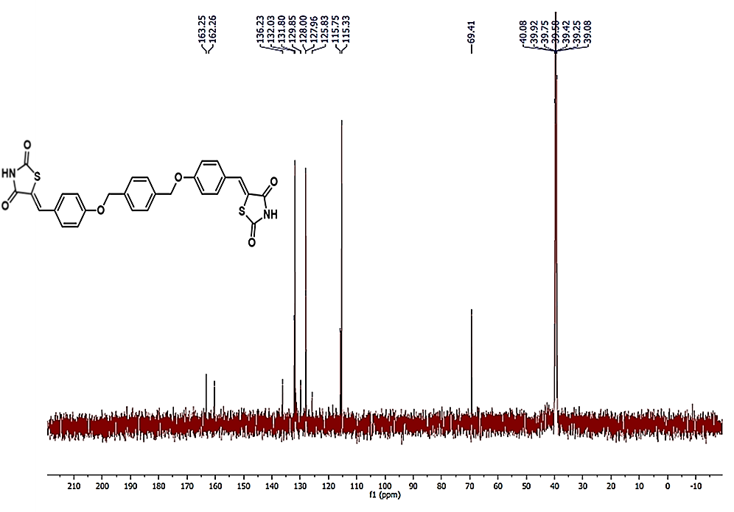
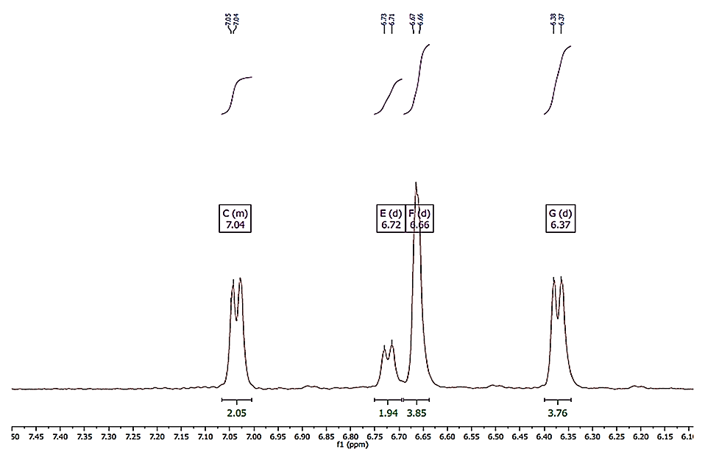

FT-IR, ¹H and ¹³C NMR data for products HP and 6:
5-(4-hydroxyphenyl)-5-phenylimidazolidine-2,4-dione --(HP)
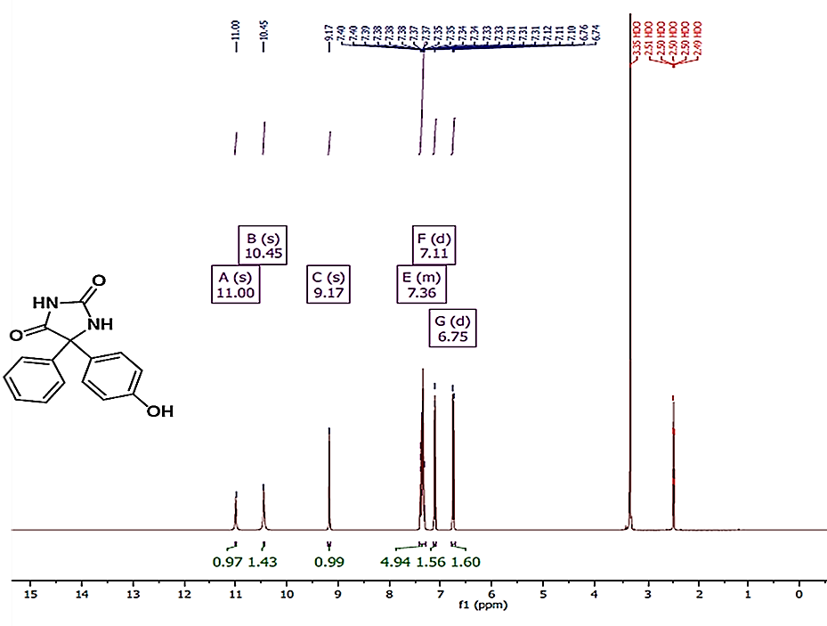
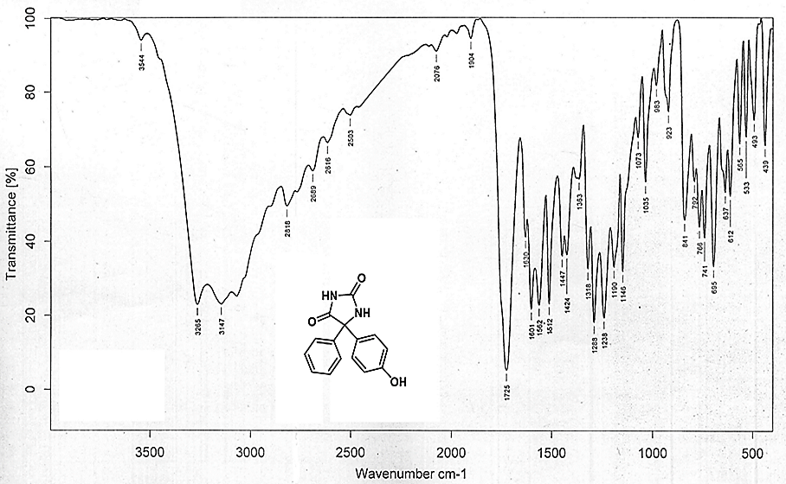

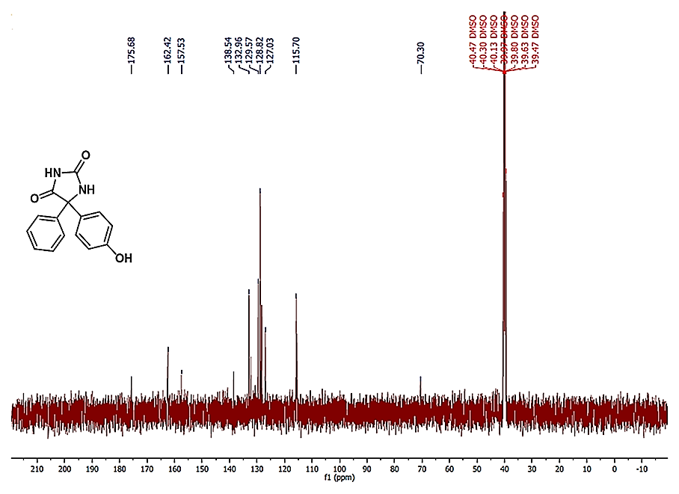
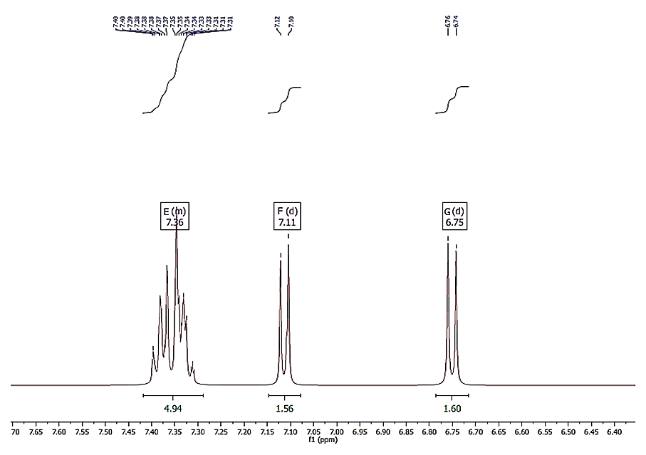

5,5'-(((1,4-phenylenebis(methylene))bis(oxy))bis(4,1-phenylene))bis(5-phenylimidazolidine-2,4-dione)-- (6)
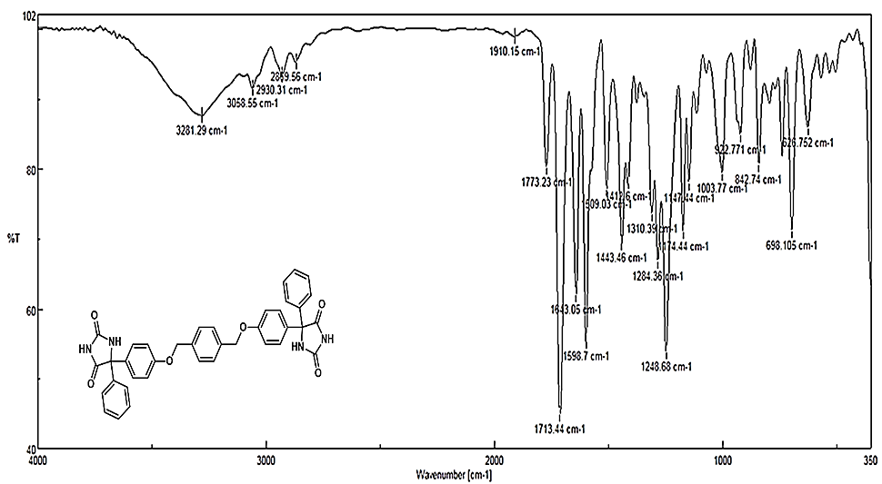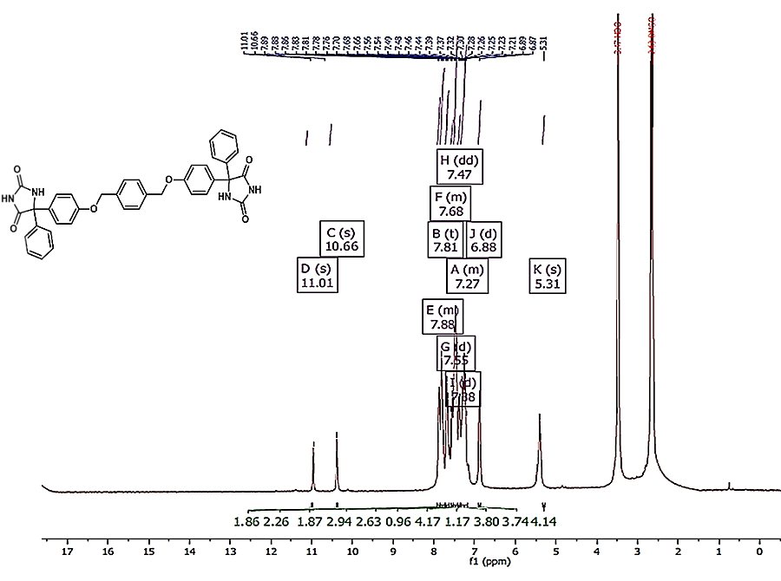
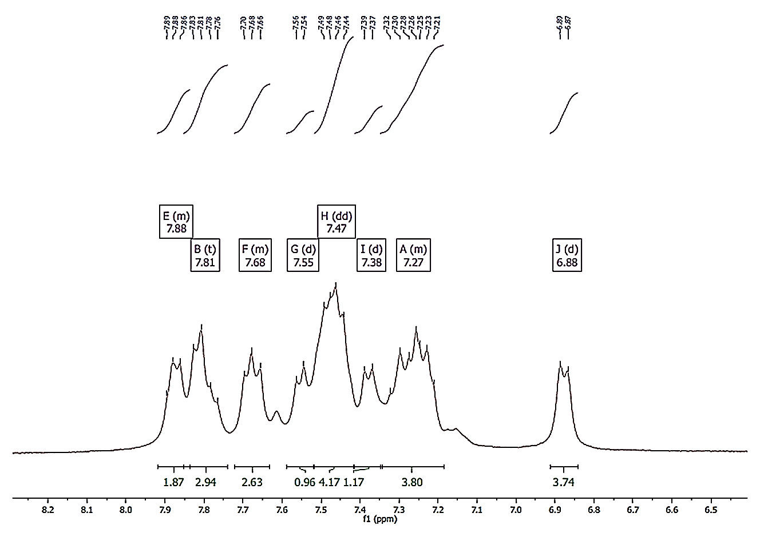
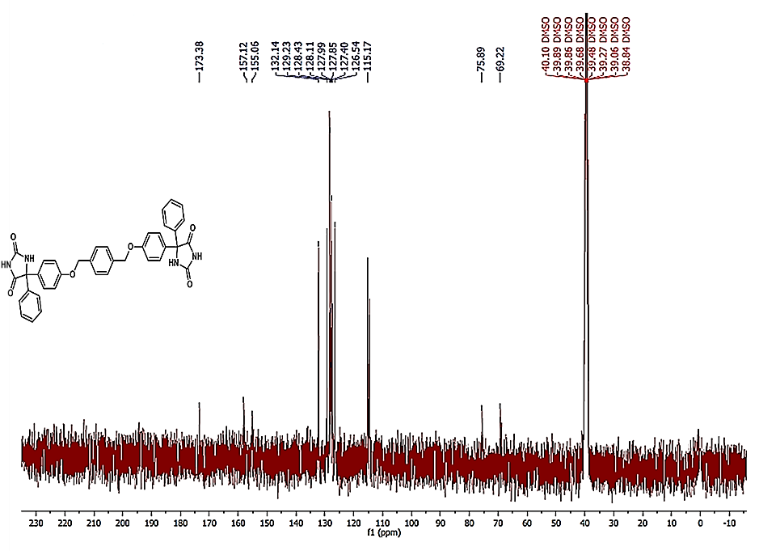

FT-IR, ¹H and ¹³C NMR data for products Tris-TZD and Tris-IMID:
4,4',4''-((1,3,5-Triazine-2,4,6-triyl)tris(oxy))tribenzaldehyde-- (Tris-ALD)
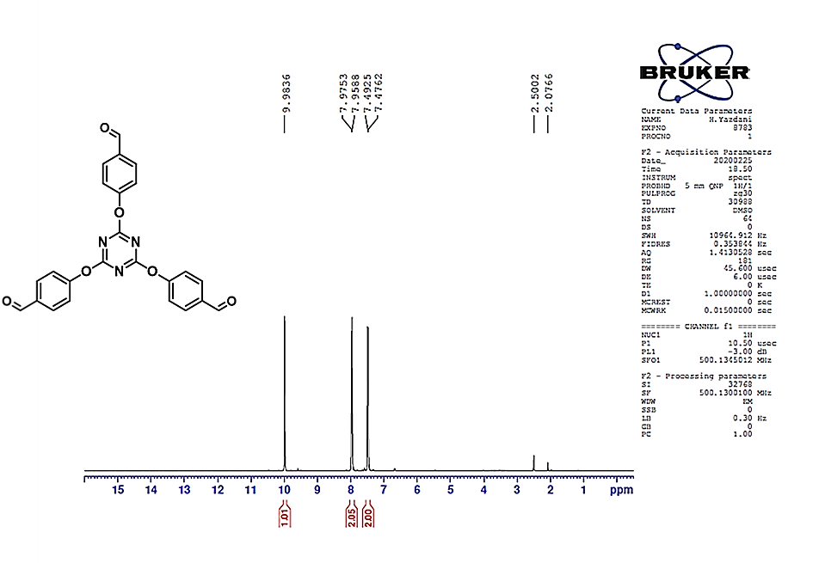
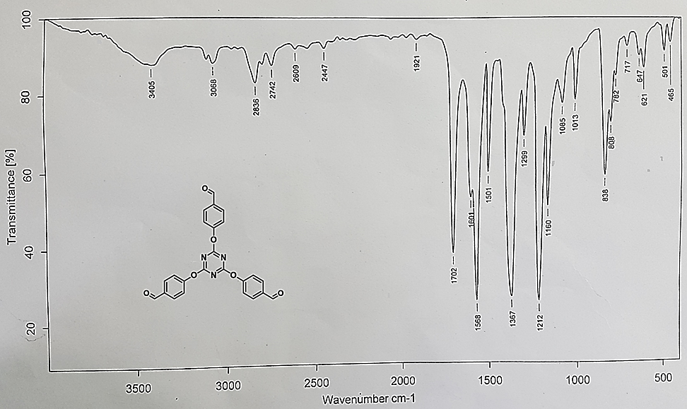

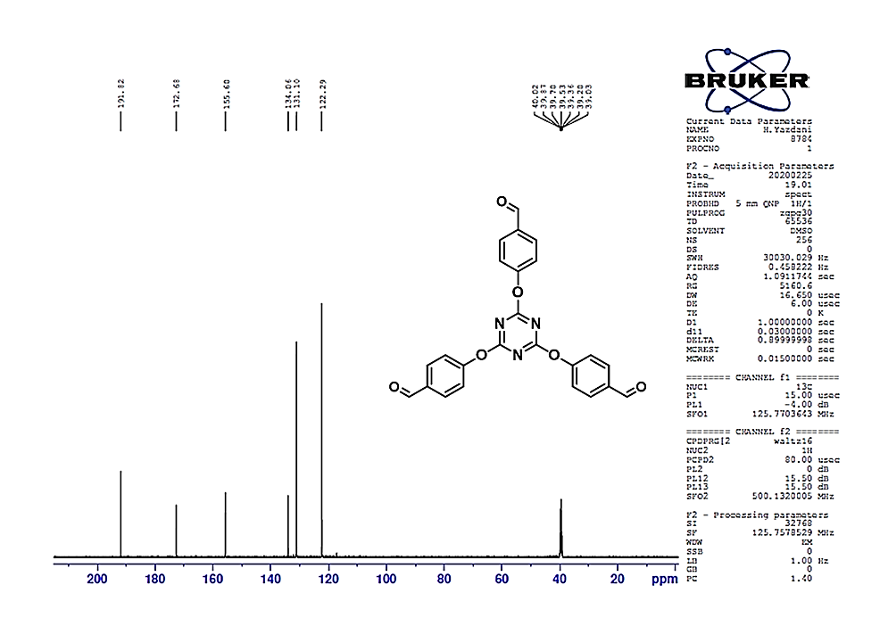
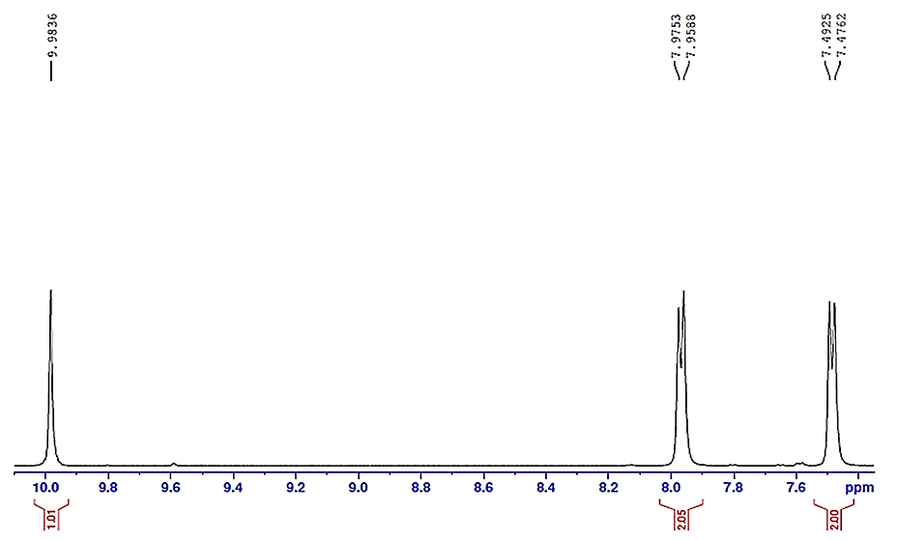

5,5',5''-(((1,3,5-triazine-2,4,6-triyl)tris(oxy))tris(benzene-4,1-diyl))tris(imidazolidine-2,4-dione)-- (7)
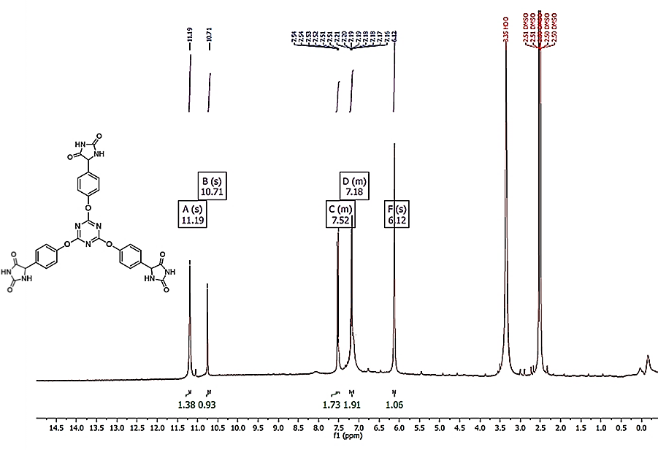
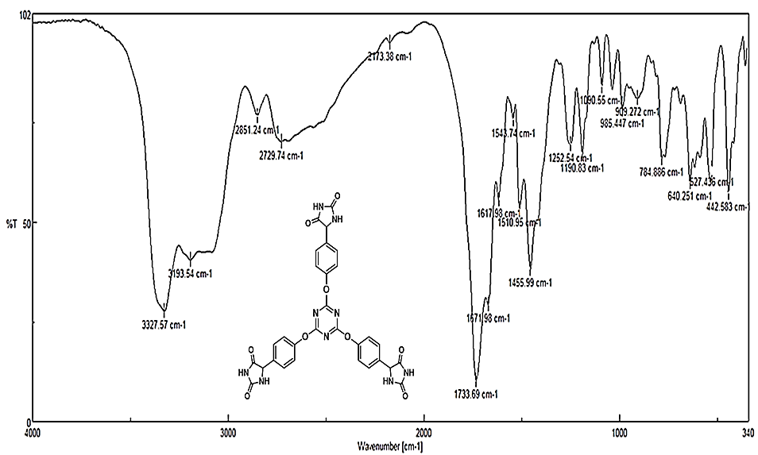

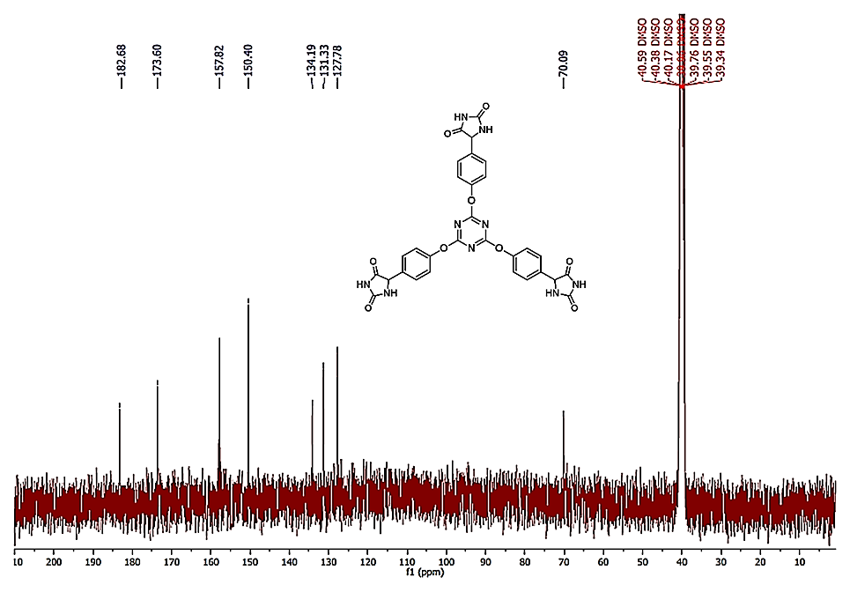
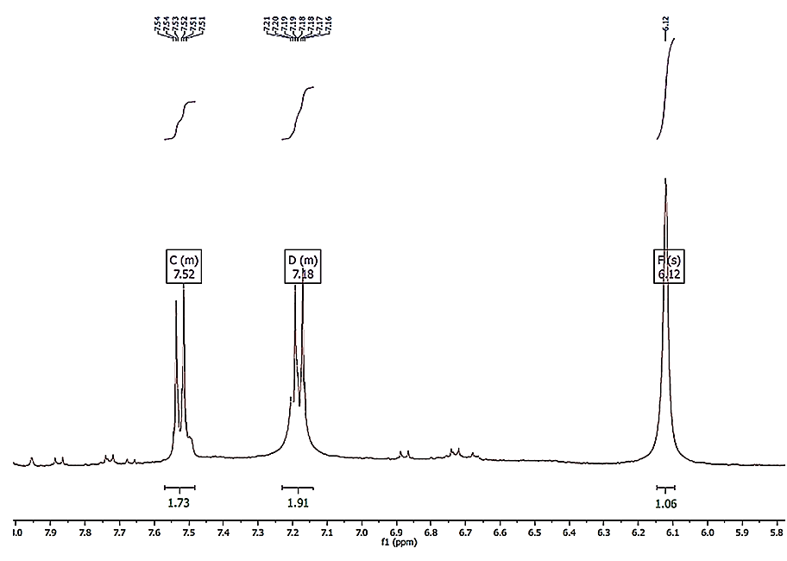

(5,5',5''-((((1,3,5-Triazine-2,4,6triyl)tris(oxy))tris(benzene-4,1-diyl))tris(methaneylylidene))tris(thiazolidine-2,4-dione))-- (8)
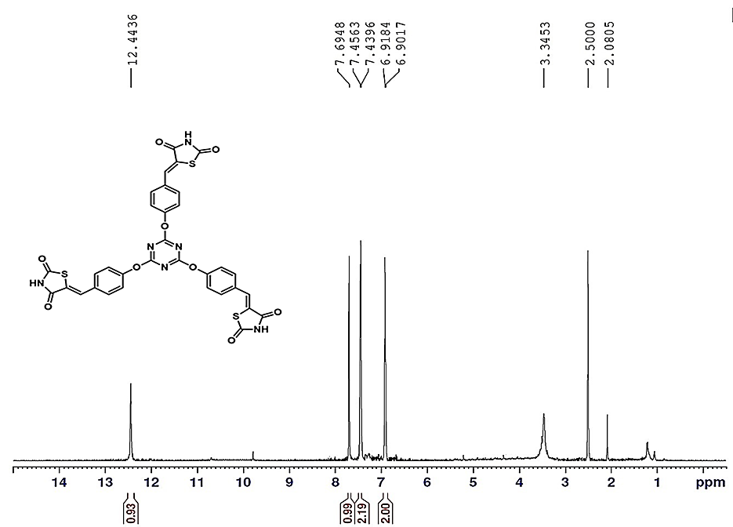
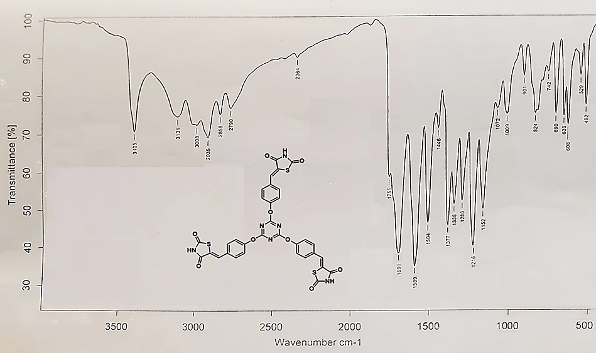

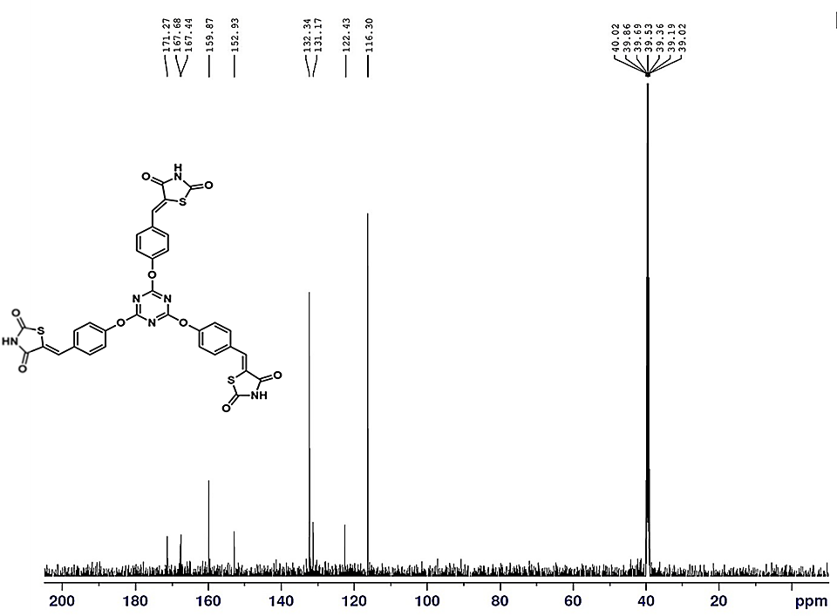
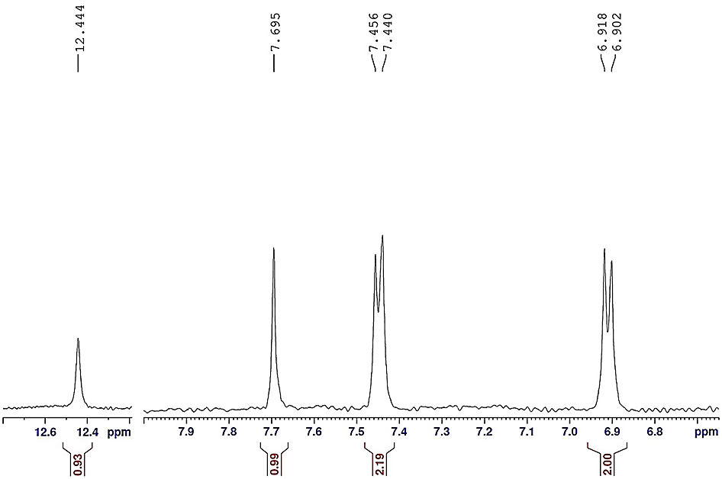

Molecular docking bonding Antibacterial
The binding mode of the ligands with the binding site of Gyrase A of E. coli (PDB ID: 1AB4)--2D, 3D and optimized structure compounds
Compound 1
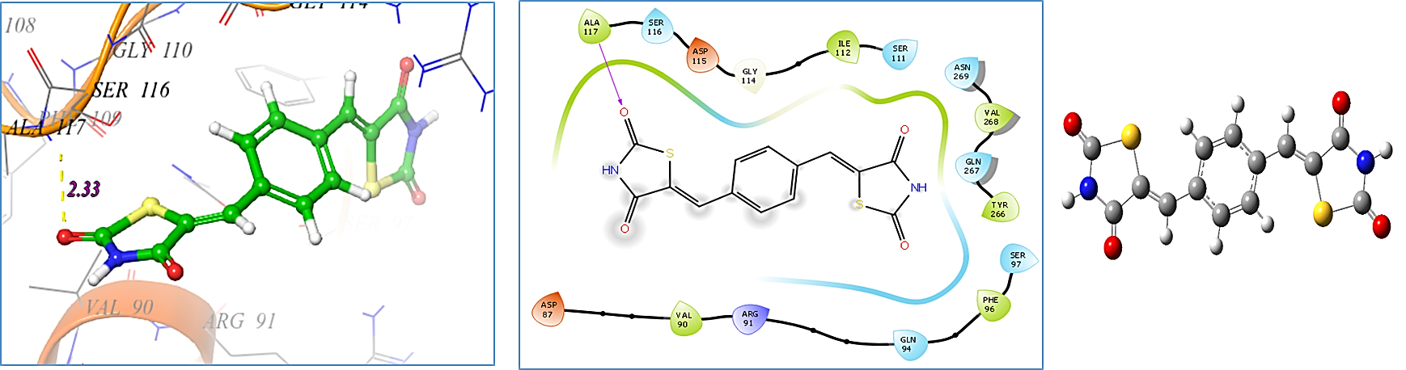
Compound 2
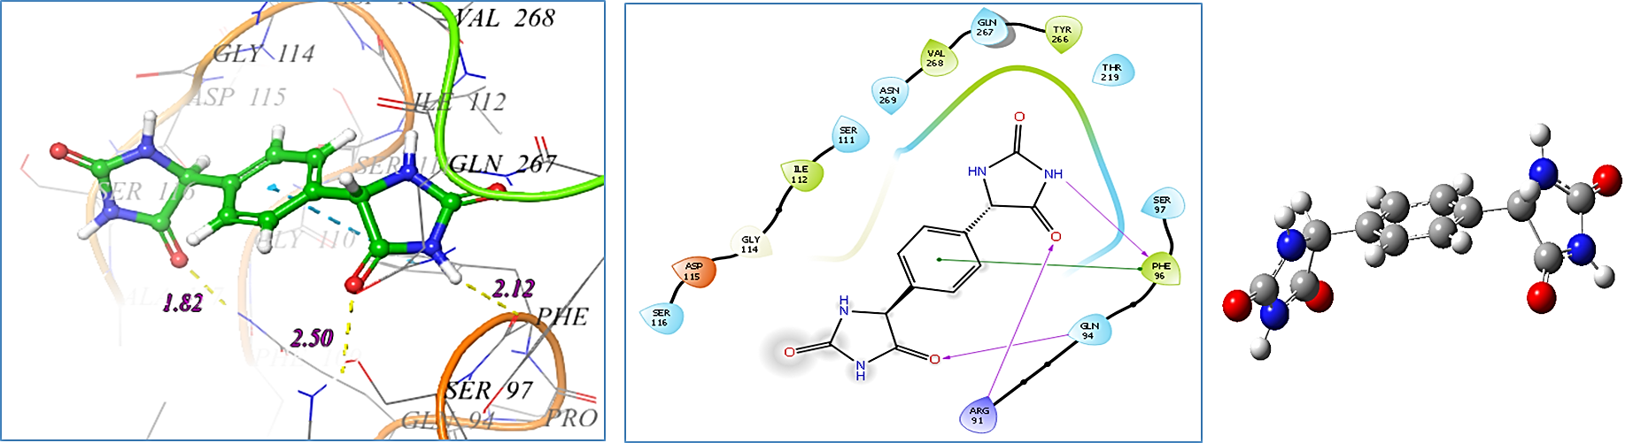
Compound 4b
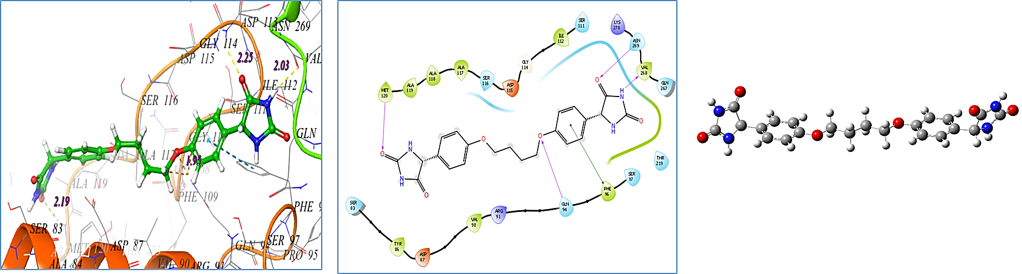
Compound 5a
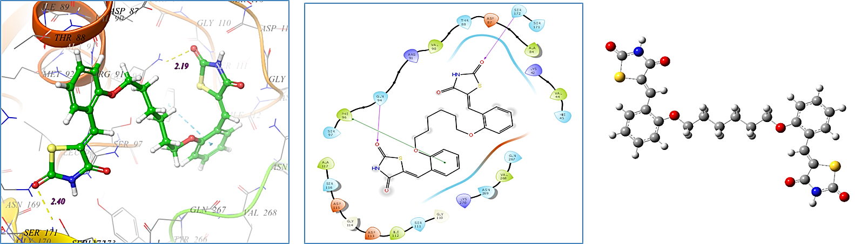
Compound 5b
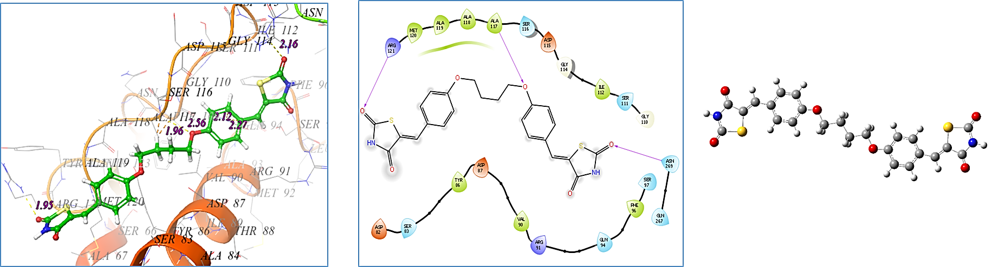
Compound 5c
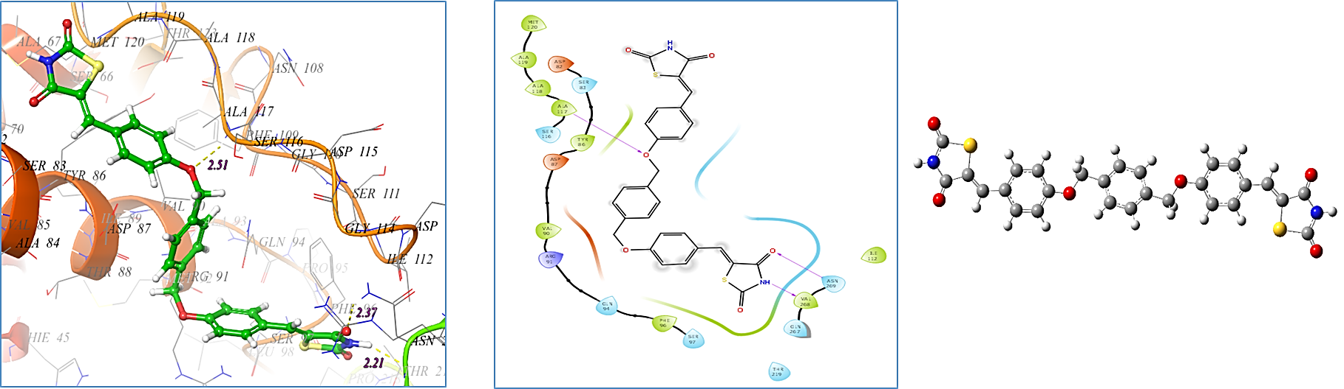

Compound 7
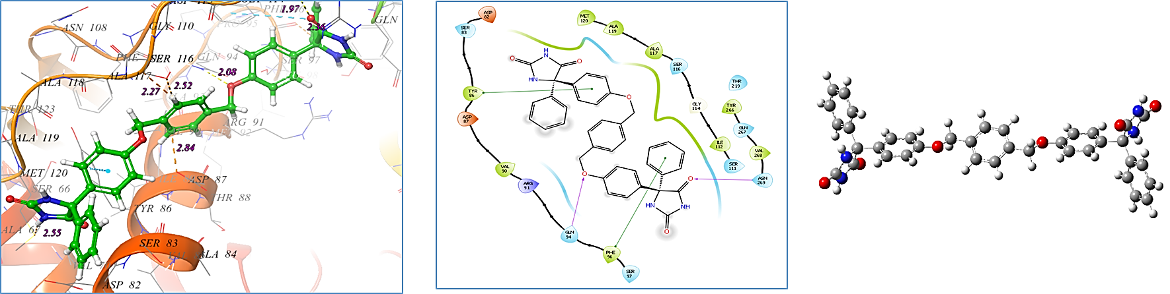
Compound 9
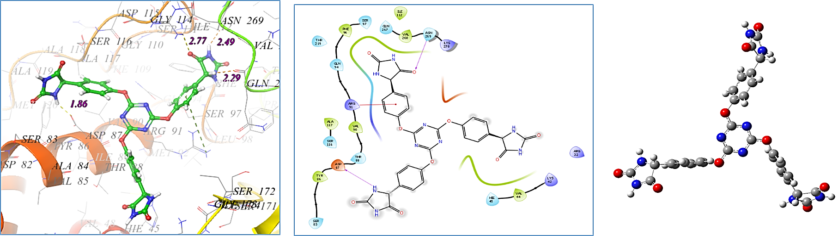
Compound 10
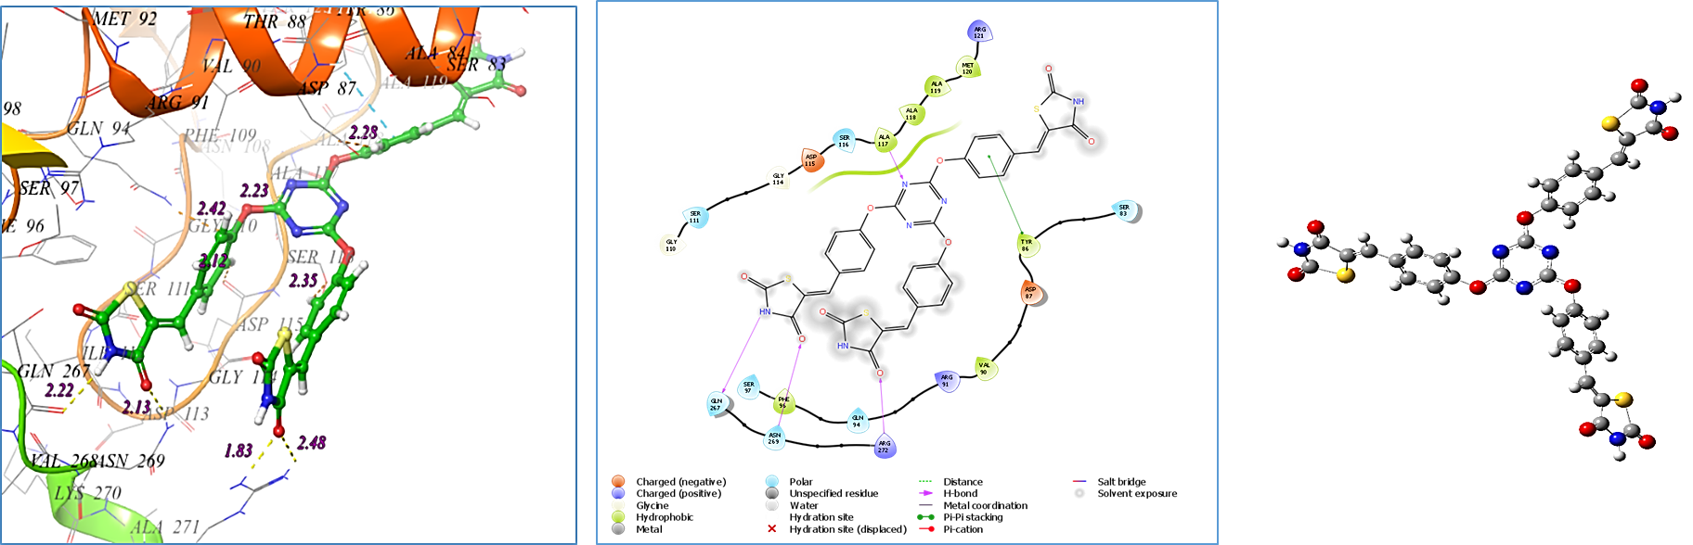

The binding mode of ligands with S. aureus (PDB ID: 3ACX) -- 2D, 3D and optimized structure compounds
Compound 1
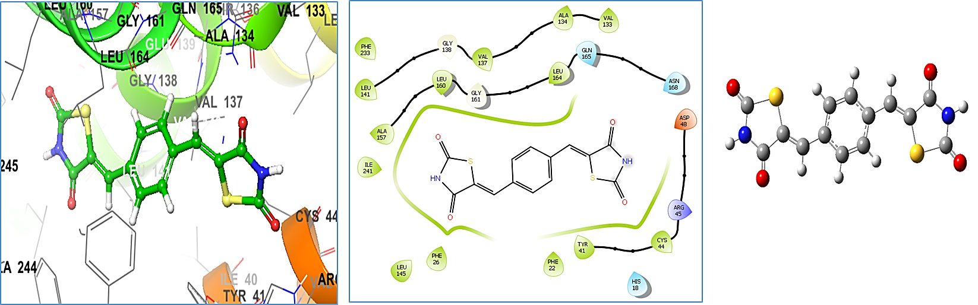
Compound 2
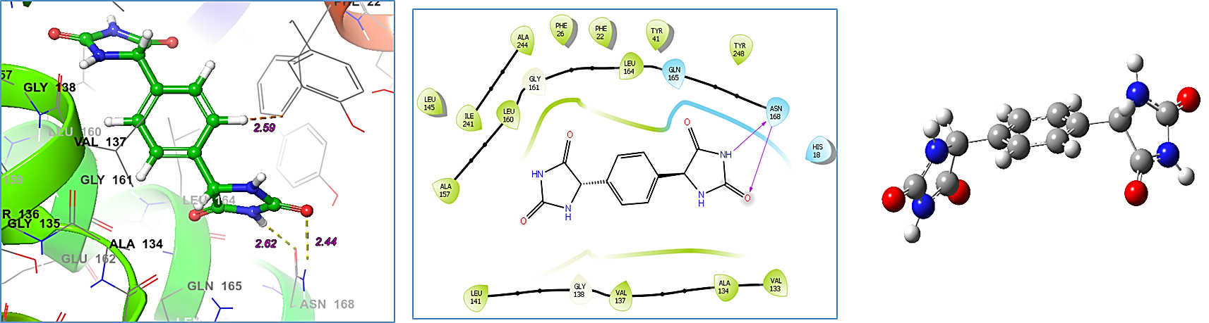
Compound 4a
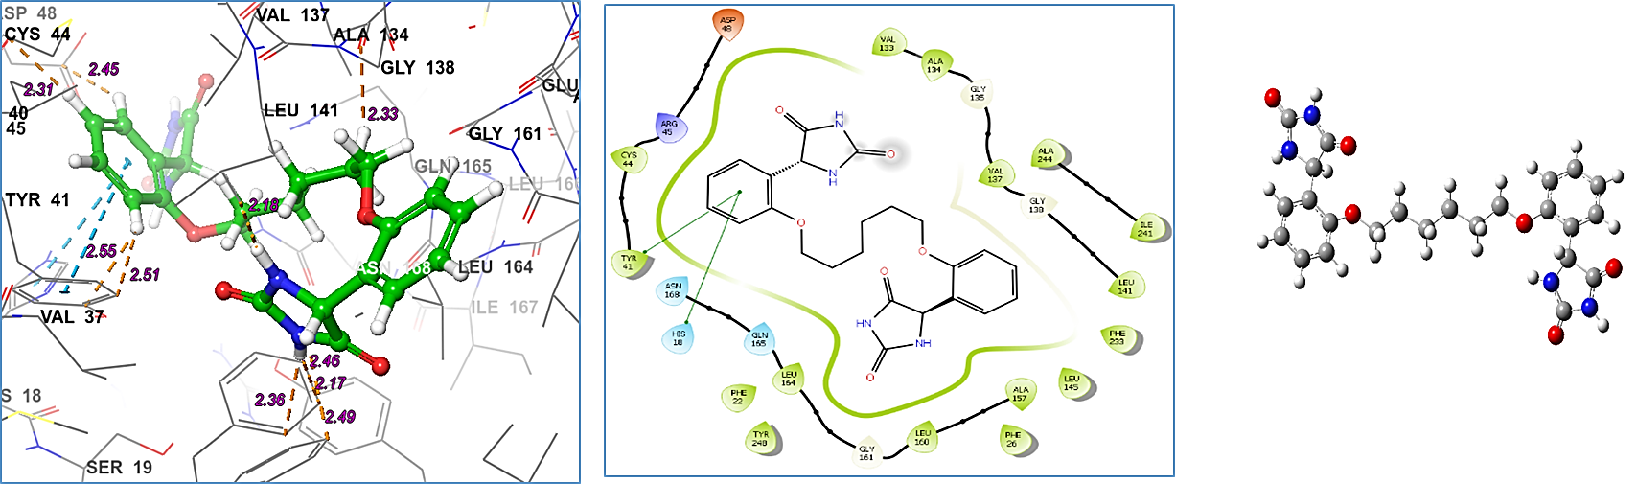
Compound 4b
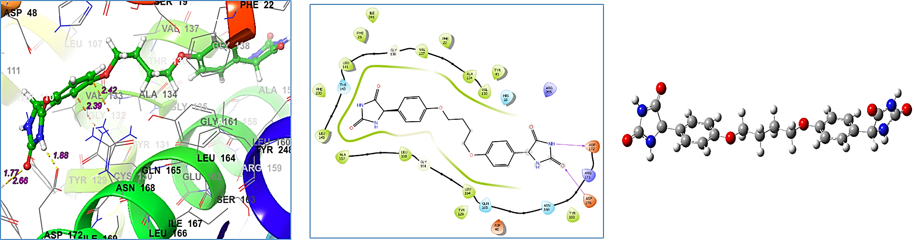
Compound 5a
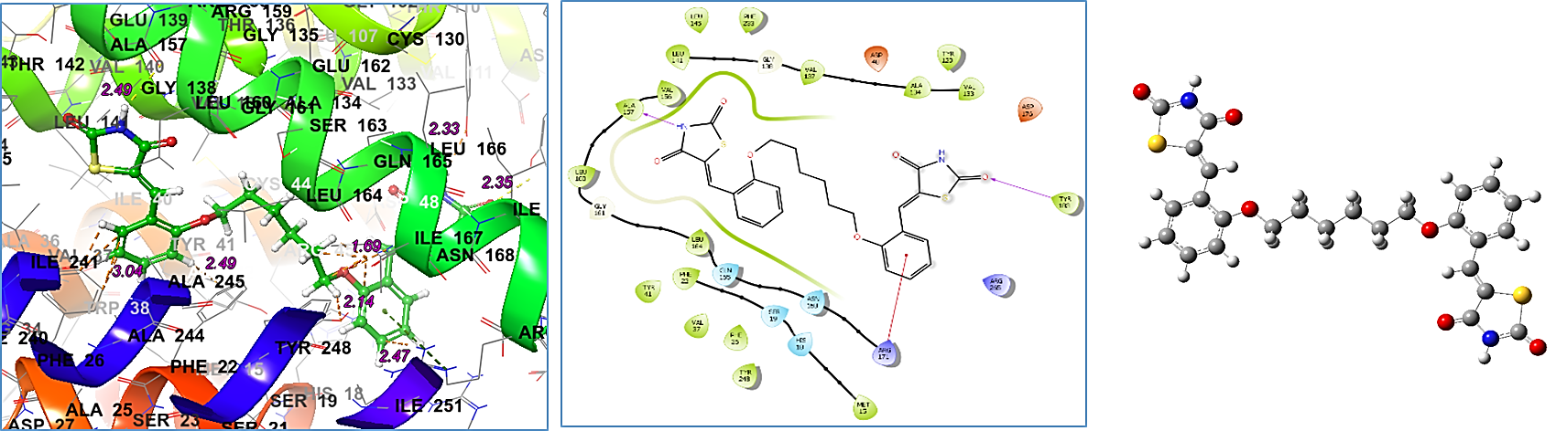
Compound 5b
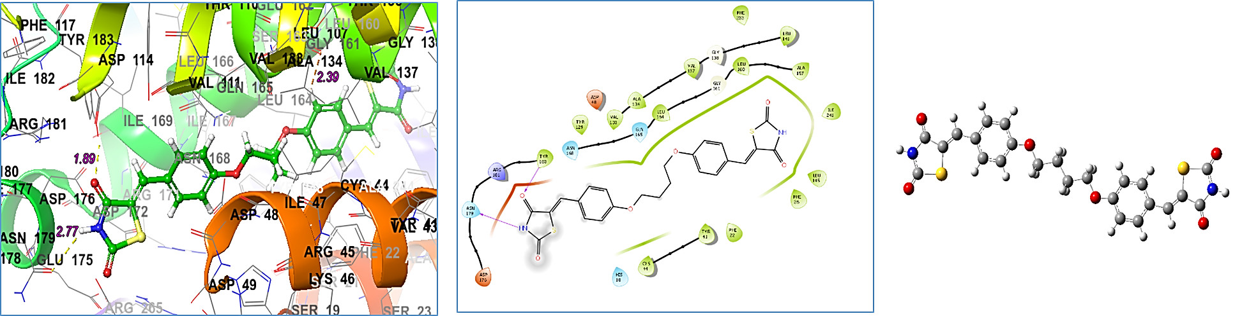

Compound 5c
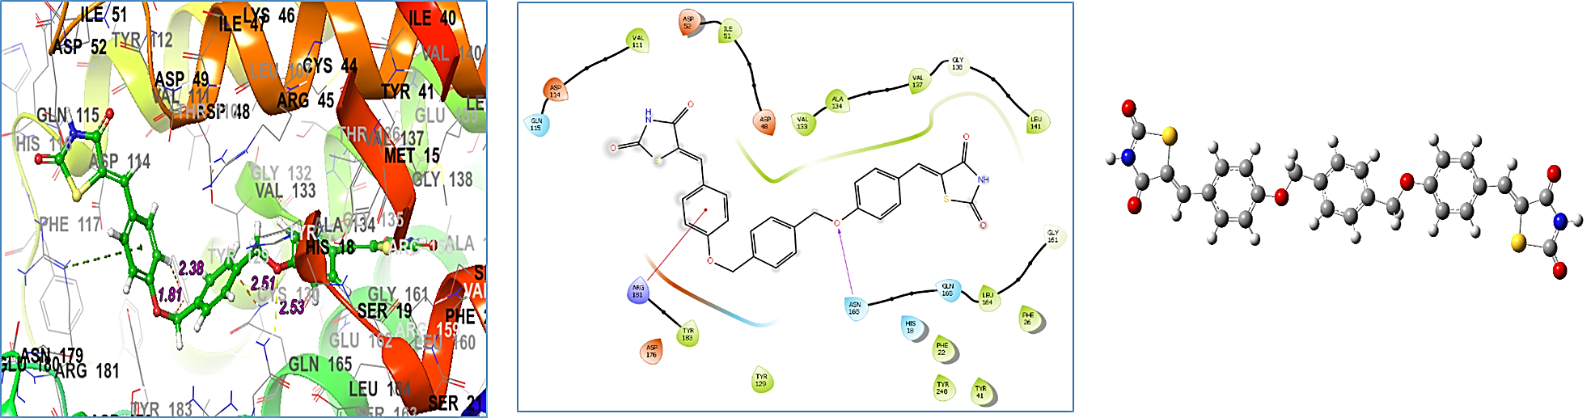
Compound 7
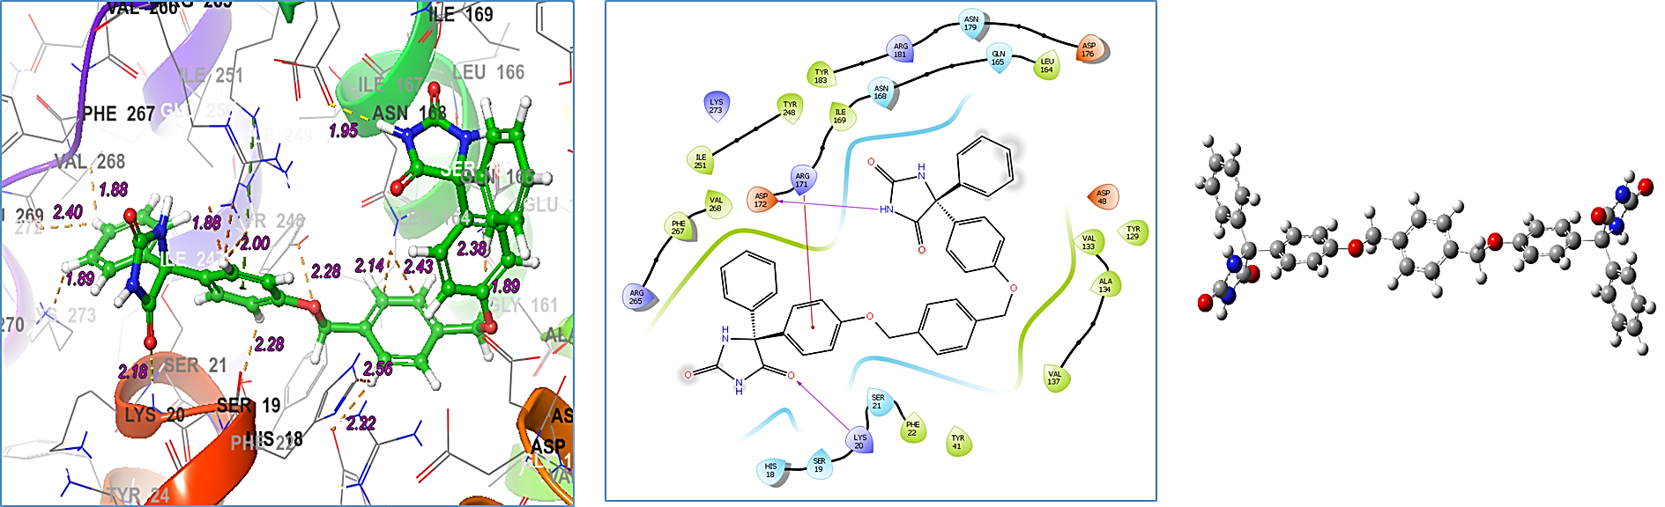
Compound 9
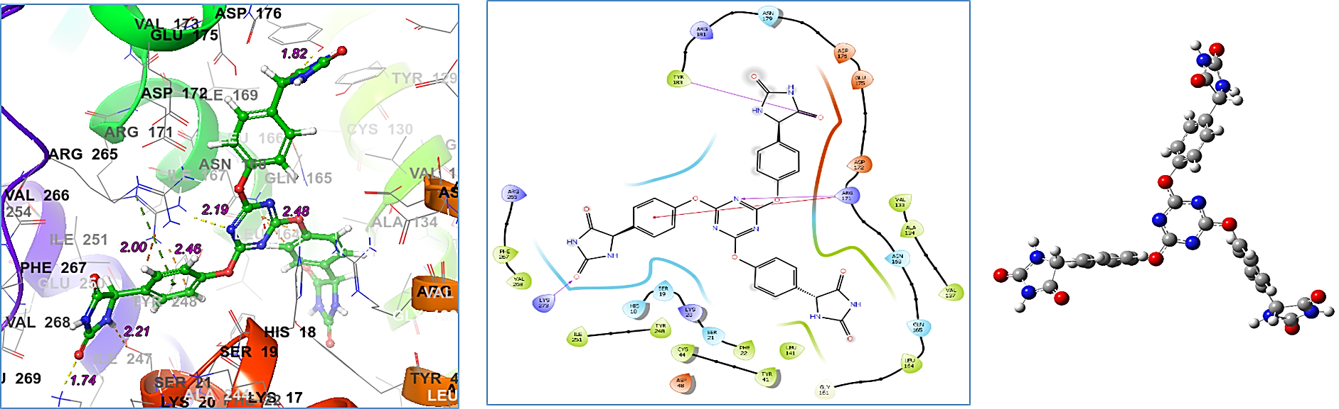
The binding mode of ligands with B. anthracis synthase (PDB ID: 3TYE) -- 2D, 3D and optimized structure compounds
Compound 1
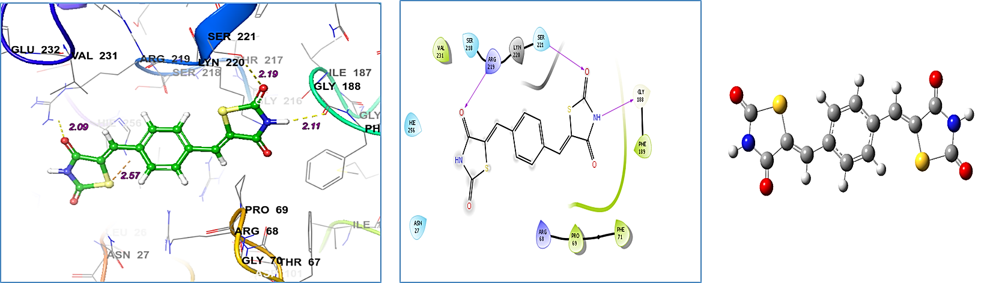
Compound 2
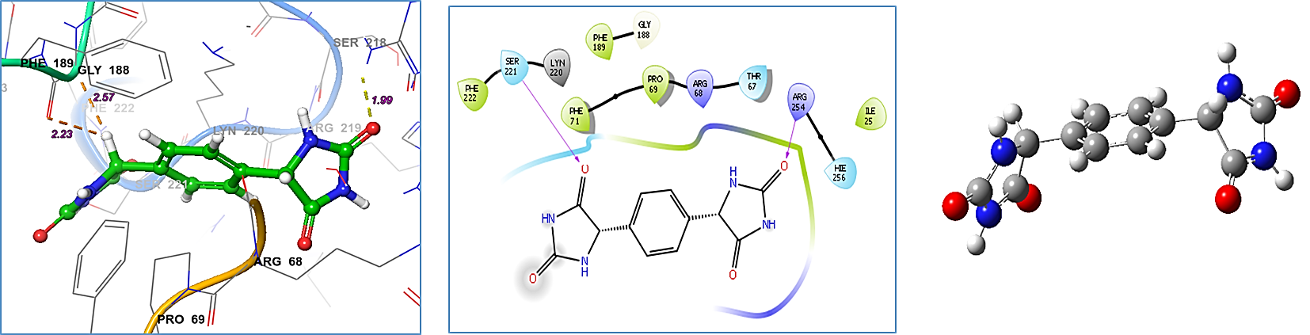
Compound 4a
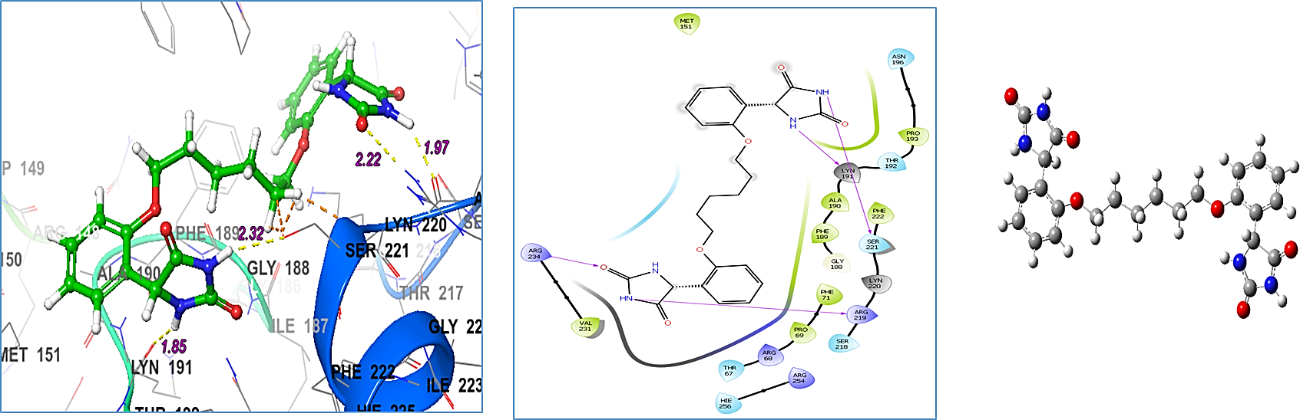
Compound 4b
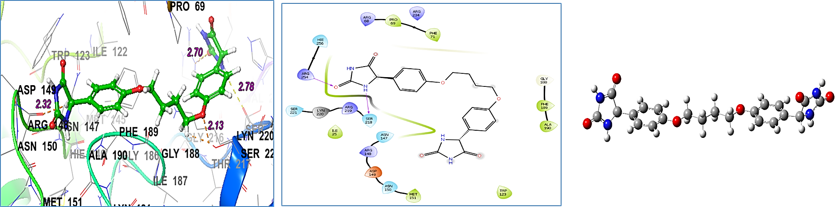
Compound 5a
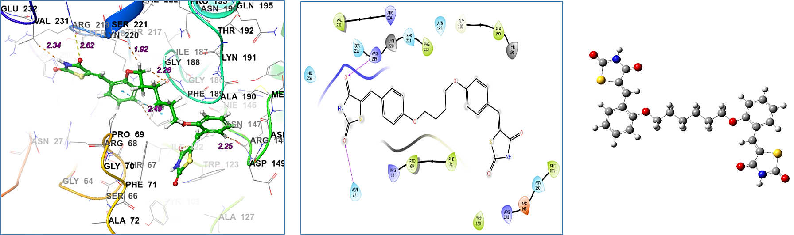
Compound 5b
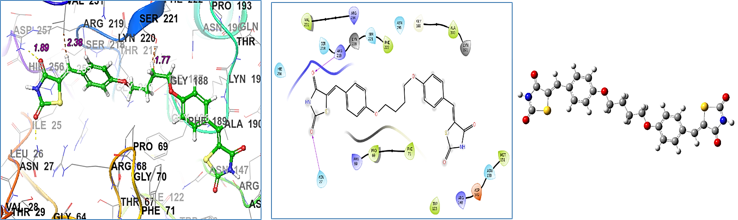

Compound 5c
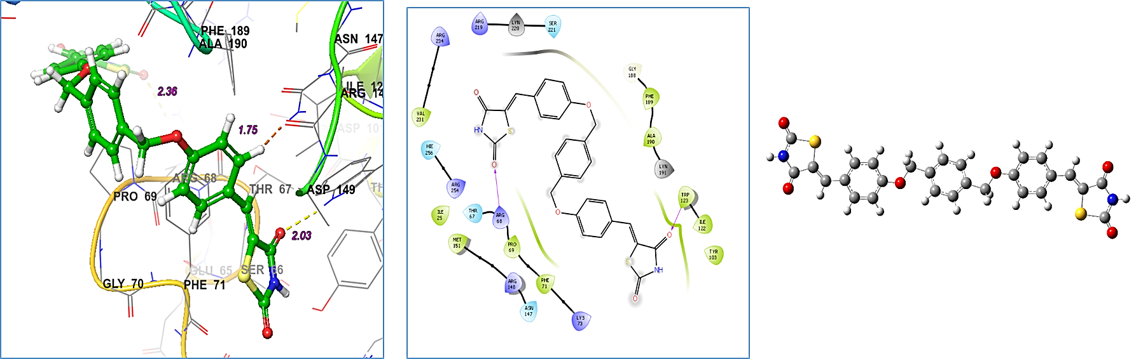
Compound 7
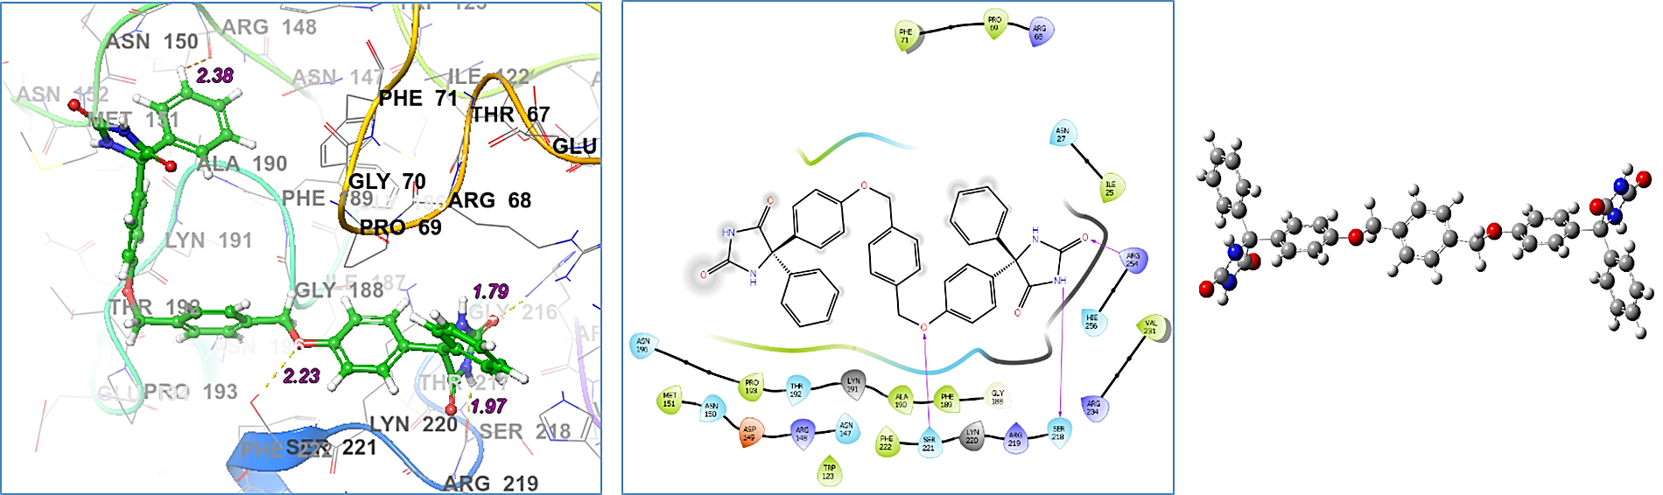

Compound 9
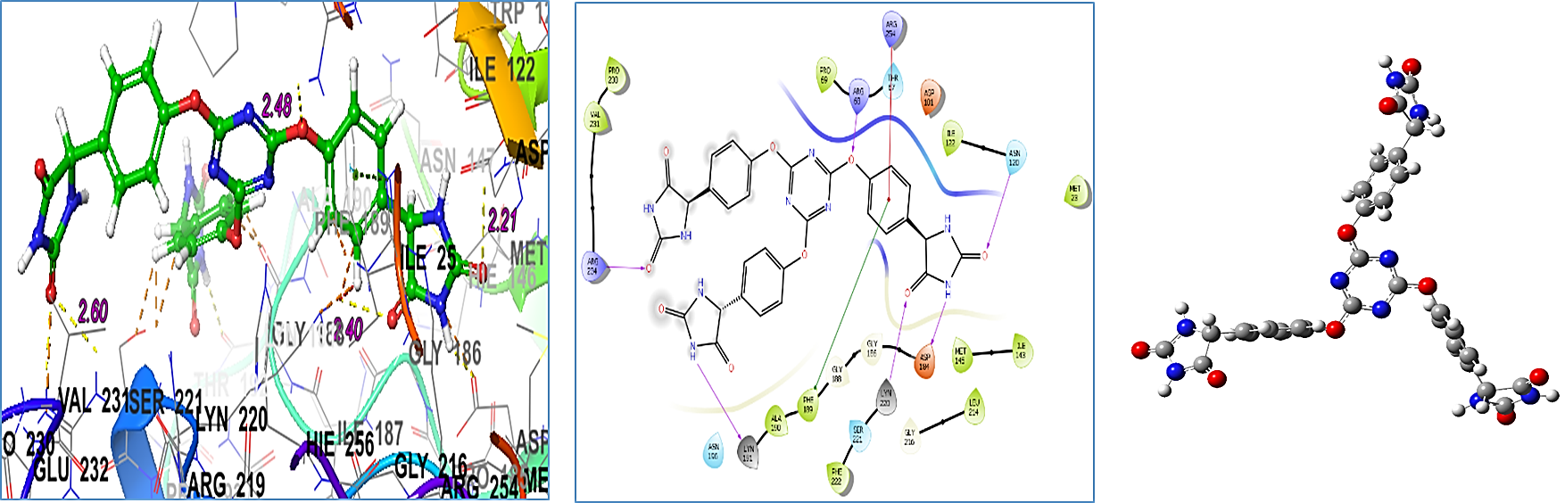
The binding mode of ligands with LpxC of P. aeruginosa (PDB ID: 5U39) -- 2D, 3D and optimized structure compounds
Compound 1
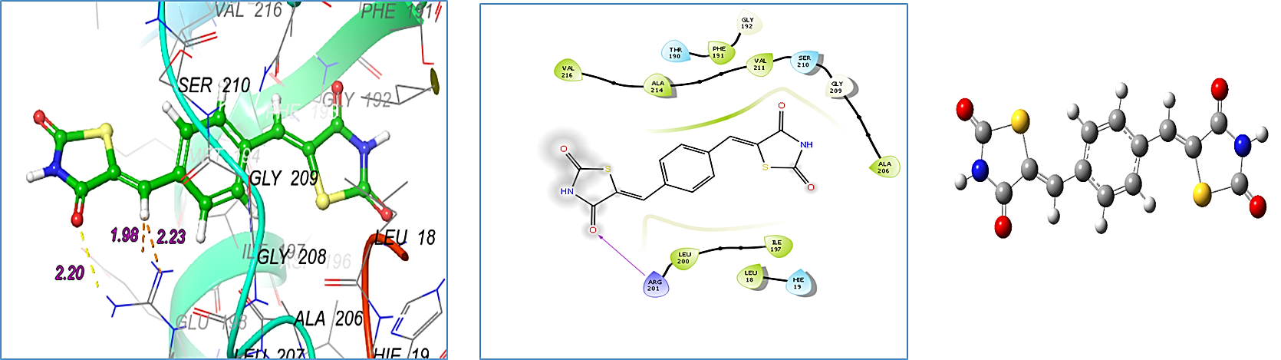
Compound 2
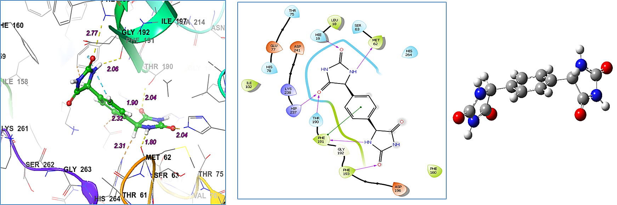
Compound 4a
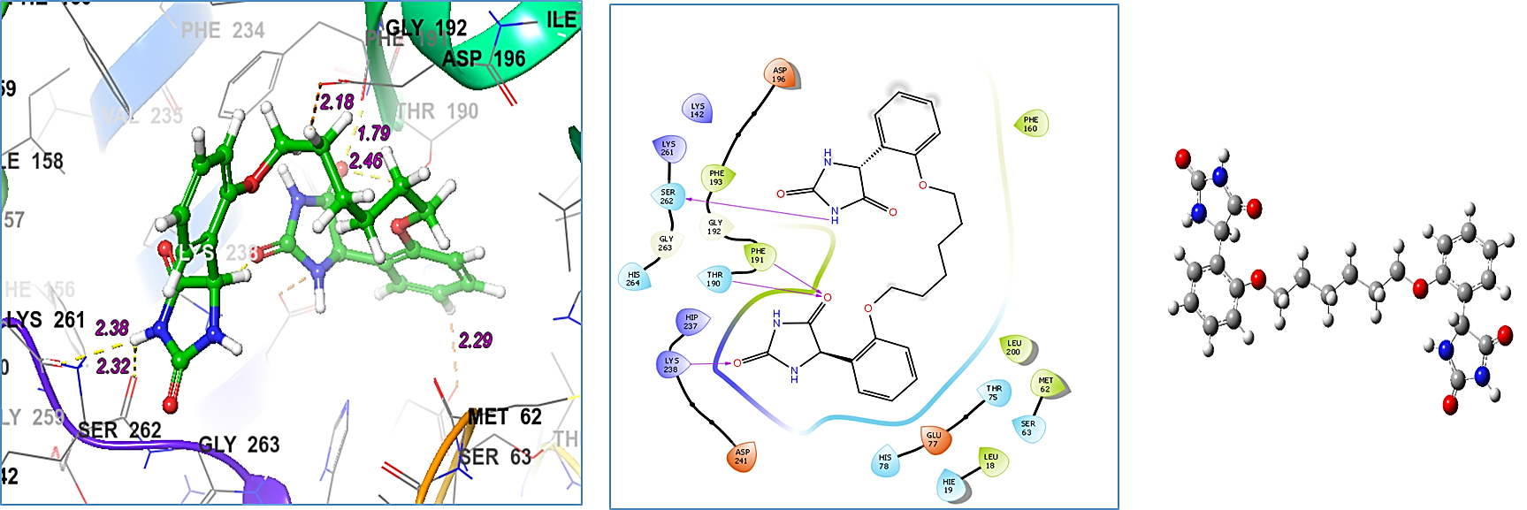
Compound 4b
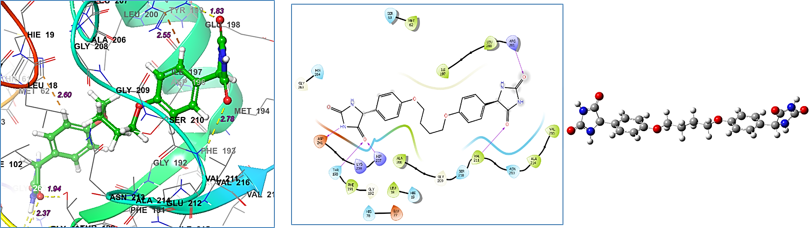
Compound 5a
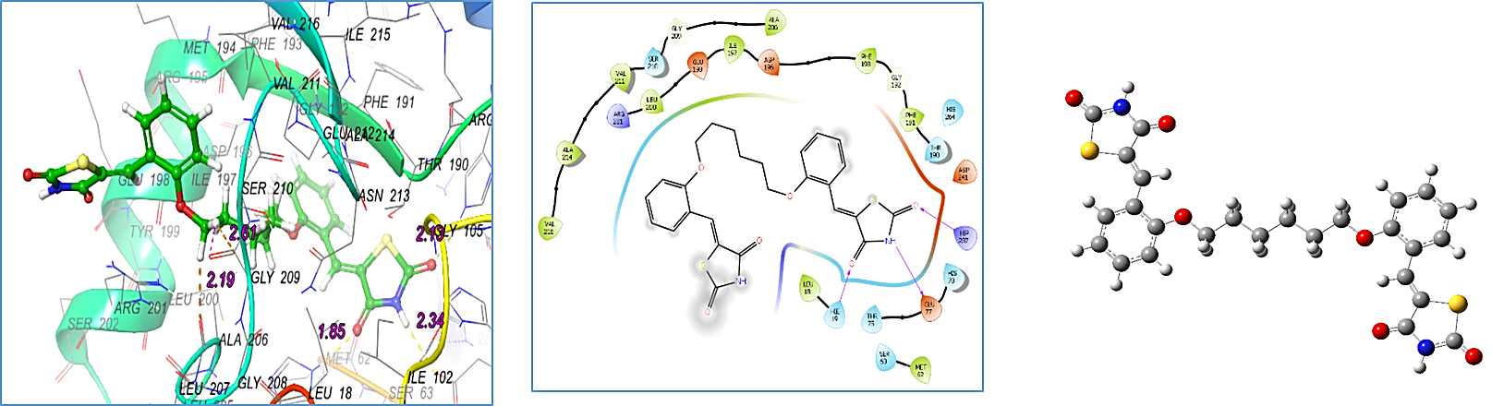
Compound 5b
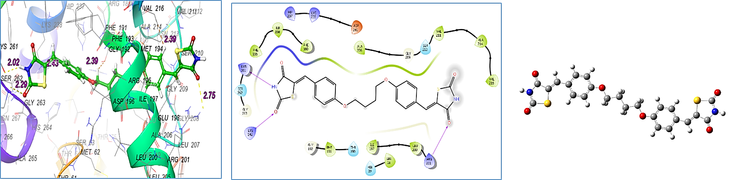

Compound 5c
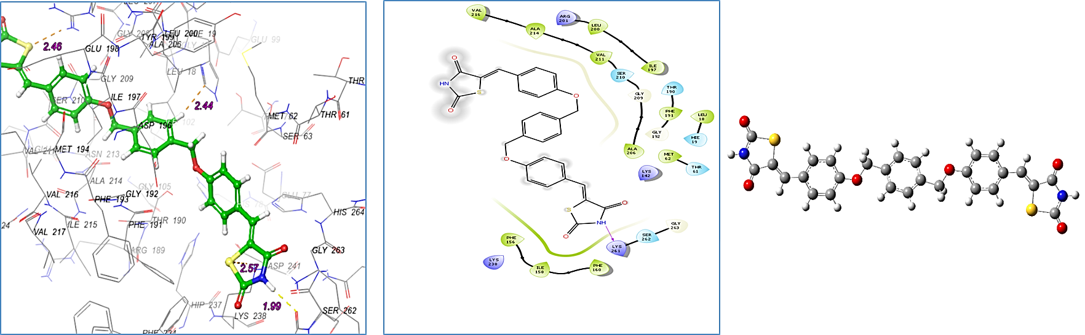
Compound 9
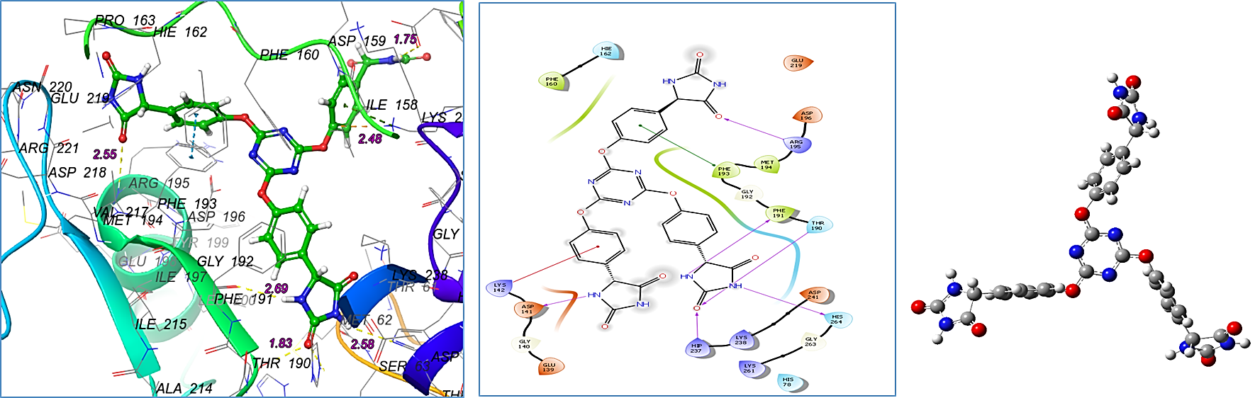
Compound 10
