SUPPLEMENTARY FIGURES
Genome wide association studies and candidate gene mining for understanding genetic basis of straw silica content in a set of Oryza nivara accessions
Rakshith S R Gowda¹, Sandeep Sharma², Ranvir Singh Gill¹, Gurjit Singh Mangat¹, Dharminder Bhatia^{1*}
¹Department of Plant Breeding and Genetics, ²Department of Soil Science; Punjab Agricultural University, Ludhiana, India - 141004
*Corresponding Author: Dharminder Bhatia, d.bhatia@pau.edu
ORCID ID: 0000-0001-6088-3886

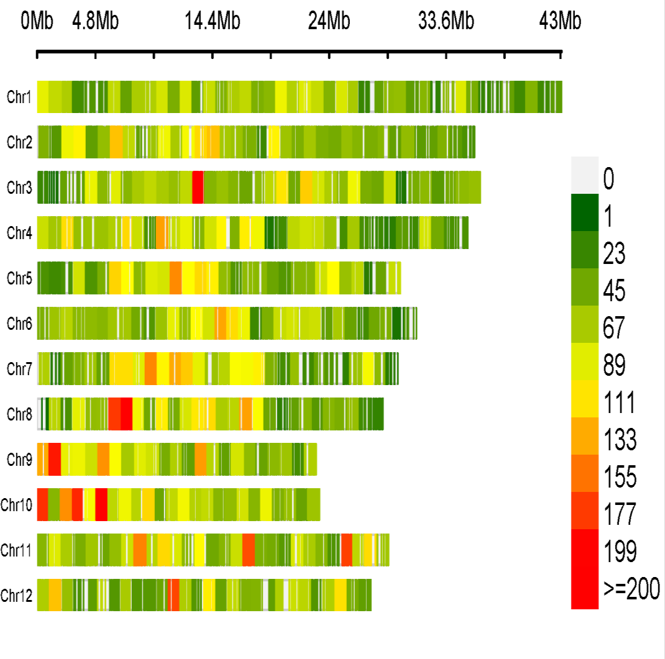
Fig. S1 SNP density plot depicting the SNP distribution along the 12 chromosomes. The different colour shades in the legend represent density of SNPs per Mb region along the genome
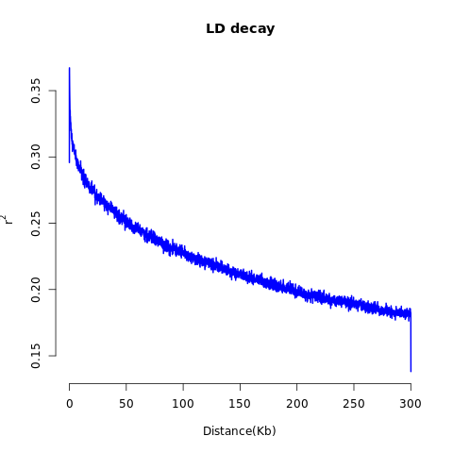

Fig. S2 Linkage disequilibrium decay across the entire genome in 258 O. nivara accessions

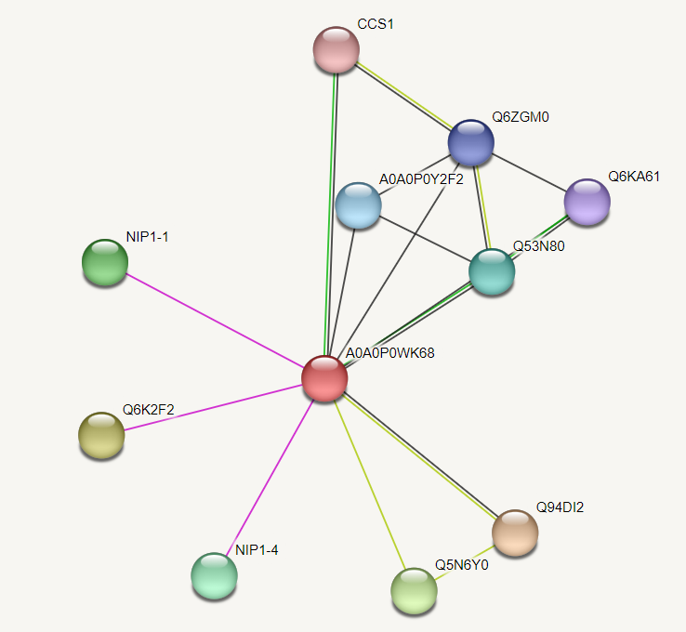
Fig. S3 Protein-protein interaction network of Os05g0295200 (A0A0P0WK68, red circle in the centre). The nodes indicate the protein interactors

