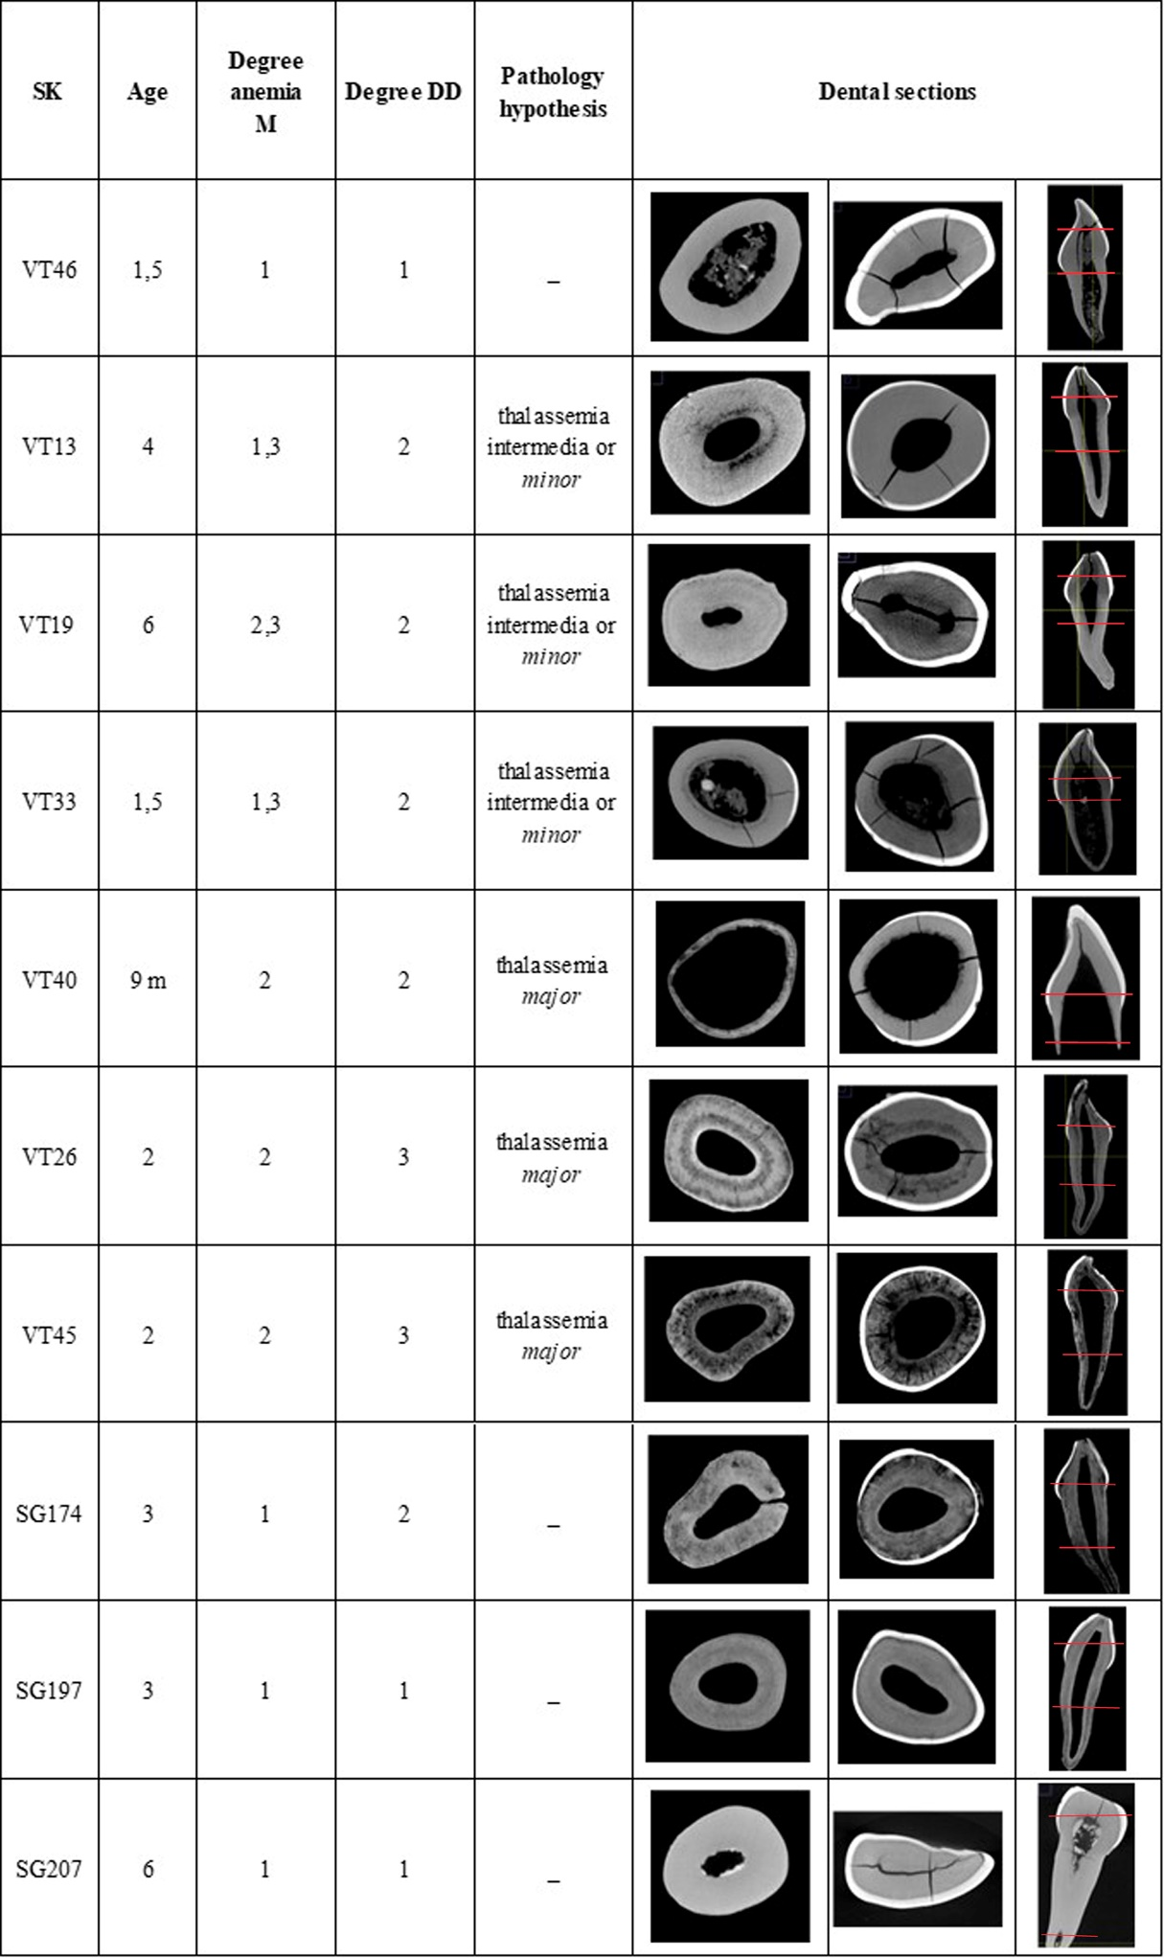
Table 2 Comparison of the average degree of anaemia (M) and dentinogenesis defects (DD) with the most representative images of micro-CT sections. Left: cross-sections along the root; centre: cross-sections of the crown; right: longitudinal sections (in red the points corresponding to root and crown cross-sections)

