Appendix

Sensitivity analysis for Ksh & Kr. To understand the sensitivity of the model to changes in ksh and kr, a simplified model with fixed state variables and fixed CRmax as the median values of each was used. The sensitivity of the model to the two parameters was assessed separately for each. To assess ksh, the kr was set at 0.30 and ksh made to range between 0.1 and 0.6. To assess kr the ksh was set at 0.6 while kr was made to range between 0.1 and 0.30.

### sensitivity calculated based on previous explanations on how to calculate ### The sensitivity was calculated based on the sum of the output variables at all time points: Wb, Wr and S as re difference of the outputs at each increment of the parameter divided by the increment of the parameter multiplied by the starting value of the parameter divided by the value of the output obtained with the starting value of the parameter
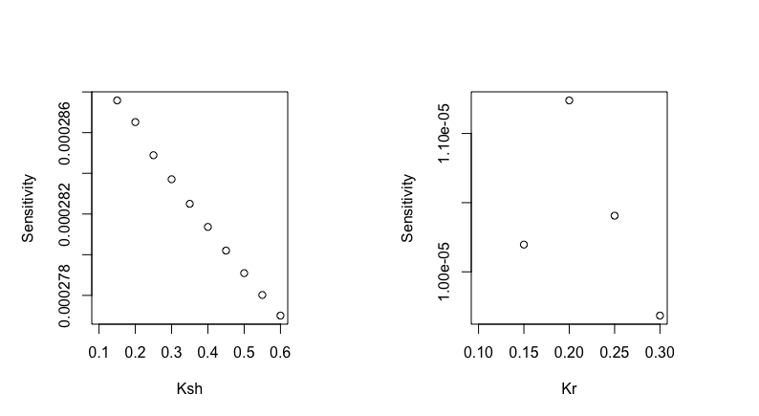

### sensitivity analysis like Bacher-Gagnery 2006

$SI=Σ\frac{ \left|Wtotend^{parnew}-Wtotend^{par0}\right|}{Wtotend^{par0}}$*100
Where Wtotend is the total weigh at the end of the simulation (day 345), as the sum of the three state variables and par0 is the value of the parameters used in the study

Ksh=1.8%
Kr= 0.02%

