S1_Normalization of GSE10334 and GSE16134 datasets. We first normalized the data so that every sample had the same baseline for calculation to accurately sort out the DEGs.
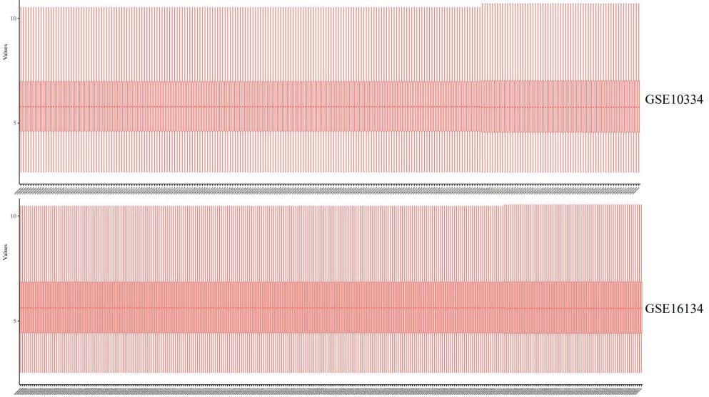

S2_Quality control of single-cell sequencing. After a series of analysis and quality control including nFeature_RNA, nCount_RNA, percent.mt, the single cell data for analysis was finally obtained.
