Additional File
File name: Supplementary File
File format: .docx
Titles of data included:
Table S1. Results from the final multivariable Cox proportional hazards model for the hazard of experiencing the composite event (intubation, ICU admission or death) by timing of Remdesivir administration. Stratified by disease severity at baseline.

Figure S1a. Time from admission to Remdesevir administration by calendar time of admission

Figure S1b. Duration of Remdesivir administration by calendar time of admission

Figure S2 . Clinical status (8-degree ordinal scale) at baseline and days 15 and 30.

Figure S3 . Clinical status (8-degree ordinal scale) at baseline and days 15 and 30 by disease severity at baseline and timing of remdesivir administration.

Figure S4a. Cumulative probability of composite event by time since admission and disease severity at baseline.

Figure S4b. Cumulative probability of composite event by time since admission and timing of Remdesivir administration stratified by disease severity at baseline.

Description of data included: This file includes Table and Figures for the further understanding of our Results regarding time between admission and remdesivir initiation for the studied time-period and patient’s clinical status during hospitalization.
Supplemental Tables and Figures:
Table S1. Results from the final multivariable Cox proportional hazards model for the hazard of experiencing the composite event (intubation, ICU admission or death) by timing of Remdesivir administration. Stratified by disease severity at baseline.

Covariate | Hazard Ratio (HR) | 95% C.I. | p-value
Remdesivir administration within 2 days/after 2nd day  (mild/moderate disease at baseline) | 0.20 | (0.03, 1.23) | 0.083
Remdesivir administration within 2 days/after 2nd day  (severe disease at baseline) | 1.49 | (0.60, 3.74) | 0.393
Interaction: Disease severity X timing of Remdesivir |  |  | 0.053
No. of coexisting conditions | 1.15 | (0.99, 1.35) | 0.072
Age above or equal to 65 vs. below 65 | 2.86 | (1.63, 5.05) | <0.001

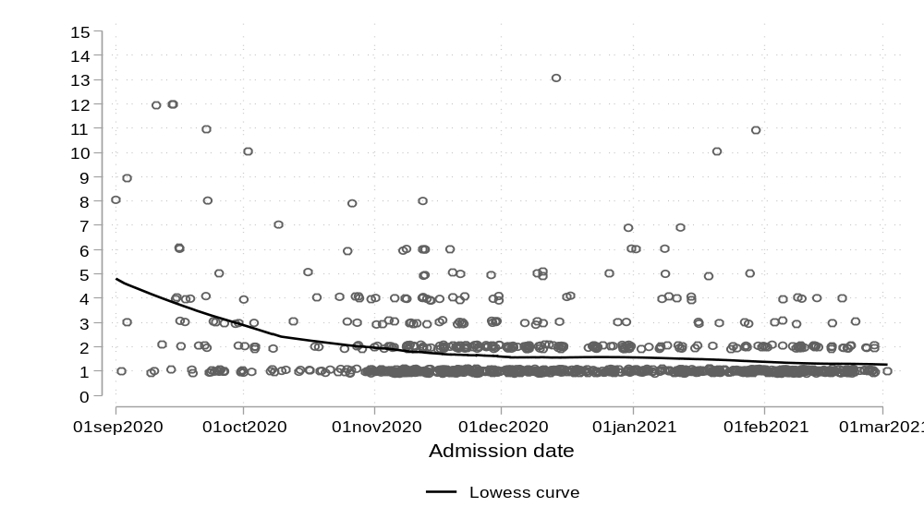
Figure S1a. Time from admission to Remdesevir administration by calendar time of admission
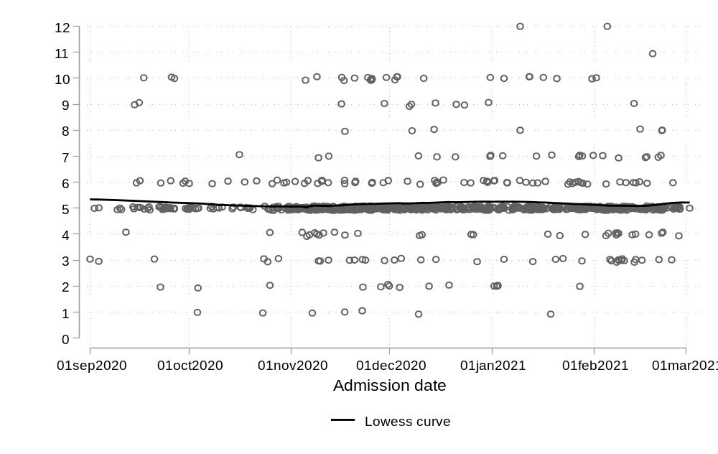
Figure S1b. Duration of Remdesivir administration by calendar time of admission

Figure S2 . Clinical status (8-degree ordinal scale) at baseline and days 15 and 30. 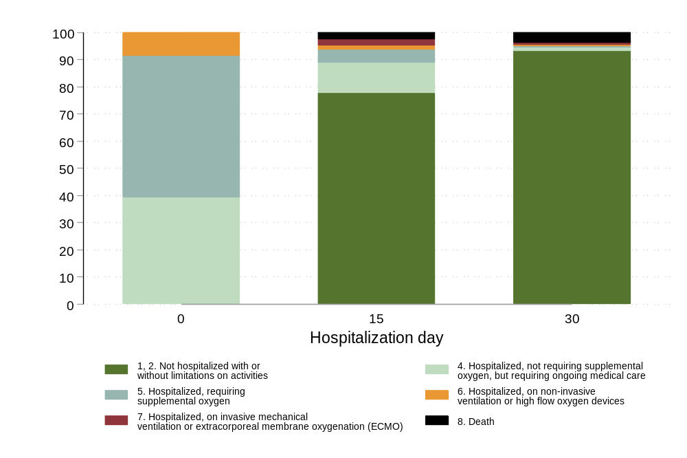
Figure S3 . Clinical status (8-degree ordinal scale) at baseline and days 15 and 30 by disease severity at baseline and timing of remdesivir administration.
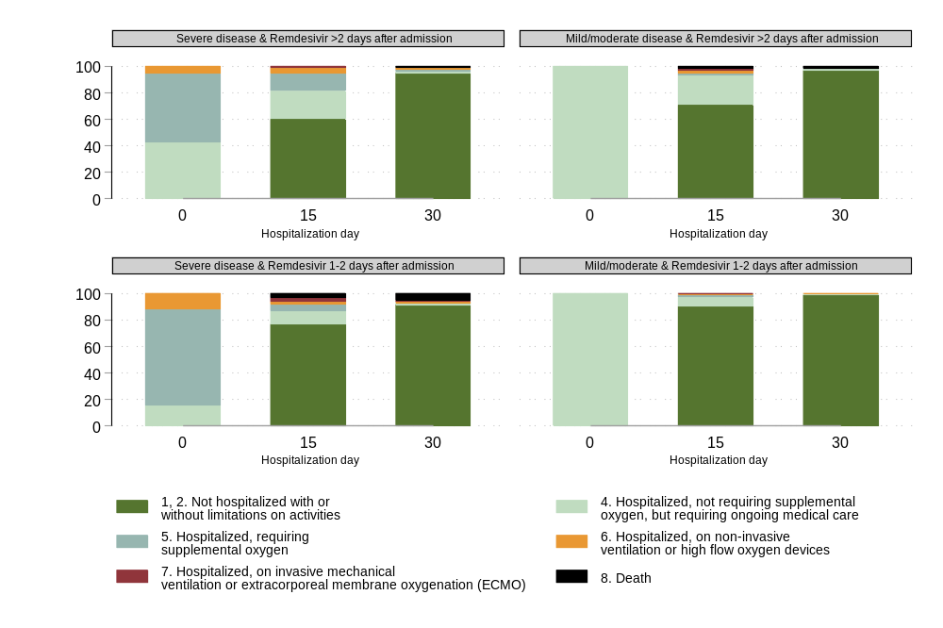
Figure S4a. Cumulative probability of composite event by time since admission and disease severity at baseline. 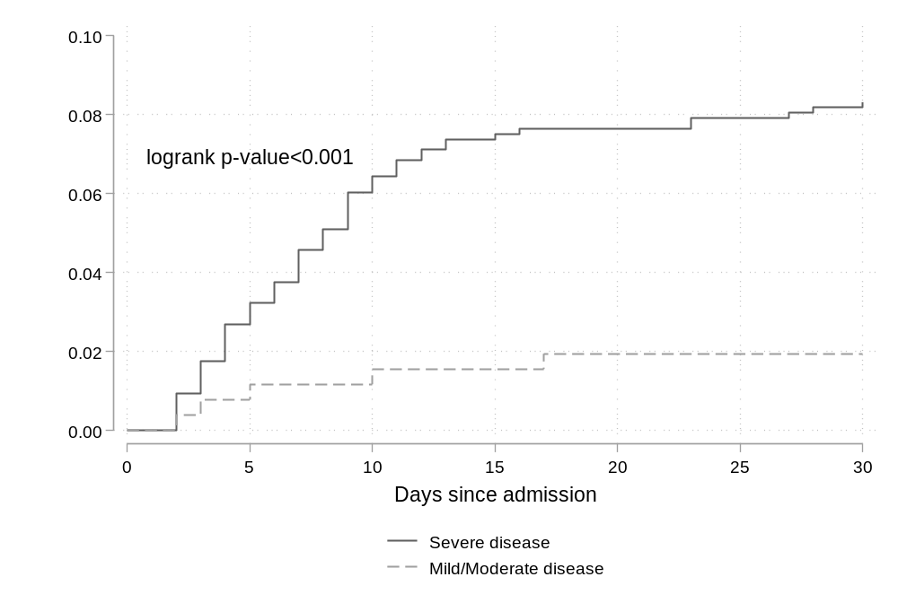
Figure S4b. Cumulative probability of composite event by time since admission and timing of Remdesivir administration stratified by disease severity at baseline. 