Extended Figure 1
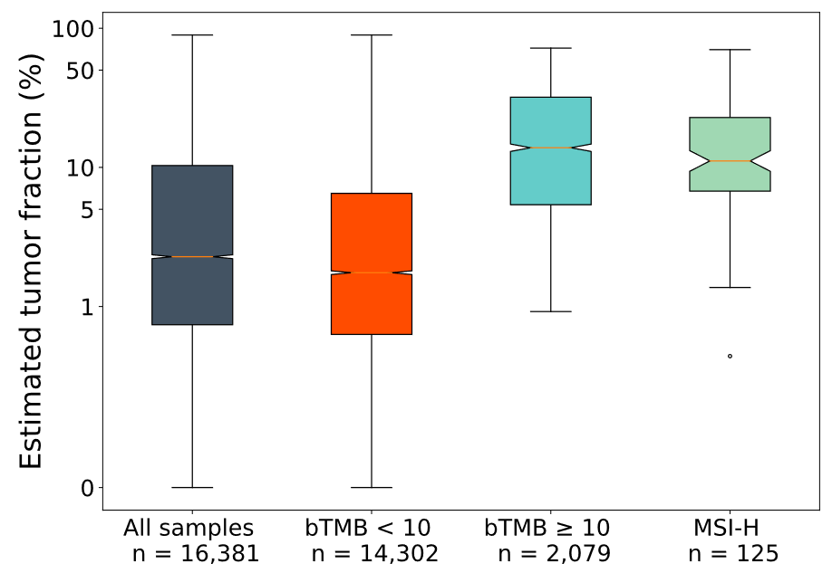
Extended Figure 1: ctDNA shed association with detection of bTMB and MSI
Estimated ctDNA fraction of samples with bTMB <10 versus ≥10 mut/Mb, and those with MSI-High signature detected.

Extended Figure 2
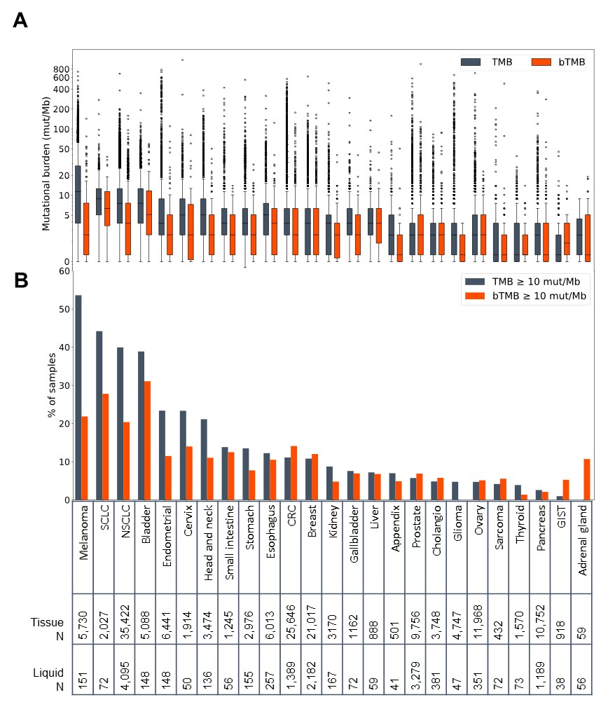Extended Figure 2: TMB and bTMB distributions in various cancer types
- Boxplot of tissue TMB and bTMB scores in each cancer type (N of at least 30 liquid biopsies). Median, interquartile range, and outliers indicated by points. Samples arranged in order of prevalence of TMB ≥10 mut/Mb (see B).
- Percentages of samples with TMB and bTMB ≥10 mut/Mb.
Extended Figure 3
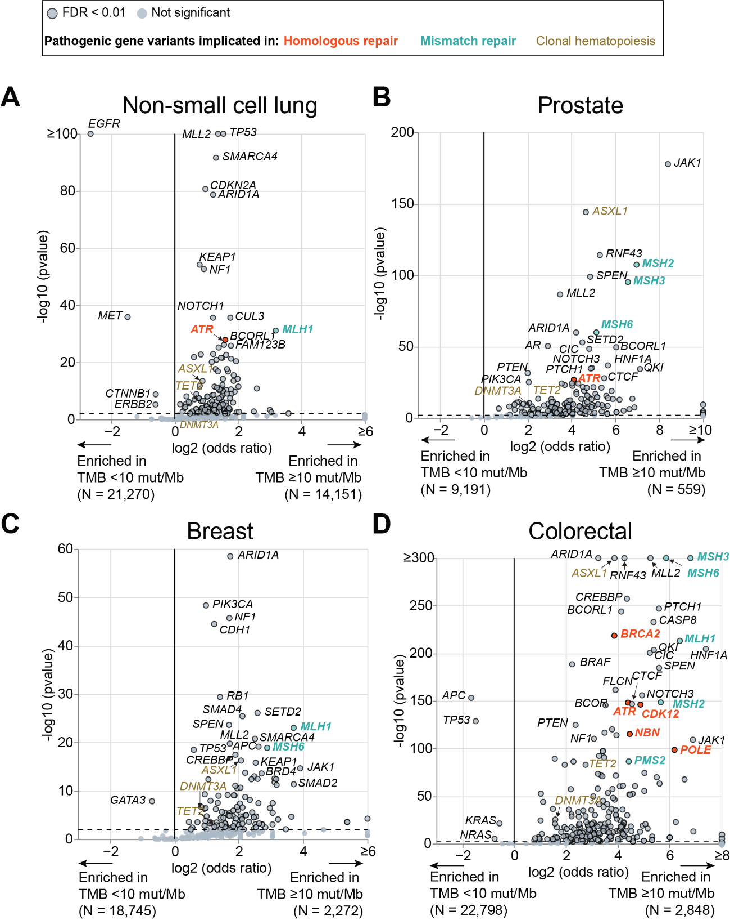

Extended Figure 3: Pathogenic variants enriched in samples with high versus low TMB
Tissue biopsies with TMB ≥10 and <10 mut/Mb were analyzed for enrichment of variants predicted to be pathogenic or oncogenic. Note that these variants are not added up into TMB calculations—only variants of unknown significance are used for mutational burden biomarkers. Genes enriched in TMB ≥10 samples associated with homologous recombination (orange) and mismatch repair (blue) are labeled in bold. Clonal hematopoieisis drivers (gold) analyzed in Figure 2 are marked here for reference. See Supplementary File for numbers behind this figure.
- Non-small cell lung cancer
- Prostate cancer
- Breast cancer
- Colorectal cancer

Extended Figure 4

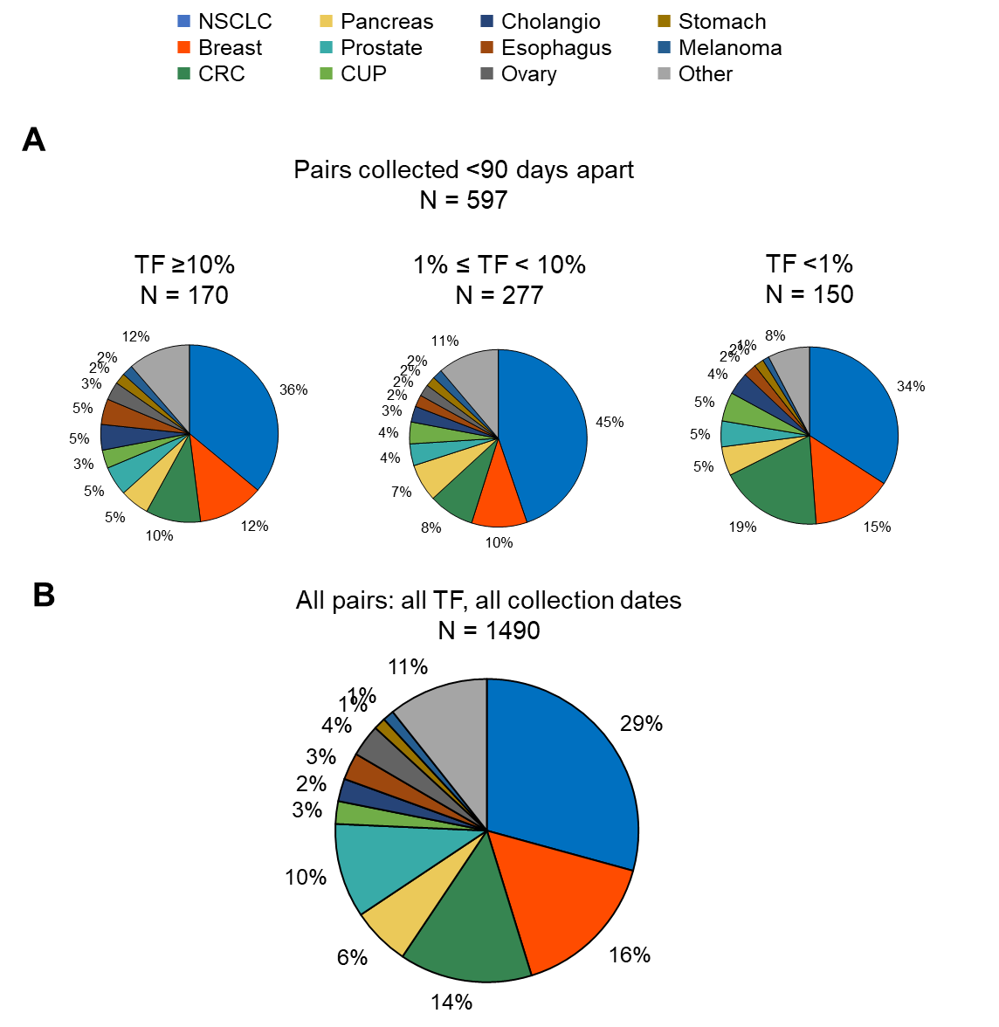Extended Figure 4: Tumor types represented in paired cohort
- Cancer types represented in the paired tissue/liquid biopsy analysis in Figure 3 split into three groups by ctDNA fraction. NSCLC: non-small cell lung cancer; CRC: colorectal cancer; CUP: carcinoma of unknown primary; Cholangio: cholangiocarcinoma.
- As in (A), but for all pairs, including those collected ≥90 days apart. Data for these pairs provided in Supplementary Figure 5.

Extended Figure 5
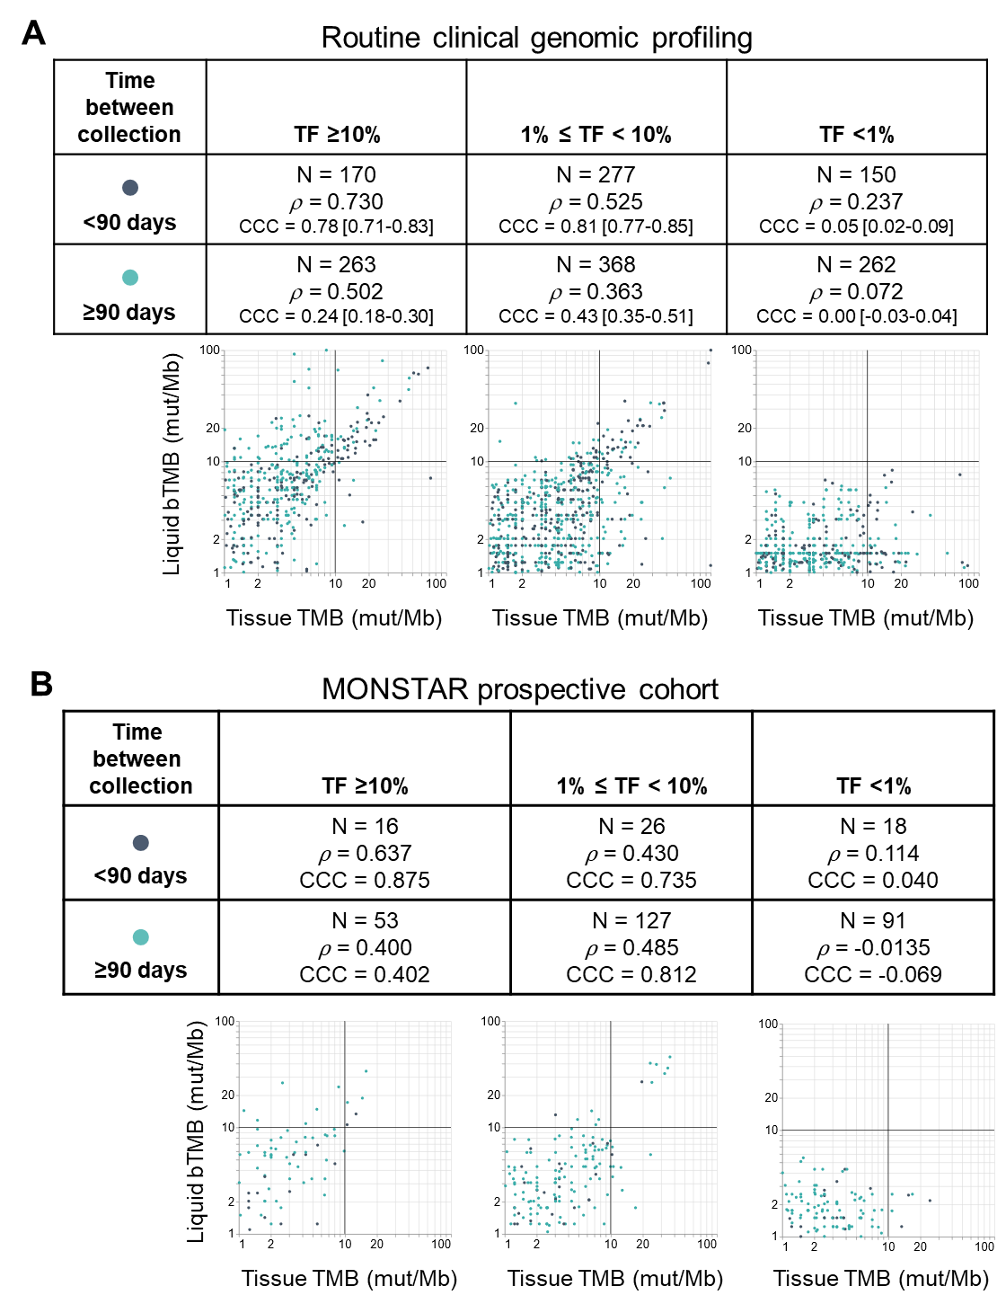
Extended Figure 5: Effects of time on mutational burden concordance
- Concordance of bTMB and TMB in liquid and tissue biopsies collected from the same patients with any time interval (median: 7.6 mo, IQR: 0.8-21.5 months). Pairs are grouped according to level of ctDNA. Spearman’s rank correlation coefficient (rho) and Lin’s Concordance Correlation Coefficient (CCC) with a 95% confidence interval are provided for each group. For display purposes, TMB and bTMB values of 0 were set to 1 on these plots and jitter was added to alleviate overplotting. Pairs collected <90 days apart in dark blue, pairs collected ≥90 days apart in light blue.
- Same analysis as in (A) for the MONSTAR observational cohort (N = 331).

Extended Figure 6
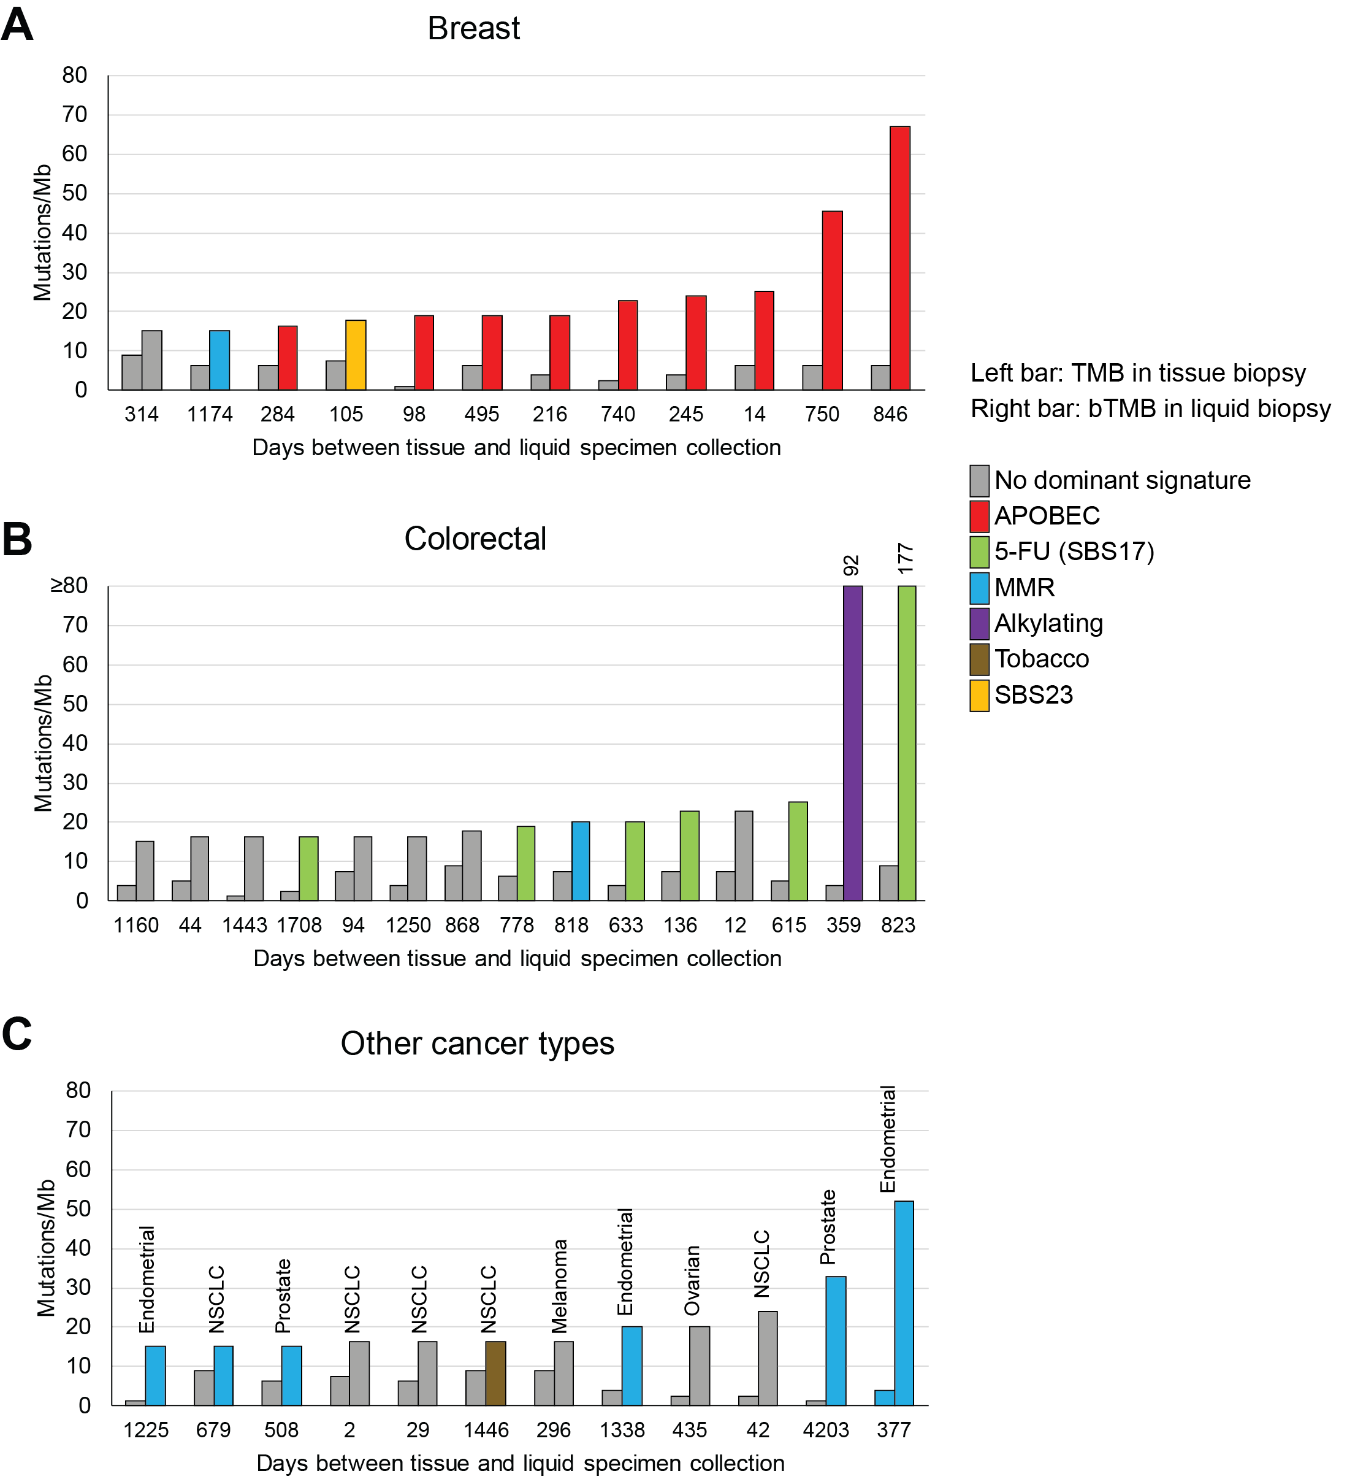 Extended Figure 6: Analysis of genomic signatures in discordant high bTMB pairs
Analysis of tissue and liquid pairs where TMB <10 and bTMB ≥14. Colors of each bar indicate the dominant single base mutational signature detected in the sample. The number of days elapsed between tissue and liquid specimen collection show at the bottom.
- 12 breast cancer pairs (9 of 12 had a dominant APOBEC signature in the liquid sample).
- 15 colorectal cancer pairs (6 of 15 had dominant SBS17 signature, consistent with DNA damage from 5-fluorouracil).
- Other cancers. 3 of 3 endometrial cancer samples, 2/2 of prostate samples had a dominant mismatch repair signature in the liquid sample.
Extended Figure 7
A
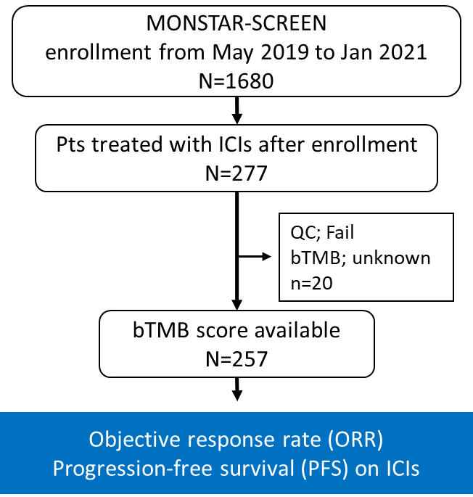
B
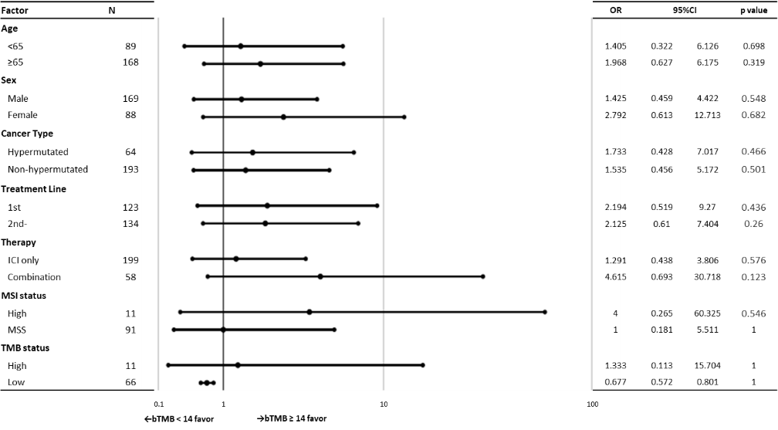

C
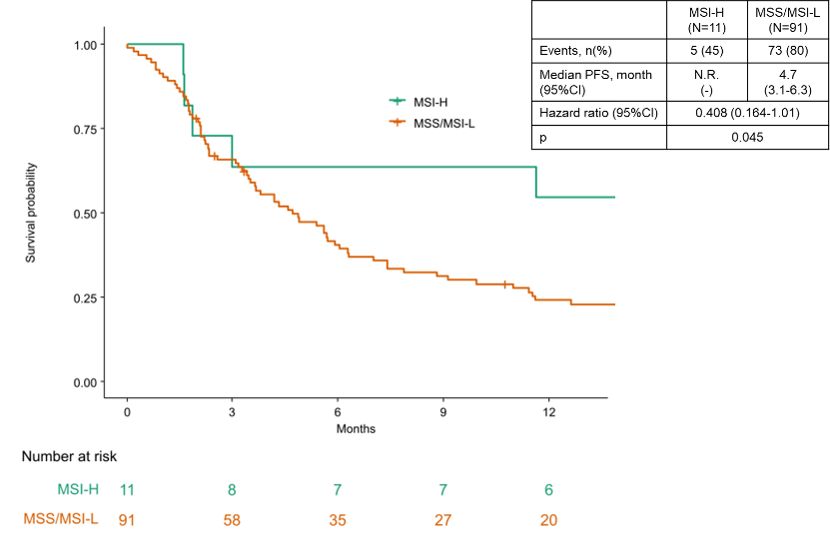

D
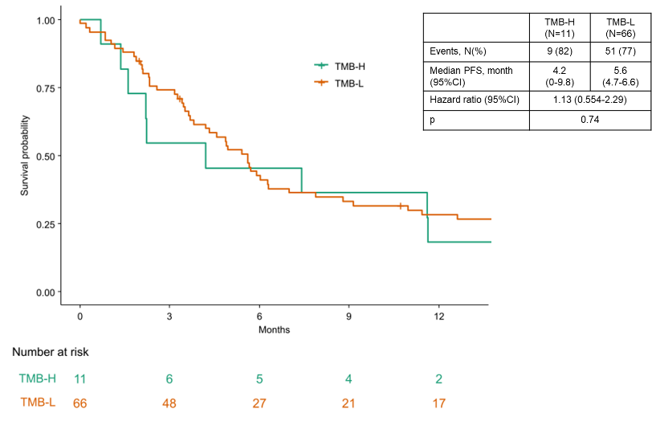
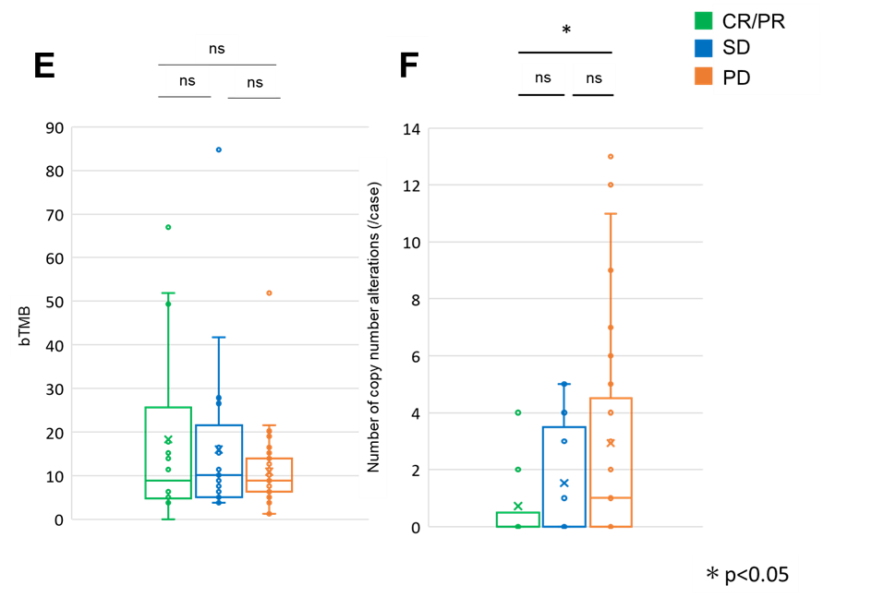
Extended Figure 7: Outcome on ICI therapy in patients with elevated bTMB
- Consort diagram of MONSTAR-SCREEN cohort.
- Forest plots of hazard ratio for Objective response rate (ORR) by patients’ characteristics. The results of the subgroup analysis of ORR in the bTMB ≥14 as compared with the bTMB <14 group. Statistical tests (log-rank) were unadjusted for multiple comparisons and two-sided at the 0.05 significance level. The error bars show the 95% CIs.
- Kaplan–Meier analysis of the probability of progression-free survival (PFS) in the MSI-H patients as compared with the MSS/MSI-L patients. Vertical lines denote patients who were censored.
- Kaplan–Meier analysis of the probability of PFS in the TMB-H patients as compared with the TMB-L patients. Vertical lines denote patients who were censored.
- Comparison of bTMB between patients with complete response (CR) or partial response (PR), stable disease (SD), and those with progressive disease (PD). No significant difference between the groups. The boxes represent 25th–75th percentiles; center lines indicate the median; whiskers extend to the maximum and minimum values within 1.5× of the interquartile range; and dots indicate outliers.
- Comparison of number of copy number alterations between patients with CR or PR, SD, and PD. Number of copy number alterations of CR/PR patients was significantly lower than PD patients (two-sided P <0.05, Mann–Whitney U-test). The boxes represent 25th–75th percentiles; center lines indicate the median; whiskers extend to the maximum and minimum values within 1.5× of the interquartile range; and dots indicate outliers.

