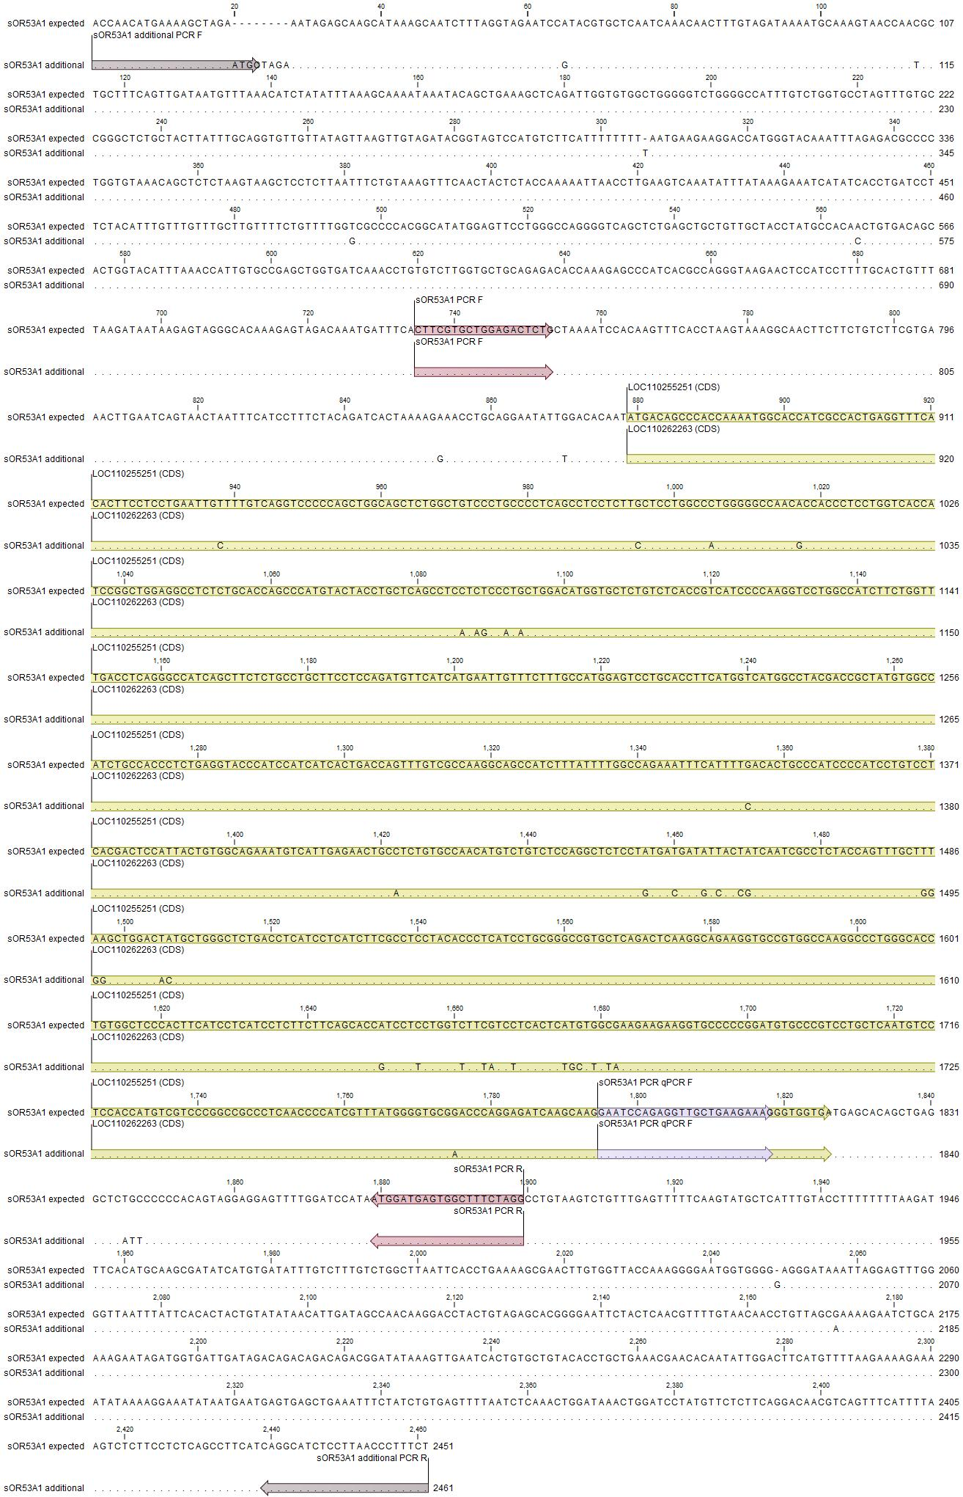
(A)

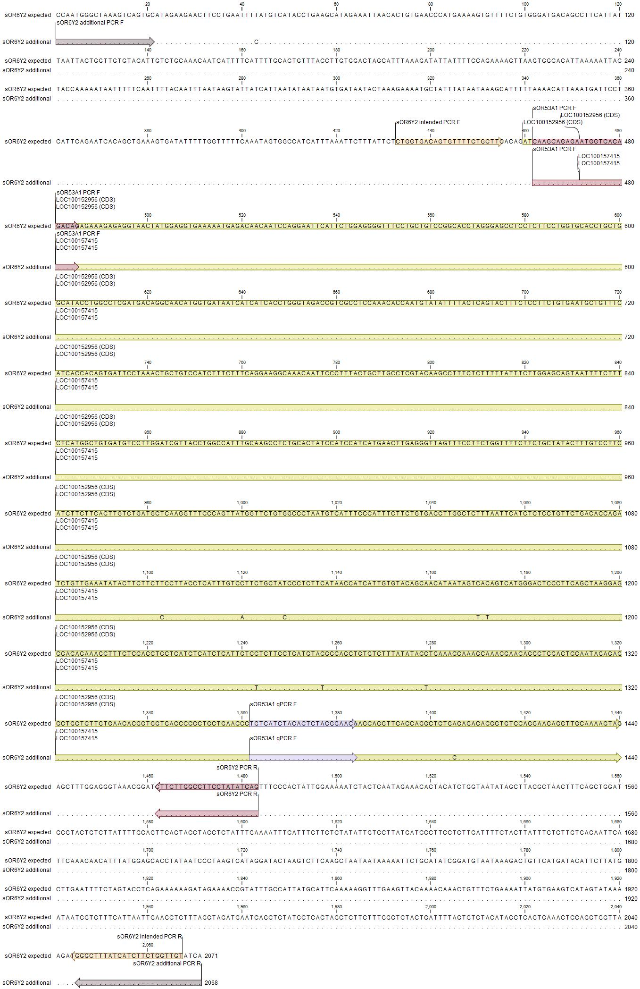
(B)

S1 Fig. Positions of sequence-specific primers for sOR53A1- (A) and sOR6Y2-related (B) sequences. Primer information for specific amplification of the expected sequences, according to the pig genome reference and the additionally detected sequence from OR typing in this study, are shown. Identical nucleotides are indicated by dots. The CDS regions are indicated with different colors.
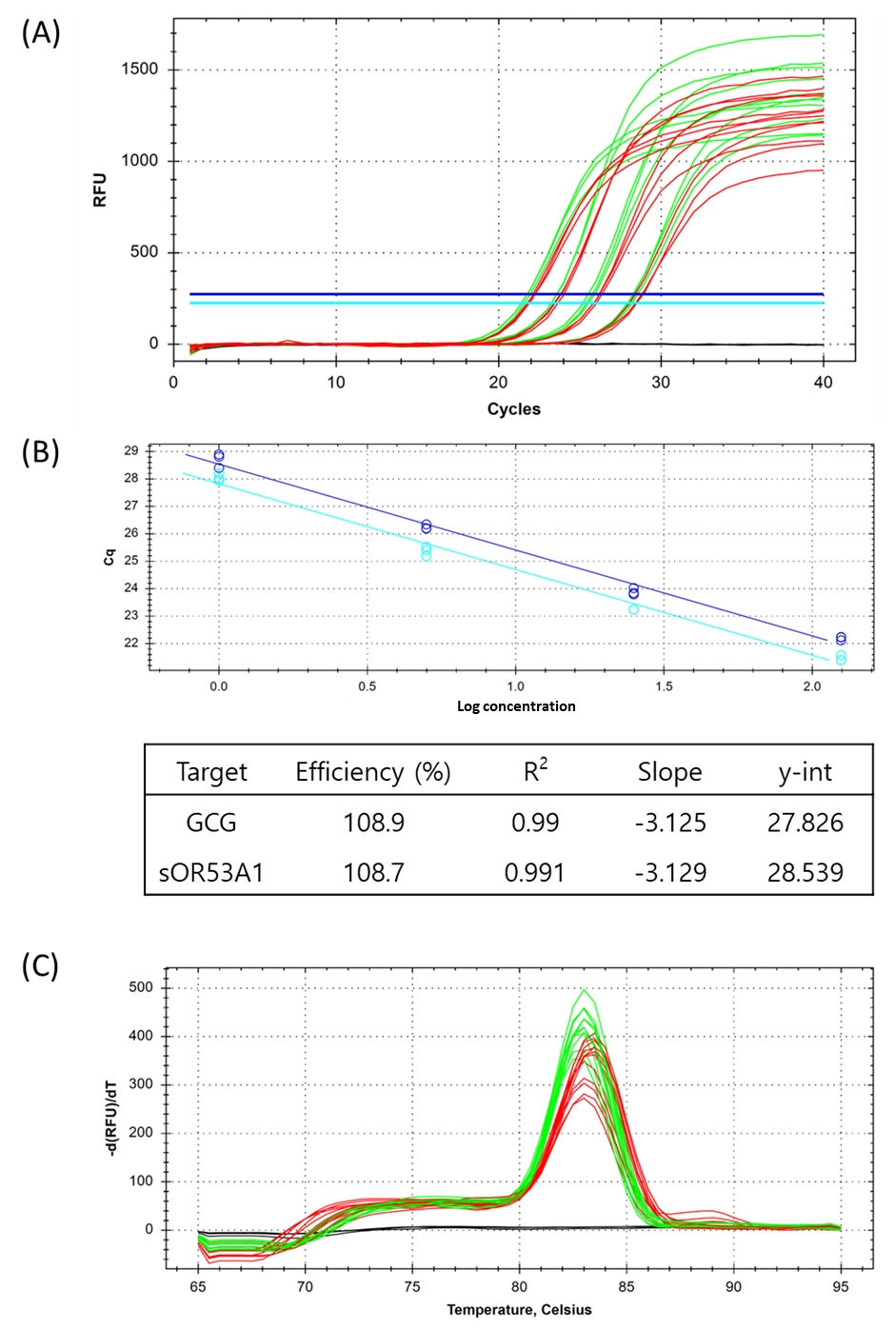
S2 Fig. Evaluation of primer efficiency for sOR53A1 and GCG qPCR. The amplification plot (A), standard curve, qPCR efficiency (B), and melting curve (C) of each target were generated using 1, 5, 25, and 125 ng of pig genomic DNA from an individual (KNP3) with single-copy sOR53A1. The experiment was repeated thrice for each reaction. (A) Results for GCG and sOR53A1 are shown in green and red, respectively. The negative controls are shown as black lines. To determine the cycle threshold (Cq), relative fluorescence units (RFU) of 225.6 and 274.1 were used for GCG (cyan) and sOR53A1 (blue), respectively. (B) Standard curves for GCG (cyan) and sOR53A1 (blue) are plotted according to the change in Cq with log concentration of genomic DNA. qPCR efficiencies were calculated from standard curves, and the values are presented in the plot. (C) Melting curves of all GCG and sOR53A1 amplifications are plotted with green and red curves, respectively. Negative controls are shown as black lines. The melting temperature of each PCR run was based on the level of fluorescence reduction corresponding to −d(RFU)/dT.

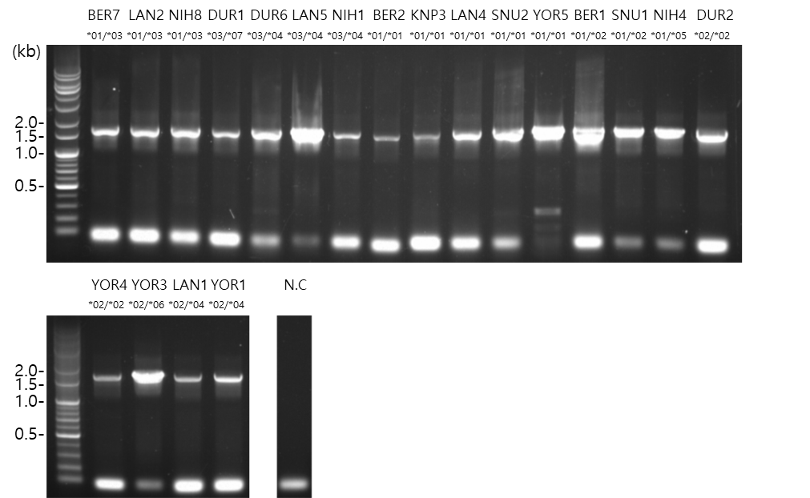
(A)

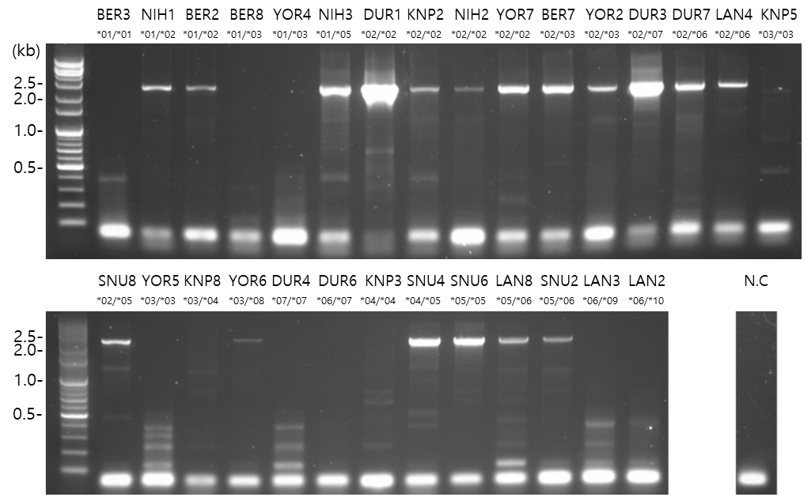
(B)

S3 Fig. Results of sequence-specific typing for sOR53A1 and sOR6Y2 from 29 pigs. (A) Amplification of the sOR53A1-related additional sequence (2,461 bp) using specific primers. (B) Amplification of sOR6Y2 reference sequence of 1,635 bp using specific primers. Primer information is described in S1 Fig. Sample names, together with genotypes of the corresponding genes in our typing, are shown at the top of the gel. N.C, negative control. A DNA ladder is indicated on the left side of the gel.
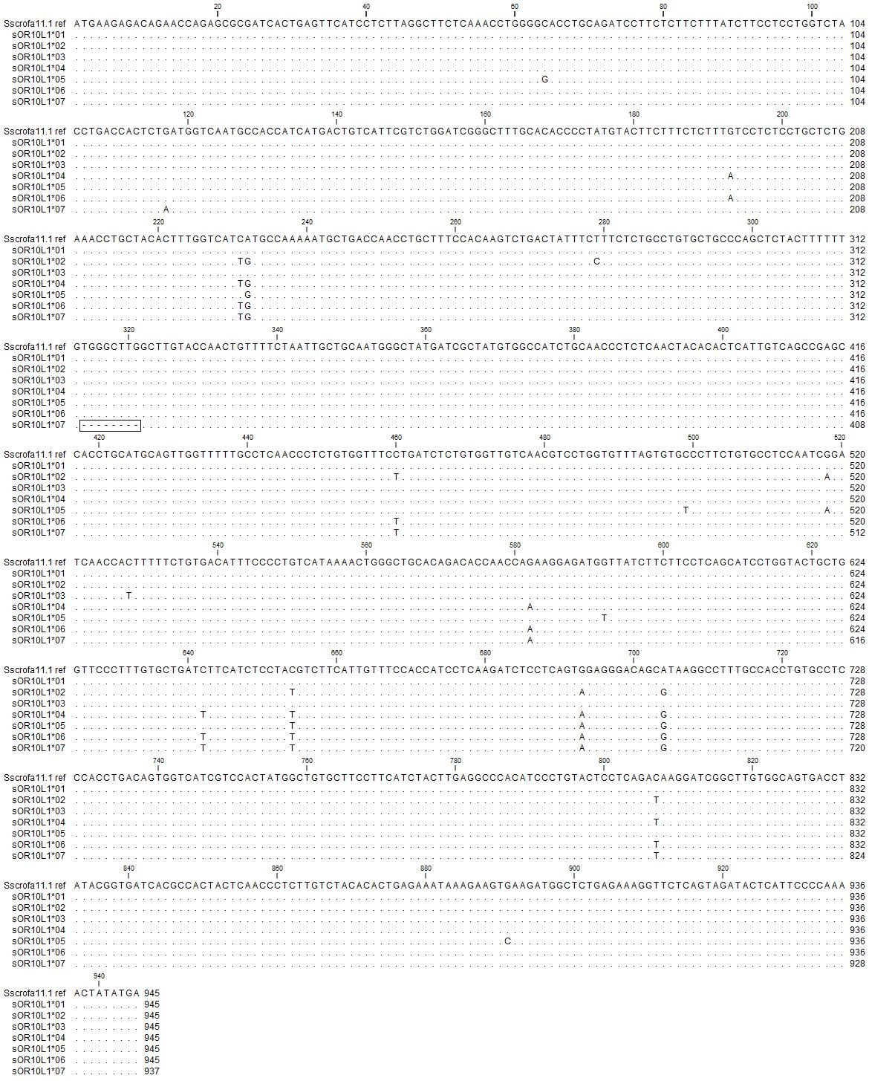 S4 Fig. Multiple sequence alignment of all identified sOR10L1 alleles. Identical nucleotides are represented by dots. The OR sequence of the pig genome assembly Sscrofa11.1 was used as a reference sequence. The indels on sOR10L1*07 are marked with a square box.
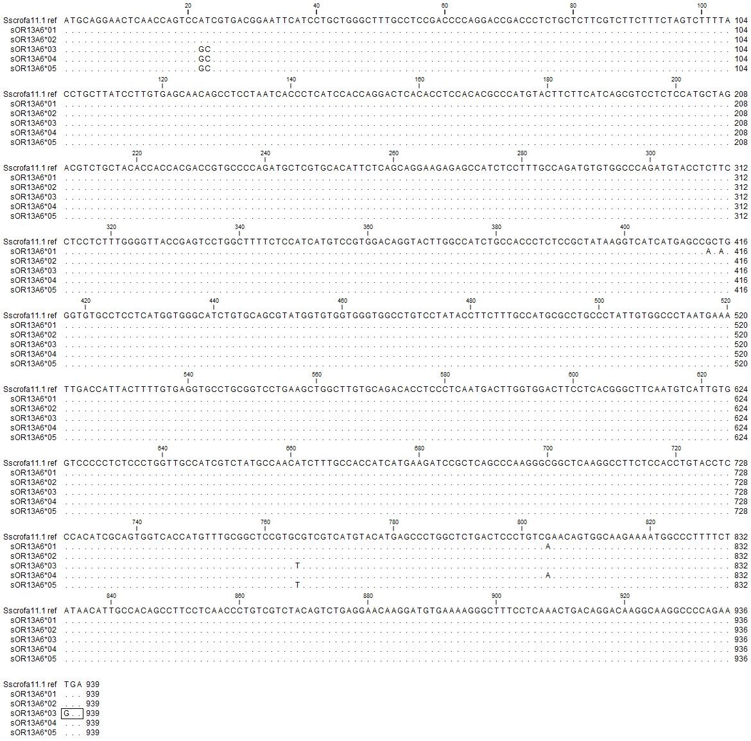 S5 Fig. Multiple sequence alignment of all identified sOR13A6 alleles. Identical nucleotides are represented by dots. The OR sequence of the pig genome assembly Sscrofa11.1 was used as a reference sequence. A nonsense mutation (TGA (stop) GGA (Gly)) on sOR13A6*03 is marked with a square box.

