Western blot

GLP-1R in intestines（n=5）
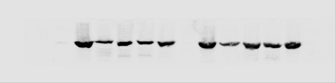
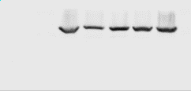
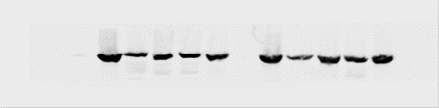
GLP-1R

actin

GLP-1R in islet（n=1）
GLP-1R

actin

PC1/3 in intestines(n=5)
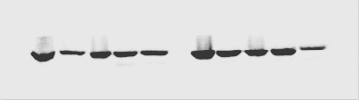

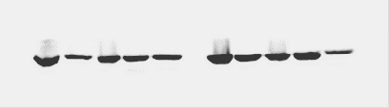
PC1/3

actin

PC1/3 in islets(n=1)
PC1/3

actin

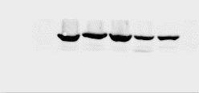
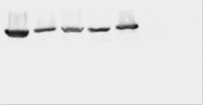
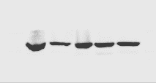
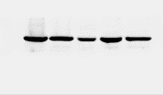
PC2 in intestines(n=5)
PC2
Sdf

actin

sd

MafA in intestines(n=5)
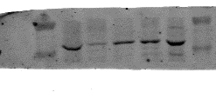
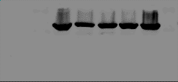
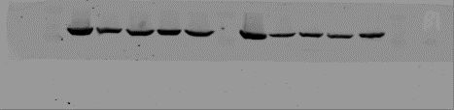
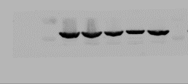
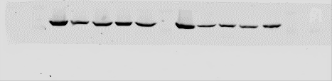

MafA

actin

