Supplementary material 1 : Search strategy
Embase search strategy
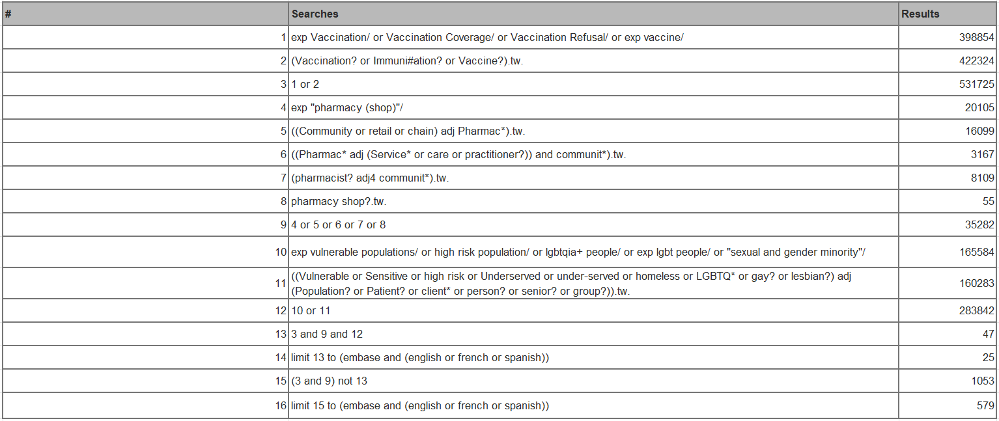

Medline search strategy
