Supplementary Information:
Delayed Impact of Interdisciplinary Research

Table of Contents
S1 Data Description 2
S2 Interdisciplinary Indicators 2
S3 Quantifying citation dynamics 3
S3.1 A generative model for citation dynamics 4
S3.1.1 Fitting WSB model 4
S3.1.2 Parameter validation 5
S3.2 Sleeping beauty index 5
S4 Robustness checks and additional results 6
S4.1 Paper Interdisciplinarity as a function of time 6
S4.2 Paper yearly citation profiles for individual fields 6
S4.3 Alternative definitions of $T_{m}$ 7
S4.4 Distributions of $T_{m}$ across several dimensions 7
S4.5 B index for individual fields 7
S4.6 Impact time 8
S5 Detailed Regression Results 8
S5.1 The effect of interdisciplinarity on $T_{m}$, B index, and impact time 8
S5.2 The effect of interdisciplinarity on $u$ 9
S5.3 Individual fixed effect 9
S5.4 Poisson regression 9
S5.5 The association between interdisciplinarity and $T_{m}$ for each year 10
S6 Potential forces underlying delayed impact of interdisciplinary research 10
S6.1 The Matthew effect 10
S6.2 Collaboration effect 11
S6.3 Content features 11
S6.4 Knowledge diffusion 12

S1 Data Description
In this study, we leverage Microsoft Academic Graph (MAG) database to extract article information, as described in the Methods section of the main text. The data is publicly available through
https://www.microsoft.com/en-us/research/project/microsoft-academic-graph/.
To visualize the time span of our sample, Figure S1A shows the yearly number of publications from 1970 to 2007, indicating an exponential growth trend. Our sample has a similar trend with the whole MAG data. Specifically, the fraction of our sample covers around 0.60 across the entire time period, indicating that our sample data does not contain substantial bias (Figure S1B). Additionally, medicine, chemistry, biology and physics cover 69.4% of our sample, while all other fields consist of 30.6% of the data (Figure S1C).

S2 Interdisciplinary Indicators
Faced with complex societal problems, many governments allocate much funding into interdisciplinary research, which attempts to fuel tomorrow’s innovations. Given such demands for interdisciplinary research, scholars use different measures in order to quantify interdisciplinary nature at individual paper level.

Prior studies pay great attention to references in order to quantify interdisciplinarity. In terms of the diversity embedded in each paper’s reference list, interdisciplinary nature includes three dimensions: variety, balance, and disparity [1]. Specifically, variety represents the number of fields in the reference list. Balance is a proxy for the evenness of cited scientific fields, and Gini coefficient/entropy is often used to measure such unevenness. Besides, disparity measures the average distance across different cited scientific fields. Recently, a few studies have considered distinct effects of these three dimensions on citations [1, 2]. For example, the Shannon entropy is proposed to measure variety and balance, which contains two components. Additionally, recent studies have combined these three components [3]. Network approach is also introduced to measure paper interdisciplinarity [4]. Apart from the perspective of references, forward citations capture the broadness of impact, which is also used to measure interdisciplinarity [5].

In this study, besides Rao-Stirling indicator in the main text, we also use two alternative indicators to quantify paper interdisciplinarity. One is DIV indicator derived by Leydesdorff et al.[5], and the other is the true diversity (TD) indicator [6]. Specifically, TD indicator can be calculated as follows:

$TD=\frac{1}{\sum_{i,j=1}^{n}{{(1-d}_{ij})p_{i}p_{j}}}$,

where $p_{i}$ and $p_{j}$ represent the fraction of references in field $i$ and $j$, respectively. And $d_{ij}$ is the knowledge distance between fields $i$ and $j$ (Figure S2A). Moreover, the DIV indicator is estimated as follows:

$DIV=\frac{n}{N}*\left(1-Gini\right)*\sum_{\begin{aligned}i=1 \\ j=1 \\ i≠j\end{aligned}}^{\begin{aligned}j=n \\ i=n\end{aligned}}{\frac{d_{ij}}{n*(n-1)}}$,

where $n/N$ represents the relative diversity in terms of the number of fields. For $Gini$ coefficient , we have $Gini= \frac{\sum_{i=1}^{n}{(2i-n-1)x_{i}}}{n\sum_{i=1}^{n}{x_{i}}}$, where $i$ represents the rank of observed value $x$ through ascending order [1]. We show the correlation matrix of these indices in Figure S2B, indicating that these three integrated interdisciplinary indices show high correlation values.

S3 Quantifying citation dynamics
Besides our definition of $T_{m}$ in the main text, we also harness several methods to quantify citation dynamics of individual papers. Prior studies use ratio indicators to quantify citation speed. However, as noted by the author, “This simplification comes with the loss of details about the citation maturation and decline” [7], suggesting possible noisy nature of such indicators. To overcome this issue, we use both the sleeping beauty index [8] and a mechanic model [9].

S3.1 A generative model for citation dynamics
We utilize the model proposed by Wang et al., and this model includes three fundamental ingredients, i.e., preferential attachment, aging and fitness (hereafter WSB model) [9]. To be precise, the preferential attachment mechanism captures the citation advantage of one article boosted by its previous cumulative citations; aging represents the impact as function of time; fitness is the popularity of one paper to its community, capturing the intrinsic value. In line with prior studies [9-11], we consider individual paper’s citation dynamics as a non-homogeneous Poisson process with the rate function:

$x_{d}\left(t\right)= λ_{d}f_{d}\left(t;μ_{d}, σ_{d}\right)i_{d}\left(t\right)$,

where $x_{d}\left(t\right)$ represents the citation rate function of paper $d$ at time $t$, $λ_{d}$ is the intrinsic fitness or attraction, $f_{d}(t;μ_{d}, σ_{d}))$ is the relaxation function describing the long-term impact decay that follows a log-normal form,

$f_{d}\left(t;θ_{d}\right)= \frac{1}{\sqrt{2π}σ_{d}t}exp⁡(-\frac{{(\ln{t}-u_{d})}^{2}}{2σ_{d}^{2}}$),

where $u_{d}$ and $σ_{d}$ characterize the dynamical pattern of individual papers, $i_{d}(t)$ is the cumulative citations the focal paper received till time $t$.

S3.1.1 Fitting WSB model
We use real cited time sequence of individual papers to fit the WSB model, estimating best parameters ($λ_{d}^{*}, u_{d}^{*}, σ_{d}^{*}$) for each paper using the maximum likelihood estimation. According to the WSB model, the time interval between two consecutive events can be modelled as a non-homogeneous Poisson process. When observing $n_{d}$ citations of paper $d$, the probability that the $i_{th}$ citation arrives at $t_{i}$ under condition that $({i-1)}_{th}$ citation arrives at $t_{i-1}$ is $P_{1}\left(t_{i} | t_{i-1}\right)$, and so forth. The likelihood function is consequently as

$L\left(λ_{d}, θ_{d}\right)= P_{1}\left(t_{1} | t_{0}\right)P_{1}\left(t_{2} | t_{1}\right)…P_{1}\left(t_{n_{d}} | t_{n_{d}-1}\right)P_{0}\left(T | t_{n_{d}}\right)$.

In the estimation process, we use a fixed conjugate prior for $λ$, and generate random values for $μ$ and $σ$ in order to avoid overfitting problems [10, 11].

The three parameters in the model have specific meanings. Specifically, $λ$ corresponds to the ultimate impact of individual paper, which can be estimated as follows:

$ultimate impact≈m(e^{λ}-1)$,

where $m$ represents initial attentions for each paper. Besides, $μ$ captures the characteristic time when a paper reaches its citation peak. Besides, $σ$ measures the speed of climbing the citation peak for individual papers. The smaller $σ$ a paper gets, the quicker this paper arrives at its citation peak point. In this paper, in order to investigate when does interdisciplinary research achieve its major impact, we focus on $μ$.

S3.1.2 Parameter validation
To further check the fitting results, we leverage the Kolmogorov-Smirnov test. Specifically, we fit journal papers published from 1970 to 2007 with at least 10 citations till 2018, yielding 8,399,588 papers. The WSB model successfully captures 85.8% papers (p-value > 0.1) (Figure S4A). To visualize the fitting results, we randomly select 1000 articles published in the year 2000, finding that the model fits real data well (Figure S4B). In the robustness check, we use two alternative fitting methods, i.e., 1) using only 10 years citation window, and 2) using another conjugate prior of $λ$ [10].

S3.2 Sleeping beauty index
As described in Methods section, we successfully quantify a major fraction of journal articles in the MAG dataset using the B index and the WSB model. We categorize papers with at least 10 citations to four quadrants according to their citation patterns [11]. We use the B index within top 1% of all papers and the p-value as thresholds, finding that 94.3% papers follow rise-and-fall citation dynamics (B < 56, p-value > 0.1), 0.46% are single-peak-awakened papers (B > 56, p-value > 0.1), 0.53% are second-act-awakened papers (B > 56, p-value < 0.1), and 4.66% are second-act-non-awakened papers (B < 56, p-value < 0.1) (see Figure S6). Note that B index also quantifies papers that can not be fitted by the WSB model. Taken together, in the main text we use $T_{m}$ to quantify the time to reach the citation peak. As robustness checks, we use the WSB model and the B index.

S4 Robustness checks and additional results

S4.1 Paper Interdisciplinarity as a function of time
In this section, we discuss whether science is becoming more interdisciplinary. A paper’s reference list reflects its sources of knowledge, and citation relationships between papers characterize knowledge diffusion [12]. As Figure S7A shows, the number of references in the past century follows a stable growth, averaging from roughly 5 references in 1990 to 35 references in 2017. We also find an analogous trend in terms of the average number of distinct cited fields, which is in line with prior studies [13]. The above observation demonstrates that current scientific papers obtain knowledge beyond their own fields in order to tackle complex scientific and societal problems. To quantify the trend of interdisciplinary level, we show in Figure S7B that paper interdisciplinarity consistently grows with time, conditional on the number of references [14]. More specifically, we find that interdisciplinary level on average increases by a factor of 1.35 from 1900 to 2017, suggesting that current science shows strong interdisciplinary nature. Also, using TD as a measure of interdisciplinarity, average paper interdisciplinarity increases by a factor of 0.4 from 1900 to 2017 (Figure S7C). We find similar results using DIV indicator (Figure S7D). Additionally, we compare the distribution of interdisciplinarity between 1970-1975 and 2002-2007 (Figure S7E), finding that the interdisciplinarity increases by a factor of 8.8% from 1970s to 2000s. Together, these results demonstrate that science is becoming more interdisciplinary.

S4.2 Paper yearly citation profiles for individual fields
In the main text, we plot in Figure 1, the average yearly citations, showing that high interdisciplinary papers tend to reach their citation peaks late. To test if the results hold for individual scientific fields, we show the same results but for different scientific fields. Specifically, we choose medicine, chemistry, biology, and physics that cover more than 70% of all papers in our sample, finding similar results. Our results suggest that such unknown pattern holds for individual fields as well (Figure S8 the first row). Additionally, we go one step further to control paper citations within 10 years after publication, finding the results even more pronounced (Figure S8). Overall, our analysis reveals that such patterns in Figure 1C of the main text are robust to individual field level.

S4.3 Alternative definitions of $T_{m}$
In the main text, we define $T_{m}$ as the time to reach its citation peak after publication, given that the citations at the peak must exceed a threshold (the average citations plus two standard deviations for all yearly citations of individual papers). To ensure our results are not affected by this definition, here we try four alternative variations. First, we define $T_{m}$ without the threshold. We also vary the peak time definition by focusing on the time to reach the citation peak using a 3-year-moving-average for individual paper’s citation dynamics. Furthermore, to test whether the citation window size would affect our results, we also focus on the time to reach the citation peak only within 10 years or 20 years. We find these results to be robust for different variations of $T_{m}$ (Figure S9).

S4.4 Distributions of $T_{m}$ across several dimensions
We test if the distributions of $T_{m}$ between high and low interdisciplinary research is significantly different. To this end, we focus on papers from different time periods (i.e., 1970-1979, 1980-1989, 1990-1999, 2000-2007). Furthermore, considering that papers with more citations tend to take more time to reach citation peak, we control for citations within 10 years after publication (i.e., $C_{10}$). Figure S10 shows the complementary cumulative distribution of $T_{m}$ for high interdisciplinary and regular research. We find that high interdisciplinary research tends to have higher probability of existing higher $T_{m}$ compared to regular research. Additionally, the average $T_{m}$ for high interdisciplinary research across different scientific fields is consistently higher (Figure S11).

S4.5 B index for individual fields
In this section, we compare the B index for individual fields. We find that high interdisciplinary papers, on average, tend to have higher B index than low interdisciplinary counterparts at individual field level and across various time periods. Specifically, B index for high interdisciplinary medicine papers is higher than regular medicine research, by a factor of 0.14. Similar results exist for chemistry, biology and physics, suggesting that our results are robust (Figure S12).

S4.6 Impact time
In this section, we directly calculate each paper’s impact time, which is the time to reach its half total citations [9]. We find that high interdisciplinary papers on average spend longer to reach half of their citations. Specifically, compared to low interdisciplinary papers, high interdisciplinary papers take 6% longer impact time (Figure S13A). We further limit papers with at least 30 citations, finding similar results (Figure S13B).

S5 Detailed Regression Results

S5.1 The effect of interdisciplinarity on $T_{m}$, B index, and impact time
In this section, we use the OLS regression with control variables in order to show the effect of interdisciplinarity on different dependent variables. Table S1 model (1) shows the association between paper interdisciplinarity and its peak time $T_{m}$. The variable of interest is paper interdisciplinarity that can be measured by the Rao-Stirling diversity (TD and DIV indicators, and we find that different interdisciplinary indicators yield similar results as shown in Figure S14A). We find that after controlling for possible covariations (e.g., author impacts, institution rank, publication time, venue, scientific field, team size and the number of references), paper interdisciplinarity is still significantly positively associated with $T_{m}$. Specifically, one standard deviation increase in the Rao-Stirling diversity results in 1.7% increase in expected time to reach the citation peak (i.e., one and half months). The results in Table S1 model (2) indicates strong positive relationship between paper interdisciplinarity and its B index. One standard deviation increasing of the Rao-Stirling diversity results in, on average, an increase of 2% in B index. Moreover, we directly focus on paper impact time, which is the time when one paper received its half citations [9, 15]. We find consistently that one standard deviation increasing of the Rao-Stirling diversity is associated with an increase of 2 months in the impact time (Table S1 model (3)). Take an extreme case, for a paper with the highest interdisciplinary level, it roughly takes 10 more months to gain recognition as opposed to papers with the lowest interdisciplinary level, holding other factors constant.

S5.2 The effect of interdisciplinarity on $u$
In this section, we use the OLS regression method to study the effect of interdisciplinarity on paper citation dynamics using the WSB model, i.e., $μ$. We show regression results in Figure S14B. While controlling for possible covariates. We find that interdisciplinary level is significantly positively correlated with $μ$, demonstrating interdisciplinary research tends to take longer to reach its citation peak.

In order to test the robustness of different fitting methods, we use two alternative methods to fit the WSB model. More specifically, we first use a fixed conjugate prior for $λ$ to overcome the overfitting problem [10]; moreover, we also fix each paper’s citation window to ten years to eliminate possible temporal effects. Figure S14B shows that the results are robust to different fitting methods.

S5.3 Individual fixed effect
In this section, we show regression results for individual fixed effect in order to control unobservable individual characters. Similar with previous regression methods, we explicitly control for possible cofounders. We show robust results in Table S2.

S5.4 Poisson regression
Considering the dependent variable is nonnegative integer, we also run Poisson regression for these counted data. The regression equation is as follows:

$$y_{d}={exp⁡(β}_{i}Inter_{d}+β_{T}ln\left(T_{d}\right)+β_{R}\ln\left(R_{d}\right)+β_{af}A_{fd}+β_{al}A_{ld}+β_{aa}A_{ad}+β_{hf}H_{fd}+β_{hl}H_{ld}+β_{ha}H_{ad}+\sum_{r}{β_{r}R_{rd}}+\sum_{j}{β_{j}J_{d}}+\sum_{y}{β_{y}Y_{d}}+\sum_{f}{β_{f}F_{d}}+ϵ_{i}).$$

In the regression analysis, the standard errors are clustered at individual journal levels. The results are shown in Table S3. We find that the significantly positive relationship between paper interdisciplinarity and $T_{m}$ is robust when controlling for possible confounding for the alternative regression method.

S5.5 The association between interdisciplinarity and $T_{m}$ for each year
To further test the robustness of the observed associations we repeat regression analyses separately for each year. We investigate how the association between interdisciplinarity and $T_{m}$ changes across time, finding consistent significant positive association between interdisciplinarity and $T_{m}$ (Figure S15). The decrease of citation time window may explain the decrease of the regression coefficients of interdisciplinarity on $T_{m}$ as a function of time.

S6 Potential forces underlying delayed impact of interdisciplinary research
While the broad idea of a citation dynamical process may take many forms, several potential forces of such delay may be detectable from data in our context. Here we illustrate these forces in details.

S6.1 The Matthew effect
Does interdisciplinary research published in high impact venues or by outstanding scientists also suffer such delay impact? The Matthew effect suggests that scientists’ reputation help attract additional attention, so that interdisciplinary papers published in prestige journals or by high impact scientists may not suffer from delayed impact [16]. To this end, we investigate the effect of paper interdisciplinarity on $T_{m}$ for papers published in different journals and by different scientists.

Namely, papers published in high impact venues, written by famous scientists or by prestige institutions are more likely to attract initial attention, so that this effect may explain such delayed impact of interdisciplinary research. To this end, we use the impact factor to measure journal reputation, the average h-index of all authors to assess author reputation and the lowest institution rank (low rank corresponds to high reputation) to quantify institution reputation. In the regression analysis, we add an interaction term between venue/author/institution reputations and paper interdisciplinarity. The regression equation is as follows:

$$y_{d}=β_{i}Inter_{d}*reputation_{d}+β_{i1}Inter_{d}+β_{i2}reputation_{d}+β_{T}ln\left(T_{d}\right)+β_{R}\ln\left(R_{d}\right)+β_{af}A_{fd}+β_{al}A_{ld}+β_{aa}A_{ad}+β_{hf}H_{fd}+β_{hl}H_{ld}+β_{ha}H_{ad}+\sum_{r}{β_{r}R_{rd}}+\sum_{j}{β_{j}J_{d}}+\sum_{y}{β_{y}Y_{d}}+\sum_{f}{β_{f}F_{d}}+ϵ_{i},$$

where $reputation_{d}$ is the venue/author/institution reputation of paper d, and all other notations are the same as Methods section in the main text. $β_{i}$ is our focused value. Namely, if $β_{i}$ is negative, it represents that reputation mediates the effect of interdisciplinarity, indicating that such delayed impact affects less on interdisciplinary research with high reputations. The results are shown in Table S4, Table S5 and Table S6. We find that the coefficients of the interaction effect are in many cases statistically indistinguishable from zero (p-value > 0.1), suggesting that interdisciplinary research shows significant delayed impact regardless of the journal or scientist reputation. We further use the highest author impact as alternative author impact measure, finding robust results (Figure S16A).

S6.2 Collaboration effect
Does interdisciplinary research published by large teams also exhibit such delayed impact? Previous studies have shown that teams are often responsible for publishing high-impact work [17]. Here, we investigate whether such delayed impact would be mediated by organizational features. More precisely, we add an interaction term between team size and interdisciplinarity. We categorize team size of all papers into 11 groups, generating classified variable for team size (We classify papers with more than 10 authors into one group). As shown in Table S7, we find that the coefficients of the interaction term become significantly negative as a function of team size, suggesting that the delayed impact of high interdisciplinary research vanishes for large teams. These results indicate that organizational structures may play a role in mediating such delayed impact of interdisciplinary research.

S6.3 Content features
Dose interdisciplinary research based on more conventional knowledge show such delay? In this section, we use regressions to study if conventional content mediates the delayed impact of interdisciplinary science. Specifically, we add an interaction term between conventionality and interdisciplinarity, and conventionality is estimated using journal pairs in the reference list [18]. As shown in Table S8 and Figure S16B, firstly we find that combination of conventional knowledge reflected in references list shorten the time to reach citation peak for individual papers. Simultaneously, conventionality decreases the difference of $T_{m}$ between high interdisciplinary and the other research by a factor of 0.94. Additionally, we test whether content conventionality is a possible mechanism of such delay.

Namely, interdisciplinary research is usually not conventional, making classical communities hard to accept such interdisciplinary ideas. To this end, we first check whether interdisciplinary research tends to be unconventional. We run the OLS regression with dependent variable the paper conventionality, finding that the Rao-Stirling diversity is negatively associated with paper conventionality (p-value < 0.001), suggesting that interdisciplinary research mostly shows unconventional features. Finally, we add paper conventionality into our OLS regressions, finding that combing conventional knowledge tends to shorten such delay (p-value < 0.001). Interestingly, we find indications that the association between interdisciplinarity and $T_{m}$ becomes weaker but significant when we add conventionality into the regression, suggesting that conventionality can explain partly the effect (p-value < 0.001).

S6.4 Knowledge diffusion
Given that interdisciplinary research has broad impact [14], we test how much knowledge diffusion between different fields (external) and within fields (internal) play a role in forcing delayed impact of interdisciplinary research. We consider citations from other scientific fields as external citations, and internal citations are citations from the same field. As shown in Figure S17A, we find that the association between interdisciplinarity and internal long-term impact is significantly negative, whereas the association between interdisciplinarity and internal peak time is significantly positive. This result indicates that interdisciplinary research gains less internal citations and more delayed recognition in the internal community, which collides with both peer bias and conventionality. Also, consistent with previous studies [19], the speed of knowledge diffusion across external fields is slower than in internal fields as shown in Figure S17B. To test whether interdisciplinary research responsible for impacting external fields implicates its knowledge dissemination speed, we present the median internal peak time as a function of external peak time (Figure S17C), finding that knowledge diffusion speed across external fields is consistently slower than in internal fields. Thus, we suggest that delayed impact of interdisciplinary research is also partly affected by the knowledge diffusion. Namely, a substantial fraction knowledge of interdisciplinary research diffuses to external fields, and such diffusion is significantly slower.

Supplementary Figures

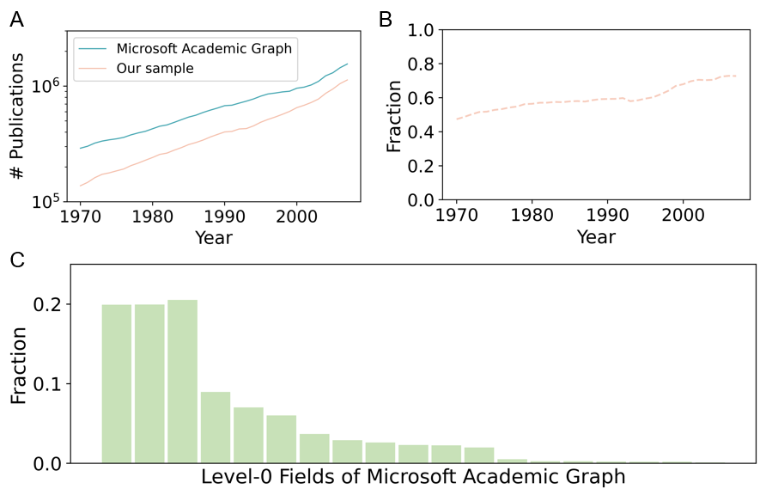

Figure S1. Data landscape extracted from the Microsoft Academic Graph. (A) Publications in Microsoft Academic Graph (MAG) and our sample as a function of time, manifesting consistent exponential growth pattern. (B) Fraction of papers in our sample relative to the whole population as a function of time. (C) Fraction of papers for different scientific fields. They are “medicine”, “chemistry”, “biology”, “physics”, “mathematics”, “psychology”, “materials science”, “economics”, “geology”, “engineering”, “computer science”, “sociology”, “history”, “business”, “philosophy”, “political science”, “art”, “geography”, “environmental science”.
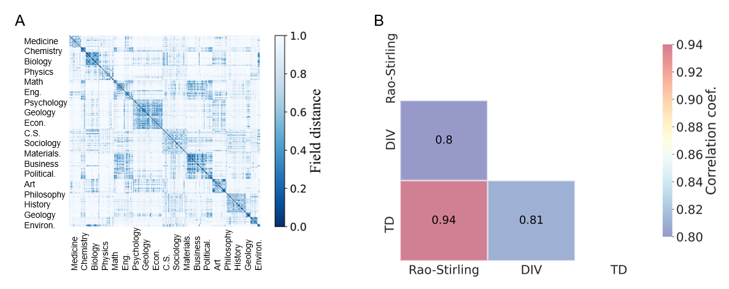

Figure S2. Statistics of interdisciplinary indicators. (A) The distance matrix between scientific fields. (B) Correlations between the Rao-Stirling diversity, TD, and DIV.

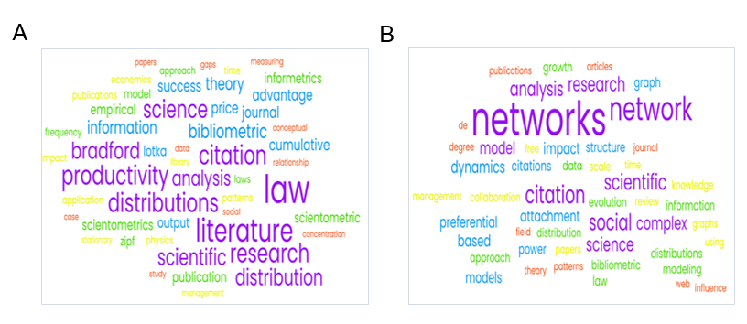

Figure S3. Word Clouds of the most frequent words for papers that cite [20] (A) before the year 2000 and (B) after 2000.

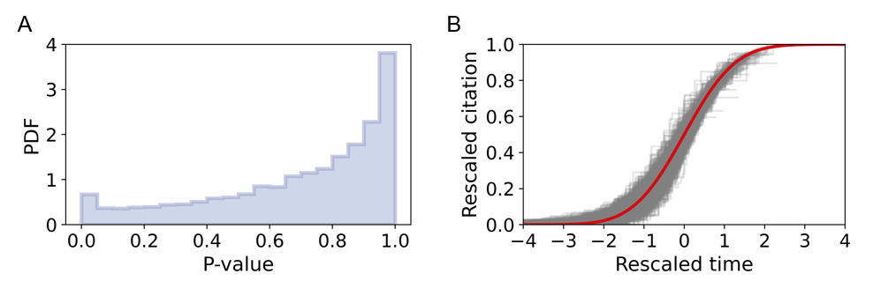

Figure S4. Parameters in the WSB model. (A) The distribution of the KS test p-value across articles with more than 10 citations from 1970 and 2007 that can be fitted by the WSB model. (B) Direct visualization of the fitting results for 1000 randomly chosen papers.
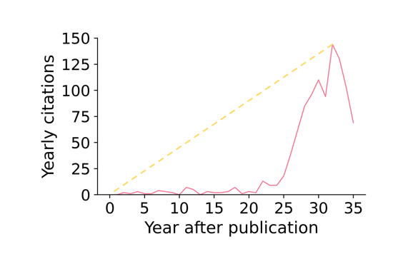

Figure S5. Graphical demonstration of calculating the B index. After [8].
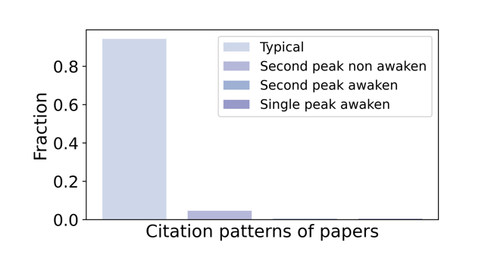

Figure S6. Fraction of typical and “atypical” papers. We calculate the B index and fit the WSB model for journal papers from 1970 to 2007. In line with prior study [11], we set threshold to identify papers with different citation patterns. Papers with p-value > 0.1 and small B index are considered as typical papers, and papers with B index within the top 1% are classified into “awaken” category.
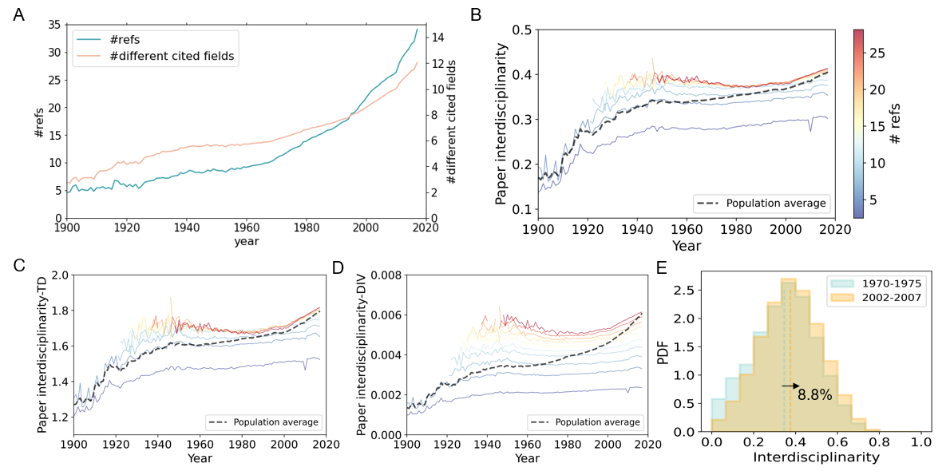

Figure S7. Science becomes more interdisciplinary. (A) The average number of references and different cited fields as a function of time, showing consistent growth pattern in the past century. Average paper interdisciplinarity measured by Rao-Stirling diversity (B), TD (C), and DIV (D) as a function of time, conditional on the number of references (shown by colors). The dashed line represents population average. We select journal papers spanning from 1900 to 2017 with number of references between 2 and 30. To reduce the noise, we remove some extreme values, such that the number of articles reaches at least 100 within the same year and approximately equal number of references. (E) Comparing the distribution of interdisciplinarity between papers published in 1970-1975 and 2002-2007. We find that interdisciplinary level on average increases by a factor of 8.8%.

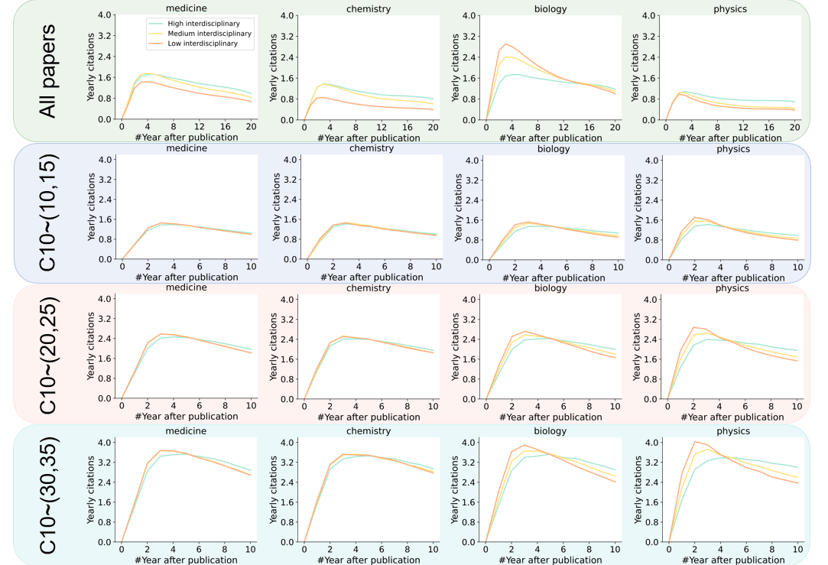

Figure S8. Yearly average citations for papers from different fields. We show paper citations till 20 years or 10 years after publication for high, medium, and low interdisciplinary research across different scientific fields while controlling for citations (i.e., $C_{10}$) intervals.

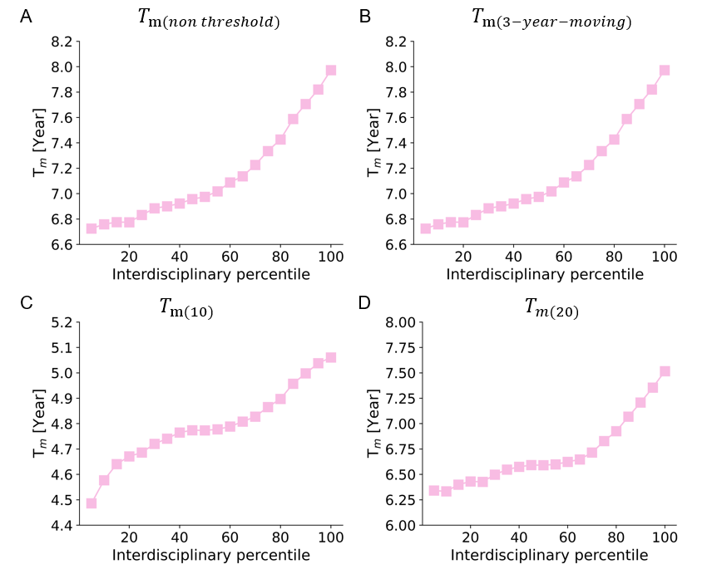

Figure S9. Peak time increases with interdisciplinary percentiles. Four definitions of peak time are provided for comparison. (A) $T_{m(non threshold)}$ is defined the same way as $T_{m}$ used in the main text, but without threshold. (B) $T_{m(3-year-moving)}$ is similar with $T_{m}$, but considering a 3-year-moving-average of yearly citations for individual paper. (C) $T_{m(10)}$, (D) $T_{m(20)}$ are defined the same way as $T_{m}$, but only focuses on 10 years and 20 years citation windows after publication, respectively.

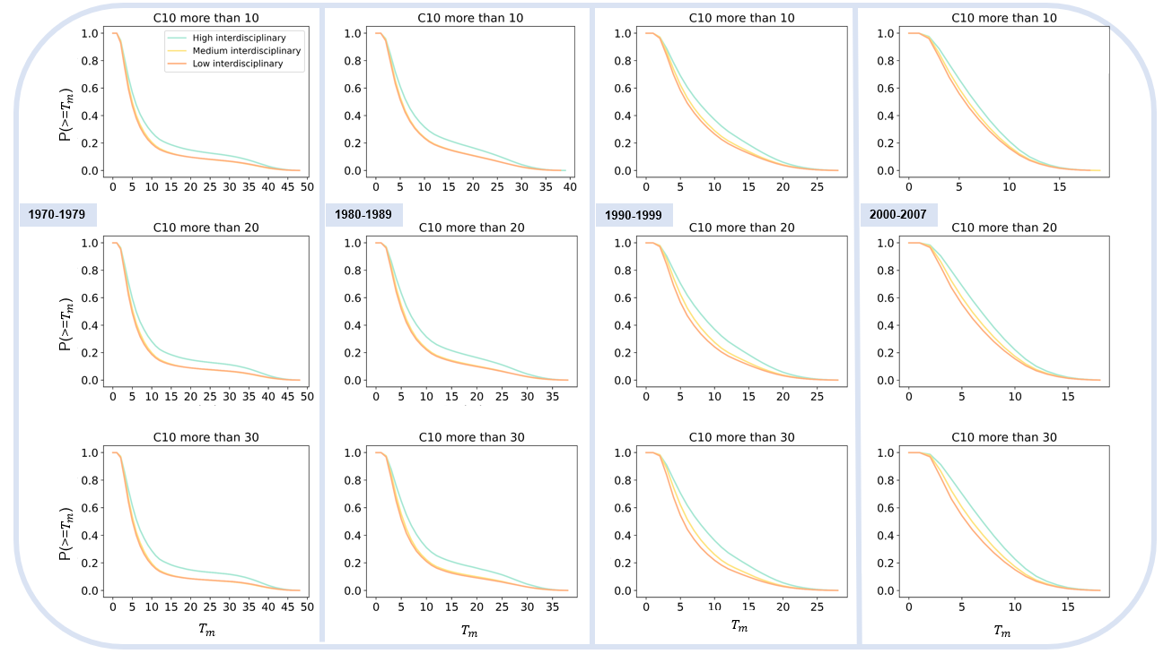

Figure S10. Complementary cumulative distribution of $T_{m}$ across different time periods (i.e., 1970-1979, 1980-1989, 1990-1999, 2000-2007) and various citations intervals (i.e., $C_{10}$ >= 10, $C_{10}$ >= 20, $C_{10}$ >= 30). KS test p-values are smaller than 0.001 for all figures while comparing high interdisciplinary and the other research.

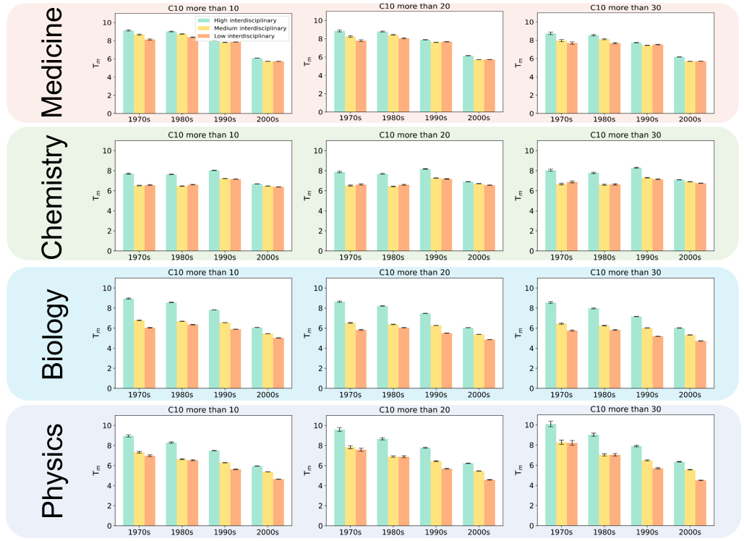

Figure S11. Average $T_{m}$ as a function of time for high, medium, and low interdisciplinary research across different scientific fields (i.e., medicine, chemistry, biology and physics) and citations intervals (i.e., $C_{10}$ >= 10, $C_{10}$ >= 20, $C_{10}$ >= 30).
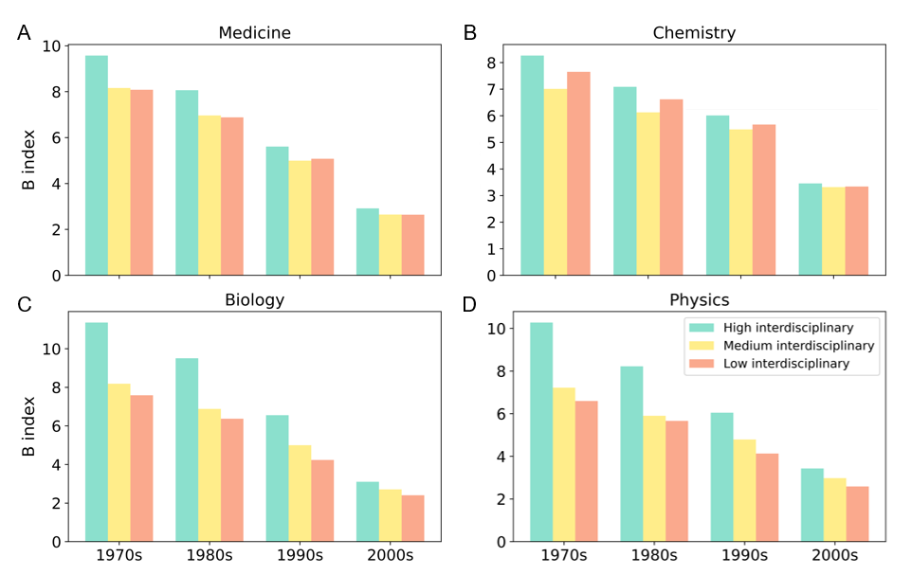

Figure S12. B index for groups of high/ medium/ low interdisciplinary levels across different scientific fields and periods, indicating that high interdisciplinary research is characterized with larger B index.
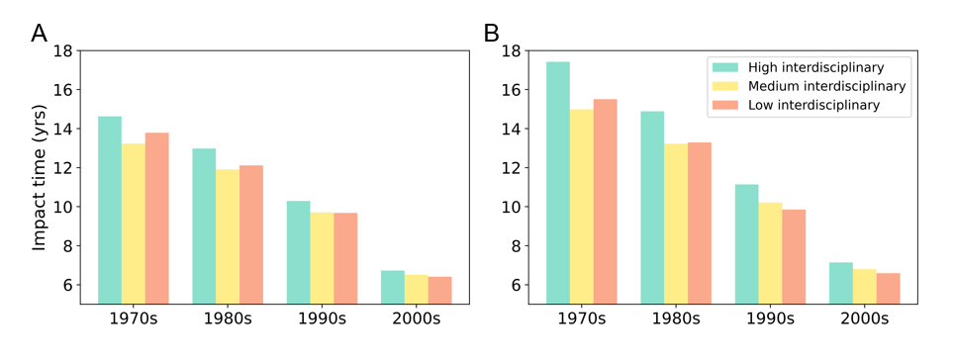

Figure S13. (A) Impact time for papers with high/ medium/ low interdisciplinary levels across different periods. (B) The same as (A) but we use papers with C10 more than 30.

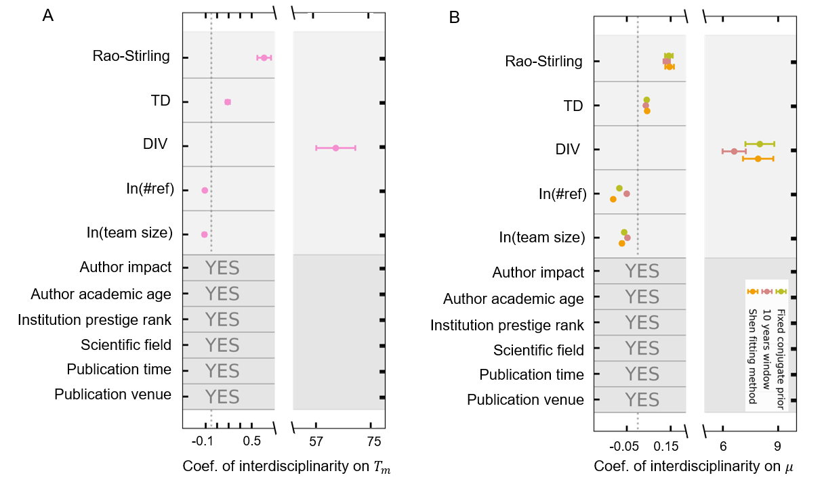
Figure S14. (A) Comparing different regression coefficients of interdisciplinarity on $T_{m}$. (B) Comparing different regression coefficients through different fitting methods. The error bars represent the 95% confidence intervals, and are clustered at individual journal level.

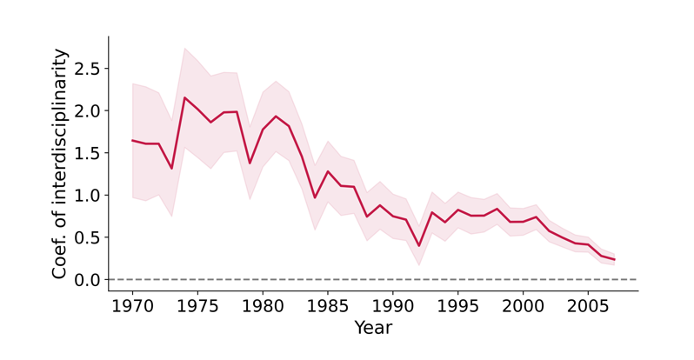

Figure S15. The regression coefficients of interdisciplinarity on $T_{m}$ as a function of time. The shaded area represents 95% confidence interval.

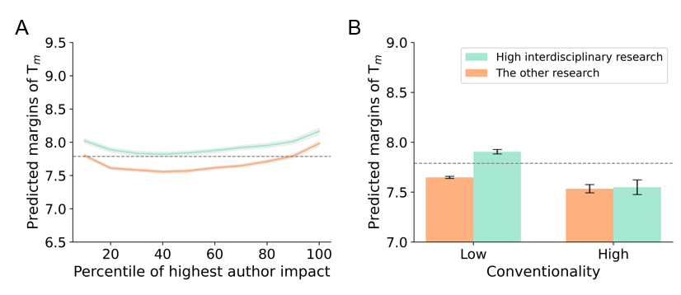

Figure S16. The Matthew effect and content features. (A) The predicted margins of $T_{m}$ conditional on paper interdisciplinarity and the highest author impact (A), and conventionality (B). Shaded area and error bars represent 95% confidence intervals.

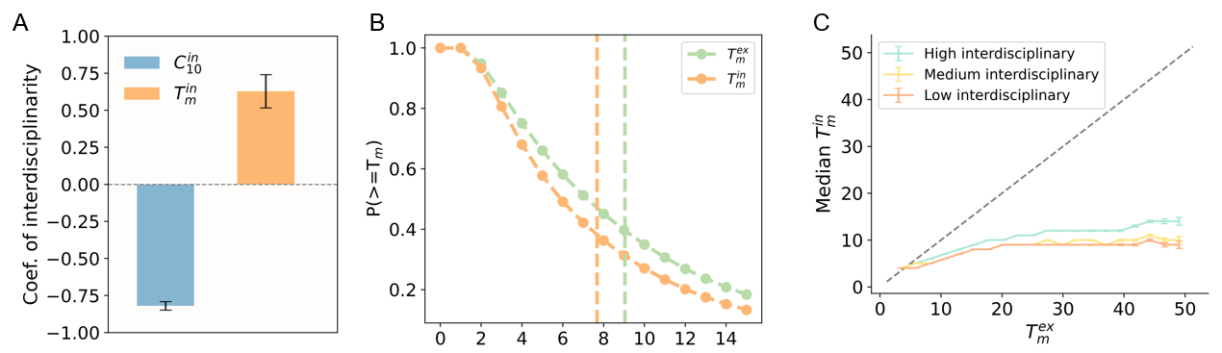

Figure S17. Knowledge diffusion. (A) Interdisciplinary research shows longer time to reach scientific impact and less citations from internal fields. (B) The complementary cumulative distribution of peak time for internal and external citations. (C) Median internal peak time as a function of external peak time for high, medium, and low interdisciplinary research.

Supplementary Tables

Table S1 The Relationship between interdisciplinarity and $T_{m}$, B index, and impact time for individual papers. In parentheses we show the standard error. *** p < 0.001, ** p < 0.05, * p < 0.1, The standard errors are clustered at individual journal level.
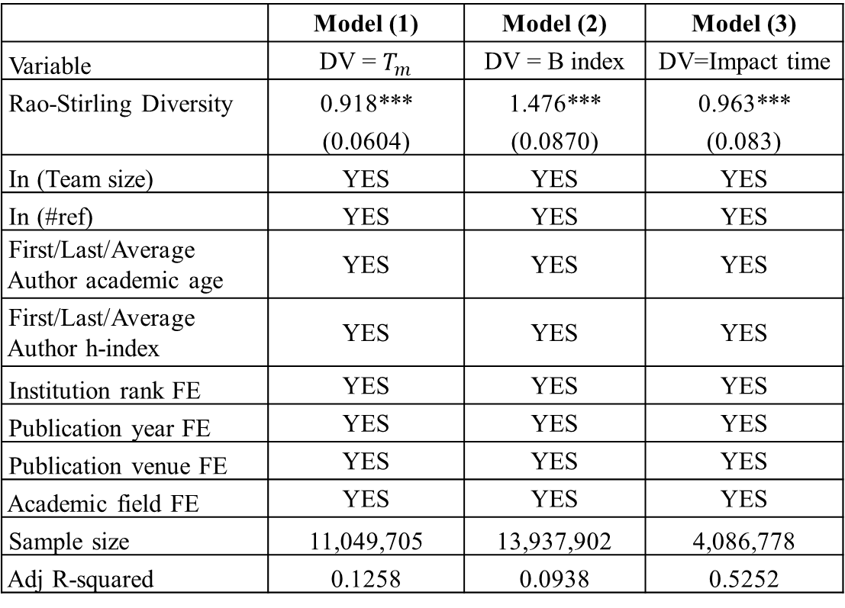

Table S2 Individual fixed effects. In parentheses we show the standard error. *** p < 0.001, ** p < 0.05, * p < 0.1, The standard errors are clustered at individual journal level.
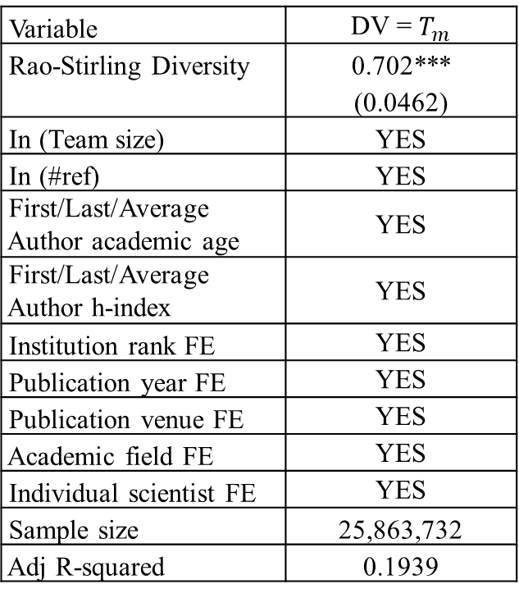

Table S3 Poisson regression for the relationship between interdisciplinarity and $T_{m}$ at individual paper level. In parentheses we show the standard error. *** p < 0.001, ** p < 0.05, * p < 0.1, The standard errors are clustered at individual journal level.
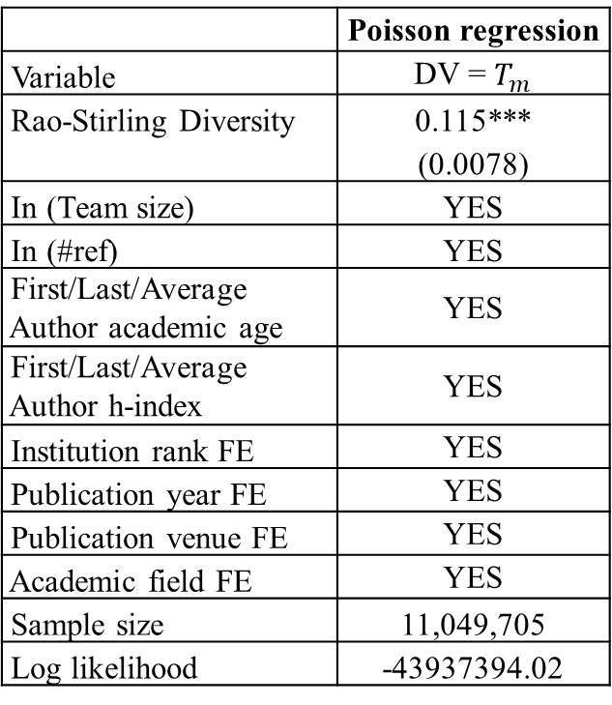

Table S4 Relationship between paper interdisciplinarity and $T_{m}$ with an interaction term between interdisciplinarity and journal impact factor. In parentheses we show the standard error. *** p < 0.001, ** p < 0.05, * p < 0.1, The standard errors are clustered at individual journal level.
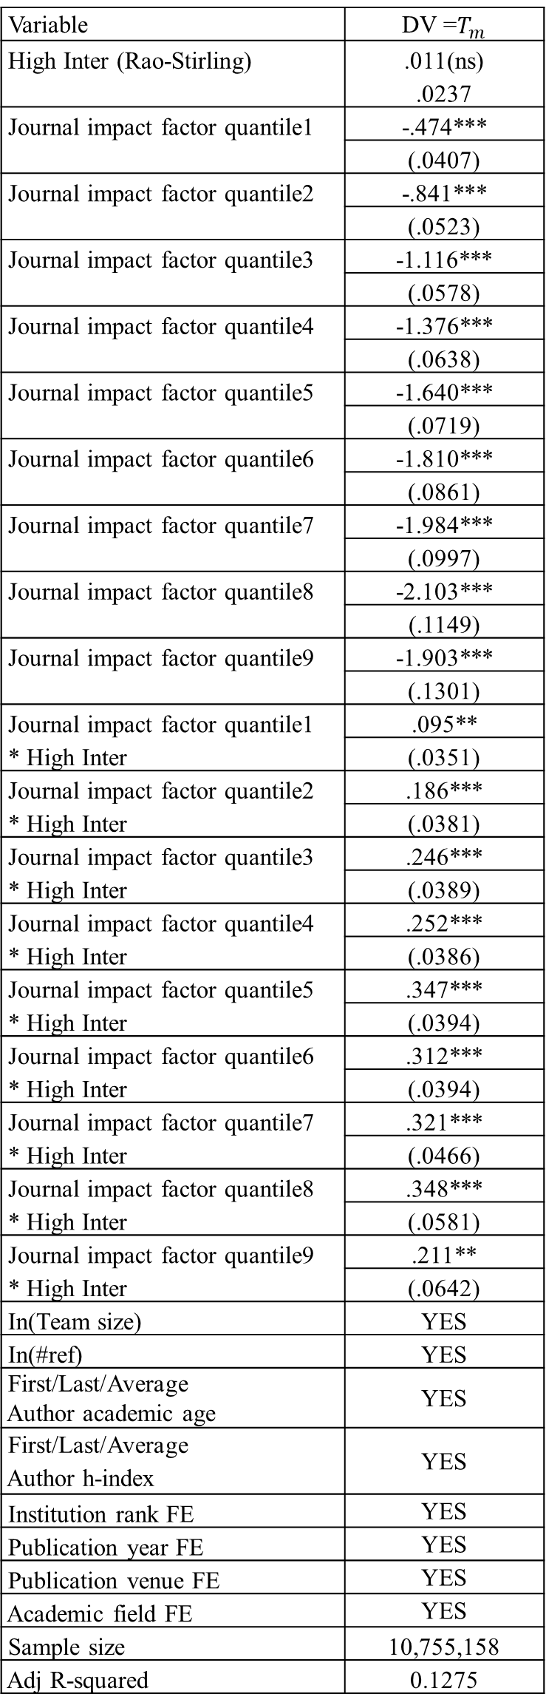
Table S5 Relationship between paper interdisciplinarity and $T_{m}$ with an interaction term between interdisciplinarity and author impact. In parentheses we show the standard error. *** p < 0.001, ** p < 0.05, * p < 0.1, The standard errors are clustered at individual journal level.
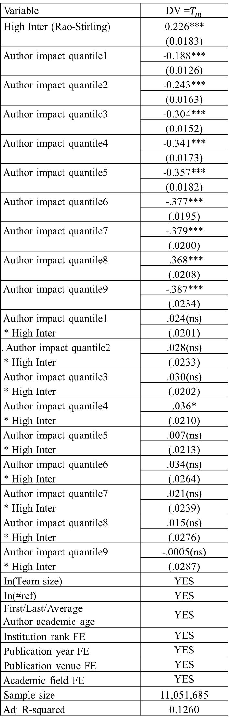
Table S6 Relationship between paper interdisciplinarity and $T_{m}$ with an interaction term between interdisciplinarity and institution prestige. In parentheses we show the standard error. *** p < 0.001, ** p < 0.05, * p < 0.1, The standard errors are clustered at individual journal level.
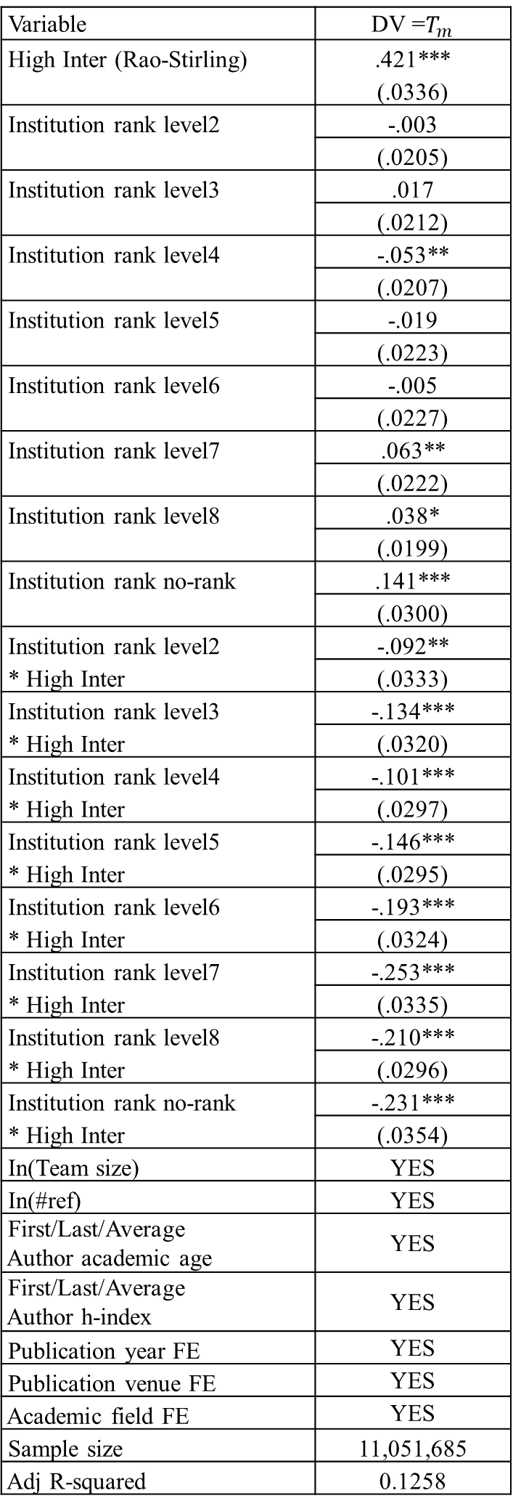
Table S7 Relationship between paper interdisciplinarity and $T_{m}$ with an interaction term between interdisciplinarity and team size. In parentheses we show the standard error. *** p < 0.001, ** p < 0.05, * p < 0.1, The standard errors are clustered at individual journal level.
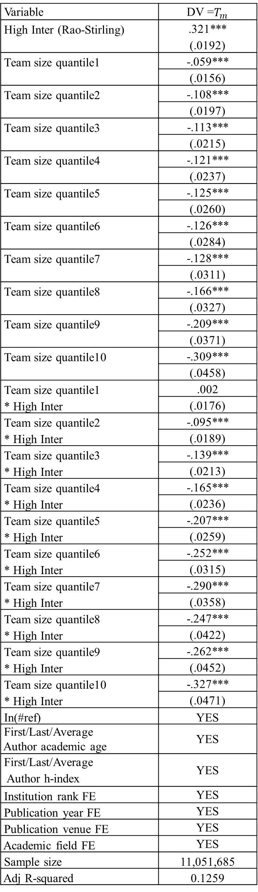
Table S8 Relationship between paper interdisciplinarity and $T_{m}$ with an interaction term between interdisciplinarity and conventionality. In parentheses we show the standard error. *** p < 0.001, ** p < 0.05, * p < 0.1, The standard errors are clustered at individual journal level.
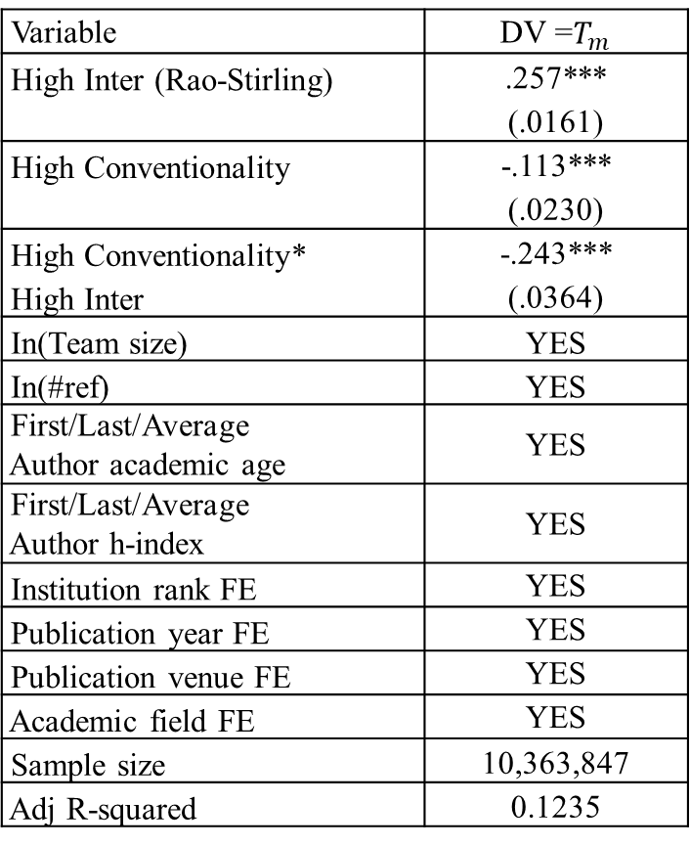

Supplementary References
[1] J. Wang, B. Thijs, W. Glänzel, Interdisciplinarity and impact: Distinct effects of variety, balance, and disparity, PloS one, 10 (2015) e0127298.
[2] A. Yegros-Yegros, I. Rafols, P. D’este, Does interdisciplinary research lead to higher citation impact? The different effect of proximal and distal interdisciplinarity, PloS one, 10 (2015) e0135095.
[3] L. Zhang, B. Sun, L. Jiang, Y. Huang, On the relationship between interdisciplinarity and impact: Distinct effects on academic and broader impact, Research Evaluation, (2021).
[4] L. Leydesdorff, Betweenness centrality as an indicator of the interdisciplinarity of scientific journals, Journal of the American Society for Information Science Technology, 58 (2007) 1303-1319.
[5] L. Leydesdorff, C.S. Wagner, L. Bornmann, Interdisciplinarity as diversity in citation patterns among journals: Rao-Stirling diversity, relative variety, and the Gini coefficient, Journal of Informetrics, 13 (2019) 255-269.
[6] L. Zhang, R. Rousseau, W. Glänzel, Diversity of references as an indicator of the interdisciplinarity of journals: Taking similarity between subject fields into account, Journal of the Association for Information Science Technology, 67 (2016) 1257-1265.
[7] J. Wang, Citation time window choice for research impact evaluation, Scientometrics, 94 (2013) 851-872.
[8] Q. Ke, E. Ferrara, F. Radicchi, A. Flammini, Defining and identifying sleeping beauties in science, Proceedings of the National Academy of Sciences, 112 (2015) 7426-7431.
[9] D. Wang, C. Song, A.-L. Barabási, Quantifying long-term scientific impact, Science, 342 (2013) 127-132.
[10] H. Shen, D. Wang, C. Song, A.-L. Barabási, Modeling and predicting popularity dynamics via reinforced poisson processes, in: Proceedings of the AAAI Conference on Artificial Intelligence, 2014.
[11] Z. He, Z. Lei, D. Wang, Modeling citation dynamics of “atypical” articles, Journal of the Association for Information Science Technology, 69 (2018) 1148-1160.
[12] Y. Sun, V. Latora, The evolution of knowledge within and across fields in modern physics, Scientific reports, 10 (2020) 1-9.
[13] R. Van Noorden, Interdisciplinary research by the numbers, Nature, 525 (2015) 306-307.
[14] A.J. Gates, Q. Ke, O. Varol, A.-L. Barabási, Nature’s reach: narrow work has broad impact, Nature, (2019).
[15] R. Costas, T.N. van Leeuwen, A.F. van Raan, Is scientific literature subject to a ‘Sell‐By‐Date’? A general methodology to analyze the ‘durability’of scientific documents, Journal of the American Society for Information Science Technology, 61 (2010) 329-339.
[16] R.K. Merton, The Matthew effect in science: The reward and communication systems of science are considered, Science, 159 (1968) 56-63.
[17] S. Wuchty, B.F. Jones, B. Uzzi, The increasing dominance of teams in production of knowledge, Science, 316 (2007) 1036-1039.
[18] B. Uzzi, S. Mukherjee, M. Stringer, B. Jones, Atypical combinations and scientific impact, Science, 342 (2013) 468-472.
[19] E. Rinia, T. Van Leeuwen, E. Bruins, H. Van Vuren, A. Van Raan, Citation delay in interdisciplinary knowledge exchange, Scientometrics, 51 (2001) 293-309.
[20] D.d.S. Price, A general theory of bibliometric and other cumulative advantage processes, Journal of the American society for Information science, 27 (1976) 292-306.

