Supplementary Note 1. Calculation process of the diffusion-based resolution limit.
Modulation transfer function (MTF) is the Fourier transform of the point spread function (p(x), that is, the image of a point source).¹ The theoretical pixel response is shown in Figure S1a.

Figure S1. (a) The point spread function of pixels at an ideal condition. (b) The point spread function of pixels when the charge diffusion between neighboring pixel happens.

The theoretical pixel response p(x) could be expressed as:
$p(x)=\left\{\begin{aligned}1,\left|x\right|<0.5pix \\ 0,\left|x\right|≥0.5pix\end{aligned}\right.$ (equation 1)
The modulation transfer function (MTF) of pixels are as followings:
$MTF\left(ν\right)=\left|F\left\{p\left(x\right)\right\}\right|=\int_{-∞}^{+∞}{p(x)e^{-i2πνx}dx}$, (equation 2)
where ν is the spatial frequency (lp/pixel) and ℱ represents the Fourier transform.
Then the maximum MTF of the pixel arrays is well known and is given by the sinc function:
$MTF\left(ν\right)=sinc\left(ν\right)=\frac{sin\left(νπ\right)}{νπ}$ (equation 3)

However, it is necessary to consider the charge sharing effects between the neighboring pixels on the theoretical resolution limit. The charge sharing in X-ray detectors includes the generation of the electron-hole pairs, reabsorption of K fluorescence and diffusion of the charge carriers during their drift towards the electrode². As calculated in our previous study³, the charge diffusion dominates the charge sharing effect compared to the primary electron-hole pairs distribution and fluorescence effect. The charge diffusion is caused by the gradient in the carrier density, while the carriers move towards the surface under the influence of the applied electric field in the vertical direction. The carrier distribution caused by diffusion can be described according to the following relation³:
$n(x)=n_{0}exp⁡(-\frac{{(x-x_{0})}^{2}}{s^{2}})$ (equation 4)
where $s^{2}=4Dt$, x₀ is the incident point of X-ray. In this equation, D is the diffusion constant ($D=kTμ_{i}/e$, where k is the Boltzmann constant, T is the temperature, μ is the carrier mobility, and e is the electron charge). The transit time is given by the relation: $t=d/μ_{i}E$, where d is the thickness of the detector, and E is the electric field applied to the detector. The charge diffusion leads to the response decrease of the given pixel and increase of the neighboring pixels, as shown in Figure S1b. In the figure, the parameter α is the increased response of the neighboring pixels, which is proportional to the above calculated carrier distribution n(x). Then the theoretical p(x) could be amended as:
$p\left(x\right)=\left\{\begin{aligned}1-2α,\left|x\right|≤0.5pix \\ α,0.5pix<\left|x\right|<1.5pix \\ 0,\left|x\right|≥1.5pix\end{aligned}\right.$ (equation 5)
The theoretical modulation transfer function (MTF) considering charge diffusion effect could be amended as:
$$MTF\left(ν\right)=\left|F\left\{p\left(x\right)\right\}\right|=\int_{-1.5pix}^{-0.5pix}{αe^{-i2πνx}dx}+\int_{0.5pix}^{1.5pix}{αe^{-i2πνx}dx}+\int_{-0.5pix}^{0.5pix}{(1-2α)e^{-i2πνx}dx}$$
$$=\left[\frac{αe^{iπν}}{-i2πν}-\frac{αe^{i3πν}}{-i2πν}\right]+\left[\frac{αe^{-i3πν}}{-i2πν}-\frac{αe^{-iπν}}{-i2πν}\right]+\left[\frac{(1-2α)e^{-iπν}}{-i2πν}-\frac{(1-2α)e^{iπν}}{-i2πν}\right]$$
$=\left(1-3α\right)\frac{\sin\left(πν\right)}{πν}+α\frac{\sin\left(3πν\right)}{πν}$ (equation 6)

Equation 6 is the final state for the theoretical spatial resolution by considering the charge diffusion effect. In specific cases, the parameter α has to be calculated according to the pixel size, electric field and film thickness, as shown in equation 4.

The parameter α could be given as:
$α=\frac{p_{N}}{p_{T}+{2p}_{N}}$ (equation 7)
where p_{T} and p_{N} is the response value of the target and neighboring pixels, respectively.
According to equation 4, p_{T} and p_{N} could be expressed as followings:
$p_{N}∝\int_{-1.5pix}^{-0.5pix}{\int_{-0.5pix}^{0.5pix}{n_{0}exp⁡(-\frac{{(x-x_{0})}^{2}}{s^{2}})dx_{0}dx}}$ (equation 8)
$p_{T}∝\int_{-0.5pix}^{0.5pix}{\int_{-0.5pix}^{0.5pix}{n_{0}exp⁡(-\frac{{(x-x_{0})}^{2}}{s^{2}})dx_{0}dx}}$ (equation 9)

Then we could derive the parameter α for the previous perovskite X-ray FPDs and this work according to the pixel size, thickness and electric field (Figure S2a).
For spatial resolution, we adopted the typical MTF value of 0.2 to determine the spatial frequency value according to equation 6. Hence, the diffusion-based resolution limit of the previous studies and our work is 0.568 lp/pix (Nature, 2017, 550, 87), 0.482 lp/pix (Nat Electron, 2021, 4, 681) and 0.560 lp/pix (this work).

Figure S2. (a) The summary of key parameters for perovskite X-ray FPDs. (b)Cross-sectional SEM image of X-ray detector. (c) The charge-diffusion determined resolution limit at MTF=0.2.

Supplementary Note 2. μτ product derived from Hecht equation fitting.
Photoconductivity measurement was carried out on the uniform perovskite and nonuniform perovskite thick film with the structure of Au/perovskite/ITO. The μτ product was obtained by fitting with a modified Hecht equation^{4,5}:
$$I= \frac{I_{0}μτV}{L^{2}} \frac{1-\exp\left(-\frac{L^{2}}{μτV}\right)}{1+\frac{L}{V}\frac{s}{μ}}$$
where I₀ is the saturated photocurrent, L is the perovskite thick film thickness, V is the applied bias, τ is the carrier lifetime, μ is carrier mobility.

Figure S3. (a) Pristine suspension, (b) Pristine suspension with 30 mg/ml MAI addition, (c) Pristine suspension with 30 mg/ml MAI and 30 mg/ml PAN addition, in horizontal position. (d) Unstable suspension (30 mg/ml MAI addition). (e) Blading-grade suspension (30 mg/ml MAI and 30 mg/ml PAN addition).

Figure S4. (a) Transparent adduct. (b) Black adduct. (c) Adducts in suspensions with different extra addition of MAI.

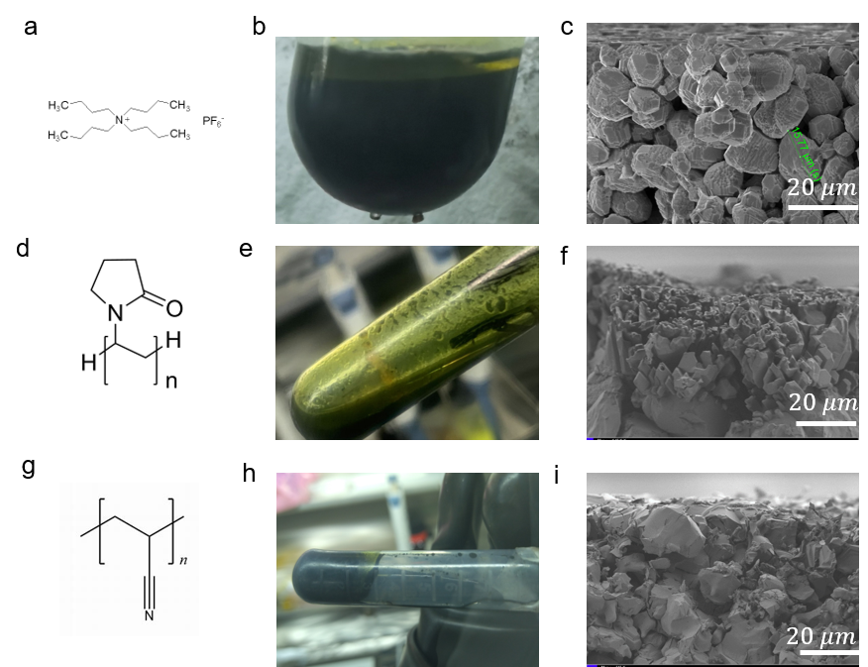
Figure S5 The chemical formula of three types of ligands TAHF (a), PVP (d) and PAN (g). The suspension states and fabricated films after adding each ligands (b, c) for TAHF, (e, f) for PVP, (h, i) for PAN.

Figure S6. The measured viscosity of pristine suspension, the suspension with 30 mg/mL addition of MAI and the suspension with 30 mg/mL addition of MAI and 30 mg/mL addition of PAN.

Figure S7. (a) Fresh pristine suspension (left) and fresh storage-grade suspension prepared by ball milling (right). (b) Pristine suspension stored for 3 weeks. (c) storage-grade suspension stored for 3 weeks.

Figure S8. X-ray diffraction patterns of films prepared with pristine and blading-grade suspensions.

Figure S9. Time dependent response of 100 μm pixels with good contact and failed contacts.

References
1. Fliegel, K. Modeling and measurement of image sensor characteristics. Radio. engineering 13, 27–34 (2004).
2. Que, W. & Rowlands, J. X-ray imaging using amorphous selenium: Inherent spatial resolution. Med. Phys. 22, 365–374 (1995).
3. Zhu, M. et al. Template directed perovskite X-ray detectors towards low ionic migration and low interpixel cross talking. Fundam. Res. 2, 108–113 (2022).
4. Many, A. High-field effects in photoconducting cadmium sulphide. J. Phys. Chem. Solids. 26, 575–578 (1965).
5. Zhou, Y. et al. Heterojunction structures for reduced noise in large-area and sensitive perovskite x-ray detectors. Sci. Adv. 7, eabg6716 (2021).

