Supplementary information

Significant improvement of green light emission efficiency of InGaN/GaN quantum wells by depositing oxide thin films and UV irradiations
S. Kaito ^{a, *}, T. Matsuyama ª, K. Wada ª, M. Funato ^{b}, Y. Kawakami ^{b}, and K. Okamoto ^{a,}
ª Department of Physics and Electronics, Osaka Metropolitan University, ^{b} Department of Electronic Science and Engineering, Kyoto University,

Figure S1 (a) shows that the PL intensity of the sample with a GaN cap layer of 11 nm did not decrease; instead, it increased by a little less than 2-fold even before UV irradiation, although the blue shift was as large as 50 nm, as in the case of the sample with a cap layer of 5 nm. The integrated PL intensity of these samples was enhanced by approximately six times when irradiated with UV for 10 min. The PL intensity of the samples with GaN cap layers 17 nm exhibited a significant increase in the first 2 min after the start of UV irradiation, followed by a gradual increase and saturation of intensity enhanced by approximately 14-fold in approximately 10 min, as shown in FigureS1 (b). Given the results of less enhancement effect when we used the samples with 5, 10, and 11 GaN cap layers and greater enhancement effect when we used the sample with a 17 nm GaN cap layer, the thickness of the GaN cap layer should be thicker than 11 nm to obtain a greater enhancement effect. It is thought that a certain thickness of the GaN cap layer can reduce the damage to the QW when sputtering SiO₂. When the thickness of the GaN cap layer is 25 nm, its PL intensity slightly increases in the first minute and steeply changes after 1 min of UV irradiation, following which the PL integrated intensity saturates and enhances more than 12-fold, as shown in Figure S1 (c). The PL intensity for the first minute remained almost flat and increases rapidly after 2 min of UV irradiation, and a 16-fold enhancement in the integrated PL intensity can be observed for the SiO₂-coated emitter. Figure S1 (d) illustrates the PL spectra of the SiO₂-coated emitter with a 40 nm GaN cap layer when irradiated with UV for 10 min continuously. No significant blue shift was observed when the GaN cap layer was 5, 10, and 11 nm, but a 5 nm blue shift from the original emission wavelength. Because the thicker the GaN cap layer, the smaller the blue shift, a thicker GaN cap layer eliminates the need to consider the large emission wavelength shift, making it easier to increase the PL intensity at the intended wavelength. A similar trend of spectral change was observed when the GaN cap layer was 70 nm, with more than 15-fold increase in the PL intensity. The spectra are shown in Figure. S1 (e). When the GaN cap layer is 100 nm, the PL intensity in the four minutes is almost flat and a steep change is observed after 5 min of UV irradiation. Then, the PL integrated intensity saturates for 17 min and enhances by more than 18-fold. The spectra are illustrated in Figure S1 (f). The sample with a GaN cap layer thickness of 150 nm did not exhibit any enhancement by depositing SiO₂ and UV irradiation, as shown in Figure S1 (g).

Figure S2 (a) shows the PL intensities of a SiO₂-uncoated InGaN/GaN SQW dependence of temperature. The PL peak wavelength is 543 nm, and the GaN cap layer is 40 nm. Figure 3b depicts the temperature dependence of the PL intensity of a 5 nm SiO₂-coated InGaN/GaN SQW following UV irradiation until the PL intensity at room temperature was saturated. Figure 3c shows the Arrhenius plots of the temperature dependence of the SQW PL intensity with and without SiO₂. Assuming that the IQE at cryogenic temperature (8 K) is 100% because excitons are almost no longer trapped in non-radiative sites at the temperature, the estimated IQE at room temperature greatly improved from approximately 4% to 25% by depositing SiO₂ and UV irradiation. We plotted the improved IQE of the SQW as a green star.

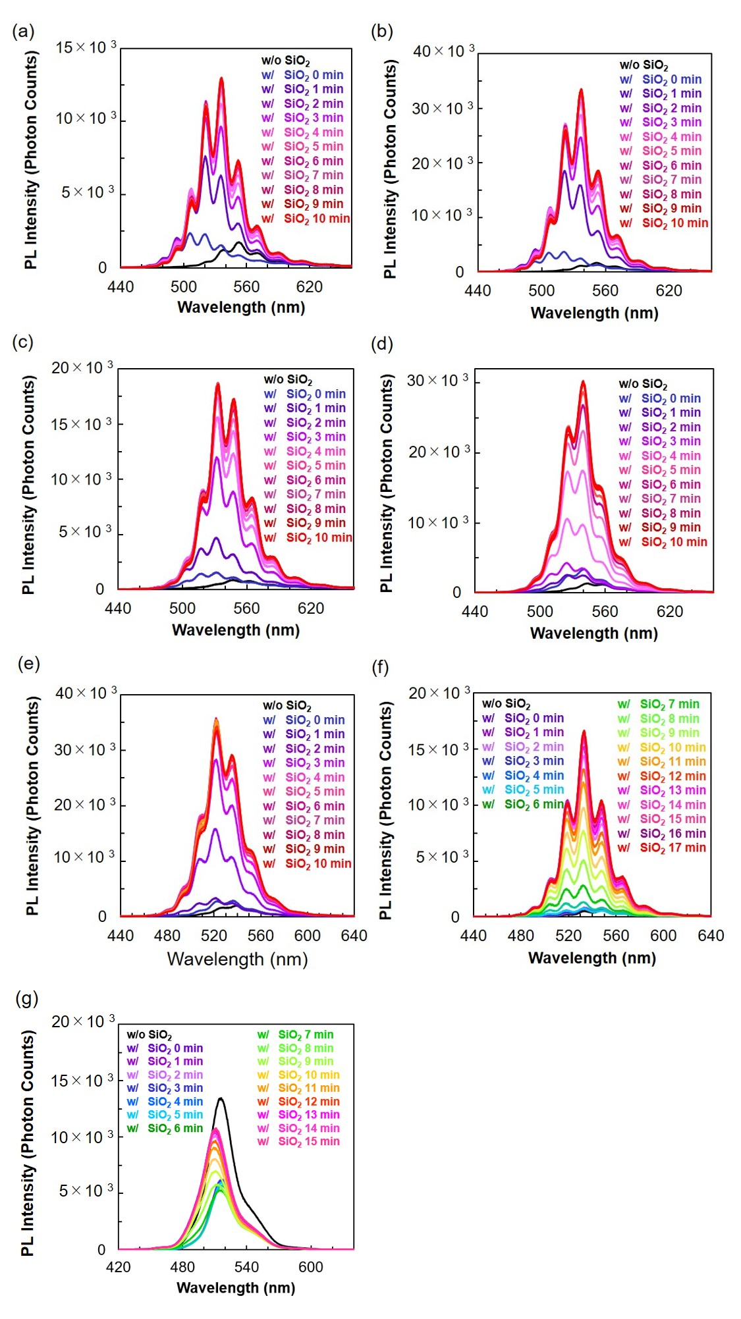
Figure S1
a The PL spectra from the SiO₂-uncoated InGaN/GaN SQW and SiO₂-coated InGaN/GaN SQW with UV irradiation for ten minutes which GaN cap layer is 11 nm. b The PL spectra from the SiO₂-uncoated InGaN/GaN SQW and SiO₂-coated InGaN/GaN SQW with UV irradiation for ten minutes in which the GaN cap layer is 17 nm. c The PL spectra from the SiO₂-uncoated InGaN/GaN SQW and SiO₂-coated InGaN/GaN SQW with UV irradiation for ten minutes, where the GaN cap layer is 25 nm. d The PL spectra from the SiO₂-uncoated InGaN/GaN SQW and SiO₂-coated InGaN/GaN SQW with UV irradiation for ten minutes has a GaN cap layer of 40 nm. e The PL spectra from the SiO₂-uncoated InGaN/GaN SQW and SiO₂-coated InGaN/GaN SQW with UV irradiation for ten minutes and GaN cap layer is 70 nm. f The PL spectra from the SiO₂-uncoated InGaN/GaN SQW and SiO₂-coated InGaN/GaN SQW with UV irradiation for ten minutes, and the GaN cap layer is 100 nm. g The PL spectra from the SiO₂-uncoated InGaN/GaN SQW and SiO₂-coated InGaN/GaN SQW with UV irradiation for ten minutes where the GaN cap layer is 140 nm.

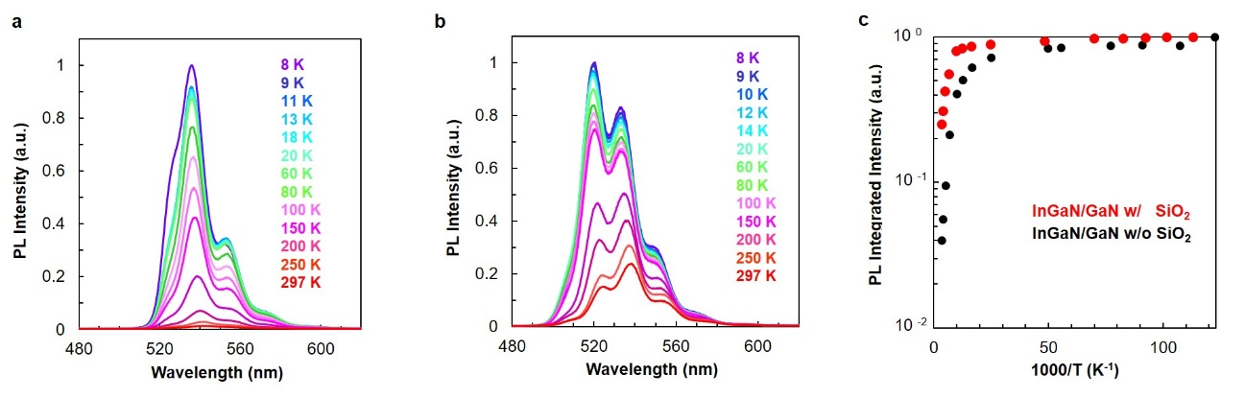

Figure S2
a Temperature dependence of the PL spectra of the SiO₂-uncoated InGaN/GaN SQW. b Temperature dependence of the PL spectra of SiO₂-coated InGaN/GaN SQW after UV irradiation. c Arrhenius plots of SQW PL intensity with or without SiO₂.

