Supplementary materials

Supplementary Figure 1. PRISMA (Preferred Reporting Items for Systematic Reviews and Meta-Analyses) flow diagram⁴²

Records identified from:
Embase (n = 210)
Web of Science (n = 165)
Records removed before screening:
Duplicate records removed (n = 105)
Records marked as ineligible by automation tools (n = 0)
Records removed for other reasons (n = 0)
Records screened
(n = 270)
Records excluded
(n = 227)
Reports sought for retrieval
(n = 43)
Reports not retrieved
(n = 4)
Reports assessed for eligibility
(n = 39)
Reports excluded:
Used pre-annotated dataset (n = 8)
Did not annotate alarms (n = 8)
Studies included in review
(n = 20)
Reports of included studies
(n = 23)
Identification of studies via databases and registers
Identification
Screening

Included

Supplementary Figure 2. Medication “Bolus” annotation rule with example data and annotation result
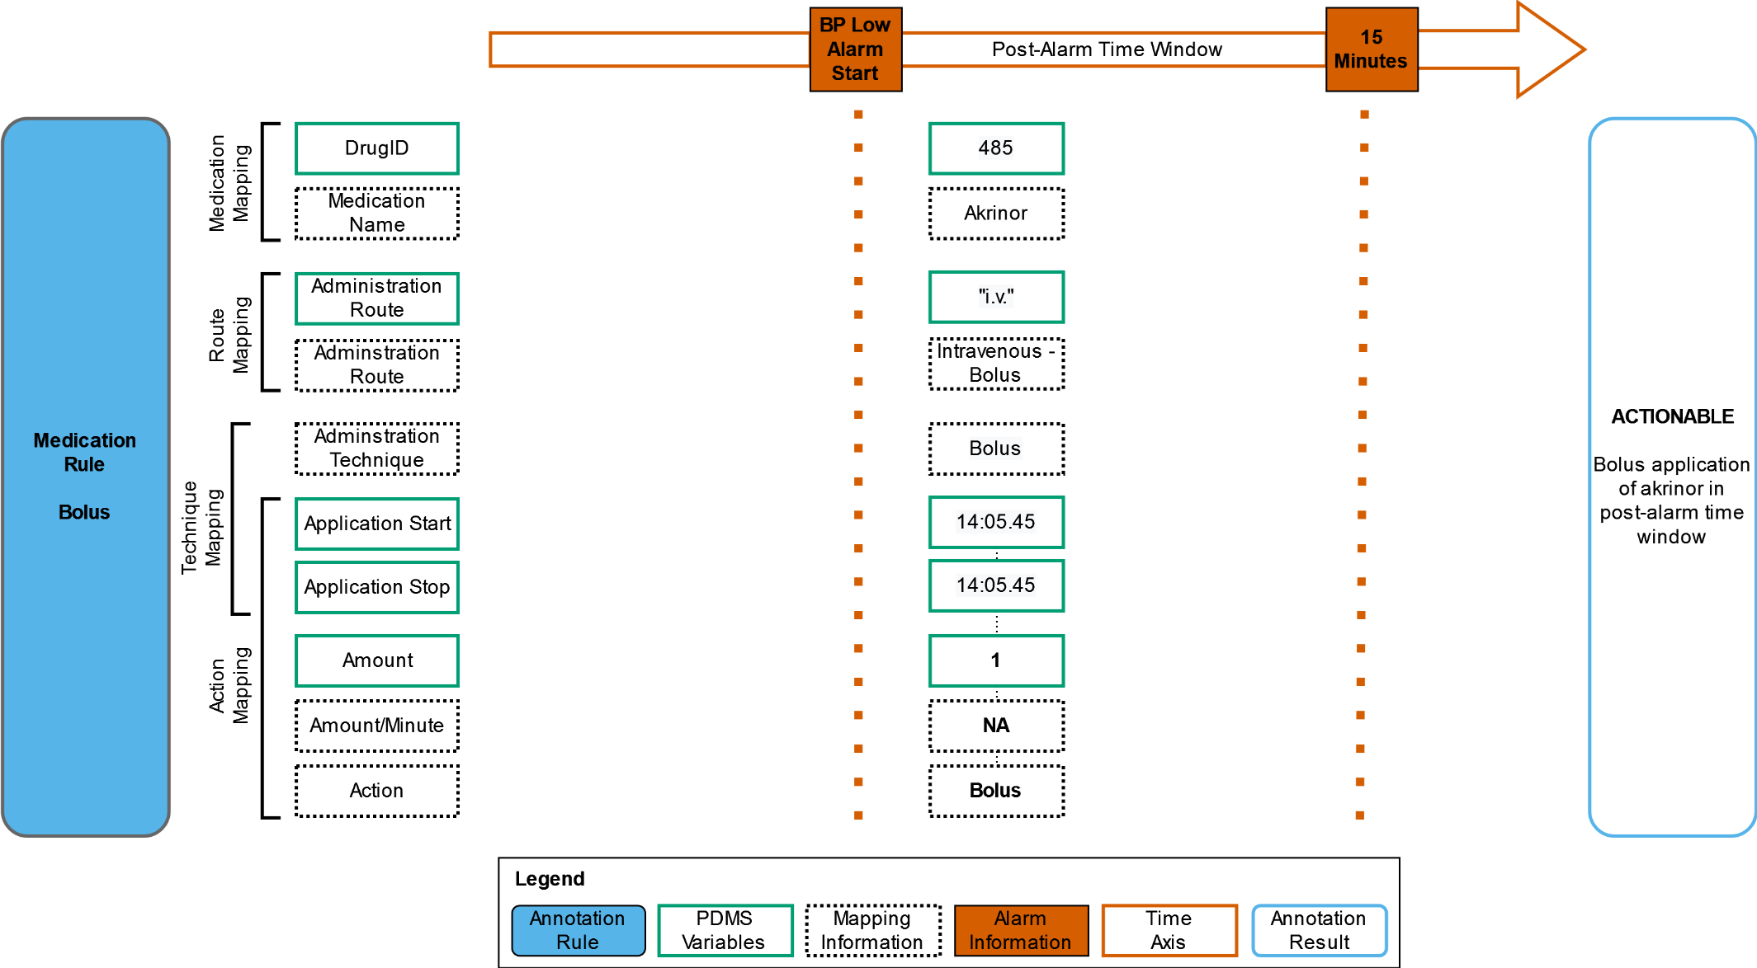

Supplementary Figure 3. Medication “Start” annotation rule with example data and annotation result.
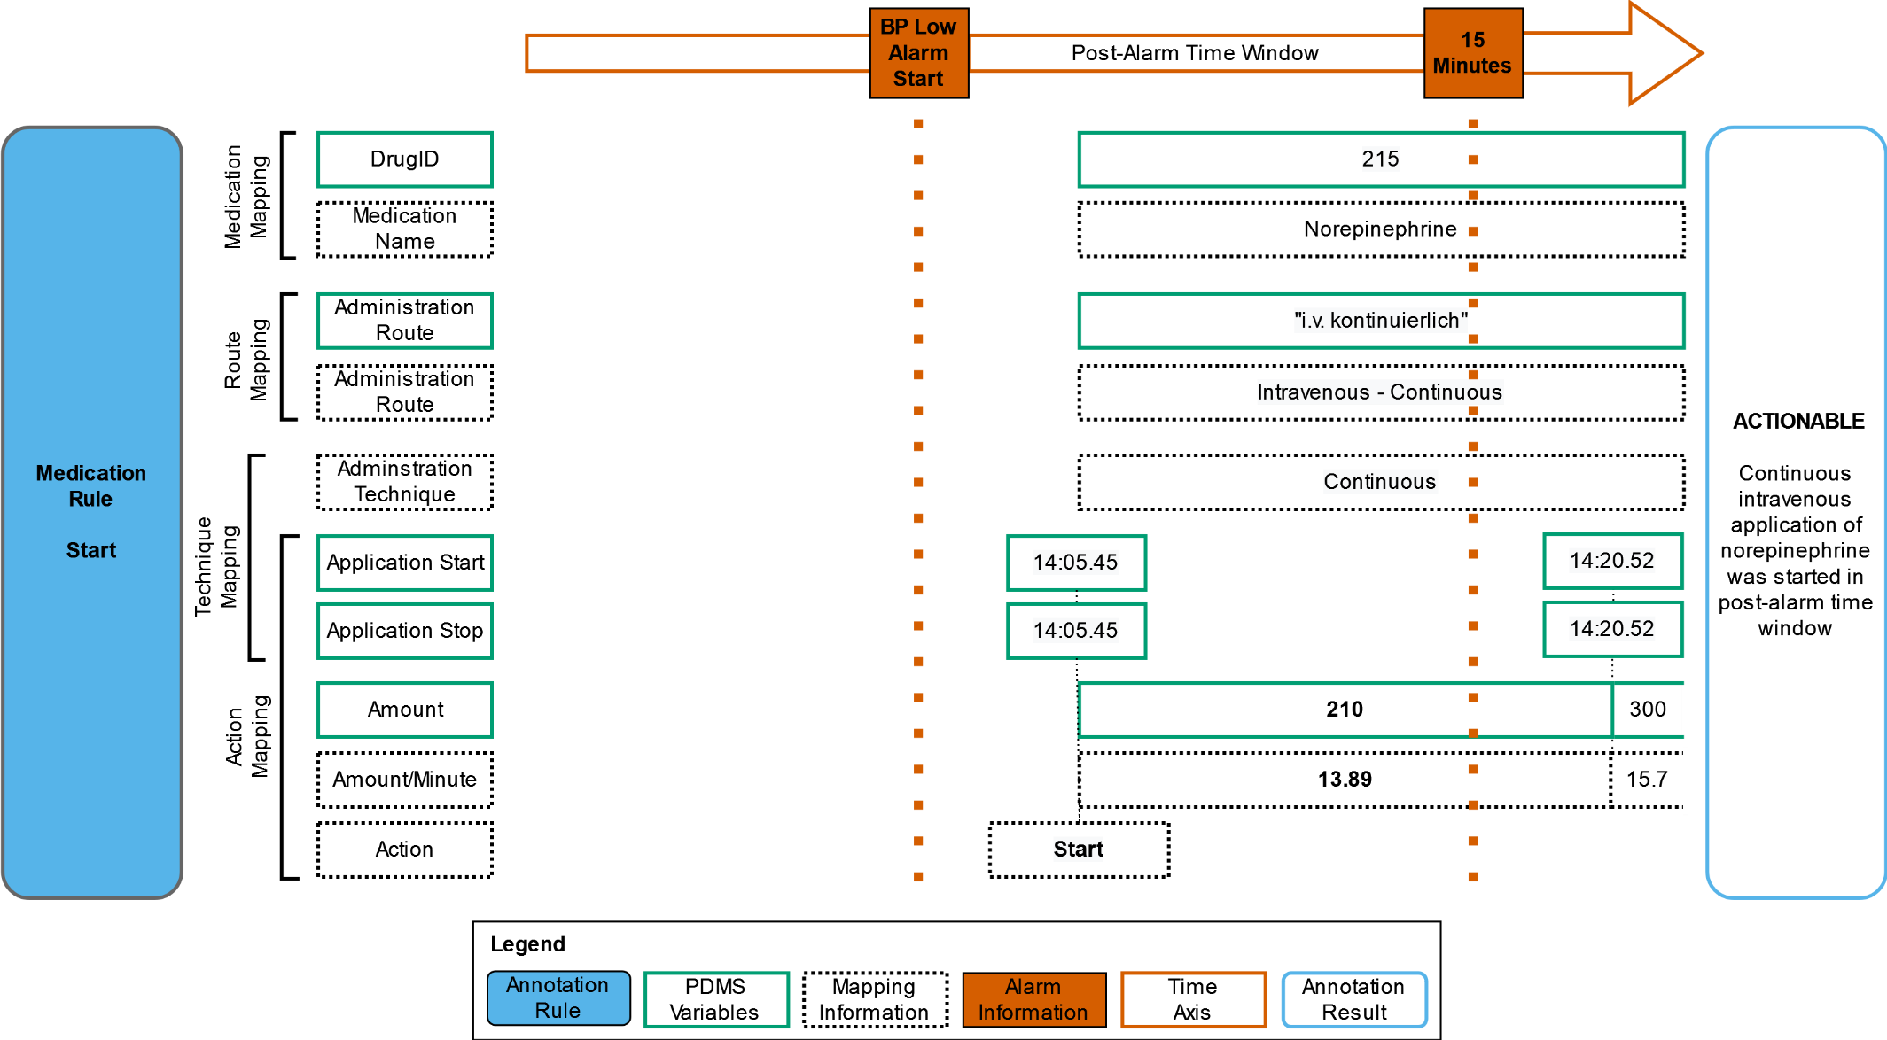

Supplementary Figure 4. Medication “Stop” annotation rule with example data and annotation result
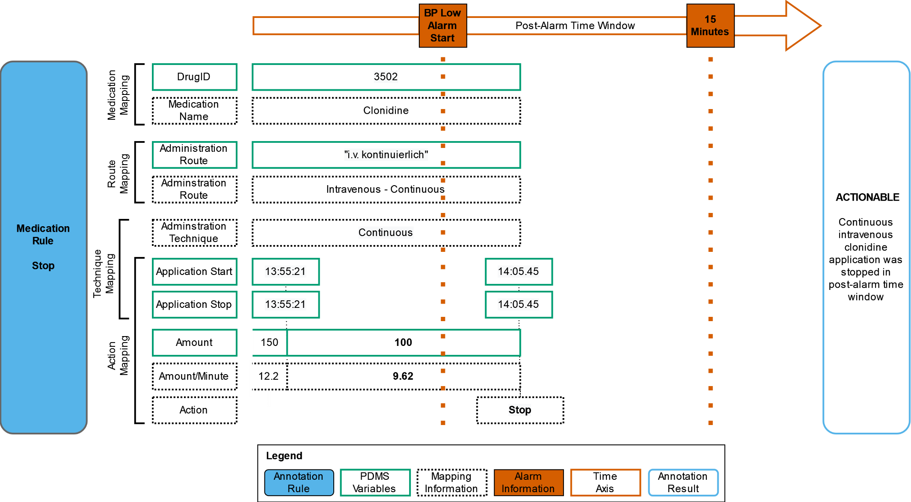

Supplementary Figure 5. Medication “Decrease” annotation rule with example data and annotation result
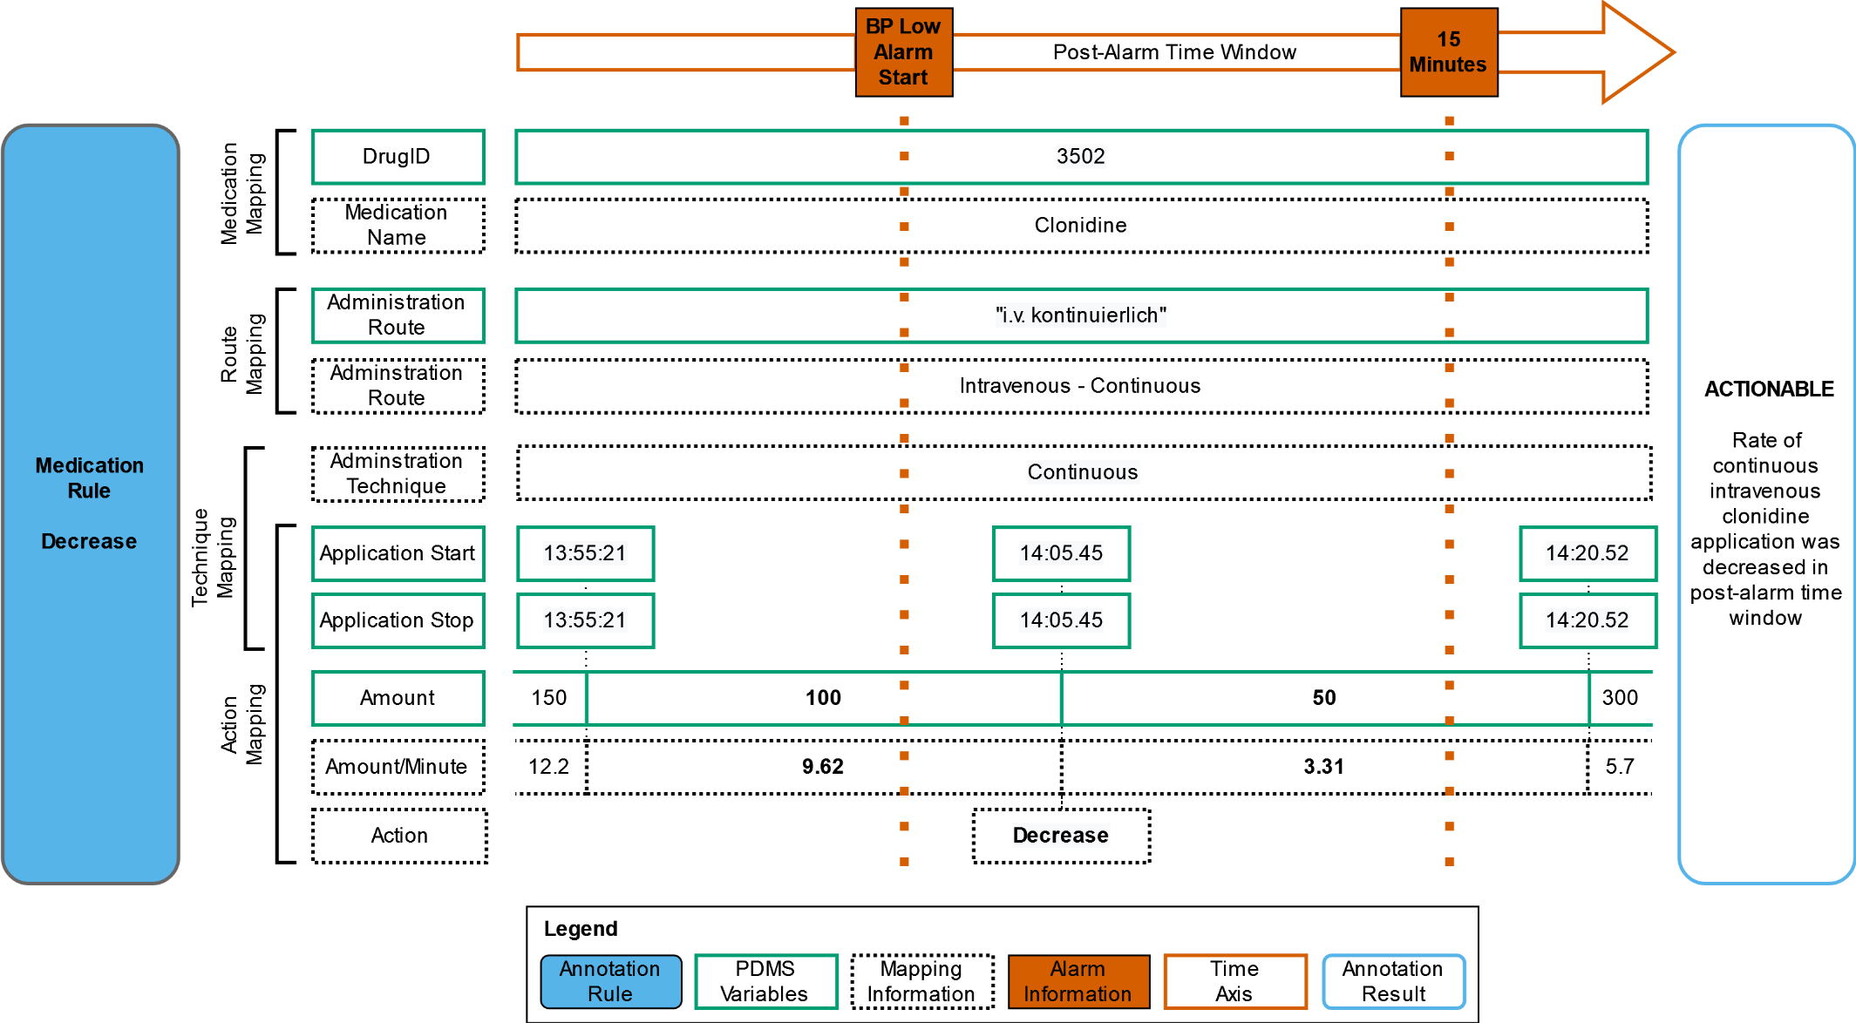

Supplementary Table 2. Results of the exploratory analysis of data sources, structures and entries
Findings | Examples and/or Explanations
Nested database structure | The medication model is complex and nested in the PDMS
Duplicate information between systems | Lab results are stored in the PDMS and HIS
Different documentation types: manually vs. automatically | Data from some devices, such as medication pumps, despite having a connection to the PDMS, need to be entered manually for legal reasons
Different data formats and structures | Unstructured and structured; string (predefined or free text or both), integer, date, codes from terminologies, etc.
Different storage frequency and data accuracy of same features across ICUs | Example 1: A parameter might be saved every time it changes, on a regular basis (for instance every 5 minutes), or both.  Example 2: A parameter might be saved as an exact value or as an average of the values measured in a set time period.  Example 3: Timestamps might be rounded up or down (e.g., to the nearest 5 minutes).
Systems and devices might use different time zones | We noticed that data contained timestamps with different time zones, such as Coordinated Universal Time, and local summer and winter time.
Different timestamps might be documented for a single variable | Two timestamps can be stored for a set of variables: “storetime” is the timestamp when the variable has been entered or updated (either manually or automatically), while “charttime” is the timestamp representing the time when the event happened. We noticed that the “storetime” might be logged before the “charttime” for automatically transmitted variables, but not for manually documented ones. On the other hand, the “storetime” might be later than the “charttime”, e.g., when personnel document interventions retrospectively.
Storage settings of devices and systems are mostly local | Every ICU can set the storage and accuracy preferences in its instance of the PDMS – the settings cannot be assessed centrally.
Ventilation devices might transmit values despite standby mode | We noticed that some ventilation devices still transmitted values for set ventilation parameters to the PDMS while their mode was standby.
PDMS does not contain much medical logic | Example 1: The PDMS cannot assess based on the relevant information if the respiratory support therapy is invasive or non-invasive – as defined in ISO19223 3.1.3⁶³.  Example 2: The PDMS does not indicate – except for lab parameters – if the values stored are in the physiological range, or even if they are plausible and compatible with life.
Alarm logs are stored locally and temporarily without integration in the PDMS or HIS | Philips IntelliVue central station stores the patient alarm logs locally for a limited amount of time and personnel need to collect those on-site using USB storage devices.
Alarm logs need extensive processing | The alarm logs are comma-separated value files (csv files) and contain the bed name, a timestamp when the alarm was entered in the log, and a string with alarm information (alarm types, criticality, timestamps such as start, end, pause, measured values of the monitored vital signs and thresholds that are exceeded or undershot). This information is extracted using Regular Expression. Alarms do not have identifying identifiers: alarm start and end can only be correlated by sorting the alarm log entries chronologically in an error-prone best effort. Additionally, alarm logs do not include patient identifying information, and need to be mapped to patients using bed name and timestamp information from the PDMS and HIS.

Supplementary Table 3. Advantages and disadvantages of different annotation methods
Methods | Time-Stamped Annotation in Person in an ICU | Annotation through Visualization of Records in PDMS Frontend | Semi-Automatic Rule-Based Annotation | Automatic Annotation
Method Description | (A) Medical expert(s) annotate(s) in real time and at the bedside clinical interventions performed after patient alarms on an ICU. | (A) Medical expert(s) investigate(s) patient data using the PDMS frontend and assess(es) the available data close to alarm timestamp(s) using medical knowledge and experience. | Development of a rule-based logic and annotation guidelines, and application of this logic using scripts (e.g., written with R, Python). The logic is based on routine clinical patient data stored in the PDMS, HDL and HIS. | Automatic annotation based on ML algorithms
Time Perspective | Prospective | Retrospective | Retrospective | Retrospective
Data Sources | Information on alarms and bedside tasks recorded by (an) annotator(s) | Alarm logs from monitoring system  All patient information recorded in PDMS | Alarm logs from monitoring system  (Selected) Patient features from PDMS/HIS and/or HDL and/or project-specific database | Alarm logs from monitoring system  (Selected) Patient features from PDMS/HIS and/or HDL and/or project-specific database
Personal Resources | Person(s) with medical background | Person(s) with medical background | To develop the guidelines: Person(s) with medical background  To implement the logic: Person(s) with data science/information technology skills | Person(s) with data science/information technology skills
Time Resources | High | High | Medium | Low
Data Size | Limited by the prospective collection setting – greater amount with increasing data collection duration or number of annotators | Limited by the annotation setting – greater amount with increasing annotation period or number of annotators | Potentially all alarm logs that include alarm types considered by the annotation guidelines | Potentially all alarm logs
Data Quality | High – “[C]linical annotations are generally accepted as an alternative [to a gold standard]”²⁰ | Medium to high | Medium | Medium
Scalability | Limited | Limited | Yes | Yes
Limitations | Administrative and organizational efforts; considerable time and personal resources | Considerable time and personal resources | Data (pre-) processing and wrangling | Requires an existing algorithm that has been trained or tested on an already labelled dataset

Supplementary Table 4. Airway device (AD) categories, mapping results (number) and examples from the patient data management system (PDMS)
AD Categories |  |  | Number of AD mapped to category | Examples from PDMS
AD_LEVEL | AD_CATEGORY_ID | AD_CATEGORY_NAME | Number of AD mapped to category | AD_ENTRY _ID | AD_ENTRY_NAME
1 | 1 | Blank / No AD | 3 | 1 | “ “
2 | 10 | Oropharyngeal Airway | 4 | 135 | “Güdel”
2 | 11 | Nasopharyngeal Airway | 15 | 743 | “Wendel”
3 | 2 | Oxygen Nasal Cannula | 45 | 303 | “O2-Nasenbrille”
4 | 4 | Oxygen Mask | 24 | 301 | “O2-Maske”
5 | 5 | Nasal CPAP Mask | 68 | 5 | “Air Fit N30i”
6 | 6 | Full Face CPAP Mask | 108 | 411 | “Resmed AirFit F30”
7 | 3 | High Flow Nasal Cannula | 84 | 141 | “HFNC-Brille”
8 | 8 | Laryngeal Mask | 44 | 202 | “LMA i-gel”
9 | 7 | Tracheal Cannula (including Speech Valve or Cannula) | 460 | 526 | “TK Rüsch”
9 | 9 | Endotracheal Tube | 251 | 225 | “Magill Tubus”
0 | 12 | Bag Valve Mask | 2 | 755 | “Ambubeutel”
0 | 13 | Inhaler or Breathing Exerciser | 9 | 172 | “inhalette”
0 | 14 | (Tracheostoma) Placeholder | 8 | 338 | “Platzhalter”
0 | 15 | Temperature / Esophageal probe | 2 | 330 | “Ösophagustemperatursonde”
0 | 16 | Nasal Stents | 3 | 35 | “Choanalröhrchen”
0 | 17 | Palate Plate | 4 | 128 | “Gaumenplatte”
0 | 18 | Documentation Error | 1 | 739 | “versehent. DOPPLUNG”

Supplementary Table 5. Respiratory support therapy categories and levels with descriptions – Note that descriptions of ventilation-mode groups were taken from ISO 19223⁶⁵. Addendum: Ventilation-mode Group 1: “group of ventilation-modes sharing ventilation-patterns in which only one inflation-type can be selected at a time, this being assured to be initiated at least at the set rate”; Ventilation-mode Group 2: “group of ventilation-modes sharing ventilation-patterns in which an inflation-type is selected to be initiated at the set rate; between these assured inflations spontaneous breathing is possible, which can be either unassisted or supported by a selected support inflation-type”; Ventilation-mode Group 3: “group of ventilation-modes sharing ventilation-patterns in which every patient-trigger event initiates a selected inflation-type; if a patient-trigger event does not occur within a set time interval a second selected inflation-type is initiated by the ventilator”; Ventilation-mode Group 4: “group of ventilation-modes sharing ventilation-patterns that enable continuous unrestricted breathing or continuous supported breathing, always with a constant baseline airway pressure at the set [baseline airway pressure] level”
RST |  | Description
Level | Category
1 | Spontaneous Breathing (without oxygen supply) | Breathing without the support of an oxygen delivery system or ventilator system
2 | Oxygen Therapy | Oxygen supply applied at a low flow rate (mostly by a conventional oxygen delivery system)
3 | Ventilation-mode Group 4b as defined by ISO 19223 | “subset of Group 4 ventilation-modes with no provision to support any inspiratory activity”
4 | High Flow Oxygen Therapy | Oxygen supply applied at a high flow rate after humidification and warming by special oxygen delivery systems
5 | Ventilation-mode Group 4a as defined by ISO 19223 | “subset of Group 4 ventilation-modes with provision to support each inspiratory activity that exceeds a threshold value”
6 | Ventilation-mode Group 1b, Group 2b, Group 3 as defined by ISO 19223 | Ventilation-mode Group 1b: “subset of Group 1 ventilation-modes in which the selected inflation-type is assured to be initiated at successive intervals determined by the set rate if not initiated within such an interval by a patient-trigger event.”  Ventilation-mode Group 2b: “subset of Group 2 ventilation modes with the initiation of each assured inflation being synchronized with any spontaneous breathing while maintaining the set rate”  Ventilation-mode Group 3: see definition in Addendum
7 | Ventilation-mode Group 1a and  Group 2a as defined by ISO 19923, and High Frequency Jet Ventilation | Ventilation-mode Group 1a: “subset of Group 1 ventilation-modes with no provision for the selected inflation-type to be initiated by a patient-trigger event”  Ventilation-mode Group 2a: “subset of Group 2 ventilation-modes with no provision for the assured inflations to be initiated by a patient-trigger event”  High Frequency Jet Ventilation: High frequency ventilation applied with a jet of gas.

Supplementary Table 6. Patient data management system (PDMS) entries (strings in German, delimited by semicolon) mapped to defined routes of administration and techniques
Routes of Administration | Techniques of Administration | PDMS entries
Per os or enteral | Bolus | “p.o”.; “enteral”
Intravenous – Bolus | Bolus | “i.v. ”; “i.v. Kurzinf.”; “Infusion”
Intravenous – Continuous | Continuous | “i.v.”; “i.v. kont.”; “i.v. kontinuierlich”; “i.v. Kurzinf.”
Sublingual | Bolus | “sublingual”; “buccal”; “bukkal”
Intramuscular | Bolus | “i.m.”
Inhalative | Bolus | “inhalativ”
Inhalative, Endobronchial or Intratracheal | Bolus | “inhalativ”; “endobronchial”; “intratracheal”
Subcutaneous | Bolus | “s.c. ”

Supplementary Table 7. Annotation output structure for airway management interventions
Column Name | Alarmlog_id | Annotation_rule | Actionable_time | Pre_value | Pre_Mapping | Pre_Invasiveness_Degree | Post_value | Post_Mapping | Post_Invasiveness_Degree | Alarm_indication
Data Type | TEXT | TEXT | DATETIME | TEXT | TEXT | TEXT | TEXT | TEXT |  | TEXT
Description | Alarm log identifier | Rule that made the alarm actionable | Time of the intervention leading to the alarm being actionable | Last value or value at the time of the alarm used for comparison | Mapping to category (AD or RST) when relevant, otherwise N/A | Last value or value at the time of the alarm | (Maximal) value in the specified post-alarm time window used for comparison | Mapping to category (AD or RST) when relevant, otherwise N/A | Maximal value in the specified post-alarm time window | Physiological Alarm Condition
Example | 3gfjbskhfza7skdbed63n3o76s3ohf76 | Insertion or change of airway device | 2019-10-10 13:15:00 | 1 | Blank / No AD | 3 | 4 | Oxygen Mask | 2 | spo2_low

Supplementary Table 8. Annotation output structure for medication management interventions
 | Column Name | Alarmlog_id | Annotation_rule | Actionable_time | DrugID | Pre_value | Post_value | Alarm_indication
 | Data Type | TEXT | TEXT | DATETIME | INT | DOUBLE | DOUBLE | TEXT
 | Description | Alarm log identifier | Rule that made the alarm actionable | Time of the intervention leading to the alarm being actionable | DrugID of the medication leading to the alarm being actionable | Dose per minute related to the administration at the time of the alarm, and used for comparison. In case of a bolus: “n/a”. | Dose (for continuous administration: per minute) related to the (new) administration post-alarm | Physiological Alarm Condition
Example 1 |  | fae3680521c3eeacafe30dbf3388e01e | Bolus | 2020-08-10 17:55:51 | 214 | n/a | 100.0 | bp_low
 | Example 2 | af89e962dce22a5ff206cb0539846dfb | Increase | 2020-08-10 17:57:00 | 236 | 33.6 | 68.57 | hf_low

