Supporting Information
For
Multi-Parameter Surface Plasmon Resonance Instrument for Multiple Nucleic Acid Quantitative Detection
Huixiang Wang, Honggang Wang, Yafeng Huang, Hao Zhang, Zhenwei Yang, Yuanyuan Chen, Xianbo Qiu, Duli Yu, and Lulu Zhang*
ª College of Information Science and Technology, Beijing University of Chemical Technology, Beijing 100029, China
^{b} Core Facility for Protein Research, Institute of Biophysics, Chinese Academy of Sciences, Beijing 100101, China
* Corresponding author: llzhang@mail.buct.edu.cn

Supplementary Information

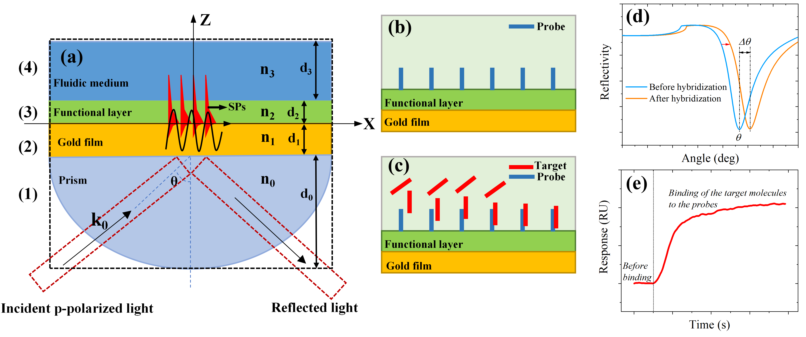
Fig. S1 Concept of a surface plasmon resonance (SPR) biosensor. (a) Four-layer Kretschmann coupling model and optical boundary conditions used for the Fresnel calculations. (b) SPR sensor surface with immobilized probes. (c) Binding of the target molecules to the probes. (d) A typical angular dependence of reflectivity curve, the angle θ denotes the SPR resonance angle. (e) Time evolution of refractive index caused by the molecular interactions
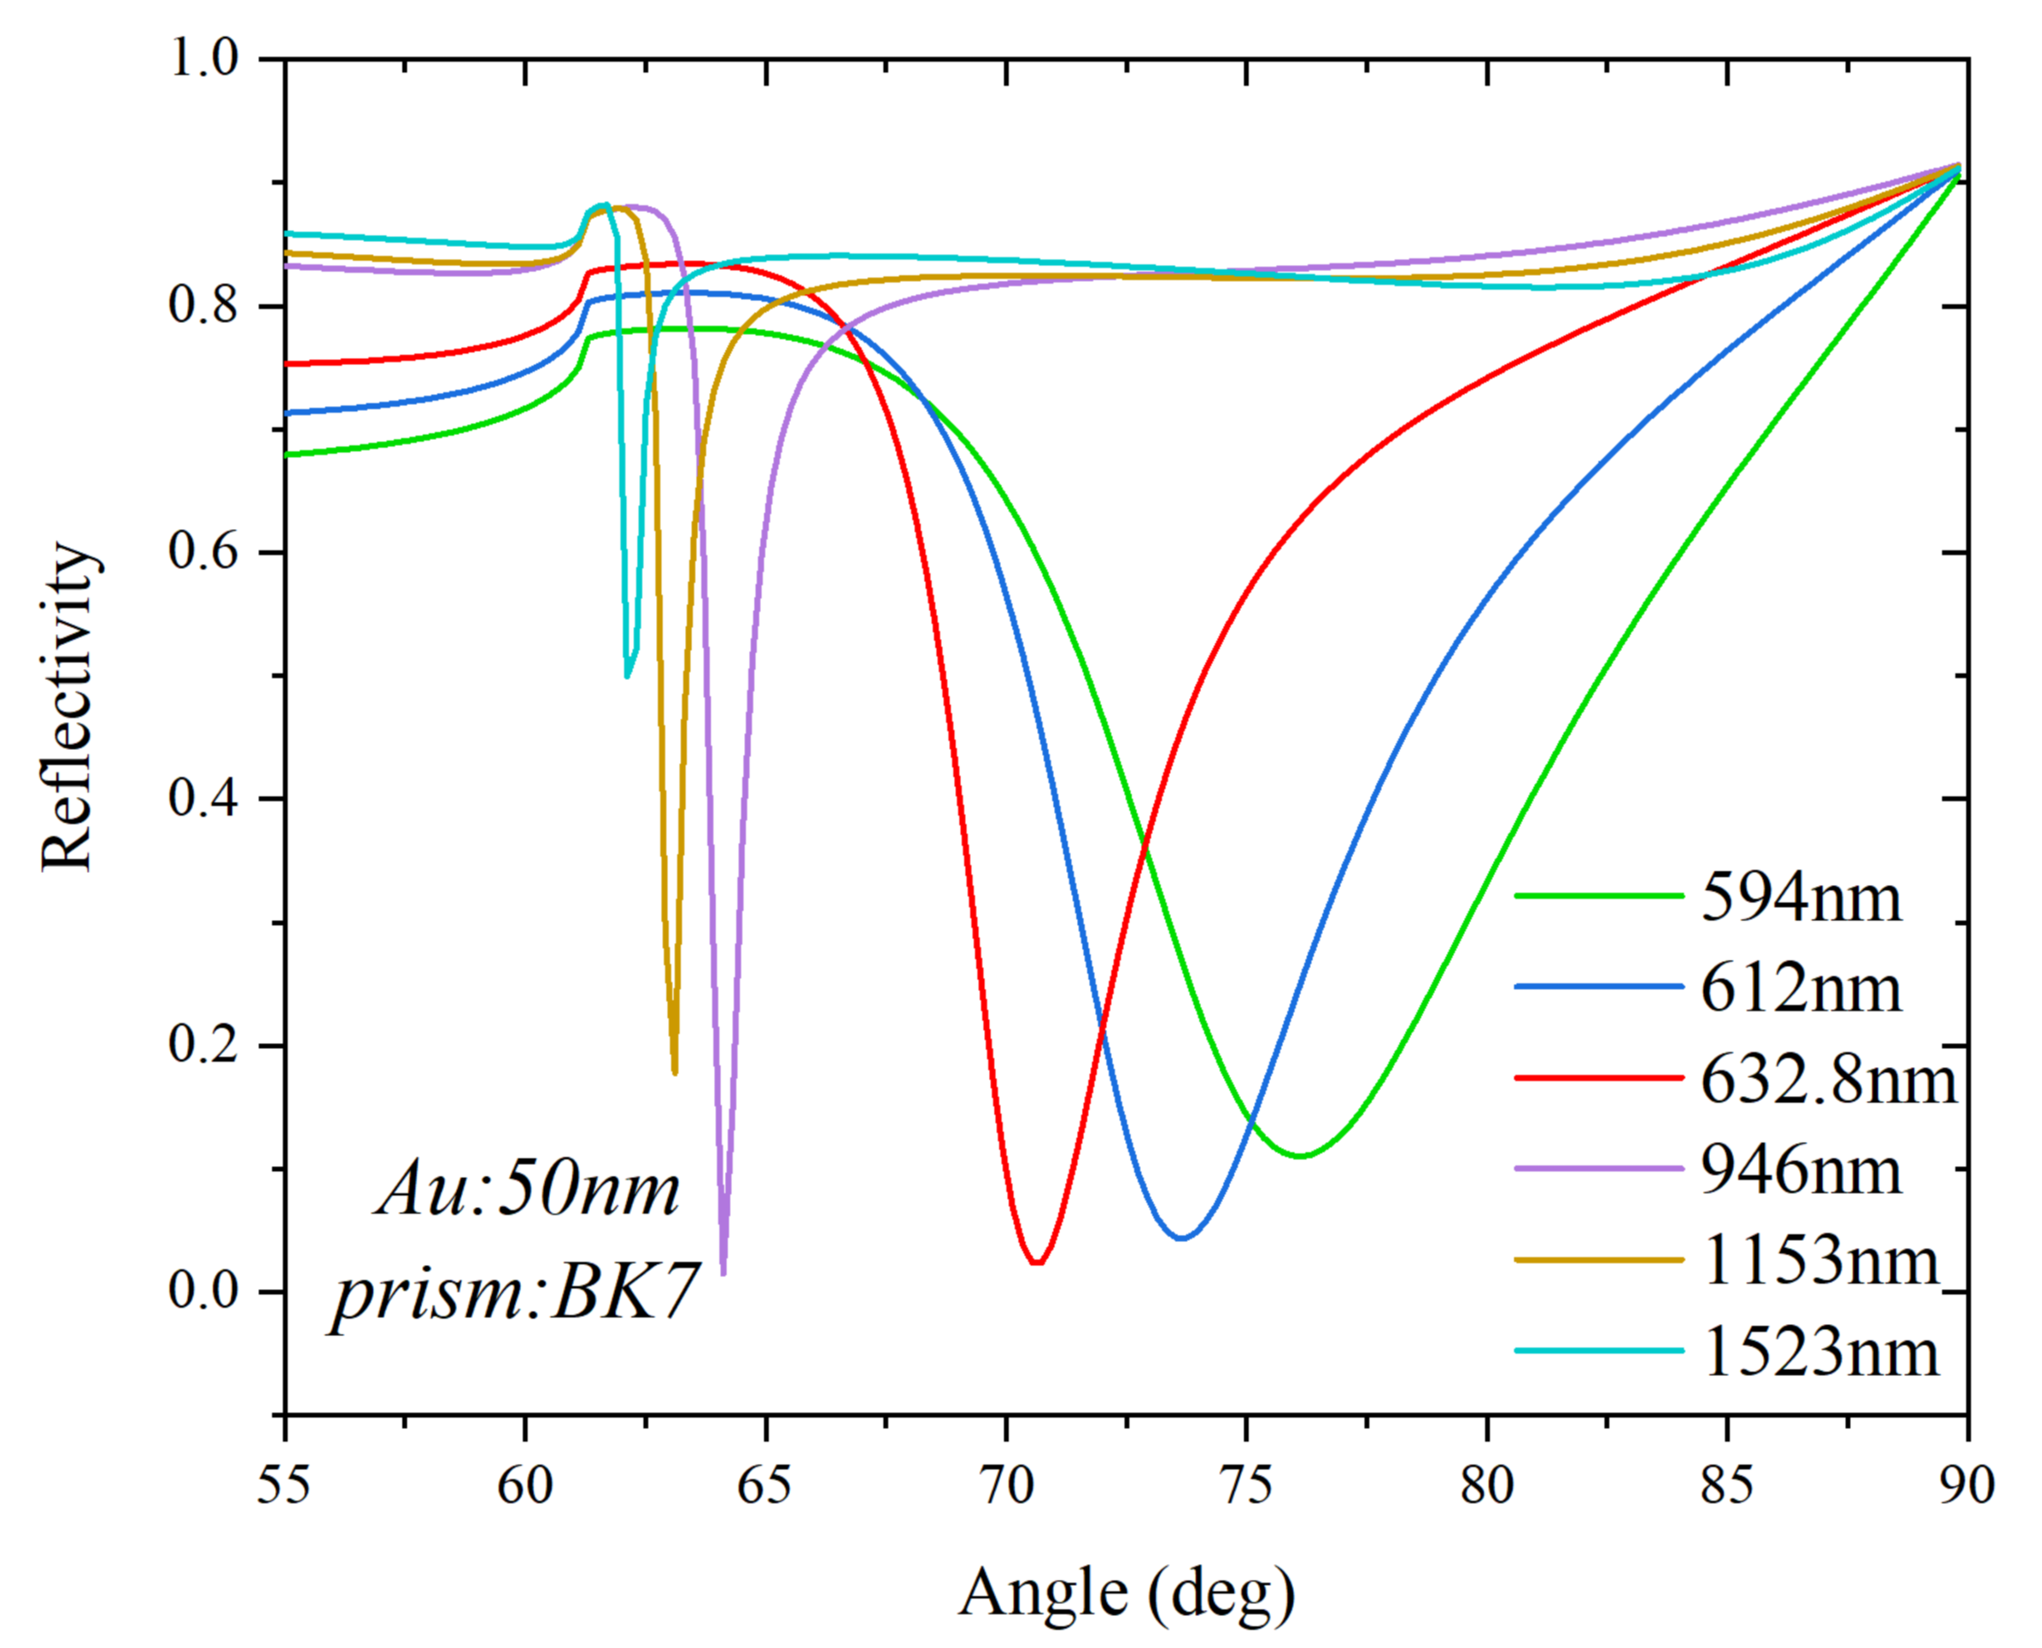
Fig. S2 Reflection spectrum of SPR sensor based on Kretschmann configuration for different wavelengths of incident light
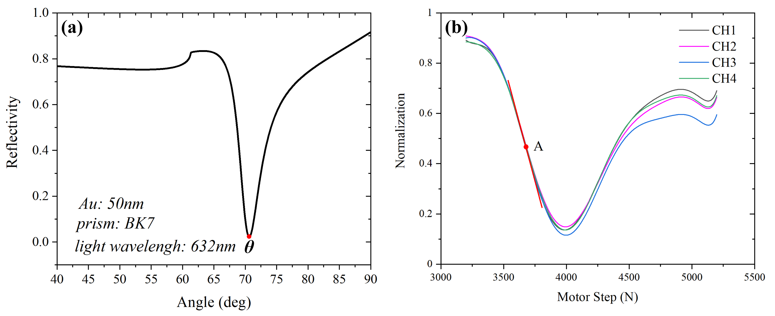
Fig. S3 (a) Reflection spectrum of SPR sensor based on Kretschmann configuration when the incident angle changes. (b) Multiplexed angular scanning SPR reflection spectrum using the four-channel flow cell and a functionalized chip modified with BSA (The working angle of the instrument: point A)
A. Principle of nucleic acid SPR biosensor
The surface plasmons (SPs) are delocalized electron oscillations that exist at the interface of a metal/dielectric medium. The excitation of Kretchmann-type SPR depends on the p-polarized light coupled to the metal/dielectric interface through a prism under conditions of total internal reflection (Nabok and Tsargorodskaya 2008). The presence of the metal film is crucial for the generation of SPR. Resonant coupling occurs when the wave vector of the incident light matches the wave vector of the surface plasmons (SPs) at the metal/dielectric interface. A four-layer Kretschmann coupling model was used to describe the SPR sensing system. As shown in Fig. S1(a), the different media layers are described as follows:
Medium 1 is a prism. Medium 2 is a thin metal film. Medium 3 is a functionalized molecular layer (i.e., the sensing layer where the chemical interactions occur), and Medium 4 is usually an aqueous solution containing the substance to be analyzed. The dielectric constant of each layer is $ε_{j}$ (j=0,...3) and the refractive index is $n_{j}$ (j=0,...3). The wavelength of incident light in vacuum is λ and the angle of incidence is θ. The wave vector of incident light in each layer is $k_{j}$ (j=0,...3) and the thickness of each layer is $d_{j}$ (j=0,...3).
The Fresnel’s equations were used to calculate the reflection coefficient r_{j,j+1} (j=0,…3) for the interface of two adjacent layers. The reflectivity R of the four-layer Kretschmann model is determined by the following equations (Raether 1977; Thirstrup et al. 2004; Othman et al. 2011):
(A.1)
(j=0,1) (A.2)
(A.3)
(A.4)
(j=0,…3) (A.5)
(A.6)
Eq. (A.2) is used to calculate the reflection coefficient of layer j relative to layer 3.
Eq. (A.3) is used to calculate the reflection coefficient of layer j relative to layer j+1.
Eq. (A.4) is used to calculate the component of the incident light wave vector in the Z-direction in layer j.
Eq. (A.6) is used to calculate the refractive index of layer j, and μ_{r} refers to relative permittivity.
The above equation shows that the reflectivity R is a function of the angle of incidence θ, the refractive index n₂ of the sensing layer, and the wavelength λ of the incident light.
(1)
When the biomolecular layer immobilized on the thin metal film is changed, its refractive index changes as well. The reflectivity curve can be calculated by the above equation. We simulated and optimized the wavelength of incident light by Winspall software. The thickness of the gold film is 50nm, and the material of the semicircular prism is BK7 glass. The refractive index of the environmental medium (n₃) is 1.333. Fig. S2 shows the reflection spectrum of the SPR sensor when different wavelengths of laser light are incident. Fig. S2 demonstrates that when a longer wavelength (> 900 nm) light source is used as illumination, the reflection spectral bandwidth is narrower and the resolution is higher. As the incident wavelength increases, however, the depth of the resonance angle decreases. When short wavelength light sources are used as incident light (< 600 nm), the bandwidth is wide. As the wavelength decreases, the depth of the resonance angle also decreases, which affects the sensitivity (Roh et al. 2011). The reflection spectra have better characteristics in sensitivity and bandwidth when the wavelength of incident light is 632.8 nm, so a semiconductor laser at 632.8 nm is usually used as the excitation source.
The parameters such as the thickness of the gold film, the material of the prism, and the environmental medium are consistent with the above simulation. The wavelength of the incident light is set to 632.8nm. Fig. S3(a) shows a typical reflectivity curve of the SPR sensor when the incident angle changes. The incident angle θ corresponding to the minimum of the reflectivity curve is called the SPR resonance angle. When the target molecule and the probe bind specifically, the refractive index of the binding site changes, and the resonance angle changes (Fig. S1(d)). Our work is based on the intensity modulation method. The wavelength of the incident light is fixed, and the angle of incidence θ is adjusted so that the sensing system operates at the position where the refractive index change is most sensitive (The point with the largest absolute value of the slope of the reflectivity curve). Fig. S3(b) is the angular scanning curve of the four channels after polynomial fitting and normalization, and point A is the working angle. The reflectivity curve can visually reflect the change in refractive index. The flow cell was immobilized above the gold film, and the probes were immobilized on the surface of the functionalized gold film (Fig. S1(b)). Buffer containing target molecules flows from the microfluidic channel over the surface of the gold film. The target binds to the immobilized probe via affinity interactions (Fig. S1(c)), causing an increase in the refractive index at the SPR sensor surface. The changes in the refractive index allow us to observe changes in the characteristics of the reflected light (SPR resonance angle, intensity, (Fig. S1(d, e))). The photodiode array is used to detect the change of reflected light intensity and obtain the response curve of refractive index-reflected light intensity at a fixed wavelength and angle.
B. Principle of multi-parameter SPR detection
Multi-parameter means that the SPR instrument can monitor multiple types or multiple different biochemical reactions on the sensor surface in real-time. The incident light enters the half-cylindrical prism from one side and converges into a linear beam on the surface of the sensor chip. The microfluidic channel flowing through the surface of the sensor chip is perpendicular to the beam. The photodiode array is used to detect the intensity change of the reflected light on the other side of the prism. Adjust the array position so that the photosensitive area of the photodiode and the outgoing light coincide. According to the relative positions of the light beam and the microchannels, the number of photosensitive pixels corresponding to the four microchannels is determined to be pixel 5, 7, 9, and 11 respectively. Collecting the light intensity values of these four photosensitive pixels can realize real-time SPR monitoring of biochemical reactions occurring on the chip surface in the microchannel.
C. Detection mode of SPR signal
The reflection spectrum curve corresponding to the change of the incident angle can prove the generation of SPR. After acquiring the angular scanning data, the stepper motor is controlled to drive the connecting rod to move to the steepest position of the SPR reflection spectrum curve (the point with the largest absolute value of the slope). This position serves as the working point of the detection platform. The working point is the most sensitive position of the refractive index change, and the strongest signal change caused by the refractive index change can be observed (Zybin et al. 2007). Fig. S3(b) is the angular scanning curve of the four channels after polynomial fitting and normalization, and point A is the working angle.
D. Process of nucleic acid detection
Based on the intensity modulation method, we obtained the response curve of refractive index-reflected light intensity. The abscissa is time, and the ordinate is the response unit of reflected light intensity. The buffer was injected into the microchannel until the baseline was stable, and then the activation reagent was injected (0.1 M NHS and 0.4 M EDC were mixed 1:1). The refractive index of the activation reagent was higher than that of the buffer, and the response signal increased first. With the injection of the buffer, the excess activation reagent was washed away, and the response signal was slightly higher than that before the baseline was established. Then streptavidin with a concentration of 50 μg/ml diluted with sodium acetate at pH 4.5 was injected. The initial drop of the response signal is due to the lower refractive index of the sodium acetate solution than the buffer. With the continuous combination of activated BSA and streptavidin on the chip, the refractive index of the chip surface increases, and the response signal increases. The buffer was continuously injected to wash away unbound streptavidin. After the baseline was stable, ethanolamine was injected to block the binding site. The refractive index of the blocking solution is higher than that of the buffer, so the response signal rises rapidly. With the injection of buffer solution, the response signal returned to the level before the injection of blocking solution. Biotinylated oligonucleotide capture probe was injected later, and the probe was immobilized on the chip surface via the interaction of biotin-streptavidin. The refractive index of the chip surface increased, causing an increase of the response signal. Finally, the target oligonucleotide solution was injected to carry out nucleic acid hybridization, and the target and the probe formed a hybrid double-strand based on complementary base pairing. During the nucleic acid hybridization process, the refractive index of the chip surface increased, and the response signal increased continuously. After the baseline had stabilized, the regeneration reagent (glycine-HCl at pH 1.5) was injected. The refractive index of the regenerated reagent is lower than that of the buffer, so the response signal decreases rapidly. Under the action of glycine-HCl, the double strand hybridized between the probe and the target was unwound, and the chip was successfully regenerated. The buffer was subsequently injected to rinse the excess regenerant away, and the response signal recovered to the level at which the target had not been injected.
E. Design of photoelectric detection circuit and multi-channel data acquisition circuit
The key component of the multi-parameter surface plasmon resonance detection platform is the photoelectric detection circuit and the multi-channel data acquisition circuit. The main noise of the photoelectric conversion circuit includes external electromagnetic interference and internal noise, among which electromagnetic interference can be solved by metal shielding and grounding. Internal noise includes photodiode noise, thermal noise of transimpedance amplifier (TIA) feedback resistor, and op-amp noise. The silicon photodiode array operates in a photoconductive mode with a reverse voltage supplied by a reference voltage source. The array has 16 pixels, which can detect the reflected light intensity signals of 16 chip reaction areas at the same time. When the detector receives the laser signal reflected by the prism, a weak current is generated due to the photoelectric effect. The current-voltage conversion is carried out through the transimpedance amplifying circuit, and then the amplified voltage signal is filtered through a low-pass filter. The transimpedance amplifier circuit is mainly composed of multi-channel operational amplifiers, feedback resistors, and compensation capacitors. The operational amplifier requires low input bias current, low offset voltage, and low noise. Four-channel rail-to-rail precision operational amplifier AD8608 from ADI is selected as a preamplifier. The feedback resistor is selected with high precision and low-temperature coefficient. The optical signal needs to be converted, amplified, and filtered to obtain an analog voltage signal. Then the analog-to-digital conversion is performed by the 24-bit high-precision analog-to-digital converter ADS1256 produced by Texas Instruments. The conversion speed can reach 30KSPS. ADS1256 integrates a multiplexer, which can effectively reduce the mutual interference between each channel. The converted digital signal is transmitted to the STMicroelectronics microcontroller STM32F407 at first for median average filtering and then transmitted to the PC through serial communication. Finally, Qt software is used to develop a GUI to realize real-time experimental data reception, curve display, and data storage.

Table S1. DNA and miRNA sequences used in this work.
Name | Nucleotide sequence [5’–3’] | Length | MW(g/mole) | Ref
miRNA-21 | UAGCUUAUCAGACUGAUGUUGA | 22 | 7005.16 | (Ding et al. 2015)
miRNA-141 | UAACACUGUCUGGUAAAGAUGG | 22 | 7067.22 | (Li et al. 2017)
DNA | AGTATGGGCATTAGCACCAAAGGGTAGAAA | 30 | 9337.17 | (Huang et al. 2020)
capture probe for miRNA-21 | bio-TCAACATCAGTCTGATAAGCTA | 22 | 7108.4 | -
capture probe for miRNA-141 | bio-CCATCTTTACCAGACAGTGTTA | 22 | 7075.4 | -
capture probe for DNA | bio-TTTCTACCCTTTGGTGCTAATGCCCATACT | 30 | 9479.45 | -

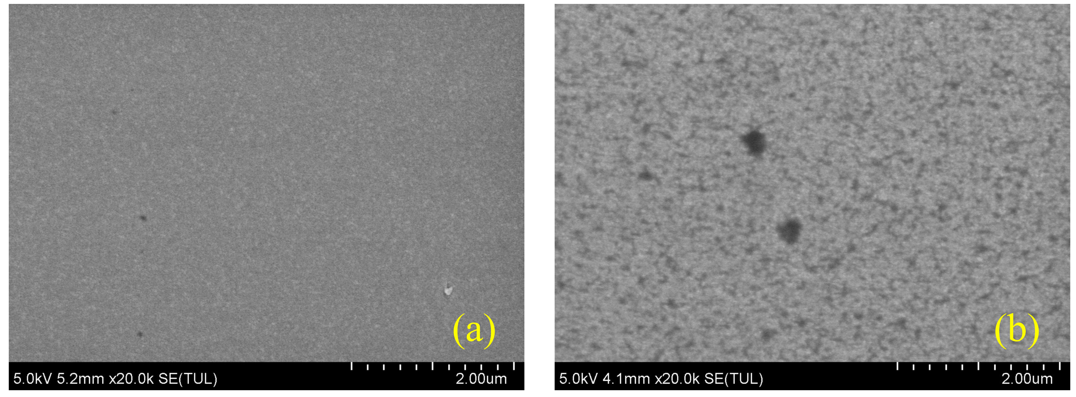
Fig. S4 SEM images. (a) SEM image of the gold-plated chip. (b) SEM image of the functionalized chip modified with BSA

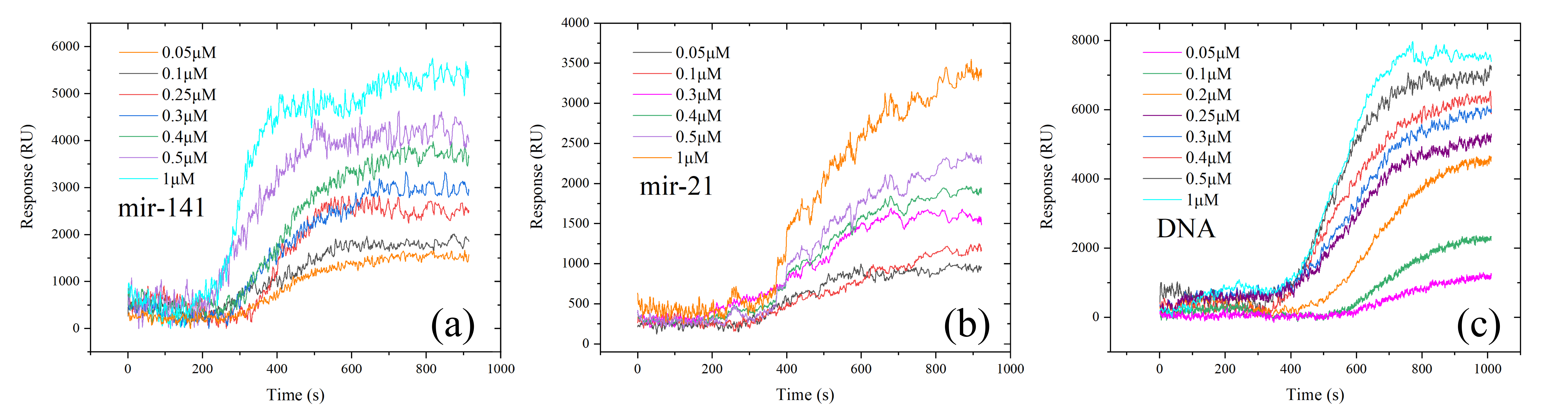
Fig. S5 The original sensing spectra of the SPR response for nucleic acid hybridization with different concentrations of target oligonucleotides. (a) mir-141. (b) mir-21. (c) DNA

References
X. Ding, Y. Yan, S. Li, Y. Zhang, W. Cheng, Q. Cheng, and S. Ding, Surface plasmon resonance biosensor for highly sensitive detection of microRNA based on DNA super-sandwich assemblies and streptavidin signal amplification. Analytica Chimica Acta 874, 59 (2015).
Y. Huang, L. Zhang, H. Zhang, Y. Li, L. Liu, Y. Chen, X. Qiu, and D. Yu, Development of a Portable SPR Sensor for Nucleic Acid Detection. Micromachines 11, 526 (2020).
Q. Li, Q. Wang, X. Yang, K. Wang, H. Zhang, and W. Nie, High sensitivity surface plasmon resonance biosensor for detection of microRNA and small molecule based on graphene oxide-gold nanoparticles composites. Talanta 174, 521 (2017).
A. Nabok and A. Tsargorodskaya, The method of total internal reflection ellipsometry for thin film characterisation and sensing. Thin Solid Films 516, 8993 (2008).
M. B. H. Othman, M. R. Ramli, L. Y. Tyng, Z. Ahmad, and H. Md. Akil, Dielectric constant and refractive index of poly (siloxane–imide) block copolymer. Materials & Design 32, 3173 (2011).
H. Raether, Surface plasma oscillations and their applications. Phys of Thin Films 9, 145 (1977).
S. Roh, T. Chung, and B. Lee, Overview of the Characteristics of Micro- and Nano-Structured Surface Plasmon Resonance Sensors. Sensors 11, 1565 (2011).
C. Thirstrup, W. Zong, M. Borre, H. Neff, H. Pedersen, and G. Holzhueter, Diffractive optical coupling element for surface plasmon resonance sensors. Sensors and Actuators B: Chemical 100, 298 (2004).
A. Zybin, D. Boecker, V. M. Mirsky, and K. Niemax, Enhancement of the Detection Power of Surface Plasmon Resonance Measurements by Optimization of the Reflection Angle. Anal. Chem. 79, 4233 (2007).

