Supplementary Material - Figures
Complete chloroplast genomes of six Neotropical palm tree species: genome structure comparison, identification of repeats sequences and evolutionary dynamic patterns

Ana Flávia Francisconi, Jonathan Andre Morales Marroquín, Luiz Augusto Cauz dos Santos, Cássio van den Berg, Kaunne Karolina Martins, Marcones Ferreira Costa, Doriane Picanço-Rodrigues, Luciano Delmodes de Alencar, Cesar Augsuto Zanello, Carlos Augusto Colombo, Brenda Gabriela Díaz, Danilo Trabuco Amaral, Maria Teresa Gomes Lopes, Elizabeth Ann Veasey, Maria Imaculada Zucchi

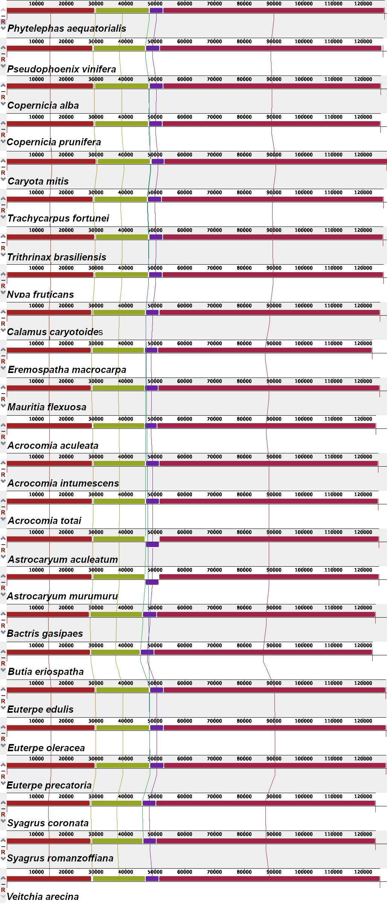

Figure S1. Synteny detected in 24 Arecaceae chloroplast genomes using the Mauve multiple-genome alignment program. Color bars indicate syntenic blocks and the lines indicate the correspondence between them. Blocks on the top row are in the same orientation, while blocks on the bottom row are in inverse orientation.

Figure S2. Conversions presented in the RNA editing sites of the species Acrocomia intumescens, A. totai, Bactris gasipaes, Copernicia alba, C. prunifera and Syagrus romanzoffiana. (A) Number of conversions according to amino acid changes in RNA editing sites shared among the six species; (B) Percentage of polarity change caused by amino acid conversions at RNA editing sites found between them.

Figure S3. Distribution of the species Acrocomia intumescens, A. totai, Bactris gasipaes, Copernicia alba, C. prunifera and Syagrus romanzoffiana according to online herbarium databases. Photos taken by the authors: A. intumescens and A. totai (BGD); B. gasipaes (AFF); C. alba and C. prunifera (MFC) and S. romanzoffiana (AFF).

