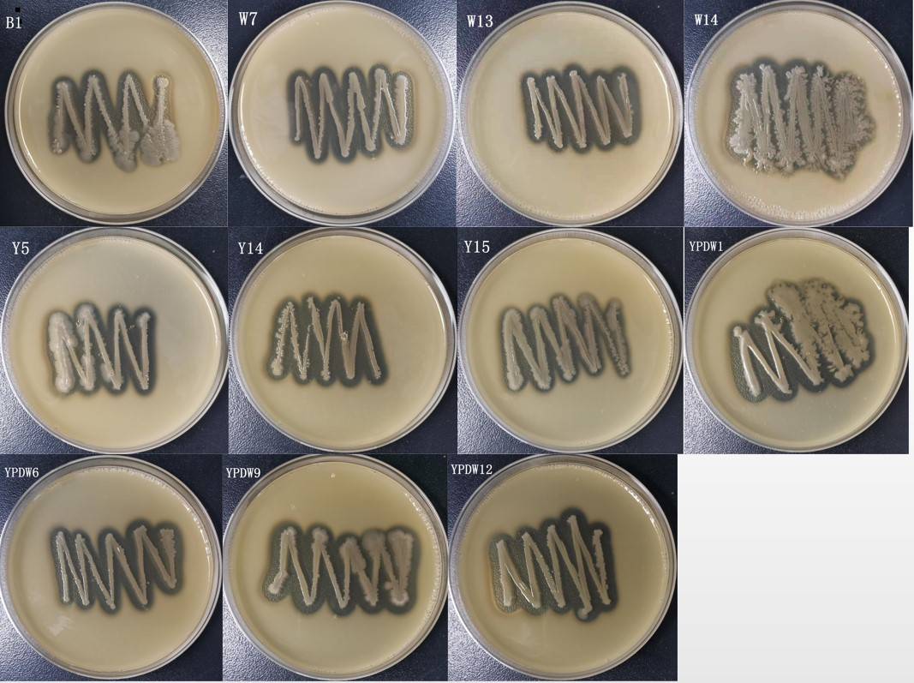
(A)

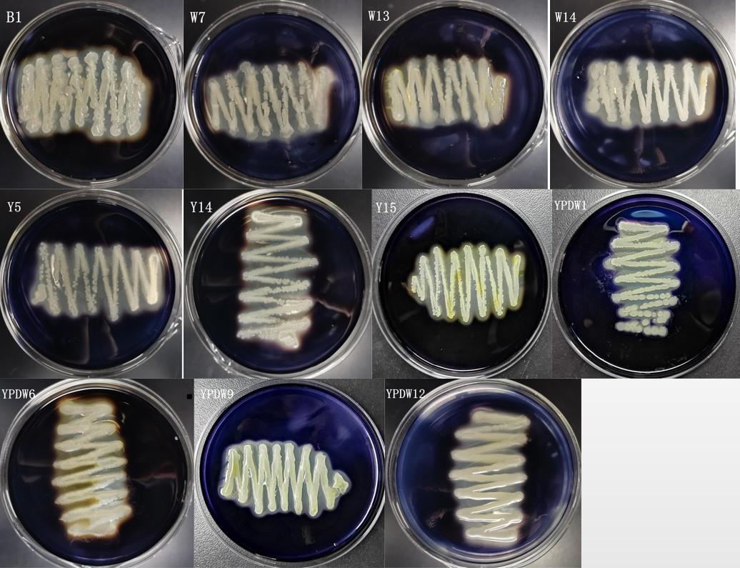
(B)
Supplementary Fig. 1 Illustration of enzyme production by Bacillus. The article only shows the schematic diagram of some strains that have both enzyme-producing activity and antibacterial activity. A is LB medium supplemented with 1% skimmed milk, and the activity of protease is detected; B is the result of adding 1% starch and staining with iodine solution, and the activity of amylase is detected. The transparent circle around the Bacterial colony means that enzyme can be produced.

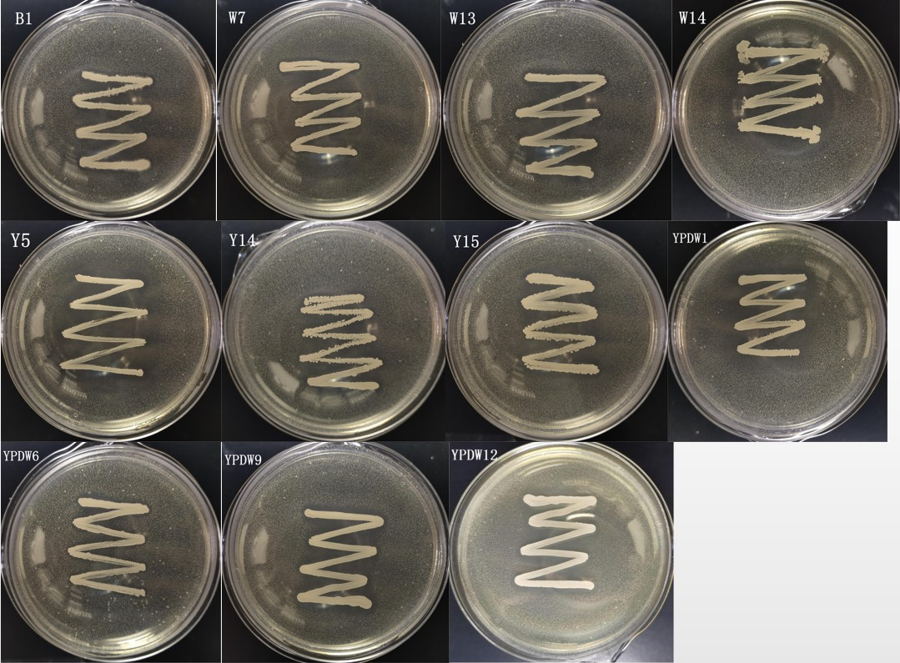
(A)

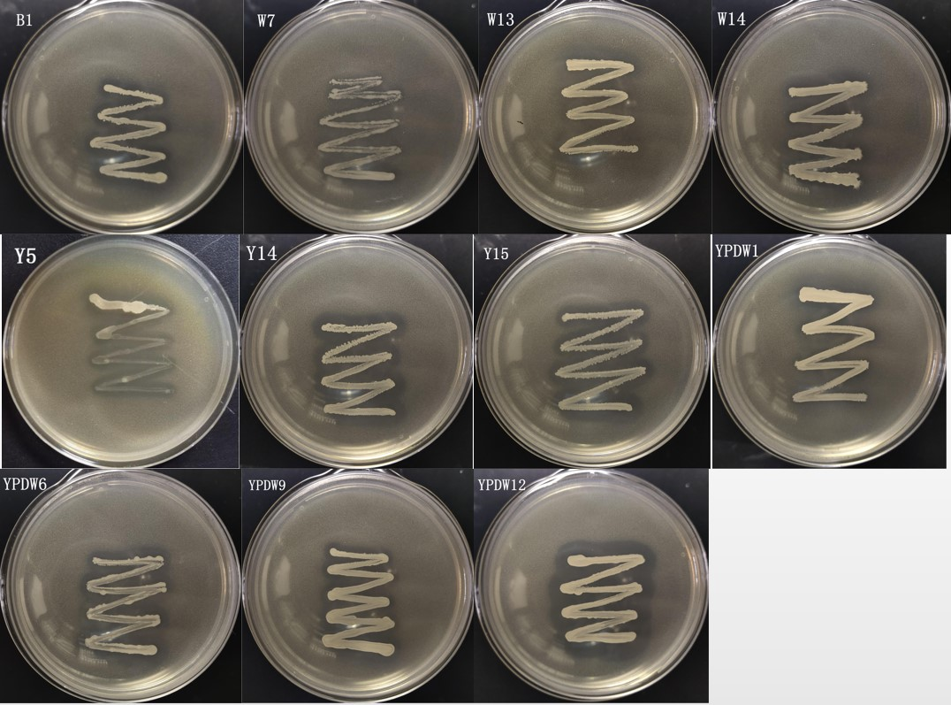
(B)
Supplementary Fig. 2 The antagonistic effect of Bacillus on common pathogens E. coli and Staphylococcus aureus. A shows the LB medium containing E. coli, and B shows the LB medium containing Staphylococcus aureus. The transparent circle around the colony represents the production of antibacterial substances and inhibits the growth of pathogenic bacteria.

