Supplementary Information

Evolution of the most species-rich family of simple thalloid liverworts (Aneuraceae) – a time-calibrated perspective into its evolutionary history and diversification

Nopparat Anantaprayoon ¹, Passorn Wonnapinij ², Steven D. Leavitt ³ & Ekaphan Kraichak ^{1. *}

¹ Department of Botany, Faculty of Science, Kasetsart University, Bangkok 10900, Thailand
² Department of Genetics, Faculty of Science, Kasetsart University, Bangkok 10900, Thailand
³ Department of Biology, College of Life Sciences, Brigham Young University, Provo, UT 84602, USA
Correspondence to E. Kraichak (ekaphan.k@ku.th)

Table S1 List of member of Metzgeriidae were used in this study.
Species | Voucher Information | trnK–psbA–trnH | rps4 | trnL–trnF
Afroriccardia comosa | Madagascar, CR13Z55; CR13Z28; CR13Z28 | KX512198 | KX512201 | KX512011
Aneura latissima | –, CR282; Reunion, ASV19811; ASV19811 | MG668649 | FM210626 | FM210482
Aneura maxima | Poland, POZW 40265; Belgium, Vanderpoorten 4786; Poland, POZW 40265 | KY705730 | DQ983854 | KY706043
Aneura mirabilis | Belgium, Boudier (CD81); Portugal, C. Sergio (35); UK, Wickett 276 | AY607936 | DQ983845 | FM210481
Aneura pinguis (A) | Poland, POZW 40340; USA, D. Wagner 4239; New Zealand, CHR 542474 | KY705651 | DQ983848 | KY705942
Aneura pinguis (B) | Poland, POZW 42793; UK, Vanderpoorten 2438; Poland, POZW 42791 | KY705669 | DQ983852 | KY705946
Aneura pinguis (C) | Poland, POZW 42749; UK, EDNA 06 06249 VC44; Poland, POZW 42749 | KY705682 | EF547741 | KY705967
Aneura pinguis (D) | UK, POZW 40238; EDNA 06 06251 VC45; POZW 40163 | KY705690 | EF547742 | KY705978
Aneura pinguis (E) | Poland, POZW 42885; Canada, Faubert & Grenier 221; Poland, POZW 42888 | KY705699 | FM210628 | KY706001
Aneura pinguis (F) | Poland, POZW 42901; Germany, MN051085; Poland, POZW 42892 | KY705704 | FM210629 | KY706010
Aneura pinguis (G) | Poland, POZW 42767; Portugal, ASV25795; Poland, POZW 42241 | KY705712 | FM210630 | KY706022
Aneura pinguis (H) | Poland, POZW 42898; Portugal, ASV25668; Poland, POZW 42755 | KY705715 | FM210631 | KY706029
Aneura pinguis (I) | Poland, POZW 42768; Dominica, ASV17946; Poland, POZW 42899 | KY705718 | FM210632 | KY706033
Aneura pinguis (J) | Japan, POZW 41053; Ecuador, Preußing s.n. (EX_MN006.09); Japan, POZW 41053 | KY705722 | FM210634 | KY706035
Lobatiriccardia alterniloba | New Zealand, ASV13731 | – | FM210636 | FM210492
Lobatiriccardia coronopus | Malaysia, ASV18641 | – | FM210638 | FM210494
Lobatiriccardia lobata | New Zealand, Crandall-Stotler 4581 | AY507507 | AY507462 | AY507553
Lobatiriccardia oberwinkleri | Ecuador, MPE04003; Brazil, ASV13020 | – | FM210640 | FM210495
Lobatiriccardia verdoornioides | Ecuador, MNE06064; Ecuador, ASV24457 | – | FM210647 | FM210503
Lobatiriccardia yakusimensis | Japan, Yamaguchi 23870 | – | FM210649 | FM210506
Riccardia aeruginosa | China, Zhu s.n. | KX512146 | KX512282 | KX512092
Riccardia alcicornis | Chile, SHAW13056; SHAW13448; SHAW13056 | KX512172 | KX512218 | KX512066
Riccardia amazonica | Ecuador, 31934SW; 31934SW; MPE04005 | KX512110 | KX512242 | FM210510
Riccardia andina | Ecuador, MNE03017 | – | FM210653 | FM210511
Riccardia bogotensis | Ecuador, MNE03017 | – | FM210654 | FM210512
Riccardia capensis | South Africa, de Roo (BOL) | – | AM398264 | –
Riccardia capillacea | Venezuela, Forrest 558 | – | AY688802 | –
Riccardia cataractarum | Guadeloupe, CR13G9; Martinique, ELB1753; Guadeloupe, CR13G9 | KX512117 | KX512241 | KX512050
Riccardia chamedryfolia | Saint Helena, 05/383Hb; Germany, Preußing s.n. (EX_MN002.02) ; Preußing s.n. (EX_MN017.08) | KX512184 | FM210656 | FM210513
Riccardia ciliolata | Ecuador, SV31879 | KX512126 | KX512214 | KX512024
Riccardia conimitra | Chile, Goff.11048; VK6524; Goff.11048 | KX512168 | KX512205 | KX512016
Riccardia corbieri | Seychelles, SEY6310 | MG668694 | – | MG602077
Riccardia crassa | New Zealand, EVK26688 | KX512124 | KX512202 | KX512012
Riccardia crenulata | Indonesia, SRG12310 | KX512145 | KX512281 | KX512091
Riccardia diminuta | Indonesia, SRG12363 | KX512144 | KX512280 | KX512090
Riccardia elata | Indonesia, SRG12341; Malaysia, YKT7943; Indonesia, SRG12367 | KX512161 | KX512247 | KX512058
Riccardia eriocaula | New Zealand, EVK24188 | KX512176 | KX512258 | KX512068
Riccardia fastigiata | Reunion, 9422AP; 9422V | MG668705 | – | MG602134
Riccardia filicina | New Zealand, EVK26946; EVK26946; EVK26948 | KX512166 | KX512221 | KX512030
Riccardia fucoides | Guadeloupe, ELB1601a; Ecuador, Preußing 2/05; Preußing 2/05 | KX512134 | FM210657 | FM210515
Riccardia graeffei | French Polynesia, Kraichak 767 | KX512197 | KX512226 | KX512036
Riccardia hans-meyeri | Ecuador, SV31767 | KX512131 | KX512274 | KX512084
Riccardia heteroclada | Indonesia, BORH3430 | KX512171 | KX512255 | KX512065
Riccardia inconspicua | Madagascar, MTM1295; Seychelles, SEY6265 | MG668717 | – | MG602092
Riccardia incurvata | France, VH1946; VH2457; VH2457 | KX512195 | KX512225 | KX512035
Riccardia longispica | Guinea, VIT39894; Reunion, PF2; Madagascar, CRAE190 | MG668783 | KX512233 | MG602163
Riccardia multifida | France, VH934; Germany, MN051090; France, VH1994 | KX512157 | FM210659 | KX512059
Riccardia pallida | Ecuador, SV32071; Preußing 26/05; Preußing 26/05 | KX512135 | FM210660 | FM210518
Riccardia palmata | France, AU9877; UK, Wickett 275; Wickett 275 | KX512156 | DQ986149 | FM210519
Riccardia parasitans | Ecuador, MB6673; SV32160; SV32160 | KX512141 | KX512265 | KX512075
Riccardia parvula | Indonesia, SRG12320 | KX512160 | KX512246 | KX512056
Riccardia plumiformis | Ecuador, MB7011; SV31760; SV31760 | KX512136 | KX512276 | KX512086
Riccardia prehensilis | Chile, SHAW14070 | KX512173 | KX512219 | KX512029
Riccardia regnellii | Guadeloupe, CR13G4 | KX512118 | KX512295 | KX512023
Riccardia saccatiflora | South Africa, B20192; Madagascar, CR13Z40 | MG668683 | – | MG602130
Riccardia schwaneckei | Guadeloupe, CR13G17 | KX512123 | KX512204 | KX512014
Riccardia smaragdina | Ecuador, SV32161; SV32161; MPE04006 | KX512140 | KX512279 | FM210520
Riccardia sprucei | Guadeloupe, ELB1162 | KX512138 | KX512278 | KX512088
Riccardia stipatiflora | Guadeloupe, ELB1680; ELB1601b; ELB1601b | KX512191 | KX512262 | KX512072
Riccardia trichomanoides | Ecuador, ASV24454 | – | FM210662 | FM210521
Riccardia wattsiana | New Caledonia, LT12102601a | KX512125 | KX512203 | KX512013
Verdoornia succulenta | New Zealand, Stotler & Crandall-Stotler 4602; CHR527380; Stotler & Crandall-Stotler 4602 | AY507516 | FM210663 | AY507561
Metzgeria ciliata | Chile, John J Engel 26263 | – | – | HQ342656
Metzgeria conjugata | – | AY507495 | – | –
Metzgeria dorsipara | Ecuador, A. Schaeffer-Verwimp, J. Heinrichs, R. A. Wilson & S. O. Yandun 24385 | – | – | HQ342625
Metzgeria furcata | Forrest & Villarreal 620; A. Lang 20090511.2 | DQ269001 | – | GQ428072
Metzgeria kinabaluensis | Japan, Yamaguchi 25231 | – | AB535650 | –
Metzgeria liebmanniana | Forrest 575 | DQ269002 | DQ268989 | –
Metzgeria limbatosetosa | Kenya, Tsubota s.n. | – | AB535658 | –
Metzgeria lindbergii | Japan, Masuzaki 49 | – | AB535659 | –
Metzgeria nudifrons | Kenya, Tsubota s.n. | – | AB535660 | –
Metzgeria pubescens | UK, Long 29523; Austria, Hofbauer & Wolfgang 2 | DQ268994 | – | HQ342666
Pleurozia conchifolia | Papua New Guinea, Koponen 29264 | – | AY462385 | –
Pleurozia gigantea | Indonesia, Hallingbaeck & Gradstein 10250; China, Zhang Li 4151; Papua New Guinea, De Sloover 42824 | AM396268 | KF851436 | AY463582
Pleurozia paradoxa | Colombia, Ramirez 11.207; Ecuador, MPE02211 | – | DQ026605 | FM210509
Pleurozia purpurea | Bhutan, Long 288868; USA, Schofield 102815; Schofield 102815 | AY877401 | AY608100 | AY608139

Table S2 Clades and species richness in Metzgeriidae, this proportion constraints used for BAMM incomplete taxon sampling assignment. For Aneura; assignment in two conditions, individually cryptic species/single species.

Clades | Total number of taxa* | Number of sampled taxa | Proportion constraints
Riccardia | 265 | 41 | 0.154717
Aneura | 58/49 | 13/4 | 0.224138/0.081633
Lobatiriccardia | 9 | 6 | 0.666667
Afroriccardia | 1 | 1 | 1.000000
Verdoornia | 1 | 1 | 1.000000
Metzgeria | 104 | 10 | 0.096154
Pleurozia | 12 | 4 | 0.333333
Note: * = based on Söderström et al. (2016)

Reference
Söderström, L., A. Hagborg, M. Von Konrat, S. Bartholomew-Began, D. Bell, L. Briscoe, E. Brown, et al. 2016. World checklist of hornworts and liverworts. PhytoKeys 59: 1–828.

Table S3 Empirical parameter from TRACER: comparison from three schemes, parameters mean value (median value).

Parameters | BD with M. sharonae calibration | FBD with M. sharonae calibration | FBD with Three-fossil calibration
posterior | –26178.8291 (–26269.4833) | –26149.9417 (–26239.3216) | –26212.4467 (–26306.7249)
likelihood | –25570.6028 (–25570.3579) | –25580.9629 (–25580.7077) | –25570.4017 (–25570.1936)
BD or FBD | –231.4761 (–231.3891) | –189.3957 (–187.3488) | –217.1961 (–214.4775)
turnoverFBD |  | 0.3705 (0.3728) | 0.4311 (0.4439)
Birth rate | 0.0802 (0.0765)
Death rate | 0.5153 (0.5374)

Figure S1 Divergence dating of subclass Metzgeriidae from the same dataset with single-fossil calibration (only Metzgeriothallus sharonae), under the Birth-Death model and normal distribution of estimated parameters.

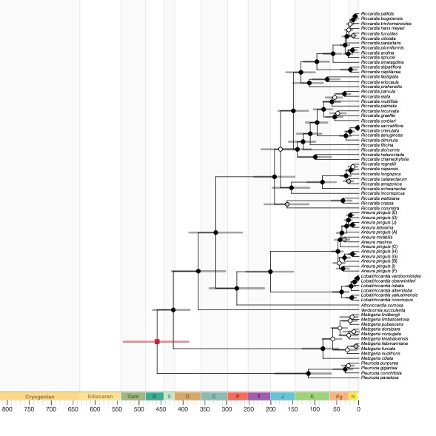

Figure S2 Divergence dating of subclass Metzgeriidae from the same dataset with three-fossil calibration (Metzgeriothallus sharonae, Riccardiothallus devonicus, and Riccardiothallus palmatus), under the Fossilized Birth-Death (FBD) model.

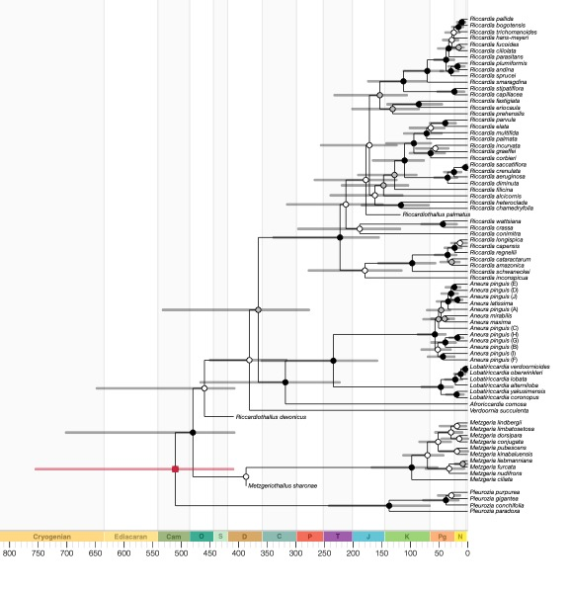

Figure S3 Multiple lineage through time (mLTT) plots from a single-fossil calibrated chronogram. Blue head arrows indicate the common ancestor of family Aneuraceae. Gray lines represent LTT lines from individual trees from the posterior space. The black line indicates LTTs line from the maximum clade credibility (MCC) tree.

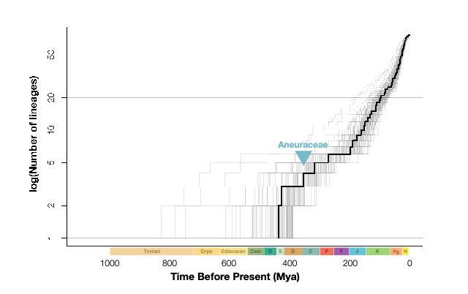

Figure S4 Null distributions of gamma-statistics from the MCCR test. The blue arrows indicate the estimated gamma value (γ = 1.2336) from the MCC tree. Reflecting last bursts diversification in our study organisms.

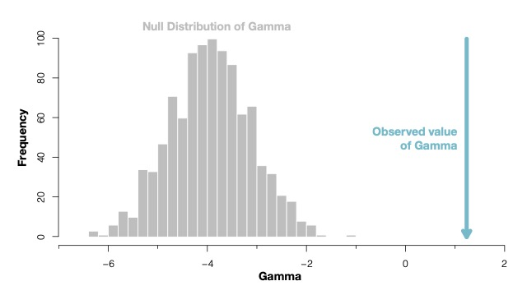

Figure S5 Cohort analyses, speciation, and extinction rates through time plots from BAMM, extensions from Fig. 3.

