Supplementary material: Original blots, accompanying the manuscript:
Normalization of hepatic ChREBP activity does not protect against liver disease progression in a mouse model for Glycogen Storage Disease type Ia

Authors
Martijn G.S. Rutten¹, Yu Lei¹, Joanne H. Hoogerland¹, Vincent W. Bloks¹, Hong Yang², Trijnie Bos³, Kishore A. Krishnamurthy¹, Aycha Bleeker¹, Mirjam H. Koster¹, Rachel E. Thomas⁴, Justina C. Wolters¹, Hilda van den Bos⁵, Gilles Mithieux^{6,7,8}, Fabienne Rajas^{6,7,8}, Adil Mardinoglu², Diana C.J. Spierings⁵, Alain de Bruin^{1,4}, Bart van de Sluis¹, Maaike H. Oosterveer¹

Explanation: In this Supplementary document, all raw blots are provided. It has to be noted that directly after transfer of proteins from gels to membranes, membranes were cut horizontally in order to allow multiple proteins to be detected on the same membrane. In this document, the remaining full blots, together with additional images of markers, are provided for all protein expression data presented in the manuscript.

Original Blots 1: nuclear YAP (quantification in Figure 3C, left; representative (cropped) blot in Figure S2C; corresponding Ponceau S loading controls provided in Figure S2C)
A
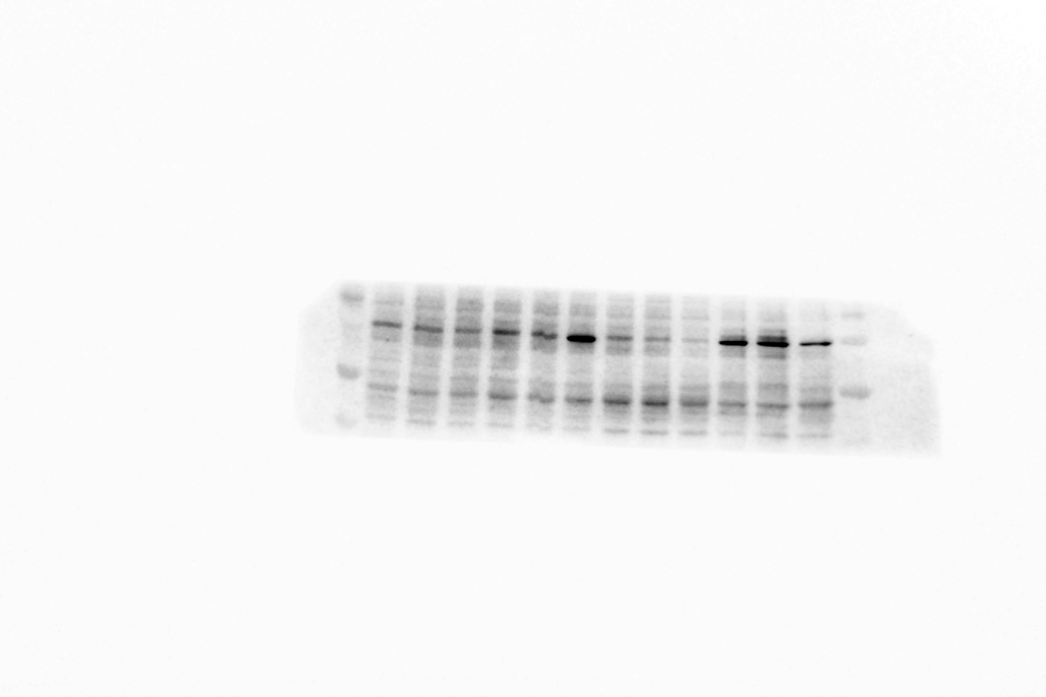
L-G6pc^{+/+}
shSCR
L-G6pc^{+/+}
shChREBP
L-G6pc^{-/-}
shChREBP
L-G6pc^{-/-}
shSCR
B
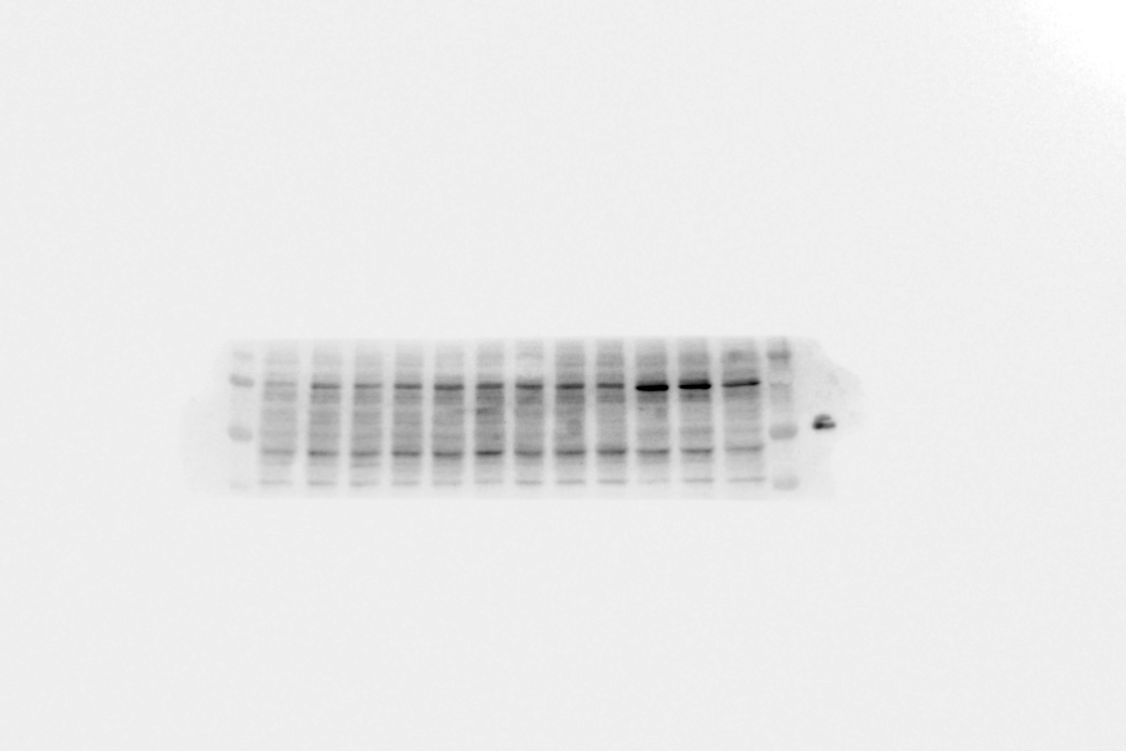
L-G6pc^{+/+}
shSCR
L-G6pc^{+/+}
shChREBP
L-G6pc^{-/-}
shChREBP
L-G6pc^{-/-}
shSCR
C
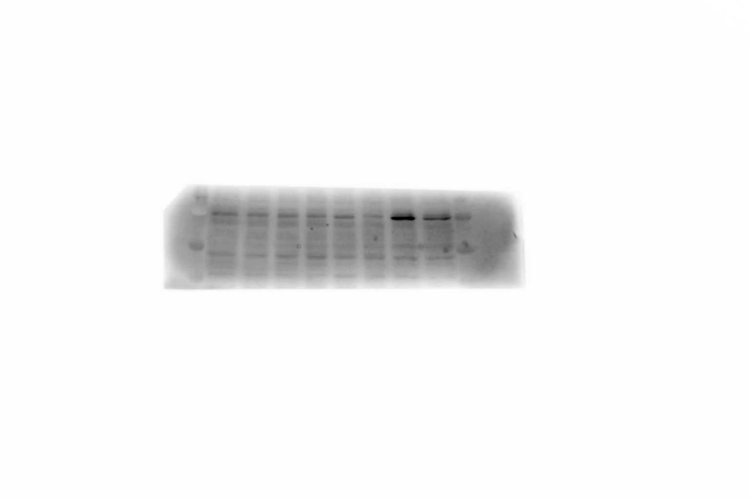
L-G6pc^{+/+}
shSCR
L-G6pc^{+/+}
shChREBP
L-G6pc^{-/-}
shChREBP
L-G6pc^{-/-}
shSCR
A: Up: Western Blot Gel 1. Sample order: L-G6pc^{+/+} shSCR (m01-m02-m03); L-G6pc^{+/+} shChREBP (m09-m10-m11); L-G6pc^{-/-} shSCR (m17-m18-m19); L-G6pc^{-/-} shChREBP (m25-m26-m27). Down: corresponding image of marker.
B: Up: Western Blot Gel 2. Sample order: L-G6pc^{+/+} shSCR (m04-m05-m06); L-G6pc^{+/+} shChREBP (m12-m13-m14); L-G6pc^{-/-} shSCR (m20-m21-m22); L-G6pc^{-/-} shChREBP (m28-m29-m30). Down: corresponding image of marker.
C: Up: Western Blot Gel 2. Sample order: L-G6pc^{+/+} shSCR (m07-m08); L-G6pc^{+/+} shChREBP (m15-m16); L-G6pc^{-/-} shSCR (m23-m24); L-G6pc^{-/-} shChREBP (m31-m32). Down: corresponding image of marker.

Original Blots 2: total YAP and pYAP in whole liver lysate (quantification of pYAP/YAP ratio in Figure 3C (right); quantification of pYAP in Figure S2D (right); representative (cropped) blot of total YAP and pYAP in Figure S2D (left); representative Ponceau S loading controls provided in Figure S2E).
A
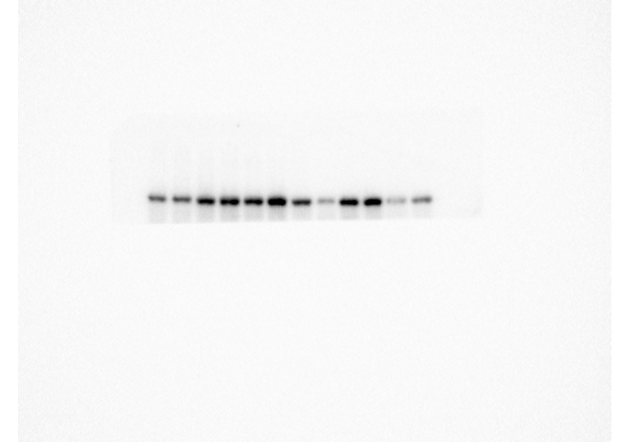
L-G6pc^{+/+}
shSCR
L-G6pc^{+/+}
shChREBP
L-G6pc^{-/-}
shChREBP
L-G6pc^{-/-}
shSCR
B
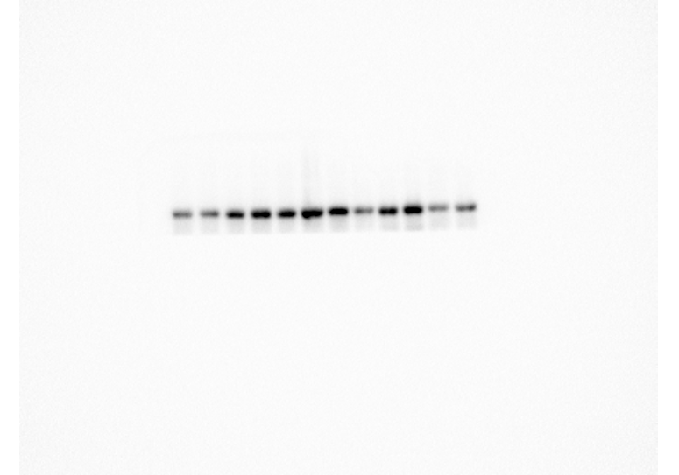
L-G6pc^{+/+}
shSCR
L-G6pc^{+/+}
shChREBP
L-G6pc^{-/-}
shChREBP
L-G6pc^{-/-}
shSCR

C
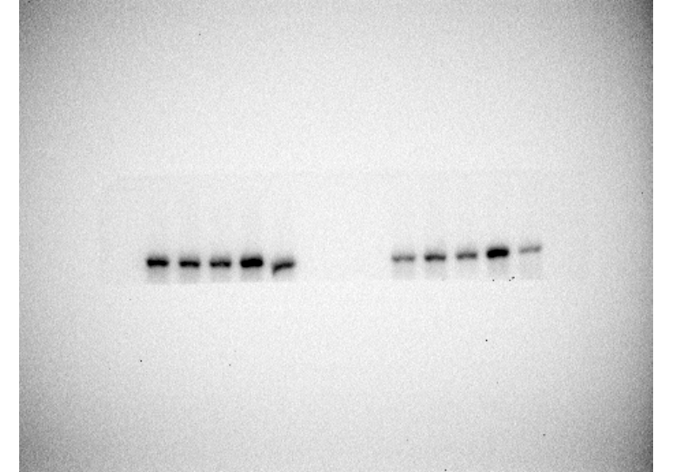
L-G6pc^{+/+}
shSCR
L-G6pc^{+/+}
shChREBP
L-G6pc^{-/-}
shChREBP
L-G6pc^{-/-}
shSCR
D
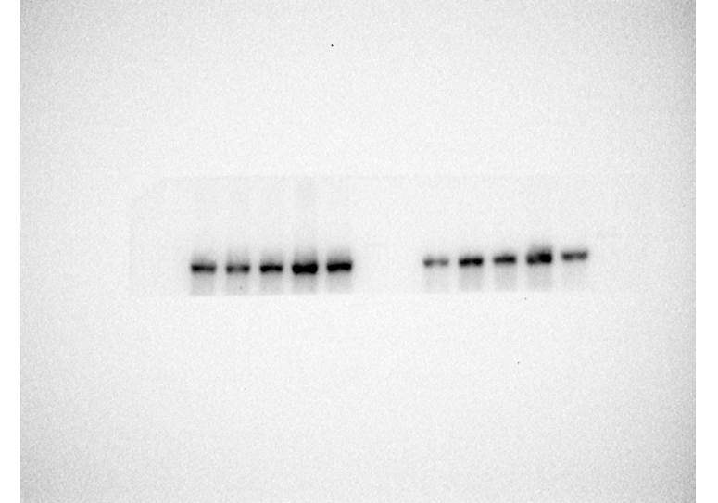
L-G6pc^{+/+}
shSCR
L-G6pc^{+/+}
shChREBP
L-G6pc^{-/-}
shChREBP
L-G6pc^{-/-}
shSCR
E
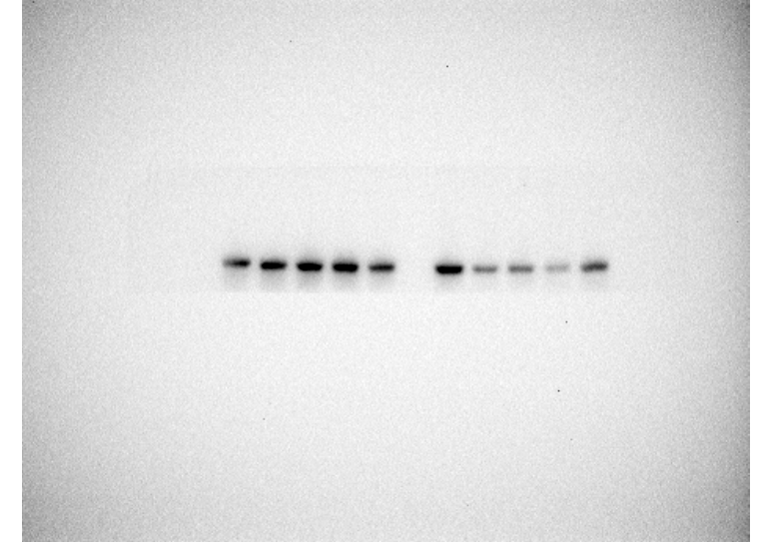
L-G6pc^{+/+}
shSCR
L-G6pc^{+/+}
shChREBP
L-G6pc^{-/-}
shChREBP
L-G6pc^{-/-}
shSCR

F
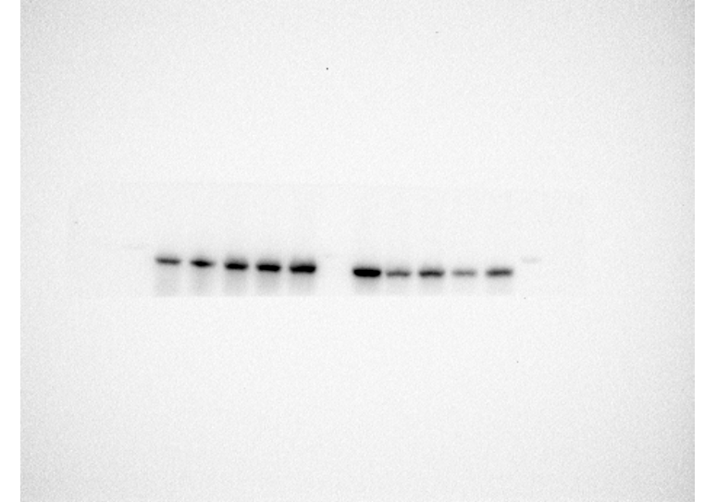
L-G6pc^{+/+}
shSCR
L-G6pc^{+/+}
shChREBP
L-G6pc^{-/-}
shChREBP
L-G6pc^{-/-}
shSCR

A: Up: Western Blot total YAP, gel 1. Sample order: L-G6pc^{+/+} shSCR (m01-m03-m05); L-G6pc^{+/+} shChREBP (m10-m12-m14); L-G6pc^{-/-} shSCR (m17 -m19); L-G6pc^{-/-} shChREBP (m25-m26-m27-m29). Down: corresponding image of marker.
B: Up: Western Blot pYAP, gel 1 (different gel). Sample order: L-G6pc^{+/+} shSCR (m01-m03-m05); L-G6pc^{+/+} shChREBP (m10-m12-m14); L-G6pc^{-/-} shSCR (m17 -m19); L-G6pc^{-/-} shChREBP (m25-m26-m27-m29). Down: corresponding image of marker.
C: Up: Western Blot total YAP, gel 2. Sample order: L-G6pc^{+/+} shSCR (m02-m04); L-G6pc^{+/+} shChREBP (m11-m13-m16); empty-ladder-empty; L-G6pc^{-/-} shSCR (m18-m20-m21); L-G6pc^{-/-} shChREBP (m28-m30). Down: corresponding image of marker.
D: Up: Western Blot pYAP, gel 2 (different gel). Sample order: L-G6pc^{+/+} shSCR (m02-m04); L-G6pc^{+/+} shChREBP (m11-m13-m16); ladder-empty; L-G6pc^{-/-} shSCR (m18-m20-m21); L-G6pc^{-/-} shChREBP (m28-m30). Down: corresponding image of marker.
E: Up: Western Blot total YAP, gel 3. Sample order: L-G6pc^{+/+} shSCR (m06-m07-m08); L-G6pc^{+/+} shChREBP (m09-m15); ladder; L-G6pc^{-/-} shSCR (m22-m23-m24); L-G6pc^{-/-} shChREBP (m31-m32). Down: corresponding image of marker.
F: Up: Western Blot pYAP, gel 3 (different gel). Sample order: L-G6pc^{+/+} shSCR (m06-m07-m08); L-G6pc^{+/+} shChREBP (m09-m15); ladder; L-G6pc^{-/-} shSCR (m22-m23-m24); L-G6pc^{-/-} shChREBP (m31-m32). Down: corresponding image of marker.
Original Blots 3: PARP in whole liver lysate (quantification of uncleaved and cleaved PARP, as well as cleaved/uncleaved PARP ratio, in Figure 4C (right); representative (cropped) blot in Figure S3B (left); corresponding Ponceau S loading controls provided in Figure S3B (right).
A
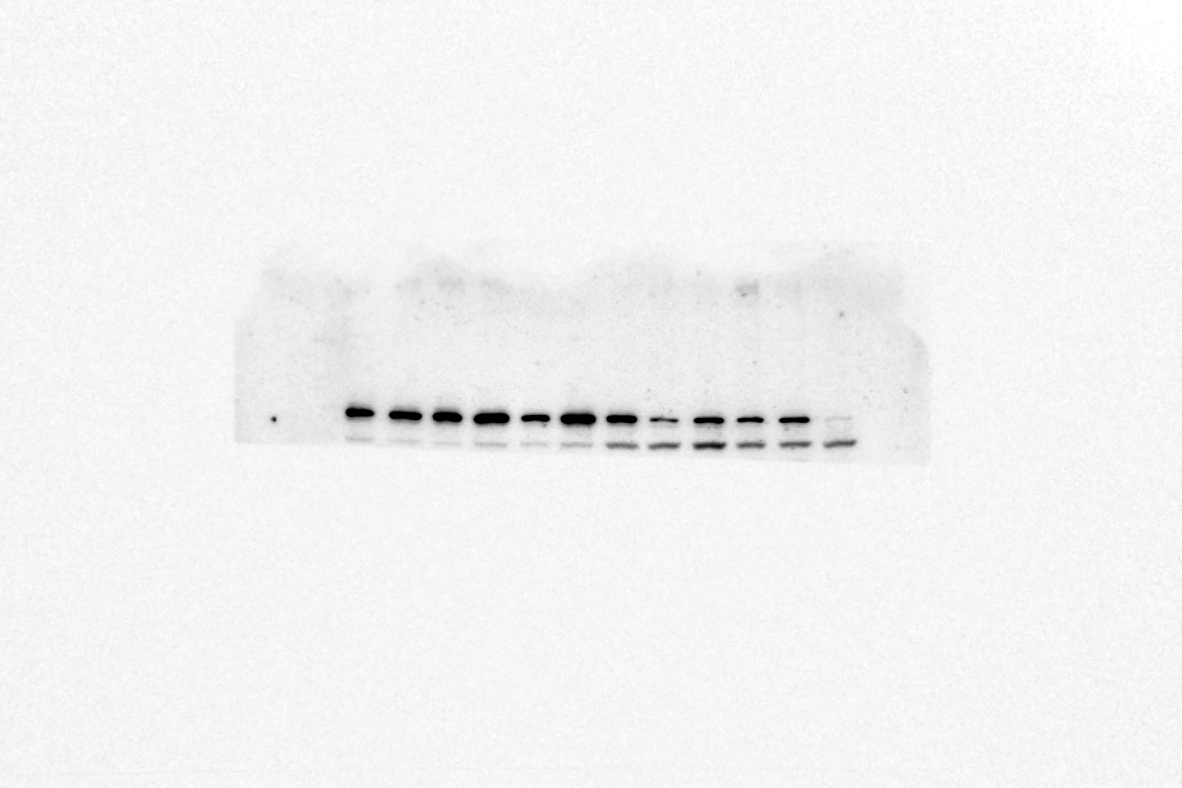
L-G6pc^{+/+}
shSCR
L-G6pc^{+/+}
shChREBP
L-G6pc^{-/-}
shChREBP
L-G6pc^{-/-}
shSCR
B
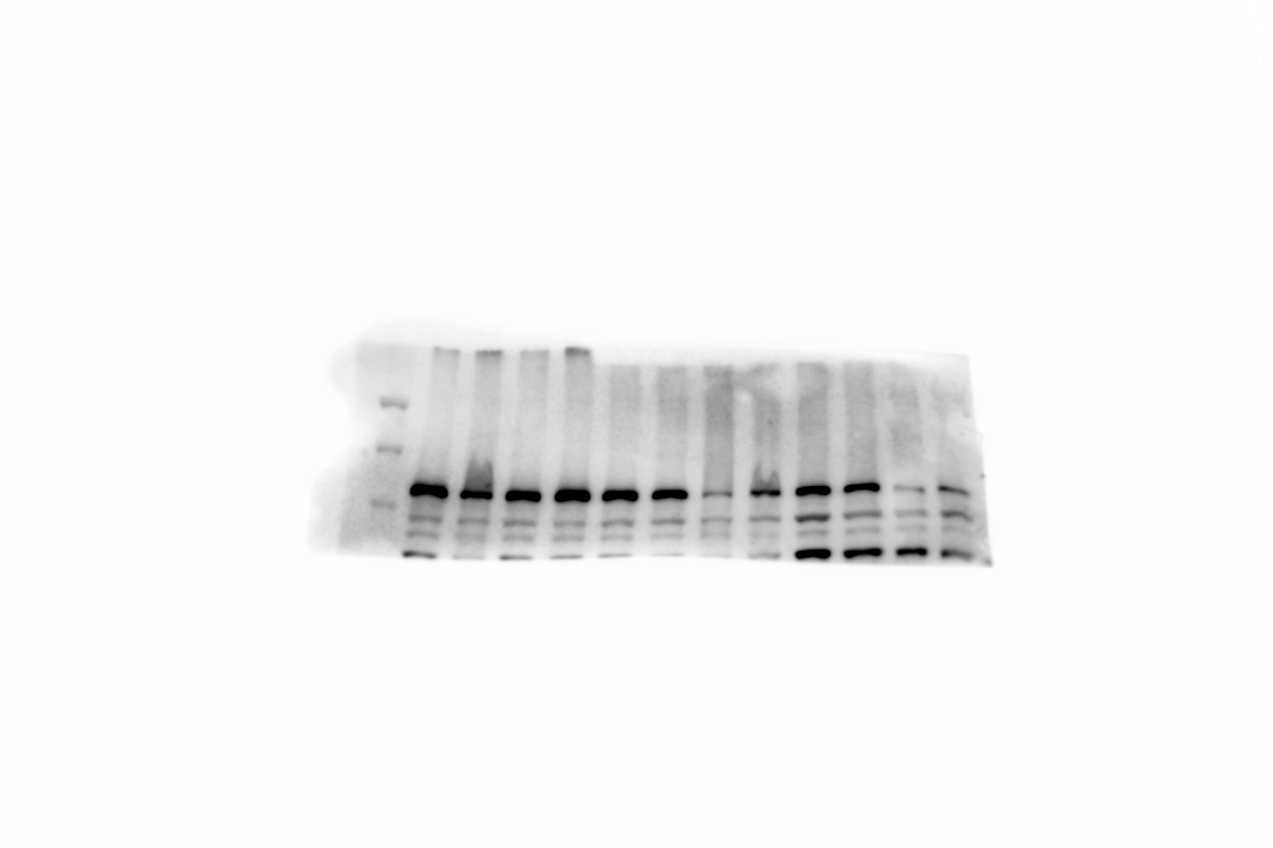
L-G6pc^{+/+}
shSCR
L-G6pc^{+/+}
shChREBP
L-G6pc^{-/-}
shChREBP
L-G6pc^{-/-}
shSCR

C
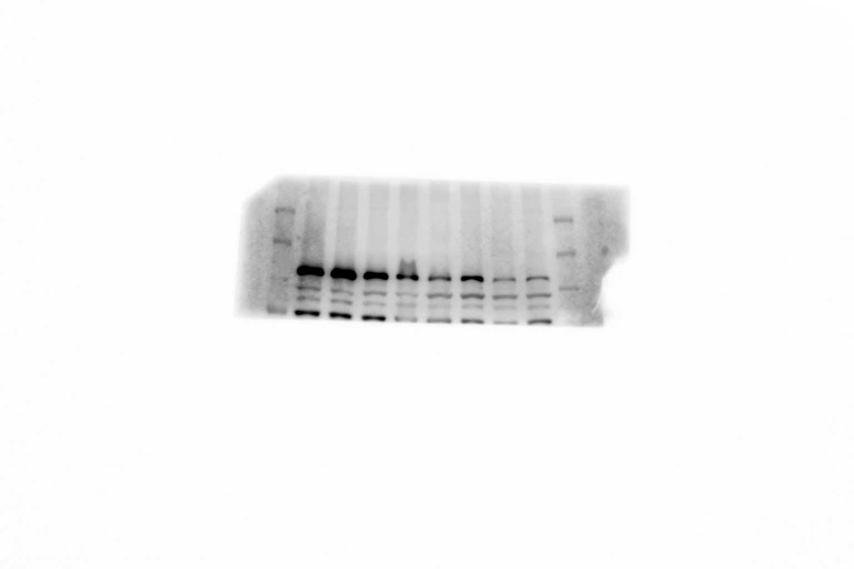
L-G6pc^{+/+}
shSCR
L-G6pc^{+/+}
shChREBP
L-G6pc^{-/-}
shChREBP
L-G6pc^{-/-}
shSCR
A: Up: Western Blot PARP, gel 1 (upper band: uncleaved; lower band: cleaved). Sample order: L-G6pc^{+/+} shSCR (m01-m03-m05); L-G6pc^{+/+} shChREBP (m09-m11-m13); L-G6pc^{-/-} shSCR (m17-m19-m21); L-G6pc^{-/-} shChREBP (m25-m26-m27). Down: corresponding image of marker.
B: Up: Western Blot PARP, gel 2 (upper band (band right above 100 kDa): uncleaved; lower band (band right below 100 kDa: cleaved). Sample order: L-G6pc^{+/+} shSCR (m02-m04-m06); L-G6pc^{+/+} shChREBP (m10-m12-m14); L-G6pc^{-/-} shSCR (m18-m20-m22); L-G6pc^{-/-} shChREBP (m28-m29-m30). Down: corresponding image of marker.
C: Up: Western Blot PARP, gel 3 (upper band (band right above 100 kDa): uncleaved; lower band (band right below 100 kDa: cleaved). Sample order: L-G6pc^{+/+} shSCR (m07-m08); L-G6pc^{+/+} shChREBP (m15-m16); L-G6pc^{-/-} shSCR (m23-m24); L-G6pc^{-/-} shChREBP (m31-m32). Down: corresponding image of marker.

Original Blots 4: p21 in whole liver lysate (quantification of p21 in Figure 4D (right); representative (cropped) blot in Figure S3C (left); corresponding Ponceau S loading controls provided in Figure S3C (right). (As observed band for this antibody is around 18 kDa, we chose the clear band between 15 and 18 kDa for quantification).
A
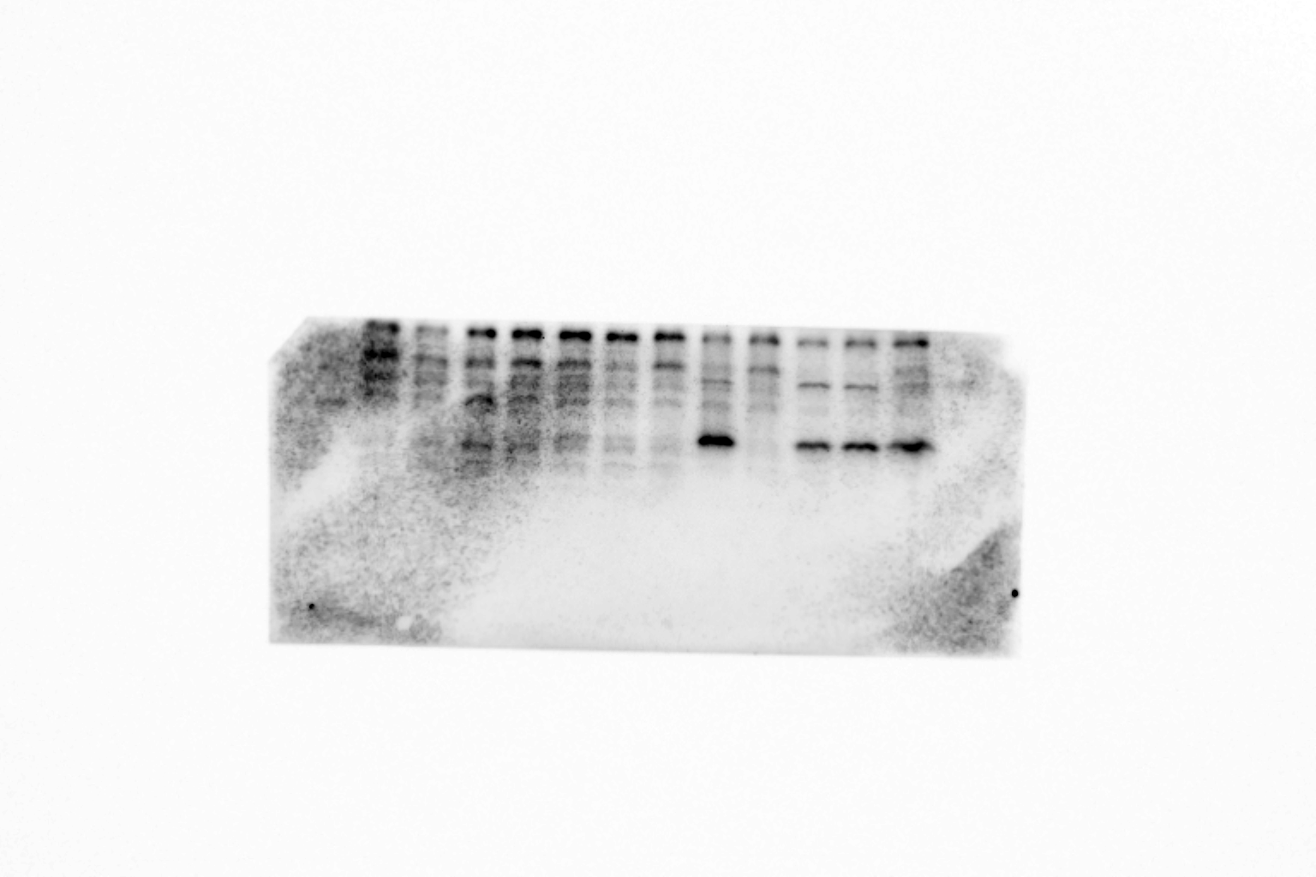
L-G6pc^{+/+}
shSCR
L-G6pc^{+/+}
shChREBP
L-G6pc^{-/-}
shChREBP
L-G6pc^{-/-}
shSCR
B
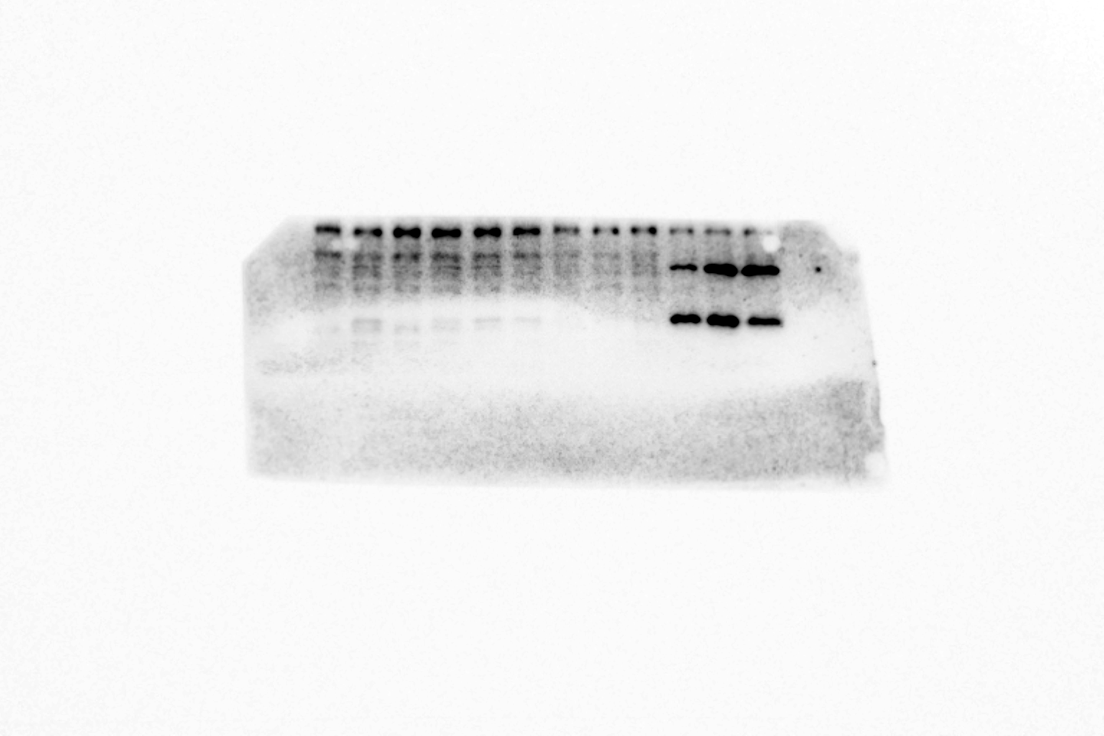
L-G6pc^{+/+}
shSCR
L-G6pc^{+/+}
shChREBP
L-G6pc^{-/-}
shChREBP
L-G6pc^{-/-}
shSCR
C
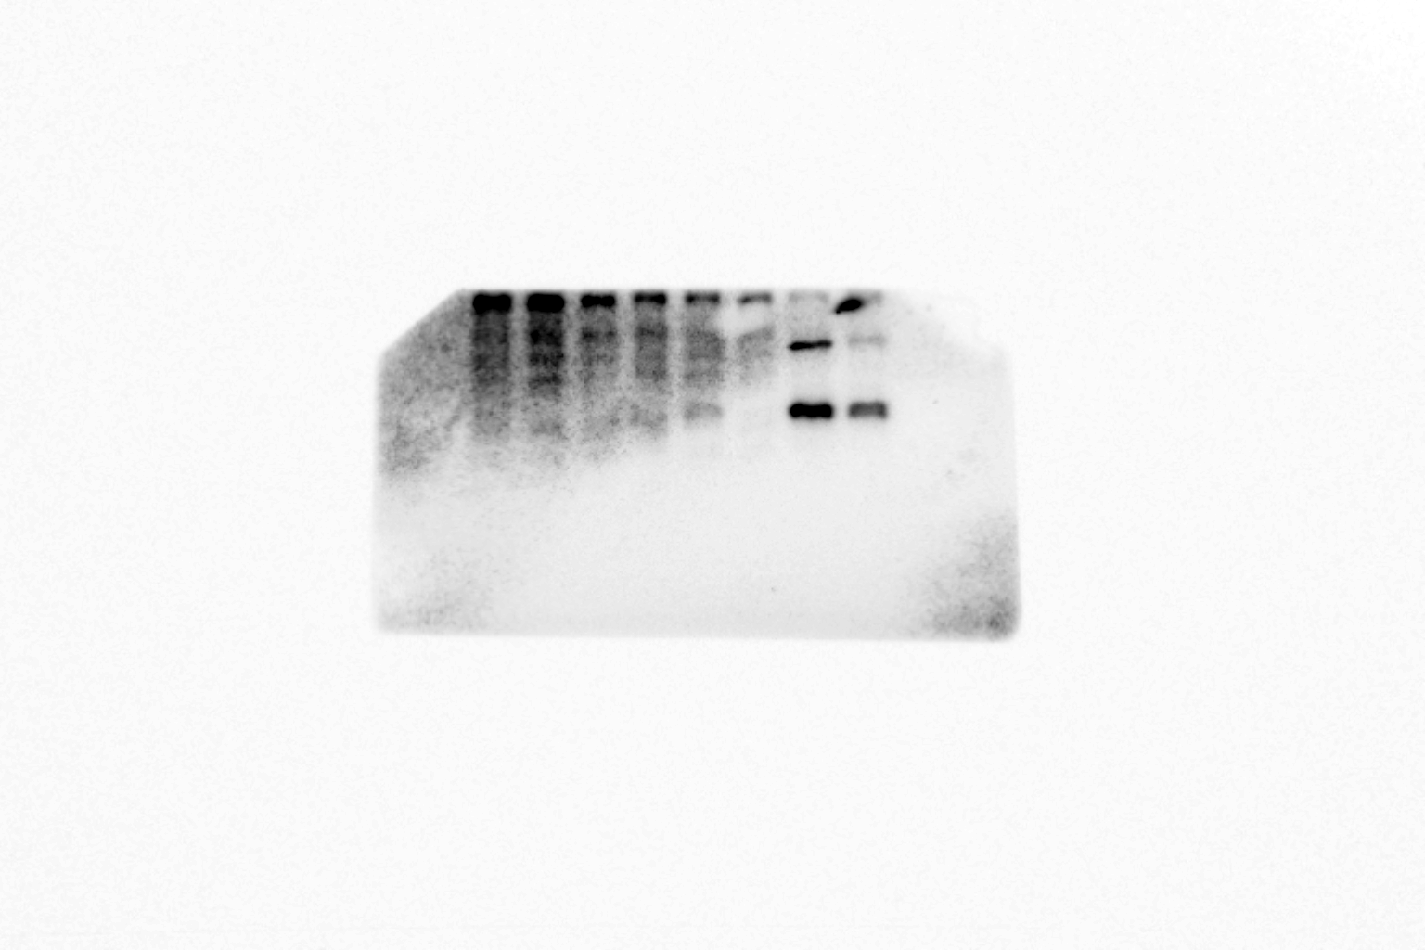
L-G6pc^{+/+}
shSCR
L-G6pc^{+/+}
shChREBP
L-G6pc^{-/-}
shChREBP
L-G6pc^{-/-}
shSCR
A: Up: Western Blot p21, gel 1. Sample order: L-G6pc^{+/+} shSCR (m01-m02-m03); L-G6pc^{+/+} shChREBP (m09-m10-m11); L-G6pc^{-/-} shSCR (m17-m18-m19); L-G6pc^{-/-} shChREBP (m25-m26-m27). Down: corresponding image of marker.
B: Up: Western Blot p21, gel 2. Sample order: L-G6pc^{+/+} shSCR (m04-m05-m06); L-G6pc^{+/+} shChREBP (m12-m13-m14); L-G6pc^{-/-} shSCR (m20-m21-m22); L-G6pc^{-/-} shChREBP (m28-m29-m30). Down: corresponding image of marker.
C: Up: Western Blot p21, gel 3. Sample order: L-G6pc^{+/+} shSCR (m07-m08); L-G6pc^{+/+} shChREBP (m15-m16); L-G6pc^{-/-} shSCR (m23-m24); L-G6pc^{-/-} shChREBP (m31-m32). Down: corresponding image of marker.

