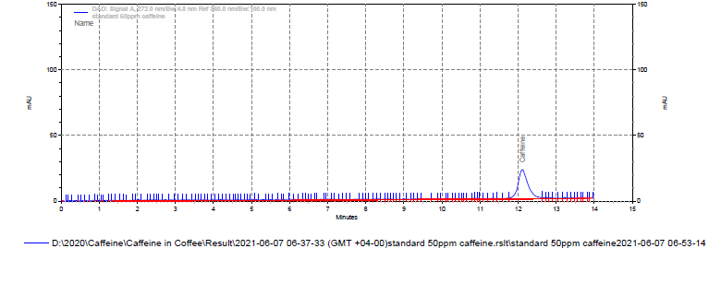

i) Chromatogram of BSC4602A
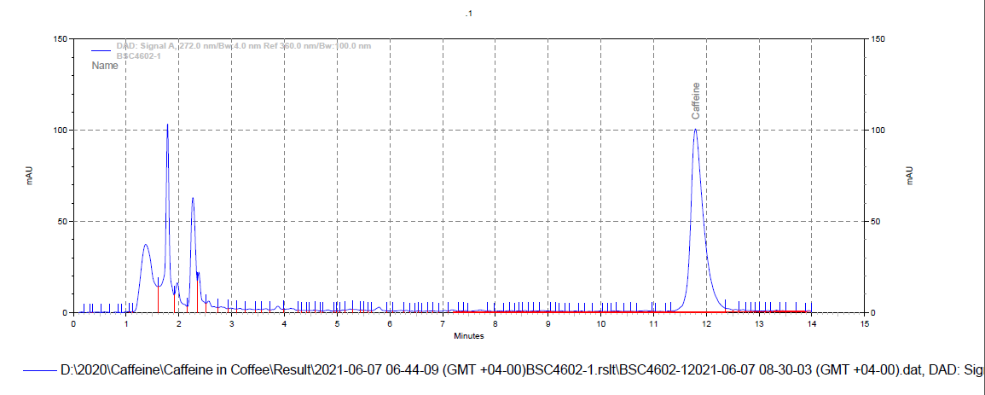
ii) Chromatogram of BSC4602B
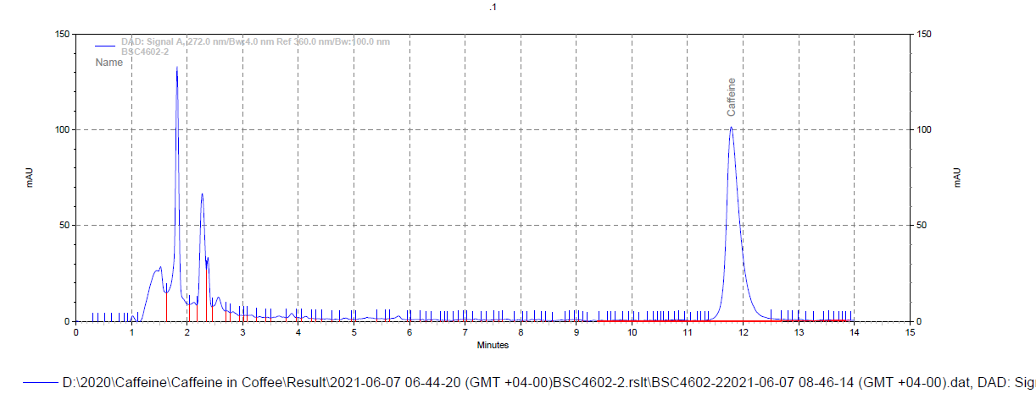

iii) Chromatogram of BSC4602C
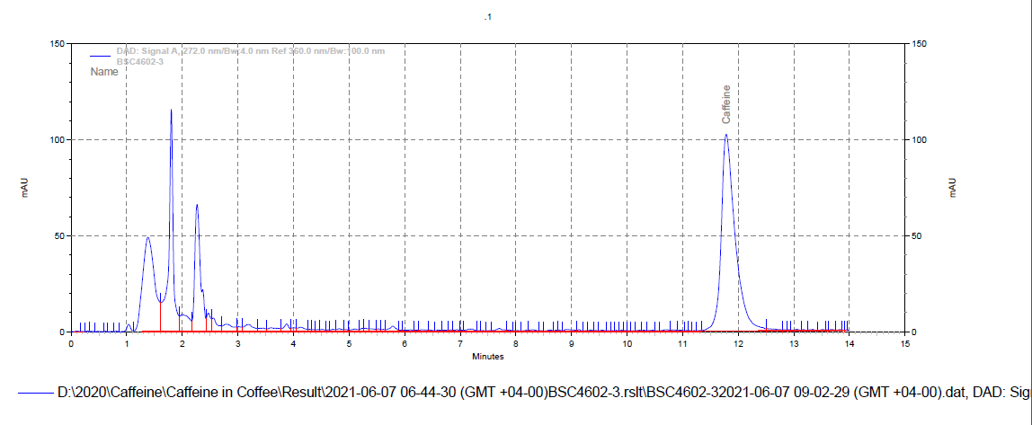

i) Chromatogram of BSC4603A
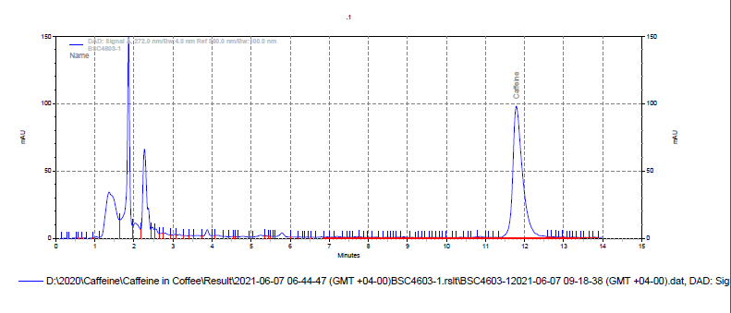

ii) Chromatogram of BSC4603B
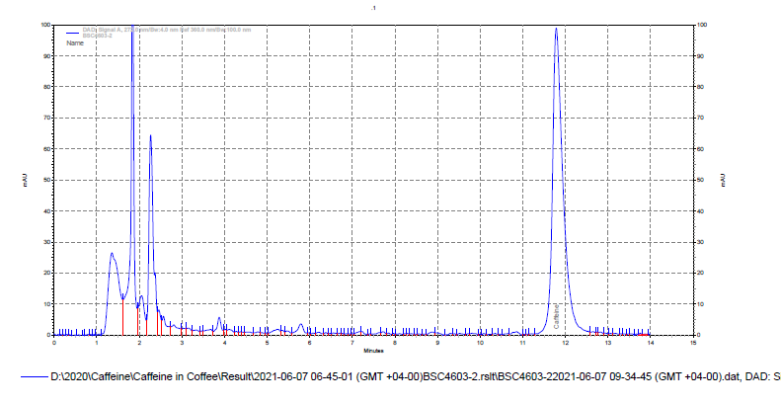
iii) Chromatogram of BSC4603C
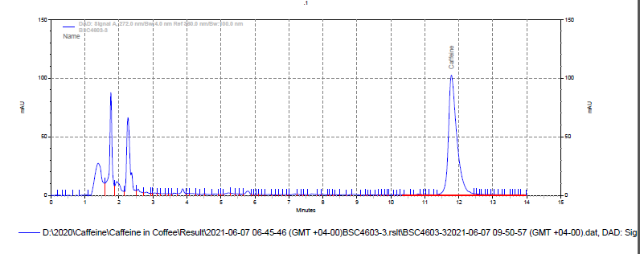

i) Chromatogram of BSC4604A
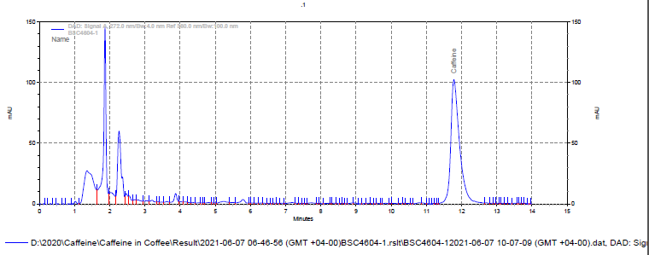

ii) Chromatogram of BSC4604B
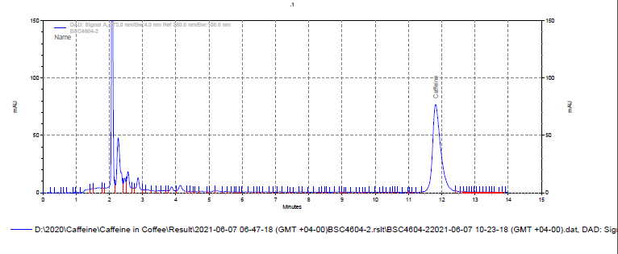

iii) Chromatogram of BSC4604C
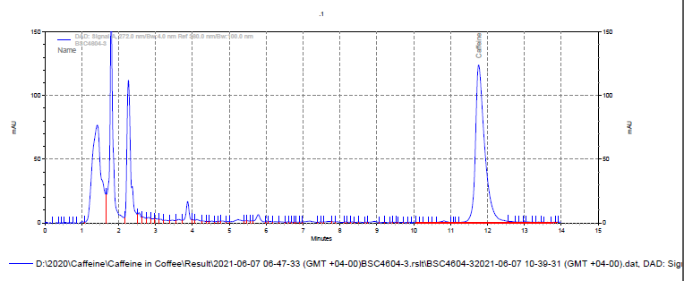

i) Chromatogram of BSC4605A
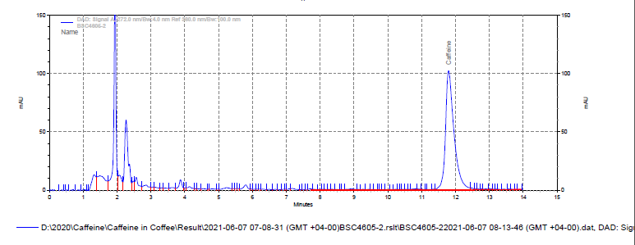

ii) Chromatogram of BSC4605B
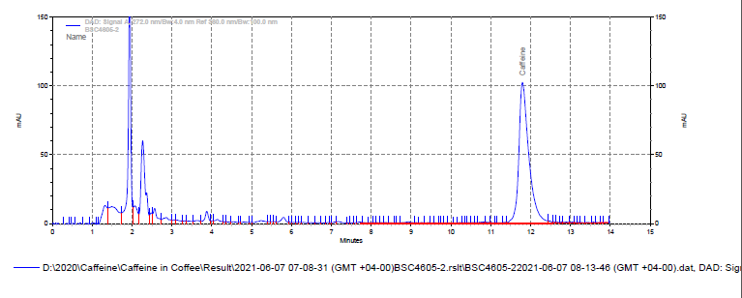

iii) Chromatogram of BSC4605C
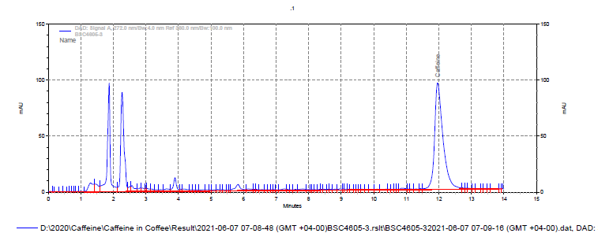

i) Chromatogram of BSC4606A
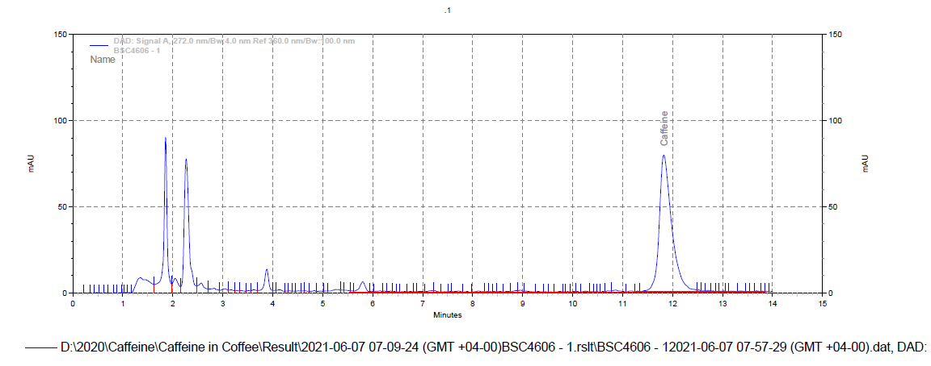

ii) Chromatogram of BSC4606B
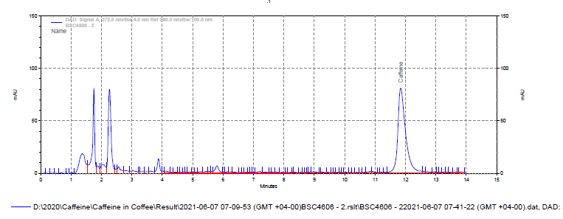

iii) Chromatogram of BSC4606C
