Supplementary Figure 1. Metagenomic composition of the five studied sections of the Amazon River microbiome. Ordination of metagenomes composing the different river sections based on the Jaccard distances calculated from the presence-absence of k-mers in each sample. NMDS groups were statistically different [PERMANOVA, F=2.34, p-value = 9.99e-5], displaying (b) intragroup heterogeneity [β-dispersion; PERMUTEST, F=7.72, p-value = 0.001].
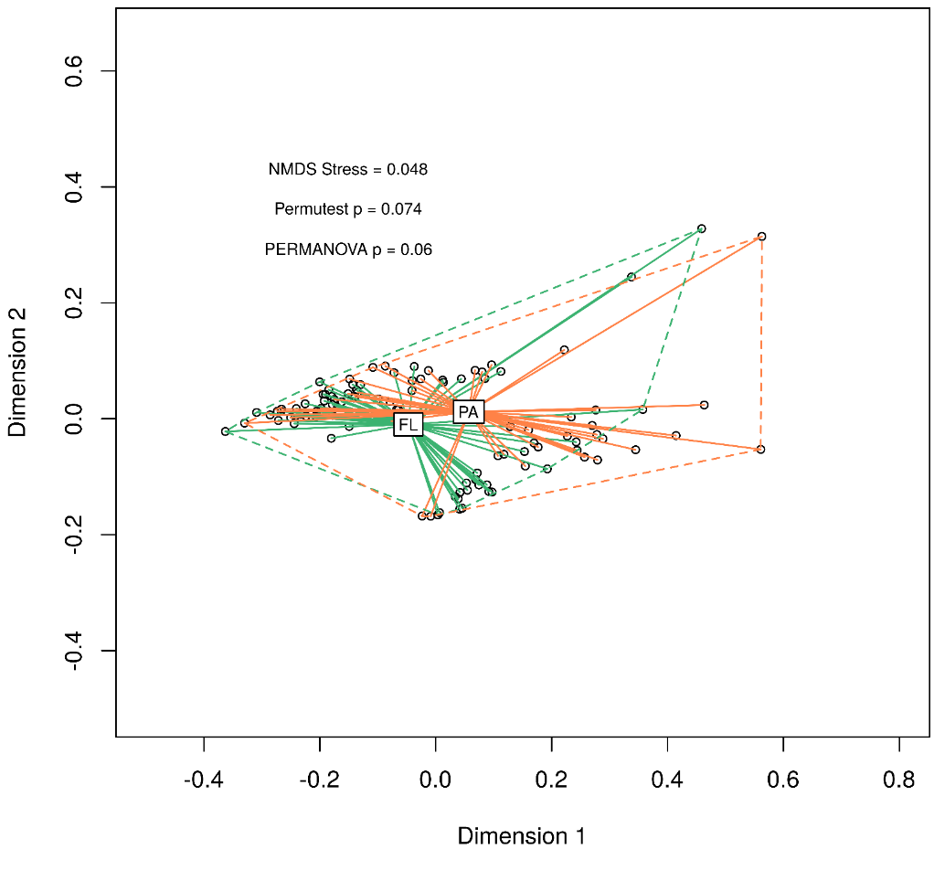
Supplementary Figure 2. Metagenomic composition of the Amazon River microbiome according to microbial lifestyle. Ordination of metagenomes composing the different river sections based on the Jaccard distances calculated from the presence-absence of k-mers in each sample. NMDS groups were statistically different [PERMANOVA, F=3.62, p-value = 0.06], displaying intragroup homogeneity [β-dispersion; PERMUTEST, F=3.62, p-value = 0.074].
Supplementary Figure 3. Functional composition across size fractions and sections of the Amazon River. Gene functions grouped into COG super classes are shown per river section and microbial lifestyle (particle-attached vs. free-living). The Upstream river section is not shown in the particle-associated fraction, since it was not sampled.

