Highly Efficient Biosynthesis of Salidroside by a UDP-glucosyltransferase-catalyzed Cascade Reaction
Guosi Li*^{,a,b}, Qilin Xu^{a,b}, Nan Huª, Xinyang Liu^{b}, Yiqi Jiang^{c}, Hailong Xue^{c}, Yongjun Zang ^{a,b}, Fucheng Zhu*^{,a,b}

G.-S. Li () ⋅ Q.-L ⋅ Xu ⋅ N. H ⋅ X.-Y. Liu ⋅ Y.-Q ⋅ Jiang ⋅ H.-L. Xue ⋅ Y.-J. Zang ⋅ F.-C. Zhu ()
ª Anhui Engineering Laboratory for Conservation and Sustainable Utilization of Traditional Chinese Medicine Resources, West Anhui University, Luʼan, 237012, Anhui, China
^{b} Anhui Engineering Research Center for Eco-agriculture of Traditional Chinese Medicine, Department of Biological and Pharmaceutical Engineering, West Anhui University, Luʼan, 237012, Anhui, China
^{c} Key Laboratory of Biomass Chemical Engineering of Ministry of Education, College of Chemical and Biological Engineering, Zhejiang University, Hangzhou, 310027, Zhejiang, China
Email: G.-S. Li: liguosi1989@163.com; F.-C. Zhu: fucheng323@163.com

List of Entries
Table S1 List of strains and plasmids used in this study.……………………….…….3
Table S2 Primers used in this study……………………….………………………….4
Fig. S1 SDS-PAGE analysis of the selected UDP-glucosyltransferases……………...5
Fig. S2 Optimal pH of UGT85A1 (a) and GmSUS (b) ……………………….………5
Fig. S3 ¹H and ¹³C NMR spectra of purified salidroside………………………. …….6
Fig. S4 ¹H and ¹³C NMR spectra of purified icariside D2…………………………….7

Table S1 List of strains and plasmids used in this study.
Strains/Plasmids | Relevant description | Reference
Strains
E. coli DH5α | E. coli strain used for standard cloning procedures | Takara
E. coli BL21 (DE3) | E. coli strain used for the expression of target gene | Takara
Bacillus licheniformis ATCC14580 | Wild-type strain | ATCC
E. coli-BlYjiC | E. coli BL21 (DE3) derivate, harboring pET28a-BlYjiC | This study
E. coli-UGT85A1 | E. coli BL21 (DE3) derivate, harboring pET28a-UGT85A1 | This study
E. coli-UGT73B6 | E. coli BL21 (DE3) derivate, harboring pET28a-UGT73B6 | This study
E. coli-UGT72B14 | E. coli BL21 (DE3) derivate, harboring pET28a-UGT72B14 | This study
E. coli-RrUGT17 | E. coli BL21 (DE3) derivate, harboring pET28a-RrUGT17 | This study
E. coli-RrUGT33 | E. coli BL21 (DE3) derivate, harboring pET28a-RrUGT33 | This study
E. coli-GmSuSy | E. coli BL21 (DE3) derivate, harboring pET28a- GmSuSy | This study
Plasmids
pET28a | T7 promoters, pBR322 replicon, Kan^{R} | Novagen
pET28a-BlYjiC | pET28a + BlYjiC (Noc I/BamH I) | This study
pET28a-UGT85A1 | pET28a + UGT85A1 (Noc I/BamH I) | This study
pET28a-UGT73B6 | pET28a + UGT73B6 (Noc I/BamH I) | This study
pET28a-UGT72B14 | pET28a + UGT72B14 (Noc I/BamH I) | This study
pET28a-RrUGT17 | pET28a + RrUGT17 (Noc I/BamH I) | This study
pET28a-RrUGT33 | pET28a + RrUGT33 (Noc I/BamH I) | This study
pET28a-GmSuSy | pET28a + GmSuSy (Noc I/BamH I) | This study

Table S2 Primers used in this study.
Name | Sequence (5’-3’)
BlYjiC-F | taagaaggagatataccatggccATGGGACATAAACATATCGCGAT
BlYjiC-R | ctcgagtgcggccgcaagcttTTTTACTCCTGCGGGTGCTAA
UGT85A1-F | taagaaggagatataccatggccATGGGCAGCCAGATTATTCATAA
UGT85A1-R | ctcgagtgcggccgcaagcttATCCTGGCTTTTCTGGCCC
UGT73B6-F | taagaaggagatataccatggccATGGGCAGCGAAACCCGT
UGT73B6-R | ctcgagtgcggccgcaagcttCACTTTTTTCAGTTTCAGTTCCTGC
UGT72B14-F | taagaaggagatataccatggccATGGCTGGCTCAGGCACA
UGT72B14-R | ctcgagtgcggccgcaagcttATGCTTTACCGAACTCCTCCAC
RrUGT17-F | taagaaggagatataccatggccATGGGCTCACTTCCTTCCACA
RrUGT17-R | ctcgagtgcggccgcaagcttGACGCTAAACTGGACCACTTTTTC
RrUGT33-F | taagaaggagatataccatggATGAGCTTAATTGAAAAACCACTCAC
RrUGT33-R | ctcgagtgcggccgcaagcttACGGATATGTTTTGTTTTTGAGAGC
GmSuSy-F | taagaaggagatataccatggATGGCCACCGATCGTCTGA
GmSuSy-R | ctcgagtgcggccgcaagcttTTCGGCTGCCAGCGGCAC
Lowercase in the sequence indicates sequences homologous to the vector used for recombination.

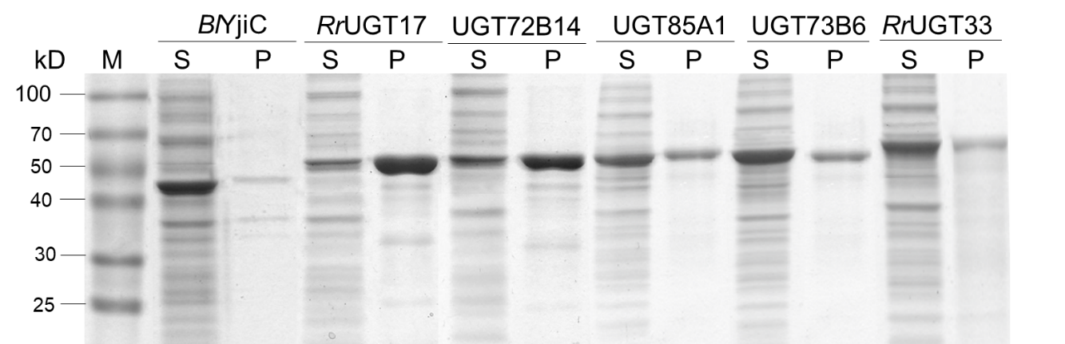
Fig. S1 SDS-PAGE analysis of the selected UDP-glucosyltransferases. M, marker; S, supernatants; P, precipitates.

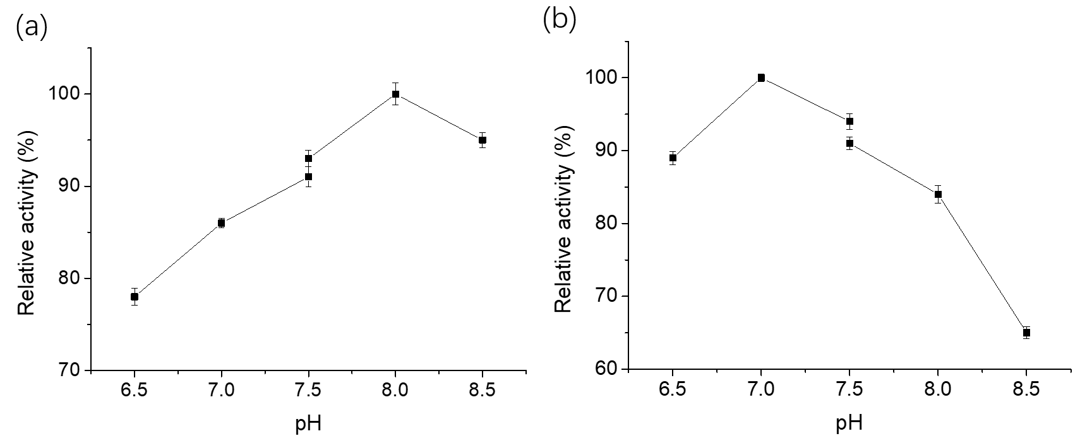
Fig. S2 Optimal pH of UGT85A1 (a) and GmSUS (b). pH 6.5−7.5: 50 mM Na₂HPO₄−NaH₂PO_{4,} pH 7.5−8.5: 50 mM Tris−HCl buffer.

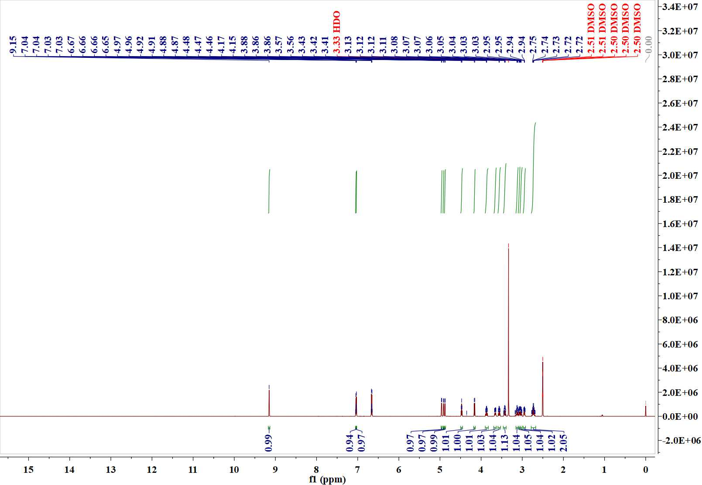

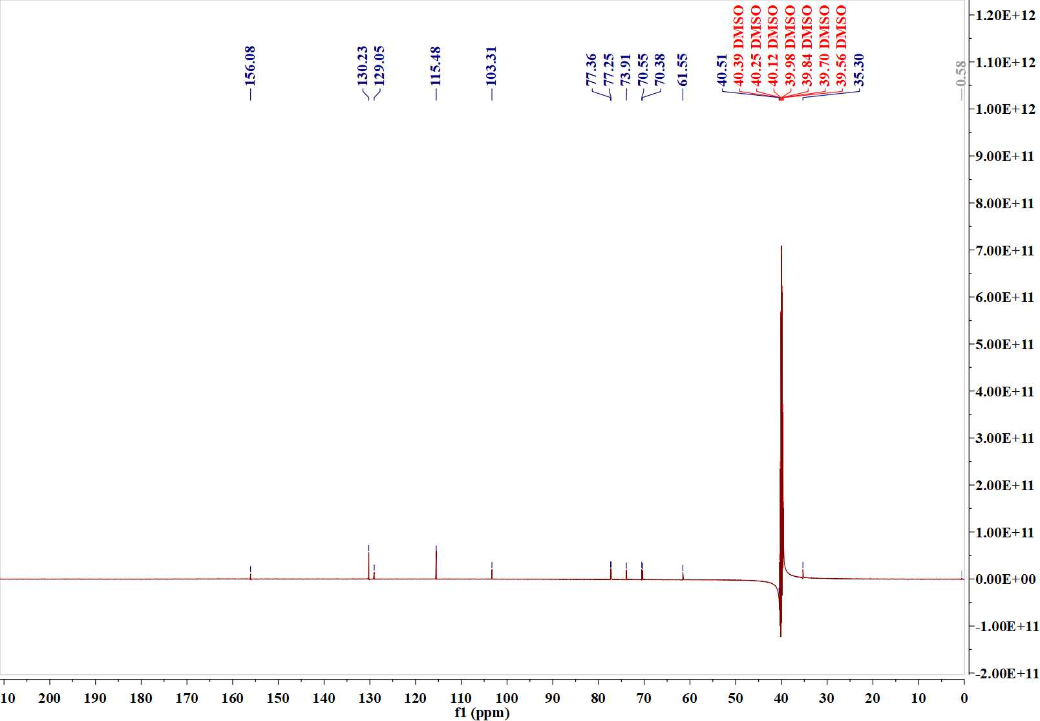
Fig. S3 ¹H and ¹³C NMR spectra of purified salidroside.

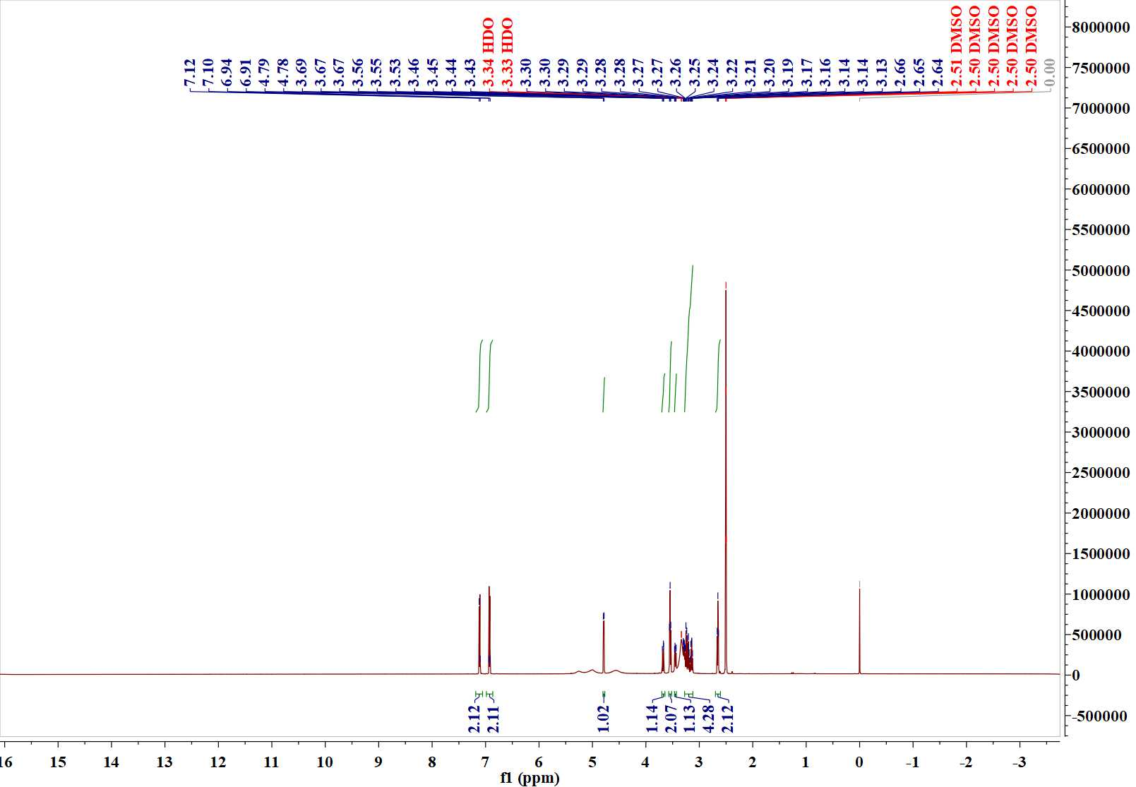

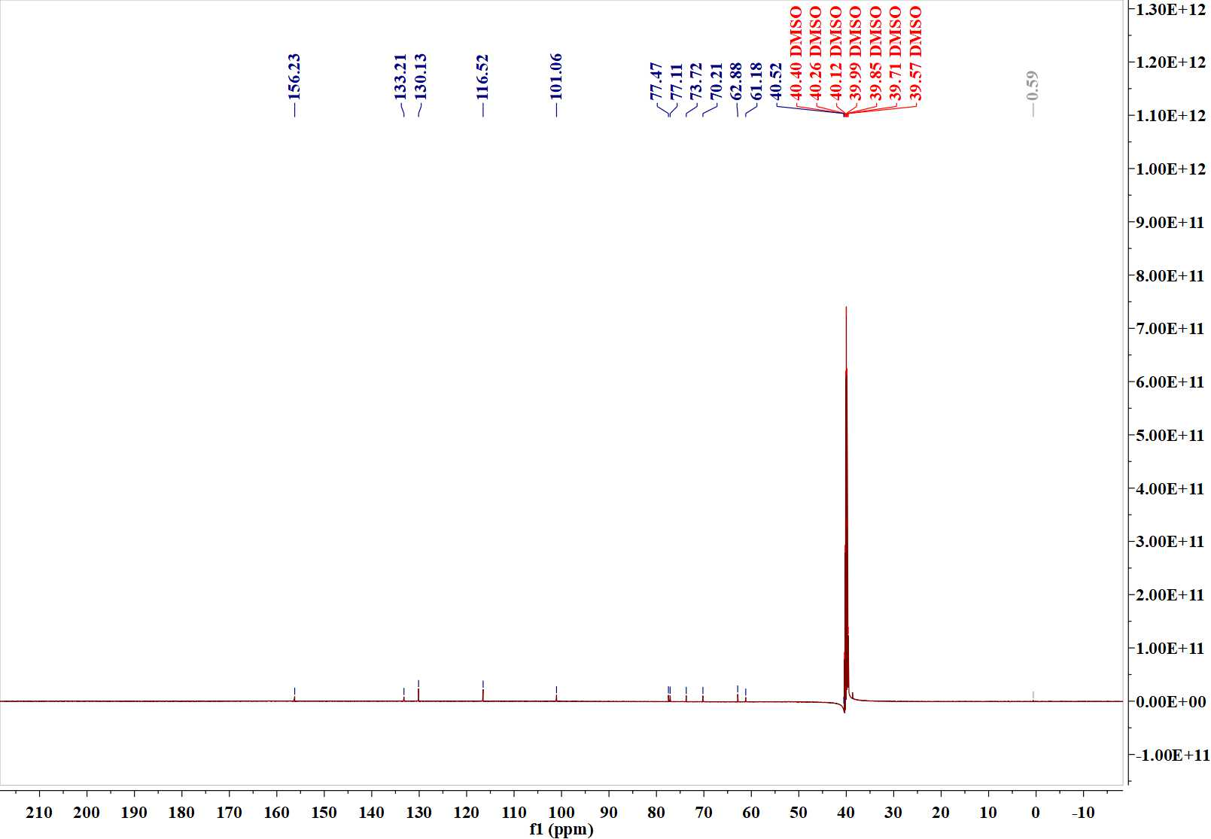
Fig. S4 ¹H and ¹³C NMR spectra of purified icariside D2.

