Supplementary data

Table S1
SNPs region for sex segregation of date palm in 12th chromosome
Contig ID | SNP location in contig "bp" | SNP in sequence
PDK_30s1101131 | 34123 | CTCCAGG[G]TACATAT
PDK_30s1113521 | 6551 | TGTCTGT[A]CGAAAAA
PDK_30s765331 | 16367 | TCAGCCG[C]CTTCTCT
PDK_30s984901 | 5366 | ACAATAC[G]TAAATCT
PDK_30s1140781 | 3605 | GTCGCAT[T]GTATTTG
PDK_30s1038101 | 11669 | AATACTC[G]TAAACAT
PDK_30s1038231 | 17401 | AAGGTGC[T]CCATCCT
PDK_30s1041181 | 1413 | CTTCGTG[T]CTGGACC
PDK_30s1048231 | 23909 | TGTCTAA[C]GGGTTTA
PDK_30s1055851 | 18992 | CCCAGTC[T]GCCTCGC
PDK_30s1055851 | 19086 | AACTCTT[A]AAGAAAC
PDK_30s1057141 | 4553 | TGAATTA[T]GATTGTA
PDK_30s1108461 | 8124 | AAACTAT[A]CTACCAA
PDK_30s1140781 | 3923 | GAGATAC[A]CATGAAC
PDK_30s1140781 | 3612 | TGTATTT[G]TTTGCAT
PDK_30s1140781 | 3950 | GCCCAGC[G]AATGTAT
PDK_30s1192921 | 32839 | TGTGATG[C]GTCATAG
PDK_30s1192921 | 33178 | GCTTTGC[G]TCTTTGC
PDK_30s1192921 | 33221 | AGACTTT[G]TCTTTTT
PDK_30s1192921 | 33237 | GTTTCTT[G]CTTATGT
PDK_30s1192921 | 33451 | AAATGGA[C]AAATTGG
PDK_30s1202771 | 8493 | GCTAATG[T]ACATAAA
PDK_30s1202771 | 8741 | TACCATT[A]TACTTAG
PDK_30s1202771 | 8750 | ACTTAGC[A]TGGCATG
PDK_30s1202771 | 8771 | TGCTAAT[A]TCTGTTG
PDK_30s1202771 | 11547 | ACGCAGC[G]CACGACT
PDK_30s1202771 | 11854 | GCGATCT[C]GGTGAAC
PDK_30s65509109 | 41588 | CCACATC[T]TGATATT
PDK_30s65509109 | 41880 | GCATTCA[G]CGAAGGC
PDK_30s65509119 | 15419 | TGAAATT[T]TAAAACA
PDK_30s65509204 | 9726 | AGGATCA[C]TAATTAA
PDK_30s65509610 | 32561 | TGATTTT[T]TGATCAA
PDK_30s65509610 | 32612 | AACTGGC[C]TCAAGTC
PDK_30s6550963 | 74069 | ATTTTAT[C]TTAGAAT
PDK_30s6550963 | 74086 | GGAGATA[C]TTTCATG
PDK_30s6550963 | 74096 | TCATGCA[G]AAATGAA
PDK_30s6550963 | 74270 | CCAGCAC[C]CATGGCC
PDK_30s6550998 | 11694 | CTGTTCT[A]GTTCTTC
PDK_30s6550998 | 11832 | AGACTGC[C]TGTGGCT
PDK_30s6550998 | 6858 | CTGATTT[G]CTTTCTG
PDK_30s749591 | 15281 | TTTCCAT[A]GTGATCA
PDK_30s749591 | 15264 | CTTTATA[C]TTTATTT
PDK_30s749591 | 15497 | GAGGAAG[C]AGGGATG
PDK_30s749591 | 15498 | AGGAAGC[A]GGGATGG
PDK_30s749591 | 15533 | GGACGGC[T]GTGGAAG
PDK_30s758601 | 4053 | TAAGCAT[G]CACCGCT
PDK_30s758601 | 4040 | GGAAGAG[A]ATCCCTA
PDK_30s798841 | 5432 | AACTCGA[A]TTCTTCC
PDK_30s798841 | 5442 | CTTCCAG[C]ACTCCAG
PDK_30s804871 | 11350 | ACTTCAA[C]AAAAAGA
PDK_30s834251 | 3781 | CTGCTTA[A]CAGAGCA
PDK_30s834251 | 3826 | AGTTAGG[A]AGTTCCC
PDK_30s865001 | 2430 | CTCTCTC[C]GATCAAA
PDK_30s865001 | 2747 | ACCGAAG[A]GGGAGGT
PDK_30s865001 | 8219 | TTATCTT[T]AAATTTA
PDK_30s867071 | 19397 | AAGGCCA[C]TTCAAAG
PDK_30s867071 | 19399 | GGCCACT[T]CAAAGTT
PDK_30s869491 | 43299 | TAATAAG[C]AACAAAA
PDK_30s876401 | 53977 | AATGCTC[T]ATAGATA
PDK_30s906831 | 16109 | AGTGATA[T]GGTGCTA
PDK_30s906831 | 15867 | AAGTGAT[C]GGGTGTA
PDK_30s906831 | 16060 | TTGGCTC[A]ACCAAAA
PDK_30s906831 | 16131 | CAACCAG[A]TCACAGC
PDK_30s925161 | 27304 | ACAGAAG[T]ATAAGAA
PDK_30s933141 | 4607 | ATTCTCC[G]GGAACAA
PDK_30s933141 | 4842 | AGGGGGG[G]TGATAAA
PDK_30s933141 | 4844 | GGGGGGT[G]ATAAACA
PDK_30s933141 | 4856 | ACAAGTA[A]GGCCAAC
PDK_30s946471 | 59768 | TATGACC[C]CTCTGGA
PDK_30s968101 | 9658 | TTCACCA[T]ATTTTGA
PDK_30s968101 | 10259 | AGTGATT[T]GCTCCCT
PDK_30s968101 | 10422 | GCCAAGG[T]GTGCCTA
PDK_30s984901 | 5433 | TGATCTT[C]TGAATAA

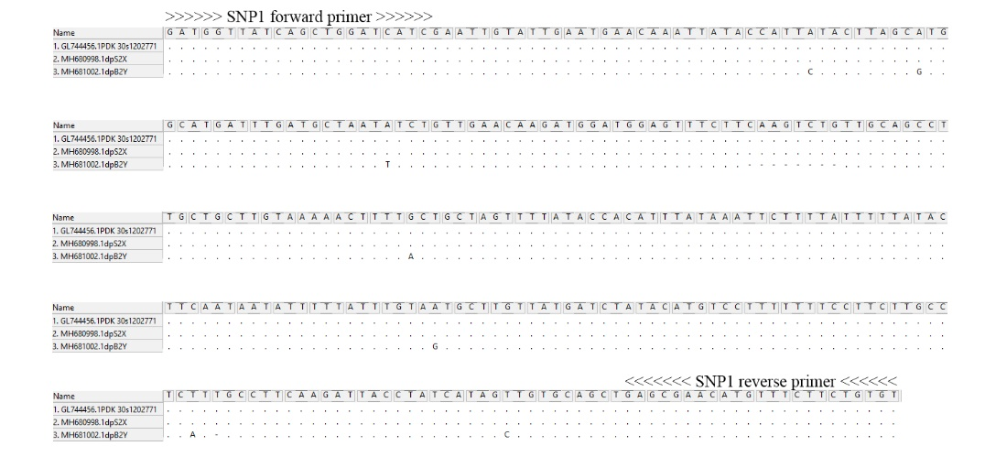

Fig. S1 Alignment of the PCR fragment sequences amplified by SNP1 primers. Identical nucleotides and deletions are represented by ‘.’ and ‘-’ respectively.

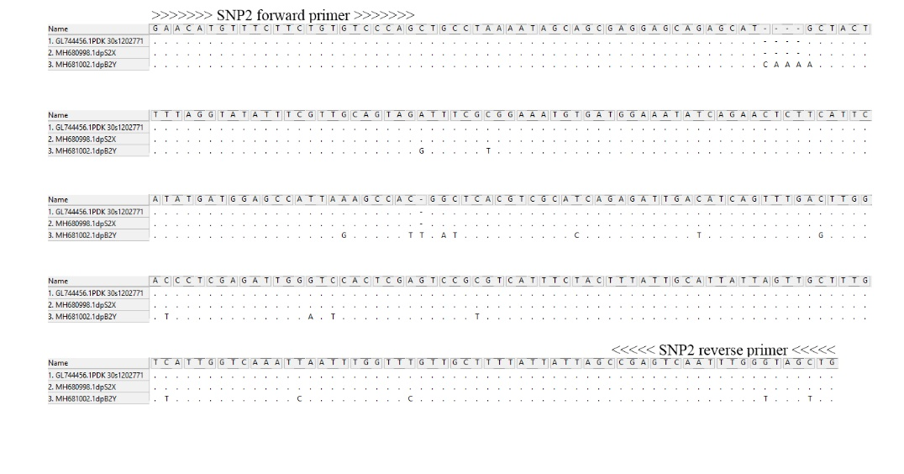

Fig. S2 Alignment of the PCR fragment sequences amplified by SNP2 primers. Identical nucleotides and deletions are represented by ‘.’ and ‘-’ respectively.

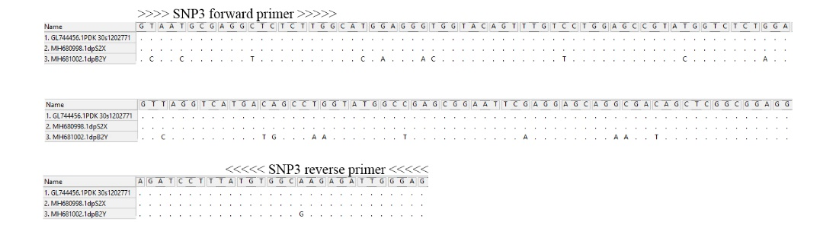

Fig. S3 Alignment of the PCR fragment sequences amplified by SNP3 primers. Identical nucleotides and deletions are represented by ‘.’ and ‘-’ respectively.

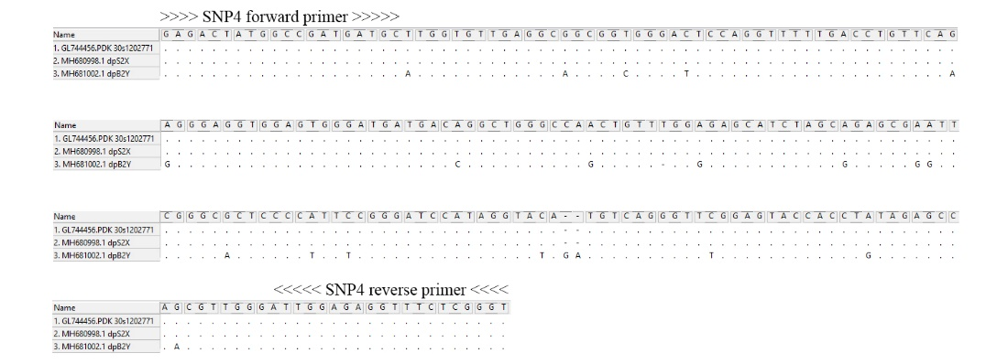

Fig. S4 Alignment of the PCR fragment sequences amplified by SNP4 primers. Identical nucleotides and deletions are represented by ‘.’ and ‘-’ respectively.

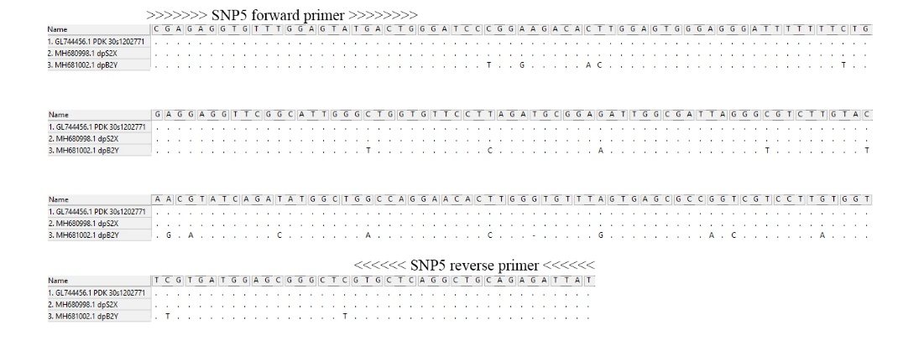

Fig. S5 Alignment of the PCR fragment sequences amplified by SNP5 primers. Identical nucleotides and deletions are represented by ‘.’ and ‘-’ respectively.

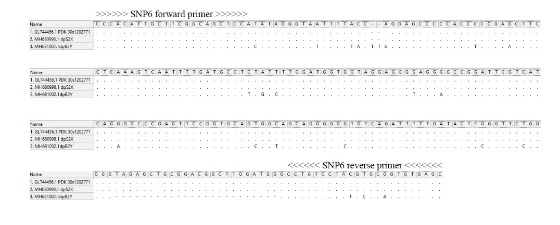

Fig. S6 Alignment of the PCR fragment sequences amplified by SNP6 primers. Identical nucleotides and deletions are represented by ‘.’ and ‘-’ respectively.

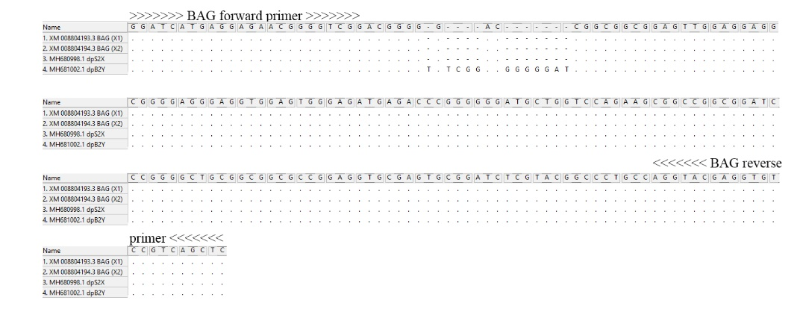

Fig. S7 Alignment of the PCR fragment sequences amplified by BAG SNP3 primers. Identical nucleotides and deletions are represented by ‘.’ and ‘-’ respectively.

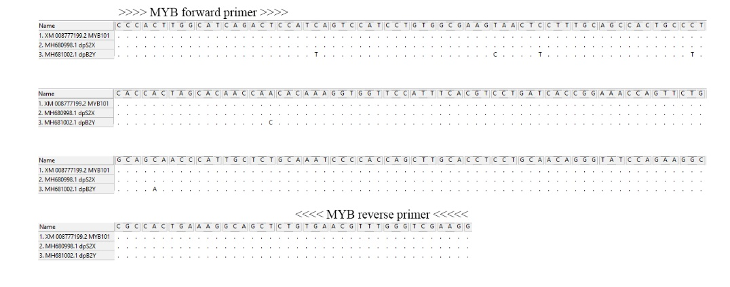

Fig. S8 Alignment of the PCR fragment sequences amplified by MYB primers. Identical nucleotides and deletions are represented by ‘.’ and ‘-’ respectively.

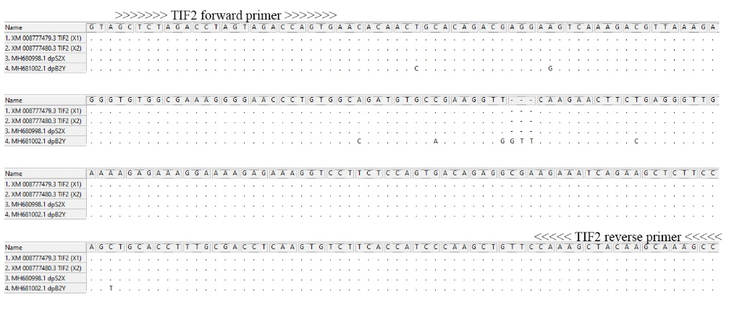
Fig. S9 Alignment of the PCR fragment sequences amplified by TIF2 primers. Identical nucleotides and deletions are represented by ‘.’ and ‘-’ respectively.

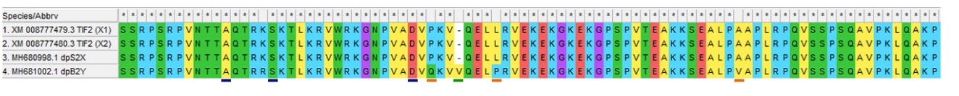

Fig. S10 Alignment of the amino acid sequences, which translate from PCR fragment sequences amplified by TIF2 primers. Blue underlining: silent mutation; orange underlining: missense mutation; green underlining: indel.

