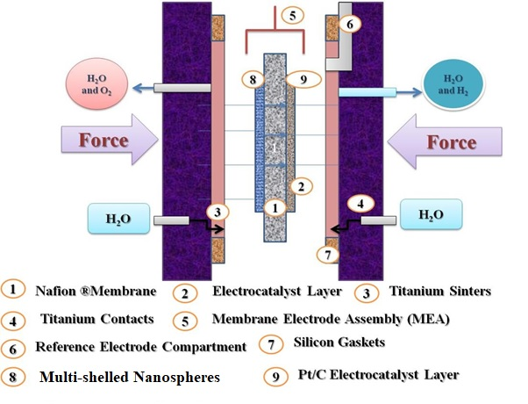
S1: Schematic Diagram of PEM Water Electrolyzer System

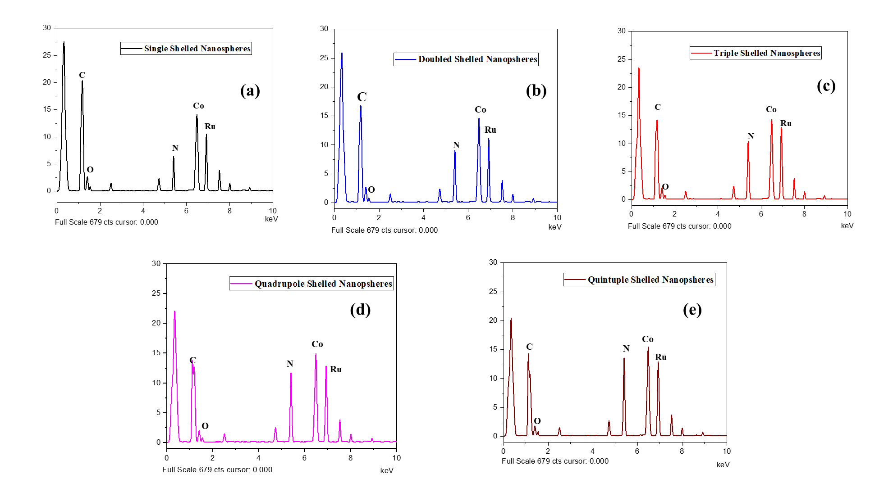
Figure S2 (a – e): EDAX results of N-incorporated Ru/Co-Co₃O₄ graphene coated multi-shelled nanospheres

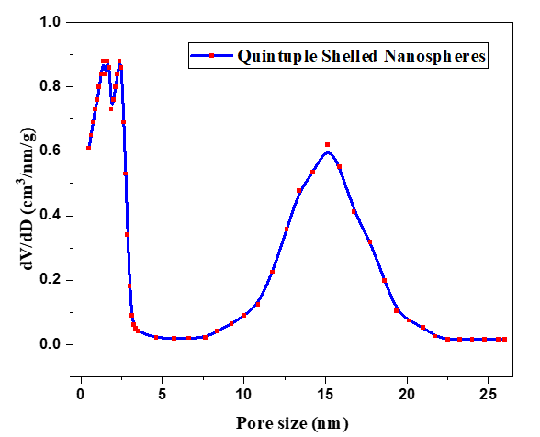
Figure S3: Pore size distribution curve for N-incorporated Ru/Co-Co₃O₄ graphene coated Quintuple shelled nanospheres

Figure S4: Schematic Diagram of H-type Electrochemical cell
S5: Electrocatalytic stability of N-doped Ru-Co/Co₃O₄ graphene nanospheres with quintuple shell
S6: Electrocatalytic stability of N-doped Ru-Co/Co₃O₄ graphene nanospheres with quintuple shell

