Title: Alkaloid-Metabolomics & DNA profiles: Role-bioassay-guided differentiation process of Six Annona cultivated in Egypt on anti-cancer therapy.
Mona A. Mohammed*¹, Nahla Elzefzafy², Piotr Kachlicki³
¹Medicinal and Aromatic Plants Research Department, pharmaceutical and Drugs industries institute, National Research Centre, Dokki, Giza, Egypt.
² Cancer Biology Department, National Cancer Institute Cairo University, Cairo, Egypt.
³ Institute of Plant Genetics Polish Academy of Sciences, Poznan, Poland.

Table S1.
Number of total bands, monomorphic bands and polymorphic bands and percentage of polymorphism revealed by the twelve 10-mer primers in the studied samples by SCoT and ISSR.

SCoT | Primer  Name | Total  Band | Monomorphic  Band | Polymorphic  band | Unique  Band | Polymorphic  %
SCoT | SCoT 1 | 8 | 4 | 4 | - | 50%
SCoT | SCoT 2 | 3 | 3 | - | - | -
SCoT | SCoT 3 | 5 | 4 | 1 | 1 | 20%
SCoT | SCoT 4 | 7 | 3 | 4 | 4 | 57.14%
SCoT | SCoT 6 | 3 | 2 | 1 | 1 | 33.33%
SCoT | SCoT 8 | 5 | 1 | 4 | 3 | 80%
SCoT | Total | 31 | 17 | 14 | 9 | 45.16%
ISSR | 14A | 4 | 3 | 1 | - | 25%
ISSR | 44A | 5 | 4 | 1 | 1 | 20%
ISSR | HB-8 | 5 | 3 | 2 | - | 40%
ISSR | HB-10 | 6 | 2 | 4 | 1 | 66.66%
ISSR | HB-12 | 8 | 5 | 3 | 3 | 37.5%
ISSR | HB-13 | 6 | 5 | 1 | - | 16.16%
ISSR | Total | 34 | 22 | 12 | 5 | 35.29%
Combination Between SCoT and ISSR | ISSR | 34 | 22 | 12 | 5 | 35.29%
Combination Between SCoT and ISSR | SCoT | 31 | 17 | 14 | 9 | 45.16%
Combination Between SCoT and ISSR | Total | 65 | 39 | 26 | 14 | 40.0%

Table S2.
Similarity Index Using SCoT and ISSR analysis for six Annona sp.

species | 1 | 2 | 3 | 4 | 5
1 | 1.0
2 | 0.166 | 1.0
3 | 0.233 | 0.538 | 1.0
4 | 0.114 | 0.132 | 0.682 | 1.0
5 | 0.589 | 0.238 | 0.875 | 0.530 | 1.0
6 | 0.308 | 0.283 | 0.845 | 0.413 | 0.378

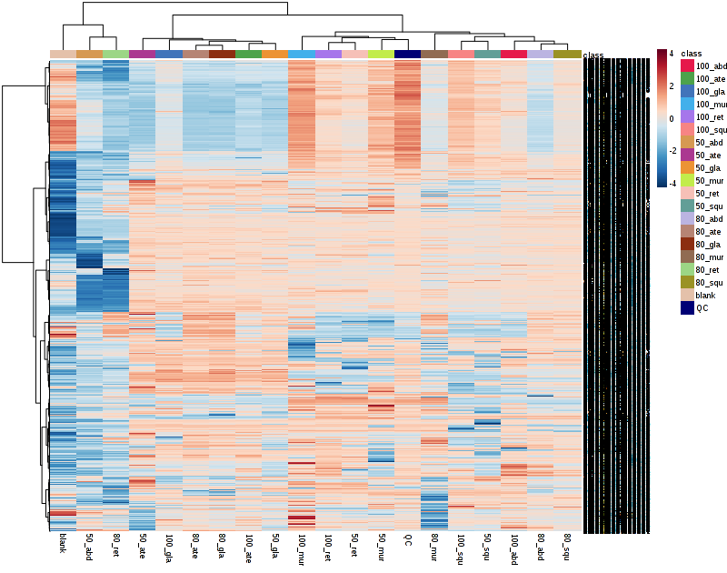
A

B

Fig S1. Bioinformatic pre-processing of LC/MS data resulted in detection of 67933 total signals in both modes in (A) the pearson correlation of heatmap of metabolic profiling of positive mode it apear different classification of compound showed in (sPLS-DA and PCA loading plot of different extract species. Hierachical clustering of all signals from different Annona species showed in clusters positive mode. B) metabolomics data positive 18 samples with three replicates Empirical P value.
2. Taxonomic - DNA finger-printing for six Annona species grown in Egypt.
A. SCoT analysis
SCoT 1
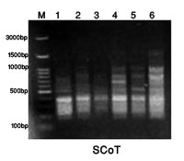
  Band  No | M.W  bp
  Band  No | M.W  bp | 1 | 2 | 3 | 4 | 5 | 6
  1 | 1740 | 0 | 0 | 0 | 1 | 0 | 1
  2 | 1160 | 0 | 1 | 0 | 1 | 1 | 1
  3 | 920 | 1 | 1 | 1 | 1 | 1 | 1
  4 | 700 | 1 | 0 | 0 | 1 | 0 | 0
  5 | 540 | 1 | 1 | 1 | 1 | 1 | 1
  6 | 380 | 1 | 1 | 1 | 1 | 1 | 1
  7 | 265 | 1 | 1 | 1 | 1 | 1 | 1
  8 | 235 | 1 | 0 | 0 | 1 | 1 | 1
  Total |  | 6 | 5 | 4 | 8 | 6 | 7
SCoT 2
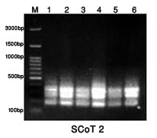
  Band  No | M.W  bp
  Band  No | M.W  bp | 1 | 2 | 3 | 4 | 5 | 6
  1 | 365 | 1 | 1 | 1 | 1 | 1 | 1
  2 | 245 | 1 | 1 | 1 | 1 | 1 | 1
  3 | 185 | 1 | 1 | 1 | 1 | 1 | 1
  Total |  | 3 | 3 | 3 | 3 | 3 | 3

SCoT 3
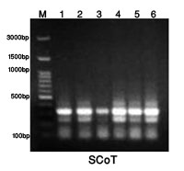
  Band  No | M.W  bp
  Band  No | M.W  bp | 1 | 2 | 3 | 4 | 5 | 6
  1 | 400 | 1 | 1 | 0 | 1 | 1 | 1
  2 | 330 | 1 | 1 | 1 | 1 | 1 | 1
  3 | 245 | 1 | 1 | 1 | 1 | 1 | 1
  4 | 175 | 1 | 1 | 1 | 1 | 1 | 1
  5 | 130 | 1 | 1 | 1 | 1 | 1 | 1
  Total |  | 5 | 5 | 4 | 5 | 5 | 5
SCoT 4
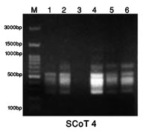
  Band  No | M.W  bp
  Band  No | M.W  bp | 1 | 2 | 3 | 4 | 5 | 6
  1 | 1185 | 0 | 0 | 0 | 1 | 0 | 0
  2 | 840 | 0 | 0 | 0 | 1 | 0 | 0
  3 | 715 | 1 | 1 | 0 | 1 | 1 | 1
  4 | 550 | 1 | 1 | 1 | 1 | 1 | 1
  5 | 470 | 1 | 1 | 1 | 1 | 1 | 1
  6 | 380 | 1 | 1 | 1 | 1 | 1 | 1
  7 | 260 | 1 | 1 | 0 | 1 | 1 | 1
  Total |  | 5 | 5 | 3 | 7 | 5 | 5
SCoT 6
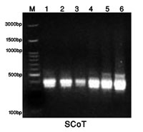
  Band  No | M.W  bp
  Band  No | M.W  bp | 1 | 2 | 3 | 4 | 5 | 6
  1 | 565 | 1 | 1 | 0 | 1 | 1 | 1
  2 | 400 | 1 | 1 | 1 | 1 | 1 | 1
  3 | 345 | 1 | 1 | 1 | 1 | 1 | 1
  Total |  | 3 | 3 | 2 | 3 | 3 | 3
SCoT 8
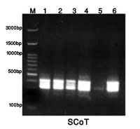
  Band  No | M.W  bp
  Band  No | M.W  bp | 1 | 2 | 3 | 4 | 5 | 6
  1 | 500 | 1 | 1 | 0 | 1 | 0 | 1
  2 | 430 | 1 | 1 | 1 | 1 | 0 | 1
  3 | 370 | 1 | 1 | 1 | 1 | 0 | 1
  4 | 315 | 1 | 1 | 1 | 1 | 1 | 1
  5 | 245 | 1 | 1 | 1 | 1 | 0 | 1
  Total |  | 5 | 5 | 4 | 5 | 1 | 5

Fig S2 DNA of primers in the studied 6 Annona samples by SCoT. As 1= A. atemoya 2= glabra , 3 = abdel razek, 4= reticulata, 5= squamosa then 6= muricata.

B. ISSR analysis
The ISSR banding profiles produced by the six 10-mer primers in the six samples of Annona species are illustrated in Fig.(5) and Tables 5for primers14A, 44B, HB-08,HB-10, HB-12 and HB-14.
14A
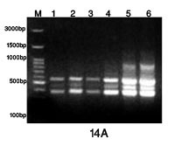
  Band  No | M.W  bp | Samples
  Band  No | M.W  bp | 1 | 2 | 3 | 4 | 5 | 6
  1 | 835 | 0 | 0 | 0 | 0 | 1 | 1
  2 | 580 | 1 | 1 | 1 | 1 | 1 | 1
  3 | 475 | 1 | 1 | 1 | 1 | 1 | 1
  4 | 390 | 1 | 1 | 1 | 1 | 1 | 1
  Total |  | 3 | 3 | 3 | 3 | 4 | 4
44A
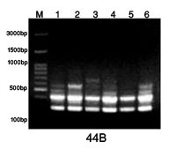
  Band  No | M.W  bp | Samples
  Band  No | M.W  bp | 1 | 2 | 3 | 4 | 5 | 6
  1 | 700 | 0 | 0 | 1 | 0 | 0 | 0
  2 | 580 | 1 | 1 | 1 | 1 | 1 | 1
  3 | 500 | 1 | 1 | 1 | 1 | 1 | 1
  4 | 400 | 1 | 1 | 1 | 1 | 1 | 1
  5 | 270 | 1 | 1 | 1 | 1 | 1 | 1
  Total |  | 4 | 4 | 5 | 4 | 4 | 4
HB-8
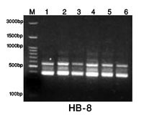
  Band  No | M.W  bp | Samples
  Band  No | M.W  bp | 1 | 2 | 3 | 4 | 5 | 6
  1 | 845 | 0 | 1 | 0 | 1 | 1 | 0
  2 | 715 | 0 | 1 | 0 | 1 | 1 | 0
  3 | 580 | 1 | 1 | 1 | 1 | 1 | 1
  4 | 485 | 1 | 1 | 1 | 1 | 1 | 1
  5 | 400 | 1 | 1 | 1 | 1 | 1 | 1
  Total |  | 3 | 5 | 3 | 5 | 5 | 3
HB-10
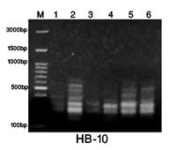
  Band  No | M.W  bp | Samples
  Band  No | M.W  bp | 1 | 2 | 3 | 4 | 5 | 6
  1 | 650 | 0 | 1 | 0 | 0 | 1 | 1
  2 | 570 | 0 | 1 | 0 | 0 | 0 | 0
  3 | 480 | 0 | 1 | 0 | 0 | 1 | 1
  4 | 430 | 0 | 0 | 0 | 0 | 1 | 0
  5 | 300 | 1 | 1 | 1 | 1 | 1 | 1
  6 | 265 | 1 | 1 | 1 | 1 | 1 | 1
  Total |  | 2 | 5 | 2 | 2 | 5 | 4

HB-12
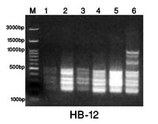
  Band  No | M.W  bp | Samples
  Band  No | M.W  bp | 1 | 2 | 3 | 4 | 5 | 6
  1 | 1040 | 0 | 0 | 0 | 0 | 0 | 1
  2 | 900 | 0 | 0 | 0 | 0 | 0 | 1
  3 | 680 | 0 | 0 | 0 | 0 | 0 | 1
  4 | 510 | 1 | 1 | 1 | 1 | 1 | 1
  5 | 425 | 1 | 1 | 1 | 1 | 1 | 1
  6 | 365 | 1 | 1 | 1 | 1 | 1 | 1
  7 | 270 | 1 | 1 | 1 | 1 | 1 | 1
  8 | 230 | 1 | 1 | 1 | 1 | 1 | 1
  Total |  | 6 | 6 | 6 | 6 | 6 | 6
HB-13
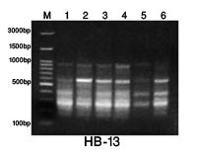
  Band  No | M.W  bp | Samples
  Band  No | M.W  bp | 1 | 2 | 3 | 4 | 5 | 6
  1 | 910 | 1 | 1 | 1 | 1 | 1 | 1
  2 | 600 | 1 | 1 | 1 | 1 | 1 | 1
  3 | 480 | 1 | 1 | 1 | 1 | 0 | 0
  4 | 400 | 1 | 1 | 1 | 1 | 1 | 1
  5 | 290 | 1 | 1 | 1 | 1 | 1 | 1
  6 | 180 | 1 | 1 | 1 | 1 | 1 | 1
  Total |  | 6 | 6 | 6 | 6 | 5 | 5

Fig S3 DNA of primers in the studied 6 Annona samples by ISSR. As 1= A. atemoya 2= glabra , 3 = abdel razek, 4= reticulata, 5= squamosa then 6= muricata..

