Tissue heterogeneity of mitochondrial activity, biogenesis and mitochondrial protein gene expression in Buffalo
Dr. Sadeesh EM*, Nancy Singla, Madhuri S. Lahamge, Sweta Kumari, Ampadi AN, and Anuj M
Laboratory of Mitochondrial Biology of Farm Animals,
Animal Biochemistry Division
ICAR- National Dairy Research Institute, Karnal, Haryana, India.
Dr. Sadeesh E.M. (Corresponding author) – Senior Scientist, Animal Biochemistry Division,
ICAR- National Dairy Research Institute, Karnal, Haryana,India.
Email ID- sadeeshcirb@gmail.com
ORCID-0000-0001-9101-4288

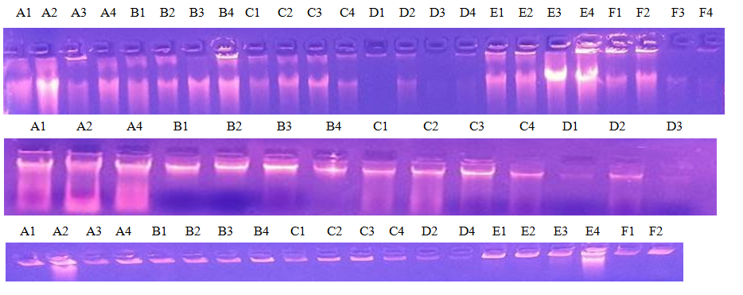

Figure S1 Integrity of the DNAs extracted from various tissues. A- Liver; B- Kidney; C-Heart; D-
Muscle; E-Ovary; F-Brain.

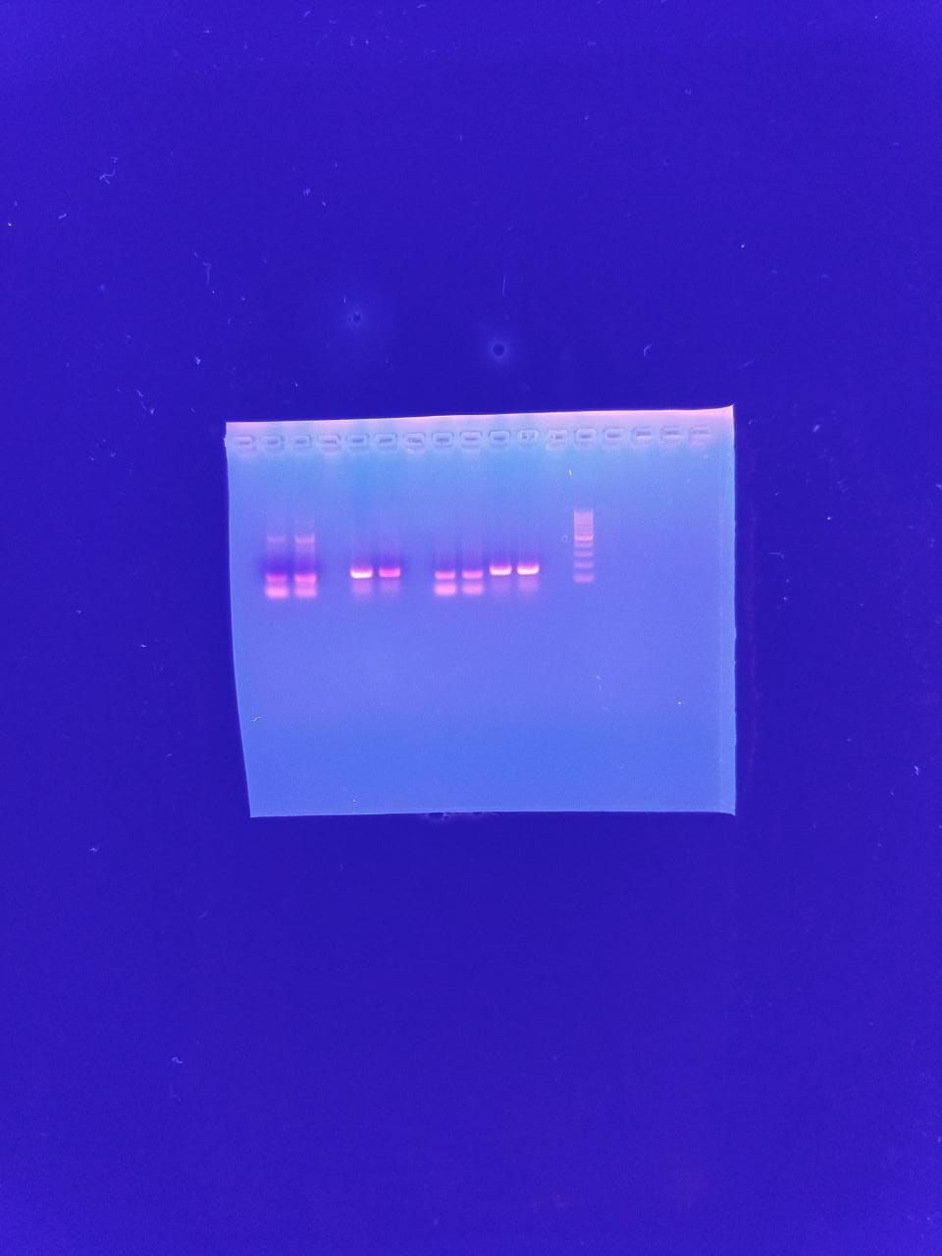
Figure S2 The specificity of tRNALeu and B2M primers by gel electrophoresis

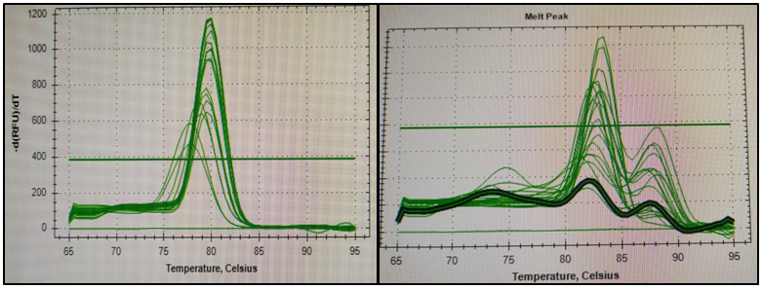
Figure S3 The melting curve of tRNALeu and B2M primers, indicating the specificity

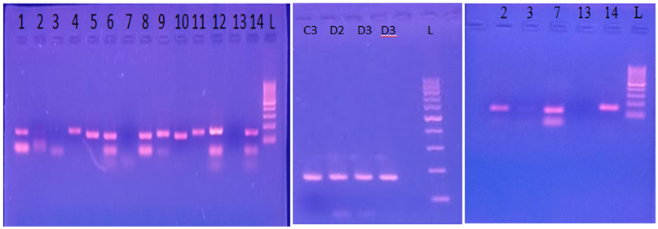
Figure S4 The specificity of primers for the amplification of 13 mitochondrial protein genes was assessed by gel
Electrophoresis (A, B & C). 1= NAD1, 2=NAD2, 3, C3 & D2=COX1, 4= COX2, 5= ATP6, 6= COX3, 7= NAD3, 8= ND4L, 9= NAD4, 10= NAD5, 11= NAD6, 12= CYTB, 13 & D3= ATP8, 14= 12s (control), L = 100bp Ladder

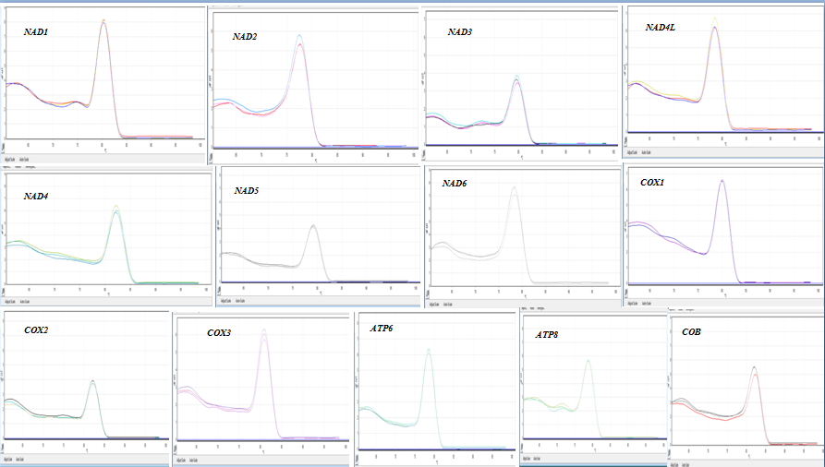
Figure S5 Melting curve of 13 protein-coding mitochondrial genes primers, indicating the specificity of primers

