Association of the barriers of pharmaceutical care perceived by clinical pharmacists and occupational stress in tertiary hospitals of China
Appendix 2: Questionnaire dimension reduction for the barriers of pharmaceutical care perceived by clinical pharmacists

Table 1 Results of questionnaire dimension reduction
Items
Resource
Lack of Electronic systems are difficult to uses
Electronic systems are difficult to uses
Standardized procedures and records
Staffing of pharmacy
Specific place
Specific time
Cooperation
Physician’s communication and support
Other staff’s support and communication
Patient’s communication and support
Leadership support and pharmacist’s right
Support from leaders of hospitals
Support from department leaders
Support from the legal system
Patient's medical information
Self-improvement
Opportunities for continuing education
Time for continuing education

Table 2 Items that should be deleted based on exploratory factor analysis (EFA)
Items
Rules and regulations
Self-identified as non-direct health care provider
Modification of therapeutic schedule

Results of exploratory factor analysis (EFA)

KMO and Bartlett's Test
Kaiser-Meyer-Olkin Measure of Sampling Adequacy. |  | .888
Bartlett's Test of Sphericity | Approx. Chi-Square | 3744.542
Bartlett's Test of Sphericity | df | 153
Bartlett's Test of Sphericity | Sig. | .000

Communalities
 | Initial | Extraction
Electronic systems are difficult to use | 1.000 | .507
Staffing of pharmacy | 1.000 | .465
Rules and regulations | 1.000 | .440
Specific place | 1.000 | .490
Specific time | 1.000 | .513
Lack of Electronic systems are difficult to uses | 1.000 | .592
Standardized procedures and records | 1.000 | .581
Self-identified as non-direct health care provider | 1.000 | .310
Physician’s communication and support | 1.000 | .758
Other staff’s support and communication | 1.000 | .728
Patient’s communication and support | 1.000 | .663
Patient's medical information | 1.000 | .376
Modification of therapeutic schedule | 1.000 | .297
Opportunities for continuing education | 1.000 | .696
Time for continuing education | 1.000 | .786
Support from leaders of hospitals | 1.000 | .675
Support from department leaders | 1.000 | .691
Support from the legal system | 1.000 | .496
Extraction Method: Principal Component Analysis.

Total Variance Explained
Component | Initial Eigenvalues |  |  | Extraction Sums of Squared Loadings |  |  | Rotation Sums of Squared Loadings
Component | Total | % of Variance | Cumulative % | Total | % of Variance | Cumulative % | Total | % of Variance | Cumulative %
1 | 5.930 | 32.945 | 32.945 | 5.930 | 32.945 | 32.945 | 3.311 | 18.397 | 18.397
2 | 1.691 | 9.395 | 42.340 | 1.691 | 9.395 | 42.340 | 2.732 | 15.179 | 33.576
3 | 1.320 | 7.334 | 49.674 | 1.320 | 7.334 | 49.674 | 2.387 | 13.263 | 46.839
4 | 1.123 | 6.240 | 55.914 | 1.123 | 6.240 | 55.914 | 1.633 | 9.075 | 55.914
5 | .895 | 4.973 | 60.887
6 | .841 | 4.670 | 65.557
7 | .766 | 4.258 | 69.815
8 | .729 | 4.049 | 73.863
9 | .696 | 3.868 | 77.731
10 | .604 | 3.358 | 81.089
11 | .543 | 3.014 | 84.103
12 | .530 | 2.945 | 87.048
13 | .485 | 2.695 | 89.743
14 | .449 | 2.493 | 92.236
15 | .409 | 2.270 | 94.506
16 | .389 | 2.160 | 96.666
17 | .338 | 1.876 | 98.542
18 | .262 | 1.458 | 100.000
Extraction Method: Principal Component Analysis.

Component Matrixª
 | Component
 | 1 | 2 | 3 | 4
Specific time | .673
Support from leaders of hospitals | .672
Standardized procedures and records | .666
Specific place | .654
Other staff’s support and communication | .631
Rules and regulations | .626
Physician’s communication and support | .614
Patient’s communication and support | .589
Lack of Electronic systems are difficult to uses | .581
Support from department leaders | .580
Support from the legal system | .580
Staffing of pharmacy | .530
Modification of therapeutic schedule | .519
Opportunities for continuing education | .518
Electronic systems are difficult to use
Self-identified as non-direct health care provider
Patient's medical information
Time for continuing education |  |  |  | .631
Extraction Method: Principal Component Analysis.
a. 4 components extracted.

Rotated Component Matrixª
 | Component
 | 1 | 2 | 3 | 4
Lack of Electronic systems are difficult to uses | .755
Electronic systems are difficult to use | .709
Standardized procedures and records | .687
Staffing of pharmacy | .657
Specific place | .605
Specific time | .540
Rules and regulations
Physician’s communication and support |  | .845
Other staff’s support and communication |  | .815
Patient’s communication and support |  | .779
Self-identified as non-direct health care provider
Modification of therapeutic schedule
Support from department leaders |  |  | .797
Support from leaders of hospitals |  |  | .741
Support from the legal system |  |  | .569
Patient's medical information |  |  | .541
Time for continuing education |  |  |  | .866
Opportunities for continuing education |  |  |  | .773
Extraction Method: Principal Component Analysis.
Rotation Method: Varimax with Kaiser Normalization.
a. Rotation converged in 6 iterations.

Component Transformation Matrix
Component | 1 | 2 | 3 | 4
1 | .629 | .516 | .497 | .300
2 | -.680 | .704 | .006 | .204
3 | -.340 | -.483 | .619 | .518
4 | .162 | -.063 | -.608 | .775
Extraction Method: Principal Component Analysis.
Rotation Method: Varimax with Kaiser Normalization.

Results of confirmatory factor analysis (CFA)
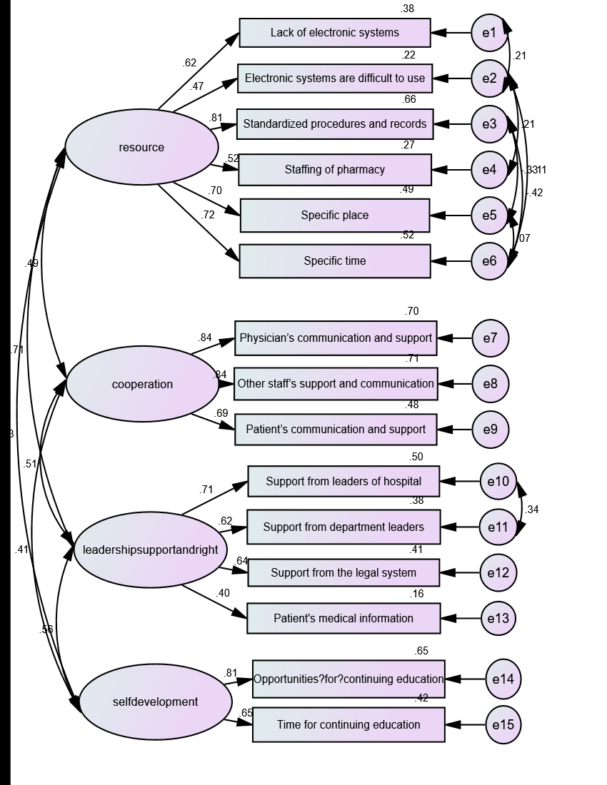
CFA Model（MI)

Overall fitting coefficient table
χ²/df | RMSEA | GFI | AGFI | CFI | IFI | TLI
1.983 | 0.040 | 0.969 | 0.951 | 0.975 | 0.976 | 0.967
χ²/df=1.983<3，RMSEA=0.04<0.05，GFI=0.969>0.9，AGFI=0.951>0.9，CFI=0.975>0.9，IFI=0.976>0.9，TFI=0.967>0.9，the model fitting index is good.

