Supplementary material for “Exploring dominant processes for multi-month MJO prediction using deep learning”

Young-Min Yang¹, Jeong-Hwan Kim², Jae-Heung Park³, Yoo-Geun Ham², Soon-Il An^{4*}, Tim Li^{1,5*} and Bin Wang^{1,5}
¹Joint International Research Laboratory of Climate and Environment Change and Key Laboratory for Prevention of Meteorological Disaster Ministry of Education, Nanjing University of Information Science and Technology, Nanjing, 210044, China. ²Department of Oceanography, Chonnam National University, Gwangju, South Korea. 2 ²Division of Environmental Science and Engineering. ³Pohang University of Science and Technology, Pohang 37673, Korea. ⁴Department of Atmospheric Sciences and Irreversible Climate Change Research Center, Yonsei University, Seoul 03722, Korea. ⁵Department of Atmospheric Sciences and International Pacific Research Center, University of Hawaii, Honolulu HI 96822, USA. email:sian@yonsei.ac.kr;bwang@hawaii.edu

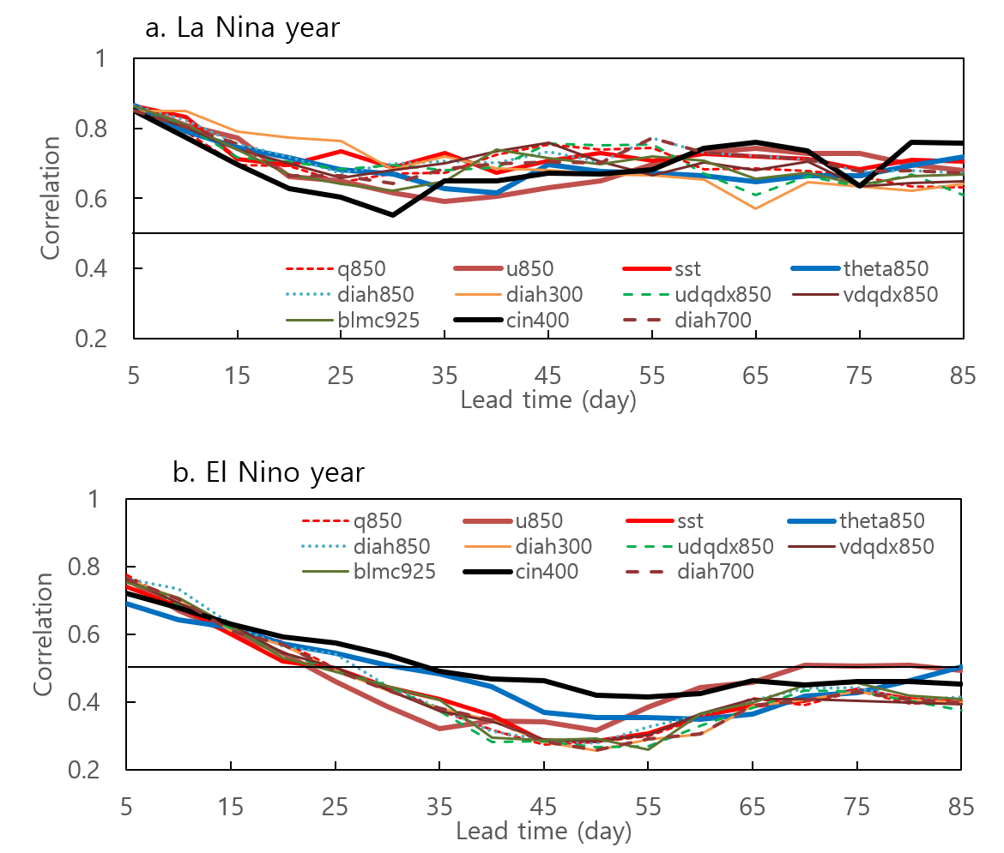

Supplementary Figure S1. Impact of ENSO on correlation skill of MJO-related precipitation index. a, Same as figure 1 but for La Nina year. b, Same as figure 1 but for El Nino year.

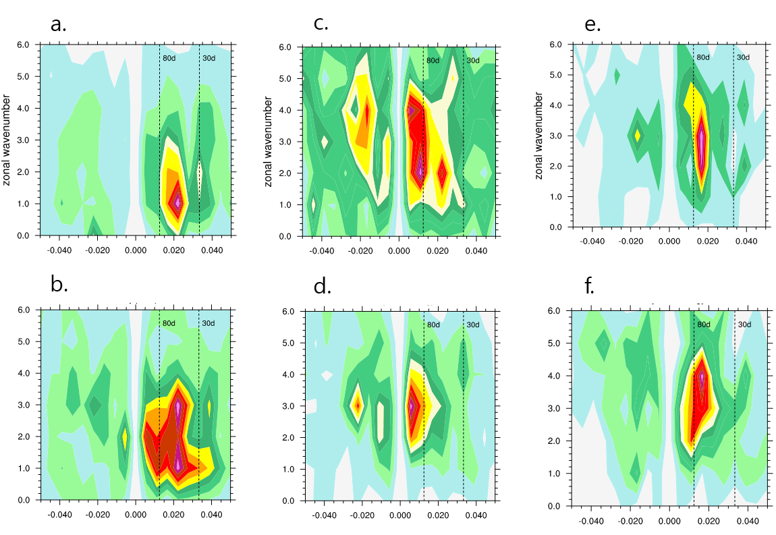

Supplementary figure S2. Role of central and eastern Pacific SST on MJO simulation. a,c,e, May-October wavenumber-frequency spectrum of 10°N–10°S-averaged an observed precipitation (a), the NESM3.0 model (c), and the NESM3.0 with the observed SST over central and eastern Pacific. Only the climatological seasonal cycle and time mean for each November–April segment were removed before the calculation of the spectra. Units for the spectrum are mm⁻² day⁻². b,d,f, same as a,c,e but for November–April, respectively.

