Supporting Information

Biomimetic hypoxia-triggered RNAi nanomedicine for synergistically mediating chemo/radiotherapy of glioblastoma

Zhen Wang^{a,b,c‡}, Xianglong Tang^{b,c‡*}, Mengjie Zhao^{b,c‡}, Yong Xiao^{a,b,c‡}, Yuyang Liuª, Yiding Zhangª, Chunfa Qianª, Yan-dong Xie ª, Yong Liuª, Yuanjie Zouª, Kun Yangª* and Hongyi Liu^{a,b,c}*

ª Department of Neurosurgery, the Affiliated Brain Hospital with Nanjing Medical University, Fourth Clinical College of Nanjing Medical University, Nanjing 210029, China
^{b} Department of Neuro-Psychiatric Institute, the Affiliated Brain Hospital with Nanjing Medical University, Nanjing 210029, China
^{c} Institute of Neuro-science, Nanjing Medical University, Nanjing 210029, China

* Corresponding author:
E-mail:1、njnkyylhy@163.com
2、xltang0326@163.com
3、yk_nj@hotmail.com

(1)
(2)
(3)
(4)
Fig. S1. Synthetic routes of poly(MIs)-PEI block copolymers by ROP reaction and condensation reaction.

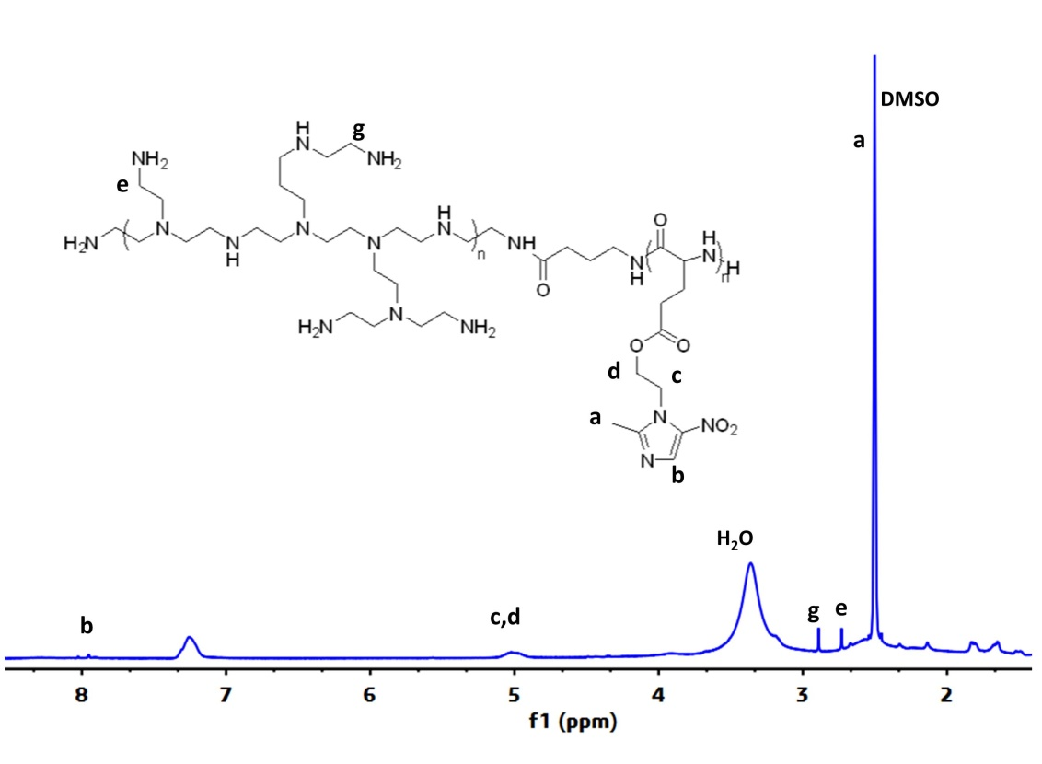
Fig. S2. ¹H NMR spectra of poly(MIs)-PEI block copolymers.

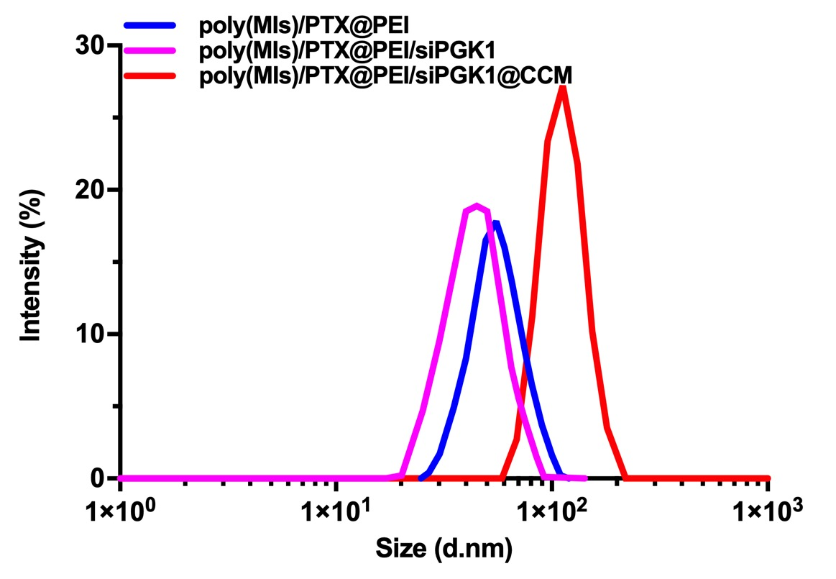
Fig. S3. Size distribution of poly(MIs)/PTX@PEI, poly(MIs)/PTX@PEI/siPGK1 and poly(MIs)/PTX@PEI/siPGK1@CCM in PBS.

Fig. S4. (A) Size distribution of poly(MIs)/PTX@PEI/siPGK1@CCM under normoxic and hypoxic conditions. (B) UV-Vis absorption spectra of poly(MIs) under normoxia and hypoxia.

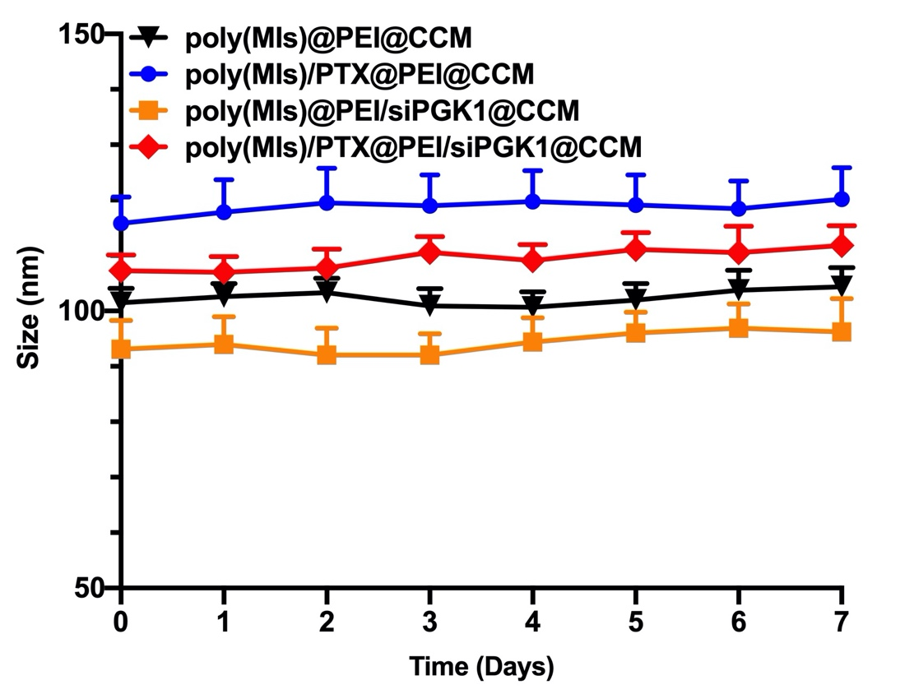
Fig. S5. The stability poly(MIs)@PEI@CCM, poly(MIs)/PTX@PEI@CCM, poly(MIs)@PEI/siPGK1@CCM and poly(MIs)/PTX@PEI/siPGK1@CCM NPs were investigated in DMEM containing 10% FBS over six days. Data are shown as mean ± SD (n=3).

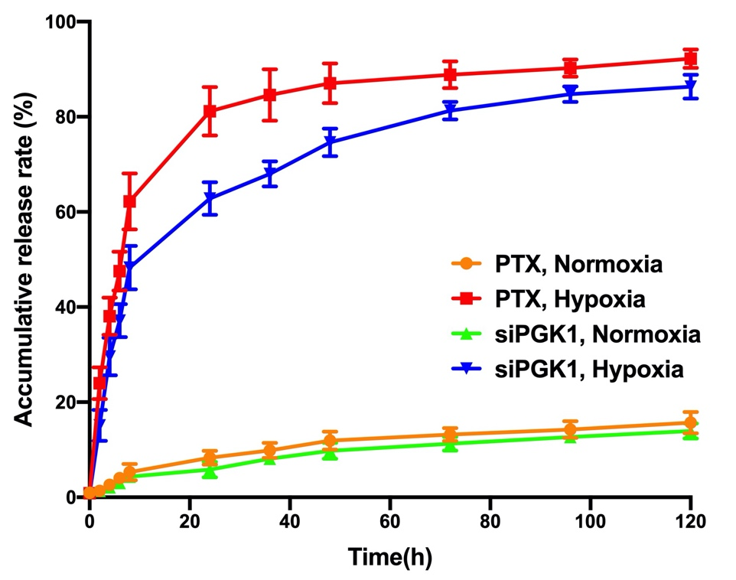
Fig. S6. Sequential release of siPGK1 and PTX from poly(MIs)/PTX@PEI/ siPGK1@CCM. Data are shown as mean ± SD (n=3).

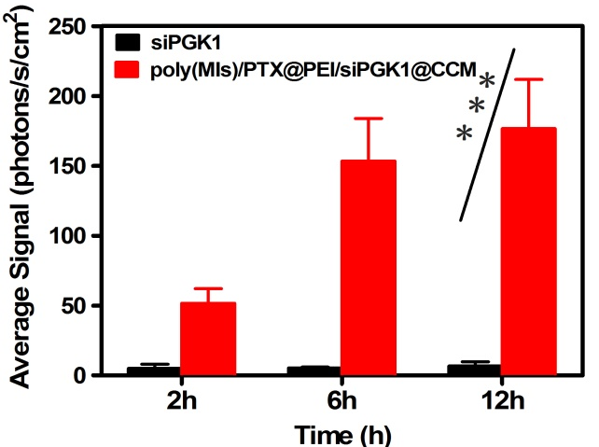
Fig. S7. Quantitative analysis of cumulative transport of poly(MIs)/PTX@PEI/ siPGK1@CCM at different time points across the bEnd.3 monolayer. Data are shown as mean ± SD (n=3).

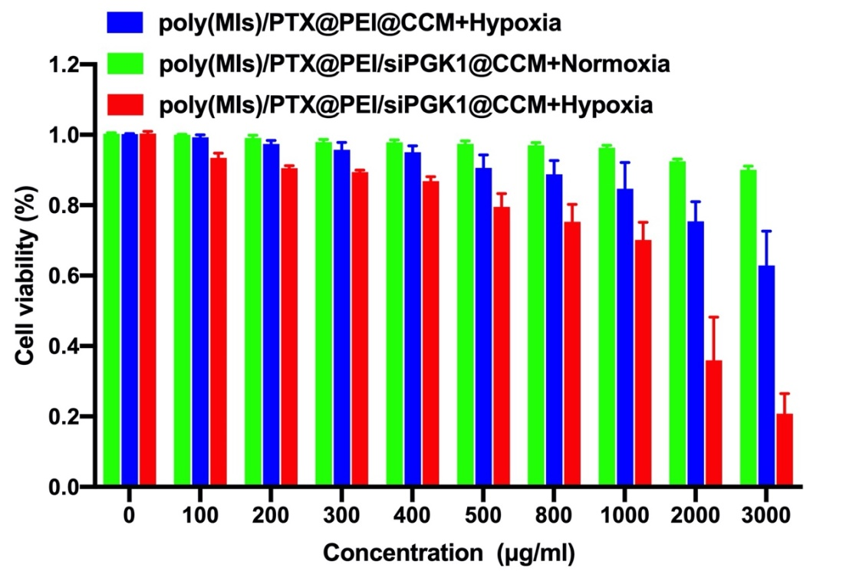
Fig. S8. Cell viability of poly(MIs)/PTX@PEI/siPGK1@CCM with various concentration in normoxia and hypoxia condition, respectively. Data are shown as mean ± SD (n=3).

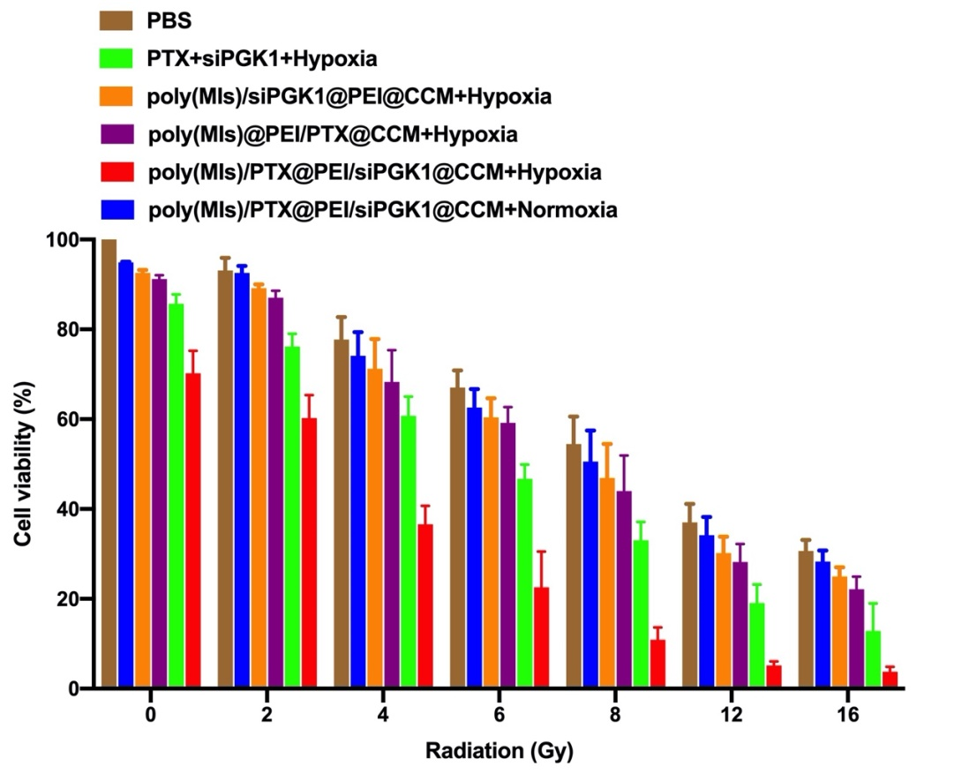
Fig. S9. Cell viability of poly(MIs)/PTX@PEI/siPGK1@CCM with different radiation dose. Data are shown as mean ± SD (n=3).

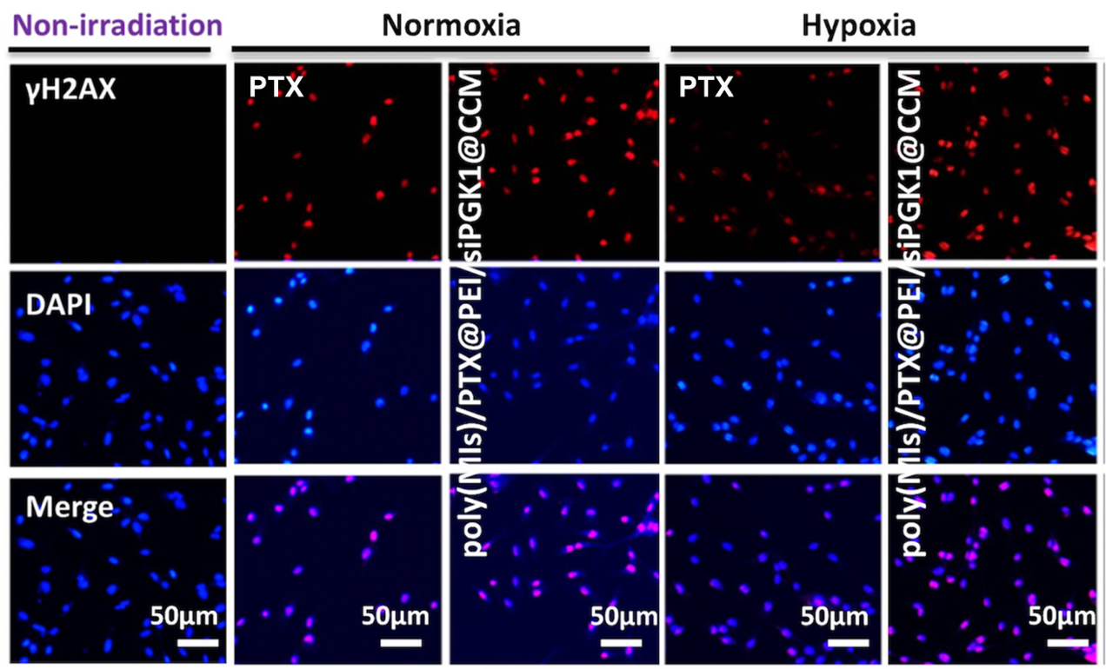
Fig. S10. Immunocytochemical analysis of γ-H2AX expressed by U87 cells. Cells were stained with an anti-γ-H2AX antibody (red) and DAPI (blue) 24 h after RT

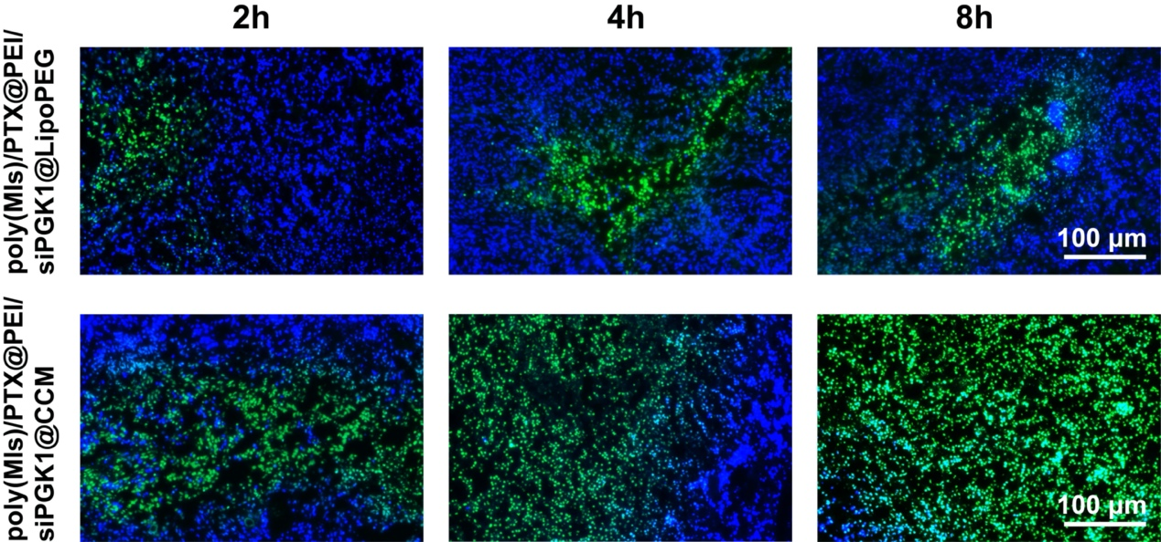
Fig. S11. Fluorescence images of frozen sections of tumor tissue (at a siPGK1 concentration of 2.3 mg kg⁻¹) at different times after injection of poly(MIs)/PTX@PEI/siPGK1@LipoPEG and poly(MIs)/PTX@PEI/siPGK1@CCM. FAM-siPGK1 (green), and cell nuclei (blue). (Scale bar: 100 μm)
Fig. S12. Representative tissue sections of mice stained with hematoxylin and eosin (H&E) after 30 days of different treatments.
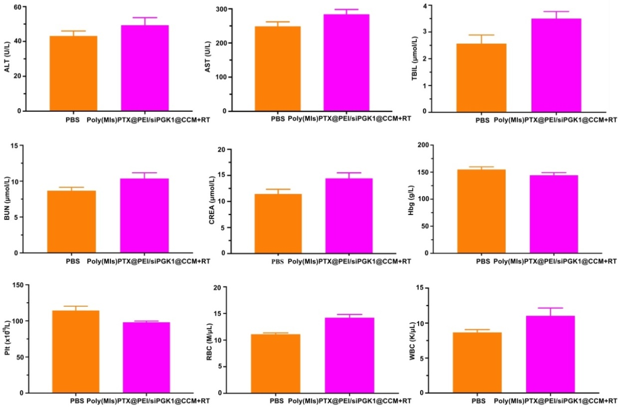
Fig. S13. Results analysis of liver and kidney functions by blood biochemistry after treatment with poly(MIs)/PTX@PEI/siPGK1@CCM.

