The Middle Stone Age sequence at Klipfonteinrand 1 (KFR1), Western Cape, South Africa
Alex Mackay^{1,2,3}*, Rosaria B.K. Saktura¹, Corey A. O’Driscoll¹, Kelsey C. Boyd¹, Ben Marwick⁴, Ian Moffat⁵, & Zenobia Jacobs^{1,3}
¹Centre of Archaeological Science, School of Earth, Atmospheric and Life Sciences, University of Wollongong, Wollongong, New South Wales 2522, AUSTRALIA; ²Department of Archaeology, University of Cape Town, Cape Town, Western Cape 8001, SOUTH AFRICA; ³ARC Centre of Excellence for Australian Biodiversity and Heritage & Centre for Archaeological Science, School of Earth, Atmospheric and Life Sciences, University of Wollongong, Wollongong, New South Wales 2522, AUSTRALIA; ⁴Department of Anthropology, University of Washington, Seattle, Washington 98195, USA; ⁵Archaeology, College of Humanities, Arts and Social Sciences, Flinders University, Flinders University, Adelaide, South Australia 5001, AUSTRALIA.
*corresponding author: amackay@uow.edu.au, +61 2 4221 5344

Conflict of Interest Statement: On behalf of all authors, the corresponding author states that there is no conflict of interest.

Data Statement: All data used in this paper are available on request.
Supporting Online Material
Section S1. Geophysics
Geophysical techniques are ubiquitous in archaeological research but have only occasionally been applied to cave and rockshelter sites. GPR (comprehensively summarised for archaeological applications by Conyers 2013 and 2016) is a geophysical technique in which short pulses of high frequency electromagnetic energy are transmitted into the subsurface before being reflected back to the antenna off boundaries in dielectric permittivity. GPR is ideally suited to the detection of rock/sediment boundaries, changes in lithology and archaeological material. GPR has previously been used to map the depth to bedrock within quartize sites in central Arnhem Land (Barker et al. 2017, David, Delannoy, Gunn, Brady et al. 2017, David, Delannoy, Gunn, Calmin et al. 2017) limestone sites at Misliya Caves in Israel (Weinstein-Evron et al., 2003), Slovakia (Putiška et al. 2016) and Indonesia (Maloney et al 2022a,b) as well as travertine bedrock at Prepoštská Cave (Putiška et al. 2016). Electrical Resistivity Tomography (ERT) (summarised for pedological applications by Samouëlian et al (2005) and more generally by Loke et al (2013)) is a geophysical technique where a constant electrical direct current is passed through the subsurface between a number of electrodes which are usually connected to the ground by metal pegs. ERT has been used for a range of archaeological investigations including mapping tombs, reconstructing palaeolandscapes and locating material culture items. ERT is closely related to the widely archaeologically applied resistivity method (Schmidt 2013) however takes measurements at a variety of depths through the use of multiple electrode spacings rather than taking many measurements from the same depth in plan view across a site. ERT has been successfully been used to determine the depth of bedrock of Canet Cave (Kopper, 1972: 14), Liang Jon and Liang Tebo (Maloney et al. 2022a,b) and Misliya and Nahal Me’arot Caves (Weinstein-Evron et al., 2003).
Ground penetrating radar data were collected with a Malå X3M instrument using a 500 Mhz antenna. Lines were collected in a parallel zig-zig configuration with a spacing of 0.5m approximately perpendicular to the drip line. Acquisition parameters included a time window of 48 ns, a trace interval of 2cm, 4 stacks and 1024 samples per trace. GPR data was processed using ReflexW using dewow, energy decay gain, background remove and bandpass butterworth filters. GPR lines were interpreted in ReflexW with reference to previous excavations and the picks of bedrock surface exported to ArcGIS where they were gridded using a spline interpretation.
ERT data were collected using a ZZ Flash-Res Universal instrument using an electrode spacing of 0.2m and collecting ZZ, Wenner and Dipole-Dipole arrays. Acquisition parameters included using 120V of current and 1.2 second current on and 0.2 second current off times. 2 perpendicular profiles were collected, one approximately parallel to and the other perpendicular to the drip line. Electrodes were watered using slated water prior to data acquisition to reduce contact resistance, although these remained ~5000 Ohm. Data were filtered using ZZ Rdatacheck software and a custom spreadsheet before being inverted using Res2D. Profiles were imported into ArcGIS and interpreted with reference to previous excavations. The position of the start and finish of each GPR line and each ERT electrode was recorded using a Nikon 2C total station oriented to the local site grid.
Section S2. OSL dating
Samples for optically stimulated luminescence (OSL) dating were collected by AM and ZJ during fieldwork in 2011 and transported to the Luminescence Dating Laboratory at the University of Wollongong in Australia, where they were prepared under subdued red-light conditions. Measurements for dose rate and equivalent dose (D_{e}) determination were undertaken in 2011 and 2013. These existing, previously unpublished datasets were collated and analysed for OSL dating in the present study, as part ongoing investigations for RS’s PhD thesis. Additional GM-25-5 beta counting measurements were made on all samples to ensure reproducibility, as well as additional D_{e} measurements on OSL9. The datum used for calculating the ages reported here is 2011.
Section S2.1. D_{e} determination
Instrumentation and measurement
OSL measurements were made using Risø TL-DA-20 luminescence readers fitted with focused green (532 nm) laser attachments for single-grain simulation. Ultraviolet (UV) emissions were detected using Electron Tubes Ltd 9235QA photomultiplier tubes through Hoya U-340 filters. Individual grains were mounted onto aluminium discs drilled with 100 holes (each 300 μm in diameter and 300 μm deep). Laboratory irradiations were undertaken using calibrated ⁹⁰Sr/⁹⁰Y beta sources within the luminescence readers, with corrections made to account for spatial variation in the beta dose rate administered to individual grain positions.
The single-aliquot regenerative-dose (SAR) procedure used for single-grain OSL measurements on the KFR1 samples is outlined in Table S1. A preheat combination of 260°C (preheat 1) and 220°C (preheat 2) was used for D_{e} measurements on all samples, with the exception of OSL10 and OSL11, where 180°C was used for both preheats. A ‘zero regenerative dose’ (0 Gy) measurement cycle was included after the highest regeneration dose cycle to monitor recuperation, followed by a duplicate regenerative dose cycle to test the adequacy of test-dose sensitivity corrections. An OSL infrared (IR) depletion ratio test (Duller, 2003) was done at the end of each SAR measurement sequence (at 50°C for 40 s) to check for feldspar contamination.
D_{e} data analysis and additional results
All data analyses for D_{e} determination were undertaken in R (R Core Team, 2020) using packages numOSL (Peng et al., 2013; Peng and Li, 2017) and Luminescence (Kreutzer et al. 2012; Kreutzer et al. 2021). The net OSL signals were determined using late background subtraction (the first 0.22 s of decay, minus the mean count recorded over the last 0.3 s), and sensitivity-corrected dose response curves (DRCs) constructed using a general-order kinetic function of the form f(x) = a[1–(1+bcx)( –1/c)] + d (Guralnik et al., 2015; Peng and Li, 2018). The function calSARED() in R package numOSL was used to implement a quality-assurance rejection criteria for all samples, similar to that proposed by Jacobs et al. (2006). Individual grains were rejected prior to D_{e} determination for one or more of the following reasons:
- OSL sensitivity is too low for reliable D_{e} determination (the test dose following the natural signal measurement is <3σ above background, or its relative error is >20%).
- There were high levels of recuperation (the recuperation ratio between the zero and maximum regenerative dose is >5%).
- A poor DRC was constructed. Accurate DRC shape is essential for D_{e} determination, and the reliability of its form was tested in a few ways. A grain was rejected if:
  - The first recycling ratio (between the first and duplicate laboratory regenerative doses) is inconsistent with unity at 2σ, which is indicative of inadequate regenerative dose sensitivity correction.
  - The OSL IR depletion ratio is >2σ below unity, indicative of feldspar contamination.
  - The second recycling ratio (between the duplicate laboratory regenerative dose and that administered prior to IR depletion) is inconsistent with unity at 2σ. This ensures the reproducibility of a grain passing a test of adequate sensitivity change correction and of feldspar contamination.
  - The sensitivity-corrected regenerative dose ratios are too scattered (the reduced chi-square (RCS) value is >5 or the figure-of-merit (FOM) value is >10%) (Peng et al., 2017; Peng and Li, 2018). These goodness-of-fit metrics are defined as:

$$RCS = \frac{1}{N-n}\text{ x ∑}{n \atop i}{ \atop =1} \frac{{\left(y{o \atop i}-y{f \atop i}\right) }^{2}}{σ{2 \atop i}}$$
and
$$FOM\left(\%\right) = 100 x \frac{∑{n \atop i}{ \atop =1} |y{o \atop i}-y{f \atop i}|}{∑{n \atop i}{ \atop =1 }y{f \atop i}}$$where the $y{o \atop i}$ and $y{f \atop i}$ denote the $i^{th}$ observed and fitted values (respectively).
- The grain D_{e} value is unable to be calculated by interpolation (‘non-intersecting’ grains) or the sensitivity-corrected natural signal does not intersect the DRC (‘saturated’ grains).
- The grain has a D_{e} value consistent with zero (likely a modern contaminant).
Grains that were accepted for D_{e} determination demonstrated a wide range of single-grain OSL characteristics. There is significant variation in the DRC shapes present and diverse patterns of sensitivity change (typically increases) between the SAR measurement cycles. The OSL decay curve shapes vary but are overall fairly reproducible, and rapidly decay to instrumental background. The OSL DRC, decay curve and pattern of sensitivity change for six accepted grains from OSL6 are provided as examples of the range present (Figure S1).
The number of grains measured, rejected and accepted are summarised in Table S2 for each KFR1 sample, as well as the reasons for rejection. Between 9.6% (OSL9) and 37.6% (OSL4) of grains were accepted, with an average acceptance rate of 22.7% across the samples. The most common reason for rejection was due to failure of criteria 1 (low OSL signal sensitivity), which accounted for between 40.0% (OSL12) to 64.3% (OSL6) of grains rejected. Failure of criteria 3a (inadequate sensitivity correction) was the next most common reason for rejection, which was failed by 4.1% (OSL1) to 20.7% of grains (OSL12). Criteria 4 (non-intersecting or saturated grains) failure became prevalent in the stratigraphically deepest units. This can be seen in Figure S2, which displays the average criteria 4 rejection rate for samples within each stratigraphic unit. Compared with the number of accepted grains in the deeper units, these rates are significant. For example, 13.1% of grains in OSL8 were rejected due to criteria 4, which is more than the 10% of grains accepted for D_{e} determination.
Single-grain D_{e} distributions for all KFR1 samples are shown in Figure S3 as radial plots. The interpretation of D_{e} distributions, and rationale for using different age models and approaches for final D_{e} determination, is discussed in the main text.
Section S2.2 Application of the LnTn method (‘Approach B’) and additional results
KFR1 is the second locality in southern Africa to have the ‘L_{n}T_{n} method’ of Li et al. (2016) applied for OSL dating, the first being Blombos Cave (Jacobs et al. 2020) on the southern Cape coast. The procedures involved in the implementation of the L_{n}T_{n} method have been thoroughly described in Li et al. (2016, 2020).
For the samples at KFR1 where the L_{n}T_{n} method was deemed most suitable for D_{e} determination (see main text), the same rejection criteria outlined in Section S2.2 was applied (Table S2), except for criteria 4 and 5, which involve L_{n}/T_{n} (sensitivity-corrected natural OSL signals). For accepted grains, the ratio between two L_{x}/T_{x} values (sensitivity-corrected regenerative dose signals) were calculated to reflect the saturation dose of the respective DRC. Doses of 60 Gy and 250 Gy were used for all samples, with the exception of OSL1 (40 Gy and 180 Gy), due to different regenerative dose sizes being administered during SAR procedure measurements. The finite mixture model (FMM) (Galbraith and Roberts, 2012) was used to statistically identify the number of groups containing grains with similar DRC shapes in each sample (assuming 0% OD). Standardised growth curves (SGCs) were established for each group using a least-square normalization (LS-normalization) procedure (Li et al., 2016), and a general order kinetic function (Guralnik et al., 2015) was used for fitting dose-response data for each group (Peng and Li, 2018).
The number of SGC groups established for each sample appears to be influenced by the use of different luminescence readers, suggesting measurement uncertainties to be a source of variability in DRC shapes (Li et al., 2017). Five groups were established for samples measured on Risø3 in 2011 (OSL1, OSL6, OSL7 and OSL8), 6 groups for OSL13 measured on Risø4 in 2013 and 9 groups for OSL9 measured on Risø5 in 2020. ‘Group 1’ grains reflect those with the earliest-saturating DRCs, while the group with the highest numerical value (e.g. Group 5 in OSL8) consists of grains with the latest-saturating DRCs present in the sample. All regenerative dose L_{x}/T_{x} values for grains in each SGC group are presented before and after LS-normalisation in Figure S4. The ratios between the measured L_{x}/T_{x} values and those expected based on each SGC were calculated to test the validity of groupings and SGC establishment (Table S3). Between ~91% (OSL9) and ~99% (OSL7) are consistent with unity at 2σ, which is excellent and supports the reliability of the SGCs (Li et al. 2016).
The L_{n}/T_{n} values for each group were LS-normalised, an appropriate age model selected to combine the values (see main text), and the weighted mean value/s projected onto the corresponding SGCs for D_{e} determination, following Li et al. (2016). The radial plots for all L_{n}/T_{n} distributions are displayed in Figure S4. For each sample, the resulting D_{e} values calculated for each SGC group are provided in Table S4, including the number of grains in each group and the OD values. D_{e} values were unable to be calculated for groups where the L_{n}/T_{n} values are consistent with, or higher than, the saturation levels of the corresponding SGCs. Likewise, reliable D_{e} values for groups were not determined when an insufficient number of grains were accepted (N < 10) following rejection criteria application.
When the normalised median absolute deviation (nMAD) (Powell et al. 2002; Rousseeuw et al., 2006) and central age model (CAM) (Galbraith et al., 1999) were used to combine L_{n}/T_{n} values, the final D_{e} value for each sample was estimated by using the weighted mean results of all SGC groups with finite D_{e} values (Li et al., 2020), an approach applied to archaeological sites elsewhere (e.g. Hu et al. 2019a, 2019b). The D_{e} estimates for each group in the KFR1 samples are statistically indistinguishable at 1σ or 2σ, with the later saturating Group 8 in OSL8 (Table S4) being the sole exception. With a sufficient number of grains accepted (N = 28) and an OD value (22 ± 2%) similar to the other groups, the reason for this lower D_{e} estimate is unclear. Therefore, Group 8 was included in the weighted mean final D_{e} estimate of OSL8, however we note that the final D_{e} is insensitive to the inclusion/exclusion of Group 8, with estimates remaining consistent at 1σ. For OSL1, the later saturating Group 5 was excluded from final D_{e} estimation due to the nMAD+CAM appearing inappropriate (OD = 44 ± 4% following nMAD outlier rejection) for this group only, suggesting an undetermined additional source of OD. However, the inclusion/exclusion of Group 5 likewise does not change the final D_{e} estimate for OSL1 within 1σ. In the field of OSL dating generally, little is currently little known about what causes the wide range of DRC shapes observed in single grains of quartz. Further work on the OSL characteristics of grains associated with different SGC groups (especially those of later saturating groups) would be valuable future work in refining the age of the KFR1 samples.
The FMM was used to combine L_{n}/T_{n} values for each group in OSL7, by taking the weighted mean D_{e} of each of the three reproducible components detected (Table S4). A minor, saturated/non-intersecting fourth component was detected in Group 5, for which D_{e} was unable to be estimated. This may represent grains which have a significantly higher L_{n} value due to beta microdosimetry (e.g. being situated in close proximity to zircon grains during burial).

S3. Phytoliths
Phytolith extraction procedures are adapted from Cordova and Johnson (2019) and Ames et al. (2020), which in turn are modified from Joines (2011), Lentfer and Boyd (1998) and Zhao and Pearsall (1998). Phytolith classifications are based on the ICPN 2.0 (Neumann et al., 2019) and recent regional studies of grass short cells and restionaceae phytoliths (Cordova and Scott, 2010; Cordova, 2013; Esteban et al., 2017a, b; Novello et al., 2018; Scott et al., 2021).
Graminoid phytoliths are identified as those morphotypes representative of primarily Poaceae (grasses) and Restionaceae (cape reeds) vegetation. Poaceae morphotypes are the short cell phytoliths, which are small distinctive phytoliths that are used to distinguish grass subfamilies and bioclimatic groups (C³/C⁴). Short cell morphotypes can be divided into C³ (cool growing season) and C⁴ (warm growing season) groups, based on previous studies examining these phytoliths (Cordova and Scott, 2010; Cordova, 2013). Restionaceae morphotypes have been investigated in previous studies (Cordova, 2013; Esteban et al., 2017a, b; Novello et al., 2018) and in this study are represented by discoidal (various irregular ovate to globular), reniform, and paddle groups. Cape reeds are native to southern Africa and are characteristic of the fynbos biomes of the southwestern Cape (Linder et al., 2003; Bergh et al., 2014). The Fy index, developed by Esteban et al. (2017b) uses the sum of Restionaceae and spheroidal (woody) phytoliths to effectively distinguish restoidal fynbos communities from other vegetation communities (Novello et al., 2018). Papillates were also included within the graminoid division, as they are most commonly deposited by grasses or by Cyperaceae (sedges) (Neumann et al., 2019). However, papillates have also been identified in modern phytolith assemblages extracted from Proteaceae family shrubs from southern Africa, which are often found in fynbos communities (Novello et al., 2018). Due to the lack of clarity about identification of this morphotype, it was not attributed to any vegetation communities in this study. Other non-specific graminoid morphotypes were also included in the graminoid group, such as blocky and elongate shapes. These shapes, although likely deposited by grass or other graminoid vegetation, cannot be attributed to any specific vegetation due a lack of diagnostic features.
Non-graminoid phytoliths are identified as those representative of woody or shrubby vegetation. This includes morphotypes specific to woody vegetation, such as spheroidal psilate or echinate/regulate shapes, as well as non-specific tracheary and sheet morphotypes. Although the graminoid to non-graminoid ratio is traditionally used in phytolith analysis to represent mixed vegetation communities, the Fy index has been demonstrated to more effectively visualise fynbos communities over time, and therefore the graminoid to non-graminoid ratio was not used in this study (Esteban et al., 2017b; Novello et al., 2018).

Step | Treatment
1 | Give regenerative dose, D_{i}*
2 | Preheat 1 (for 10 s)
3 | Single-grain green laser stimulation (2 s) at 125 °C
4 | Give test dose (~11 Gy)
5 | Preheat 2 (for 5 s)
6 | Single-grain green laser stimulation (2 s) at 125 °C
7 | Return to step 1

*For the natural dose measurement, D_{i} = 0 Gy
Table S1. The SAR measurement procedure used for single-grain D_{e} determination on the KFR1 quartz samples.

Sample | Laboratory code (UOW-) | N of grains measured | Rejection criteria (see Section S1.2) |  |  |  |  |  |  |  | Sum of grains rejected | N of grains accepted
Sample | Laboratory code (UOW-) | N of grains measured | 1 | 2 | 3a | 3b | 3c | 3d | 4 | 5 | Sum of grains rejected | N of grains accepted
OSL1 | 636 | 1000 | 593 | 1 | 41 | 10 | 24 | 30 | 31 | 7 | 737 | 263
OSL2 | 637 | 1000 | 611 | 2 | 49 | 9 | 20 | 32 | 6 | 2 | 731 | 269
OSL3 | 638 | 1000 | 524 | 1 | 77 | 13 | 39 | 46 | 10 | 3 | 713 | 287
OSL4 | 639 | 1000 | 415 | 3 | 89 | 12 | 31 | 33 | 40 | 1 | 624 | 376
OSL5 | 640 | 1000 | 439 | 1 | 120 | 10 | 40 | 35 | 61 | 0 | 706 | 294
OSL6 | 641 | 900 | 579 | 0 | 75 | 2 | 31 | 29 | 26 | 6 | 748 | 152
OSL7 | 642 | 1000 | 492 | 1 | 91 | 6 | 28 | 47 | 78 | 5 | 748 | 252
OSL8 | 643 | 1000 | 622 | 3 | 60 | 4 | 28 | 52 | 131 | 0 | 900 | 100
OSL9 | 644 | 1300 | 707 | 4 | 222 | 33 | 77 | 64 | 68 | 0 | 1175 | 125
OSL10 | 994 | 500 | 235 | 0 | 42 | 18 | 32 | 68 | 3 | 1 | 399 | 101
OSL11 | 995 | 1000 | 496 | 2 | 90 | 19 | 56 | 107 | 10 | 0 | 780 | 220
OSL12 | 996 | 900 | 360 | 5 | 186 | 25 | 61 | 33 | 30 | 0 | 700 | 200
OSL13 | 997 | 1000 | 418 | 2 | 153 | 20 | 87 | 56 | 34 | 0 | 770 | 230
OSL14 | 998 | 900 | 409 | 0 | 171 | 37 | 64 | 31 | 21 | 0 | 733 | 167
OSL15 | 999 | 800 | 340 | 3 | 157 | 16 | 57 | 31 | 8 | 2 | 614 | 186

Table S2. The number of individual quartz grains measured from each KFR1 sample using the SAR procedure, with the number of grains rejected for each applied criteria and number accepted for D_{e} determination.
Sample | SGC group | Measured to SGC Ratio within 2σ (%)
OSL1 | 1 | 97.6
 | 2 | 99.5
 | 3 | 98.7
 | 4 | 98.3
 | 5 | 96.2
 | Average | 98.1
OSL6 | 1 | 97.4
 | 2 | 99.7
 | 3 | 97.3
 | 4 | 99.3
 | 5 | 100.0
 | Average | 98.7
OSL7 | 1 | 98.8
 | 2 | 99.2
 | 3 | 99.3
 | 4 | 99.3
 | 5 | 97.4
 | Average | 98.8
OSL8 | 1 | 98.4
 | 2 | 98.8
 | 3 | 99.4
 | 4 | 97.1
 | 5 | 94.4
 | Average | 97.6
OSL9 | 1 | 91.4
 | 2 | 91.6
 | 3 | 87.0
 | 4 | 87.0
 | 5 | 89.3
 | 6 | 93.0
 | 7 | 91.2
 | 8 | 86.7
 | 9 | 100.0
 | Average | 90.8
OSL13 | 1 | 93.5
 | 2 | 95.6
 | 3 | 97.0
 | 4 | 89.7
 | 5 | 94.2
 | 6 | 90.2
 | Average | 93.1

Table S4. Ratios between the measured L_{x}/T_{x} values and those expected based on each SGC, for each group.
Sample | SGC group | N accepted grains* | OD (%)* | Age model | SGC group D_{e} (Gy)# | Final sample D_{e} (Gy)
OSL1 | 1 | 14 (13) | 8 ± 3 (8 ± 3) | nMAD+CAM | Saturated | 91.7 ± 3.8
OSL1 | 2 | 36 (34) | 17 ± 3 (13 ± 2) | nMAD+CAM | Saturated | 91.7 ± 3.8
OSL1 | 3 | 89 (74) | 44 ± 4 (18 ± 2) | nMAD+CAM | 86.7 ± 6.4 | 91.7 ± 3.8
OSL1 | 4 | 87 (76) | 35 ± 3 (18 ± 2) | nMAD+CAM | 94.0 ± 4.6 | 91.7 ± 3.8
OSL1 | 5 | 75 (72) | 44 ± 4 (40 ± 4) | nMAD+CAM | 82.1 ± 6.3 | 91.7 ± 3.8
OSL6 | 1 | 13 (13) | 22 ± 5 (22 ± 5) | nMAD+CAM | Saturated | 121.2 ± 4.2
OSL6 | 2 | 49 (40) | 46 ± 5 (16 ± 3) | nMAD+CAM | 115.7 ± 14.0 | 121.2 ± 4.2
OSL6 | 3 | 43 (37) | 34 ± 4 (19 ± 3) | nMAD+CAM | 117.6 ± 10.2 | 121.2 ± 4.2
OSL6 | 4 | 69 (59) | 53 ± 5 (16 ± 2) | nMAD+CAM | 121.1 ± 5.0 | 121.2 ± 4.2
OSL6 | 5 | 10 (8) | 53 ± 13 (27 ± 8) | nMAD+CAM | 150.2 ± 25.9 | 121.2 ± 4.2
OSL7 | 1 | 55 | 38 ± 4 |  | Saturated
OSL7 | 2 | 81 | 42 ± 4 |  | Saturated
OSL7 | 3 | 91 | 47 ± 4 | FMM1 (4%) | 13.4 ± 8.8
 |  |  |  | FMM2 (22%) | 29.0 ± 11.3
 |  |  |  | FMM3 (74%) | 124.5 ± 60.9 | FMM1 (5%) = 13.9 ± 7.7
OSL7 | 4 | 69 | 43 ± 4 | FMM1 (0%) | - | FMM2 (22%) = 28.0 ± 7.0
 |  |  |  | FMM2 (20%) | 30.0 ± 12.7 | FMM3 (73%) = 122.6 ± 23.2
 |  |  |  | FMM3 (80%) | 128.4 ± 41.7
OSL7 | 5 | 39 | 82 ± 9 | FMM1 (13%) | 15.2 ± 15.7
 |  |  |  | FMM2 (25%) | 24.1 ± 12.0
 |  |  |  | FMM3 (56%) | 118.3 ± 31.2
 |  |  |  | FMM4 (6%) | Saturated
OSL8 | 1 | 41 (38) | 28 ± 3 (8 ± 2) | nMAD+CAM | Saturated | 229.9 ± 15.9
OSL8 | 2 | 80 (76) | 18 ± 2 (8 ± 1) | nMAD+CAM | Saturated | 229.9 ± 15.9
OSL8 | 3 | 53 (47) | 24 ± 3 (13 ± 2) | nMAD+CAM | 277.6 ± 34.4 | 229.9 ± 15.9
OSL8 | 4 | 51 (49) | 21 ± 2 (15 ± 2) | nMAD+CAM | 215.2 ± 12.5 | 229.9 ± 15.9
OSL8 | 5 | 6 (6) | 53 ± 16 (53 ± 16) | nMAD+CAM | - | 229.9 ± 15.9
OSL9 | 1 | 5 | 2 ± 2 | nMAD+CAM | - | 213.8 ± 20.9
OSL9 | 2 | 22 (20) | 19 ± 3 (14 ± 3) | nMAD+CAM | Saturated | 213.8 ± 20.9
OSL9 | 3 | 11 (8) | 17 ± 4 (4 ± 2) | nMAD+CAM | Saturated | 213.8 ± 20.9
OSL9 | 4 | 33 (32) | 24 ± 3 (13 ± 2) | nMAD+CAM | 158.2 ± 36.9 | 213.8 ± 20.9
OSL9 | 5 | 32 (31) | 25 ± 3 (14 ± 2) | nMAD+CAM | 211.2 ± 58.6 | 213.8 ± 20.9
OSL9 | 6 | 39 (37) | 31 ± 4 (15 ± 2) | nMAD+CAM | 198.9 ± 40.2 | 213.8 ± 20.9
OSL9 | 7 | 21 (20) | 16 ± 3 (12 ± 2) | nMAD+CAM | 231.6 ± 25.1 | 213.8 ± 20.9
OSL9 | 8 | 28 (28) | 22 ± 3 (22 ± 3) | nMAD+CAM | 160.3 ± 12.8 | 213.8 ± 20.9
OSL9 | 9 | 2 | 37 ± 19 | nMAD+CAM | - | 213.8 ± 20.9
OSL13 | 1 | 10 (8) | 15 ± 4 (4 ± 2) | nMAD+CAM | Saturated | 115.9 ± 3.1
OSL13 | 2 | 47 (38) | 23 ± 3 (7 ± 2) | nMAD+CAM | 111.9 ± 8.0 | 115.9 ± 3.1
OSL13 | 3 | 71 (65) | 29 ± 3 (12 ± 1) | nMAD+CAM | 110.6 ± 5.5 | 115.9 ± 3.1
OSL13 | 4 | 80 (76) | 22 ± 2 (15 ± 2) | nMAD+CAM | 122.9 ± 5.7 | 115.9 ± 3.1
OSL13 | 5 | 42 (36) | 36 ± 4 (24 ± 3) | nMAD+CAM | 119.8 ± 8.3 | 115.9 ± 3.1
OSL13 | 6 | 14 (13) | 27 ± 5 (22 ± 5) | nMAD+CAM | 109.0 ± 9.2 | 115.9 ± 3.1

*Bracketed number of accepted grain and OD values represent those obtained after the application of the nMAD.
#Finite D_{e} values were unable to be calculated for groups with L_{n}/T_{n} values consistent with, or higher than, the saturation level of the corresponding SGCs (‘saturated’), and reliable estimates were unable to be determined for groups that contain <10 grains (‘-’). D_{e} values highlighted in grey represent those that contributed towards the final calculation of D_{e} for the sample.
Table S4. SGC group summary for the KFR1 samples, displaying the number of grains in each group, as well as their OD and D_{e} values. The final D_{e} value/s estimated for each sample using the L_{n}T_{n} method are highlighted in bold.

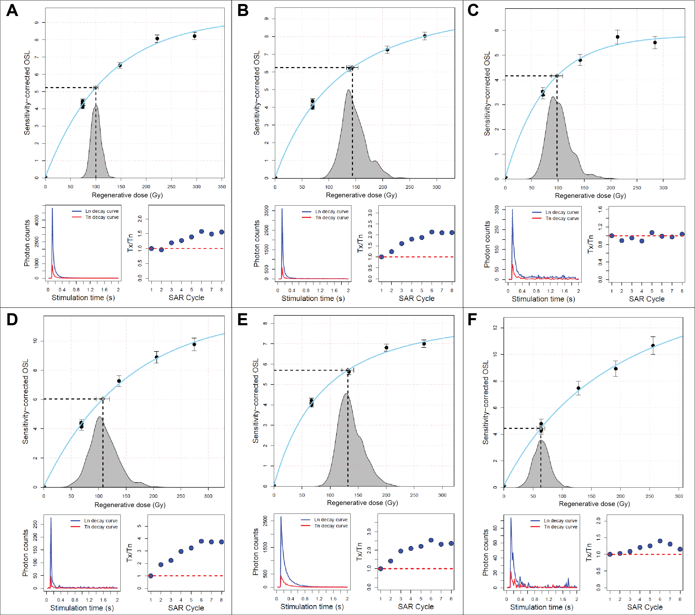
Figure S1. Examples of single-grain OSL DRC shapes, decay curve shapes and patterns of sensitivity change occurring during the SAR procedure measurement of grains from OSL6 at KFR1. Note that y-axis scales differ.

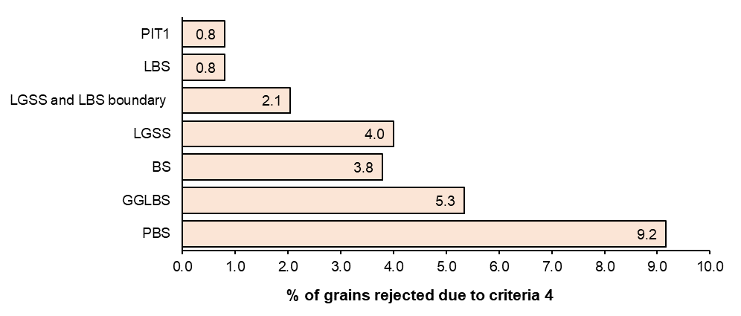
Figure S2. Average rate of grains failing criteria 4 (non-intersecting or saturated grains) for samples within each stratigraphic unit at KFR1.
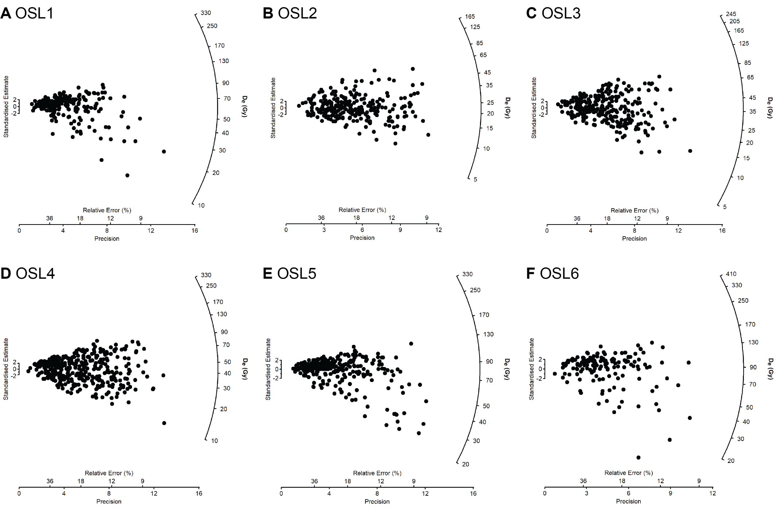
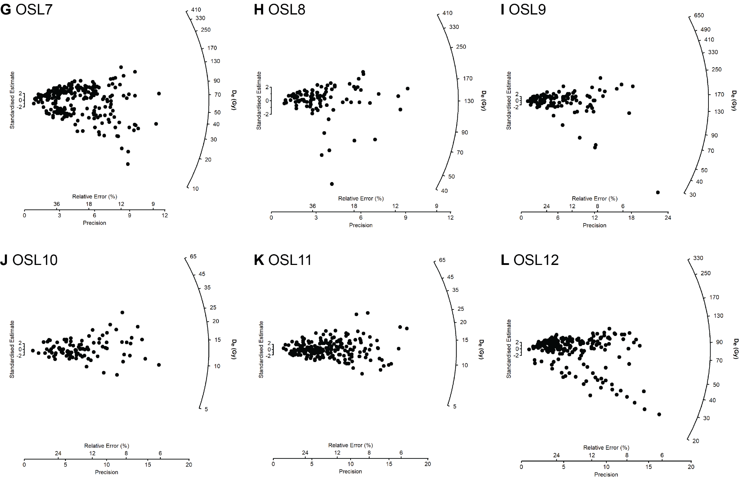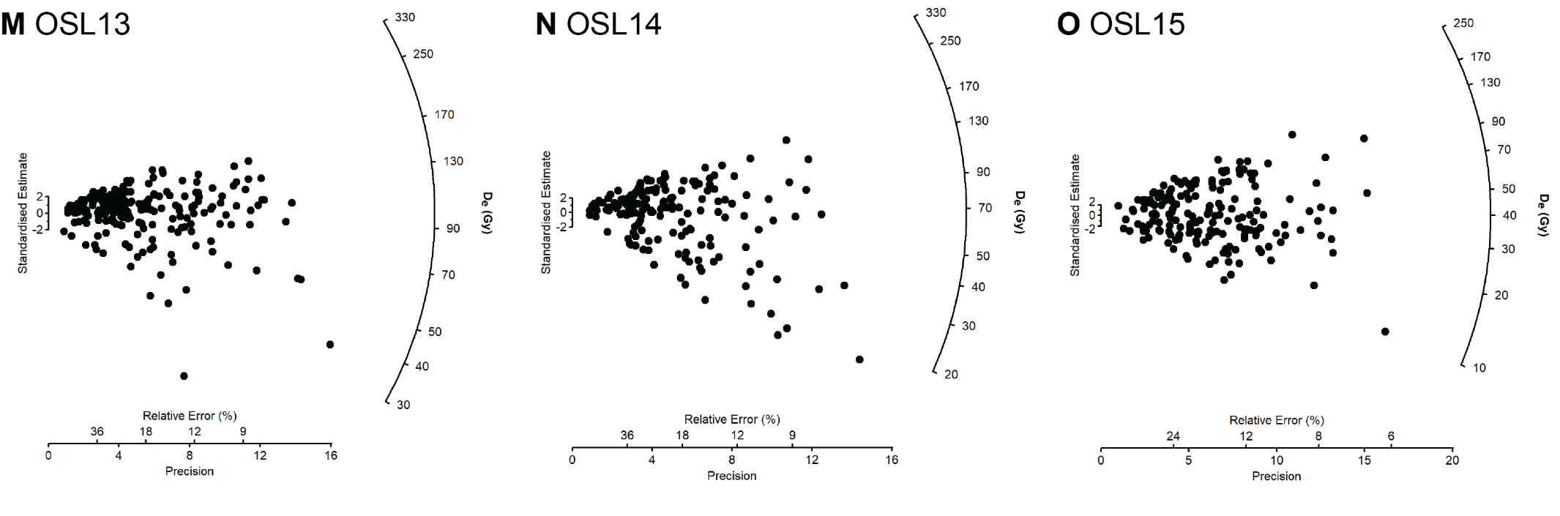
Figure S3. Single-grain quartz D_{e} distributions for all KFR1 samples. Note that radial axis scales differ. Values <5 Gy excluded for the clarity of display.
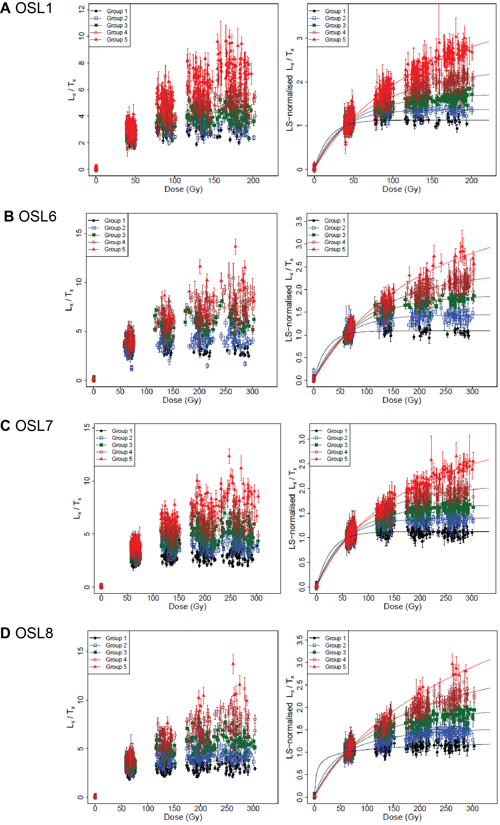
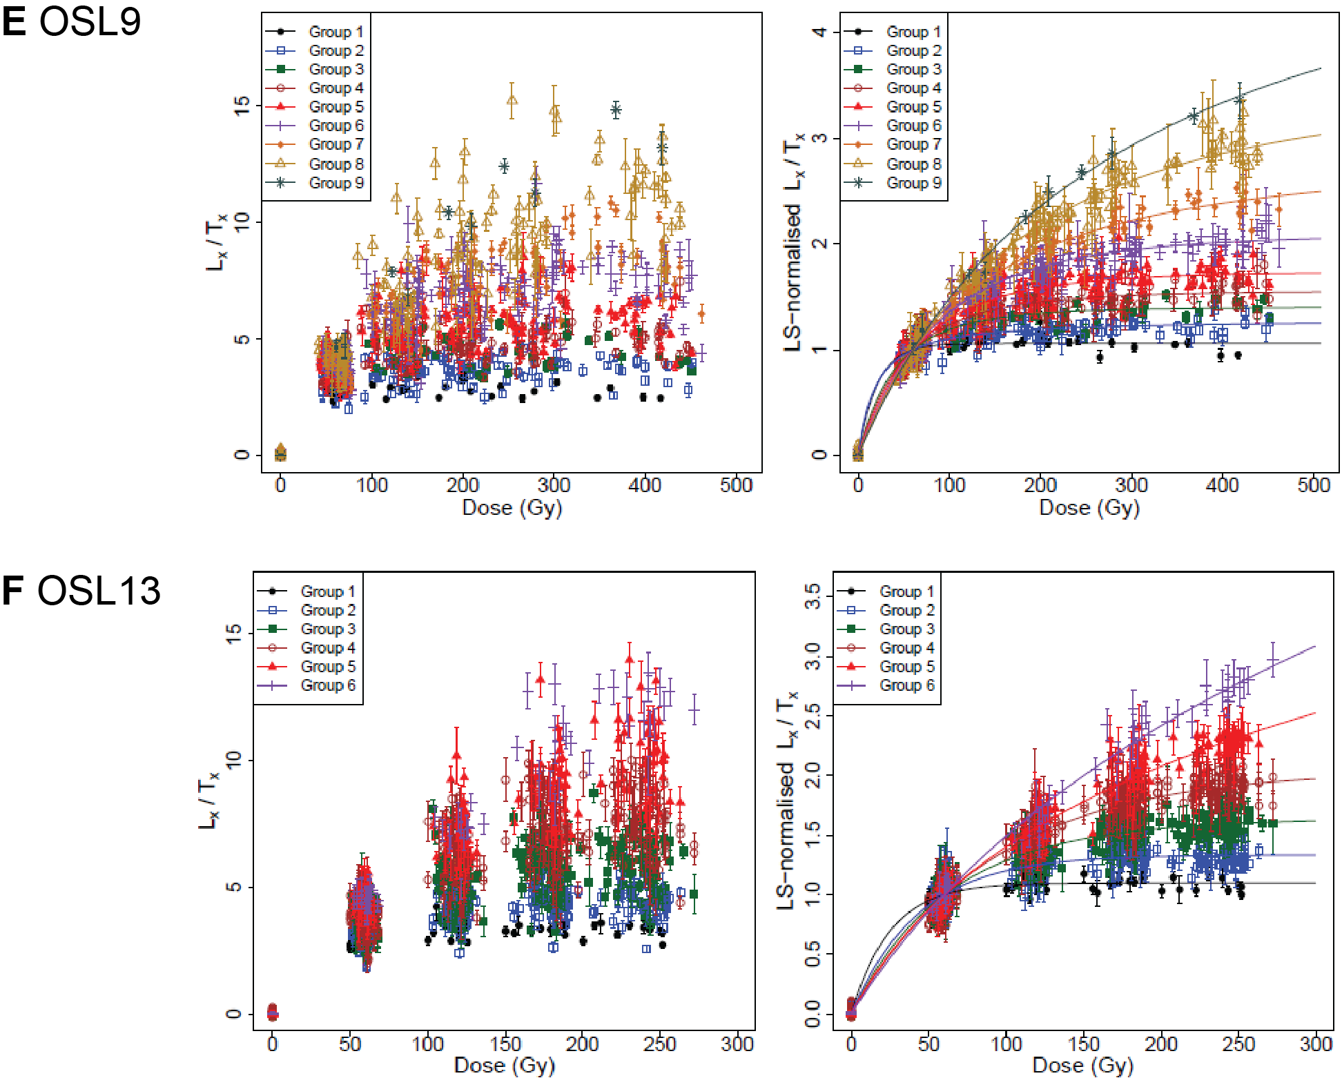
Figure S4. Comparison of the L_{x}/T_{x} values for different SGC groups, before (left) and after (right) LS-normalisation. A general-order kinetic function (full lines) was used for fitting the data and then normalised to unity at 60 Gy (40 Gy for OSL1).

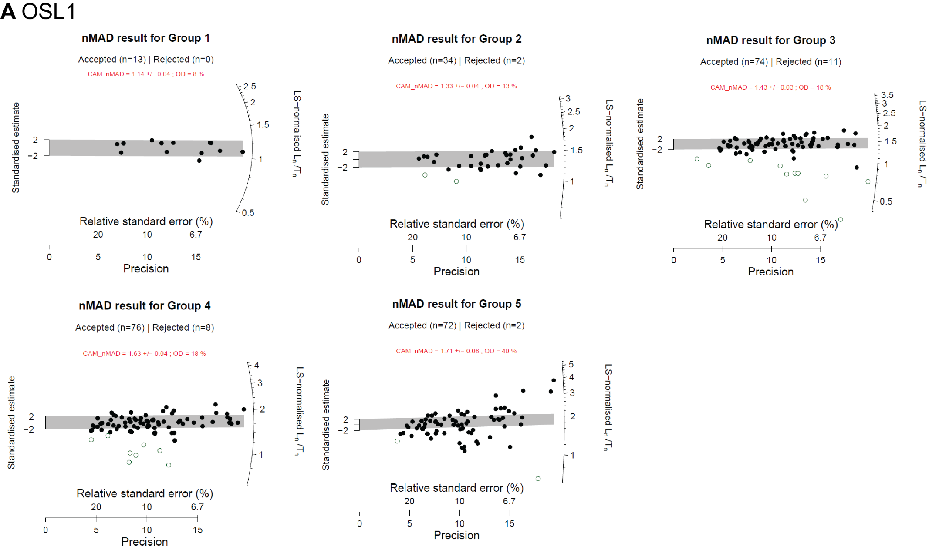

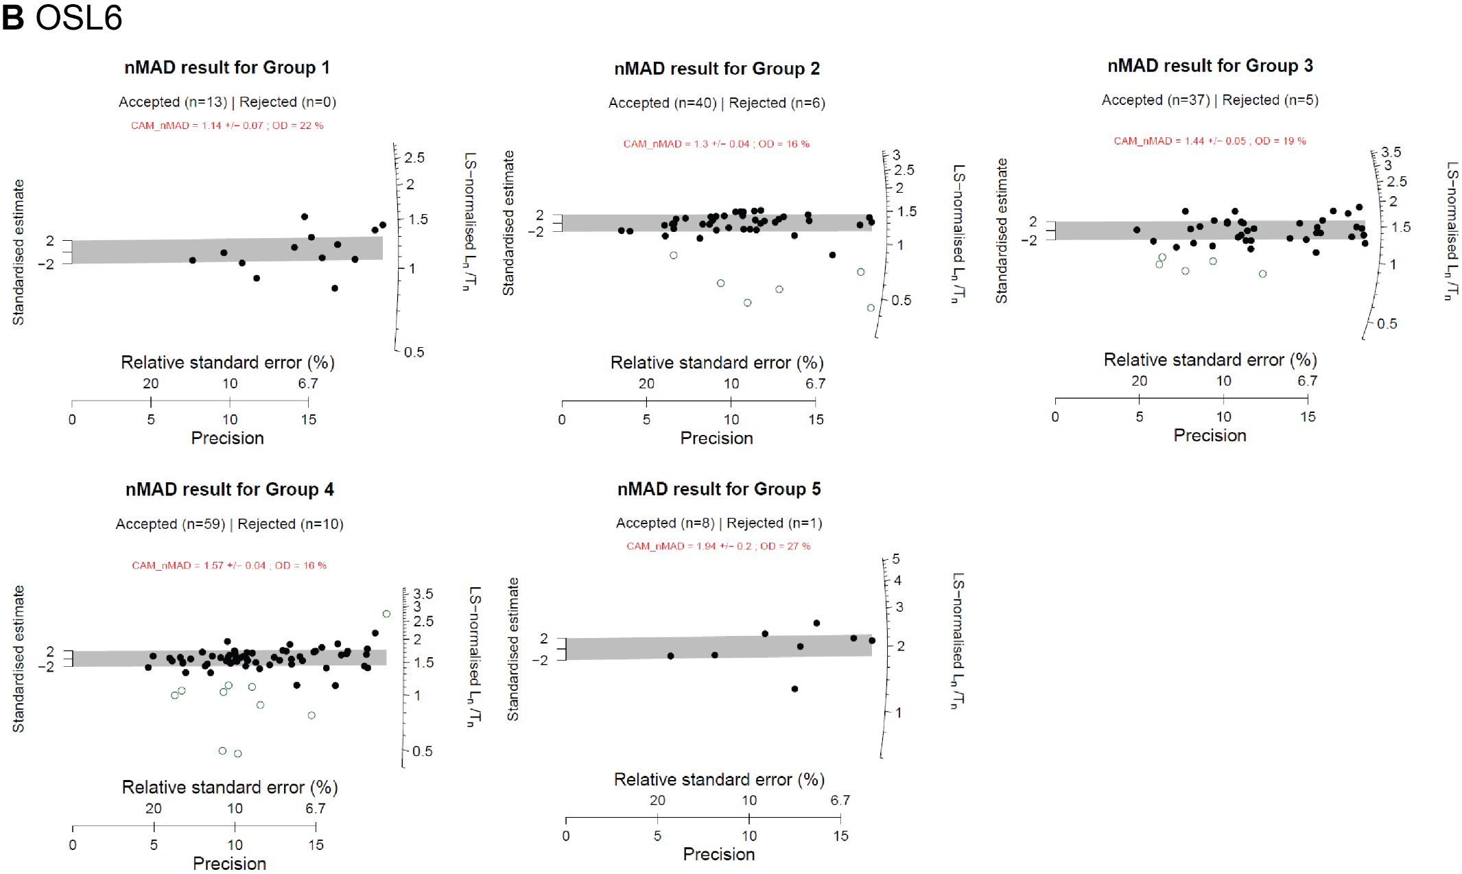

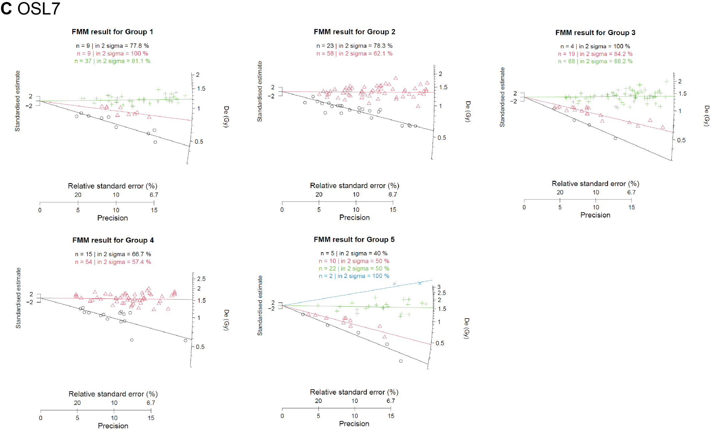

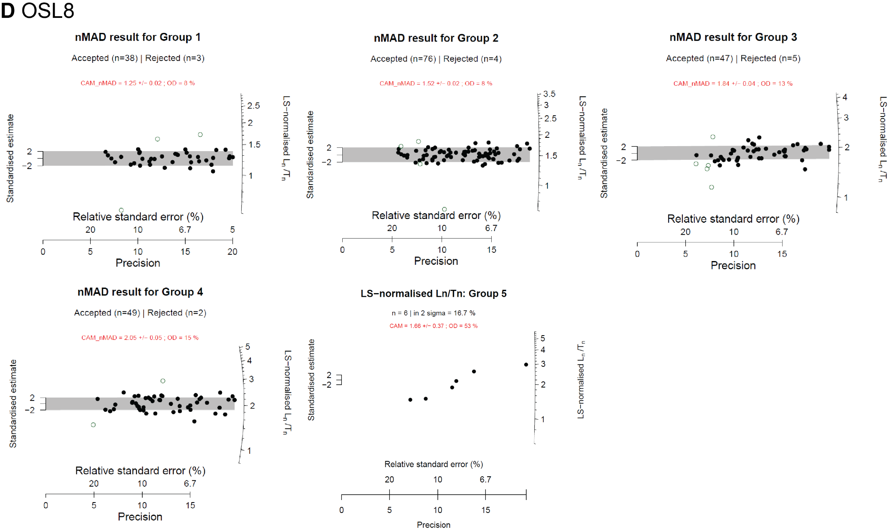

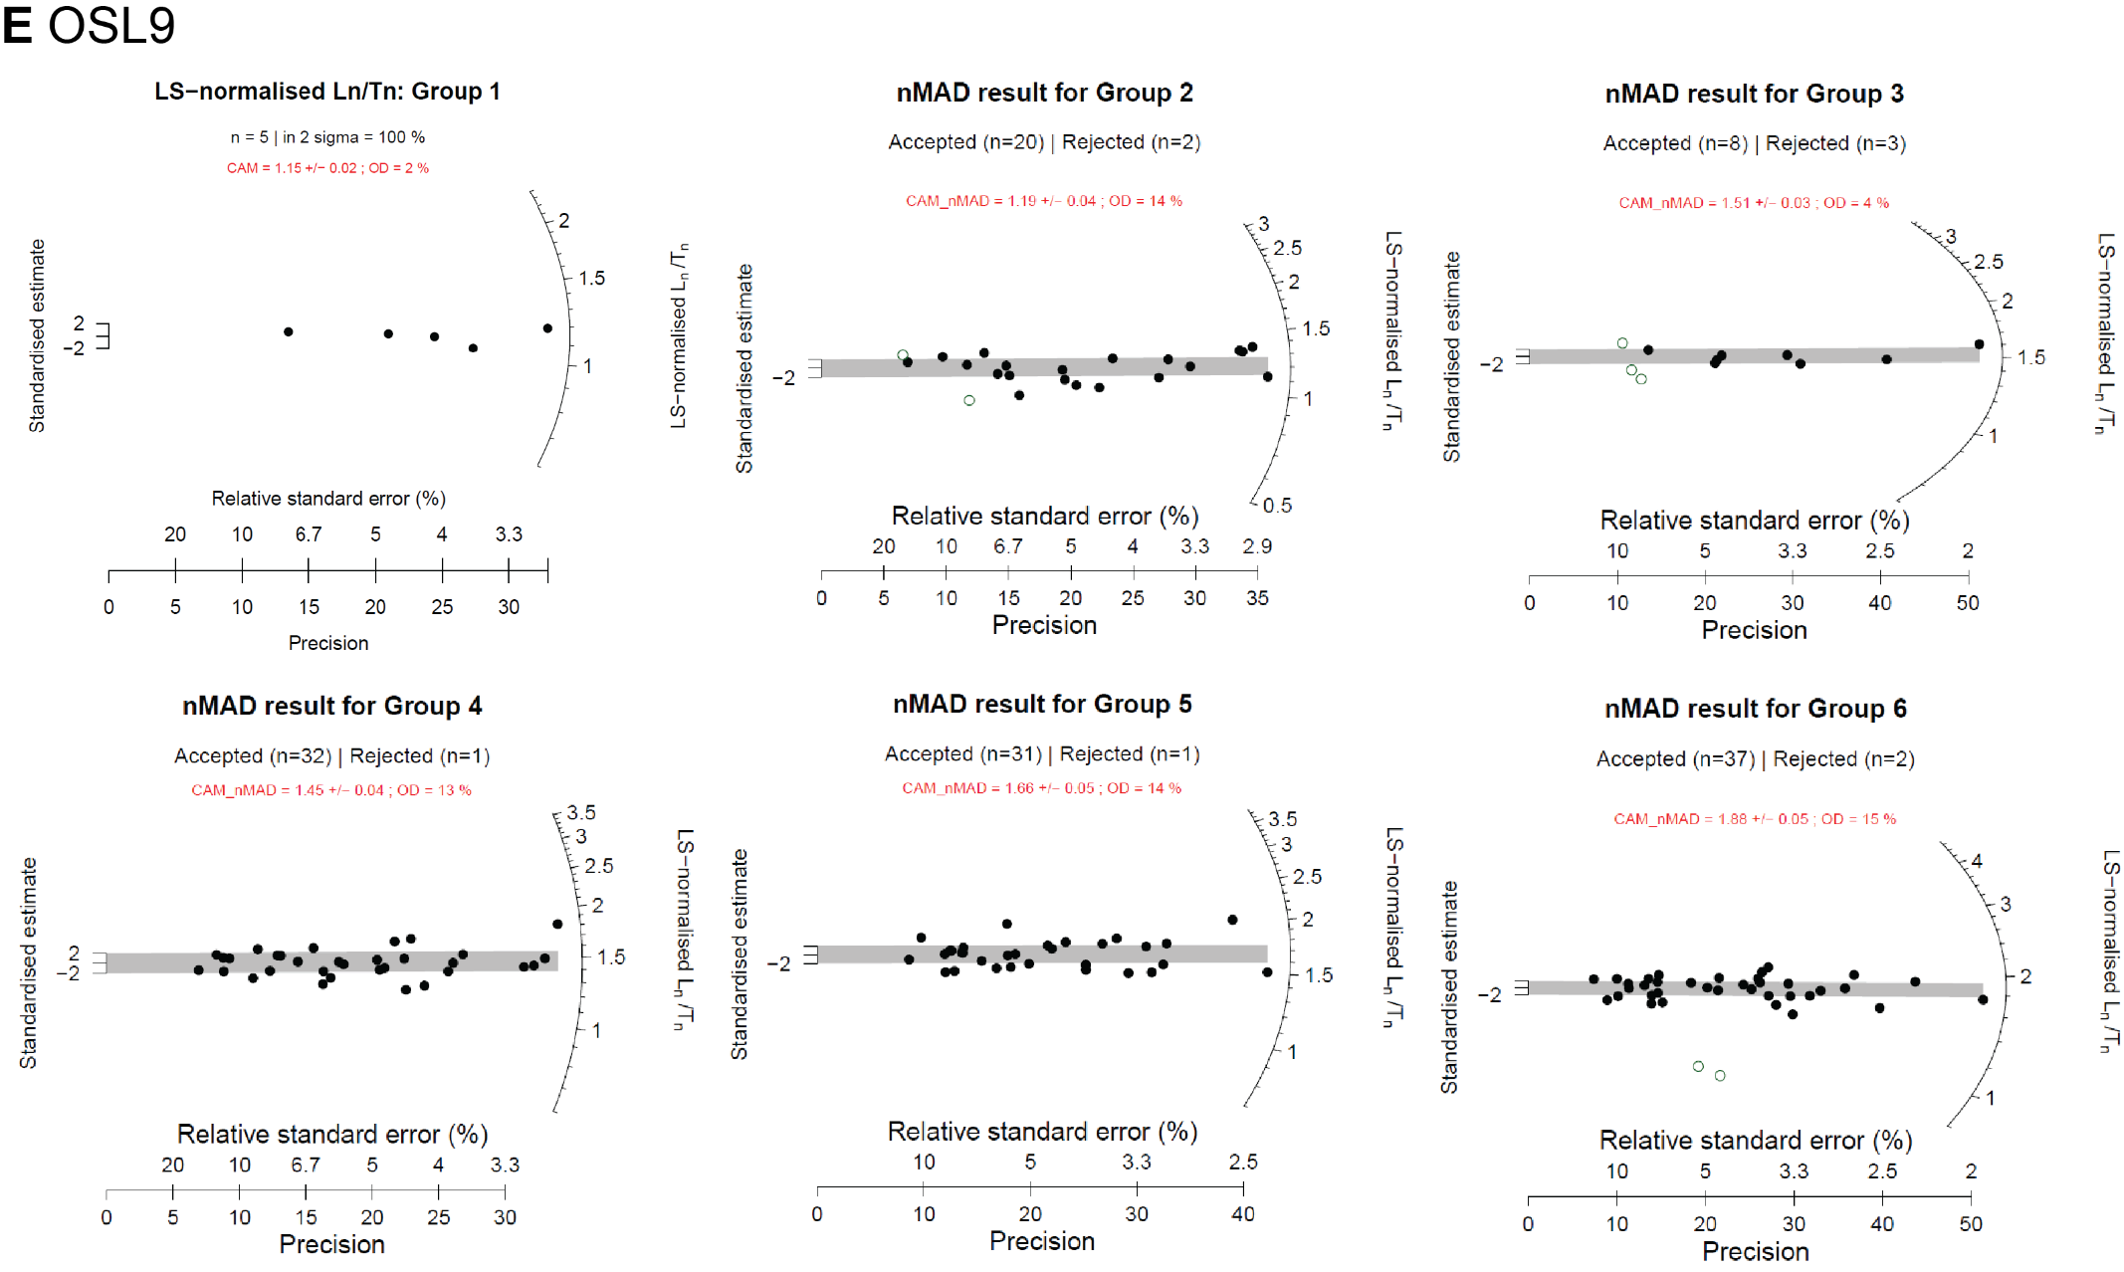
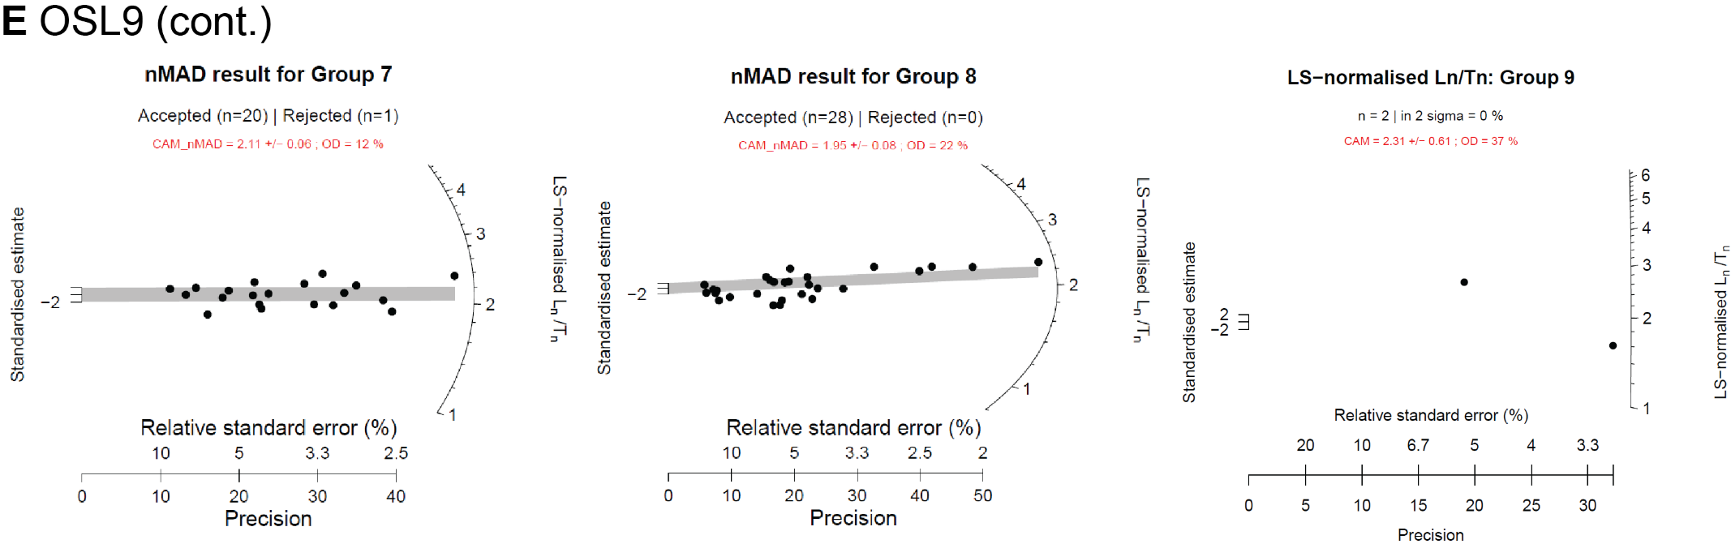

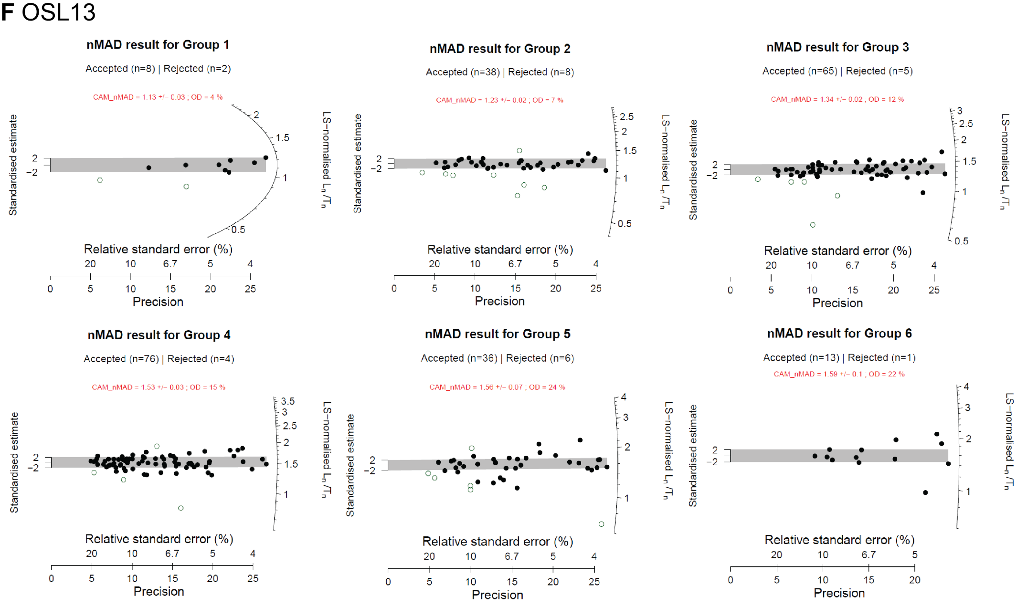

Figure S5. Radial plots showing the LS-normalised L_{n}/T_{n} values obtained for different groups from the KFR1 samples. Unfilled circles represent data points rejected as outliers using the nMAD method. The grey bars represent the weighted mean LS-normalised L_{n}/T_{n} value of the filled circles (calculated using the CAM), used for D_{e} determination. The straight, colour-coded lines shown for OSL7 (Figure S5-C) are centred on the weighted mean value for each component identified using the FMM, based on the data points of the matching colour. A reliable L_{n}/T_{n} value for D_{e} determination was unable to be calculated for groups with less than 10 grains.

References
Ames, C. J., Gliganic, L. A., Cordova, C., Boyd, K., Jones, B. G., Maher, L., & Collins, B. (2020). Chronostratigraphy, site formation, and palaeoenvironmental context of late Pleistocene and Holocene occupations at Grassridge rock shelter (Eastern Cape, South Africa). Open Quaternary 6, 1–19. DOI: https://doi.org/10.5334/oq.77
Cordova, C. E. (2013). C3 Poaceae and Restionaceae phytoliths as potential proxies for reconstructing winter rainfall in South Africa. Quaternary International 287, 121–140.
Barker, B., Lamb, L. Delannoy, J-J., David, B. Gunn, R.G., Chalmin, E., Castets, G., Aplin, K., Sadier, B., Moffat, I., Mialanes, J., Katherine, M., Geneste, J-M. and Hoerlé, S., 2017, Archaeology of JSARN-124 site 3, central western Arnhem Land: determining the age of the so-called “Genyornis” painting in David, B., Tacon, P., Delannoy, J.-J. and Geneste, J.-M. (eds.) The Archaeology of Rock Art in Western Arnhem Land, Terra Australis 48, ANU Press, Canberra. 423-496.
Conyers, L.B., 2013. Ground-penetrating Radar for Archaeology. Alta Mira, Lanham.
Cordova, C. E., & Scott, L. (2010). The potential of Poaceae, Cyperaceae and Restionaceae phytoliths to reflect past environmental conditions in South Africa. In African palaeoenvironments and geomorphic landscape evolution (pp. 133–160). CRC Press.
Cordova, C. E., & Johnson, W. C. (2019). An 18 ka to present pollen-and phytolith-based vegetation reconstruction from Hall's Cave, south-central Texas, USA. Quaternary Research 92, 497-518.
David, B., Delannoy, J-J., Gunn, R.G., Brady, L.M., Petchey, F., Mialanes, J., Chalmin, E., Geneste, J-M., Moffat, I., Aplin, K. and Katherine, M., 2017, Determining the age of a paintings at JSARN-113/23, Jawoyn country, western Arnhem Land, in David, B., Tacon, P., Delannoy, J.-J. and Geneste, J.-M. (eds.) The Archaeology of Rock Art in Western Arnhem Land, Terra Australis 48, ANU Press, Canberra. 371-422.
David, B., Delannoy, J-J., Gunn, R., Calmin, E., Castets, G., Petchey, F., Aplin, K., O’Farrell, M., Moffat, I., Mialanes, J., Geneste, J-M., Barker, B., Sadier, B., Katherine, M., Manataki, M. and Pietrzak, U., 2017, Dating painted Panel E1 at Nawarla Gabarnmang, central-western Arnhem Land plateau, in David, B., Tacon, P., Delannoy, J.-J. and Geneste, J.-M. (eds.) The Archaeology of Rock Art in Western Arnhem Land, Terra Australis 48, ANU Press, Canberra. 245-302.
Duller, G.A.T. 2003. Distinguishing quartz and feldspar in single grain luminescence measurements. Radiation Measurements 37 161–165.
Esteban, I., Vlok, J., Kotina, E. L., Bamford, M. K., Cowling, R. M., Cabanes, D., & Albert, R. M. (2017a). Phytoliths in plants from the south coast of the Greater Cape Floristic Region (South Africa). Review of Palaeobotany and Palynology 245, 69–84.
Esteban, I., De Vynck, J. C., Singels, E., Vlok, J., Marean, C. W., Cowling, R. M., Fisher, E. C., Cabanes, D., & Albert, R. M. (2017b). Modern soil phytolith assemblages used as proxies for Paleoscape reconstruction on the south coast of South Africa. Quaternary International 434, 160–179.
Galbraith. R. F., Roberts, R. G., Laslett, G.M., Yoshida, H. & Olley, J. M. 1999. Optical dating of single and multiple grains of quartz from Jinmium rock shelter, northern Australia: Part I, experimental design and statistical models. Archaeometry 41, 339–364. https://doi.org/10.1111/j.1475-4754.1999.tb00987.x
Galbraith, R. F. & Roberts, R. G. 2012. Statistical aspects of equivalent dose and error calculation and display in OSL dating: an overview and some recommendations. Quaternary Geochronology 11, 1–27. https://doi.org/10.1016/j.quageo.2012.04.020
Guralnik, B., Li, B., Jain, M., Chen. R., Paris, R.B., Murray. A.S., Li S-H., Pagonis, V., Valla, P.G., Herman, F. 2015. Radiation-induced growth and isothermal decay of infrared-stimulated luminescence from feldspar. Radiation Measurements 81 224–231.
Hu, Y., Ruan, Q., Liu, J., Marwick, B. & Li, B. 2019b. Luminescence chronology and lithic technology of Tianhuadong Cave, an early Upper Pleistocene Paleolithic site in southwest China. Quaternary Research 94, 121–136. https://doi.org/10.1017/qua.2019.67
Hu, Y., Marwick, B., Zhang, JF. et al. 2019a. Late Middle Pleistocene Levallois stone-tool technology in southwest China. Nature 565, 82–85. https://doi.org/10.1038/s41586-018-0710-1
Jacobs, Z., Jones, B.G., Cawthra, H.C., Henshilwood, C.S., Roberts, R.G. 2020. The chronological, sedimentary and environmental context for the archaeological deposits at Blombos Cave, South Africa. Quaternary Science Reviews 235, 105850.
Jacobs, Z., Duller, G.A.T., Wintle, A.G. 2006. Interpretation of single grain De distributions and calculation of De. Radiation Measurements 41, 264–277.
Joines, J., 2011. 17,000 Years of Climate Change: The Phytolith Record from Hall's Cave, Texas. Master's thesis. Oklahoma State University, Stillwater.
Kopper, S. (1972). Geophysical Surveying of Cave Sites. Pyrenae 8, 7-16.
Kreutzer, S., Schmidt, S., Fuchs, M. C., Dietze, M., Fischer, M. & Fuchs, M. 2012. Introducing an R package for luminescence dating analysis. Ancient TL 30, 1–8.
Kreutzer, S., Burow, C., Dietze, M., Fuchs, M., Schmidt, C., Fischer, M., Friedrich, J., Mercier, N., Philippe, A., Riedesel, S., Autzen, M., Mittelstrass, D. & Gray, H. 2021. Luminescence: Comprehensive Luminescence Dating Data Analysis. R package version 0.9.15, https://CRAN.R-project.org/package=Luminescence
Lentfer, C.J., Boyd, W.E., 1998. A comparison of three methods for the extraction of phytoliths from sediments. Journal of Archaeological Science 25, 1159–1183Neumann, K., Strömberg, C. A. E., Ball, T., Albert, R. M., Vrydaghs, L., & Cummings, L. S. (2019). International Code for Phytolith Nomenclature (ICPN) 2.0. Annals of Botany 124(2), 189–199.
Li, B., Jacobs, Z. & Roberts, R. G. 2016. Investigation of the applicability of standardised growth curves for OSL dating of quartz from Haua Fteah cave, Libya. Quaternary Geochronology 35, 1–15. https://doi.org/10.1016/j.quageo.2016.05.001
Li, B., Jacobs, Z., Roberts, R. G., Galbraith, R. & Peng, J. 2017. Variability in quartz OSL signals caused by measurement uncertainties: problems and solutions. Quaternary Geochronology 41, 11–25. https://doi.org/10.1016/j.quageo.2017.05.006
Li, B., Jacobs, Z. & Roberts, R. G. 2020. Validation of the LnTn method for De determination in optical dating of K-feldspar and quartz. Quaternary Geochronology 58, 101066. https://doi.org/10.1016/j.quageo.2020.101066
Loke, M.H., Chambers, J.E., Rucker, D.F., Kuras, O., Wilkinson, P.B., 2013. Recent developments in the direct-current geoelectrical imaging method. Journal of Applied Geophysics 95, 135–156.
Maloney, T.R., Dilkes-Hall, I.E., Setiawan, P. Oktaviana, A.A., Geria, I.M., Effendy, M., Ririmasse, M., Febryanto, Sriputri, E., Priyatno, A. Atmoko, F.T., Moffat, I., Brumm, A. and Aubert, M., 2022, A late Pleistocene to Holocene archaeological record from East Kalimantan, borneo, Quaternary Science Reviews, 277: 107313. DOI: https://doi.org/10.1016/j.quascirev.2021.107313
Maloney, T., Dilkes-Hall, I., Vlok, M., Oktaviana, A., Setiawan, P., Priyatno, A., Ririmasse, M., Geria, I.M., Effendy, M., Istiawan, B., Atmoko, F., Adhityatama, S., Moffat, I., Joannes-Boyau, R., Brumm, A., and Aubert, M., 2022, Surgical amputation of a limb 31,000 years ago in Borneo, Nature 609: 547-551. DOI: https://doi.org/10.1038/s41586-022-05160-8
Novello, A., Bamford, M. K., van Wijk, Y., & Wurz, S. (2018). Phytoliths in modern plants and soils from Klasies River, Cape Region (South Africa). Quaternary International 464, 440–459.
Peng, J., Dong, Z. B., Han, F. Q., Long, H. & Liu, X. J. 2013. R package numOSL: numeric routines for optically stimulated luminescence dating. Ancient TL 31, 41-48
Peng, J., Pagonis, V., Li B. 2016. On the intrinsic accuracy and precision of the standardised growth curve (SGC) and global-SGC (gSGC) methods for equivalent dose determination: a simulation study. Radiation Measurements 94, 53–64.
Peng, J. & Li, B. 2017. Single-aliquot Regenerative-Dose (SAR) and Standardised Growth Curve (SGC) Equivalent Dose Determination in a Batch Model Using the R Package 'numOSL'. Ancient TL 35, 32-53.
Powell, R., Hergt, J. & Woodhead, J. 2002. Improving isochron calculations with robust statistics and the bootstrap. Chemical Geology 185, 191–204. https://doi.org/10.1016/S0009-2541(01)00403-X
Putiška, R., Sabol, M., Kušnirák, D., Dostál, I., 2017. Geophysical Research at the Prepoštská Cave and Čertova Pec Cave Neanderthal Sites (Western Slovakia): Geophysical research at Neanderthal sites of western Slovakia. Archaeological Prospection 24, 119–131.
R Core Team. 2020. R: a language and environment for statistical computing, Vienna, Austria. URL: https://www.R-project.org/
Rousseeuw, P. J., Debruyne, M., Engelen, S. & Hubert, M. 2006. Robustness and outlier detection in chemometrics. Critical Reviews in Analytical Chemistry 36, 221–242. https://doi.org/10.1080/10408340600969403
Samouëlian, A., Cousin, I., Tabbagh, A., Bruand, A., Richard, G., 2005. Electrical resistivity survey in soil science: a review. Soil and Tillage Research 83, 173–193.
Schmidt, A., 2013. Earth Resistance for Archaeologists. AltaMira Press,U.S., Lanham, Maryland.
Scott, L., Manzano, S., Carr, A. S., Cordova, C., Ochando, J., Bateman, M. D., & Carrión, J. S. (2021). A 14000 year multi-proxy alluvial record of ecotone changes in a Fynbos-Succulent Karoo transition in South Africa. Palaeogeography, Palaeoclimatology, Palaeoecology 569, 110331.
Weinstein-Evron, M., Mart, Y., Beck, A., 1991. Geophysical investigations in the El-Wad Cave, MT. Carmel, Israel. Geoarchaeology 6, 355–365
Zhao, Z., Pearsall, D.M., 1998. Experiments for improving phytolith extraction from soils. Journal of Archaeological Science 25, 587–598

