The Effect and Mechanism of Exercise on Executive Function among Young Adults: A Double-blinded Randomised Controlled Trial Study
Jianxiu Liu, Ph.D.^{1, 2, †}, Leizi Min, M.S.^{2, †}, Xiaoyu Zhang, M.S.³, Meiting Wu, M.S.⁴, Ruidong Liu, Ph.D.^{5*}, Xindong Ma, Ph.D.^{2, 6*}

1. Vanke School of Public Health, Tsinghua University, Beijing, China, 100084, liujianxiu@mail.tsinghua.edu.cn
2. Division of Sports Science and Physical Education, Tsinghua University, Beijing, China, 100084, mlz20@mails.tsinghua.edu.cn
3. University Savoie Mont Blanc, Le Bourget du Lac, France, 73376, xiaoyuzhang_0714@163.com
4. Zhejiang College of Sports, Hangzhou City, Zhejiang Province, China, 310013, wumeitinghhxx@163.com
5. Sports Coaching College, Beijing Sport University, Beijing, China, 100084, lrd5156@bsu.edu.cn
6. IDG/McGovern Institute for Brain Research, Tsinghua University, Beijing 100084, maxd@mail.tsinghua.edu.cn
†These authors contributed equally to this work
* Equal corresponding authors
Corresponding author: R.D. Liu, Sports Coaching College, Beijing Sport University, Beijing 100084, China, lrd5156@bsu.edu.cn; X.D. Ma, Division of Sports Science & Physical Education, Tsinghua University, Beijing 100084, China, maxd@mail.tsinghua.edu.cn.
Table S1 The effect of acute exercise on RPE and PACES
 | MICT（N=21） | HIIT（N=26） | t | P
RPE | 13.485 | 12.724 | -1.004 | 0.320
PACES | 59.939 | 66.828 | 1.093 | 0.279
Notes: MICT: moderate-intensity continuous training; HIIT: high-intensity interval training; RPE: the rating of perceived exertion scale; PACES: the physical activity enjoyment scale. The effects were estimated by the independent-sample t test.
Table S2 The estimated effect of interventions on executive function and CBF among three groups at pre and post measurements
Variables | Group | Estimated values ª | p
Time | MICT | 17.33(10.33, 24.33) | <.0001
Time | HIIT | 10.77(4.48, 17.06) | 0.001
Time | Control | 7.16(-0.19, 14.51) | 0.061
Accuracy | MICT | -0.04(-0.08, -0.01) | 0.016
Accuracy | HIIT | -0.03(-0.06, 0.01) | 0.105
Accuracy | Control | -0.002(-0.04, 0.03) | 0.910
Vs (cm/s) | MICT | -3.10(-9.10, 2.90) | 0.315
Vs (cm/s) | HIIT | -1.73(-7.12, 3.66) | 0.531
Vs (cm/s) | Control | 1.20(-4.93, 7.33) | 0.703
Vm (cm/s) | MICT | 0.10(-4.12, 4.31) | 0.965
Vm (cm/s) | HIIT | 0(-3.80, 3.80) | 1.000
Vm (cm/s) | Control | 0.15(-4.18, 4.48) | 0.946
Vd (cm/s) | MICT | 1.62(-2.16, 5.4) | 0.404
Vd (cm/s) | HIIT | 0.96(-2.43, 4.35) | 0.581
Vd (cm/s) | Control | -0.55(-4.41, 3.31) | 0.781
PI | MICT | -0.10(-0.17, -0.03) | 0.010
PI | HIIT | -0.04(-0.10, 0.03) | 0.238
PI | Control | 0.02(-0.05, 0.10) | 0.521
RI | MICT | -0.03(-0.06, -0.01) | 0.018
RI | HIIT | -0.02(-0.04, 0.01) | 0.229
RI | Control | 0.01(-0.02, 0.04) | 0.481
S/D | MICT | -0.23(-0.39, -0.06) | 0.008
S/D | HIIT | -0.08(-0.23, 0.06) | 0.274
S/D | Control | 0.050(-0.11, 0.22) | 0.537
Notes: a indicated the adjusted mean difference of pre and post. Vs: peak-systolic; Vd: end-diastolic; Vm: mean cerebral blood flow velocities; PI: pulsatility index; RI: resistance index; S/D: peak-systolic of cerebral blood flow/end-diastolic of cerebral blood flow.
Table S3 The associations between executive function and CBF estimated by generalization additive model
Variables | Group | F | p-value
Timeª | Vs | 5.414 | 0.022
Timeª | Vm | 2.224 | 0.075
Timeª | Vd | 2.434 | 0.136
Timeª | PI | 4.973 | 0.012
Timeª | RI | 5.845 | 0.006
Timeª | SD | 3.168 | 0.063
Accuracy^{b} | Vs | 2.300 | 0.143
Accuracy^{b} | Vm | 0.117 | 0.832
Accuracy^{b} | Vd | 0.535 | 0.466
Accuracy^{b} | PI | 4.797 | 0.036
Accuracy^{b} | RI | 5.394 | 0.024
Accuracy^{b} | SD | 4.312 | 0.050
Notes: CBF: cerebral blood flow; a indicated the total time of trail-making test; b indicated the accuracy of trail-making test. Vs: peak-systolic; Vd: end-diastolic; Vm: mean cerebral blood flow velocities; PI: pulsatility index; RI: resistance index; S/D: peak-systolic of cerebral blood flow/end-diastolic of cerebral blood flow.
Table S4 Sensitive analysis of the associations between executive function and CBF using generalization linear model
Variables | Group | β (95% CI) | p-value
Time | Vs | -0.288(-0.5, -0.076) | 0.009
Time | Vm | -0.334(-0.667, -0.001) | 0.051
Time | Vd | -0.227(-0.637, 0.184) | 0.282
Time | PI | -16.243(-38.274, 5.788) | 0.151
Time | RI | -50.813(-108.165, 6.54) | 0.085
Time | SD | -5.711(-15.757, 4.336) | 0.267
Accuracy | Vs | 0.0003(-0.0004, 0.001) | 0.379
Accuracy | Vm | 0.0001(-0.001, 0.001) | 0.908
Accuracy | Vd | -0.001(-0.002, 0.001) | 0.466
Accuracy | PI | 0.091(0.019, 0.164) | 0.015
Accuracy | RI | 0.255(0.065, 0.444) | 0.01
Accuracy | SD | 0.039(0.006, 0.072) | 0.023
Notes: CBF: cerebral blood flow; a indicated the total time of trail-making test; b indicated the accuracy of trail-making test. Vs: peak-systolic; Vd: end-diastolic; Vm: mean cerebral blood flow velocities; PI: pulsatility index; RI: resistance index; S/D: peak-systolic of cerebral blood flow/end-diastolic of cerebral blood flow.
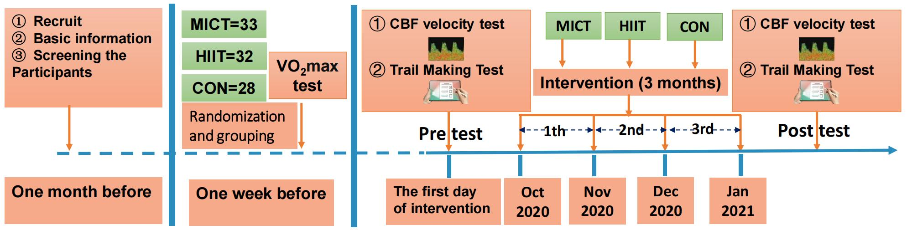
Figure S1. The Schematic Diagram of Experimental Procedures
Notes: MICT: moderate-intensity continuous training; HIIT: high-intensity interval training; CON: control; CBF: cerebral blood flow

