Supplementary
Table S1. Lists of the Atlantic Niño/Niña, El Niño/La Niña and (+)/(-) AMM years used in this study. Atlantic Niño events are identified based on the criterion that the area-averaged SSTA over the ATL3 Atlantic Niño 3 region (ATL3, 3S° - 3°N, 20°W - 0°) exceeds one standard deviation (σ = 0.32 K) during JJASON. Atlantic Niña events are defined using the criterion that ATL3 SSTA is less than -σ. The same criteria are applied for ENSO based on the area-averged SSTA over the NINO3.4 region (σ = 0.50 K; 5S° - 5°N, 170°E - 120W°). Similarly, (+)/(-) AMM years are identified when the normalized AMM index during JJASON exceeds one standard deviation (positive AMM) or is less than negative one standard deviation (negative AMM).
Atlantic Niño (n=19) | Atlantic Niña (n=14) | El Niño (n=17) | La Niña (n=21) | (+) AMM (n=15) | (-) AMM (n=18)
1949, 1951, 1960, 1963, 1966, 1968, 1973, 1981, 1984, 1987, 1988, 1995, 1998, 1999, 2003, 2008, 2010, 2016, 2021 | 1958, 1964, 1965, 1967, 1969, 1971, 1976, 1978, 1982, 1983, 1992, 1994, 2005, 2013 | 1951, 1953, 1957, 1963, 1965, 1969, 1972, 1976, 1977, 1982, 1987, 1991, 1994, 1997, 2002, 2009, 2015 | 1950, 1954, 1955, 1956, 1964, 1970, 1971, 1973, 1975, 1984, 1985, 1988, 1998, 1999, 2000, 2007, 2010, 2011, 2016, 2020, 2021 | 1952, 1955, 1958, 1980, 1995, 1998, 2001, 2004, 2005, 2006, 2010, 2011, 2012, 2013, 2017 | 1963, 1965, 1968, 1971, 1972, 1973, 1974, 1975, 1977, 1982, 1984, 1986, 1991, 1993, 1994, 2000, 2002, 2018
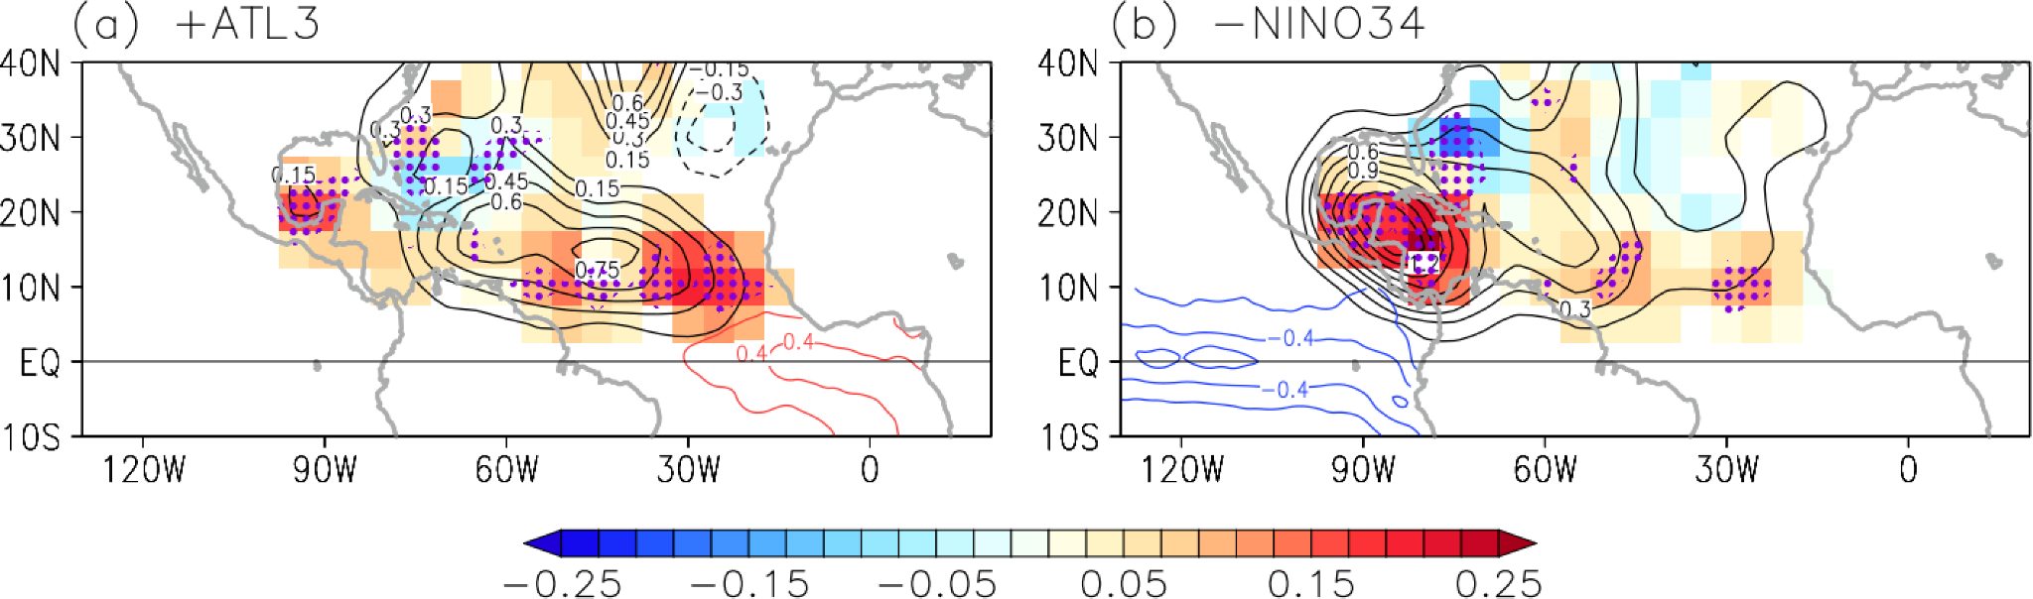
Fig. S1. Same as Fig. 2a-b but for the post-satellite period (1979-2021).

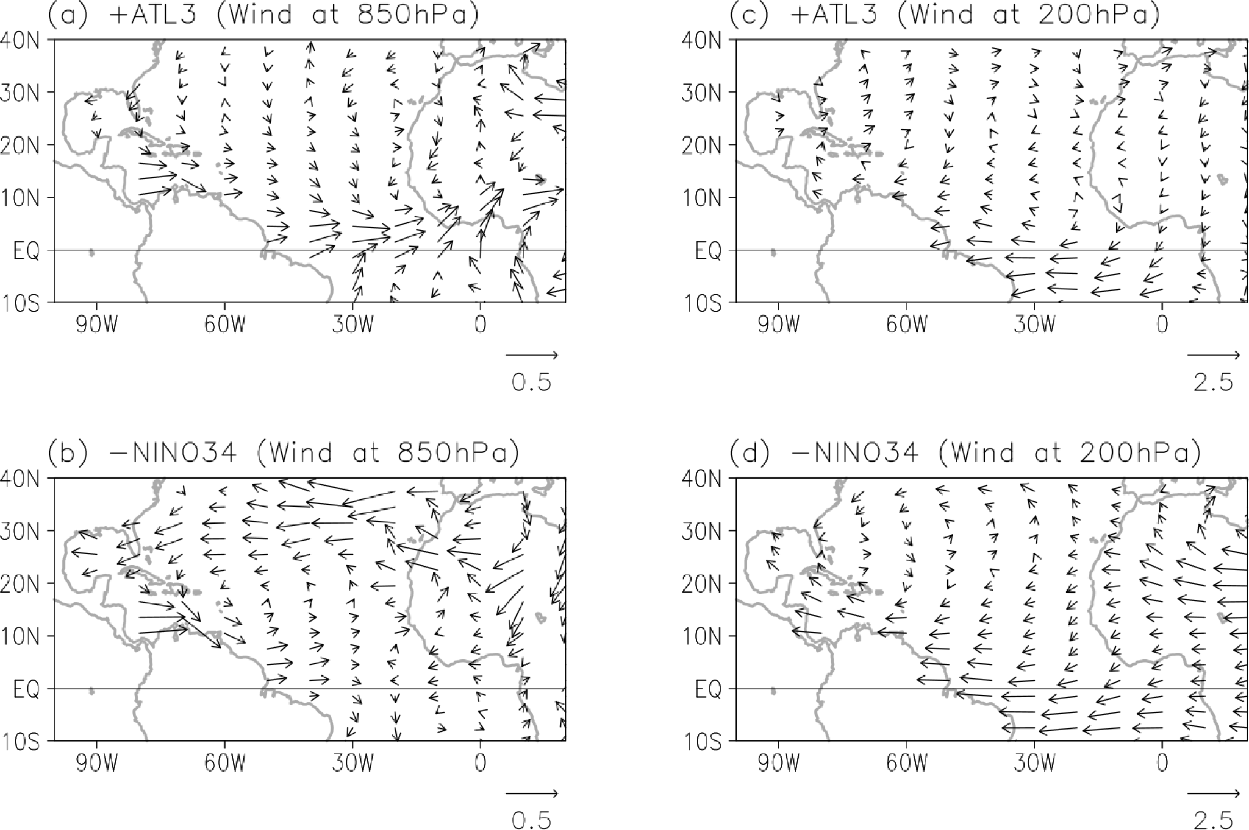
Fig. S2. Partial regressions of wind at 850 hPa onto (a) ATL3 and (b) NINO3.4 indices. (c) and (d) are the same as (a) and (b) but for wind at 200 hPa. The sign of NINO3.4 is reversed, and the regressed wind vectors over the Americas and Pacific Ocean are masked out.

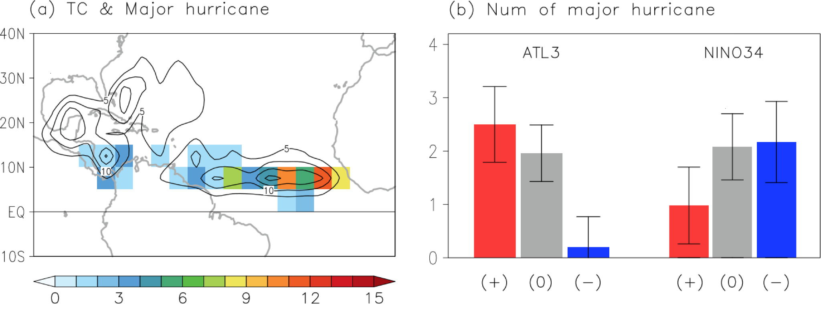
Fig. S3. Same as Fig.3a-b but for the post-satellite period (1979-2021).

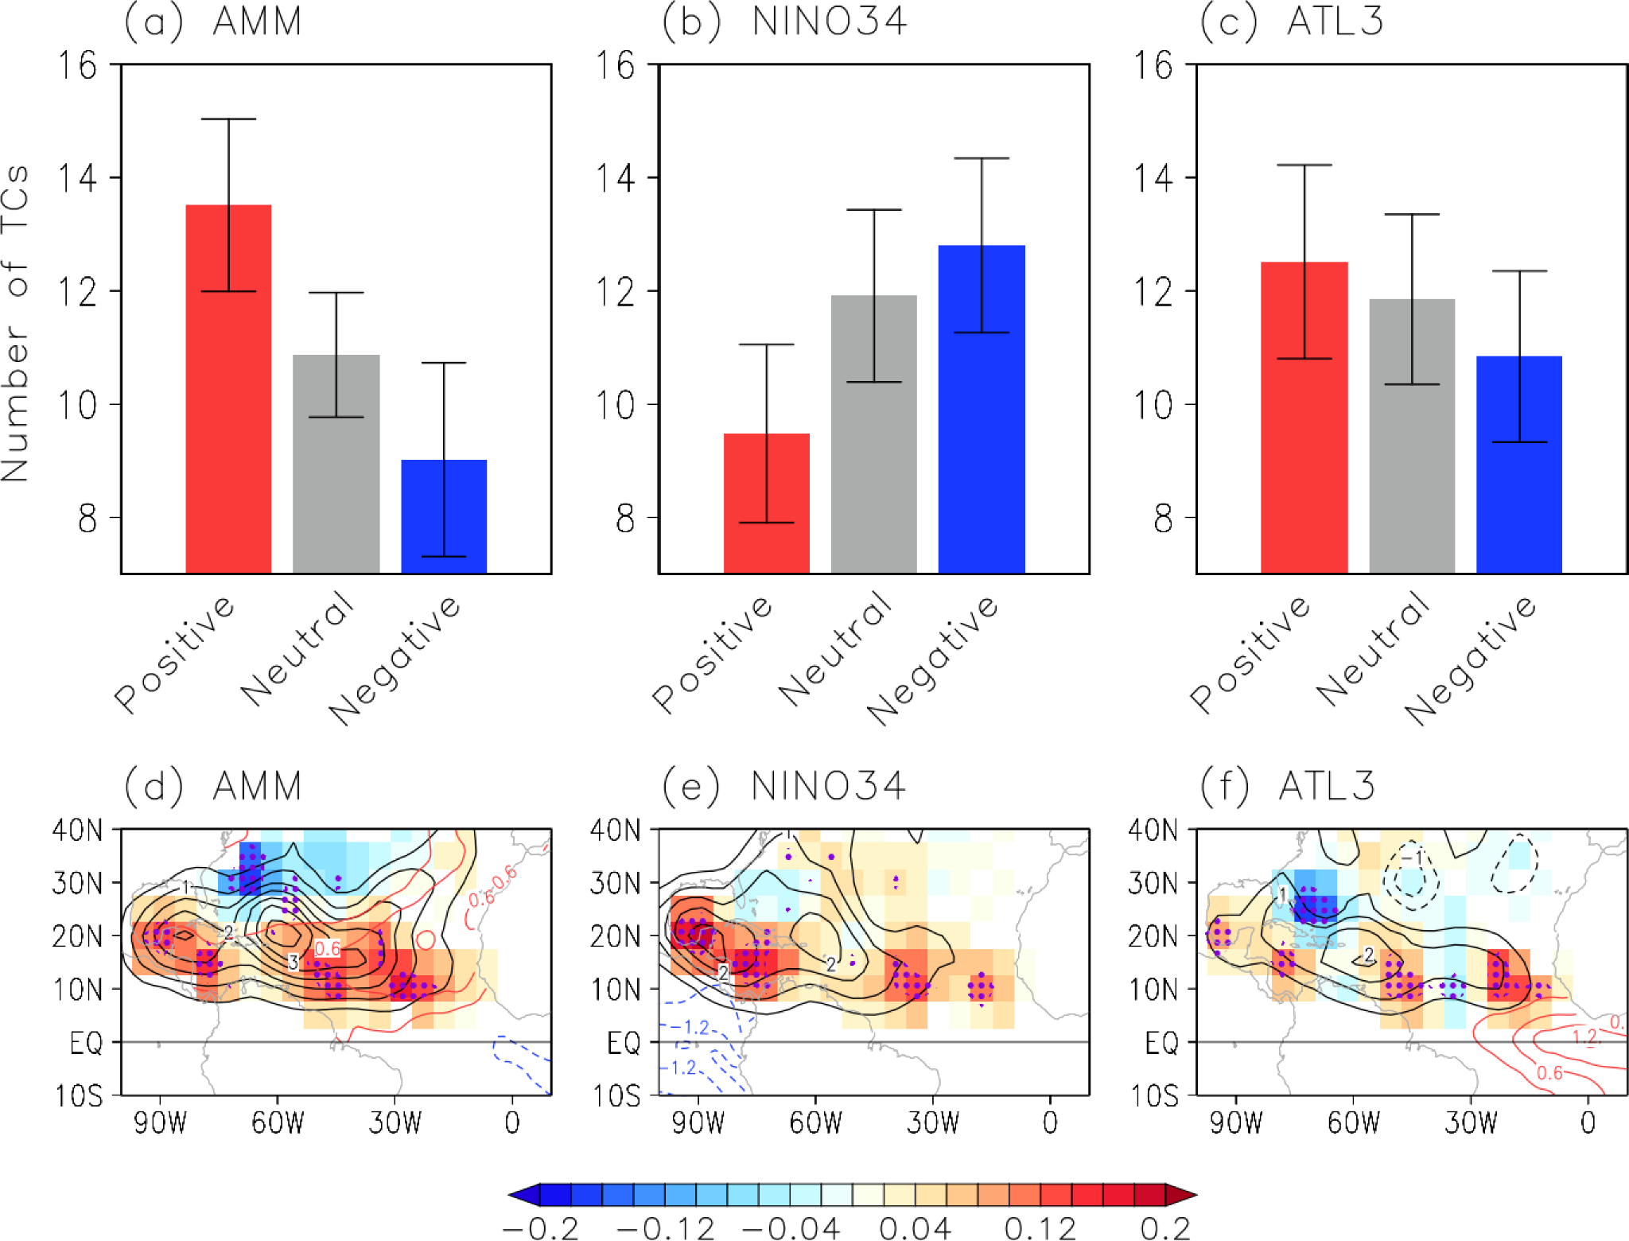Fig. S4. (a) Number of June-November tropical cyclones (TC) over the Atlantic during positive AMM (red bar), neutral (gray bar), and negative AMM (blue bar) years. (b) is the same as (a) but for El Niño (red bar), neutral (gray bar), and La Niña (blue bar). (c) is the same as (a) but for Atlantic Niño (red bar), neutral (gray bar), and Atlantic Niña (blue bar), respectively. Error bars indicate the 95% confidence level based on a two-tailed Student’s t-test. (d) Difference in TC genesis (shaded, per year), track density (black contours, intervals of 0.5 TCs per year), and SSTAs (red and blue contours, intervals of 0.3 K) between positive and negative AMM. (e) is the same as (d) but between La Niña and El Niño. (f) is the same as (d) but between Atlantic Niño and Atlantic Niña. Purple dots indicate where the difference in TC genesis is significant above the 95% confidence level based on a two-tailed Student’s t-test. TC genesis and track density are spatially smoothed to aid visual comparison.
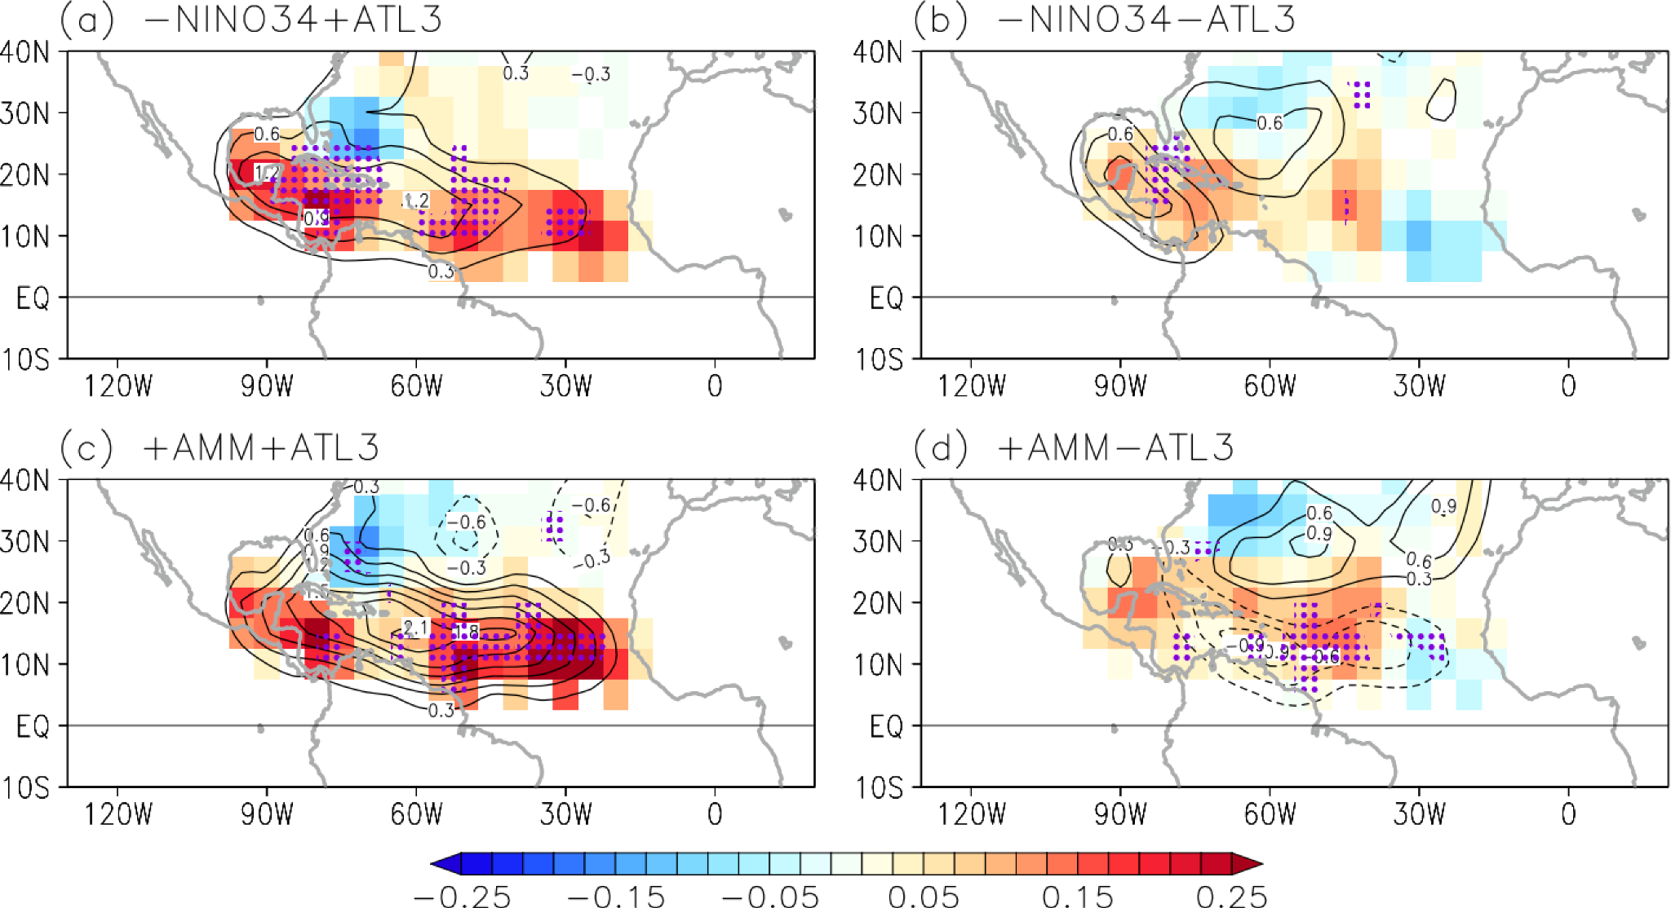
Fig. S5. (a) Linear summation of the partial regression of tropical cyclone genesis (shaded), and track density (black contours) onto ATL3 and NINO3.4 indices. (b) is the same as (a) but for linear subtraction. (c) is the same as (a) but for ATL3 and AMM indices. (d) is the same as (b) but for ATL3 and AMM. Purple dots indicate where TC genesis regressions are significant above the 90% confidence level based on a Student’s t-test.

