Behavior dynamics at high temporal resolutions: the relevance of a right scale for sampling
Barberis, L.^{1,2}, Simien, C.⁴, Marin, R.H. ³⁻⁴, Kembro, J.M.³⁻⁴
¹ Universidad Nacional de Córdoba, Facultad de Matemática, Astronomía Física y Computación, Córdoba, Argentina.
² Consejo Nacional de Investigaciones Científicas y Técnicas (CONICET), Instituto de Física Enrique Gaviola (IFEG), Córdoba, Córdoba, Argentina.
³ Consejo Nacional de Investigaciones Científicas y Técnicas (CONICET), Instituto de Investigaciones Biológicas y Tecnológicas (IIByT), Córdoba, Córdoba, Argentina.
⁴ Universidad Nacional de Córdoba, Facultad de Ciencias Exactas, Físicas y Naturales, Instituto de Ciencia y Tecnología de los Alimentos (ICTA), Córdoba, Córdoba, Argentina.

Supplementary Information

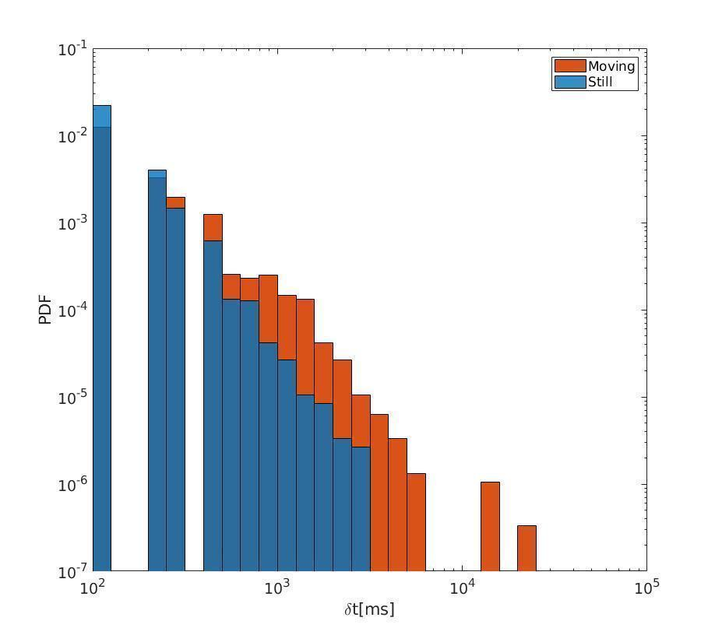

Supplementary Figure S1. Probability distribution of the duration (δ) of with (red) and without (blue) spatial displacement of a single individual sampled at 0.1 s. Note the overall similar shape as shown in Figure 3a and b for all birds combined. PDs are estimated as by counting the number of events that fall in the bin, divided by the bin width and the total number of observations.

Supplementary Note S1. Power law distributions and exponential cut offs

Power law distributions are mathematically described by the function , and predict that it is possible to observe events of any duration, being the larger ones the less probable. Since real systems are not infinite in size and limited by both sampling resolution and the duration of the experiment; extremely large or extremely short spanned events are not possible. This is the case of distributions in Figure 2 (Main Text). Such distribution is expected to fall faster after some value. In practice, this is achieved by multiplying the Power Law by an exponential function. i.e. 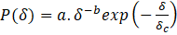. The value is a “characteristic value” that defines a “cut-off” that represents the largest event duration before the power law type distribution is abandoned. Interestingly, in the distribution for immobility events in Figure 2c, the exponential cutoff is not observed for the range of time scales evaluated. Hence, the cutoff for the power law most likely occurs at temporal scales larger than those evaluated herein, as has been observed previously in Guzman et al (2017). A complementary commonly used method for visualizing PL is the Cumulative Distribution (CD), which is provided for comparison in Figure S2. Just, note that linearity is also observed in the log-log plot of the CDF of durations of immobility events, providing further evidence of PL-type distributions.
To summarize, the power law behavior of the duration of events without spatial displacement is consistent with the previously described properties of long-range correlations and scale invariance ^{9-11,19,29}. Specifically, scale invariance implies that the same pattern is observed independently of the temporal scale of observation. Hence, the sampling interval used (within reasonable limits) does not affect the scaling properties (i.e. linearity in the double logarithmic plot or slope) as observed in Figure 2C. Conversely, since the probability distribution of the duration of with spatial displacement events not a power law, but rather presents an exponential cutoff, it is evidently affected by the temporal scale of observation with important consequences. Since 1 s sampling interval is very close to the exponential cutoff, overestimation occurs and caution is needed when extrapolations are considered.

Supplementary Figure 1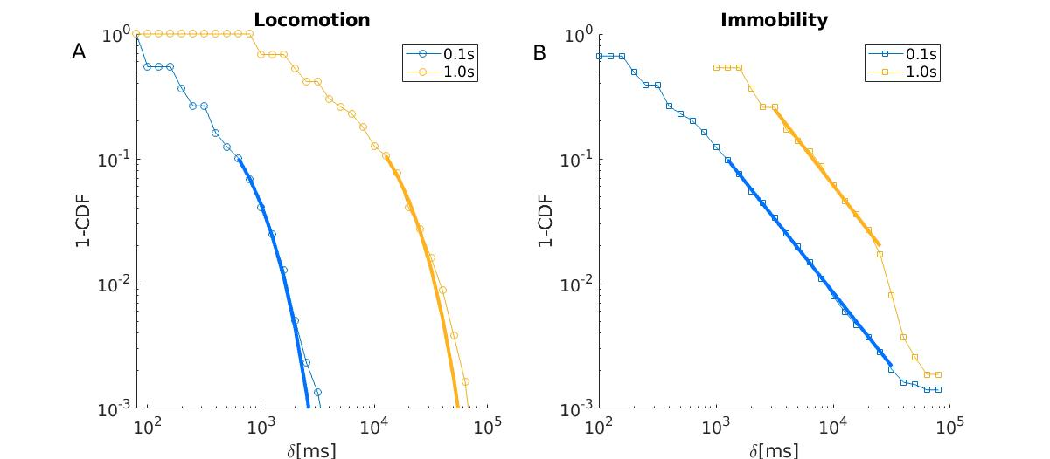
Supplementary Figure S2: Complementary cumulative functions of the same probability distributions shown in Figure 2 for both sampling rates. Thick lines highlight fittings. A) With displacement events show exponential cutoff. At higher exponential sampling the cutoff shift to the left. B) Without spatial displacement events show a power law distribution with exponent . Note the enlargement of the tail at a higher sampling frequency. Mathematical expressions and developments for CD’s are presented in Kembro et al, (2019; Supplementary Material) and considerations are taken into account when applied to the biological time series explored in Flesia et al. (2022) ⁵⁸

Supplementary Table S1. Definition of behavioral variables recorded in social groups using ANY-maze ™
VARIABLE |  |  | DEFINITION
 |  | Peck |  | When one bird raises its head and vigorously pecks the other bird’s body.
 | Grabs |  |  | When a bird catches (“grabs”) with their beak the neck or head region of the other bird.
 | Mount |  |  | While performing a grab, the bird approaches the other bird from behind, and places both feet on the dorsal surface of its torso, stepping over the other bird's tail (adapted from ⁵⁵).
 | Cloacal contact |  |  | During mounting, the bird lifts his tail and tilts his pelvis underneath the other bird, and briefly presses its cloaca against the other bird (adapted from ⁵⁵).
 | Threats |  |  | One bird raises its head and neck rapidly and moves forward and backward vigorously in the direction of the opponent without making physical contact (adapted from ⁵⁵).
 | Chase |  |  | A bird runs after another that is escaping (adapted from⁵⁶).
 | Foraging |  |  | Pecking at the ground or actively moving litter with the beak.
 | Feeding |  |  | Pecking at food in the feeding trough.
 | Dust bathing |  |  | Vertical wing shakes in a lying position ⁵⁷ .

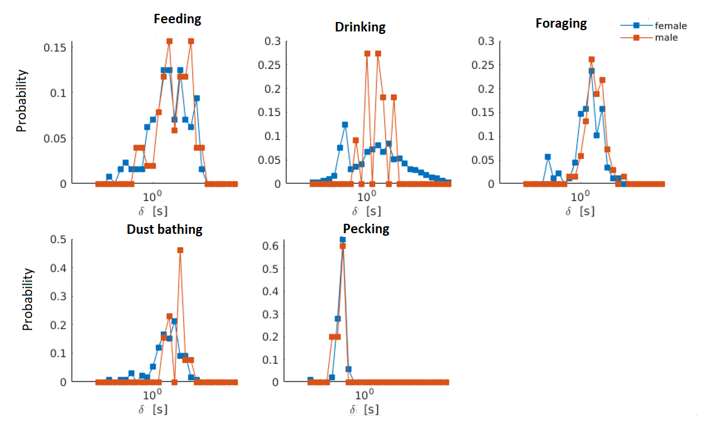
Supplementary Figure S3. Comparison between female (blue) and male (red) quail within social groups in regard to probability distribution functions of the duration (δ) of behavioral events.
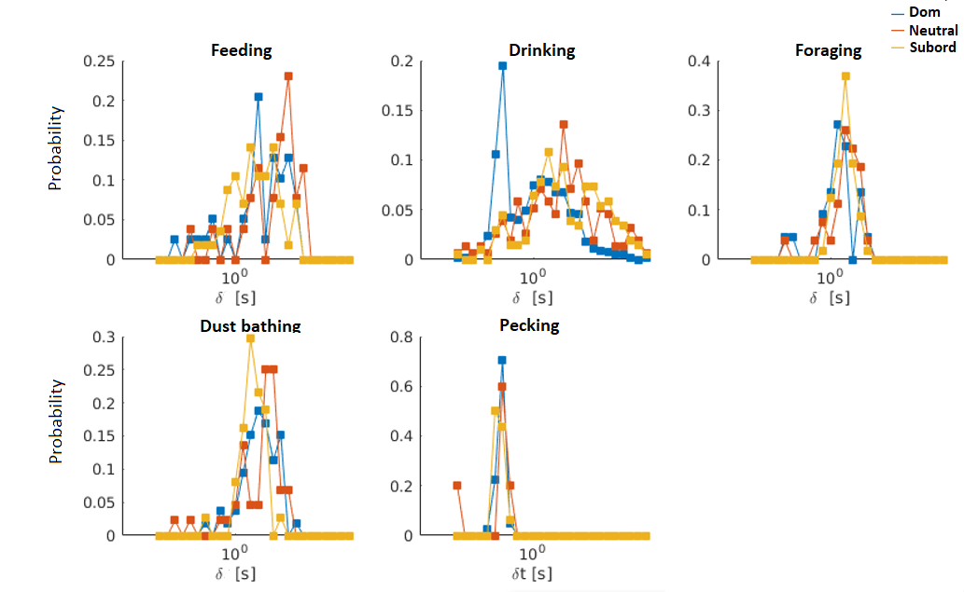Supplementary Figure S4. Comparison between quail clasified within social groups as dominant (blue), neutral (red) or subordinate (yellow) in regard to probability distribution functions of the duration (δ) of behavioral events.

