Environmental Challenges and Concurrent Trend of Weather Extremes over Uttarakhand Himalayan
Pramod Kumar^{1@}, Arbind Patel³, Jaya Rai², and Prem Kumar²

Supplementary (S)

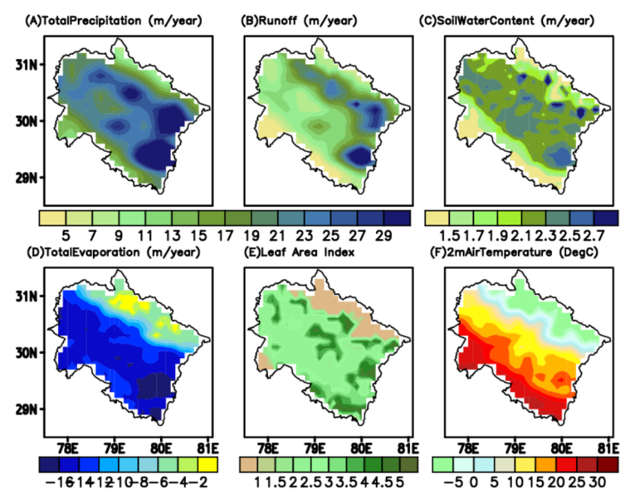

Supplementary S1. Climatology of the accumulated yearly total precipitation, total runoff, total evaporation, soil water content of upper layer, leaf area index and 2m air temperature.

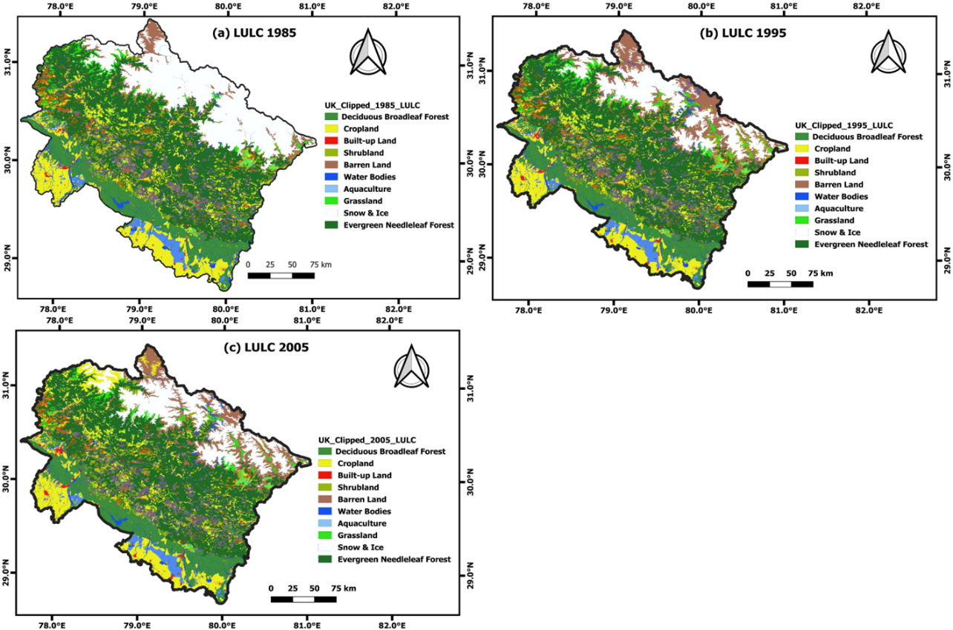

Supplementary S2A. Land Use Land Cover (LULC) during (a) 1985; (b) 1995; and (c) 2005. The dark-red/red colour shows the urban/rural builtup land, yellow colour shows cropland. (https://daac.ornl.gov/)

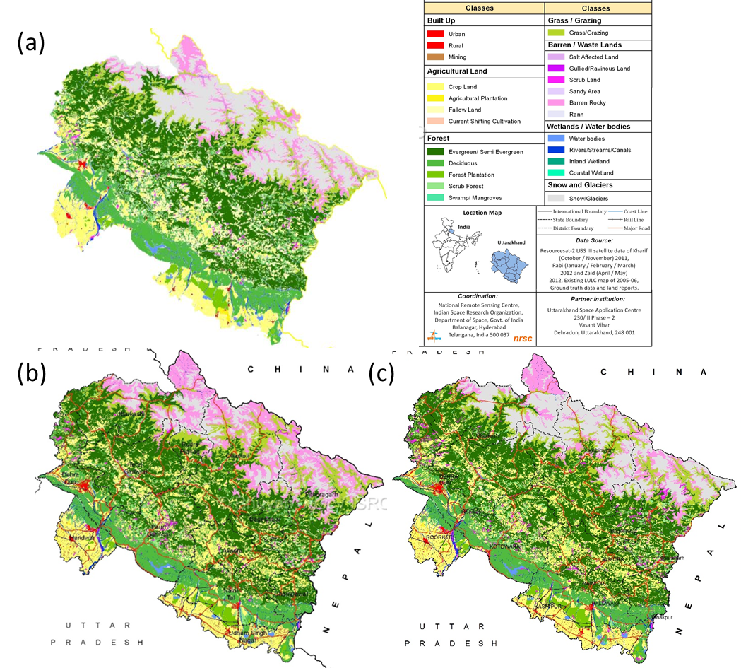

Supplementary S2B. Land Use Land Cover (LULC) during (a) 2005-2006; (b) 2011-2012; and (c) 2015-2016. The dark-red/red colour shows the urban/rural land, yellow colour shows cropland. (https://bhuvan.nrsc.gov.in)

Variables | N | Minimum | Maximum | Mean | Std. Deviation
Precip | 40 | 13.06 | 28.67 | 22.43 | 3.15
Runoff | 40 | 6.80 | 19.70 | 13.28 | 2.79
Soilwater | 40 | 1.32 | 2.21 | 2.03 | 0.13
Evapotranspiration | 40 | -12.91 | -7.74 | -11.94 | 0.82
Temp | 40 | 9.57 | 12.06 | 10.97 | 0.48
LAI | 40 | 2.36 | 2.45 | 2.45 | 0.014

Supplementary S3. Descriptive Statistics of the data is depicted in this table.
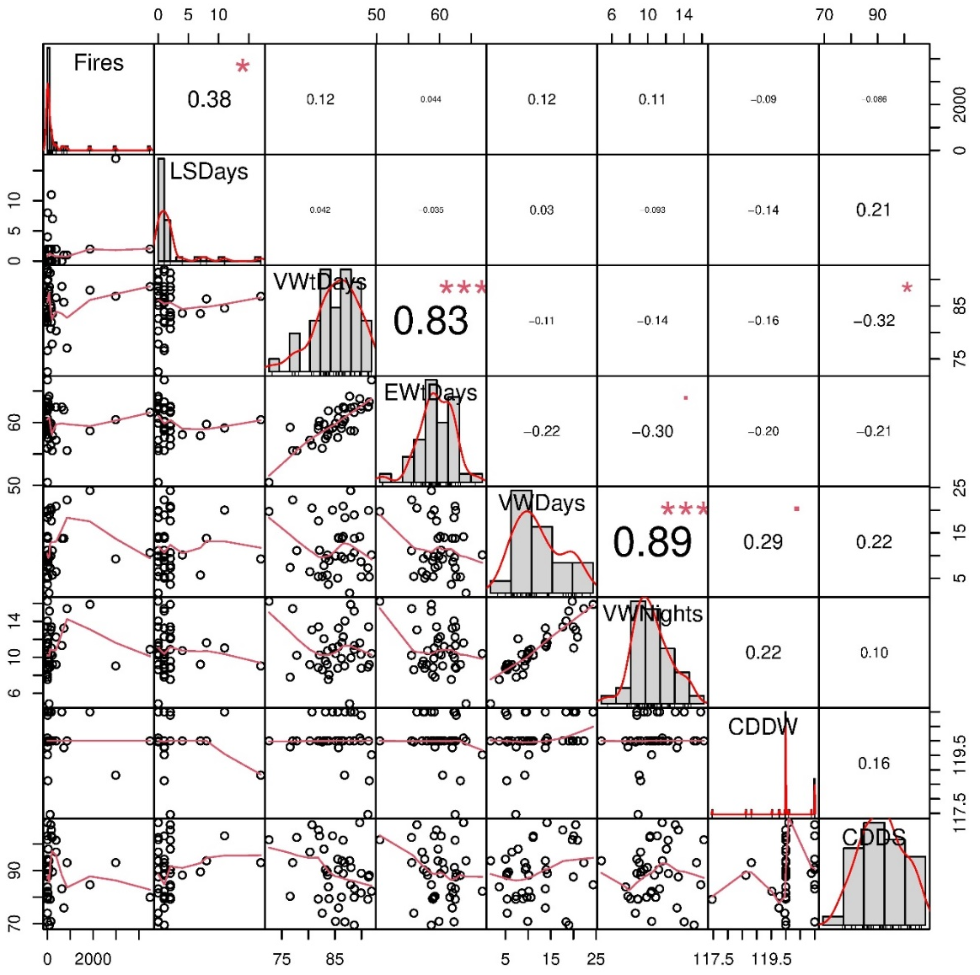

Supplementary S4. The distribution of Fires: forest fires, LSDays: landslide days, VWtDays: very wet days, EWtDays: extremely wet days, VWDays: very warm days, VWNights: very warm nights, CDDW: consecutive dry days winter and CDDS: consecutive dry days summer are shown on the diagonal. On the bottom of the diagonal: the bivariate scatter plots with a fitted line are displayed. On the top of the diagonal: the value of the correlation plus the significance level as stars is given. Each significance level is associated to a symbol: p-values (0, 0.001, 0.01, 0.05, 0.1, 1) to respective symbols (“***”, “**”, “*”, “.”, " “).

Variables | Principal Components
Variables | PCA1 | PCA2 | PCA3 | PCA4 | PCA5 | PCA6
precip | 0.423 |  |  | 0.076 | 0.071 | 0.728
runoff | 0.373 |  |  | 0.092 | 0.116
soilwater | 0.508 | 0.235 |  | 0.024
evapo |  |  |  |  |  | 0.022
temp |  |  | 0.951 | 0.142 |  | 0.029
LAI | 0.480 | 0.243 | 0.251 |  | 0.323
Eigenvalues | 3.380 | 1.386 | 1.028 | 0.125 | 0.063 | 0.018
% of variance | 56.340 | 23.108 | 17.130 | 2.078 | 1.043 | 0.300
Cumulative % | 56.340 | 79.448 | 96.578 | 98.657 | 99.700 | 100.0
Supplementary S5. PCA descriptive statistics of the data are depicted in this table. Only factor loading ≥0.02 is shown. Loadings ≥0.4 are in bold, Extraction method: principal component analysis, Rotation method: varimax with Kaiser normalization.

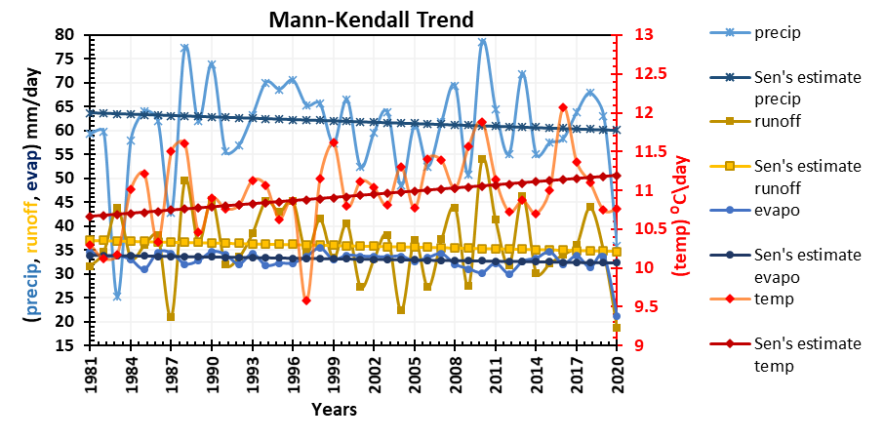

Figure S6. Mann-Kendall trend of the total precipitation, total runoff, total evaporation, soil water content of upper layer and 2m air temperature area-averaged over the Uttarakhand region.

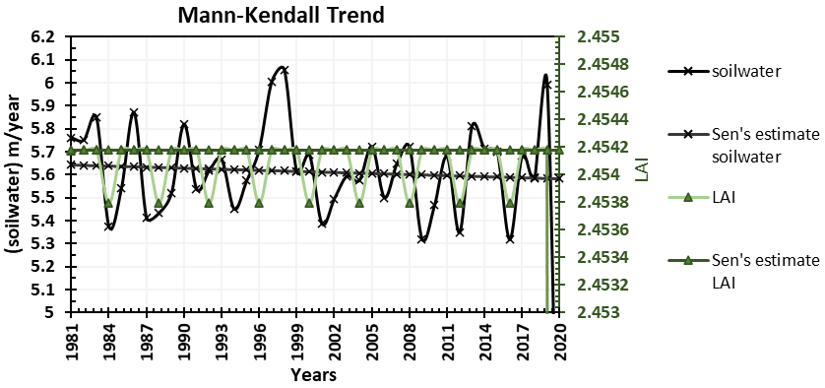

Supplementary S7. Mann-Kendall Trend of the soil water content of upper layer and Leaf Area Index (LAI) area averaged over Uttarakhand region.
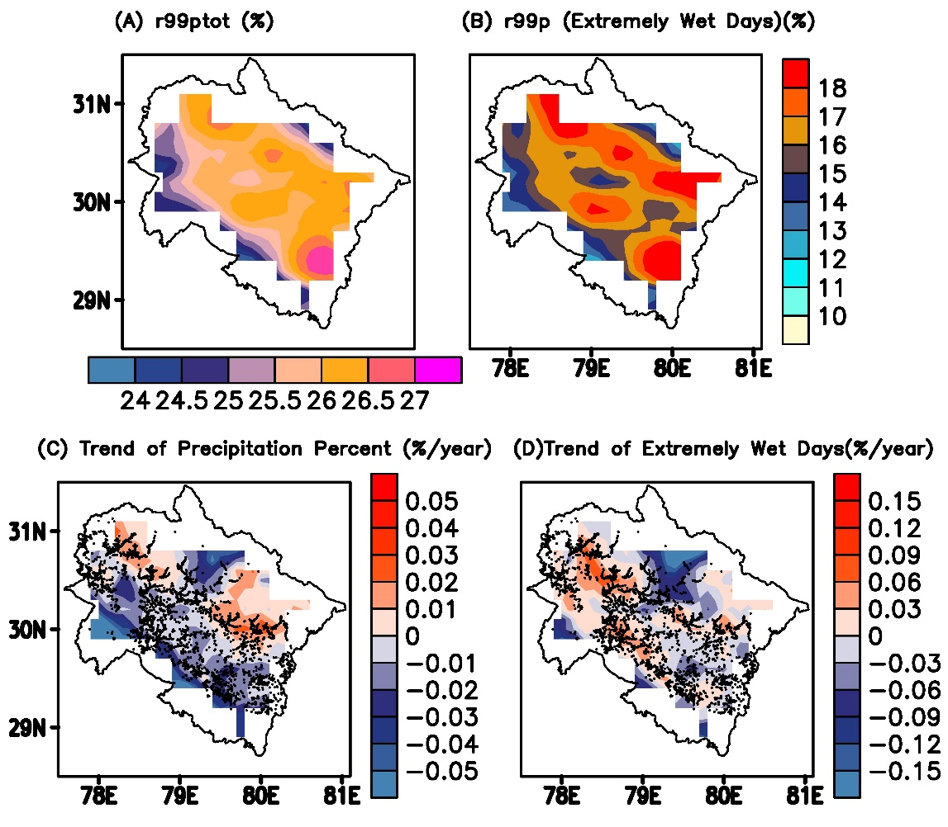

Supplementary S8. Climatology for 1981-2020; (A) r99ptot: Percentage of total precipitation amount per time period due to very wet days with respect to 99th percentile of reference (1951-1990) period (percent)., (B) r99p: This is the percent of time per time period of wet days (daily sum at least 1 mm/day) where daily precipitation amount of a wet day is above a reference value. The reference value is calculated as the 99th percentile of all wet days of a given (1951-1990) 40 years (Percent). Trend for 1981-2020 (% change/year) with respect to (1951-1990); (C) r99ptot, (D) r99p. The black dots represent the landslides incident in (C) and (D).

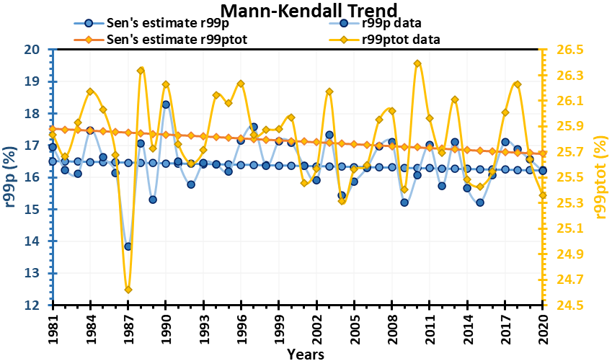

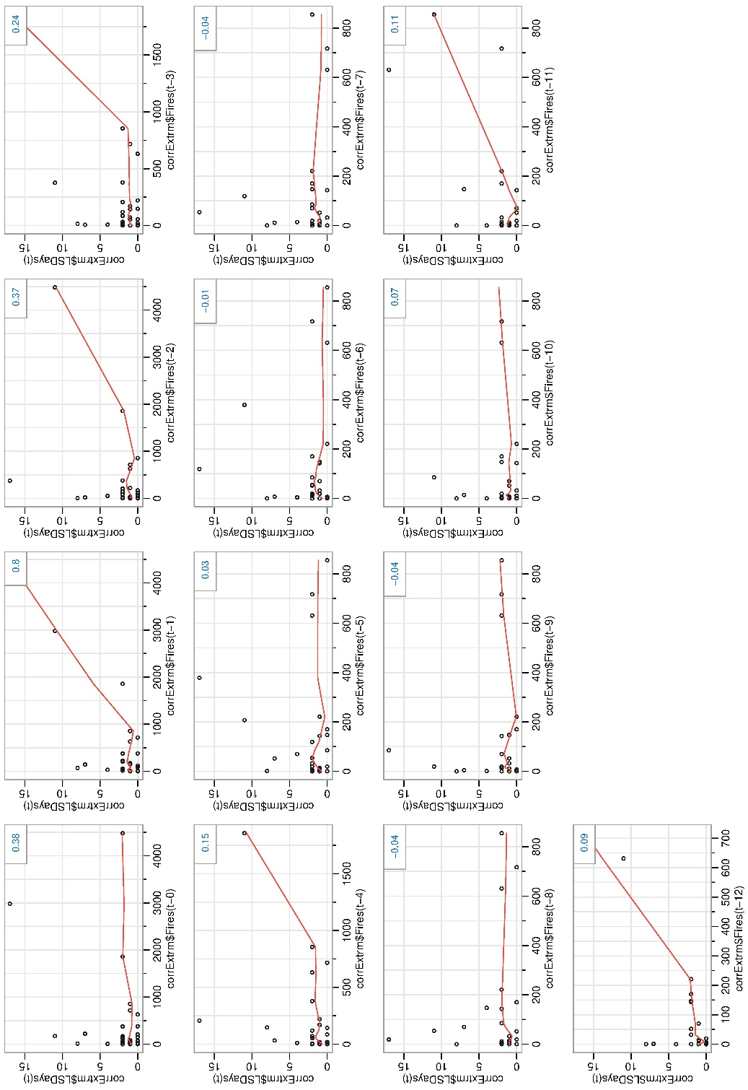
Supplementary S9. Mann-Kendall Test and Sen's Slope Estimates for the trend of annual data (r99p) Z_{r99p} value= -0.757, (r99ptot) Z_{r99ptot} value= -1.036.
Supplementary S10. Autocorrelation between forest fires and landslides up to 12-lag.

S11: Detail Geology of the Study region
1.0 Tectonics and structural configuration
Various litho-stratigraphic units of the Uttarakhand Himalayas are demarcated by numerous thrust systems such as MBT (The Main Central Thrust), MCT (The Himalayan Frontal Thrust), HFT, etc. These thrust systems run throughout the Himalayan orogeny (Validya, 2015). Near these massive thrust systems, the rock mass is comparably weaker and more prone to mass wasting (Sati et. al., 2011). Additionally, several small zones of cracks and faults exist due to multiple phases of deformation during upliftment, increasing the area’s sensitivity to landslides (Deshpande et. al., 2009).
2.0 Geomorphology
The geography of the hills in Uttarakhand is rough and undulating, with many high peaks, cliffs, steep slopes, ridges, gorges, deep and narrow valleys, etc. (Singh and Bartlett, 2018; Sajwan et. al., 2016). Apart from this, there are several glacial landforms, such as U-shaped glacial valleys, hanging walls, steep tillites, etc., which also contribute to the weaker geomorphic configuration of the state (Nair and Singh, 2014). The transverse of numerous rivers and streams makes the area weathered and eroded, making the slopes unstable and prone to sliding. Additionally, because they have very few cohesive linkages, unconsolidated Neogal deposits are more likely to be eroded and slide down during a landslide event (Sati et. al., 2011).
3.0 Lithology
Because each type of rock reacts differently to weathering and tectonic-structural processes like faulting, folding, fracturing, etc., lithology is one of the most significant governing elements for the occurrence of landslides in an area (Deshpande et. al., 2009; Ramakrishnan and Vaidynathan, 2010; Perumal et. al., 2018). The presence of calcitic rocks such as limestone makes the area more susceptible to cavity dissolution weathering, while the low-grade metamorphic rocks of argillaceous nature are more susceptible to fracturing; ultimately, both of these activities enhance the chances of occurrence of landslides in the area (Nair and Singh, 2014). In addition to all of these, claystone, sand, and siltstones are abundant in hydrous clay minerals that, when exposed to water, create a slick substrate for landmass sliding (Deshpande et. al., 2009) (For details, see supplementary S11).

TECTONO-STRATIGRAPHIC BELT | GROUP | LITHOLOGY | AGE
Indo-Gangetic  plains | Neogal | River terraces, fluvio-alluvial and glacio-alluvial deposits in foothills | Pleistocene
Siwaliks | Upper siwalik | Conglomerate, Sandstone, interbeds of clay and siltstone with calcitic cementation | Pliocene
Siwaliks | Middle siwalik | Sandstone with claystone, Conglomerate  closer to MBT, Kyanite | Miocene
Siwaliks | Lower siwalik | Alternate bands of sandstone and claystone with minor presence of siltstone and pebbles | Miocene
Dharmshala | Upper Dharmshala | Sandstone and claystone | Miocene
Dharmshala | Lower Dharmshala | Purple Clay, Siltstone and Sandstone | Oligocene
Upper-Cretaceous-Eocene | Subathu formation | Sandstone, Limestone and Shale. | Palaeocene-Eocene
Upper-Cretaceous-Eocene | Singtali formation | Limstone | Cretaceous
UNCONFORMITY
Cambrian | Tal | Quartz arenite, Phosphate Chert, Shale | Cambrian
Neo-proterozoic | Krol group | Shale, Slate, Quartzite, Dolomite, Limestone, Chert, fractured limestones | Pre-Cambrian
Neo-proterozoic | Blain group | Limestone, Green Diamictite, Shale, Quartzite Diamictite | Pre-Cambrian
Neo-proterozoic | Jaunsar group | Conglomerate, Sandstone, Limestone, Quartzite, Phyllite, Marble, Slate | Pre-Cambrian
Neo-proterozoic | Pauri group | Conglomerate, Greywacke, Quartz, Siltstone, Shale, Quartzite, Dolomite | Pre-Cambrian
UNCONFORMITY
Palaeoproterozoic | Garhwal group | Quartz arenite, Dolomite, Limestone, Shcist, Amphibolite, slate | Pre-Cambrian
Unexposed  base | Vindhyan Groups | Unmetamorphosed and undeformed to weakly deformed sandstone, siltstone and limestone | Pre-Cambrian
Unexposed  base | Delhi and Aravalli groups | Calcareous and garnet schist, arkosic marble and sandstones | Pre-Cambrian

Supplementary S11. Stratigraphy of Uttarakhand Himalaya (modified after Ramakrishnan and Vaidynathan, 2010; Chakrabarty, 2016; Pandita and Bhat, 2011 and Jain et. al., 2020).

