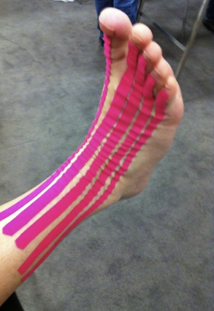
Photograph1. Dorsal aspect of NMT decompression. The patient is in the supine position with the feet on the edge of the examination table.
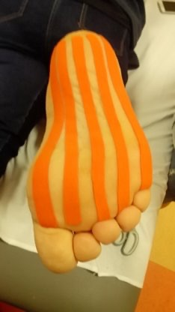
Photograph2. Installation of NMT with the plantar aspect. The patient is in the supine position with the feet on the edge of the examination table.
p = 0.0001
Graph 1.Average pain scale comparison (NPRS) between the treatment and control groups.
* T-Independent. Source: Primary Data

