Supplementary
Electrochemical Synthesis and Antimicrobial Evaluation of some N-Substituted α-Amino Acids
Kishanpal Singh, Neetu Singh, Asmita Goswami, Harvinder Singh Sohal, Baljit Singh
ªDepartment of Chemistry, Punjabi University, Patiala-147002, Punjab, India
^{b}Medicinal and Natural Product Laboratory, Department of Chemistry, Chandigarh University, Gharuan-140413, Mohali, Punjab, India
Materials and Methods
The Sigma Aldrich chemical business provided all of the compounds utilized in the current methods, and they were all used without any further purification. Overnight, 4A molecular sieves were used to preserve the commercially available solvent CH₃CN (Merck). It was collected for further use in the reaction after distillation at a temperature of (80-82ºC). The distillate solution was placed in P₂O₅ for roughly a night before being distilled once again to produce dry and pure CH₃CN. Bottles of acetonitrile were kept in a dark, airtight colour. All of the aqueous solutions were created using double-distilled water. We bought all of the solvents of the analytical grade from Loba Chemie. All of the developed heterocyclic compounds had their melting points measured using the open capillary method and a digital melting point instrument. IR spectrum recording is done using a Perkin Elmer Spectrum II with a diamond ATR. Using a Bruker Advanced NMR spectrometer in CDCl₃ and TMS as the internal standard, ¹H and ¹³C NMR data were both collected at 500 MHz. On the LC-MS Spectrometer Model Q-ToF Micromass, Waters, the MS of the compounds was recorded. With the aid of the Thin Layer Chromatography (TLC) method and UV light, the purity of compounds was verified.
Electrochemical Instrumentation:
Power source:
Direct current (DC) was used to power the electrocarboxylation process, and the electrophoresis power supply (Toshniwal) was equipped with a voltmeter that reads from 0-300V and an ammeter that can read 0-100mA.
Undivided cell:
An undivided three-necked electrochemical chamber made of Pyrex glass was utilised for the electrocarboxylation procedure. Cathode and anode electrodes were both submerged through two different openings in the proposed cell, and CO2 gas was continuously passed through this third hole throughout the reaction.
As an inert cathode and sacrificial anode electrode, platinum gauze and magnesium electrodes with dimensions of (1cm X 1cm X 0.1cm) and (1cm diameter & 5cm length), respectively, were employed. Using a DC power supply, the cathode and anode were eventually connected to the positive and negative ends of the electric circuit, respectively.
Investigating the behaviour of concentrations of substrate and electrode matter
Under optimized conditions, the effect of sacrificial anodes, such as Al, Ni, and Mg was critically studied by electrolysed mixture of compound 3a (0.54 mmol), MeCN (100 mL),TPAC (5 mmol), CO₂, at 20ºC temperature by taking Pt as a cathode Table 1. Mg as a sacrificial anode gave the final product 4a in a high yield of 92% (Table 1, Entries 9), while the utmost of 64% and 72% yield was obtained with Ni and Al electrode, respectively (Table 1, Entries 1& 5). In present research, it was found that Pt as inert cathode with Mg as anode was the only suitable combination to carry on with considering other conditions.
Table 1 Effect of SRP of concentration on the electrocarboxylation and sacrificial electrodes 4a.

Entry | Sacrificial anode | Conc.(mmol/L) | SRP (Volts) | Yield (%)
1. | Ni | 0.64 | -0.19 | 64
2. | Ni | 1.12 | -0.19 | 53
3. | Ni | 1.53 | -0.19 | 41
4. | Ni | 2.15 | -0.19 | 30
5. | Al | 0.59 | -1.62 | 72
6. | Al | 1.05 | -1.62 | 63
7. | Al | 1.61 | -1.62 | 59
8. | Al | 2.15 | -1.62 | 47
9. | Mg | 0.54 | -2.36 | 92
10. | Mg | 1.05 | -2.36 | 89
11. | Mg | 1.59 | -2.36 | 77
12. | Mg | 2.15 | -2.36 | 65

    - Investigation of the relation of current density with temperature variation and pressure of carbon dioxide:
Other characteristics such as CO₂ pressure, temperature, and current density were studied in order to optimise the reaction conditions. In electrocarboxylation, current density is a critical factor (Table 2). The experiment was carried out at three densities i.e.,10, 15 & 20 mA/cm², among them current densities at 10 & 20 mA/cm² gave lesser yield of tested compound 4a however, at 15 mA/cm² better yield of the same compound was obtained. To determine the suitable temperature in combination with an appropriate CO₂ pressure was the next required step. After testing the reaction at temperature ranges between 0-25ºC, it was observed that the yield of the formed product was less at low temperature range and data current density of 10mA/cm² (Table-2, entry-1), while, the better yield was obtained at slightly high temperature (25ºC) and at a current density of 20mA/cm²(Table-2, entry-17). So, the current density of 15mA/cm², temperature 20-25ºC, and CO₂ pressure at 1 atm, were ideal conditions (Table-2, entry-11 & 12) to get a higher yield of product i.e. 92%(Table-2, entry-12).
Table 2 Standardization of current density and temperature (ºC) for the synthesis of 4a.
Entry | Current Density(mA/cm²) | Temperature(⁰C) | Yieldª(%)
1. | 10 | 0 | 61
2. | 10 | 5 | 65
3. | 10 | 10 | 69
4. | 10 | 15 | 75
5. | 10 | 20 | 79
6. | 10 | 25 | 75
7. | 15 | 0 | 63
8. | 15 | 5 | 74
9. | 15 | 10 | 79
10. | 15 | 15 | 80
11. | 15 | 20 | 90
12. | 15 | 25 | 92
13. | 20 | 0 | 65
14. | 20 | 5 | 69
15. | 20 | 10 | 73
16. | 20 | 15 | 75
17. | 20 | 20 | 81
18. | 20 | 25 | 79
    - Effect of solvents and supporting electrolyte
The results from distinct supporting electrolytes (TPAB, TPAC, and TBABF₄) with different solvents (n-Pentanol, n-Butanol, and MeCN) are summarized in Table 3 on the yield of reference compound. Out of all the three solvents, MeCN along with TPAC as the supporting electrolyte comes out to be the best combination to produce 92% of 4a. However, the other two solvents were difficult to remove, so it was supposed that the yield of the product was also diminished while evaporating those solvents.
Table 3 Standardization of solvent and supporting electrolyte for the synthesis of 4a.
Entry | Solvent | Supporting Electrolyte | Yieldª(%)
1. | MeCN | TBABF₄ | 89
2. | n-Butanol | TBABF₄ | 83
3. | n-Pentanol | TBABF₄ | 82
4. | MeCN | TPAC | 92
5. | n-Butanol | TPAC | 84
6. | n-Pentanol | TPAC | 79
7. | MeCN | TPAB | 81
8. | n-Butanol | TPAB | 75
9. | n-Pentanol | TPAB | 72

General procedure of synthesis
Series 3a-l have been already reported previously. Here imine derivative 3a was prepared by the reaction of benzaldehyde (1.01mL, 10mmol) with aniline (0.91mL, 10mmol) at 85ºC in ethanol for 2min using in microwave reactor. The completion of the reaction observed by TLC and finally works up in ice-cold water. The crude so obtained was recrystallized with ethanol to obtain colorless crystalline compound.
Scheme 1: Synthesis of imine derivatives.

Table 5. Derivatives 3a-l with observed results
Entry | Product | R | R_{f} | Yield | Melting Point | Literature Melting Point
1 | 3a | 4-Cl C₆H₄ | 0.61 | 98 | 62 | 62-64[25]
2 | 3b | C₆H₅ | 0.66 | 98 | 55 | 54[25]
3 | 3c | 4-Me C₆H₄ | 0.63 | 96 | 39-41 | 38-40[25]
4 | 3d | 4-OH C₆H₄ | 0.69 | 95 | 96-97 | 94-96[25]
5 | 3e | 4-NO₂ C₆H₄ | 0.71 | 97 | 90-93 | 90-92[25]
6 | 3f | 3-NO₂ C₆H₄ | 0.68 | 98 | 64-65 | 65-66[25]
7 | 3g | 4-OMe C₆H₄ | 0.62 | 93 | 64-66 | 63-65[25]
8 | 3h | 4-Br C₆H₄ | 0.63 | 95 | 75-77 | 76-77[25]
9 | 3i | C₆H_{s} CH=CH | 0.65 | 89 | 103-105 | 106-108[25]
10 | 3j | 2-Furyl | 0.67 | 91 | 56-58 | 55-57[25]
11 | 3k | 2-Thiopheyl | 0.63 | 92 | 61-63 | -
12 | 3l | 2-Pyridyl | 0.59 | 90 | 65-66 | -
ªYield refers to total mass of collection from different crops

3a: Yield 98%, colourless solid, MP 55ºC. IR spectrum, ʋ, cm⁻¹: 3060 (sp^{2,} C-H), 3028 (Ar-H), 1590 (C=N). ¹H NMR spectrum, δ, ppm (J, Hz): 8.13 (s, 1H, CH), 7.10-7.35 (m, 10H, Ar-H). Mass spectrum, m/z(I_{rel}, %): 182 (M+1).

3b: Yield 96%, colourless solid, MP 39-41ºC. IR spectrum, ʋ, cm⁻¹: 3140 (sp² C-H), 3030 (Ar-H), 1586 (C=N). ¹H NMR spectrum, δ, ppm (J, Hz): 8.28 (s, 1H, CH), 7.06-7.26 (m, 9H, Ar-H), 2.14 (s, 3H, CH₃). Mass spectrum, m/z(I_{rel}, %): 196 (M+1).

3c: Yield 95%, colourless solid, MP 96-97ºC. IR spectrum, ʋ, cm⁻¹: 3315(O-H), 3142 (sp² C-H), 3010 (Ar-H), 1584 (C=N). ¹H NMR spectrum, δ, ppm (J, Hz): 9.1 (s, 1H, OH), 8.28 (s, 1H, CH), 7.09-7.27 (m, 9H, Ar-H). Mass spectrum, m/z(I_{rel}, %): 198 (M+1).

3d: Yield 97%, pale yellow solid, MP 90-93ºC. IR spectrum, ʋ, cm⁻¹: 3170 (sp² C-H), 3039 (Ar-H), 1610 (C=N). ¹H NMR spectrum, δ, ppm (J, Hz): 8.59 (s, 1H, CH), 7.23-7.84 (m, 9H, Ar-H). Mass spectrum, m/z(I_{rel}, %): 227 (M+1).

3e: Yield 98%, pale yellow solid, MP 64-65ºC. IR spectrum, ʋ, cm⁻¹: 3152 (sp² C-H), 3033 (Ar-H), 1608 (C=N). ¹H NMR spectrum, δ, ppm (J, Hz): 8.52 (s, 1H, CH), 7.22-7.79 (m, 10Ar-H). Mass spectrum, m/z(I_{rel}, %): 227 (M+1).

3f: Yield 96%, colourless solid, MP 62ºC. IR spectrum, ʋ, cm⁻¹: 3149 (sp² C-H), 3029 (Ar-H), 1597 (C=N). ¹H NMR spectrum, δ, ppm (J, Hz): 8.44 (s, 1H, CH), 7.13-7.44 (m, 9H, Ar-H). Mass spectrum, m/z(I_{rel}, %): 216 (M+1), 217(M+2).
3g: Yield 93%, colourless solid, MP 64-66ºC. IR spectrum, ʋ, cm⁻¹: 3122 (sp² C-H), 3019 (Ar-H), 1582 (C=N). ¹H NMR spectrum, δ, ppm (J, Hz): 8.24 (s, 1H, CH), 7.09-7.23 (m, 9H, Ar-H). Mass spectrum, m/z(I_{rel}, %): 212 (M+1).
3h: Yield 95%, colourless solid, MP 75-77ºC. IR spectrum, ʋ, cm⁻¹: 3148 (sp² C-H), 3024 (Ar-H), 1599 (C=N). ¹H NMR spectrum, δ, ppm (J, Hz): 8.27 (s, 1H, CH), 7.15-7.42 (m, 9H, Ar-H). Mass spectrum, m/z(I_{rel}, %): 261 (M+1), 262 (M+2).
3i: Yield 89%, yellow solid, MP 103-105ºC. IR spectrum, ʋ, cm⁻¹: 3149 (sp² C-H), 3015 (Ar-H), 1581 (C=N). ¹H NMR spectrum, δ, ppm (J, Hz): 8.27 (s, 1H, CH), 7.11-7.34 (m, 9H, Ar-H). Mass spectrum, m/z(I_{rel}, %): 208 (M+1).
3j: Yield 91%, yellow solid, MP 56-58ºC. IR spectrum, ʋ, cm⁻¹: 3144 (sp² C-H), 3033 (Ar-H), 1601 (C=N). ¹H NMR spectrum, δ, ppm (J, Hz): 8.43 (s, 1H, CH), 7.17-7.45 (m, 9H, Ar-H). Mass spectrum, m/z(I_{rel}, %): 172 (M+1).
3k: Yield 92%, yellow-brown solid, MP 61-63ºC. IR spectrum, ʋ, cm⁻¹: 3140 (sp² C-H), 3025 (Ar-H), 1599 (C=N). ¹H NMR spectrum, δ, ppm (J, Hz): 8.47 (s, 1H, CH), 7.16-7.48 (m, 9H, Ar-H). Mass spectrum, m/z(I_{rel}, %): 188 (M+1).
3l: Yield 90%, brown solid, MP 65-66ºC. IR spectrum, ʋ, cm⁻¹: 3132 (sp² C-H), 3029 (Ar-H), 1597 (C=N). ¹H NMR spectrum, δ, ppm (J, Hz): 8.46 (s, 1H, CH), 7.14-7.51 (m, 9H, Ar-H). Mass spectrum, m/z(I_{rel}, %): 183 (M+1).

To synthesize (4a)
Scheme 2: Synthesis of amino acids derivatives.
Table 6. Derivatives 4a-l with observed results.
Entry | Product | R1 | R_{f} | Yieldª | Melting Point
1 | 4a | 4-Cl C₆H₄ | 0.66 | 92 | 196-197
2 | 4b | C₆H₅ | 0.69 | 91 | 183-185
3 | 4c | 4-Me C₆H₄ | 0.61 | 86 | 174-175
4 | 4d | 4-OH C₆H₄ | 0.72 | 84 | 216-217
5 | 4e | 4-NO₂ C₆H₄ | 0.70 | 91 | 210-212
6 | 4f | 3-NO₂ C₆H₄ | 0.64 | 89 | 191-192
7 | 4g | 4-OMe C₆H₄ | 0.66 | 86 | 206-208
8 | 4h | 4-Br C₆H₄ | 0.69 | 85 | 178-180
9 | 4i | C₆H_{s} CH=CH | 0.73 | 82 | 225-226
10 | 4j | 2-Furyl | 0.66 | 87 | 199-201
11 | 4k | 2-Thiopehyl | 0.67 | 86 | 188-190
12 | 4l | 2-Pyridyl | 0.63 | 83 | 178-181
ªYield refers to total mass of collection from different crops

4a: Yield 92%, colourless solid, MP 183-185ºC. IR spectrum, ʋ, cm⁻¹: 3356 (OH), 2970 (Ar-H), 2873 (C-H), 1619 (C=O). ¹H NMR spectrum, δ, ppm (J, Hz): 12.79 (s, 1H, OH), 9.62 (s, 1H, NH), 8.23 (s, 1H, CH), 7.22-7.53 (m, 10H, ArH). ¹³C NMR spectrum, δ, ppm: 188.3, 145.9, 136.9, 129.7, 129.5, 129.1, 127.5, 120.8, 113.5, 64.3.Mass spectrum, m/z(I_{rel}, %): 228 (M+1).

4b: Yield 86%, colourless solid, MP 183-185ºC. IR spectrum, ʋ, cm⁻¹: 3440 (OH), 3031 (Ar-H), 2978 (C-H), 1628 (C=O). ¹H NMR spectrum, δ, ppm (J, Hz): 12.83 (s, 1H, OH), 9.51 (s, 1H, NH), 8.37 (s, 1H, CH), 7.14-7.739 (m, 9H, ArH), 2.23 (s, 3H, CH₃). ¹³C NMR spectrum, δ, ppm: 180.5, 155.9, 147.2, 143.9, 139.6, 139.5, 139.4, 130.8, 123.5, 74.3, 31.3. Mass spectrum, m/z(I_{rel}, %): 242 (M+1).

4c: Yield 84%,colourless solid, MP 183-185ºC. IR spectrum, ʋ, cm⁻¹: 3428 (OH), 3031 (Ar-H), 2978 (C-H), 1610 (C=O). ¹H NMR spectrum, δ, ppm (J, Hz): 12.87 (s, 1H, OH), 9.55 (s, 1H, NH), 8.42 (s, 1H, CH), 7.21-7.43 (m, 9H, ArH). ¹³C NMR spectrum, δ, ppm: 180.5, 157.3, 145.9, 129.5, 128.9, 120.8, 116.3, 113.5, 64.3.Mass spectrum, m/z(I_{rel}, %): 244 (M+1).

4d: Yield 91%,colourless solid, MP 183-185ºC. IR spectrum, ʋ, cm⁻¹: 3478 (OH), 3057 (Ar-H), 3020 (C-H), 1625(C=O). ¹H NMR spectrum, δ, ppm (J, Hz): 13.15 (s, 1H, OH), 9.87 (s, 1H, NH), 8.69 (s, 1H, CH), 7.38-8.03 (m, 9H, ArH). ¹³C NMR spectrum, δ, ppm: 180.5, 146.7, 145.9, 143.0, 129.5, 128.9, 127.9, 120.8, 113.5, 64.3. Mass spectrum, m/z(I_{rel}, %): 273 (M+1).

4e: Yield 89%,colourless solid, MP 183-185ºC. IR spectrum, ʋ, cm⁻¹: 3470 (OH), 3053 (Ar-H), 3017 (C-H), 1612(C=O). ¹H NMR spectrum, δ, ppm (J, Hz): 13.03 (s, 1H, OH), 9.83 (s, 1H, NH), 8.63 (s, 1H, CH), 7.37-7.99 (m, 9H, ArH). ¹³C NMR spectrum, δ, ppm:180.5, 148.3, 145.9, 136.8, 135.8, 130.0, 129.5, 123.5, 122.7, 120.8, 113.5, 63.3. Mass spectrum, m/z(I_{rel}, %): 273 (M+1).

4f: Yield 83%, colourless solid, MP 183-185ºC. IR spectrum, ʋ, cm⁻¹: 3448 (OH), 3048 (Ar-H), 2991 (C-H), 1628(C=O). ¹H NMR spectrum, δ, ppm (J, Hz): 12.85 (s, 1H, OH), 9.59 (s, 1H, NH), 8.54 (s, 1H, CH), 7.25-7.60 (m, 9H, ArH). ¹³C NMR spectrum, δ, ppm:180.5, 145.9, 135.0, 133.1, 129.5, 129.2, 128.9, 120.8, 113.5, 64.3.Mass spectrum, m/z(I_{rel}, %): 262 (M+1), 263(M+2).

4g: Yield 86%, colourless solid, MP 183-185ºC. IR spectrum, ʋ, cm⁻¹: 3421 (OH), 3039 (Ar-H), 2983 (C-H), 1605(C=O). ¹H NMR spectrum, δ, ppm (J, Hz): 12.80 (s, 1H, OH), 9.51 (s, 1H, NH), 8.37 (s, 1H, CH), 7.22-7.53 (m, 9H, ArH), 3.98 (s, OMe). ¹³C NMR spectrum, δ, ppm:180.5, 159.4, 145.9, 129.5, 129.2, 128.5, 120.8, 114.7, 113.5, 64.3, 55.8. Mass spectrum, m/z(I_{rel}, %): 258 (M+1).

4h: Yield 85%, colourless solid, MP 183-185ºC. IR spectrum, ʋ, cm⁻¹: 3446 (OH), 3037 (Ar-H), 2989 (C-H), 1622(C=O). ¹H NMR spectrum, δ, ppm (J, Hz): 12.89 (s, 1H, OH), 9.62 (s, 1H, NH), 8.42 (s, 1H, CH), 7.22-7.57 (m, 9H, ArH), 5.34 (d, 2H). ¹³C NMR spectrum, δ, ppm:180.5, 145.9, 135.9, 132.0, 131.9, 129.5, 121.9, 120.8, 113.5, 64.3. Mass spectrum, m/z(I_{rel}, %): 307 (M+1), 308(M+2).

4i: Yield 82%, colourless solid, MP 183-185ºC. IR spectrum, ʋ, cm⁻¹: 3442 (OH), 3050 (Ar-H), 2987 (C-H), 1616(C=O). ¹H NMR spectrum, δ, ppm (J, Hz): 12.92 (s, 1H, OH), 9.63 (s, 1H, NH), 8.60 (s, 1H, CH), 7.25-7.58 (m, 10H, ArH). ¹³C NMR spectrum, δ, ppm:184.1, 147.6, 136.4, 129.5, 128.6, 128.5, 127.9, 123.3, 120.8, 113.5, 72.3.Mass spectrum, m/z(I_{rel}, %): 254 (M+1).

4j: Yield 87%, colourless solid, MP 183-185ºC. IR spectrum, ʋ, cm⁻¹: 3434 (OH), 3049 (Ar-H), 2997 (C-H), 1633(C=O). ¹H NMR spectrum, δ, ppm (J, Hz): 12.95 (s, 1H, OH), 9.57 (s, 1H, NH), 8.62 (s, 1H, CH), 7.28-7.68 (m, 10H, ArH). ¹³C NMR spectrum, δ, ppm:178.5, 145.9, 142.8, 139.3, 129.5, 120.8, 118.6, 113.5, 110.7, 60.0. Mass spectrum, m/z(I_{rel}, %): 218 (M+1).

4k: Yield 86%, colourless solid, MP 183-185ºC. IR spectrum, ʋ, cm⁻¹: 3439 (OH), 3047 (Ar-H), 2998 (C-H), 1628(C=O). ¹H NMR spectrum, δ, ppm (J, Hz): 12.87 (s, 1H, OH), 9.58 (s, 1H, NH), 8.61 (s, 1H, CH), 7.23-7.62 (m, 10H, ArH). ¹³C NMR spectrum, δ, ppm:178.5, 145.9, 137.5, 129.5, 128.1, 126.1, 121.3, 120.8, 113.5, 65.5. Mass spectrum, m/z(I_{rel}, %): 234 (M+1).

4l: Yield 83%, colourless solid, MP 183-185ºC. IR spectrum, ʋ, cm⁻¹: 3445 (OH), 3055 (Ar-H), 3002 (C-H), 1615(C=O). ¹H NMR spectrum, δ, ppm (J, Hz): 12.93 (s, 1H, OH), 9.65 (s, 1H, NH), 8.63 (s, 1H, CH), 7.30-7.79 (m, 10H, ArH). ¹³C NMR spectrum, δ, ppm:178.5, 155.4, 148.6, 145.9, 136.2, 129.5, 121.9, 120.9, 120.8, 113.5, 72.9. Mass spectrum, m/z(I_{rel}, %): 229 (M+1).

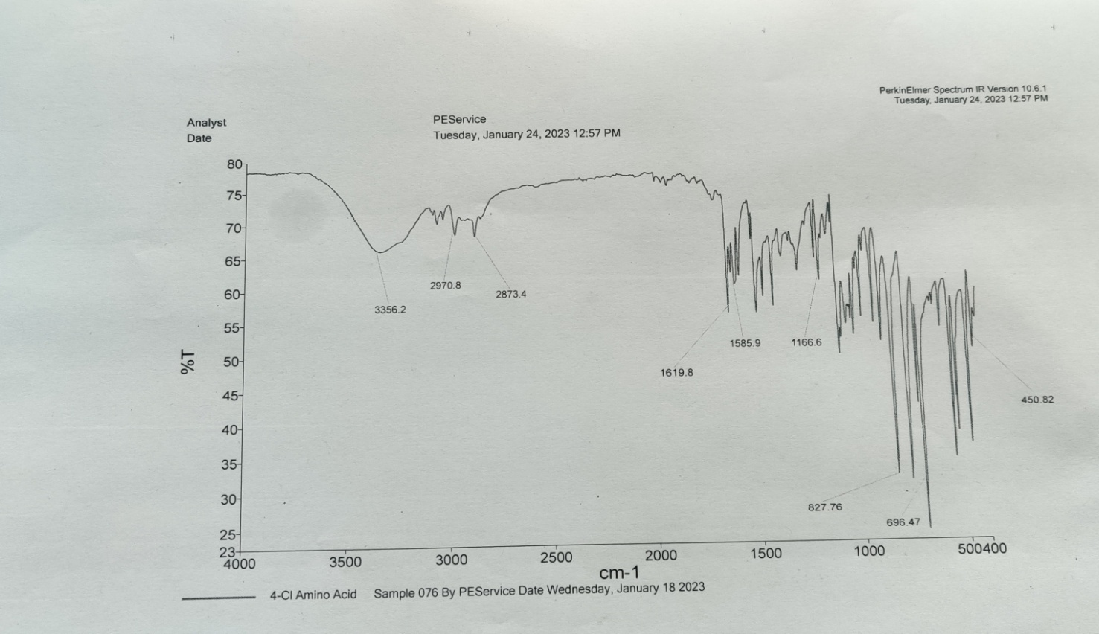
Figure 1: IR spectra of compound 4a

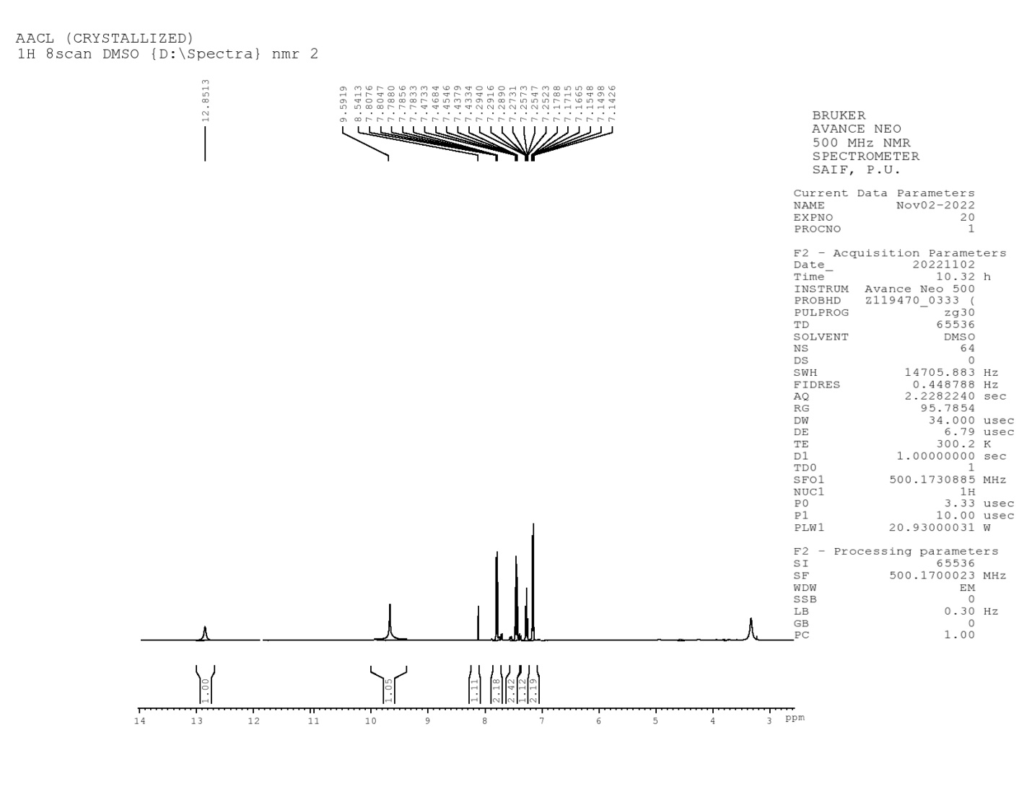
Figure 2: ¹H-NMR of compound 4a

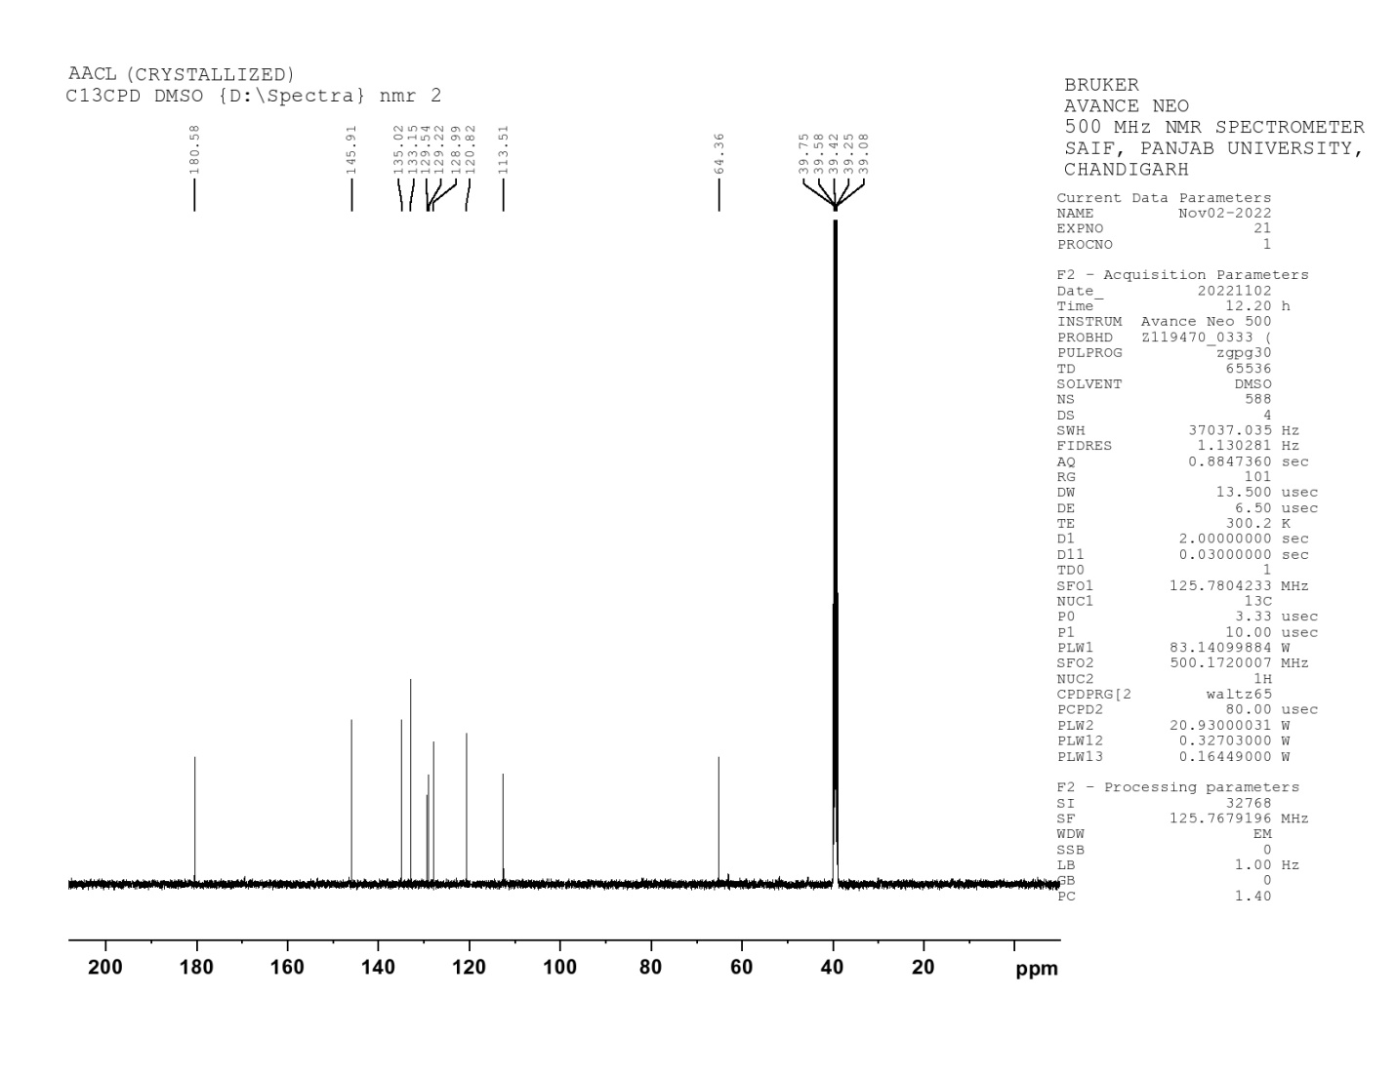
Figure 3: ¹³C-NMR of compound 4a

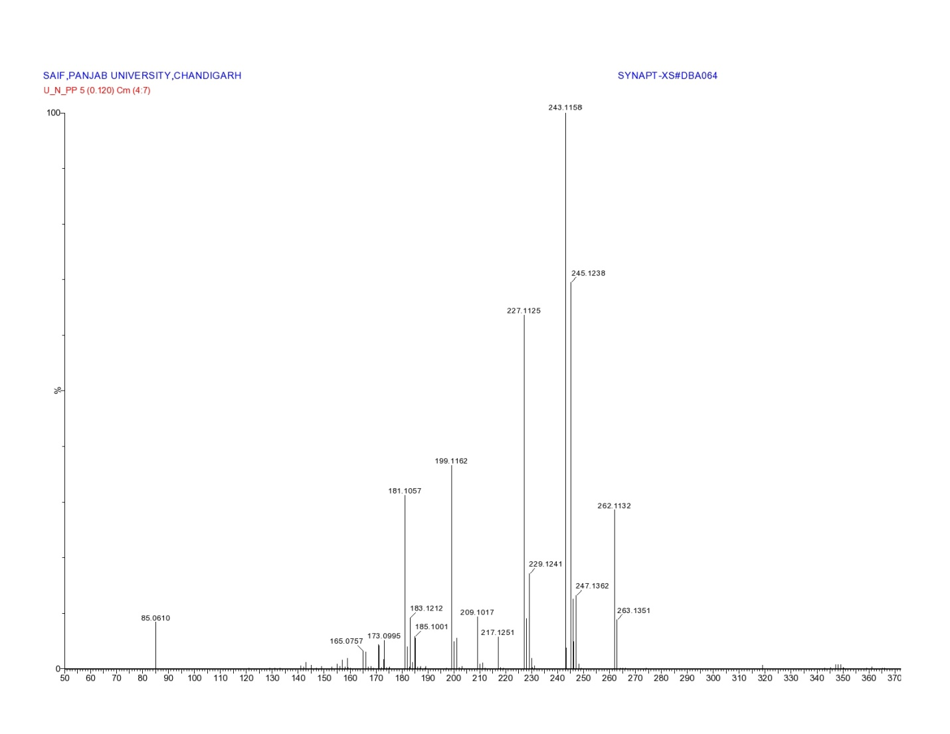
Figure 4: Mass spectrum of compound 4a

