Supplementary Information for CardiacField: Computational Echocardiography for Universal Screening
Chengkang Shen^{1, †}, Hao Zhu ^{1, †}, You Zhou ^{1, †}, Yu Liu^{2, †}, Si Yi¹, Lili Dong², Weipeng Zhao², David J. Brady⁴, Xun Cao^{1, *}, Zhan Ma ^{1, *}, and Yi Lin ^{3, *}
¹School of Electronic Science and Engineering, Nanjing University, Nanjing, 210023, China
²Department of Echocardiography of Zhongshan Hospital, Fudan University, Shanghai, 200032, China
³Department of Cardiovascular Surgery of Zhongshan Hospital, Fudan University, Shanghai, 200032, China
⁴College of Optical Sciences, University of Arizona, Tucson, AZ 85721, USA
† These authors contribute equally to this work.
* Corresponding authors: Y. Lin, Z. Ma and X. Cao
Table of Contents
Overview 3
Supplementary Figures 4
Supplementary Tables 5
Supplementary Table 1. Analysis of Volume and EF of LV and RV. 6
Supplementary Table 2. Generalization to Different Ultrasound Machines. 7
Supplementary Table 3. The Performance of Segmentation Model. 9
Supplementary Video Descriptions 10
Supplementary Video 1. The Workflow of the CardiacField. 10
Supplementary Video 2. Volume Segmentation Results. 10
Supplementary Video 3. Different Views of Reconstructed 3D Heart. 10
References 11

Overview
This document provides additional experimental results of the CardiacField.
More results on volume and EF calculation. We present more results of volume and EF calculation in Supplementary Table 1 and Supplementary Table 2. We also provide a video to visualize the volume segmentation results in Supplementary Video 1.
The architecture of the segmentation model. We show the architecture of our segmentation model in Supplementary Fig. 1. Then we provide the quantitative results of the segmentation model in Supplementary Table 3.
More video results. We provide the Supplementary Video 2 to illustrate the workflow of CardiacField, which includes 2D echocardiographic images acquisition, 3D heart reconstruction, ‘continuous-slicing’ functionality, and EF calculation. Additionally, we provide more views (i.e., apical four-chamber view, long-axis view, and short-axis view) of our reconstructed 3D heart in Supplementary Video 3.

Supplementary Figures
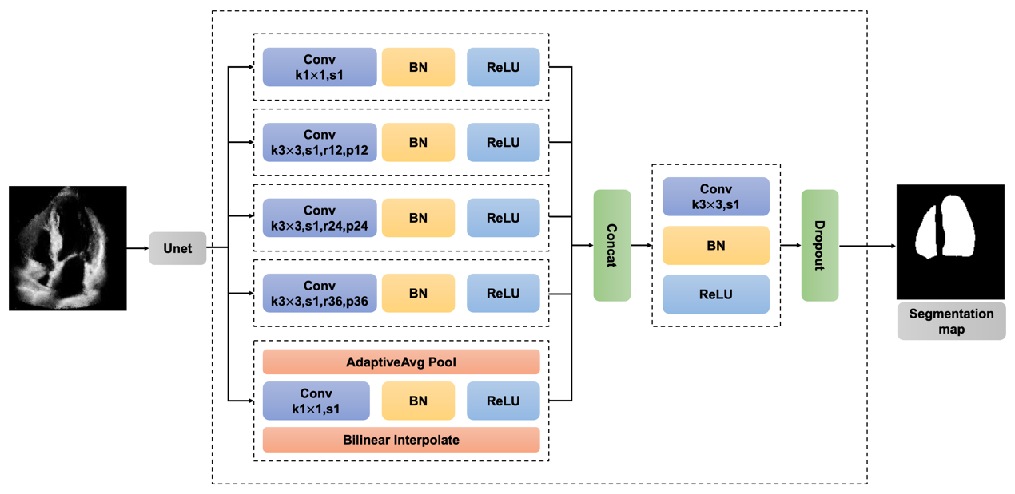 Supplementary Fig. 1. The Architecture of the Segmentation Model. We use the segmentation model developed in EchoNet¹ to automatically classify the area of the LV and RV. ‘Conv’, ‘k’, ‘s’, ‘r’, ‘p’, and ‘BN’ represent the convolution, kernel size, stride, rate, average pooling, and batch normalization, respectively.

Supplementary Tables
Table S1 | Analysis of Volume and EF of LV and RV
ID of Volunteers | Methods | EDV(LV) | ESV(LV) | EF(LV) | EDV(RV) | ESV(RV) | EF(RV)
1 | 3D Ultrasound Machine | 189.0 | 103.1 | 46.0 | 152.4 | 71.8 | 52.9
1 | EchoNet | - | - | 47.3 | - | - | -
1 | Ours | 193.0 | 104.8 | 45.7 | 148.5 | 65.5 | 55.9
2 | 3D Ultrasound Machine | 142.0 | 59.6 | 58.1 | 104.1 | 50.2 | 51.8
2 | EchoNet | - | - | 60.4 | - | - | -
2 | Ours | 147.2 | 64.8 | 56.0 | 91.5 | 43.7 | 52.3
3 | 3D Ultrasound Machine | 95.0 | 37.0 | 61.0 | 77.6 | 36.3 | 53.3
3 | EchoNet | - | - | 64.9 | - | - | -
3 | Ours | 89.5 | 35.7 | 60.1 | 64.9 | 30.0 | 53.8
4 | 3D Ultrasound Machine | 88.0 | 34.0 | 62.0 | 70.9 | 36.3 | 48.8
4 | EchoNet | - | - | 62.9 | - | - | -
4 | Ours | 84.9 | 32.1 | 62.3 | 64.9 | 33.4 | 48.6
5 | 3D Ultrasound Machine | 99.0 | 29.0 | 70.0 | 77.7 | 29.6 | 61.9
5 | EchoNet | - | - | 66.1 | - | - | -
5 | Ours | 86.7 | 30.0 | 65.4 | 61.1 | 24.2 | 60.5
6 | 3D Ultrasound Machine | 108.0 | 53.0 | 51.0 | 70.9 | 35.7 | 49.6
6 | EchoNet | - | - | 60.3 | - | - | -
6 | Ours | 123.2 | 59.7 | 51.6 | 73.8 | 33.0 | 55.3
7 | 3D Ultrasound Machine | 170.0 | 86.0 | 49.0 | 86.8 | 42.5 | 51.1
7 | EchoNet | - | - | 35.7 | - | - | -
7 | Ours | 166.3 | 90.5 | 45.6 | 80.3 | 39.9 | 50.2
8 | 3D Ultrasound Machine | 180.0 | 70.0 | 61.0 | 118.9 | 54.2 | 54.4
8 | EchoNet | - | - | 57.0 | - | - | -
8 | Ours | 165.2 | 68.6 | 58.5 | 116.9 | 50.2 | 57.1
Dashes represent unavailable data.
Supplementary Table 1. Analysis of Volume and EF of LV and RV. We show the results of the volume and EF estimation of randomly-selected 8 patients in this table. ‘3D Ultrasound Machine’ and ‘EchoNet’ denote the results obtained by the 3D ultrasound machine (after calibration by the experienced sonographers) and the EchoNet¹ (realized by us using their released code), respectively. Full results of all 56 patients can be found in the supplementary Excel document.
Table S2 | Generalization to Different Ultrasound Machines
ID of Volunteers | Methods | Machines | EDV  (LV) | ESV  (LV) | EF  (LV) | EDV  (RV) | ESV  (RV) | EF  (RV)
1 | 3D Ultrasound Machine | PHILIPS | 180.0 | 70.0 | 61.0 | 118.9 | 54.2 | 54.4
1 | EchoNet | PHILIPS | - | - | 56.9 | - | - | -
1 | EchoNet | SIEMENS | - | - | 60.5 | - | - | -
1 | Ours | PHILIPS | 165.2 | 68.6 | 58.5 | 116.9 | 50.2 | 57.1
1 | Ours | SIEMENS | 159.3 | 57.6 | 63.8 | 101.1 | 44.4 | 56.1
2 | 3D Ultrasound Machine | PHILIPS | 137.0 | 51.0 | 63.0 | 101.0 | 42.6 | 57.8
2 | EchoNet | PHILIPS | - | - | 59.4 | - | - | -
2 | EchoNet | SIEMENS | - | - | 64.9 | - | - | -
2 | Ours | PHILIPS | 134.4 | 52.8 | 60.7 | 115.9 | 48.3 | 58.4
2 | Ours | SIEMENS | 133.3 | 49.7 | 62.7 | 105.7 | 45.0 | 57.5
3 | 3D Ultrasound Machine | PHILIPS | 125.0 | 49.0 | 61.0 | 122.0 | 51.6 | 57.7
3 | EchoNet | PHILIPS | - | - | 63.0 | - | - | -
3 | EchoNet | SIEMENS | - | - | 61.8 | - | - | -
3 | Ours | PHILIPS | 125.3 | 46.8 | 62.7 | 120.6 | 49.8 | 58.7
3 | Ours | SIEMENS | 129.8 | 50.9 | 60.8 | 117.0 | 51.4 | 56.1
4 | 3D Ultrasound Machine | PHILIPS | 136.0 | 62.0 | 55.0 | 137.5 | 70.8 | 48.5
4 | EchoNet | PHILIPS | - | - | 59.3 | - | - | -
4 | EchoNet | SIEMENS | - | - | 61.1 | - | - | -
4 | Ours | PHILIPS | 127.3 | 55.0 | 56.8 | 124.3 | 65.0 | 47.7
4 | Ours | SIEMENS | 128.3 | 60.1 | 53.1 | 135.4 | 69.5 | 48.6
5 | 3D Ultrasound Machine | PHILIPS | 120.0 | 46.0 | 62.0 | 113.3 | 50.6 | 55.4
5 | EchoNet | PHILIPS | - | - | 59.0 | - | - | -
5 | EchoNet | SIEMENS | - | - | 61.1 | - | - | -
5 | Ours | PHILIPS | 119.4 | 43.7 | 63.4 | 98.2 | 44.4 | 54.8
5 | Ours | SIEMENS | 124.0 | 43.0 | 65.3 | 101.6 | 49.4 | 51.3
Dashes represent unavailable data.
Supplementary Table 2. Generalization to Different Ultrasound Machines. We recruit another 5 volunteers to conduct generalization experiments using two widely-used but different 2D ultrasound machines, i.e., PHILIPS and SIEMENS. Here, we show the the volume and EF estimation results of these 5 volunteers.
Table S3 | The Performance of Segmentation Model
Class | Dice | Acc
Background | 98.16 | 97.89
LV | 91.34 | 91.84
RV | 87.19 | 89.98
Supplementary Table 3. The Performance of Segmentation Model. Quantitative results of our segmentation model. ‘Dice’ denotes the dice similarity coefficient (DSC). ‘Acc’ denotes the accuracy of segmentation, which is the ratio of correctly classified pixels to the total number of pixels.

Supplementary Video Descriptions

Supplementary Video 1. The Workflow of the CardiacField.
This video demonstrates the workflow of the CardiacField, which includes 2D echocardiographic images acquisition, 3D heart reconstruction, ‘continuous-slicing’ functionality, and EF calculation.

Supplementary Video 2. Volume Segmentation Results.
This video shows the volume segmentation results of LV and RV. First, we perform the uniform sampling on the 3D cardiac volume to generate about 20-30, 3$mm$-thick 2D slices parallel to the apical four-chamber view. Then we use the segmentation model to classify the regions of the LV and RV from one slice to another. Lastly, we map all slices into 3D space to visualize the LV and RV volumes.

Supplementary Video 3. Different Views of Reconstructed 3D Heart.
This video exhibits the apical four-chamber view, long-axis view, and short-axis view of the reconstructed 3D heart by our proposed CardiacField.

References
1. Ouyang, D., et al., Video-based AI for beat-to-beat assessment of cardiac function. Nature, 2020. 580(7802): p. 252-256.

