Establishing the Catabolic Pathway of Commercial Cypermethrin and Discovering the Inhibitor of 3- Phenoxy Benzoic Acid Biodegradation by Fig Farm Isolated Enterobacter hormaechei strain ZK101 and Stenotrophomonas maltophilia strain ZK102
Zöhre KURT*, Department of Environmental Engineering, Middle East Technical University, 06800 Ankara, Turkey, Department of Biochemistry, Middle East Technical University, 06800 Ankara, Turkey and Sistema Nacional de Investigación, SENACYT, Edificio 205, Ciudad del Saber, Clayton, Panamá
Merve KOKANGUL, Department of Biochemistry, Middle East Technical University, 06800 Ankara, Turkey

Figure S1. CYP and 3PBA concentration change in the first enrichment culture measured in triplicates. (a) 2g soil sample taken after one and a half week later of CYP application (b) 5g soil sample taken after one and a half week later of CYP application (c) 5 g soil sample taken one and a month later of CYP application. The red arrow shows the commercial CYP addition day.

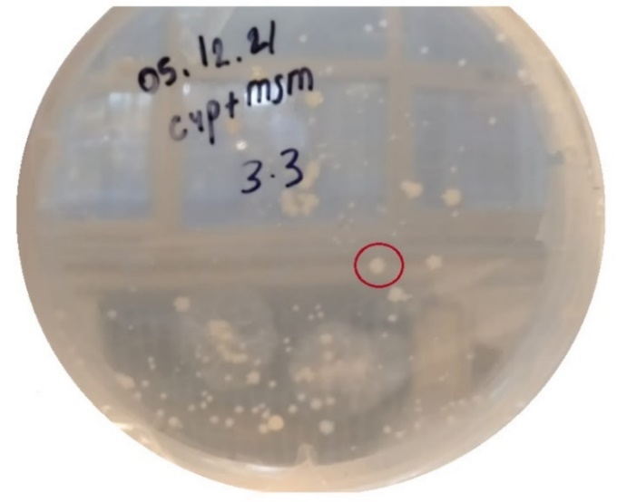
Figure S2. Growth of colonies on MSM supplemented with commercial-grade CYP plate by spread method. The colonies shown with red circle was used for further studies.

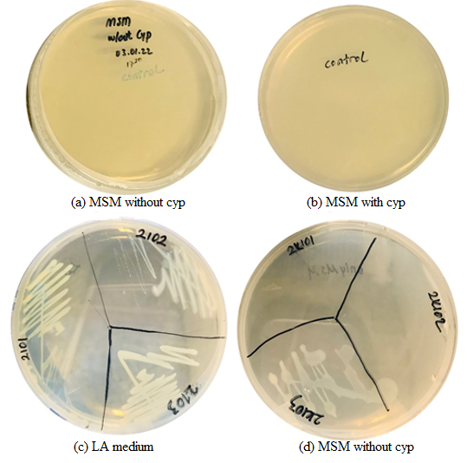
Figure S3. Isolation results of enrichment studies. (a) Control plate containing only MSM medium (b) Control plate containing MSM with CYP media (c) Growth of colonies on LA medium by spread method (d) Growth of colonies on MSM without CYP plate

Table S1. Soil Samples Physicochemical properties
Sample | pH | Moisture Content (%) | External Temperature | Porosity (%)
(1) | 8.28 | 5.2 | 28 C° | 39
(2) | 8.08 | 7.0 | 35 C° | 42.9

Table S2. Previously found CYP degrader strains with degradation percentage and isolated strains from this study

Bacteria |  | CYP Concentration (mg. L⁻¹) |  | % Degradation | Accession Number | Reference
Enterobacter hormaechei ZK101 |  | 5.69 |  | 67.7 | ON329342
Stenotrophomonas maltophilia ZK102 |  | 6.62 |  | 81.9 | ON329343
Brevibacillus parabrevis strain FCm9 |  | 100 |  | 99 | KJ009250 | Akbar et al.,2015a
Acinetobacter calcoaceucus MCm5 |  | 100 |  | 84.7 | KJ009251 | Akbar et al.,2015a
Sphingomonas sp. RCm6 |  | 100 |  | 91.8 | KJ009252 | Akbar et al.,2015a
Serratia spp. JC1 |  | 100 |  | 92 | FJ009445 | Zhang et al., 2010
Serratia spp. JCN13 |  | 100 |  | 89 | FJ009447 | Zhang et al., 2010
Azoarcus indigens HZ5 |  | 50 |  | 71.6 | GU592532 | Ma et al., 2013
Rhodopseudomonas palustris GJ22 | 50 |  | 83.5 |  | FJ824030 | Yin et al., 2012
Bacillus subtilis 1D | 100 |  | 95 |  | MG948470 | Gangola et al., 2018
Bacillus subtilis BSF01 | 50 |  | 89.4 |  | JF06263 | Xiao et al.,2015
Bacillus thuringiensis SG4 | 50 |  | 80 |  | KT186610 | Bhatt et al., 2020
Bacillus cereus BCC01 | 100 |  | 99.6 |  | MH588686 | Hu et al., 2019
Bacillus parabrevis BCP09 | 30 |  | 75.87 |  | JX556220 | Tang et al., 2018
Flavobacterium haoranii LQY-7 | --- |  | --- |  | GQ988780 | Zhang et al., 2010
Pseudomonas aeruginosa GF31 | --- |  | --- |  | KT735188 | Tang et al., 2017
Table S3. First order kinetic parameters of CYP degradation by control, in CYP induced ZK101 strain and in CYP induced ZK102 strain
Control | Equation | k (d⁻¹) | t_{1/2} (d) | R²
1ppm | 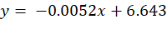 | 0.125 | 6 | 0.8379
2ppm | 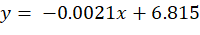 | 0.050 | 14 | 0.9841
4ppm | 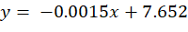 | 0.036 | 19 | 0.6768
E. hormaechei ZK101 | Regression Equation | k (d⁻¹) | t_{1/2} (d) | R²
1ppm | 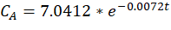 | 0.0480 | 14.4 | 0.9384
2ppm | 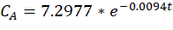 | 0.0175 | 3.96 | 0.9748
4ppm | 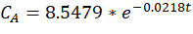 | 0.468 | 1.5 | 0.9636
S. maltophilia ZK102 | Regression Equation | k (d⁻¹) | t_{1/2} (d) | R²
1ppm | 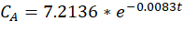 | 0.0740 | 9.4 | 0.9973
2ppm | 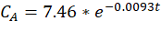 | 0.0173 | 4 | 0.9978
4ppm | 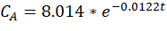 | 0.257 | 2.7 | 0.7887

Table S4. First order kinetic parameters of 3PBA degradation in 3PBA induced ZK101 strain and in 3PBA induced ZK102
E. hormaechei | Equation | k (d⁻¹) | t_{1/2} (d) | R²
1ppm | 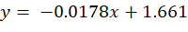 | 0.427 | 1.6 | 0.9931
2ppm | 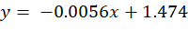 | 0.134 | 5.2 | 0.6334
4ppm | 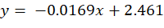 | 0.406 | 1.7 | 0.8541
5ppm | 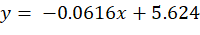 | 1.386 | 0.5 | 0.9924
S. maltophilia | Equation | k (d⁻¹) | t_{1/2} (d) | R²
1ppm | 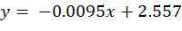 | 0.228 | 3 | 0.9576
2ppm | 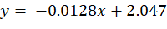 | 0.307 | 2.3 | 0.7027
4ppm | 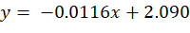 | 0.278 | 2.5 | 0.8471
5ppm | 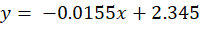 | 0.372 | 1.9 | 0.7719

Figure S4. Kinetic study results for CYP (a) control groups containing CYP but no culture (b) CYP induced ZK101 strain (c)CYP induced ZK102 strain

Figure S5. 3PBA kinetic study results (a) 3PBA induced ZK101 strain (b) 3PBA induced ZK102 strain

Figure S6. Lineweaver plots (a) ZK101 and (b) ZK102

Table S5. Results of the optimization study of different initial concentrations, temperature, and pH
RUN | X₁  (ppm) | X₂  (°C) | X₃ | Biodegradation by Enterobacter hormaechei (%) | Biodegradation by Stenotrophomonas maltophilia (%)
1 | 4 | 40 | 6 | 65.2 | 64.4
2 | 4 | 30 | 6 | 46.6 | 36.2
3 | 2 | 35 | 6 | 74.0 | 78.9
4 | 2 | 35 | 6 | 49.3 | 60.1
5 | 4 | 40 | 8 | 75.8 | 75.7
6 | 4 | 30 | 8 | 71.0 | 56.6
7 | 6 | 35 | 8 | 87.0 | 85.5
8 | 2 | 35 | 8 | 56.0 | 53.2
9 | 2 | 40 | 7 | 30.6 | 28.5
10 | 6 | 30 | 7 | 69.8 | 39.0
11 | 6 | 40 | 7 | 44.7 | 83.5
12 | 2 | 30 | 7 | 24.5 | 10.6
13 | 4 | 35 | 7 | 64.1 | 58.6
14 | 4 | 35 | 7 | 64.0 | 64.7
15 | 4 | 35 | 7 | 60.0 | 76.6

Table S6. Crude cell extract (including 100 mg/L of protein) activity (mg of 3PBA/ mg protein/min) with different concentrations of copper (in ppm) including initial concentration of 10 mg/L 3PBA
Copper | 0 | 20 | 30 | 40 | 50 | 60
ZK101 | 21 ± 3 | 18 ± 4 | 8 ± 5 | ND | ND | ND
ZK102 | 15 ± 1 | 13 ± 2 | 5 ± 3 | ND | ND | ND
ND: not detectable

- 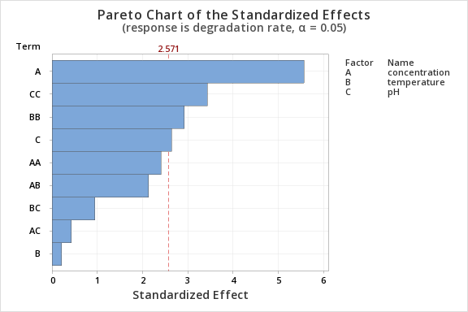

- 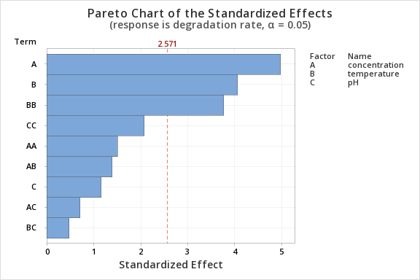

Figure S7. Pareto charts from Minitab Software for significant effects on biodegradation with ZK101 and ZK102 (a) ZK101 and (b) ZK102.

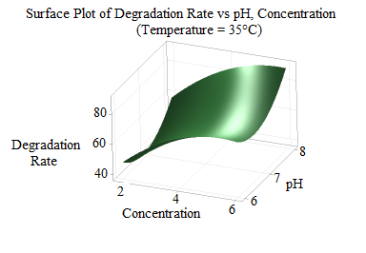
Figure S8. Surface plots from Minitab Software for ZK101 for biodegradation under different temperature and pH conditions

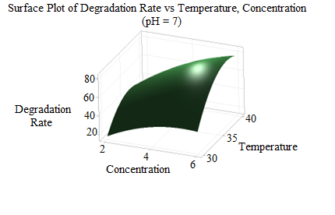
Figure S9. Surface plots from Minitab Software for ZK102 for biodegradation under different CYP concentration and temperature conditions

Figure S10. CYP degradation and 3PBA production with crude cell extracts’ enzymes. (a) ZK101, (b) ZK102
( ; CYP, ; 3PBA, protein contents are 0.062 and 4.956 μg. ml⁻¹ for ZK101 and ZK102, respectively)

Figure S11. Previously found CYP degradation pathways by monooxygenase, aminopeptidase and esterase enzyme

Stoichiometric Calculations for Oxygen Uptake

$3 \left(C_{22}H_{19}{Cl}_{2}{NO}_{3}\right)+8\left({NH}_{3}\right)+18\left(O_{2}\right)→11\left(C_{5}H_{7}NO_{2}\right)+11\left({CO}_{2}\right)+(H_{2}O)$ Eq. (S1)
$3 \left(C_{13}H_{10}O_{3}\right)+6.5\left({NH}_{3}\right)+9.5\left(O_{2}\right)→6.5\left(C_{5}H_{7}NO_{2}\right)+6.5\left({CO}_{2}\right)+2(H_{2}O)$ Eq. (S2)
$3 \left(C_{6}H_{6}O\right)+3\left({NH}_{3}\right)+6\left(O_{2}\right)→3\left(C_{5}H_{7}NO_{2}\right)+3\left({CO}_{2}\right)+3(H_{2}O)$ Eq. (S3)

