Figure S1. Field view of BC₂F₁ derived intercross F₂ population at MFRC, Khudwani, SKUAST-K, J&K, India during the year 2018
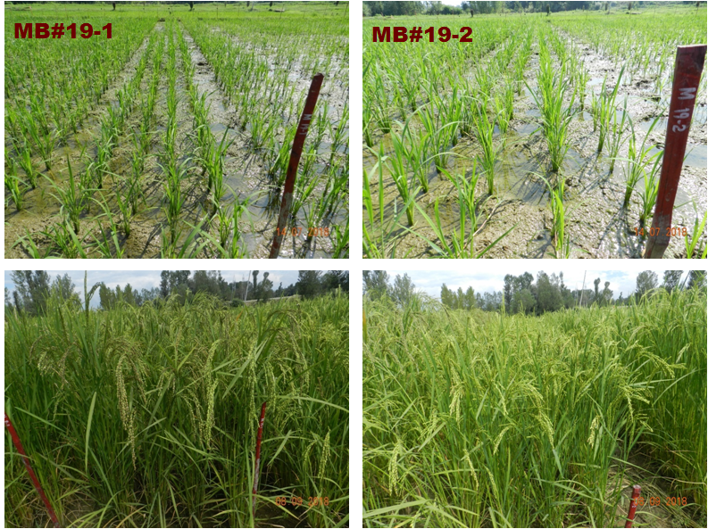

Figure S2. The distribution of polymorphic markers between aromatic landrace Mushk Budji and blast resistance donors DHMAS 70Q 164-1b (Pi54) andIRBL9-W (Pi9)

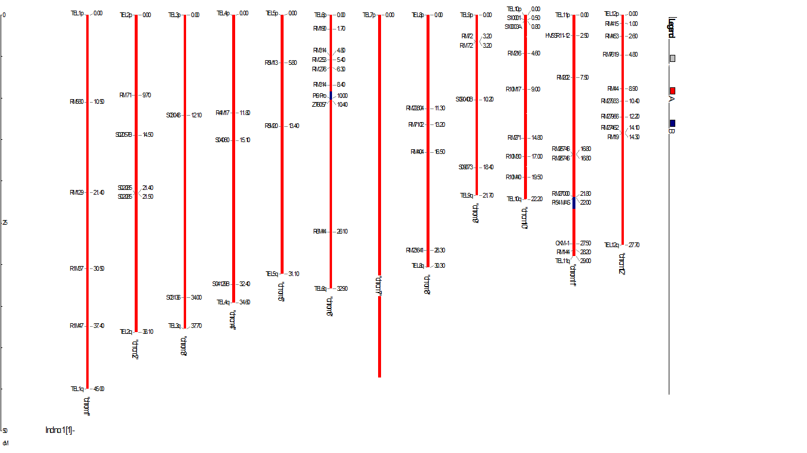

Figure S3. Genome wide Recipient Parent Genome Recovery of pyramided lines
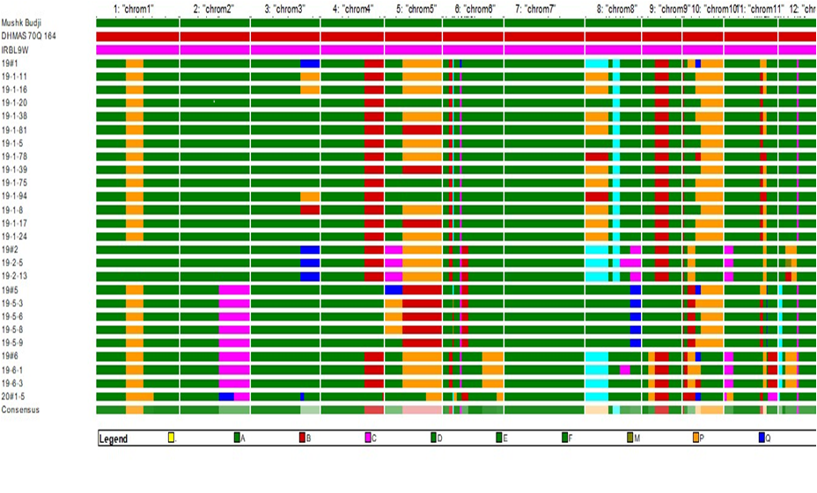

Figure S4. Recipient Parent Genome Recovery for carrier chromosome 6 for selected lines

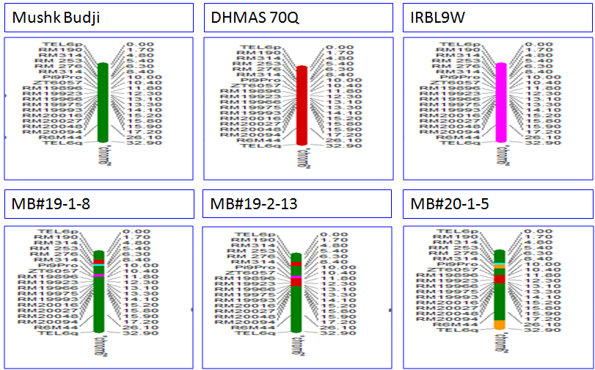
Figure S5. Recipient Parent Genome Recovery for Carrier Chromosome 11 for selected lines
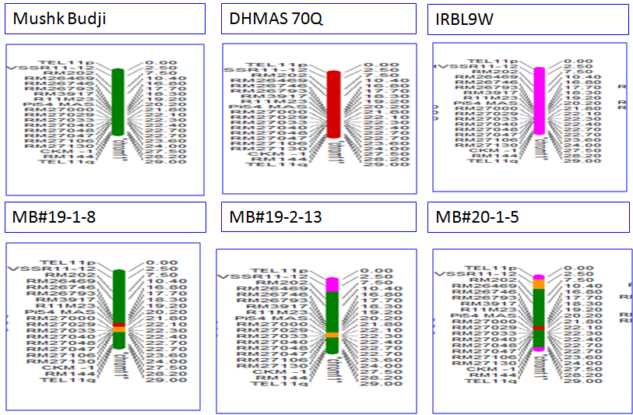

Figure S6. Marker-assisted background selection in BC2F1 for identifying individuals with high recurrent parent genome recovery
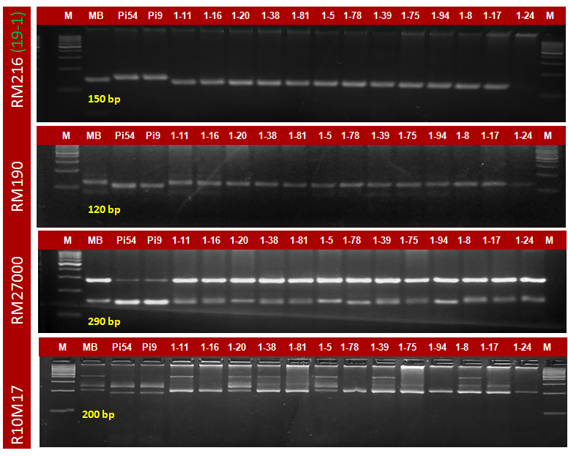
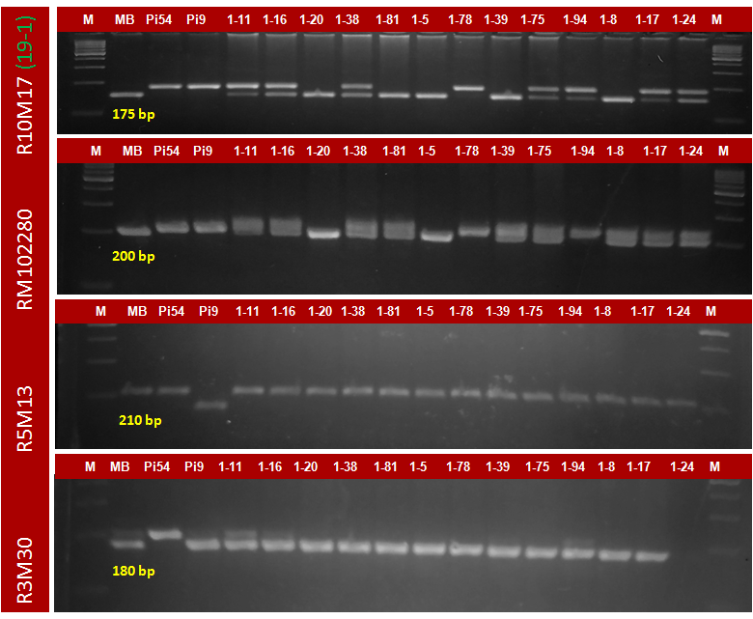
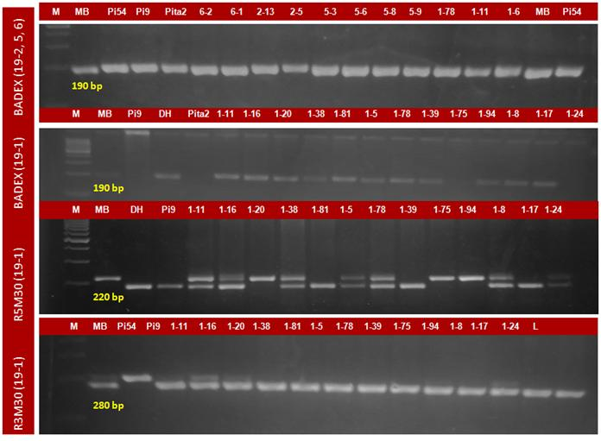

Figure S7. Comparison of relative gene expression among NILs carrying blast resistance genes Pi54 and Pi9
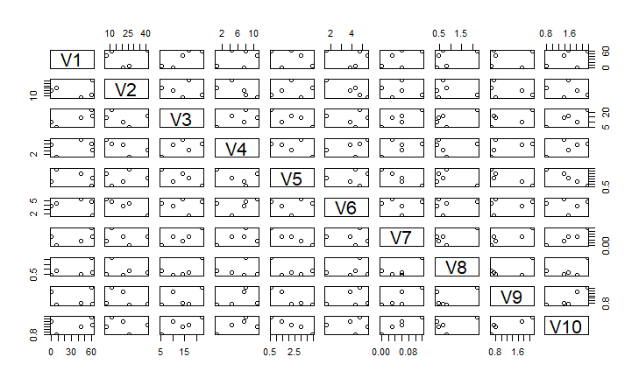
v1: Pi9, v2: Pi54, v3: WRKY 71, v4: WRKY 108, v5: Chitinase, v6: Peroxidase, v7: Cytochrome P450, v8: NB-ARC/LRR, v9: bZIP transcription factor domain containing protein, v10: DR

