Additional information
Supplementary Table 1 The aggregated 14 economic sectors
No. | Sector | No. | Sector
1 | Grains & Crops | 8 | Mineral products necessity
2 | Fuel | 9 | Ferrous metals
3 | Other extraction | 10 | Metal necessity
4 | Processed products | 11 | Metal products
5 | Textile and clothes | 12 | Equipment and machinery
6 | Wood and paper | 13 | Utility
7 | Chemical products | 14 | Other

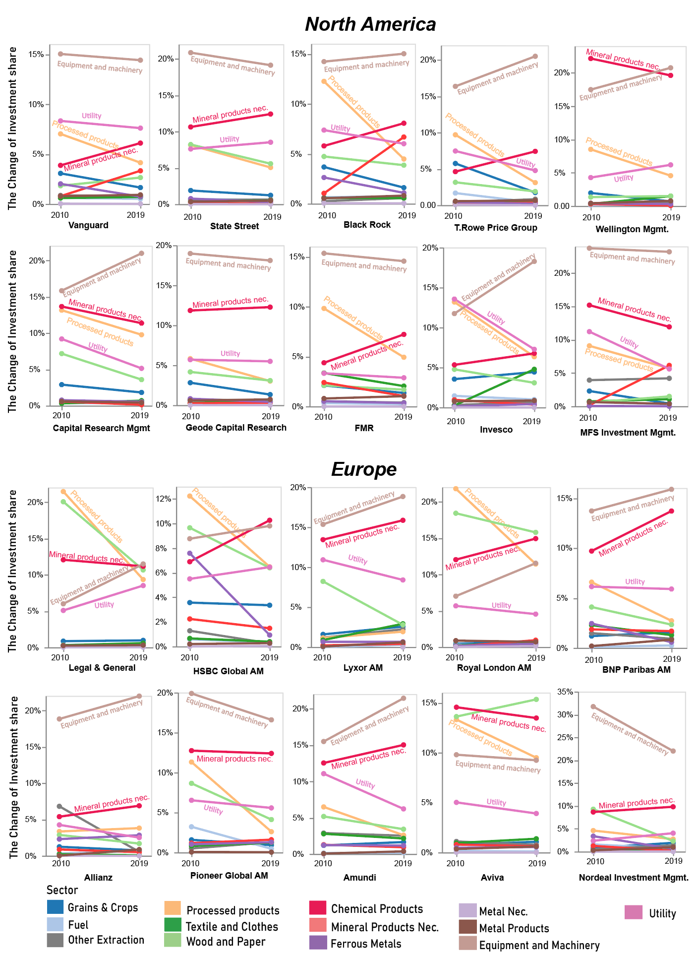
Supplementary Fig 1|The sectoral charge of portfolio holding share between 2010 and 2019 for the top 20 selected asset managers in North America and Europe.
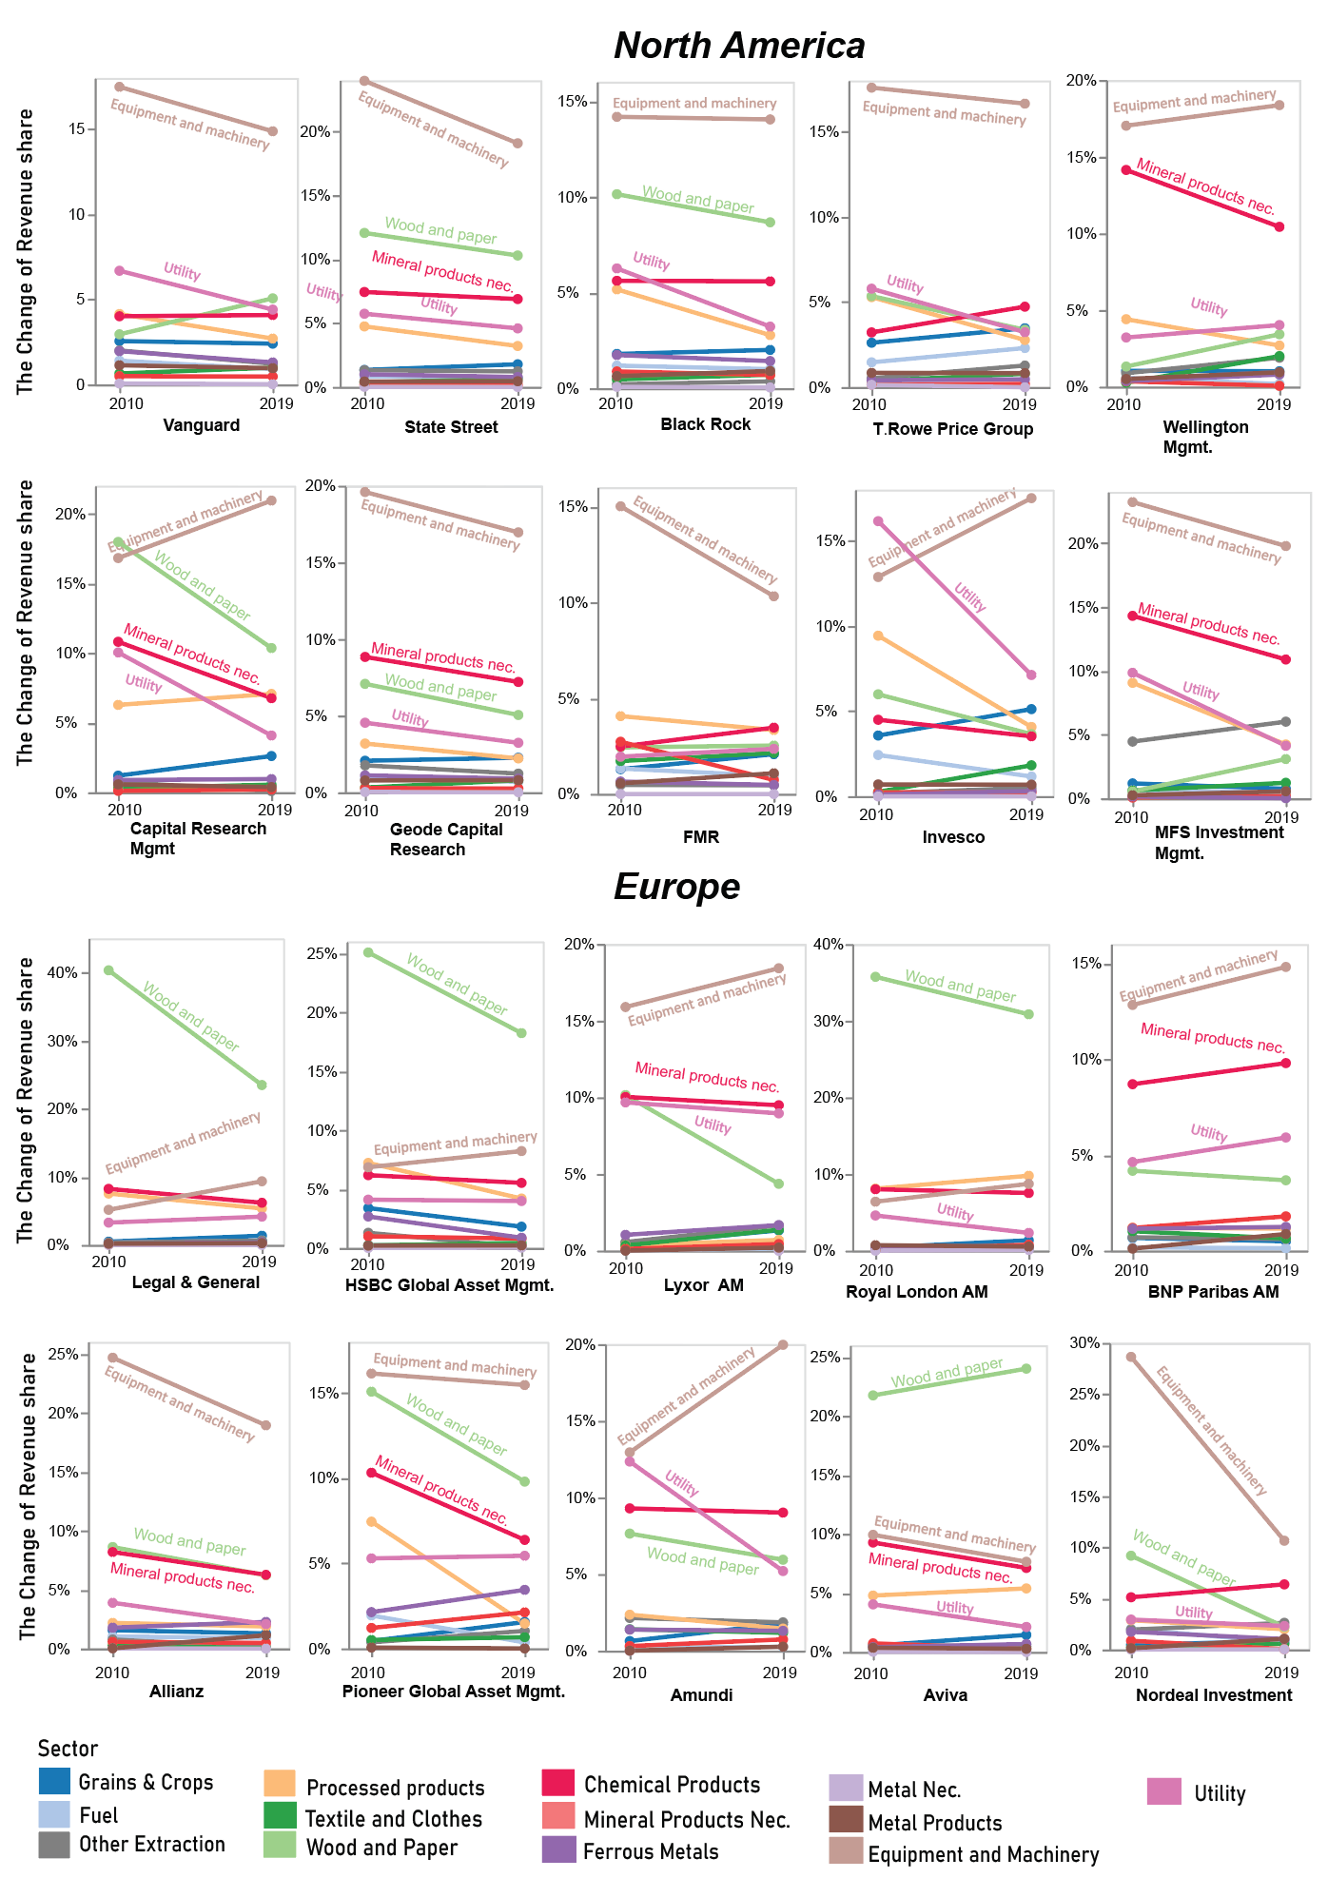
Supplementary Fig 2|The sectoral charge of portfolio revenue share between 2010 and 2019 for the top 20 selected asset managers in North America and Europe.

