Supplementary Materials

A porous biochar supported nanoscale zero-valent iron highly efficient for the remediation of cadmium and lead contaminated soil

Wei Qian¹, Zeng-Hui Diao ^{1,2*}

¹ Zhongkai University of Agriculture and Engineering, Guangzhou 510225, China
² Hong Kong Polytechnic University, Hong Kong

Figure captions
Fig. S1. SEM image and EDS data of the BC-nZVI.
Table S1 The main physicochemical properties of soil samples.
Table S2 Variations of pH and SOM in soil induced by different amendments.
Table S3 Variations of pH and SOM in soil induced by different BC-nZVI dosages.
Table S4 Variations of pH and SOM real contaminated soil induced by different BC-nZVI dosages.

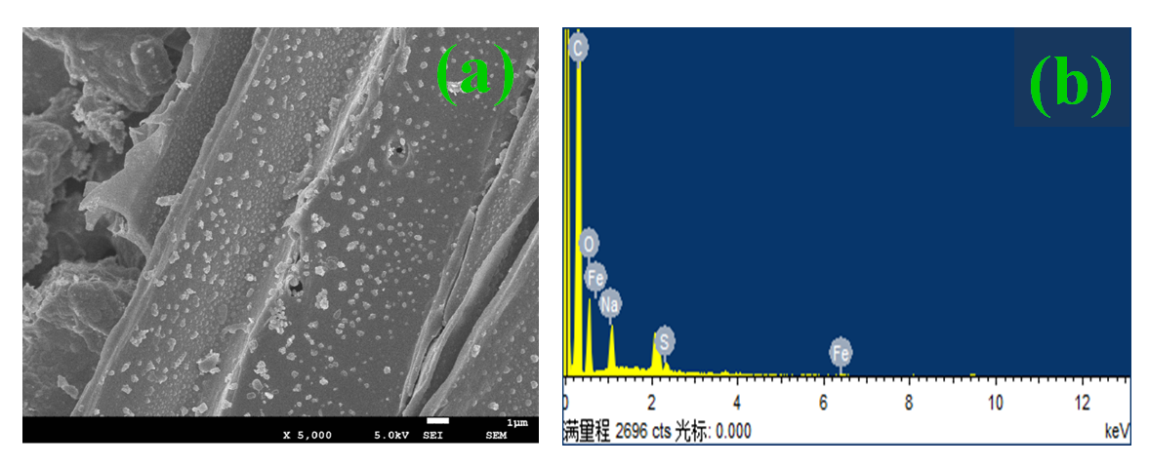
Fig. S1

Table S1
Soil types | pH | CEC  (cmol /kg) | SSA | SOM (mg/kg) | Sand (%) | Silt  (%) | Clay  (%) | Total Fe  (mg/kg) |  | Cd  (mg/kg) | Pb  (mg/kg)
Farm Soil | 6.54 | 13.69 | 12.25 | 10.41 | 24.48 | 22.89 | 52.63 | 2,365 |  | - | -
Real contaminated soil | 6.08 | 11.24 | 9.67 | 18.36 | 21.74 | 23.68 | 54.58 | 2,352 |  | 2.53 | 167.12

Table S2
 | Cd immobilization |  |  |  |  | Pb immobilization
 | Blank | BC | nZVI | BC-nZVI | Blank | BC | nZVI | BC-nZVI
pH | 6.54 | 6.82 | 6.68 | 6.79 | 6.56 | 6.85 | 6.79 | 6.83
SOM (mg/kg) | 10.41 | 12.87 | 10.43 | 12.32 | 10.43 | 12.89 | 10.50 | 12.57

Table S3
 | Cd immobilization |  |  |  |  | Pb immobilization
 | Blank | 0.5 (g/L) | 1.0 (g/L) | 2.0 (g/L) | 3.0 (g/L) | Blank | 0.5 (g/L) | 1.0 (g/L) | 2.0 (g/L) | 3.0 (g/L)
pH | 6.54 | 6.59 | 6.67 | 6.79 | 6.92 | 6.56 | 6.62 | 6.71 | 6.83 | 6.97
SOM (mg/kg) | 10.41 | 10.96 | 11.53 | 12.32 | 13.41 | 10.45 | 10.99 | 11.49 | 12.57 | 13.48

Table S4
 | Cd immobilization |  |  | Pb immobilization
 | Blank | 1.0 (g/L) | 3.0 (g/L) | 1.0 (g/L) | 3.0 (g/L)
pH | 6.08 | 6.19 | 6.37 | 6.17 | 6.41
SOM (mg/kg) | 18.36 | 19.25 | 21.95 | 19.29 | 22.03

Statistical analysis
All statistical treatments of the data were performed using SPSS software version 22.0 (SPSS Inc., Chicago, IL, USA). The experimental data were evaluated using analysis of variance (ANOVA) at the Tukey test, and the minimal level for statistical significance was P < 0.05.

* Corresponding author: E-mail address: zenghuid86@163.com (Z.H. Diao).

