Online-Only Supplementary Figures:

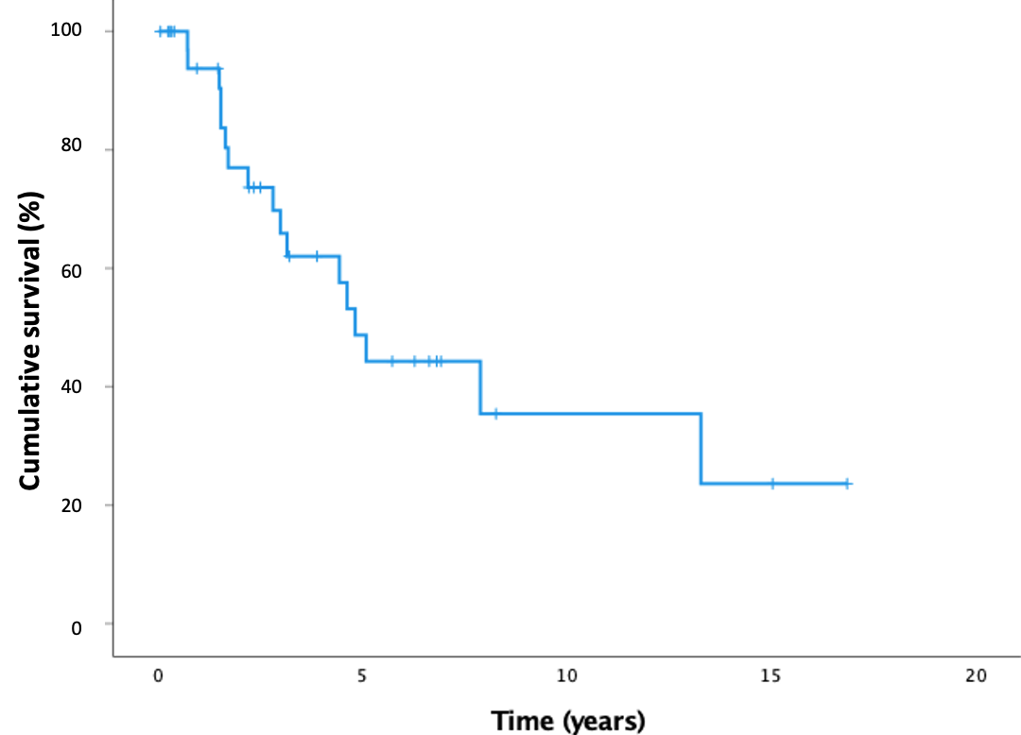
eFigure 1: Kaplan-Meier Survival Curve
With overall survival defined as time to death or transplant. Median survival time was 4.81 years.

