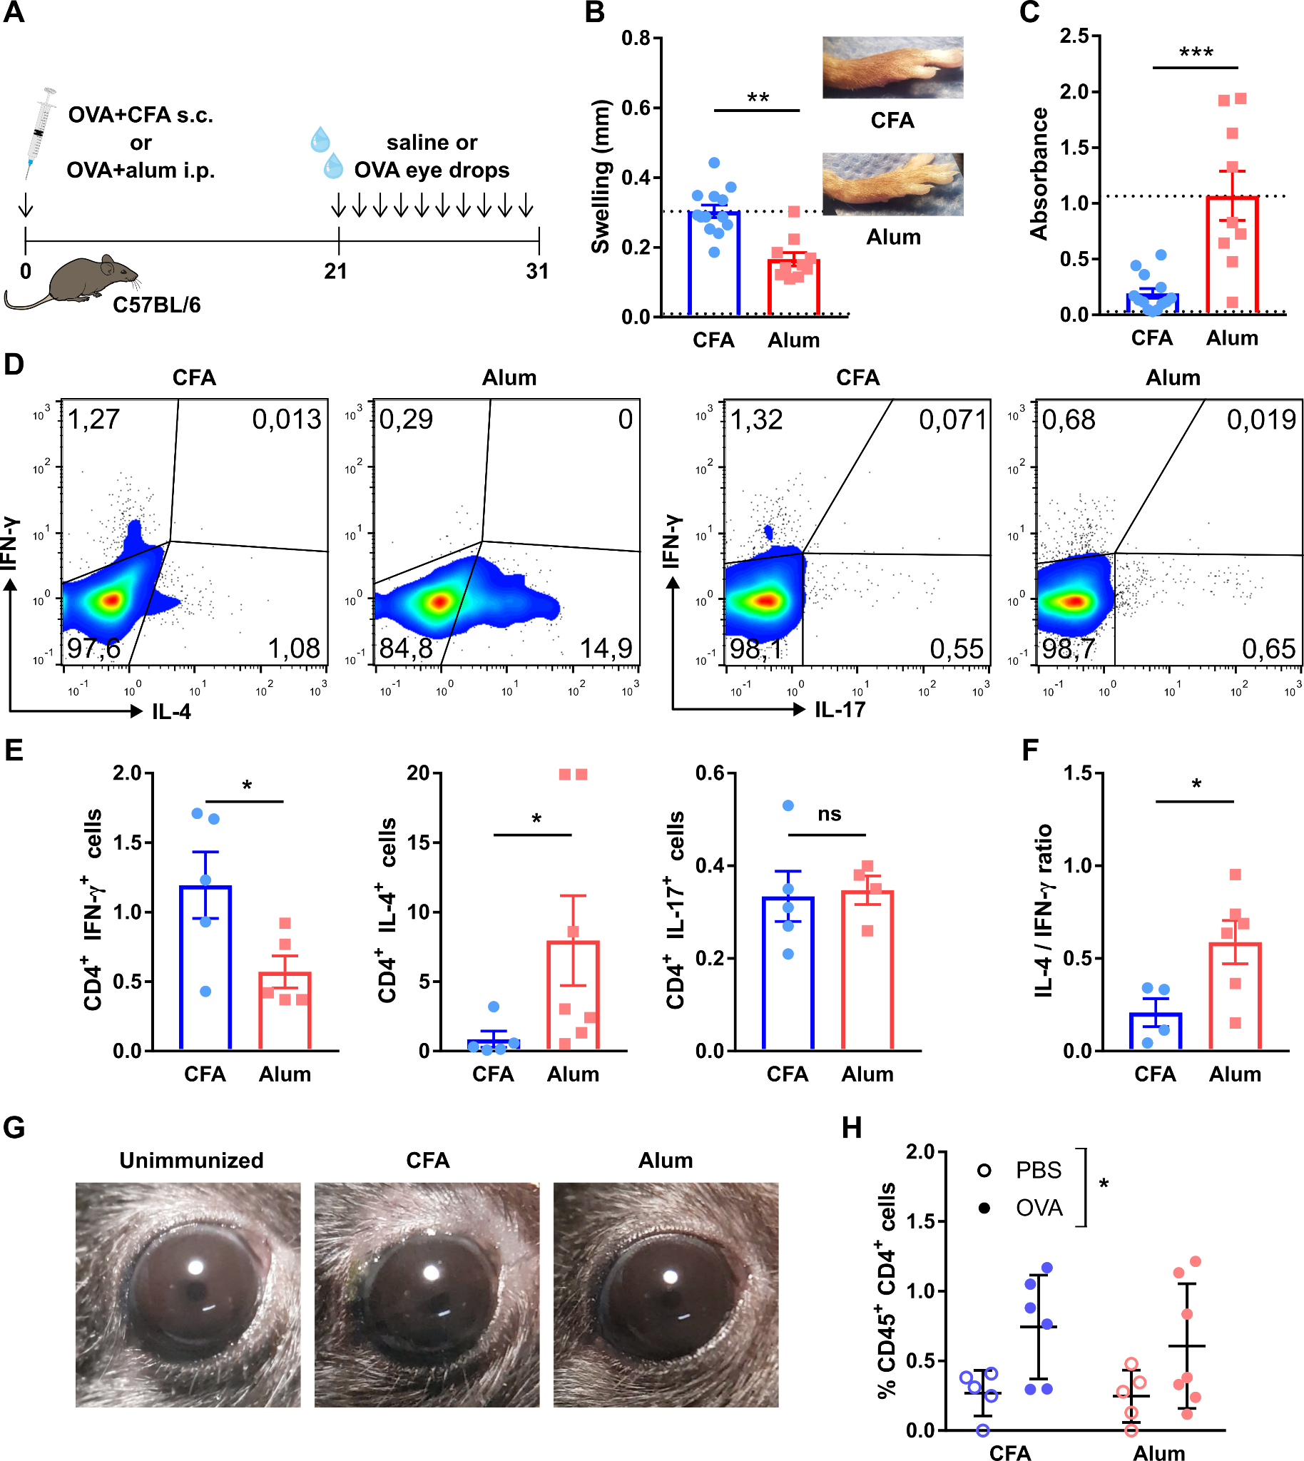
Supplementary Figure 1 - Th1 and Th2-skewing of the adaptive immune response in the ocular surface of wild-type mice. A) Wild-type (wt) mice were immunized with OVA in combination with either complete Freund’s adjuvant (CFA) or alum to induce a Th1- or Th2-skewed immune response, respectively. Three weeks later, mice were given saline or OVA eye drops daily for 10 days to induce an ocular immune response. B) Delayed-type hypersensitivity response to footpad OVA injection in immunized wt mice. Pooled data (left) and representative images (right) of footpads. C) Serum OVA-specific IgE levels in wt mice 30 days after immunization as assessed by ELISA. Upper and lower reference lines correspond to positive (alum-immunized) and negative (non-immune) wild-type controls from another experiment. D) Representative dot plots and E) pooled data of interferon-γ (IFN-γ), interleukin (IL)-4, and IL-17 production by CD4⁺ T cells obtained from spleens of immunized mice. F) Pooled data of ratio of IL-4/IFN-γ producing CD4⁺ T cells. G) Representative photographs of mouse eyes on day 31 of the experiment. H) Conjunctival CD4⁺ T cells in immunized mice as assessed by flow cytometry (pooled data). All experiments were performed twice or more with 6 mice/group/experiment. For all experiments, mean±standard error of measurement is shown. To compare means, Student’s t test was used for B, C, E, and F, and two-way ANOVA (immunization and ocular challenge) was used for H. * indicates p<0.05, ** indicates p<0.01, *** indicates p<0.001, and ns indicates not significant.
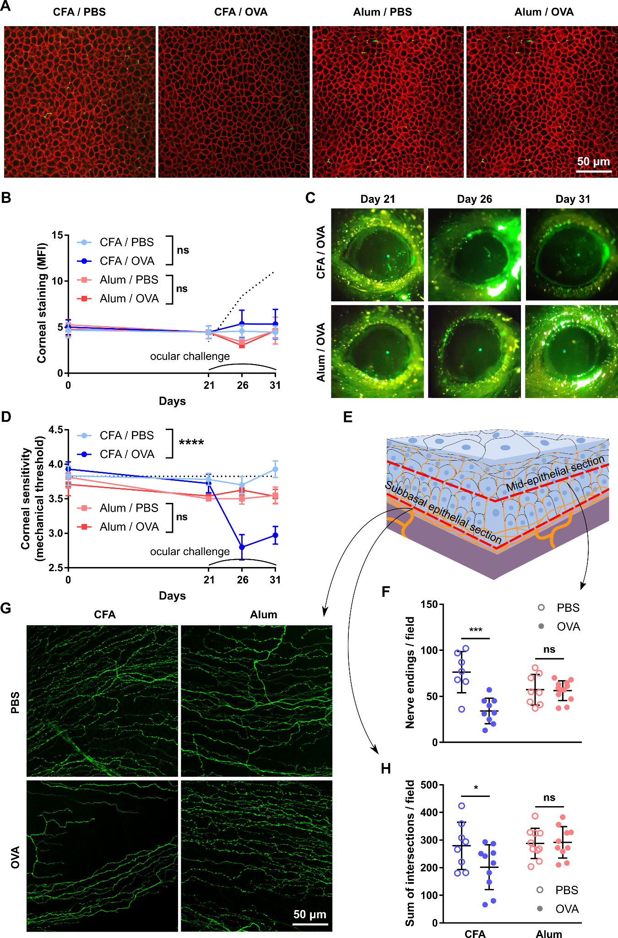
Supplementary Figure 2 - Effect of a local Th1- and Th2-skewed immune response on the corneal epithelium and nerves of wild-type mice. Wild-type (wt) mice were immunized with ovalbumin (OVA) in combination with complete Freund’s adjuvant (CFA) or alum and later given OVA or saline (PBS) eye drops, as detailed in the previous figure. A) Representative micrographs of corneal whole mounts stained with E-cadherin (red) and tubulin β3 (green) from immunized wt mice. B) Cumulative data and C) representative of corneal dextran-fluorescein uptake in immunized wt mice. The dotted reference line corresponds to wt mice with dry eye surgically induced on the same day as the ocular challenge (positive control for corneal epitheliopathy). D) Corneal mechanical sensitivity thresholds of immunized mice over the 31-day experiment. The dotted reference line corresponds to the average baseline measurements of all the mice in the experiment. E) Schematic of the levels at which corneal nerve morphology was analyzed. F) Density of vertical intraepithelial nerve terminals in mid-epithelial corneal sections (representative example). G) Representative micrographs of mid-peripheral subbasal sections (tubulin β3 staining) and H) pooled data (representative experiment) of corneal neural complexity quantification (sum of intersections, Sholl analysis). All experiments were performed twice or more with 6 mice/group/experiment. For all experiments, mean±standard error of measurement is shown. To compare means, two-way ANOVA (immunization and ocular challenge) was used. * indicates p<0.05, *** indicates p<0.001, **** indicates p<0.0001 and ns indicates not significant.

