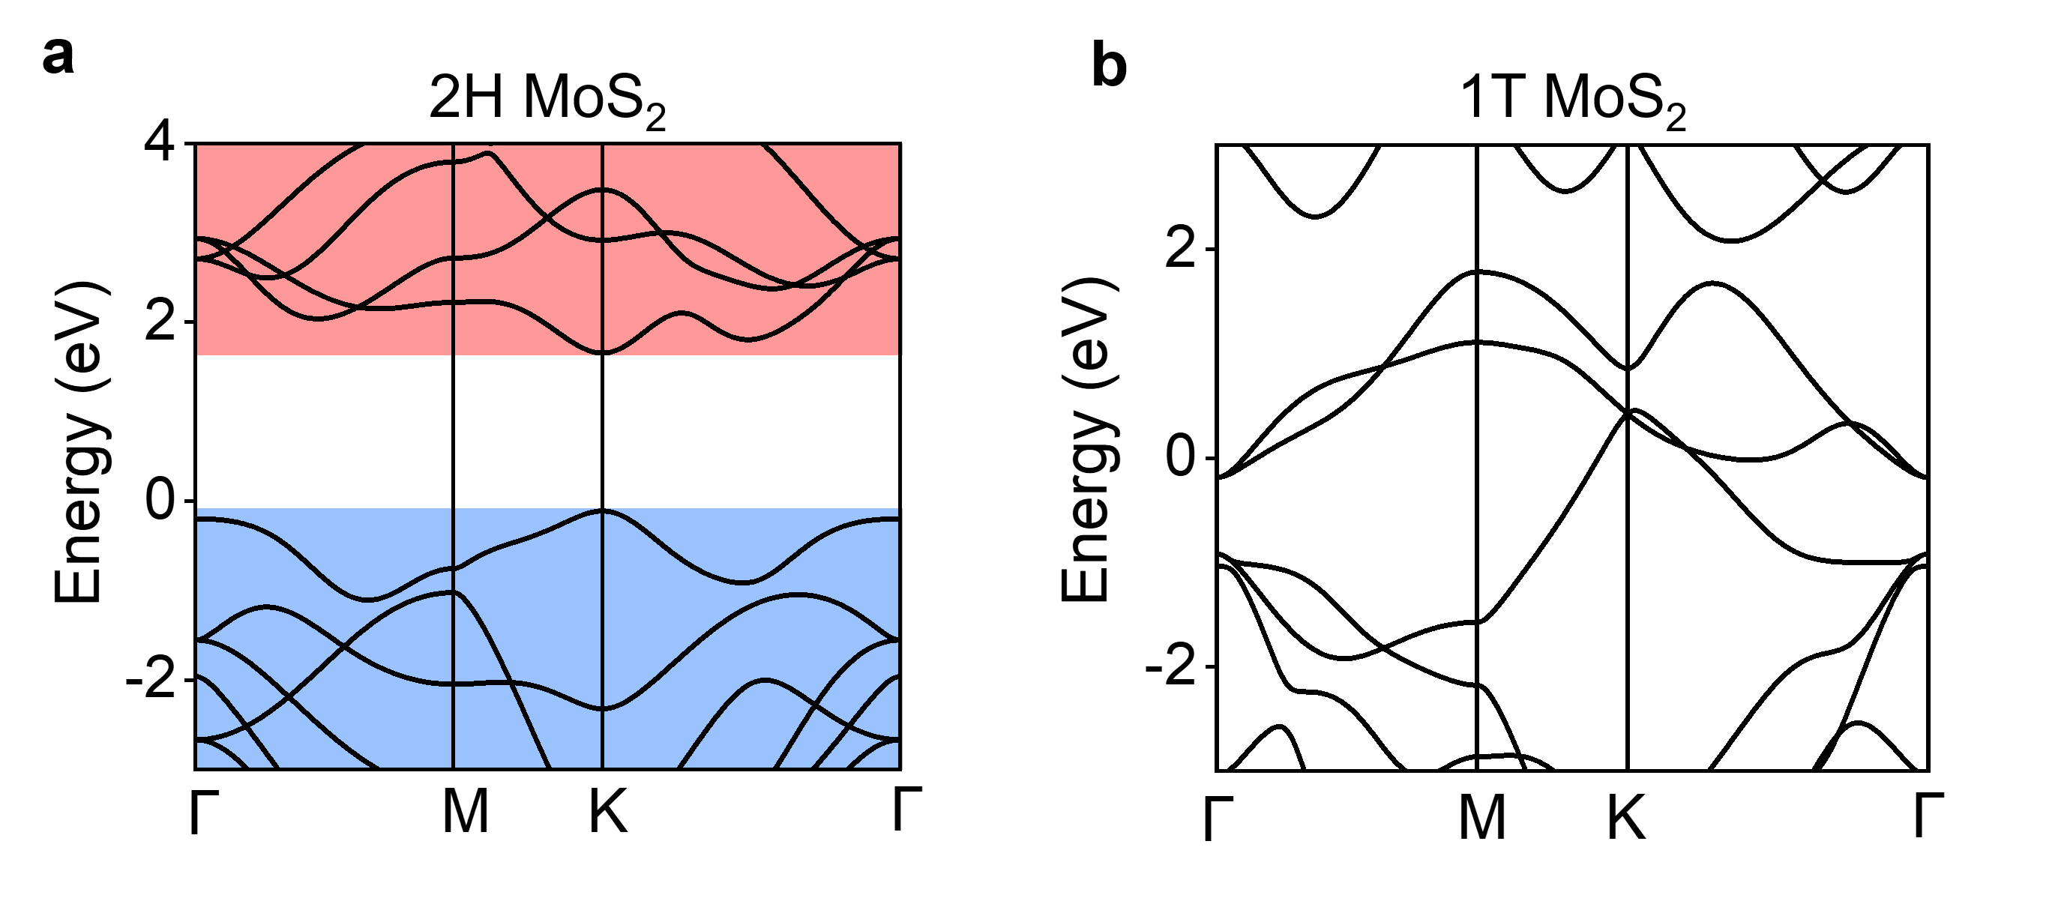
Extended Data Fig. 1 | Band structures calculated by DFT. a, Calculated band structure for intrinsic 2H MoS₂. b, Calculated band structure for intrinsic semimetallic 1T MoS₂.

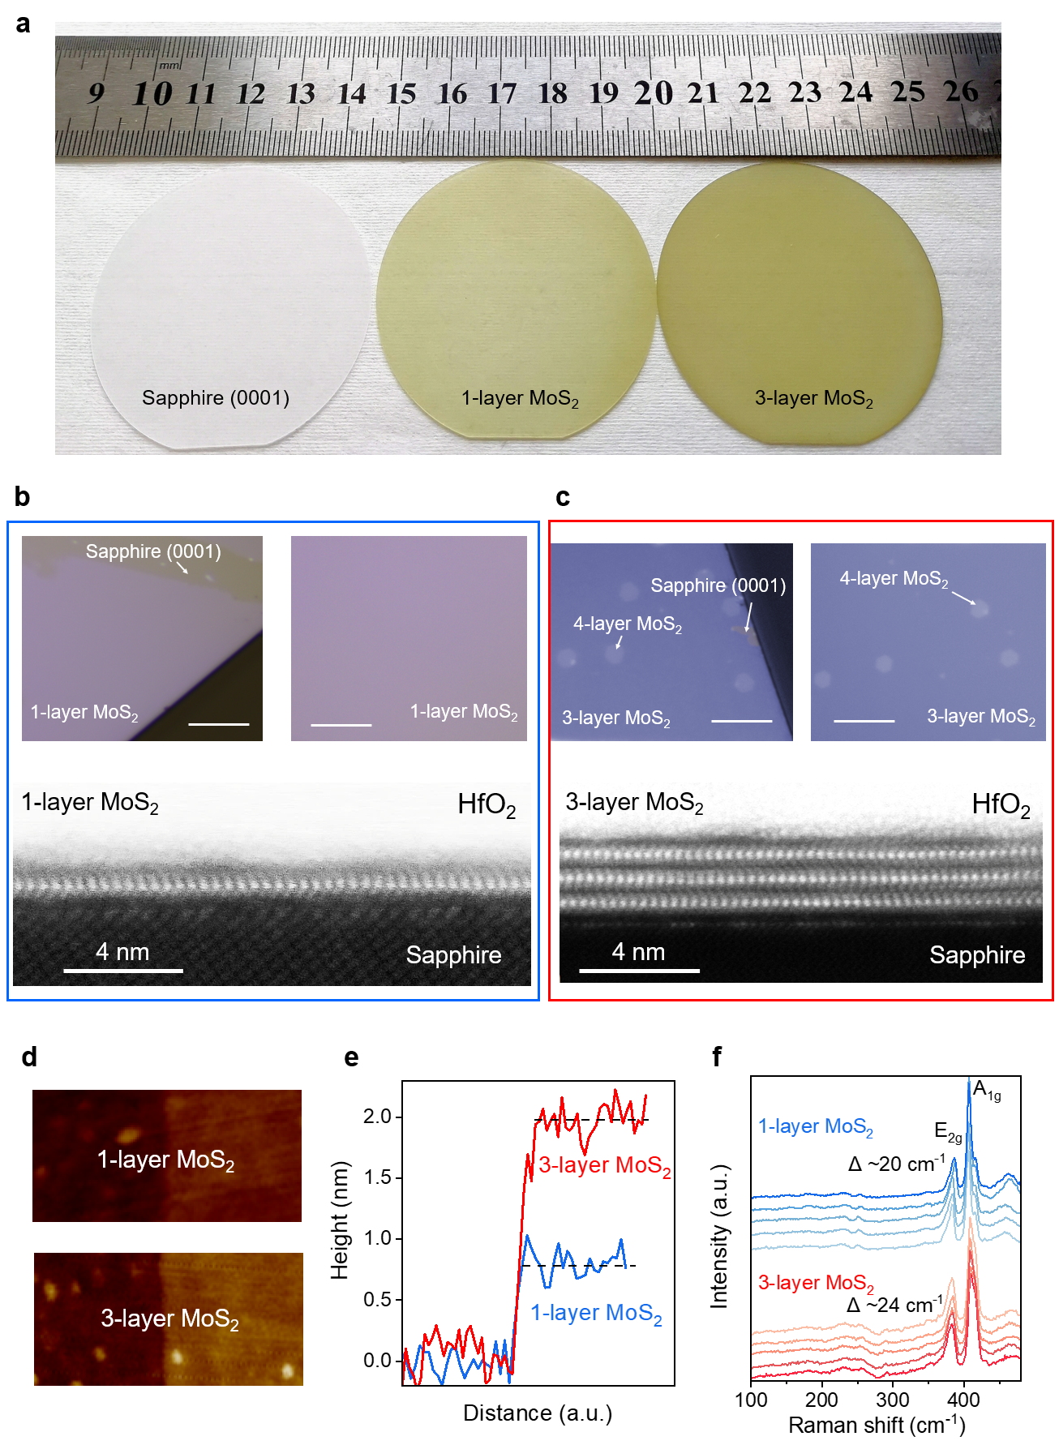
Extended Data Fig. 2 | Layer-by-layer epitaxy of MoS₂ wafers. a, Photograph of 2-inch wafers, including the sapphire (0001) substrate, monolayer, and trilayer MoS₂ wafers. b, Photographs and scanning transmission electron microscopy image of monolayer MoS₂. Scale bars, 30 μm and 4 nm. c, Photographs and scanning transmission electron microscopy image of trilayer MoS₂. Scale bars, 30 μm and 4 nm. The trilayer MoS₂ wafers were partially topped by 4-layer areas (20%-30%), which is consistent with the previous reports⁴⁸. The MoS₂ wafers have excellent crystal structures and atomically sharp interfaces. The material above MoS₂ is HfO₂ dielectric, which provides different interfacial conditions and a more dopant-free environment than the metal layer, resulting in clearer imaging^{20,48,72,73}. d and e, AFM amplitude images of the mono- and trilayer MoS₂ wafers. The blue curve and the red curve show the mono- and trilayer, respectively. f, Raman spectra of the as-grown mono- and trilayer MoS₂ wafers. Raman A_{1g}-E¹_{2g} splitting (Δ) of approximately 20 cm⁻¹ and 24 cm⁻¹ confirmed that the MoS₂ films were mono-layer and tri-layer.

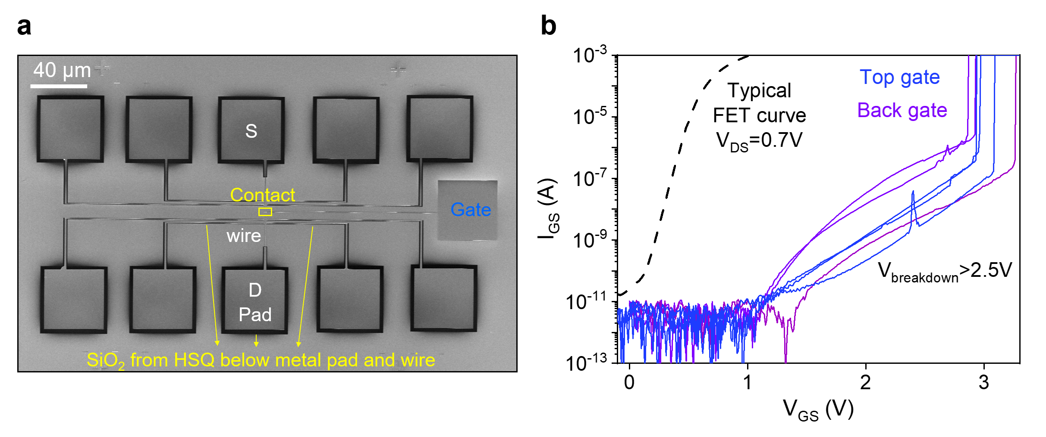
Extended Data Fig. 3 | Gate leakage current of ballistic MoS₂ FETs. a, A top-view SEM image of our dual-gated ballistic MoS₂ FETs. SiO₂ from the HSQ was placed under the metal pads and wires to reduce back-gated leakage. b, Gate leakage currents of 10⁻¹² A, and breakdown voltages of larger than 2.5 V of our ballistic MoS₂ FETs. The blue curves are the top-gate leakage currents, and the purple curves are the back-gate leakage currents.

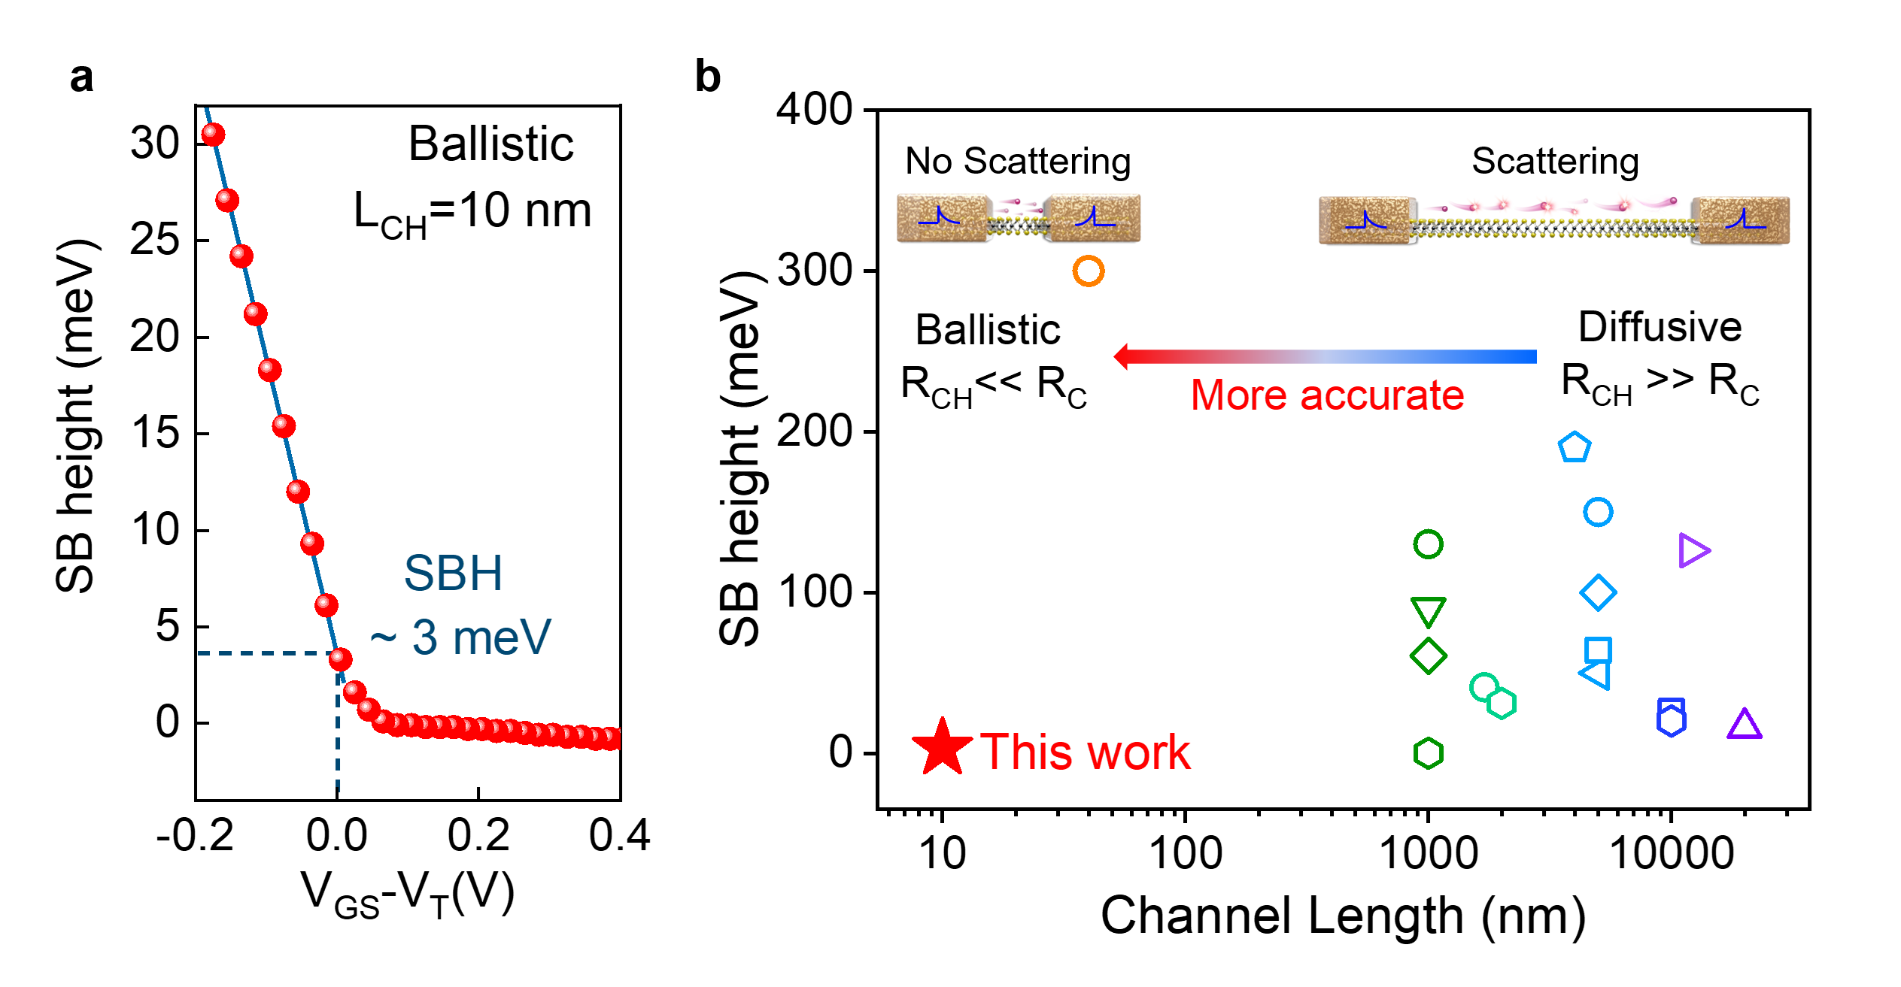
Extended Data Fig. 4 | Extraction of Schottky Barrier Height (SBH). a, The SBH extracted from the transfer characteristics of our ballistic MoS₂ FET represents approximately the theoretical limit, and the flat-band voltage and the corresponding Schottky barrier height are indicated by the dashed lines. Note that to obtain strict extraction of the SBH, the threshold voltages of the transfer characteristics at various temperatures should be normalized to avoid SBH errors due to threshold voltage shifts. b, Comparison of the extracted SBHs of our ballistic MoS₂ FETs and other 2D FETs^{28,31-34,56,63-65,74}. Inset: Schematic diagram of the temperature-dependent diffusive and ballistic transport modes in 2D MoS₂ FETs, where scattering in the long channel affects the accuracy of SBH extraction with the variable temperature method.
It should be noted that the Schottky barrier height here is only used as a reference value. Because the conduction band motion is slowed down by the quantum capacitance as the conduction band approaches the Fermi energy level. When the Schottky barrier height is below a certain value, which is difficult to extract accurately the SBH by the Arrhenius curve method (although this is a widely used method in literatures). Therefore, the total resistance of ballistic FETs is a more reliable estimation of the quality of the contact.

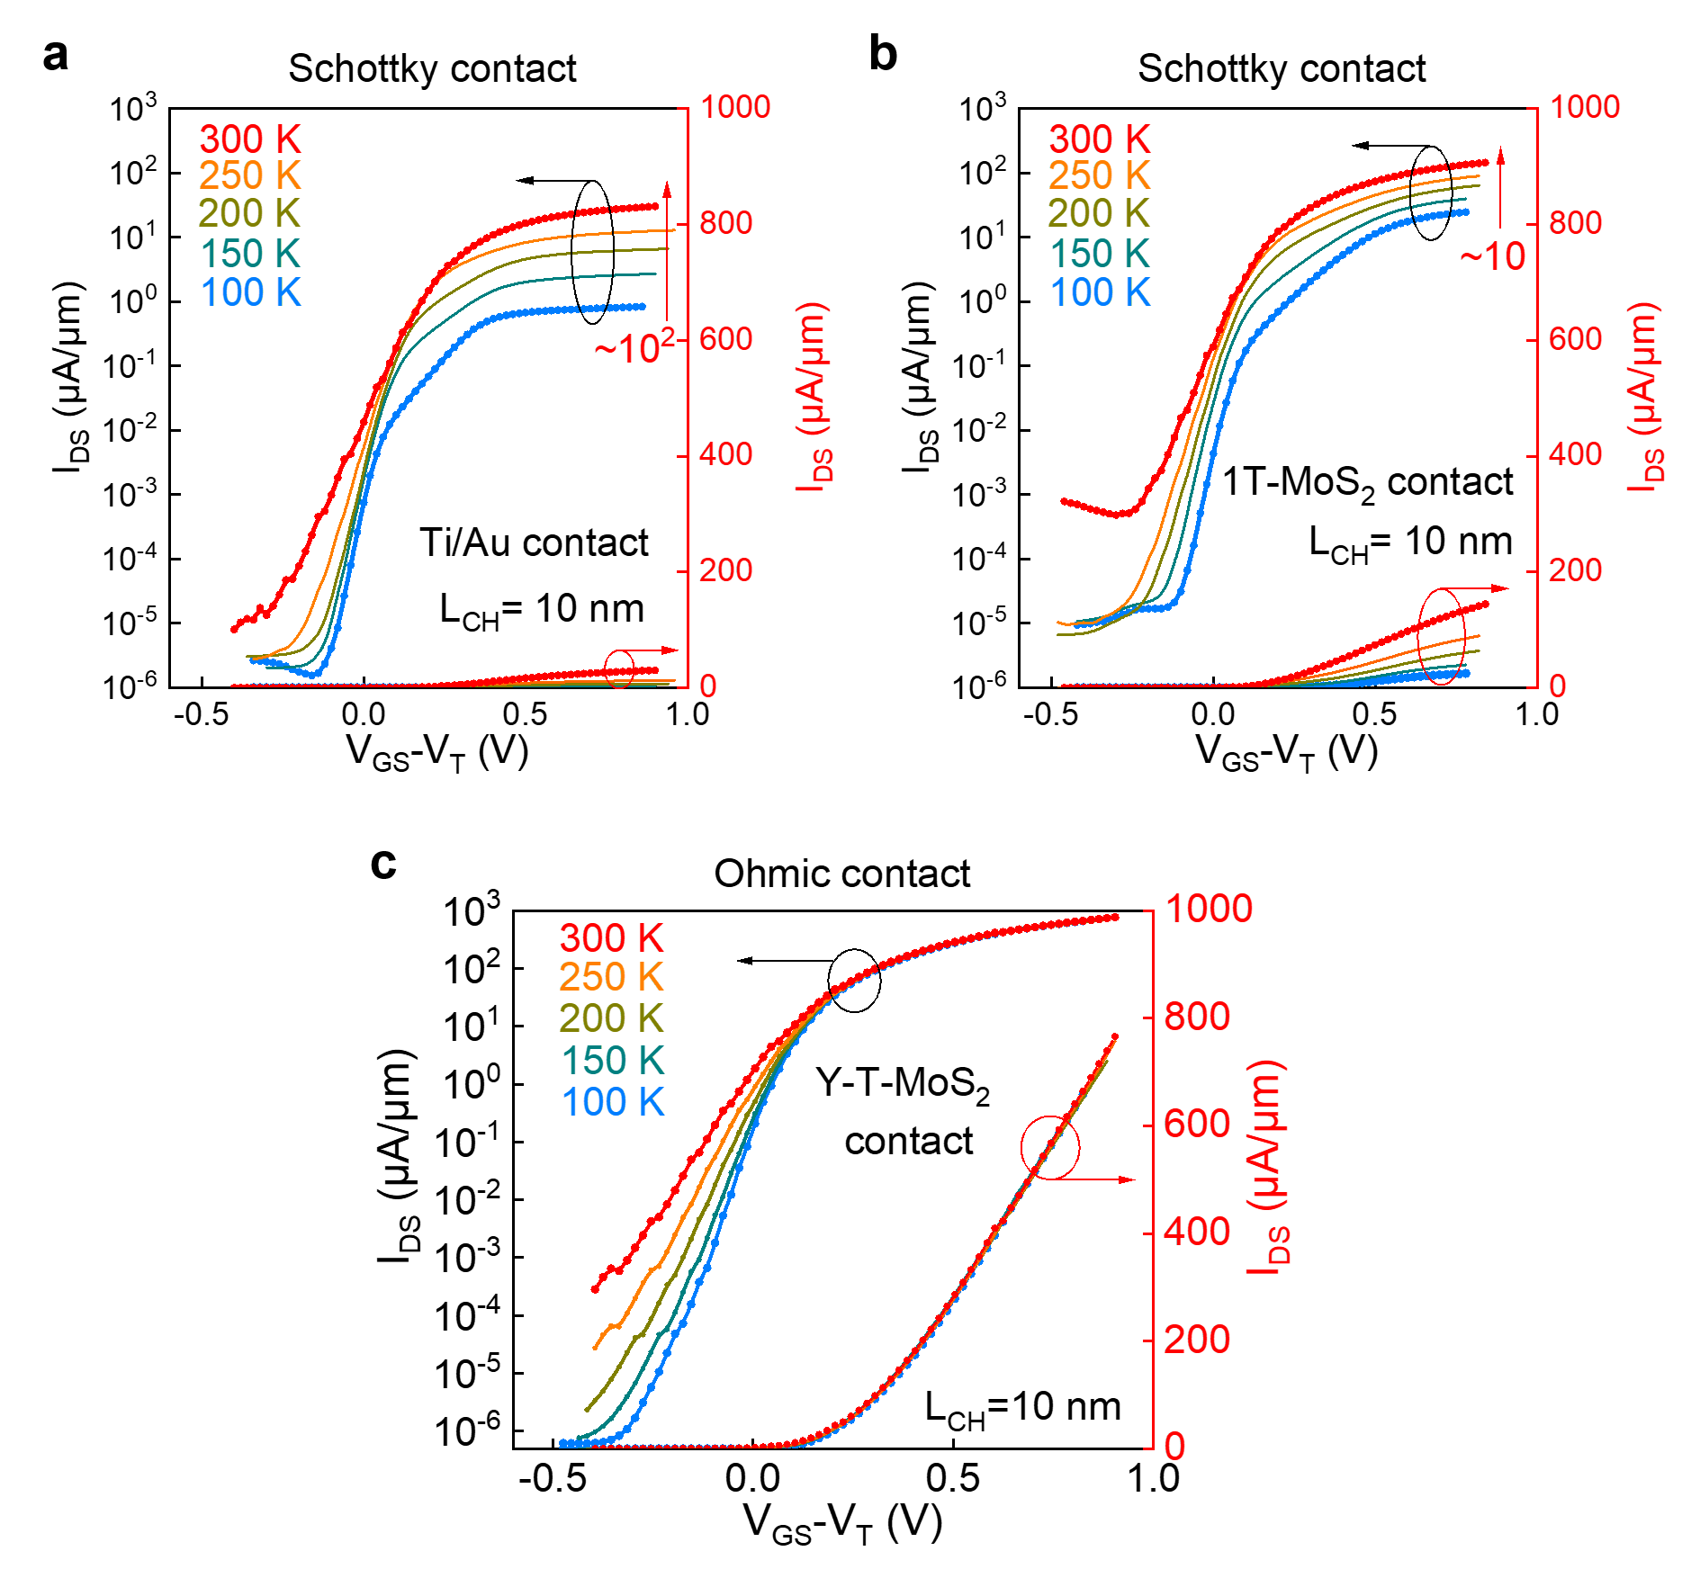
Extended Data Fig. 5 | Comparison of transfer characteristics under various temperatures for ballistic MoS₂ FETs with different contacts. a, Transfer characteristics of a 10-nm ballistic MoS₂ FET using a conventional Ti/Au metal contact, demonstrating a Schottky contact in a ballistic FET. b, Transfer characteristics of a 10-nm ballistic MoS₂ FET using an intrinsic undoped 1T MoS₂ contact, demonstrating a Schottky contact in a ballistic FET. Intrinsic 1T MoS₂ was obtained via using a low-power argon plasma treatment (for 40 s), which is consistent with previous reports^{41,55}. c, Transfer characteristics of a 10-nm ballistic MoS₂ FET using a doping-induced Y-T-MoS₂ contact, showing a true ohmic contact in a ballistic FET.

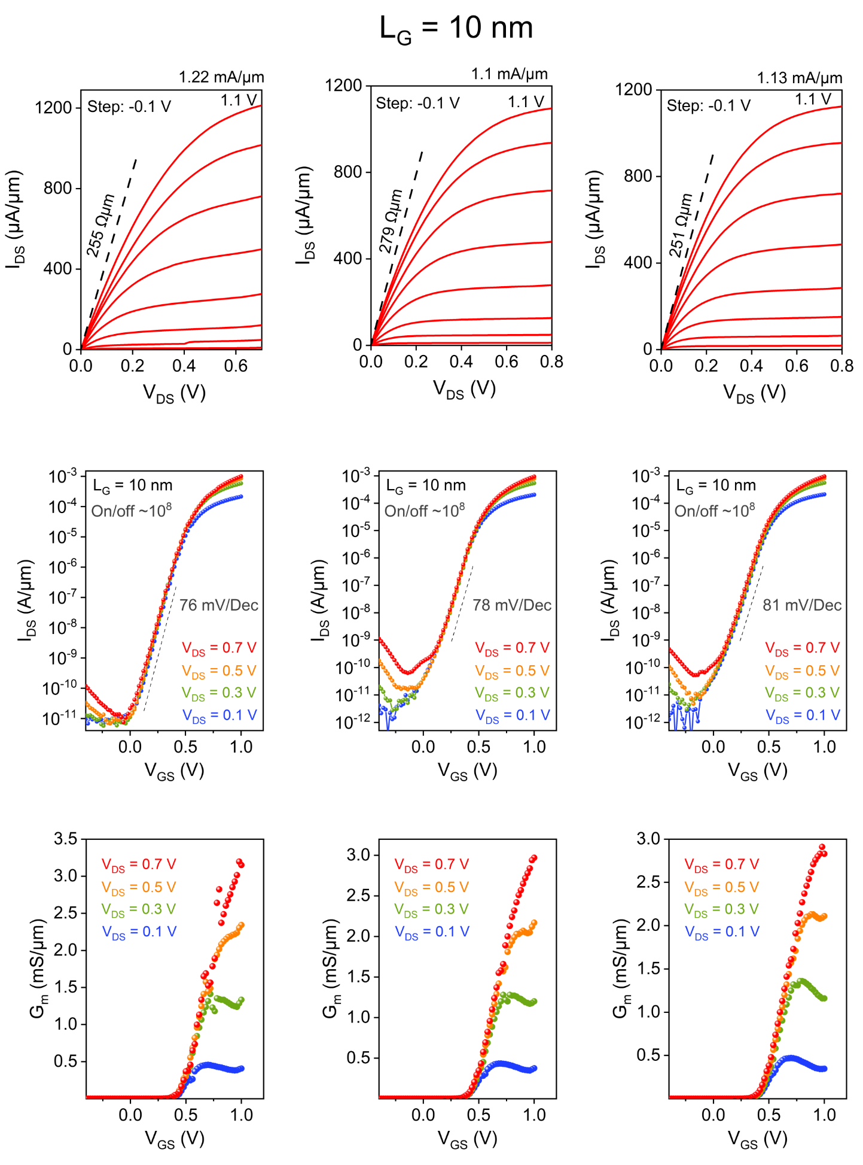
Extended Data Fig. 6 | Electrical characteristics of 10-nm gate-length ballistic MoS₂ FETs. Output characteristics, transfer characteristics at V_{DS}= 0.1, 0.3, 0.5, and 0.7 V, including SS and DIBL, and the corresponding transconductances of three typical 10-nm gate-length ballistic MoS₂ FETs.
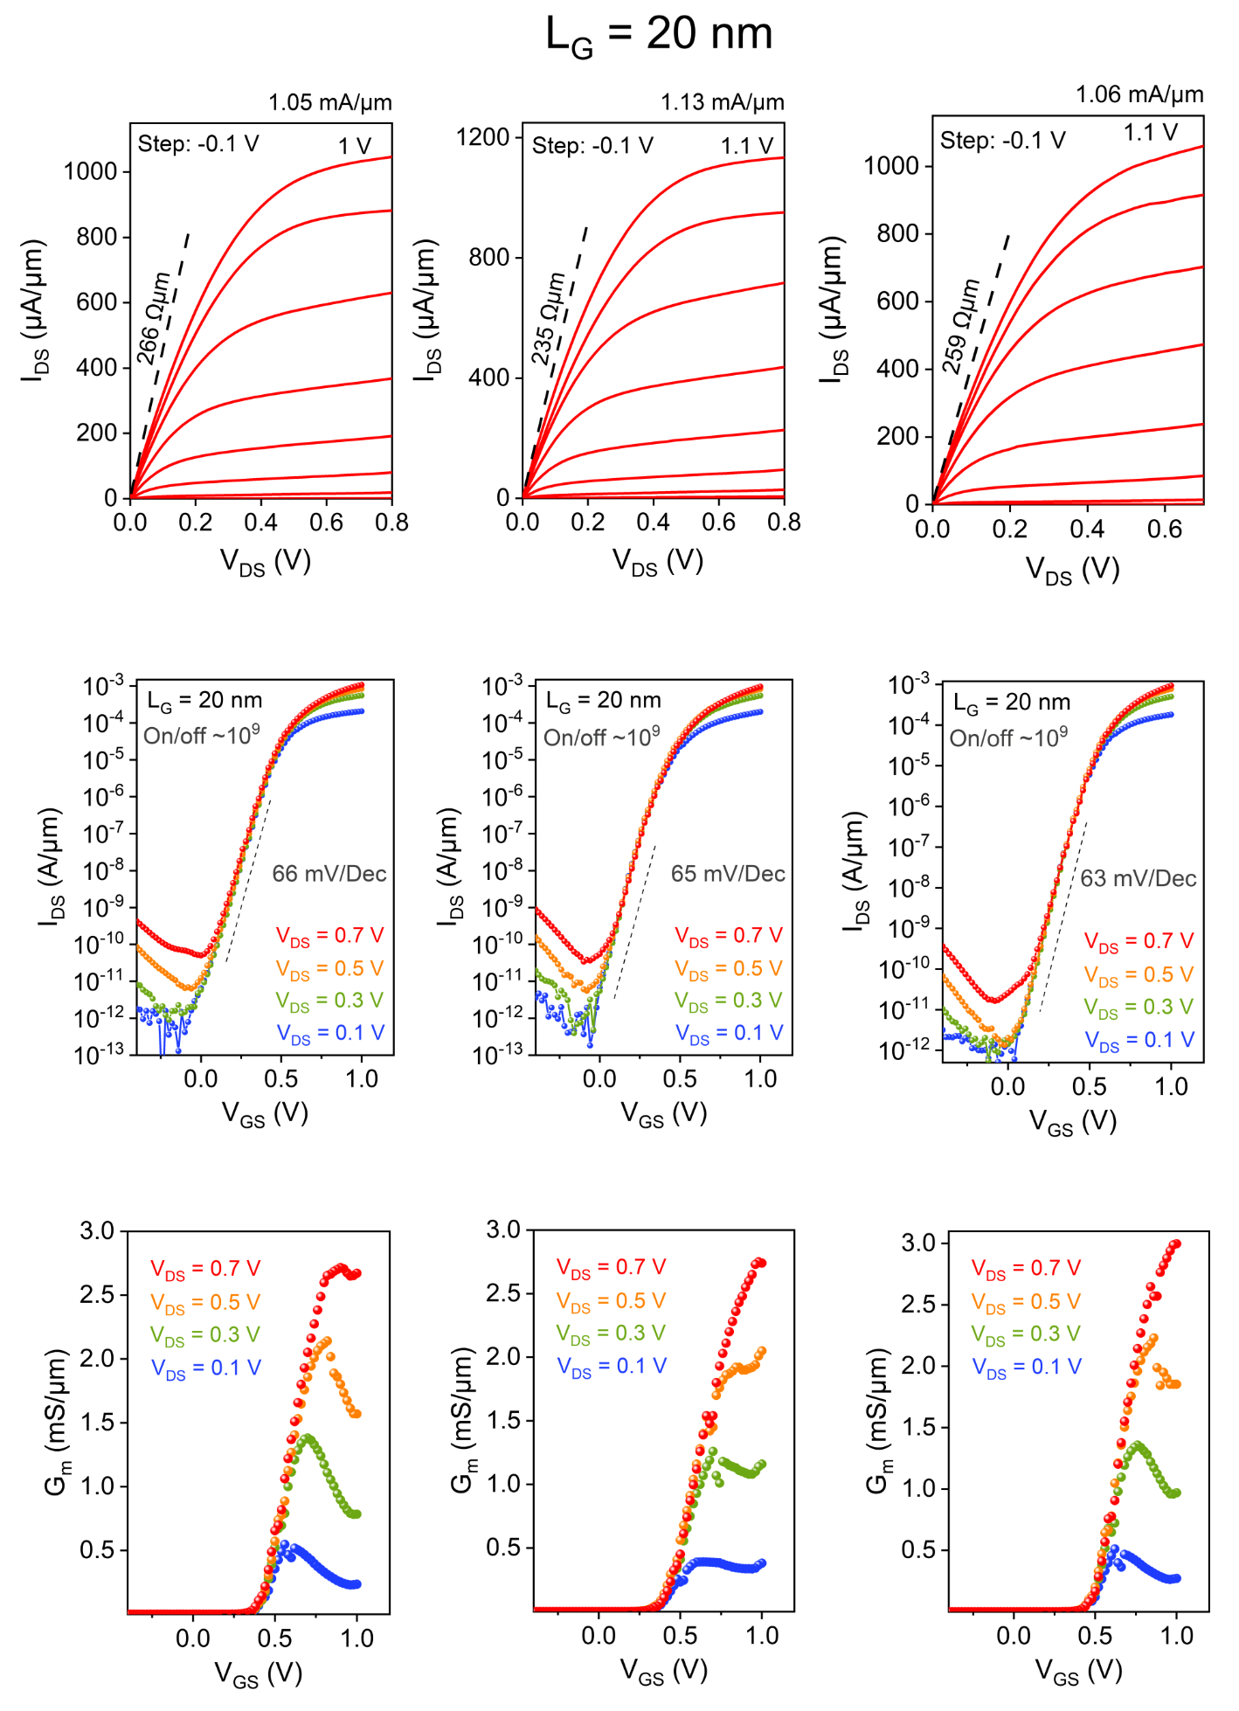
Extended Data Fig. 7 | Electrical characteristics of 20-nm gate-length ballistic MoS₂ FETs. Output characteristics, transfer characteristics at V_{DS}= 0.1, 0.3, 0.5, and 0.7 V, including SS and DIBL, and the corresponding transconductances of three typical 20-nm gate-length ballistic MoS₂ FETs.

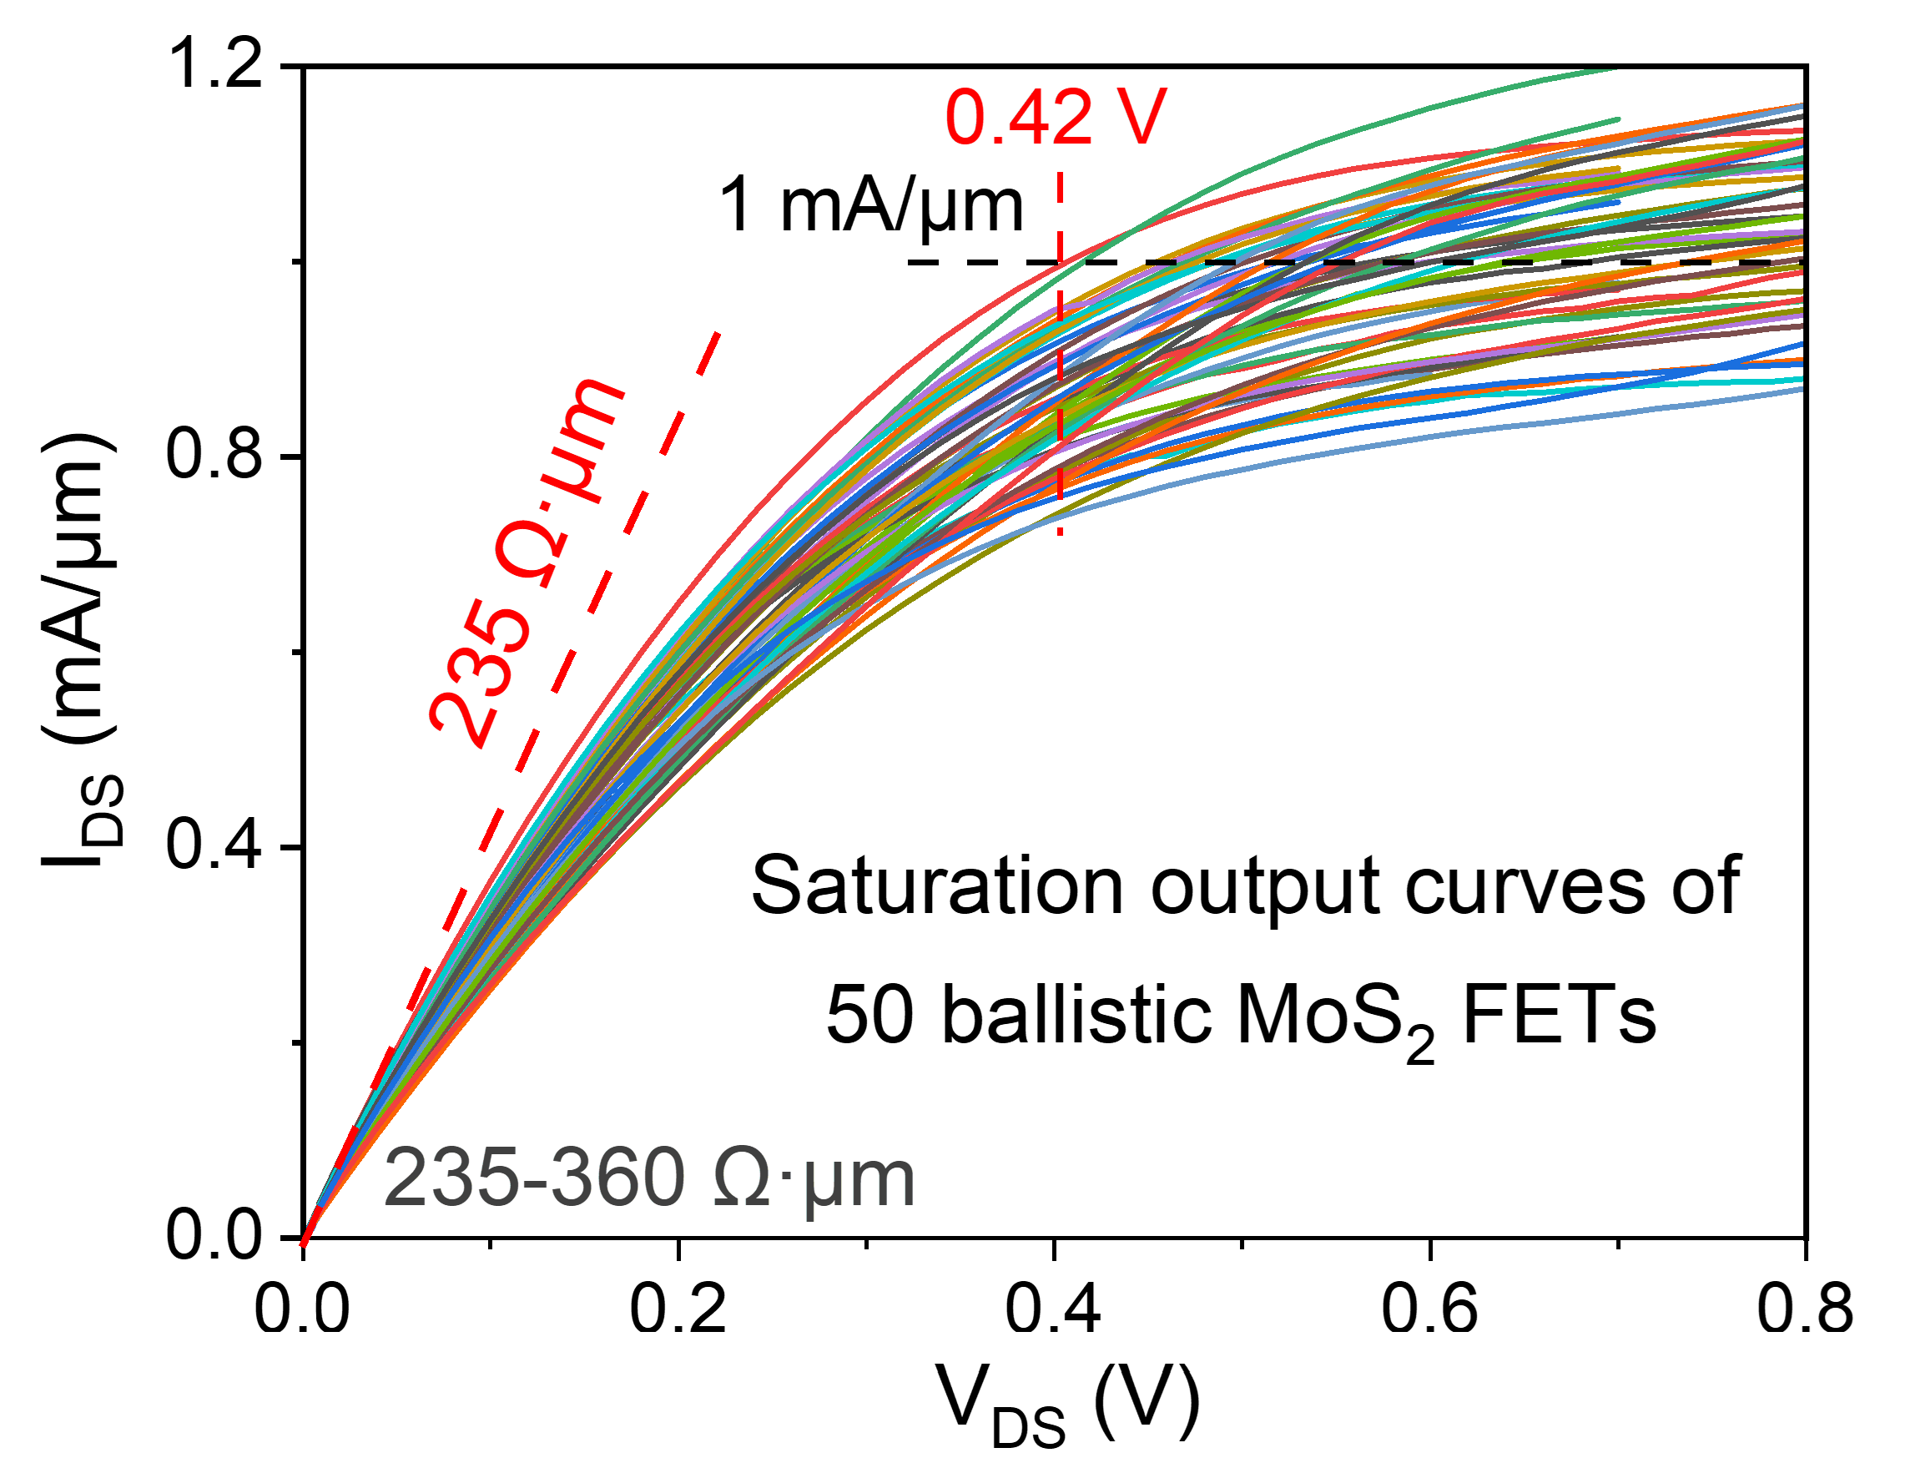
Extended Data Fig. 8 | Saturation output characteristics for fifty sub-20 nm ballistic MoS₂ FETs.

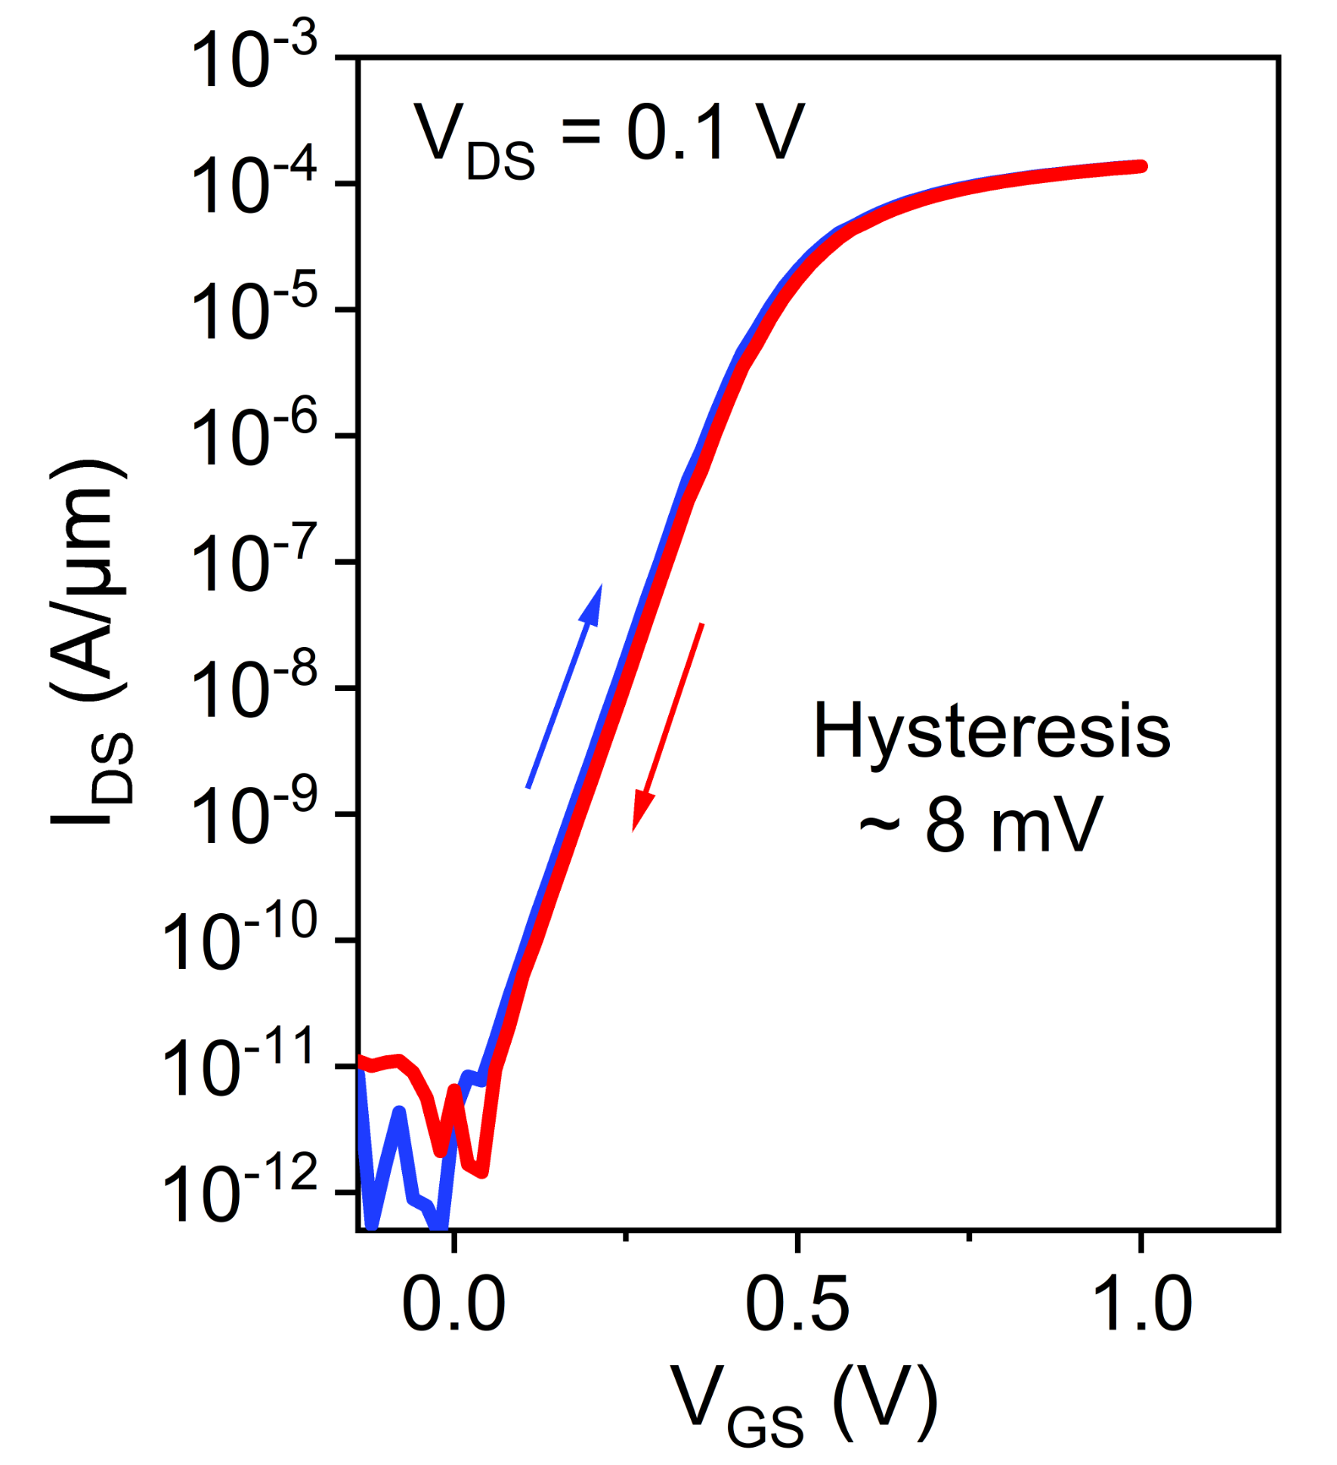
Extended Data Fig. 9 | Hysteresis of transfer characteristics for a typical MoS₂ FET.

