Figures and Figure Legends

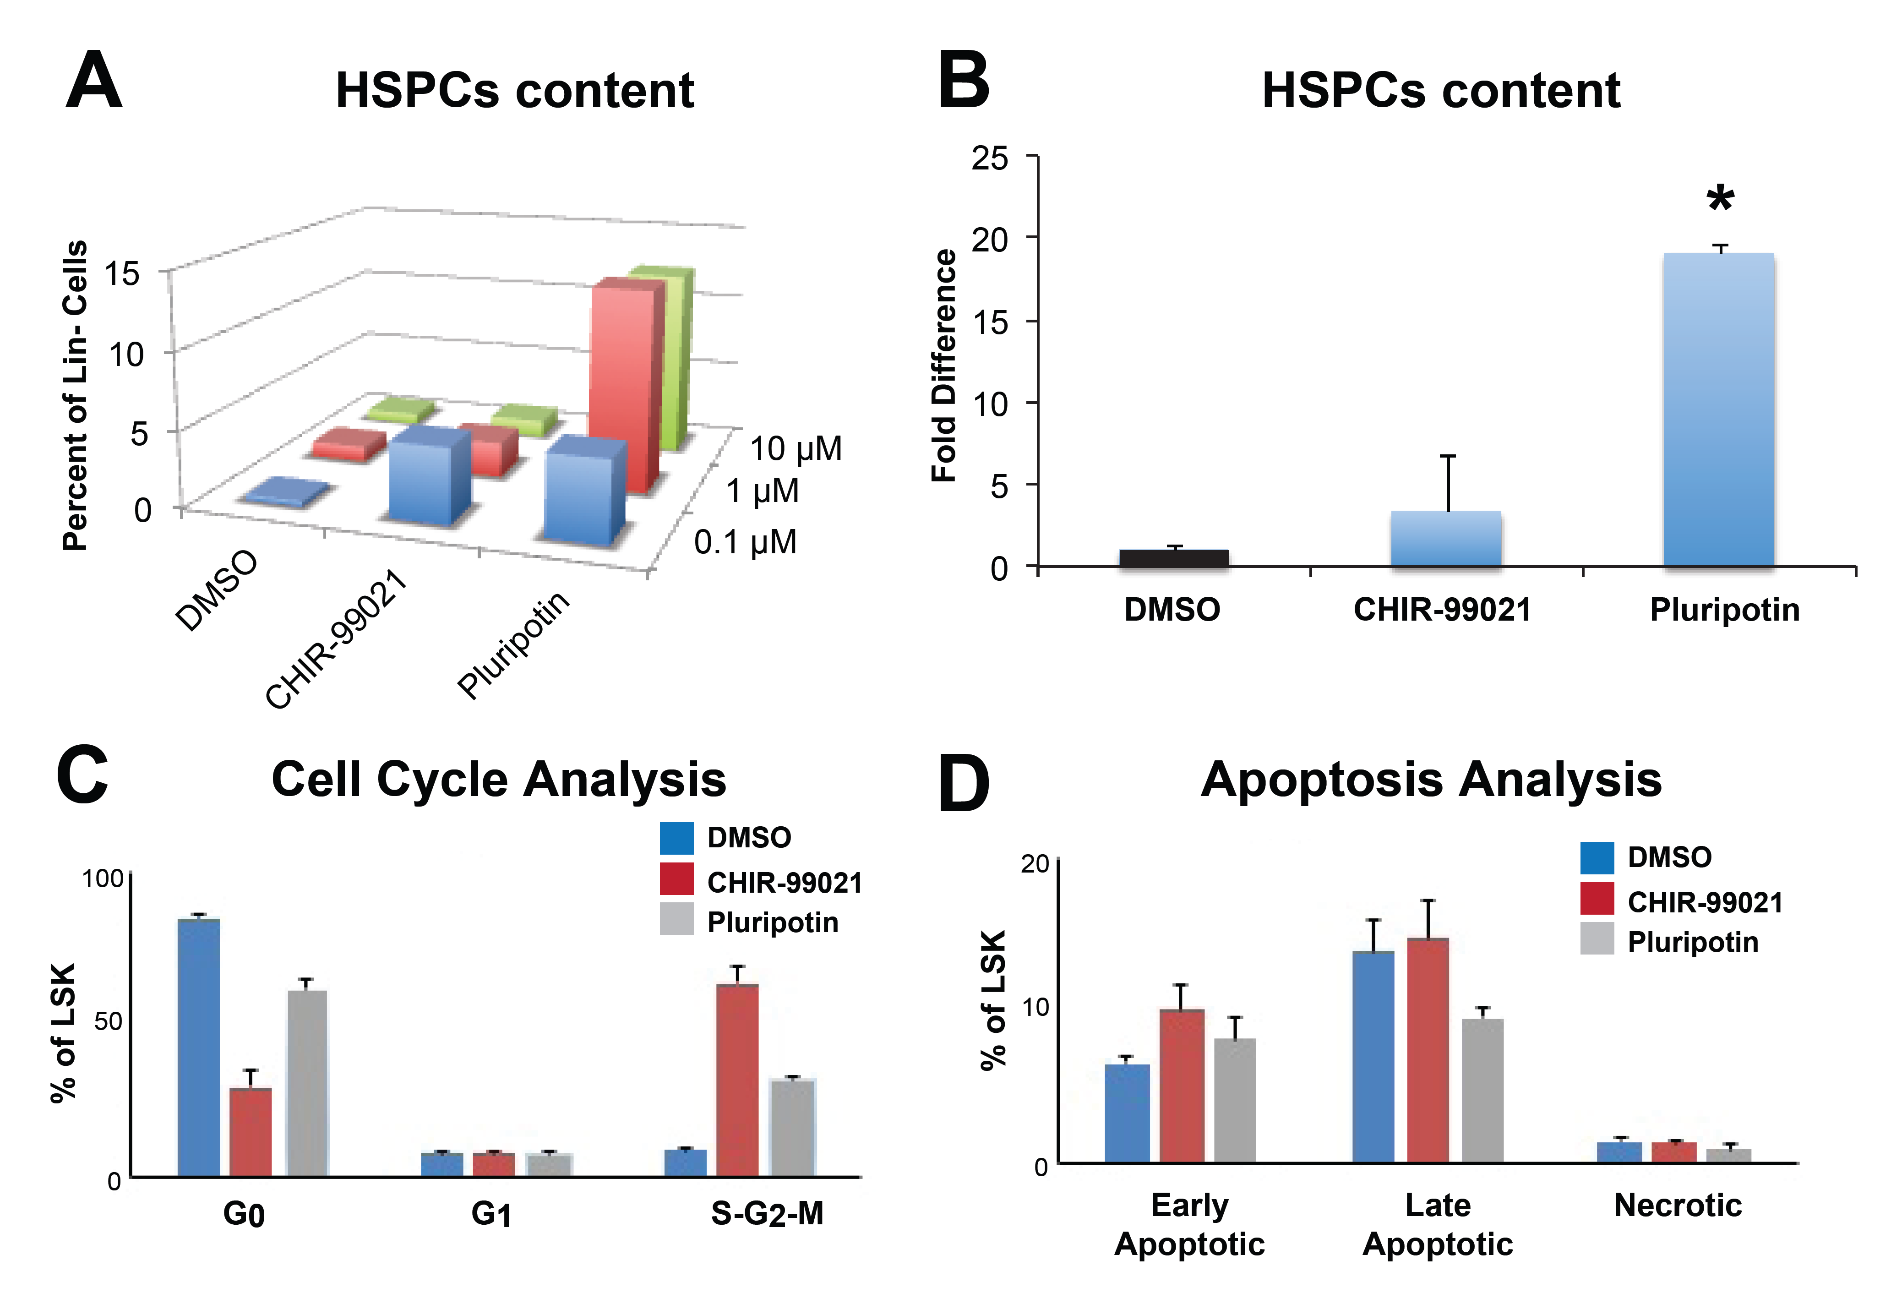Figure 1. Analysis of HSPC content in murine BM MNCs treated with CHIR-99021 and Pluripotin. A) The percentage of HSPC content in the Lin- cell population after 7 days of treatment with 0.1 µM, 1 µM, and 10 µM doses of CHIR-99021 and Pluripotin. DMSO treated cells were used as the control group. B) The fold differences of HSPCs after 7 days of treatment with 0.1 µM of CHIR-99021 and 1 of µM of Pluripotin. Cell cycle and apoptosis analysis in murine HSPCs post CHIR-99021 and Pluripotin treatments: Murine HSPCs were isolated and treated with CHIR-99021 and Pluripotin. C) Cell cycle analysis and D) Apoptosis analysis post 3 days of treatments. n=3, *p<0.05.
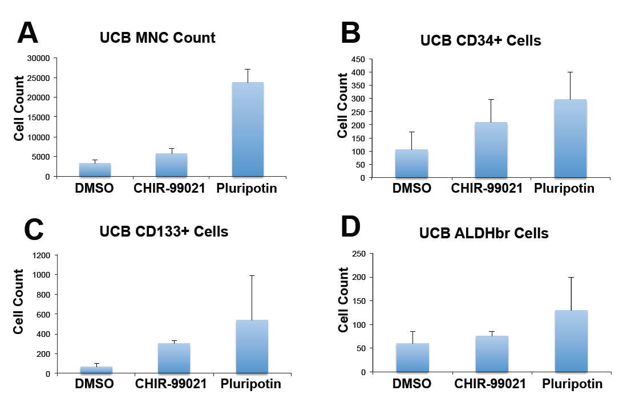Figure 2. Analysis of HSPC content in UCB MNCs after treatments with CHIR-99021 and Pluripotin. Analysis of A) total MNC content, B) CD34+ HSPC content, and C) CD123+ HSPC content in UCB MNCs post 7 days of treatment with CHIR-99021 and Pluripotin small molecules. D) Assessment of ALDHbr activity in UCB MNCs post 7 days of treatment with CHIR-99021 and Pluripotin small molecules. n=3.

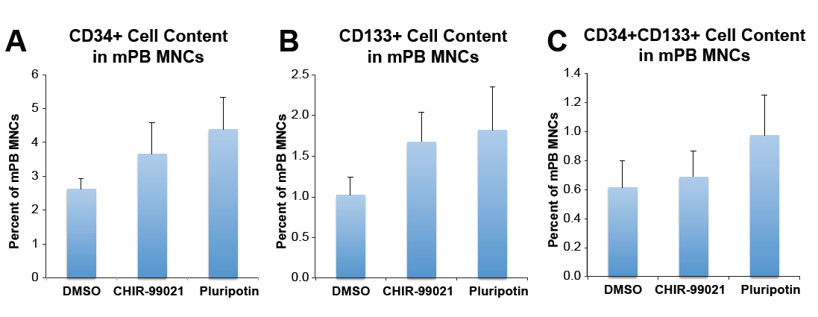
Figure 3. Analysis of HSPC content in mPB MNCs post CHIR-99021 and Pluripotin treatments. A) Determination of CD34+ HSPC content, B) CD133+ HSPC content and C) CD34+CD133+ HSPC content of human mPB MNCs post 7 days of treatments. These results consist of an average of different dosages which are 0.1 µM, 1 µM, 10 µM and compared with DMSO. n=3.

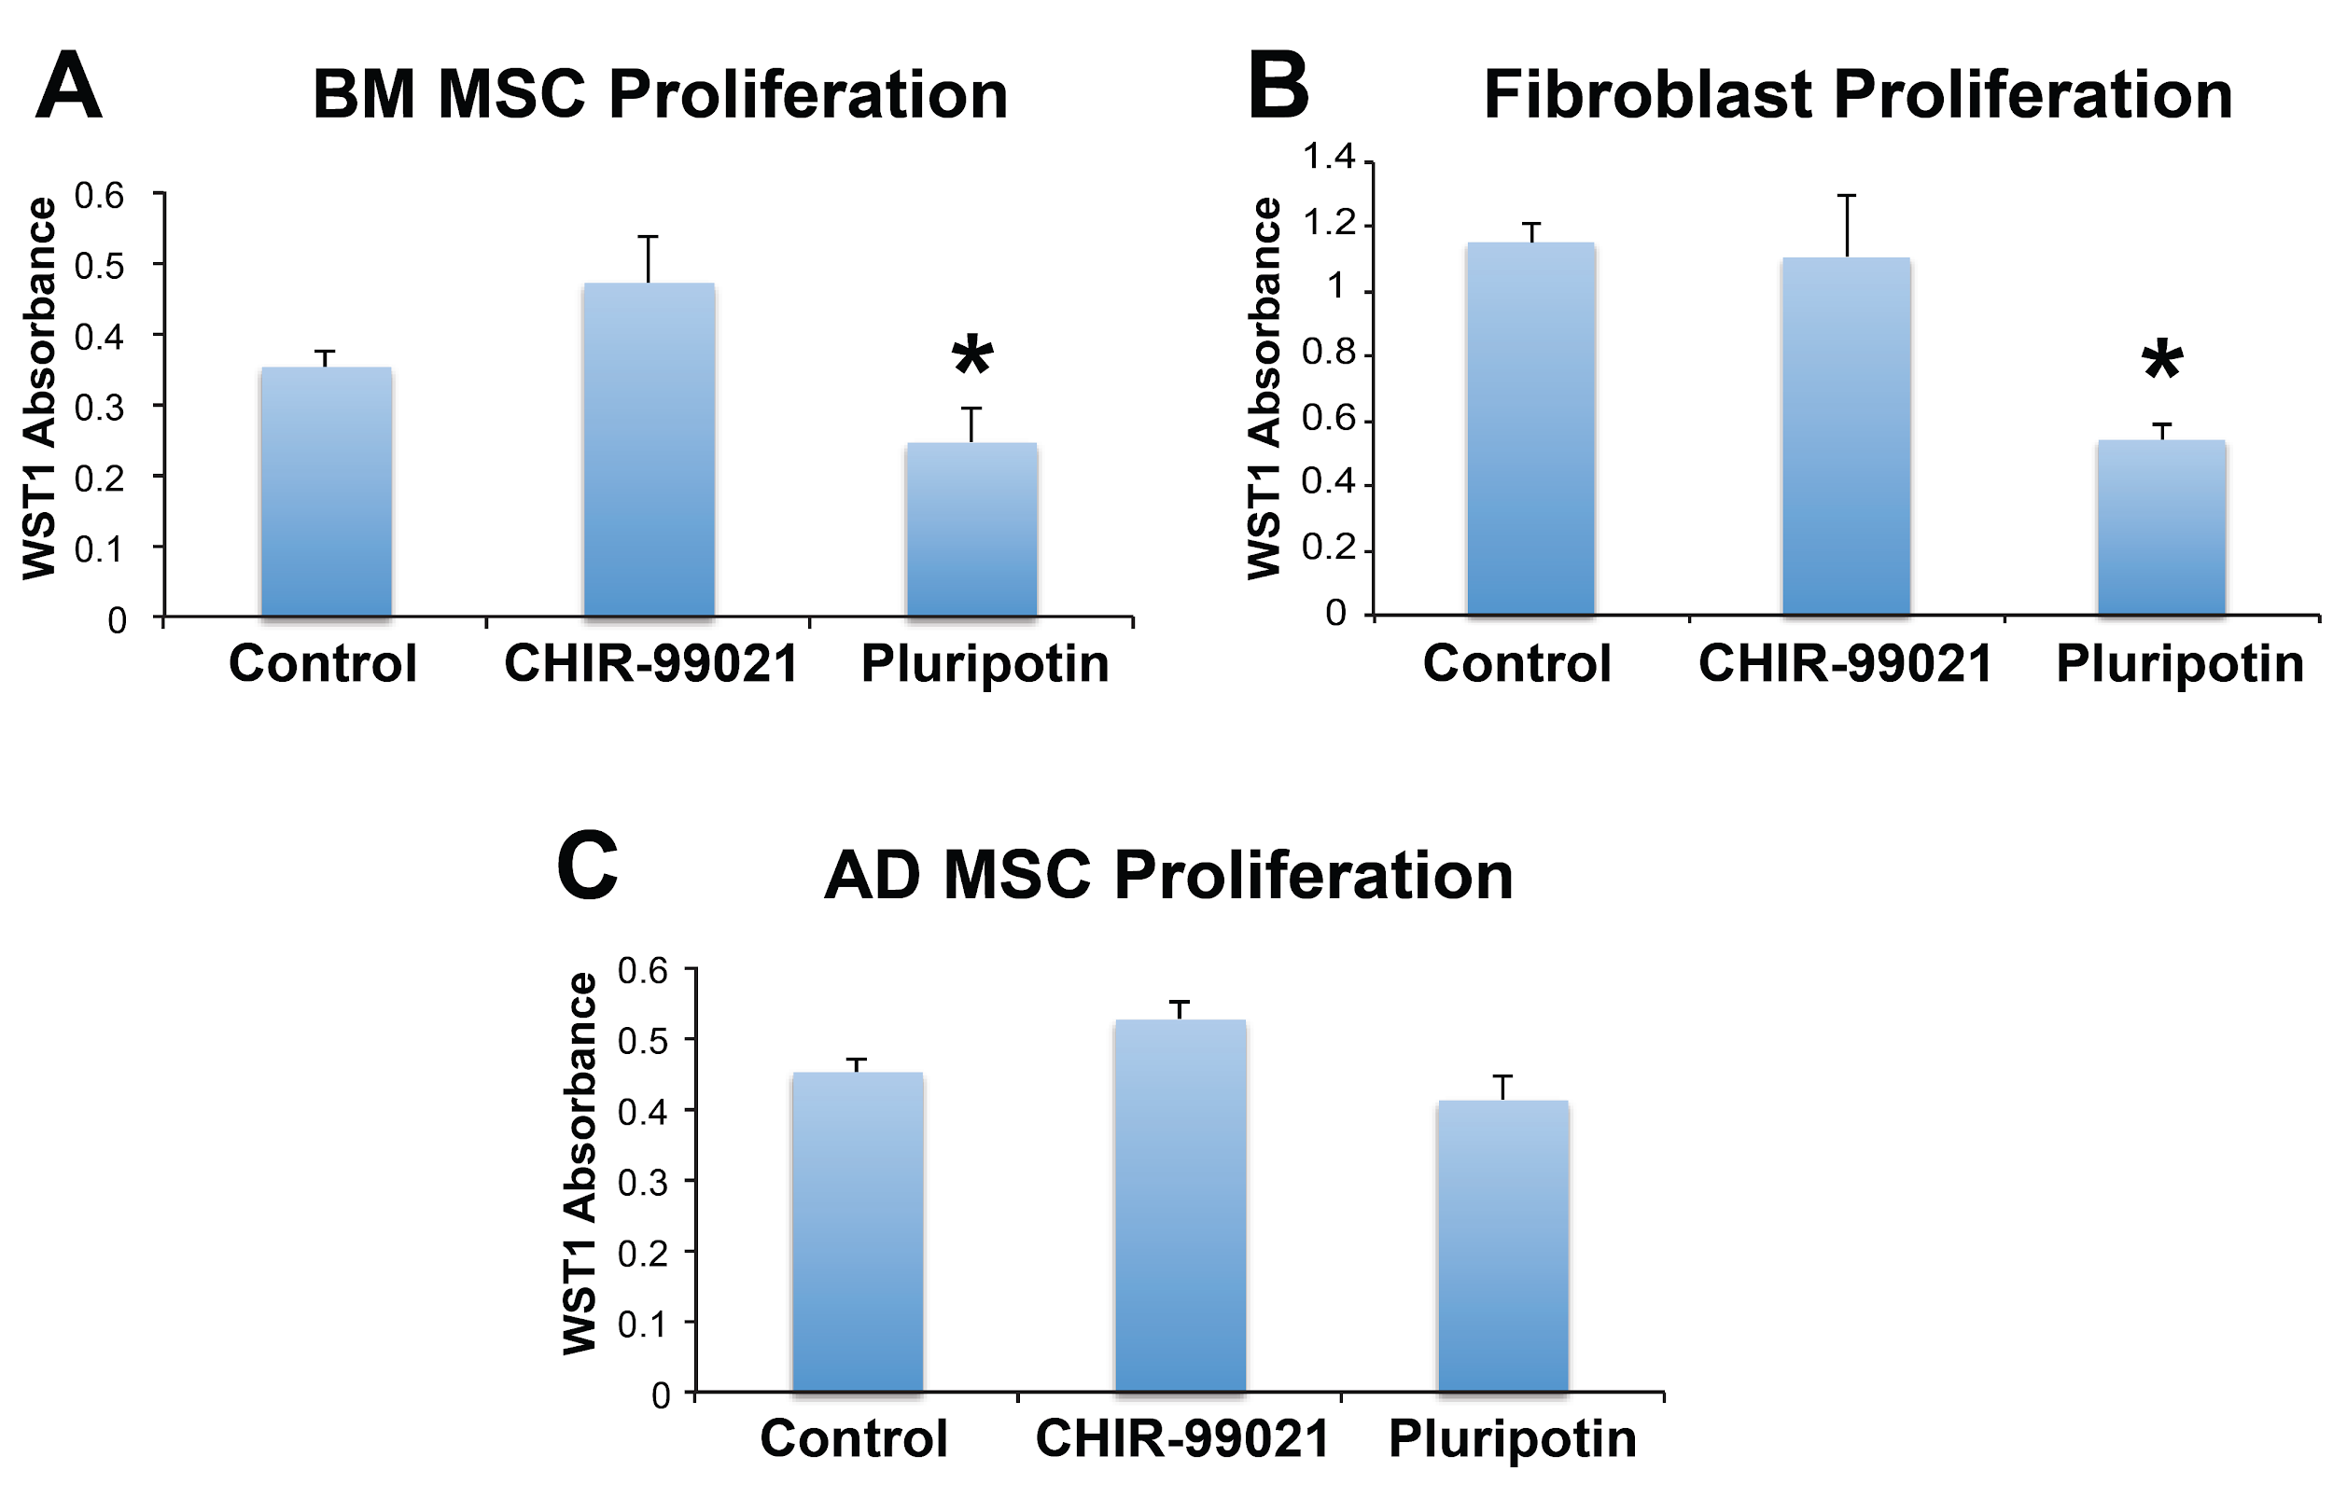
Figure 4. Analysis of MSC and fibroblast proliferations post CHIR-99021 and Pluripotin treatments. Assessment of A) BM MSC proliferation, B) human fibroblast (HDFs), and C) AD MSC proliferation post 3 days of treatment with CHIR-99021 and Pluripotin small molecules. The graph shows the percentage of cells according to WST1 absorbance. n=3, *p<0.05.

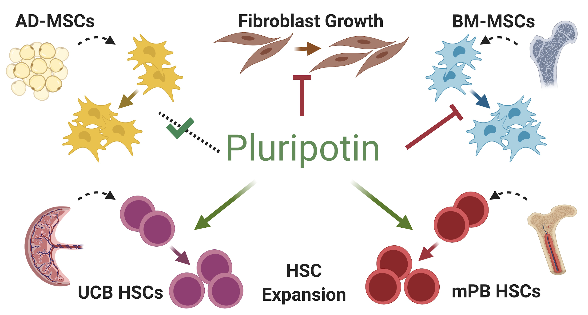
Figure 5. Effects of Pluripotin in stem and fibroblasts ex vivo. Pluripotin enhances expansion of UCB and mPB HSCs, and reduces fibroblast and BM-MSCs growth ex vivo. There is no significant effect of Pluripotin in the AD-MSCs during their expansion.

Supplementary Figures and Figure Legends

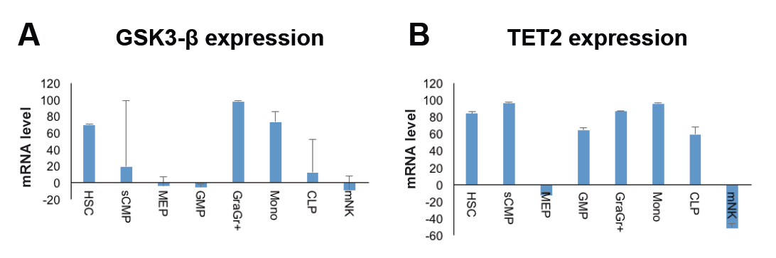
Figure S1. Relative gene expression in hematopoietic cells related to Pluripotin and CHIR-99021. A) GSK3-β and B) Tet2 expression levels in hematopoietic stem cells, granulocyte, monocyte and some progenitor cells such as common myeloid progenitors (sCMP), megakaryocyte–erythroid progenitor (MEP), granulocyte-macrophage progenitor (GMP), common lymphoid progenitor (CLP) and mature natural killer cells (mNK) were retrieved from GENX database. Note that Pluripotin and CHIR-99021 may modulate Tet2 and GSK3-β activity and expression in HSPCs, respectively.

